Total time for test: 6hrs

Includes design of database, coding ,tests ,documentation, deliverables preparation.

**Requeriments:**

**OS:** Windows 10 Pro

**SQL SERVER:**

Microsoft SQL Server 2016 (RTM) - 13.0.1601.5 (X64) Apr 29 2016 23:23:58 Copyright (c) Microsoft Corporation Developer Edition (64-bit) on Windows 10 Pro 6.3 <X64> (Build 18362: )

**Visual Studio**

Microsoft Visual Studio Professional 2015

Versión 14.0.25431.01 Update 3

Microsoft .NET Framework

Versión 4.8.03752

Versión instalada: Professional

**Postman:**

Latest Version

**Type of project:**

Aplicacion we ASP.NET, C# language

Web Api / MVC

**Steps to run the app**

1. Run the script “script.sql” in SQL Server

CHANGE the “FILENAME” values in the script.sql , for the mdf and ldf.

This creates the database BLOG, tables, and store procedures.

2. Open the WebApiBlogCM Solution whit visual studio 2015 and Run it

3. Install the Nuget packages:

Autofac

Autofac.WebApi2

4. Run the application, a browser will open, write down the **URL**.

5. Open Postman to test functionalities, see postman collections below you’ll need the **URL** you wrote down.

6. Execute tests.

**Postman:**

**Authentication:**

**Create token for users:**

**To create a token, enter values like the image below, don’t forget to change the url , must be : YOUR_URL/token**

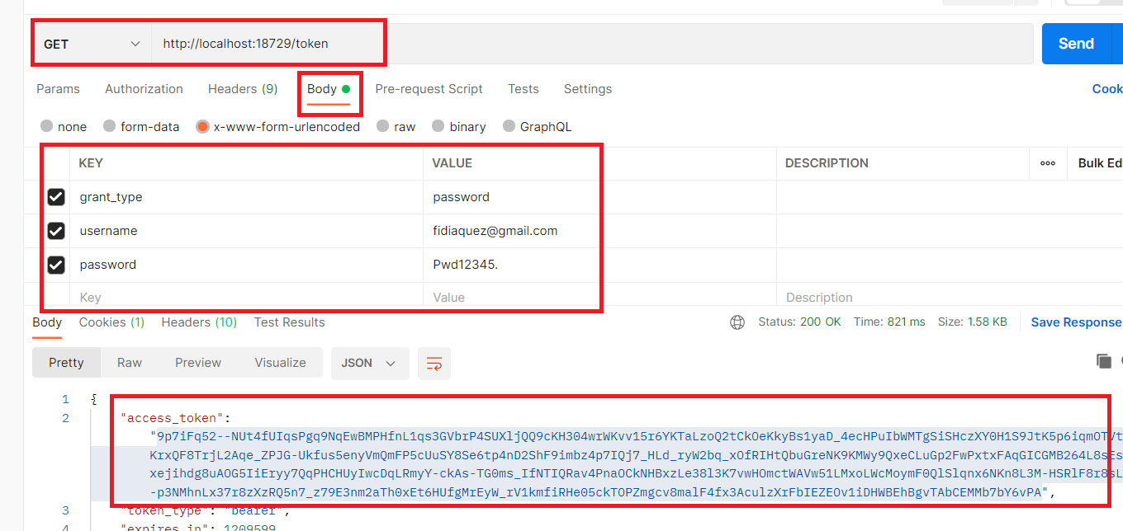

You will get the access token in the response, save it for later.

**Postman Collections**

**Important: ALL request need a header with KEY and TOKEN like below, don’t forget to include the word ”Bearer” before the token value**

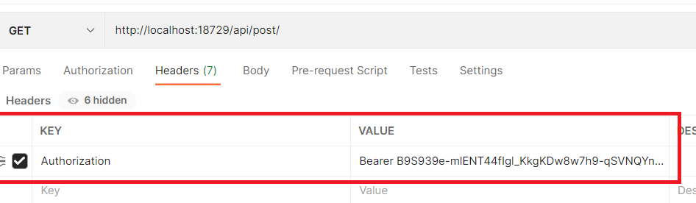

**Requests examples:**

|  |  |  |  |  |
| --- | --- | --- | --- | --- |
| **Operation** | **Method** | **URL** | **Body example** | **Comment** |
| List all published/submitted posts | GET | YOUR_URL/api/post/ |  |  |
| List all writer posts | GET | YOUR_URL/api/post/listwriterposts |  | List all posts from writer(writer identified with the token of the request) |
| List all editor posts | GET | YOUR_URL/api/post/listeditorposts |  | List all posts from editor(editor identified with the token of the request) |
| Add post | POST | YOUR_URL/api/post/ | { writeriterid" : 1 ,  "editorid" : 2 ,  "title" : "My review",  "description" : "this is my review"  } | Only if the user is a writer.  The “writerid” must be an id from the BLOG database [user] table,  And must be with role “writer” |
| Update post | PUT | YOUR_URL/api/post/updatepost | {  "writerid" : 1 ,  "id" : 1 ,  "title" : "My third review",  "description" : "this is my third review"  } | Where “id” is the postid |
| Submit Post | PUT | YOUR_URL/api/post/submitpost | {  "id" : 1  } | Where “id” is the postid |
| reject Post | PUT | YOUR_URL/api/post/rejectpost | {  "id" : 1  } | Where “id” is the postid |
| publish Post | PUT | YOUR_URL/api/post/publishpost | {  "id" : 1  } | Where “id” is the postid |