Supplementary Material for:

Finding the P3 in the P600: Decoding shared neural mechanisms of responses to syntactic violations and oddball paradigms

Jona Sassenhagen¹, Christian J. Fiebach^{1,2}

¹ Department of Psychology, Goethe University Frankfurt, Frankfurt am Main, Germany
² Brain Imaging Center, Goethe University Frankfurt, Frankfurt am Main, Germany

Address for Correspondence:
Dr. Jona Sassenhagen
Department of Psychology
Goethe University Frankfurt am Main
Theodor-W.-Adorno-Platz 6,
D-60323 Frankfurt am Main, Germany
Email: jona.sassenhagen@gmail.com
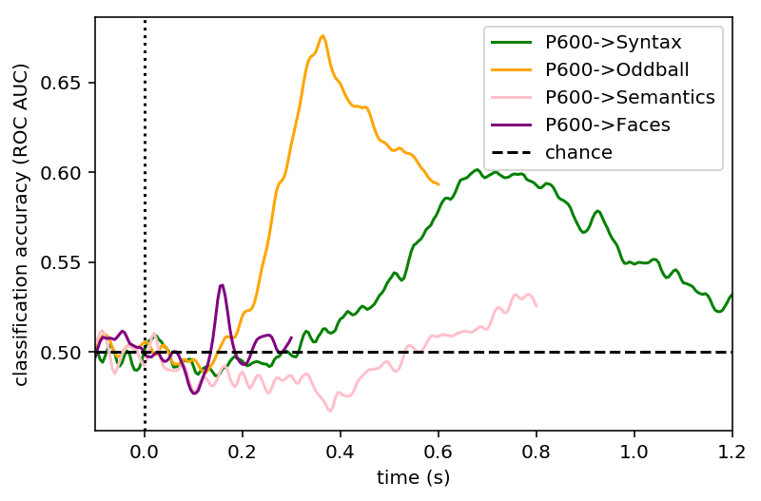
Supplement Figure 1: Cross-experiment decoding from the syntactic violation experiment to all other experiments, for pre-defined time windows of interest (see Methods). This supplementary analysis is presented here in analogy to the layout of main Fig. 4E, right, but displaying the reverse direction of between-experiment decoding. As described in the main text, data reflect the average decoding performance across decoders trained on all time points of the pre-defined P600 time window of interest. Results indicate that – beyond within-experiment P600 decoding (green), learned P600 patterns can be used to classify Oddball experiment trials (yellow, 200-600 msec; as in Study 1, where we find high decoding accuracies at the intersection of P3 peak training times and P600 peak testing times), but not the other experiments (pink and purple lines). Time courses are of different lengths because epochs of different lengths were extracted for the different experiments (corresponding to the respective component in question; see Methods section in the main text, and pre-registration). We thank a reviewer of an earlier version of this manuscript for suggesting this analysis.

Supplement Figure 2: Generalization across time (GAT) results, Study 2. Visualization as in the bottom panels of Figure 3 of the main text (Study 1), displaying testing time (X-axis) by training time (Y-axis) decoding scores for classifying trials from the syntax experiment as violation vs. control trials, based on classifiers trained on all four experiments in Study 2 (A: Syntactic task, B: Oddball task, C: Semantic violation task, D: Face task). The Y axis shows where in the training set the pattern occurs, the X axis shows when in time the respective pattern can be decoded in the syntactic violation trials. Results indicate cross-experiment decoding from Oddball to syntactic violation trials (top right). Decoding for the other two classifier sets (bottom rows) is much worse. Syntax->syntax decoding is shown in the top left box.

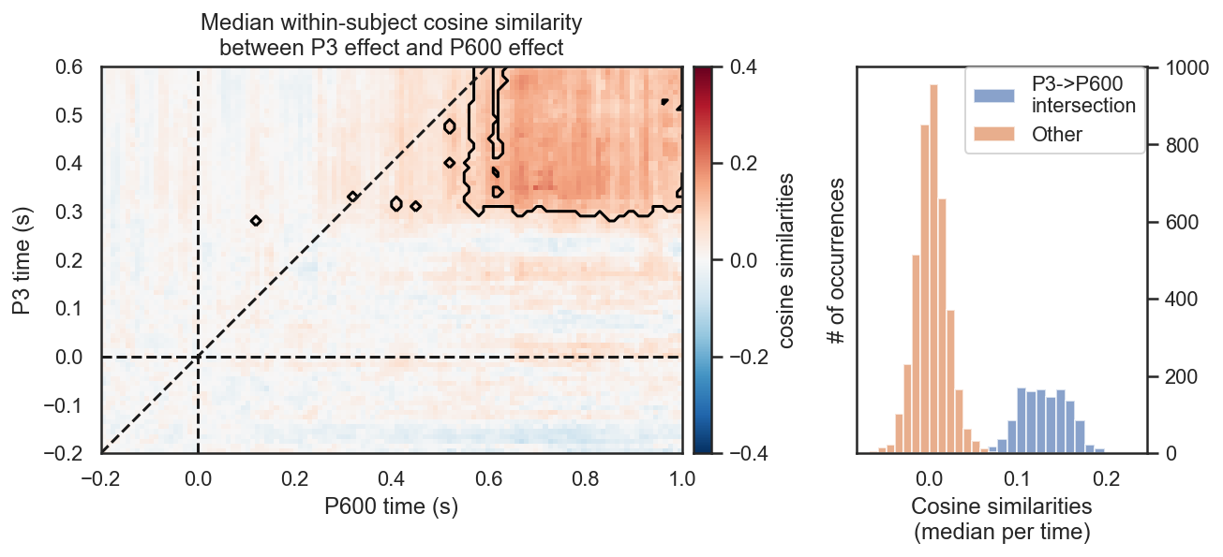

Supplement Figure 3: Time generalization of cosine similarities of ERP contrast effects, for Study 1. For each time point of the P3 contrast and each time point of the P600 contrast, the average cosine similarity was calculated between the P600 violation trials (minus the mean of all control trials) and the average of the P3 effect, nested inside a cross-validation loop. The masked area indicates FDR corrected significance. The histogram on the right shows the distribution of cosine similarities, binned by whether or not they are at the intersection of the P3 and P600 time windows (i.e., 300 to 600 msec; 600 to 1000 msec, respectively). We thank a reviewer of an earlier version of this manuscript for suggesting this analysis.

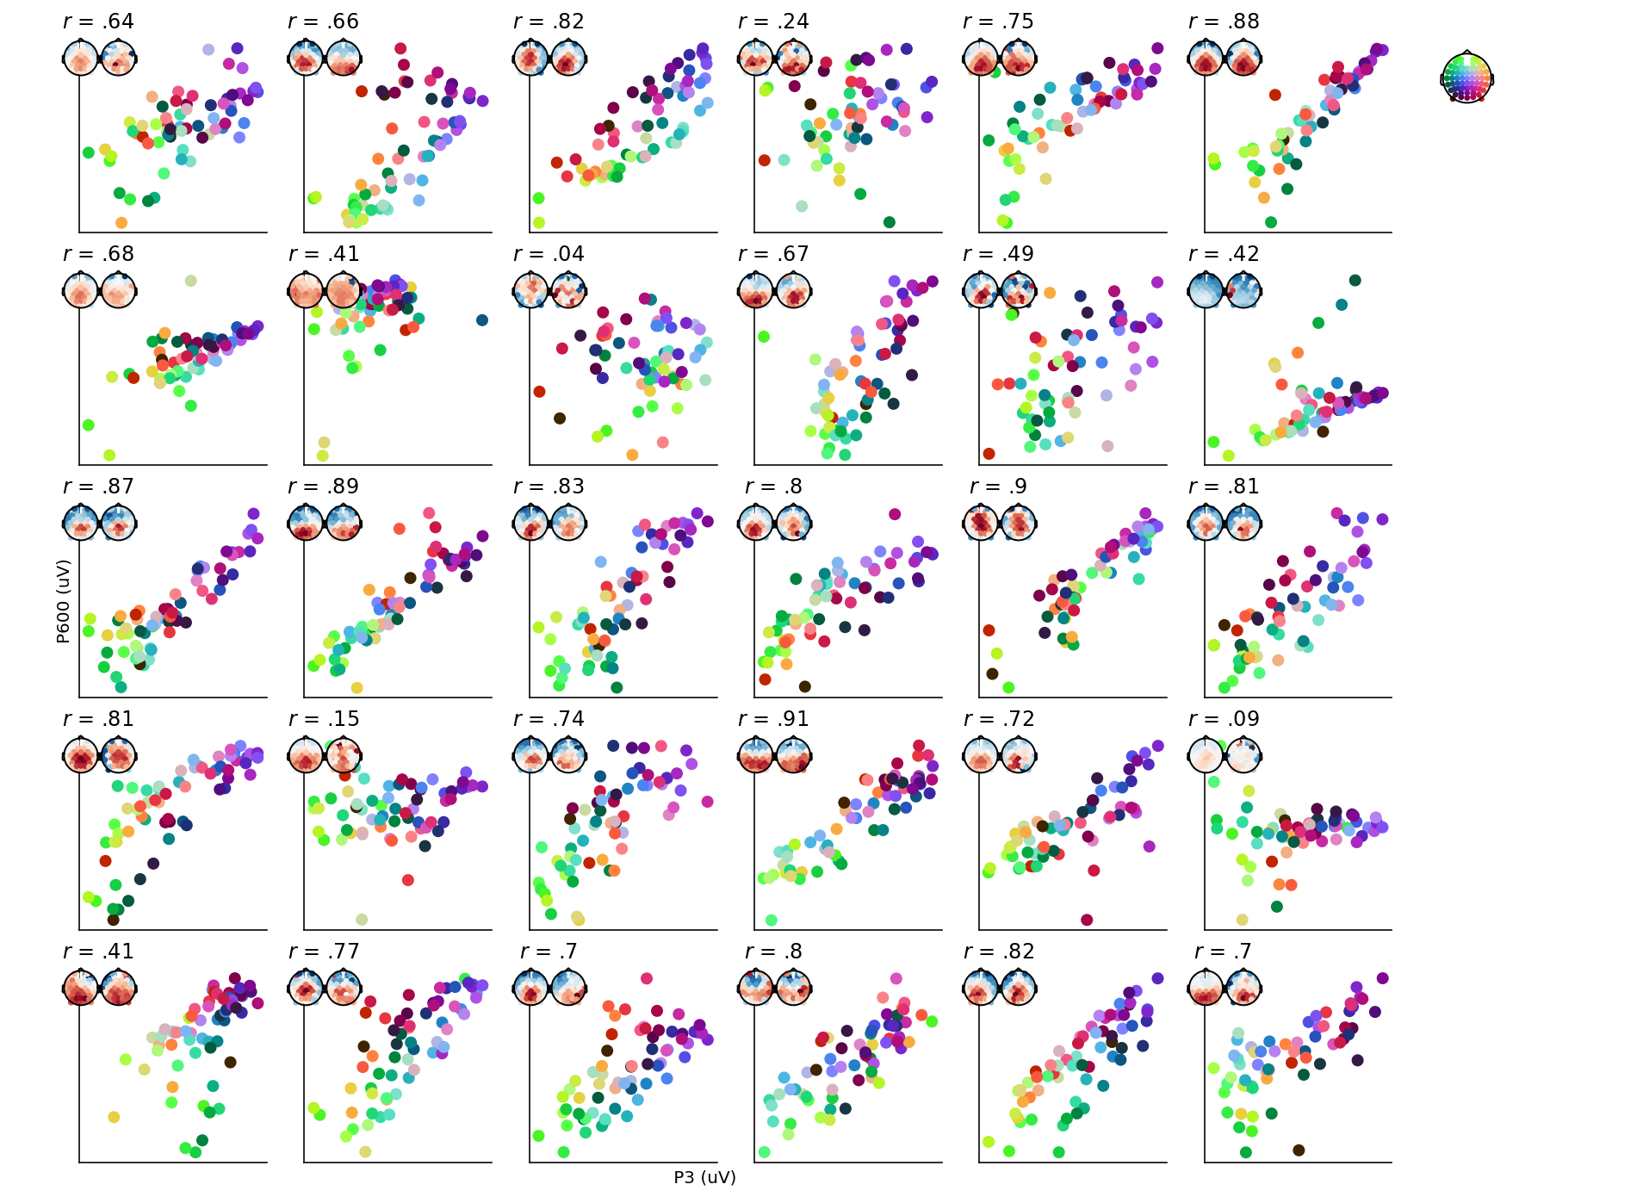

Supplement Figure 4: Relationship between P3 and P600 for all individual subjects. The value per electrode (electrode location represented by the dots’ colors) of the mean P600 (y axis) plotted against mean P3 amplitude (x axis). Also shown are for each subject the Pearson’s correlation coefficient and the subject-specific scalp maps for the peak effects (i.e., Oddball left, Syntax right). Study 1.

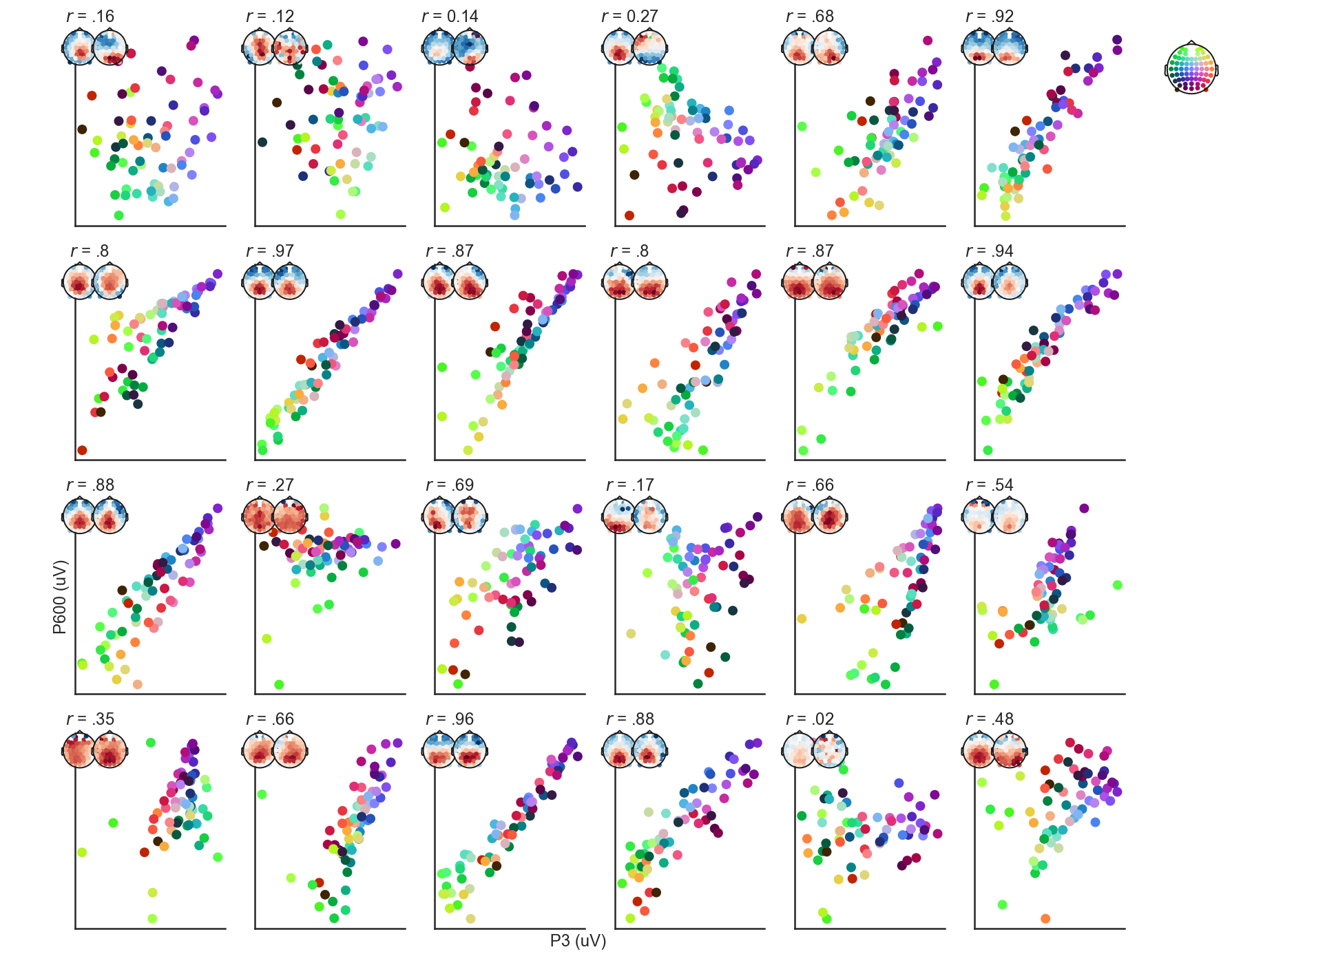
Supplement Figure 5: As Fig. S4, but for Study 2.

