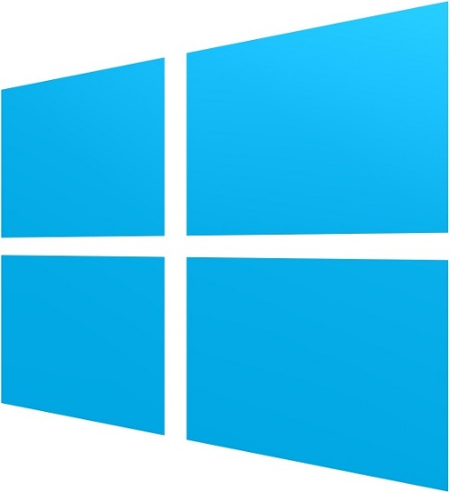



M1 Report

Status Report for Milestone 1 – Jan. 6 – Feb 15, 2013

Chris Field | Eric Foertsch | Jason Tierney

### Intended Progress

We use the SCRUM development process to determine our workload and tasks we want to accomplish during specific periods of time. This allows us to easily determine if we are on schedule. Using TFS and SCRUM we are able to track our weekly progress and determine what tasks need more time and if we need to extend to another sprint.

At this point in the project we anticipated getting ready to release our Minimal Viable Product (MVP). The MVP would be released to the Windows Store after it was approved. We wanted the MVP to include three major categories: Professors, News, and Events pages for the GVSU School of CIS. We also had stretch goals which included incorporating the GVSU School of CIS’s YouTube channel in the app as well. The intended was also to include live data feeds for each of our pages. Some of the key items we hoped to have accomplished by this milestone include the following:

* Learn Windows Store development
* Create a Minimal Viable Product and submit it to the Windows Store
  + Create Professor, News, and Events sections
* Learn about Windows Store application development
* Learn about the Windows Store app submission process
* Submit an app (MVP) to the Windows Store
* Connect to live data feeds for each section
* Create a YouTube video section (stretch goal)

The last goal on the list is defined as a stretch goal. This goal means we would like to accomplish it if every other goals was accomplished first.

### Progress to Date

We were able to create an MVP by the fifth week and we submitted the app to the Windows Store. The app is currently under the review process in the Windows Store. The first submission failed due to not having a privacy policy. This was remedied and the app was resubmitted to the Windows Store. As of this point we have accomplished the following goals:

* Learned about developing apps for the Windows Store
* Created a section for the Professors/Faculty
* Created the news page
* Created the events page
* Learned about the Windows Store app submission process
* Submitted our MVP to the Windows Store
* Learned how to develop Windows Store apps

However, some of our goals were not accomplished as of this milestone. Two main goals were not accomplished, one of which was a stretch goal:

* Connect to live data feeds for each section
* Create a YouTube video section (stretch goal)

#### Reasons for lack of completion

As we started working on the project we had initially wanted to get live data feeds working by the time we released our MVP. We realized that learning the Windows Store app development took a longer amount of time than we initially figured. Given that, we had pushed a goal that was not as feasible as we had originally thought. Live feeds will instead be given another shot in a later sprint.

### Projected Progress

As it stands, we already have a few goals we would like to accomplish by M2. The time period for these goals is between February 18 and March 15, 2013. This includes three sprints in which we hope to accomplish the following major goals/tasks.

**Code cleanup / Refactoring.** Over the first sprint (2/18 – 2/22) we are planning to overhaul and refactor a lot of the code. Cleaning up this code will result in a more efficient and effective platform in the long run and will allow us to easily adapt for features and functionality in the future.

**Create Service Classes.** The next week (2/25 – 3/1) we are planning on creating backend service classes which will help feed the data to our application.

**Create backend data services.** The eighth/ninth weeks (3/4 – 3/15) we plan on creating our backend data services. This will be an ambitious goal and may require two weeks to accomplish. Because this sprint will overlap with spring break, we feel very confident we could use that time to accomplish these goals in those two weeks.

### Conclusion

As a group, we feel like we are on track with getting this app completed by the end of this semester. We have achieved most of the goals we initially set forth up to the M1 release. At this point, we do not feel like we will have any trouble accomplishing future goals from now until the M2 release. A lot of our time in the first five weeks was spent learning the technologies and services that we needed to use in order to create the initial MVP. We will continue to track our progress through weekly sprints and make sure that we are on track throughout the semester and make adjustments accordingly to accommodate being behind or ahead of schedule.