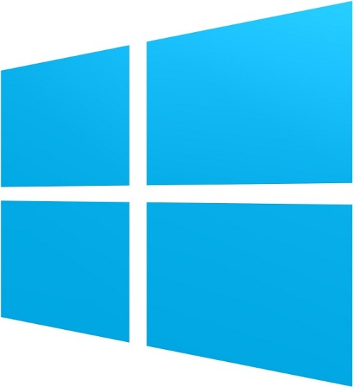



M2 Report

Status Report for Milestone 2 – Feb 18 – Mar 15, 2013

Chris Field | Eric Foertsch | Jason Tierney

### Intended Progress

We use the SCRUM development process to determine our workload and tasks we want to accomplish during specific periods of time. This allows us to easily determine if we are on schedule. Using TFS and SCRUM we are able to track our weekly progress and determine what tasks need more time and if we need to extend to another sprint.

At this point in the project we have already released our Minimal Viable Product (MVP). The MVP was released to the Windows Store after it was approved. After the MVP was approved we wanted to add more features and functionality to the app while also polishing up the UI and making it look more professional. There was also a lot of code refactoring we needed to do, thus we spent an entire sprint on code cleanup and refactoring. Some of the key items we hoped to have accomplished by this milestone include the following:

* **Code cleanup / Refactoring.** We planned to overhaul and refactor a lot of the code. Cleaning up this code will result in a more efficient and effective platform in the long run and will allow us to easily adapt for features and functionality in the future.
* **Create Service Classes.** We planned on creating backend service classes which will help feed the data to our application.
* **Create backend data services.** The eighth/ninth weeks (3/4 – 3/15) we plan on creating our backend data services. This will be an ambitious goal and may require two weeks to accomplish. Because this sprint will overlap with spring break, we feel very confident we could use that time to accomplish these goals in those two weeks.
* **Create a YouTube video section.** This is essentially creating a video feed of the GVSU CIS YouTube page.
* **Connect to live data feeds for each section (Stretch Goal).** In order to get data on our app we need to connect to live data feeds to retrieve the data. These feeds may either be preexisting or custom feeds that we create using Windows Azure.

The last goal on the list is defined as a stretch goal. This goal means we would like to accomplish it if every other goals was accomplished first.

### Progress since M1

We were able to accomplish all of our tasks we planned between M1 and M2. In addition to the tasks we wanted to complete, we were also able to finish a few other tasks as well.

* Completed code cleanup / Refactoring
* Created service classes
* Created backend data services
* Created a YouTube video section
* Started connecting to live data feeds

In addition to our required tasks, we also implemented the following:

* Created a Jobs page – not entirely complete, but the basic structure / layout is there
* Created a Twitter page – we may integrate Facebook as well into this page.

There were no real goals that we felt we did not accomplish for this milestone.

#### Areas of issues / struggle

Although we accomplished our tasks, we did have some setbacks. Some of the tasks took a lot longer time than we initially planned for them to be completed. This led to us spending a lot more time working on the project than what we had originally planned and made us push one of our sprints an extra week through spring break. We still also have some design issues we need to fix that we couldn’t figure out within the timeframe. However, we will dedicate one or two sprints in the future specifically for modifying the UI and making it look more professional and better for the end user. We also had some issues with the standard RSS feeds used in the School of CIS website. We decided to use standard GVSU RSS feeds for the time being for our News / Events pages.

### Projected Progress

From now until M3, we will be working a lot on polishing the app, creating better services for the app and making custom front end web apps to update the data for some of our custom services.

* **Polish the UI.** This will be a later sprint which we will focus on making the UI very professional looking for the end user. We will try to incorporate as much of the Windows Store app experience as we can in this sprint to enhance the overall user experience of the app.
* **Create a front-end**. We need a front end for people to update our back end data services. This will probably be written using ASP.NET. This will belong to one of our sprints, but will be one of other tasks for that sprint.
* **Enhance our current backend Azure services**.We have an Azure web service that we are using for our backend data. However, we would like to enhance this beyond what it currently is (allow updates, new data entries, etc.) This will probably be included in the same sprint as creating a front end for the Azure services.
* **Bug fixing / Issue fixing**. We will spend a significant amount of time testing the app and fixing any bugs we find present.
* **Adding bonus features**. There are still some features / functionality we would like to add if we have time. However, the primary focus of the sprints between M2 / M3 will be to polish the app and make it a presentable final product.

### Conclusion

As a group, we feel like we are on track with getting this app completed by the end of this semester. We have achieved most of the goals we initially set forth up to the M2 release. At this point, we do not feel like we will have any trouble accomplishing future goals from now until the M3 release. We have a solid understanding of the frameworks and APIs that we are using and there isn’t a whole lot of learning now as there was at the beginning of the semester. We will continue to track our progress through weekly sprints and make sure that we are on track throughout the semester and make adjustments accordingly to accommodate being behind or ahead of schedule. The group is functioning well. Although we have had a few issues with procrastination on some sprints, overall we feel we are accomplishing tasks and getting our goals accomplished. The initial five weeks involved a lot of learning, both from a development and managerial perspective. Learning a new framework while also learning a new programming paradigm (SCRUM) was definitely a challenge at first.

### Appendix

For reference, below is a summary of the tasks we intended to complete for M1.

* **Learn Windows Store development (Exploration Sprint 1 & 2).** This was simply a process of getting to learn and understand the development behind building our first Windows Store app. Although all three of us had C# experience, learning the APIs and SDKs for the Windows Store apps was a barrier for the first couple of weeks. This initial task ensures we have an understanding of the technologies we will use throughout the semester.
* **Create a Minimal Viable Product (MVP Sprints 1 – 3).** This was one of our big goals for the first milestone. Not only did we have to already have code written by the fifth week, but we need to submit the app to the Windows Store by the fifth week as well. The sections we decided to support for the MVP are the following:
  + Professor / Faculty
  + News
  + Events
* **Learn about the Windows Store app submission process (MVP Sprint 3).** Before we can submit an app to the store we need to make sure we have all of our bases covered. This task entails making sure we have an account setup and we have all of the appropriate information required to submit an application to the Windows Store.
* **Submit an app (MVP) to the Windows Store (MVP Sprint 3).** Our next step is to submit the MVP to the Windows Store. This process, although very important and crucial to the overall end product, should be fairly simple, as long as we have already created an account on the Windows Store.
* **Connect to live data feeds for each section (Sprint?).** In order to get data on our app we need to connect to live data feeds to retrieve the data. These feeds may either be preexisting or custom feeds that we create using Windows Azure.
* **Create a YouTube video section (stretch goal).** This goal is a stretch goal which means if we don’t accomplish it by M1 that is okay. This task should not be completed until all of the other tasks are completed first.