Official Documentation

SkillAlign
Intelligent Recruitment & Candidate-Job Matching Platform
A full-stack recruitment platform that matches candidates to jobs using a transparent, rule-based scoring engine and manages the complete hiring lifecycle — from resume upload to signed offer.
StackFastAPI · React 18 · PostgreSQL · Redis · Celery | User RolesAdmin · HR/Hiring Manager · Recruiter · Candidate
Pipeline21-state controlled hiring lifecycle | Score ModelSkills 60% · Experience 20% · Education 10% · Work Mode 10%
Version: 3.0 Production Baseline | Date: September 2026
Table of Contents
- 01Executive Overview
- 02The Problem SkillAlign Solves
- 03Project Objectives
- 04How SkillAlign Works
- 05User Roles & Responsibilities
- 06Technical Reference
- 07Authentication
- 08Candidate Journey
- 09Resume Upload & Processing
- 10Job Creation & Requirements
- 11Skill Taxonomy
- 12Matching Engine & Fit Score
- 13Recruiter Workflow
- 14HR / Hiring Manager Workflow
- 1521-Stage Recruitment Pipeline
- 16Interview Management & Evaluation
- 17Offer Management & Candidate Response
- 18Notifications & Communication
- 19Audit Trail
- 20Security & Access Control
- 21End-to-End Journey & Test Verification
- 22Future Enhancements
01

Executive Overview
SkillAlign is a complete recruitment platform that ranks candidates against jobs using a transparent Fit Score, then manages every step of the hiring journey — shortlisting, interviews, offers, and final outcomes — within one connected system.
🎯  Explainable Matching  Every score breaks down into skills, experience, education, and work mode. No black boxes. | ⚙️  Controlled Pipeline  A 21-stage lifecycle enforced by the workflow engine. No step can be skipped. | 🔐  Role-Separated Access  JWT-based RBAC ensures each role sees and does only what it is permitted to.
📄  End-to-End Offers  Draft → HR approval → PDF generation → candidate response. Fully tracked. | 📊  Complete Audit Trail  Every state transition, actor, and timestamp is permanently logged in the audit_logs table. | 📨  Automated Communication  Interview invitations and offer letters dispatched via SendGrid with secure token links.

02

The Problem SkillAlign Solves
Traditional recruitment is slowed down by manual friction, surface-level keyword matching, and fragmented tooling. SkillAlign solves these six fundamental pain points:
📥  Resume Overload  High-volume applicants lead to screening fatigue, slow response times, and missed top talent. | 🔍  Shallow Keyword Matching  Mentioning a tool is not mastery. Traditional systems ignore depth, recency, and contextual evidence. | ❓  Unexplainable Decisions  Opaque scoring and arbitrary rejections create compliance risks and candidate frustration.
🔀  Fragmented Tooling  Sourcing, scheduling, feedback, and offers scattered across separate systems with no single source of truth. | 📭  Poor Candidate Experience  Radio silence and awkward scheduling emails damage employer brand reputation.

03

Project Objectives
1

Automate Candidate Ranking
Background Celery tasks score and rank candidates deterministically as soon as jobs are activated.
2

Provide Explainable Fit Scores
Every score clearly itemizes skills (60%), experience (20%), education (10%), and work mode (10%) with resume evidence.
3

Enforce a 21-Stage Workflow
Server-side state engine guarantees no lifecycle stages are skipped and every transition is role-gated and logged.
4

Streamline Interview Coordination
HM proposes multi-slot options; candidates select via secure token links without needing account login.
5

Govern Offer Approvals
Recruiter drafts, HR reviews against salary bands, ReportLab generates S3-backed PDF, candidate responds via token.
6

Maintain Complete Auditability
Immutable logging in PostgreSQL tracking actor, action, timestamp, and previous/next states.

04

How SkillAlign Works
SkillAlign follows a single connected story: a job is created → candidates are matched → recruiters screen → HR decides → interviews are scheduled → an offer is sent → the candidate responds.
Figure 1 · Complete Hiring Journey
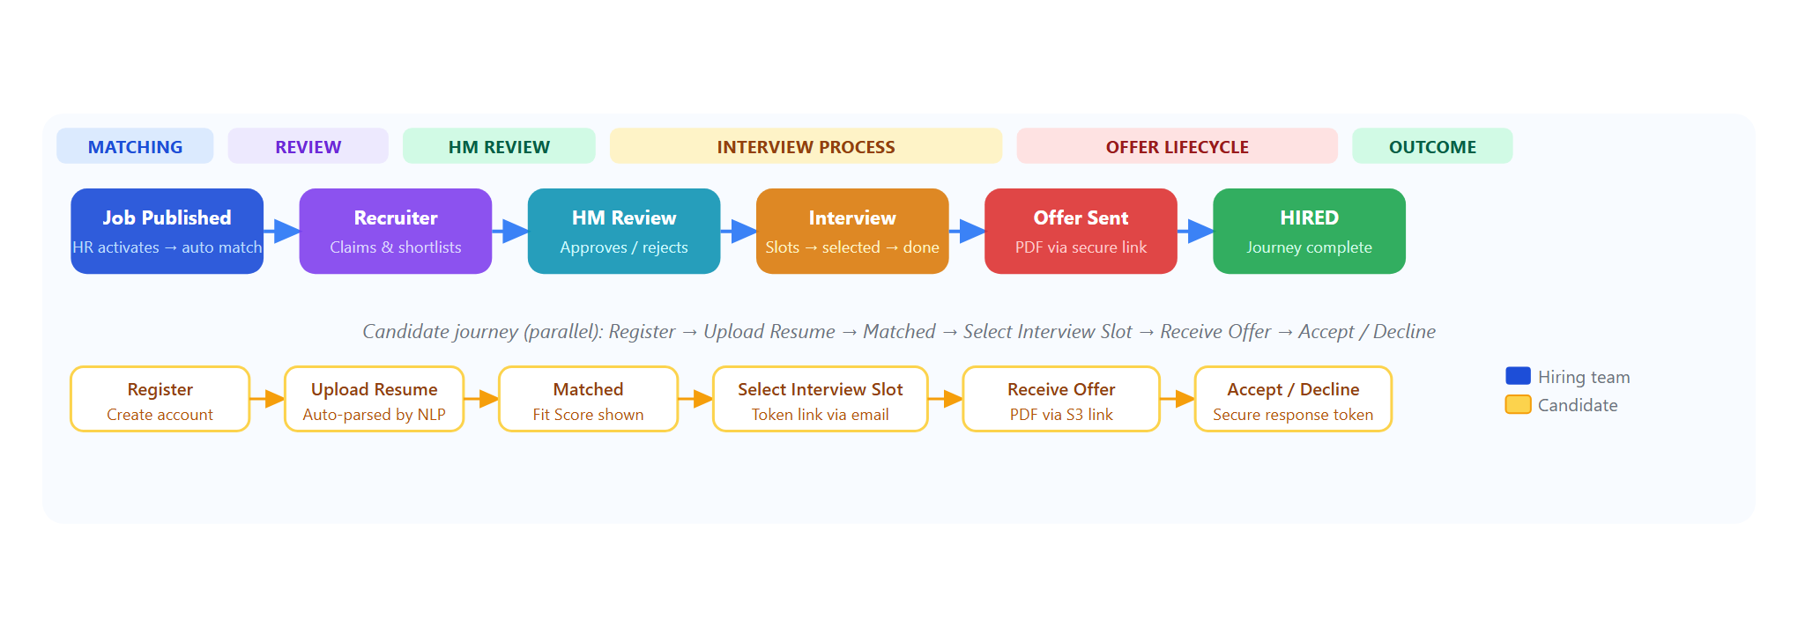
Figure 1. The hiring team's workflow (top) and candidate's journey (bottom) run in parallel and connect at interview scheduling and offer response.

05

User Roles & Responsibilities
SkillAlign enforces four distinct roles via JWT-based RBAC. Each role has a defined scope — what it can see and what actions its API endpoints accept.
Administrator  Admin  - Manages all user accounts  - Maintains the master skill taxonomy  - Views the global audit log  - Full platform access | HR / Hiring Manager  HR · HM  - Creates and owns job requisitions  - Defines skill weights and requirements  - Reviews shortlists and makes GO / NO-GO decisions  - Reviews and approves offers before they are sent
Recruiter  Recruiter  - Works on assigned jobs only  - Claims, screens, and shortlists candidates  - Coordinates interview scheduling  - Drafts offers and sends approved PDFs to candidates | Candidate  Candidate  - Self-registers and manages their profile  - Uploads resume for automated parsing  - Selects interview slots via secure token link  - Accepts or declines offers via secure token link

Role Permissions Matrix
Capability | Admin | HR / HM | Recruiter | Candidate
Create / edit / close jobs | Yes | Yes | No | No
Assign Recruiters to jobs | Yes | Yes | No | No
Run / trigger matching | Yes | Yes | Yes | No
Claim and screen candidates | Yes | No | Yes | No
Shortlist and submit to HM | No | No | Yes | No
HM review / reject candidates | No | Yes | No | No
Request interview & propose slots | No | Yes | No | No
Send slots / confirm interview | No | No | Yes | No
Select interview slot | No | No | No | Token
Submit interview GO / NO-GO | No | Yes | No | No
Draft compensation offer | No | No | Yes | No
Approve offer | No | Yes | No | No
Generate PDF & send offer | No | No | Yes | No
Accept / decline offer | No | No | No | Token
Manage user accounts | Yes | No | No | No
View hiring audit log | Yes | No | No | No

06

Technical Reference
SkillAlign is a six-layer system — each layer has a focused responsibility and communicates with the others through well-defined interfaces.
Layer | Technology | Purpose
Frontend | React 18 + TypeScript + Vite + Tailwind CSS | Role-based dashboards — Admin, HR, Recruiter, Candidate views
Backend API | Python 3.12 + FastAPI + Uvicorn + Pydantic v2 | REST API with RBAC, request validation, business logic
Database / ORM | PostgreSQL 16 + SQLAlchemy 2.0 + Alembic | Relational data store — 24+ tables, enforced constraints, migrations
File Storage | AWS S3 / MinIO | Resume binaries, extracted text, offer PDFs — presigned URL access
Async Processing | Celery 5.x + Redis | Background matching tasks, resume processing queues
Resume Parsing | pdfplumber + python-docx | Text extraction from PDF, DOCX, TXT — section detection and skill mapping
PDF Generation | ReportLab | Offer letter PDF creation — stored to S3, delivered via presigned URL
Authentication | JWT HS256 + bcrypt | Stateless session tokens, password hashing, OTP flow
Email | SendGrid | Interview invitations, offer letters, password reset
SMS / OTP | Twilio | Phone-based candidate authentication
Rate Limiting | SlowAPI | Throttle on OTP and password-reset endpoints
AI / NLP (Optional) | Google Gemini | Supplementary candidate narrative and interview question suggestions

API Surface
Auth  11 endpoints — register, login, OTP, password reset, refresh, logout | Jobs & Skills  19 endpoints — job CRUD, taxonomy, recruiter assignment, job messages
Candidates & Resumes  14 endpoints — profile, skills, resume upload / download / re-parse | Matching Engine  10 endpoints — run matching, results, scorecards, AI narrative
Recruiter Ops  9 endpoints — dashboard, candidate queue, claiming, tasks | Workflow Engine  24 endpoints — all 21 pipeline transitions, interview management, action center
Offers  14 endpoints — draft, approval, PDF, send, respond, download | Admin & Audit  11 endpoints — user management, hiring logs, statistics
Total: 115+ REST endpoints across 16 domain-focused FastAPI routers.

07

Authentication
All protected endpoints require a valid JWT Bearer token. Role claims inside the token are verified on every request by the dependency-injection layer in FastAPI.
✉️  Email & Password  Standard login — password verified against bcrypt hash. Available for all roles. | 📱  Phone OTP  Candidate login via Twilio SMS. OTP is valid for 5 minutes, rate-limited by SlowAPI.
🔑

Password Reset
Cryptographically random token, SHA-256 hashed at rest, delivered via SendGrid. One-use and time-limited.

08

Candidate Journey
1

Register & Build Profile
Create account, enter location, total experience, education qualification, and work mode preference.
2

Upload Resume
Upload PDF, DOCX, or TXT. A Celery task processes the file asynchronously — no manual entry needed.
3

Review Extracted Skills
See which skills were detected from the resume, their proficiency signals, and the supporting evidence text snippets.
4

Get Matched to Jobs
Once the profile is ready, Fit Scores are automatically calculated against all active jobs. Track application status from the candidate dashboard.
5

Receive Interview Invitation
A SendGrid email arrives with proposed time slots and a secure, one-use selection link — no login required.
6

Select a Slot & Attend
Click the link, choose a slot. System cancels the remaining slots automatically. Confirmation email follows with the meeting link.
7

Receive the Offer
If the interview outcome is GO, a ReportLab-generated PDF offer arrives via a S3 presigned link in email.
8

Accept or Decline
One click on the secure token link. Response is recorded instantly, all parties notified, and the match_result row updated.

09

Resume Upload & Processing
Figure 2 · Resume Processing Pipeline
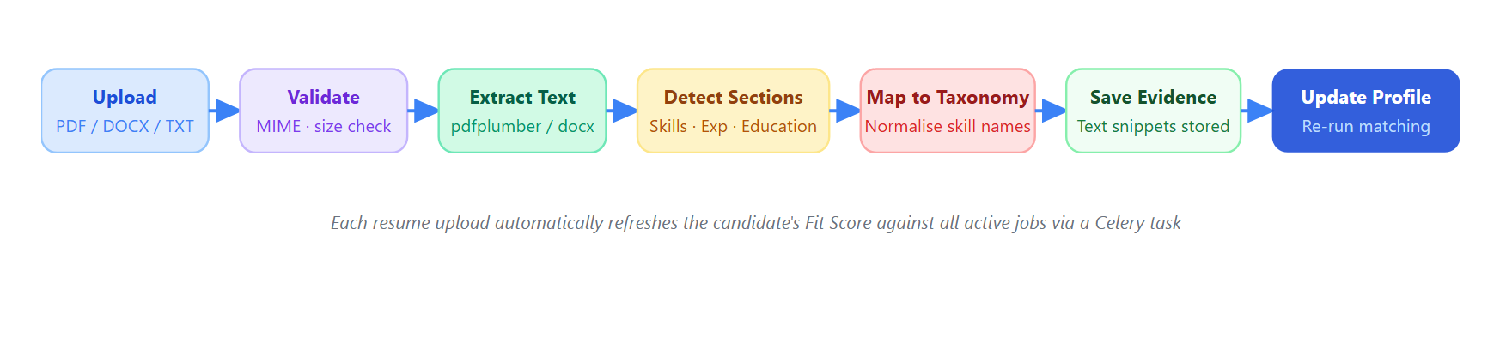
Figure 2. Resume processing runs asynchronously. The candidate's match scores are refreshed automatically on completion.

What Gets Extracted
Contact & Identity  Name, email, phone (via phonenumbers lib), location. | Skills + Evidence  Each detected skill is mapped to the master taxonomy and paired with the supporting text snippet from the resume.
Work Experience  Roles, companies, and durations — used to calculate total experience for the Fit Score. | Education  Degrees, institutions, and graduation years — contributes the Education component (10 pts).

10

Job Creation & Requirements
Jobs are created by HR via POST /api/jobs (HR / Admin only). When a job is set to Active, the backend automatically enqueues a Celery matching task against all available candidates.
Role Details  Title, department, client name, and full description. | Required Skills  Up to 20 skills — each with a weight (1–5) and type: MUST-HAVE or NICE-TO-HAVE.

Experience Threshold
Minimum years of relevant experience. Factors into the 20-pt experience component.

11

Skill Taxonomy
A curated master list — maintained by the Administrator — ensures that "React", "React.js", and "ReactJS" all resolve to the same canonical skill entry. Every skill used in job requirements and candidate profiles references this taxonomy, making matching consistent across all records in the skills table.
📄  Resume-Detected Skills  Found automatically during parsing. Backed by evidence snippets stored in candidate_skills.evidence_text. | ✍️  Manually Declared Skills  Added by the candidate with a self-assessed proficiency level (Beginner / Intermediate / Expert). Stored with source = MANUAL.
Both skill sources are scored during matching, but resume-backed skills with evidence receive a higher proficiency factor than unverified manual entries.

12

Matching Engine & Fit Score
The matching engine is the core intelligence of SkillAlign. It evaluates candidate profiles against job requirements using a deterministic, rule-based algorithm (0–100 scale), persisted to match_results.
Design Principle: The Fit Score is computed by a transparent, deterministic mathematical formula — not an unpredictable black-box model. Given identical inputs, it always yields the identical authoritative score.
Figure 3 · Matching Engine Flow
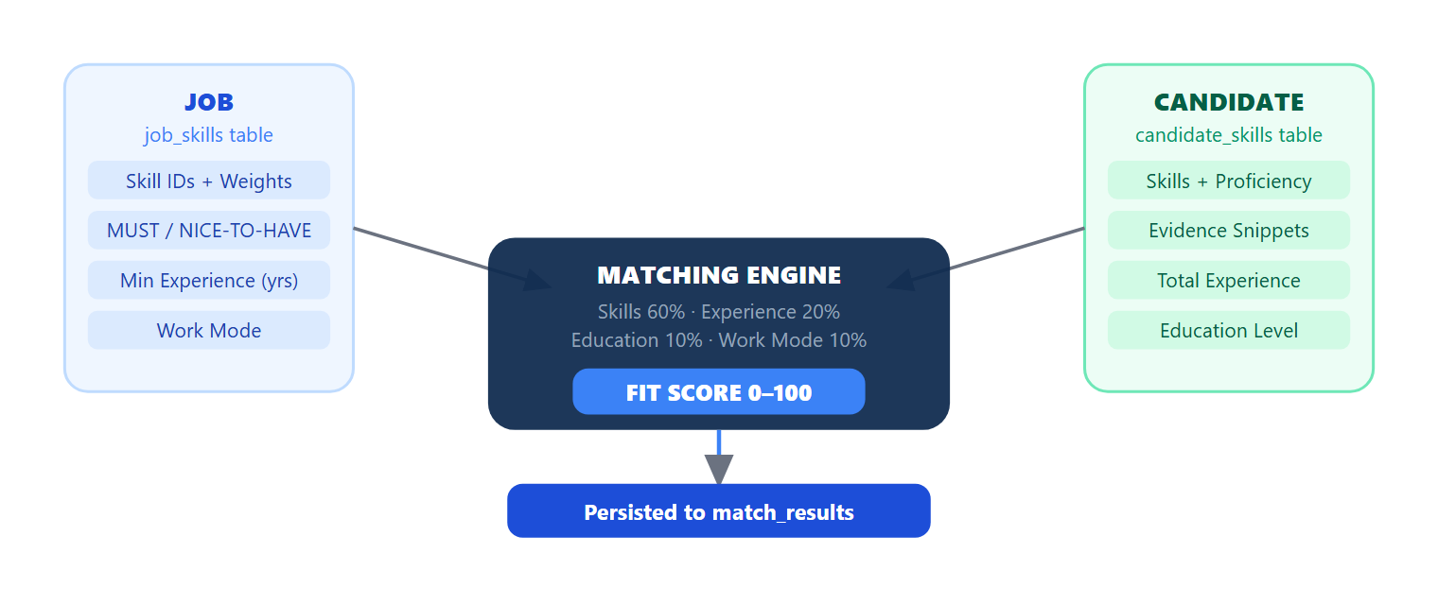
Figure 3. The deterministic matching engine compares job and candidate data and persists the result to the match_results table — the central record linking every job-candidate pair.

Score Model Breakdown
Skills & Proficiency 60% | Experience 20% | Education 10% | Work Mode 10%
Experience 20%
Education 10%
Work Mode 10%
Skills & Proficiency (max 60 pts) Experience Match (max 20 pts) Education Level (max 10 pts) Work Mode Compatibility (max 10 pts)
Component | Max | Scoring Logic
Skills + Proficiency | 60 pts | Weighted sum: (Σ factor × weight) / Σ weights × 60. Factor depends on source (resume/manual) and proficiency level. Evidence boosts the factor.
Experience | 20 pts | 20 if fully met · 12 if ≥70% · 6 if partial · 0 if none
Education | 10 pts | 10 if a degree is present in the profile · 0 otherwise
Work Mode | 10 pts | 10 if compatible (remote/hybrid/exact match) · 4 for mismatch
Worked Example — Rahul vs. Backend Developer:
Python (Expert + evidence): 5.00 pts · FastAPI (Intermediate + evidence): 3.24 pts · PostgreSQL (Resume detected): 2.55 pts · Docker (Missing): 0
Skill Score = (10.79 / 14) × 60 = 46.2 · Experience: 20 · Education: 10 · Work Mode: 10
Overall Fit Score = 86.2 / 100
An optional AI narrative (via Gemini) can supplement the score with a plain-language strengths/gaps summary and suggested interview questions. It is clearly labelled and does not modify the authoritative Fit Score.

13

Recruiter Workflow
1

Dashboard
Metrics across assigned jobs: total candidates, pending review, screened count, open tasks. Powered by GET /api/recruiter/dashboard-stats.
2

Review Ranked Candidates
Sorted by Fit Score. Each entry shows the score breakdown, missing skills, and evidence snippets from the resume.
3

Claim a Candidate
Race-condition safe claiming via an atomic SELECT FOR UPDATE — prevents two recruiters owning the same candidate simultaneously.
4

Shortlist & Submit to HM
Moves the match_result.pipeline_state to SENT_TO_HIRING_MANAGER and triggers an in-app notification to the HM.
5

Coordinate Interview
Forward the HM's proposed slots to the candidate. After slot selection, confirm the booking with meeting details.
6

Draft & Send Offer
Draft compensation → submit for HR approval → generate ReportLab PDF → upload to S3 → send to candidate.

14

HR / Hiring Manager Workflow
1

Create Job Requisition
HR is the sole owner of job creation via POST /api/jobs. Requires require_hr_or_admin dependency.
2

Assign Recruiters
Assign one or more recruiters with roles: Primary, Secondary, Sourcing, or Support. Determines which jobs appear in each recruiter's workspace.
3

Review Shortlists
HM Dashboard shows all candidates in HIRING_MANAGER_REVIEW state across active jobs.
4

Accept or Reject
Approve for interview (pipeline advances) or reject with a documented reason (terminal state).
5

Propose Interview Slots
Minimum 2 future windows. Server validates no conflicts and no active blacklist before accepting.
6

Submit Feedback
Post-interview: Technical · Communication · Problem-Solving (1–5 each) + GO / NO-GO decision. Persisted to interview_feedback table.
7

Approve Offer
Review the recruiter's draft. Approve, request changes, or reject. Any post-approval modification auto-revokes approval and triggers re-review.

15

21-Stage Recruitment Pipeline
Every candidate application moves through a controlled set of pipeline states stored in match_results.pipeline_state. Transitions are enforced server-side by the workflow engine — invalid moves are rejected with a 400/403 error and no state change occurs.
Figure 4 · 21-Stage Lifecycle

Figure 4. All 21 pipeline states. Every transition is role-gated and permanently logged in audit_logs. Multi-round interviews loop back from INTERVIEW_PASS to INTERVIEW_REQUESTED.
Multi-Round Support: An INTERVIEW_PASS outcome allows the HM to request an additional round. The workflow loops back to INTERVIEW_REQUESTED. A final GO decision advances to COMPENSATION_DISCUSSION.

16

Interview Management & Evaluation
SkillAlign coordinates interview scheduling across Hiring Managers, Recruiters, and Candidates with zero back-and-forth email churn, and captures structured post-interview evaluations.
Figure 5 · Interview Scheduling Flow
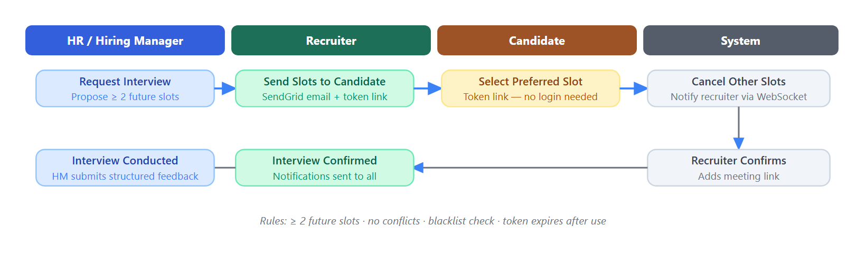
Figure 5. Interview scheduling involves all parties. Slot selection uses a cryptographically random token validated server-side — no platform login required from the candidate.

Structured Evaluation Rubric
Post-interview, the HM submits structured feedback persisted to the interview_feedback table. This drives the next pipeline transition.
Dimension | Scale | Purpose
Technical Knowledge | 1–5 | Depth and accuracy of domain expertise demonstrated.
Communication Skills | 1–5 | Clarity and professional articulation.
Problem-Solving | 1–5 | Analytical approach to challenges.
Role Fit | 1–5 | Alignment with the specific role context.
Overall Rating | 1–5 | Holistic assessment.
Decision | GO / NO-GO / PASS | Drives the next pipeline_state transition.
Round Done
→
HM Submits
→
PASS → Next Round
/
GO → Offer
/
NO-GO → Rejected

17

Offer Management & Candidate Response
Offers are governed by strict approval workflows, salary band validations, and automated PDF generation with secure, one-click candidate acceptance or rejection.
Figure 6 · Offer Approval Lifecycle

Figure 6. Every offer state is persisted to the offers table. Any post-approval modification by the recruiter auto-revokes HR approval and re-queues the offer for review.
Compensation  Base salary, fixed/variable pay, performance bonus, joining bonus. | Benefits & Equity  Other benefits, stock options, or RSU details where applicable.

Joining Details
Start date, work location, work arrangement (remote/hybrid/on-site).

Candidate Response & Outcomes
When an offer is sent, the candidate receives a SendGrid email with an S3 presigned link to the PDF and a secure response token. No platform login is required.
✅

On Acceptance
Offer → ACCEPTED · pipeline_state → HIRED · all parties notified · audit record created.

18

Notifications & Communication
Channel | Technology | Use
In-App Notifications | notifications table | Alerts for HR, Recruiters, and Candidates on key workflow events
Email | SendGrid | Interview invitations, offer letters, password reset
SMS | Twilio | Phone OTP for candidate login
Recruitment Tasks | recruitment_tasks table | HR-to-Recruiter task assignment with priority, status, and due date
Message Threads | messages table | Job-scoped and candidate-scoped recruiter-HR messaging

19

Audit Trail
Every significant pipeline transition writes an immutable row to the audit_logs table capturing: actor_id, action, entity_type, entity_id, old_state, new_state, and created_at. Records cannot be deleted or modified.
Category | Events Logged
OFFER | Draft created, submitted, approved, rejected, sent, accepted, declined
INTERVIEW | Requested, slots sent, slot selected, confirmed, completed, feedback submitted
HM_REVIEW | Shortlist received, candidate approved, candidate rejected
SOURCING | Candidate claimed, screened, shortlisted, submitted to HM
TASKS | Task created, assigned, status changed, completed
Administrators access the full log via GET /api/admin/hiring-audit-logs with filters for category, action, date range, candidate, job, and actor.

20

Security & Access Control
Layer | Technology | Protection
Transport | HTTPS + CORS | Explicit allowed origins; all traffic encrypted in transit.
Rate Limiting | SlowAPI | OTP and password-reset endpoints throttled per IP to block brute force.
Identity | JWT HS256 | Signed tokens with expiry and role claims; validated on every request.
Passwords | bcrypt | One-way adaptive hash — even if the DB is compromised, passwords are unreadable.
Public Tokens | CSPRNG + SHA-256 | Slot-selection and offer-response tokens are cryptographically random, hashed at rest, one-use.
File Access | S3 Presigned URLs | Time-limited download links — no permanent public URLs for resumes or offer PDFs.
Input Validation | Pydantic v2 | All request bodies validated at the API boundary. ORM parameterization prevents SQL injection.
Security Headers | Middleware | X-Frame-Options, X-Content-Type-Options, and CSP headers set on every response.
Server-side enforcement: RBAC is enforced at the API layer via FastAPI dependency injection — not just in the frontend. Bypassing the browser UI does not bypass access control.

21

End-to-End Journey & Test Verification
The complete recruitment lifecycle orchestrates four user roles across all 21 pipeline states. Below is the cross-functional responsibility matrix followed by the authoritative end-to-end test execution trace.
Complete Hiring Journey — All Parties

Authoritative Test Case Execution (Rahul Sharma · Backend Developer)
Candidate  Rahul Sharma — 3 yrs experience · Python, FastAPI, PostgreSQL, React · B.Tech · Hybrid | Job  Backend Developer — Python (5, MUST), FastAPI (4, MUST), PostgreSQL (3, MUST), Docker (2, NICE) · 2 yr min

Recruiter
Priya — assigned as Primary Recruiter

22

Future Enhancements
🧠  Semantic Skill Matching  Complement the deterministic scorer with vector embeddings (e.g. pgvector) to capture conceptual skill similarity. | 📅  Calendar Integration  Direct sync with Google Calendar and Outlook so proposed slots reflect real-time availability. | 🎥  Video Interviews  Built-in video with structured recording and automated Whisper-based transcription for review.
💬  WhatsApp Notifications  Extend candidate notifications to WhatsApp via Twilio Conversations API. | 📈  Analytics Dashboard  Time-to-hire, offer acceptance rate, pipeline conversion funnels, and recruiter performance metrics. | 🌐  Multi-Tenant Support  Schema-based isolation in PostgreSQL for multiple clients within a single SkillAlign deployment.
SkillAlign — Official Documentation
Intelligent Recruitment & Candidate-Job Matching Platform · FastAPI · React 18 · PostgreSQL
Version 3.0 · September 2026 · Confidential

