Executive Overview & System Architecture
Platform Overview, Technology Stack, Architecture Layers, Codebase Structure & Deployment
DOCUMENT  Executive Overview & System Architecture | AUTHOR  SkillAlign Architecture Team | STATUS  Production Verified | VERSION  2.0 Consolidated

Volume 01: Executive Overview & System Architecture
This volume provides a comprehensive architectural and operational breakdown of SkillAlign, covering the foundational problem statement, measurable engineering objectives, actor definitions, verified technology stacks, and detailed multi-tier architectural specifications.
1. Executive Project Overview
1.1 Problem Statement
Modern corporate talent acquisition suffers from severe inefficiencies across the recruitment funnel:
- Unstructured Resume Data: Candidates submit resumes in heterogeneous formats (multi-column PDFs, DOCX, scanned layouts) containing inconsistent terminology, non-standard headings, and varying degrees of detail.
- Superficial Keyword Matching: Traditional Applicant Tracking Systems (ATS) rely on simple substring matching, ignoring skill proficiency levels, contextual evidence, candidate total experience, educational qualifications, and work-mode alignment.
- Fragmented Recruitment Workflows: Recruiting teams, hiring managers (HMs), and HR administrators often operate across disjointed tools (spreadsheets, email threads, calendar invites), causing communication bottlenecks, lack of auditability, and dropped candidates.
- Slow Feedback & Offer Cycles: Coordinating interview slots across time zones, gathering structured evaluation scorecards, generating formal compensation breakdown letters, and enforcing cooling-off/blacklisting periods are frequently manual and error-prone.
1.2 Proposed Solution
SkillAlign addresses these challenges by delivering an end-to-end, enterprise-grade talent acquisition and skill-matching platform:
- Deterministic Resume Processing Pipeline: High-speed, reproducible text extraction (pdfplumber, python-docx) coupled with a 100% rule-based section and taxonomy parsing engine (resume_txt_parser.py) that identifies skills and extracts contextual evidence snippets without hallucination.
- Multi-Factor Weighted Matching Engine: A deterministic scoring algorithm (matching_service.py) evaluating:
- Skill coverage and proficiency levels (with an evidence-backed verification bonus) — 60%
- Experience tenure relevance against job requisitions — 20%
- Educational degree qualification — 10%
- Work mode compatibility (Remote / Hybrid / Onsite) — 10%
- 21-State Enterprise State Machine: A fully audited recruitment lifecycle (workflow_service.py) governing candidate shortlisting, hiring manager review, multi-round slot proposing, candidate self-service slot selection, Go/No-Go feedback, compensation negotiation, automated ReportLab PDF offer generation, and 6-month rejection cooling-off.
- Role-Tailored Portals: Unified single-page application built with React, TypeScript, and Tailwind CSS offering tailored dashboards for Candidates, Recruiters, HR / Hiring Managers, and System Admins.
1.3 System Objectives
Objective ID | Measurable Engineering Metric | Implementation Mechanism
OBJ-01 | Sub-second algorithmic match scoring | In-memory vectorized dictionary matching with O(N \cdot S) computational complexity.
OBJ-02 | Zero-AI dependency for core parsing | 100% deterministic regex and section-boundary parsing ensuring 100% offline availability and zero API costs.
OBJ-03 | 100% Auditability of Pipeline Transitions | Relational audit logging (audit_log.py) tracking actor ID, previous state, new state, timestamp, and metadata for every state change.
OBJ-04 | Strict Role-Based Security | Layered FastAPI dependency injection (dependencies.py) validating HS256 JWT claims before reaching route handlers.
OBJ-05 | Production Document Generation | Sub-500ms server-side dynamic PDF compilation (offer_pdf_service.py) with dual annexures and cryptographic verification tokens.

1.4 Target Users & Roles Matrix
The codebase strictly implements four distinct system roles defined in role.py:
Role | System Responsibility | Core Capabilities & Workspaces | Primary UI Routes
Admin | System governance, global user management, skill taxonomy curation, health monitoring. | Create/deactivate users, assign roles, inspect system health metrics, manage global skill catalog, view platform audit timeline. | /admin, /admin/users, /admin/skills
HR / Hiring Manager | Job requisition creation, candidate shortlist review, interview feedback, offer approval. | Create job openings, define skill weights, review recruiter-submitted candidates, request interview rounds, submit Go/No-Go feedback, review/approve offers, track hiring pipeline. | /hr, /hr/jobs/create, /hr/decisions, /hr/shortlists, /hr/pipeline
Recruiter | Sourcing execution, candidate matching, interview coordination, offer drafting. | Run matching engine on requisitions, claim candidates, review resume evidence, propose interview slots, coordinate candidate selection, draft offer terms, execute Action Center tasks. | /recruiter, /recruiter/action-center, /recruiter/jobs/:id, /recruiter/candidates, /recruiter/offers/create
Candidate | Profile maintenance, resume management, slot selection, offer response. | Self-register, upload PDF/DOCX resumes, view parsed profile/skills, pick interview time slots via tokenized links, review formal offer letter, accept/decline offers. | /candidate, /candidate/profile, /candidate/skills, /select-slot, /offers/:id

2. Technology Stack & Verification
To maintain engineering integrity, the technology stack has been categorized based on active code inspection:
┌──────────────────────────────────────────────────────────────────────────┐
│ Technology Status │
├────────────────────────────────┬─────────────────────────────────────────┤
│ [✓] Implemented │ Actively executed in core application │
│ [⚙] Configured / Partial │ Configured in settings or optional path │
│ [✦] Planned / Future │ Designed conceptually for scale │
└────────────────────────────────┴─────────────────────────────────────────┘

2.1 Backend Technology Stack
- Language: Python 3.11+ [✓ Implemented]
- Web Framework: FastAPI 0.110+ [✓ Implemented] — Selected for ASGI high concurrency, native OpenAPI/Swagger generation, and Pydantic request validation.
- Database & ORM: PostgreSQL 15+ [✓ Implemented] with SQLAlchemy 2.0 Declarative Mapped Columns [✓ Implemented].
- Database Migrations: Alembic [✓ Implemented] (alembic/).
- Authentication: Direct bcrypt and passlib password hashing + python-jose HS256 JWT tokens [✓ Implemented].
- Rate Limiting: SlowAPI / limits library [✓ Implemented] (rate_limit.py).
- Document Parsing: pdfplumber (PDF layout extraction), python-docx (Word processing), phonenumbers (E.164 normalization) [✓ Implemented].
- PDF Compilation Engine: ReportLab 3.x [✓ Implemented] (offer_pdf_service.py).
- Asynchronous Queue: Celery 5.x with Redis broker [✓ Implemented with synchronous fallback] (celery_app.py, resume_tasks.py).
- Object Storage: Local file storage + AWS S3 Boto3 storage manager [✓ Implemented with dual mode] (storage_manager.py).
2.2 Frontend Technology Stack
- Core Framework: React 18 with TypeScript [✓ Implemented] (App.tsx).
- Build Tool: Vite [✓ Implemented] (vite.config.ts).
- Styling: Tailwind CSS + Custom Dark/Glassmorphism CSS utilities [✓ Implemented] (tailwind.config.js, index.css).
- Icons & Visuals: Lucide React + Canvas Confetti effects [✓ Implemented].
- HTTP Client: Axios with automatic request/response JWT interceptors [✓ Implemented] (api.ts).
- Routing: React Router DOM v6 [✓ Implemented] (AppRoutes.tsx).
- State Management: React Context API (AuthContext) + Local Component State Hooks [✓ Implemented].
2.3 AI & External Integrations
- Google Gemini API: Direct REST integration via urllib.request using models gemini-3.5-flash / gemini-2.5-flash with deterministic JSON extraction and graceful fallback [✓ Implemented] (gemini_service.py).
- Transactional Email: SendGrid API client [✓ Implemented] (email_service.py).
- SMS Gateway: Twilio REST API client [✓ Implemented] (sms_service.py).
- LangChain / ChromaDB / Vector RAG: [⚙ Configured in dependencies / Planned for future semantic expansion]. Currently, core skill matching and resume extraction are executed deterministically in Python.
3. System Architecture Layers
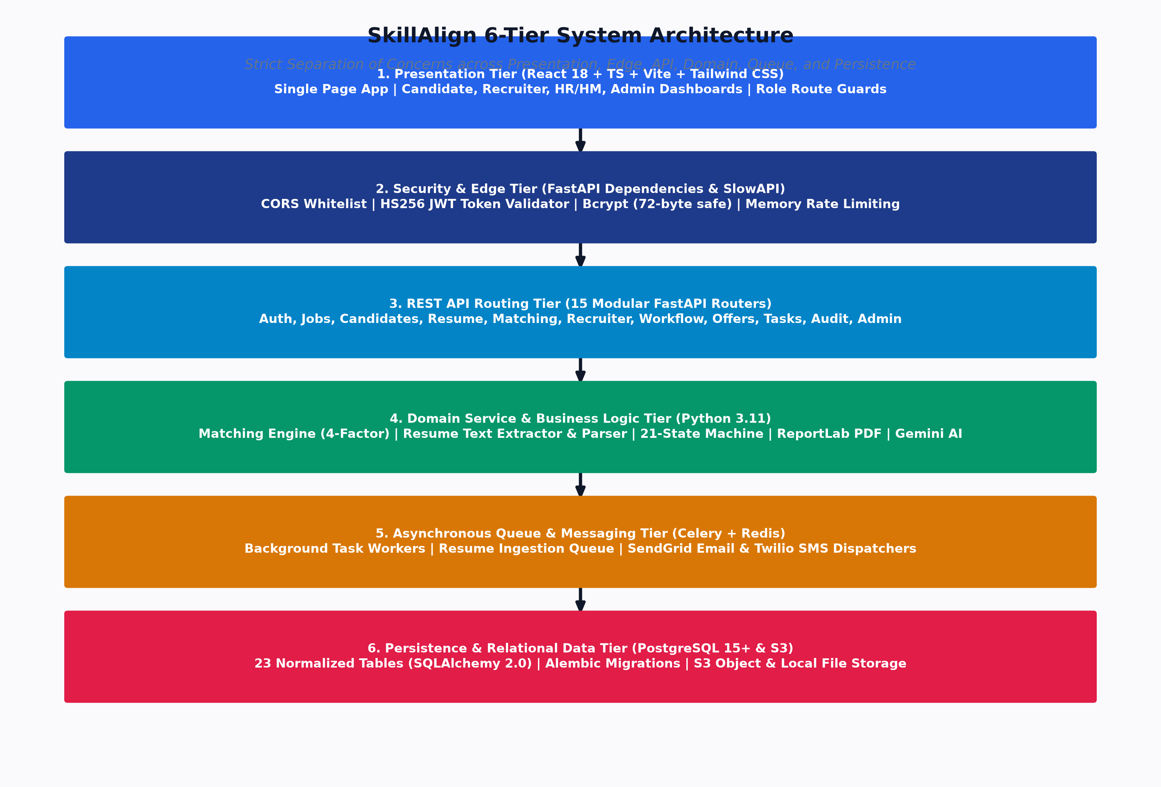
Figure: SkillAlign 6-Tier Layered System Architecture
The SkillAlign backend follows a strict Separation of Concerns (SoC) structured across 6 distinct layers:
┌────────────────────────────────────────────────────────────────────────┐
│ 1. Presentation Layer │
│ React 18 + TypeScript + Vite + Tailwind CSS + Lucide Icons │
└──────────────────────────────────┬─────────────────────────────────────┘
│ HTTPS / JSON REST
┌──────────────────────────────────▼─────────────────────────────────────┐
│ 2. API Routing Layer │
│ FastAPI APIRouters (15 Routers) + Pydantic v2 Request/Response │
└──────────────────────────────────┬─────────────────────────────────────┘
│ Validated DTOs / Tokens
┌──────────────────────────────────▼─────────────────────────────────────┐
│ 3. Security & Middleware Boundary │
│ JWT HS256 Decode + Role Check + SlowAPI Limiter + CORS Handler │
└──────────────────────────────────┬─────────────────────────────────────┘
│ Injected Session + User Entity
┌──────────────────────────────────▼─────────────────────────────────────┐
│ 4. Business Logic Layer │
│ Services: Matching, Workflow State Machine, Resume, PDF, Gemini │
└──────────────────────────────────┬─────────────────────────────────────┘
│ SQLAlchemy 2.0 ORM Operations
┌──────────────────────────────────▼─────────────────────────────────────┐
│ 5. Data Access / Persistence │
│ PostgreSQL 15 (23 Models, Foreign Keys, Indexes, Check Constraints) │
└──────────────────────────────────┬─────────────────────────────────────┘
│ Async Tasks / Outbound HTTP
┌──────────────────────────────────▼─────────────────────────────────────┐
│ 6. External & Worker Services │
│ Redis Broker + Celery Worker + AWS S3 + SendGrid + Twilio + Gemini │
└────────────────────────────────────────────────────────────────────────┘

3.1 Presentation Layer (Frontend)
- Component Architecture: Atomic design separating reusable UI primitives (/components/ui), complex workflow modals (/components/workflow), domain panels (/components/candidate, /components/job), and layout wrappers (/components/layout/DashboardLayout.tsx).
- State & Context: AuthContext provides global authentication state (user, token, login, logout) with token persistence in localStorage.
- Interceptors: Axios instance interceptor automatically injects Authorization: Bearer <token> on outgoing requests and intercepts 401 Unauthorized responses to purge expired tokens and redirect to /login.
3.2 API Layer (FastAPI Routers)
- 15 specialized routers registered under /api/ in main.py:
- auth: /api/auth (Candidate registration, login, phone OTP, password reset).
- users: /api/users (User management and role enumeration).
- admin: /api/admin (System statistics, audit logs, user provisioning).
- skills: /api/skills (Global taxonomy management).
- jobs: /api/jobs (Requisition management and skill requirement weighting).
- candidates: /api/candidates (Candidate profiles and self-declared skills).
- resume: /api/candidates/me/resume (Resume uploading, text extraction, re-parsing).
- matching: /api/matching (Matching engine execution, shortlist filtering, scorecards).
- match_results: /api/match-results (Direct match record inspection).
- interviews: /api/interviews (Interview scheduling and slot tracking).
- notifications: /api/notifications (In-app notifications and unread counters).
- recruiter: /api/recruiter (Candidate claims, pipeline queries, recruiter metrics).
- communication: /api/communication (Recruiter-candidate messaging and bulk dispatch).
- tasks: /api/tasks (Recruitment Action Center tasks).
- workflow & offers: /api/workflow and /api/offers (21-state state machine and offer lifecycle).
3.3 Security & Middleware Layer
- CORS Middleware: Configured in main.py allowing explicit frontend origins (localhost:5173, 127.0.0.1:5173, localhost:3000, etc.) with credentials support.
- Rate Limiting: Configured using SlowAPI with memory-backed limiter enforcing endpoint thresholds (e.g., 5/minute on password reset and OTP generation).
- Dependency-Based Authorization: Route-level security guards (require_admin, require_hr, require_recruiter, require_candidate, require_hr_or_recruiter) resolving and validating JWT tokens in dependencies.py.
3.4 Service Layer (Business Logic)
- Encapsulates pure business logic away from HTTP transport concerns:
- MatchingService: Calculates multi-factor scores, experience thresholds, and skill breakdowns.
- WorkflowService: Validates state machine transitions, writes audit logs, and creates notification tasks.
- ResumeService & ResumeTxtParser: Coordinates storage, text extraction, and deterministic parsing.
- OfferPDFService: Compiles multi-page corporate offer PDFs using ReportLab.
- GeminiService: Generates AI-assisted candidate fit summaries and interview questions.
- EmailService & SMSService: Dispatches transactional notifications via SendGrid and Twilio.
3.5 Data Access Layer (ORM & Persistence)
- Built on SQLAlchemy 2.0 utilizing Mapped and mapped_column annotations.
- Manages relational transactions, foreign key constraints (CASCADE / SET NULL), unique constraints (uq_match_result), check constraints (ck_match_result_score_range), and composite indexes for high-throughput querying.
3.6 External Integrations Layer
- Handles outbound communication with third-party APIs and async worker queues:
- Redis / Celery: Offloads CPU-intensive resume parsing and batch matching.
- AWS S3 / Local Storage: Abstracted via StorageManager to store original resumes and extracted TXT files.
- SendGrid & Twilio: Reliable delivery of transactional emails and OTP codes.
- Google Gemini: Large Language Model API for optional AI analysis.
4. System Architecture Diagrams
4.1 High-Level End-to-End System Architecture
Figure: SkillAlign 6-Tier Layered Architecture
4.2 Backend Modular Architecture
flowchart LR
subgraph Core["app/core"]
Config["config.py<br/>(Pydantic Settings)"]
Sec["security.py<br/>(bcrypt, JWT, Tokens)"]
Deps["dependencies.py<br/>(Auth Guards)"]
RL["rate_limit.py<br/>(SlowAPI)"]
end
subgraph Routers["app/routers"]
R_Auth["auth.py"]
R_Jobs["jobs.py"]
R_Match["matching.py"]
R_Work["workflow.py"]
R_Cand["candidates.py"]
R_Rec["recruiter.py"]
R_Adm["admin.py"]
end
subgraph Services["app/services"]
S_Match["matching_service.py"]
S_Work["workflow_service.py"]
S_Res["resume_service.py"]
S_Extract["resume_text_extractor.py"]
S_Parse["resume_txt_parser.py"]
S_PDF["offer_pdf_service.py"]
S_Gemini["gemini_service.py"]
end
subgraph Models["app/models"]
M_User["user.py / role.py"]
M_Job["job.py / job_skill.py"]
M_Cand["candidate.py / candidate_skill.py"]
M_Match["match_result.py / candidate_scorecard.py"]
M_Inv["interview.py / interview_slot.py / interview_feedback.py"]
M_Offer["offer.py / candidate_blacklist.py"]
M_Audit["audit_log.py / notification.py / recruitment_task.py"]
end
Routers --> Deps
Routers --> Services
Services --> Models
Services --> Core
Models --> DBEngine[(SQLAlchemy Engine)]

4.3 Frontend Routing & View Architecture
flowchart TD
App["App.tsx"] --> Router["AppRoutes.tsx"]
subgraph PublicRoutes["Public Routes"]
Lnd["/ (LandingPage)"]
Log["/login (LoginPage)"]
Reg["/register (RegisterPage)"]
FP["/forgot-password"]
RP["/reset-password"]
Slot["/select-slot (SlotSelectionPage)"]
OffPub["/offers/:id (CandidateOfferPage)"]
end
subgraph ProtectedRoutes["Protected Routes (DashboardLayout)"]
subgraph AdminViews["Admin Workspace (/admin)"]
AdmDash["AdminDashboard"]
AdmUsers["UsersPage / AdminUserDetailPage"]
AdmSkills["SkillsPage"]
end
subgraph HRViews["HR / HM Workspace (/hr)"]
HRDash["HRDashboard"]
HRDec["HRDecisionDashboard"]
HRJob["HRCreateJobPage"]
HRMatch["HRJobMatchesPage"]
HRRev["HMCandidateReviewPage"]
HRFeed["HMFeedbackPage"]
HRPipe["HiringPipelinePage"]
HROff["HMOfferReviewPage"]
end
subgraph RecruiterViews["Recruiter Workspace (/recruiter)"]
RecDash["RecruiterDashboard"]
RecAct["ActionCenterPage"]
RecJob["JobDetailPage"]
RecCand["RecruiterCandidatesPage / RecruiterCandidateDetailPage"]
RecShort["ShortlistSubmissionPage / ShortlistsPage"]
RecOff["RecruiterOfferPage"]
end
subgraph CandidateViews["Candidate Workspace (/candidate)"]
CandDash["CandidateDashboard"]
CandProf["CandidateProfilePage"]
CandSkill["CandidateSkillsPage"]
CandHire["CandidateHiringPage"]
end
end
Router --> PublicRoutes
Router --> ProtectedRoutes

Proceed to [Volume 02: End-to-End Workflows & State Machines](file:///c:/Users/shiva/OneDrive/Desktop/SkillAlign/docs/02_END_TO_END_WORKFLOWS_AND_STATE_MACHINES.md) for detailed lifecycle state machines, sequence flows, and business rules.

Codebase Structure, Deployment & Engineering Decisions

Volume 08: Codebase Structure, Deployment & Engineering Decisions
This volume details the exact directory structure and module responsibilities of both the backend and frontend codebases, infrastructure and deployment topologies, Architectural Decision Records (ADRs), scalability roadmap (100 \to 1,000,000 candidates), and the test suite audit.
1. Frontend Codebase Structure
The frontend is structured as a modern React 18 + TypeScript + Vite Single Page Application adhering to clean component separation.
frontend/
├── index.html # HTML5 entrypoint with Google Fonts (Inter / Outfit)
├── package.json # Dependencies: React 18, React Router v6, Axios, Lucide React
├── tailwind.config.js # Tailwind CSS utility configuration & color tokens
├── tsconfig.json # TypeScript compiler settings & path aliases
├── vite.config.ts # Vite build & dev-server proxy configuration
└── src/
├── App.tsx # Root React Application component
├── main.tsx # DOM mounting point with AuthProvider & BrowserRouter
├── index.css # Custom design system tokens, animations, glassmorphism
├── routes/
│ └── AppRoutes.tsx # 25+ application routes with Role ProtectedRoute guards
├── context/
│ └── AuthContext.tsx # Authentication provider (user, token, login, logout)
├── services/
│ └── api.ts # Central Axios client with Bearer token & 401 interceptors
├── types/
│ └── index.ts # Full TypeScript interface definitions matching backend DTOs
├── components/
│ ├── common/ # ProtectedRoute, StatCard, Badge, LoadingSpinner
│ ├── layout/ # DashboardLayout, Sidebar, Navbar, NotificationDropdown
│ ├── ui/ # Reusable Button, Modal, Input, Table, Card primitives
│ ├── candidate/ # CandidateSlotPickerModal, SkillBadge, ResumeUploadCard
│ ├── job/ # JobRequirementForm, SkillWeightSlider
│ ├── pipeline/ # Visual 21-state progress tracker
│ └── workflow/ # RequestInterviewModal, HMFeedbackModal, OfferModal
└── pages/
├── LandingPage.tsx # Public marketing & feature overview page
├── auth/ # LoginPage, RegisterPage, ForgotPasswordPage, ResetPasswordPage
├── admin/ # AdminDashboard, UsersPage, SkillsPage, AdminUserDetailPage
├── hr/ # HRDashboard, HRDecisionDashboard, HRCreateJobPage,
│ # HRJobMatchesPage, HMCandidateReviewPage, HMFeedbackPage,
│ # HiringPipelinePage, HMOfferReviewPage, HRShortlistsPage
├── recruiter/ # RecruiterDashboard, ActionCenterPage, JobDetailPage,
│ # RecruiterCandidatesPage, RecruiterCandidateDetailPage,
│ # ShortlistSubmissionPage, RecruiterOfferPage, ShortlistsPage
└── candidate/ # CandidateDashboard, CandidateProfilePage, CandidateSkillsPage,
# CandidateHiringPage, SlotSelectionPage, CandidateOfferPage,
# ApplicationTimelinePage

2. Backend Codebase Structure
The backend follows a domain-driven, layered service architecture implemented in FastAPI and SQLAlchemy 2.0.
backend/
├── main.py # FastAPI entrypoint, middleware, and router aggregator
├── celery_app.py # Celery async worker & Redis connection initializer
├── worker.py # Standalone CLI entrypoint for background Celery worker
├── alembic.ini # Alembic migration environment configuration
├── requirements.txt # Pinned Python package dependencies
├── alembic/ # Database version migration scripts
├── tests/ # Pytest automated test suite (11 test modules)
│ ├── conftest.py # Pytest fixtures, test database setup, and mock users
│ ├── test_auth.py # Candidate registration & JWT authentication tests
│ ├── test_otp_auth.py # SMS OTP generation, verification & rate limiting tests
│ ├── test_deterministic_matching.py # Multi-factor mathematical scoring validation
│ ├── test_resume_extraction.py # pdfplumber / docx text extraction tests
│ ├── test_resume_parsing.py # Rule-based section segmenter & taxonomy parsing tests
│ ├── test_candidate_authorization_security.py # RBAC security boundary tests
│ └── test_multi_recruiter_and_evidence.py # Candidate claiming & evidence tests
├── scripts/ # Database inspection & mock data seeding scripts
└── app/
├── core/ # System configuration, security, and rate limiting
│ ├── config.py # Pydantic BaseSettings loading from .env
│ ├── security.py # Bcrypt hashing, HS256 JWT encoding, reset token hasher
│ ├── dependencies.py # Route security guards (require_admin, require_hr, etc.)
│ └── rate_limit.py # SlowAPI memory-backed rate limiter
├── database/ # Database engine and session lifecycle
│ ├── base.py # SQLAlchemy Declarative Base
│ └── session.py # SessionLocal generator (get_db dependency)
├── models/ # 23 SQLAlchemy declarative relational models
│ ├── role.py, user.py, skill.py, job.py, job_skill.py
│ ├── candidate.py, candidate_skill.py, match_result.py, candidate_scorecard.py
│ ├── interview.py, interview_slot.py, interview_feedback.py, job_interview_round.py
│ ├── offer.py, candidate_blacklist.py, audit_log.py, notification.py
│ └── recruitment_task.py, recruitment_message.py, candidate_recruiter_assignment.py
├── schemas/ # Pydantic v2 validation DTOs (Request / Response)
│ ├── auth.py, user.py, job.py, candidate.py, skill.py, matching.py
│ ├── interview.py, workflow.py, task.py, audit_log.py, notification.py
├── services/ # Pure domain business logic & third-party integrations
│ ├── auth_service.py # User authentication, OTP verification, password resets
│ ├── matching_service.py # 4-factor matching algorithm & fit scoring
│ ├── resume_service.py # Resume upload coordinator & S3 storage dispatcher
│ ├── resume_text_extractor.py # Deterministic pdfplumber / docx text extraction
│ ├── resume_txt_parser.py # Rule-based regex parser & evidence extraction
│ ├── workflow_service.py # 21-state recruitment state machine & audit logger
│ ├── offer_pdf_service.py # ReportLab multi-page corporate PDF generator
│ ├── gemini_service.py # Google Gemini REST client with fallback
│ ├── email_service.py # SendGrid transactional email dispatcher
│ ├── sms_service.py # Twilio SMS OTP gateway
│ └── storage/ # StorageManager (Local disk + AWS S3 Boto3)
├── tasks/ # Celery background asynchronous task handlers
│ ├── resume_tasks.py # Background resume extraction, parsing & skill sync
│ └── matching_tasks.py # Batch job candidate matching tasks
└── routers/ # 15 FastAPI endpoint routing modules
├── auth.py, users.py, admin.py, skills.py, jobs.py, candidates.py
├── resume.py, matching.py, match_results.py, interviews.py, notifications.py
├── recruiter.py, communication.py, tasks.py, workflow.py

3. Infrastructure & Deployment Architecture
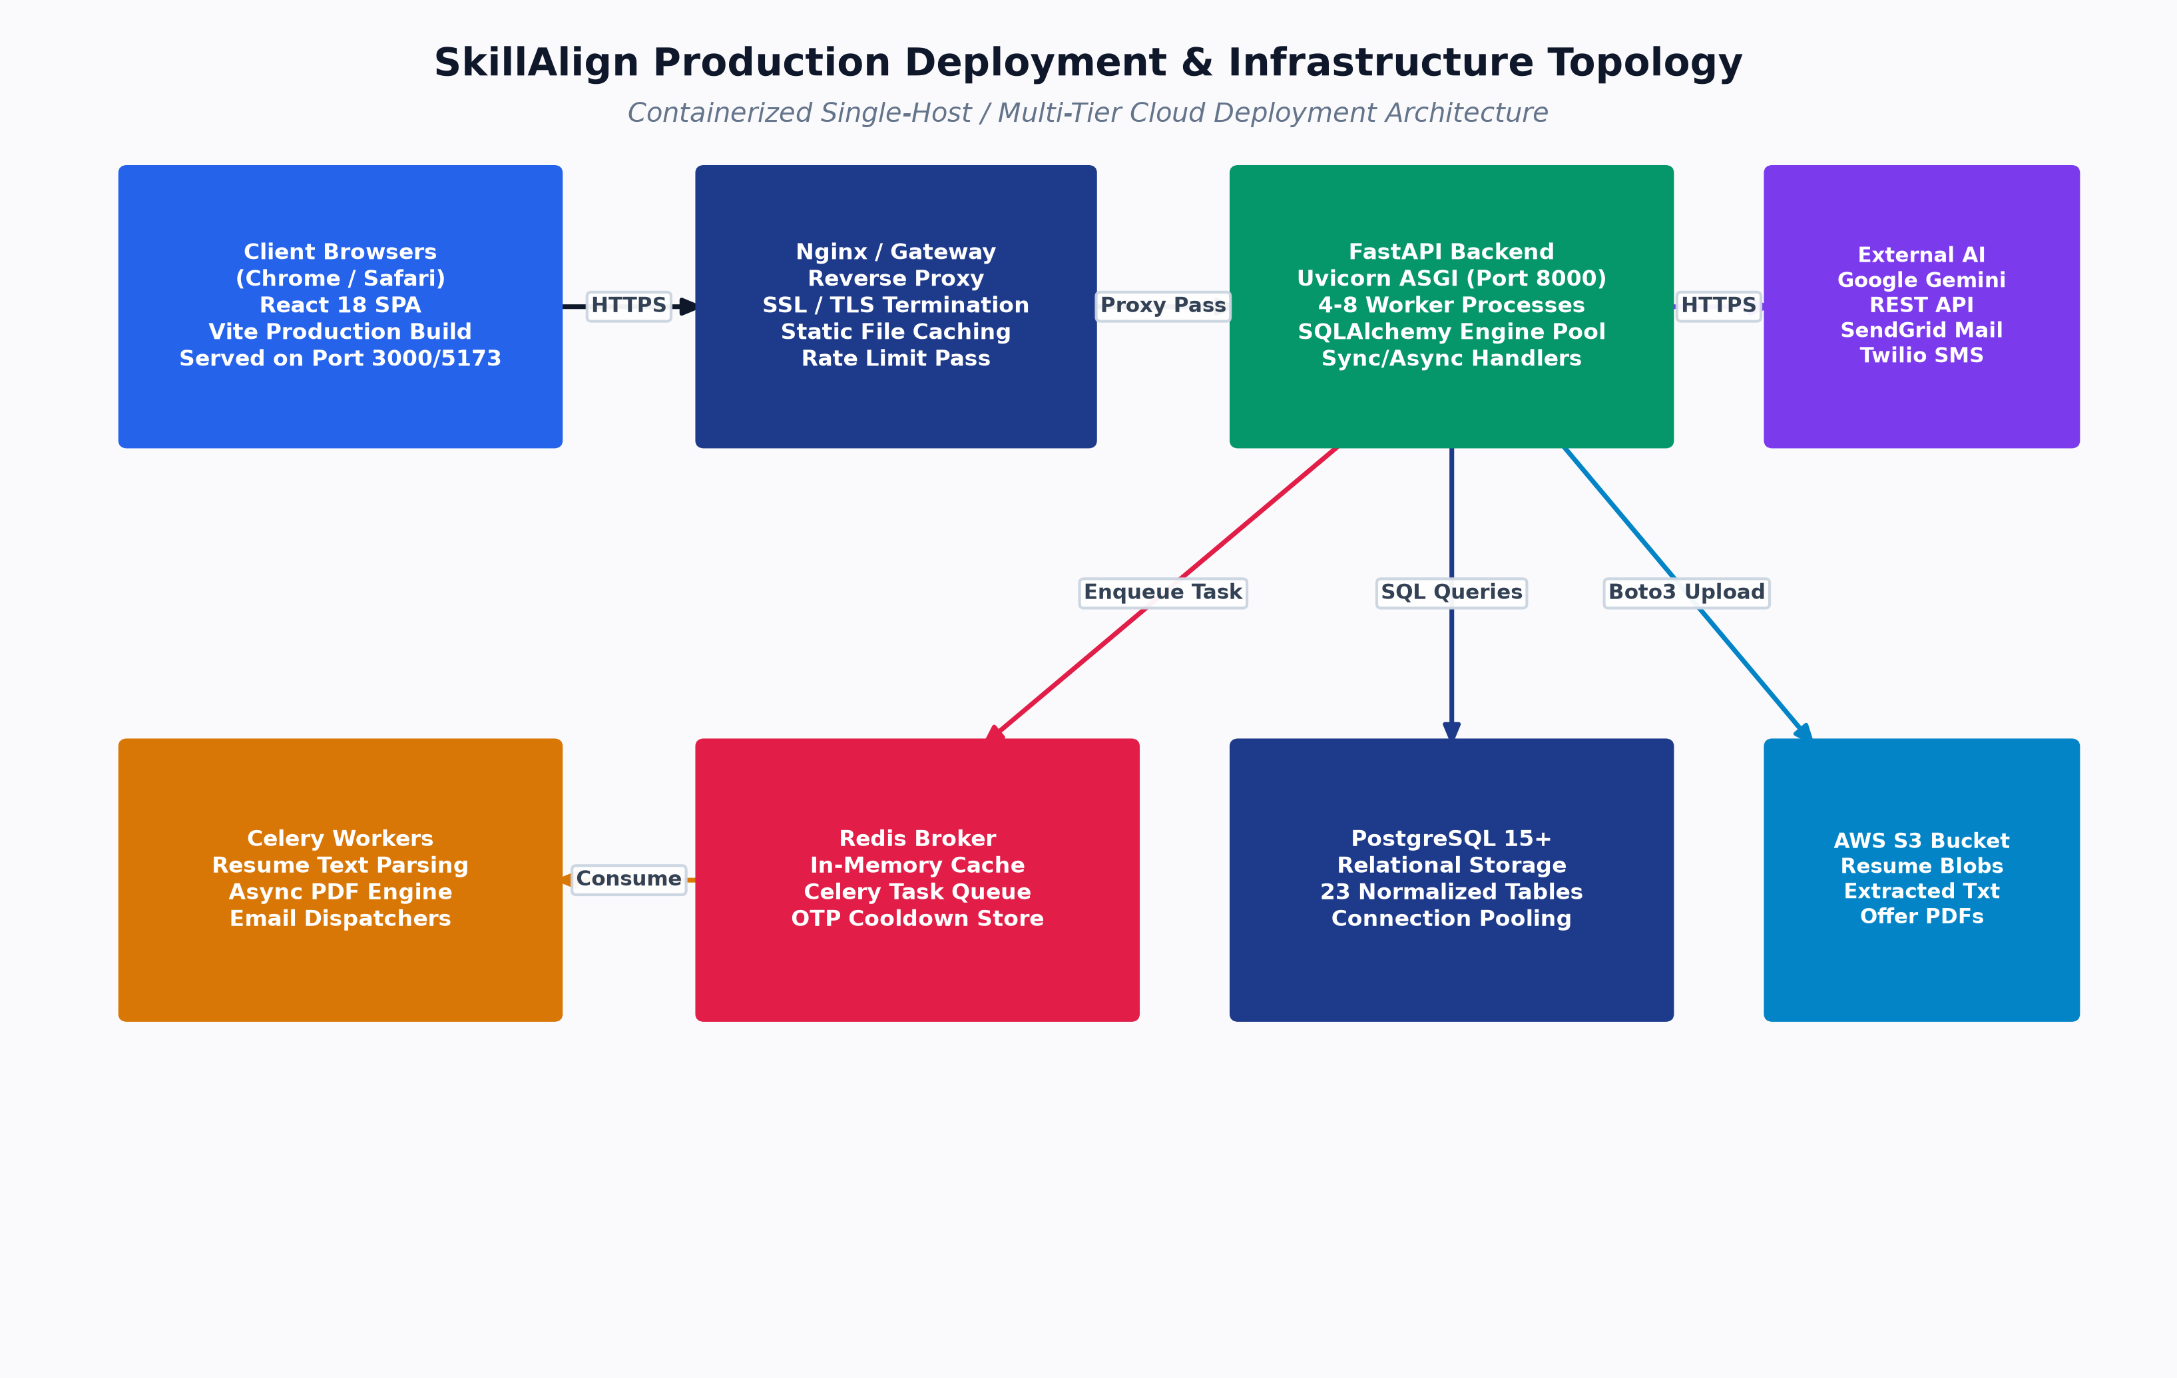
Figure: Production Deployment & Infrastructure Topology
Figure: Containerized Infrastructure & Cluster Topology
4. Architectural Decision Records (ADRs)
# | Architectural Decision | Technical Rationale & Benefit | Trade-Offs & Mitigations
ADR-01 | FastAPI over Django / Flask | High async I/O throughput via Starlette/Uvicorn, native OpenAPI Swagger generation, and strict type safety with Pydantic v2. | Less built-in admin UI compared to Django; mitigated by custom React Admin Console.
ADR-02 | PostgreSQL + SQLAlchemy 2.0 over MongoDB | Strict ACID transactional guarantees, foreign key cascade integrity, complex relational joins between 23 models, and check constraints. | Schema changes require Alembic migrations; mitigated by automated migration pipelines.
ADR-03 | Deterministic Parsing over Pure LLM Parsing | 100% reproducible, explainable, zero API cost, sub-100ms execution time, and zero risk of hallucinating unpossessed skills. | Complex regex maintenance; mitigated by comprehensive Pytest regression suites.
ADR-04 | React + TypeScript + Vite over SSR / Plain JS | Strict compile-time type validation against backend DTOs, sub-second HMR dev cycle, and rich SPA component interactivity. | Initial client bundle download; mitigated by Vite code-splitting and asset compression.
ADR-05 | ReportLab for Server-Side PDF Compilation | Direct programmatic canvas drawing, zero headless Chrome browser overhead, pixel-perfect A4 geometry, and dynamic two-pass page numbering. | Python canvas scripting is more verbose than HTML-to-PDF tools; mitigated by modular OfferPDFService.
ADR-06 | Celery + Redis with Sync Fallback | Decouples CPU-heavy document parsing from the API request-response loop, while allowing seamless single-process execution in development. | Redis operational dependency in production; mitigated by graceful in-process fallback execution.
ADR-07 | 4-Factor Weighted Algorithmic Matching | Balances hard skills (60%), experience (20%), education (10%), and work mode (10%) with verified resume evidence multipliers. | Requires recruiters to assign skill weights; mitigated by standard weight defaults (Weight = 3).
ADR-08 | 21-State Explicit State Machine | Prevents illegal state skips (e.g. issuing offer before completing interview), maintains immutable audit logs, and enforces dual-control. | Strict server-side transition checks; mitigated by clear HTTP 422 error details.
ADR-09 | Direct Bcrypt Hashing over Plain SHA-256 | Salted key stretching (2^{12} rounds) protects against offline GPU dictionary and rainbow table attacks. | Truncates passwords >72 bytes; mitigated by standard pre-validation in Pydantic.
ADR-10 | Cryptographic Public Tokens for Candidate Actions | Eliminates candidate login friction during time-sensitive operations (slot selection and offer response) via 256-bit entropy tokens. | Tokens must have expiration timestamps; enforced via selection_token_expires_at.
ADR-11 | Dual Storage Manager (Local Disk + S3) | Allows local zero-cloud development and testing while seamlessly scaling to cloud object storage in staging and production. | Minor abstraction overhead; encapsulated in StorageManager strategy pattern.
ADR-12 | SlowAPI Rate Limiting on Auth Endpoints | Prevents credential stuffing, OTP SMS flooding, and denial-of-service on public endpoints. | Memory-backed limiter in single-instance mode; scalable to Redis backend in multi-node clusters.

5. Performance & Scalability Roadmap
flowchart LR
Phase1["Stage 1: Current Scale<br/>(100 - 10,000 Candidates)<br/>• Single PostgreSQL Node<br/>• In-Memory Match Scoring<br/>• Celery Async Parsing"]
Phase2["Stage 2: Enterprise Scale<br/>(10,000 - 100,000 Candidates)<br/>• Read Replicas for Match Queries<br/>• Redis Match Score Caching<br/>• Multi-Worker Celery Cluster"]
Phase3["Stage 3: Hyper-Scale<br/>(100,000 - 1,000,000+ Candidates)<br/>• Inverted Skill Index (PostgreSQL GIN)<br/>• Chunked Parallel Map-Reduce Matching<br/>• Vector DB Pre-Filtering"]
Phase1 --> Phase2
Phase2 --> Phase3

6. Testing Strategy & Automated Test Suite Audit
The codebase includes an extensive Pytest test suite located in backend/tests/:
Test Module | Focus Area & Test Coverage | Key Scenarios Verified
test_auth.py | User Registration & JWT Login | Valid registration, duplicate email rejection, invalid password rejection, JWT token claim verification.
test_otp_auth.py | Phone SMS OTP Workflow | OTP dispatch, rate limiting (5/min), incorrect OTP retry count, valid OTP login, auto-candidate creation.
test_deterministic_matching.py | 4-Factor Matching Formula | Exact numerical score validation, evidence multiplier calculation, zero-match filtering, experience weighting.
test_resume_extraction.py | Multi-Format Document Extraction | pdfplumber PDF parsing, python-docx table extraction, multi-encoding TXT decoding, corrupted file handling.
test_resume_parsing.py | Rule-Based Section Segmenter | Line-anchored section extraction, skill taxonomy matching, education CGPA parsing, work tenure calculation.
test_candidate_authorization_security.py | RBAC Security & API Boundaries | Role permission enforcement, token tampering detection, candidate cross-profile isolation.
test_multi_recruiter_and_evidence.py | Recruiter Claims & Concurrency | Candidate claiming locks, evidence snippet display, recruiter re-assignment conflict handling.
test_admin_user_deletion.py | Cascading Integrity & Audit Logs | User deactivation, foreign key SET NULL verification, audit log persistence upon entity removal.

Proceed to [Volume 09: Engineering Demo Script, Postman Flow & Q&A Defense](file:///c:/Users/shiva/OneDrive/Desktop/SkillAlign/docs/09_ENGINEERING_DEMO_SCRIPT_AND_QA.md) for the complete 15-minute presentation script and technical defense.

