Workflows, State Machines & Functional Specification
End-to-End Recruitment Workflows, 21-State Machine & 26 Feature Specifications
DOCUMENT  Workflows, State Machines & Functional Specification | AUTHOR  SkillAlign Architecture Team | STATUS  Production Verified | VERSION  2.0 Consolidated

Volume 02: End-to-End Workflows & State Machines
This volume details the complete end-to-end recruitment lifecycle implemented in SkillAlign, providing role-specific workflow flowcharts, the formal mathematical transition matrix for the 21-state enterprise state machine, business rules, and multi-tier Data Flow Diagrams (DFDs).
1. Complete End-to-End Recruitment Workflow
SkillAlign orchestrates a collaborative, multi-stakeholder recruitment lifecycle connecting Candidates, Recruiters, HR / Hiring Managers, and System Admins.
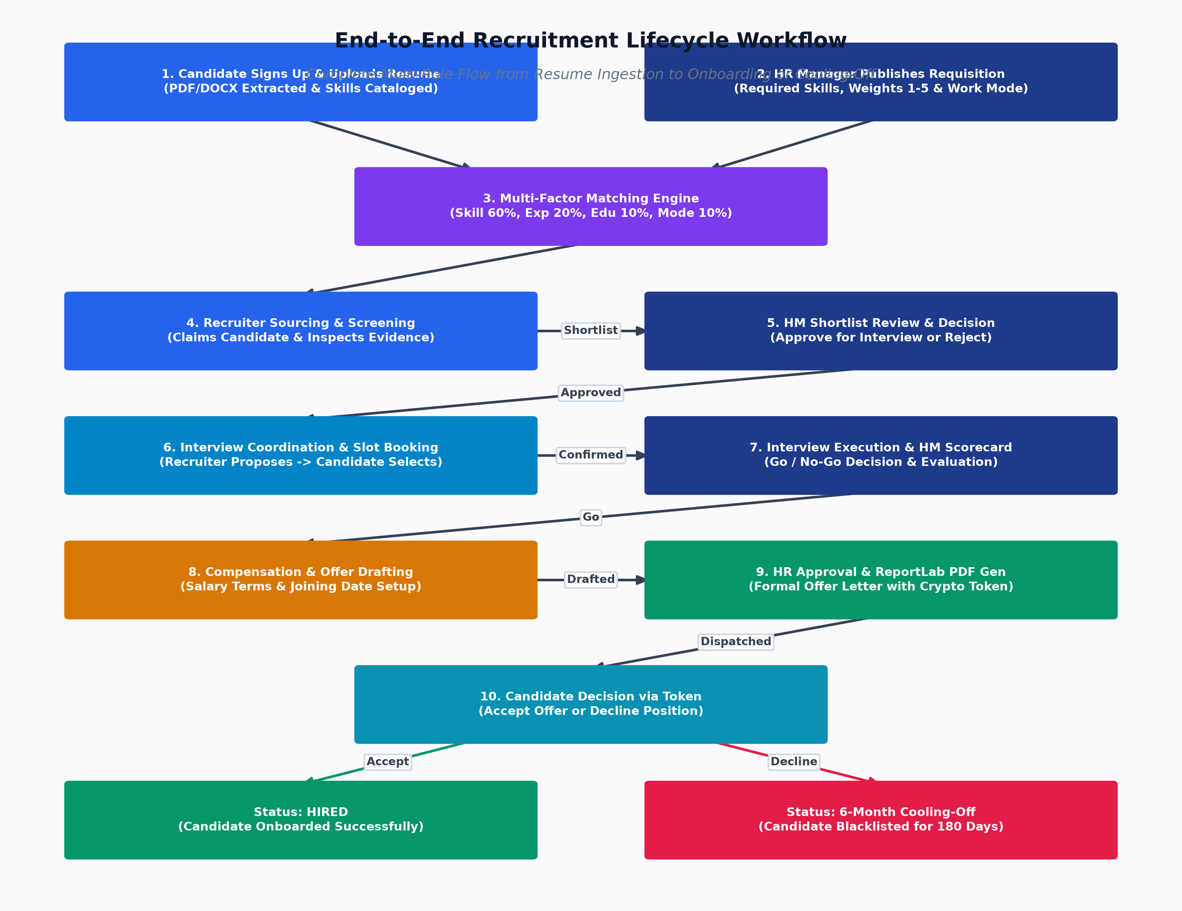
Figure: Complete End-to-End Recruitment Workflow
2. Role-Specific Workflows
2.1 Candidate Workflow
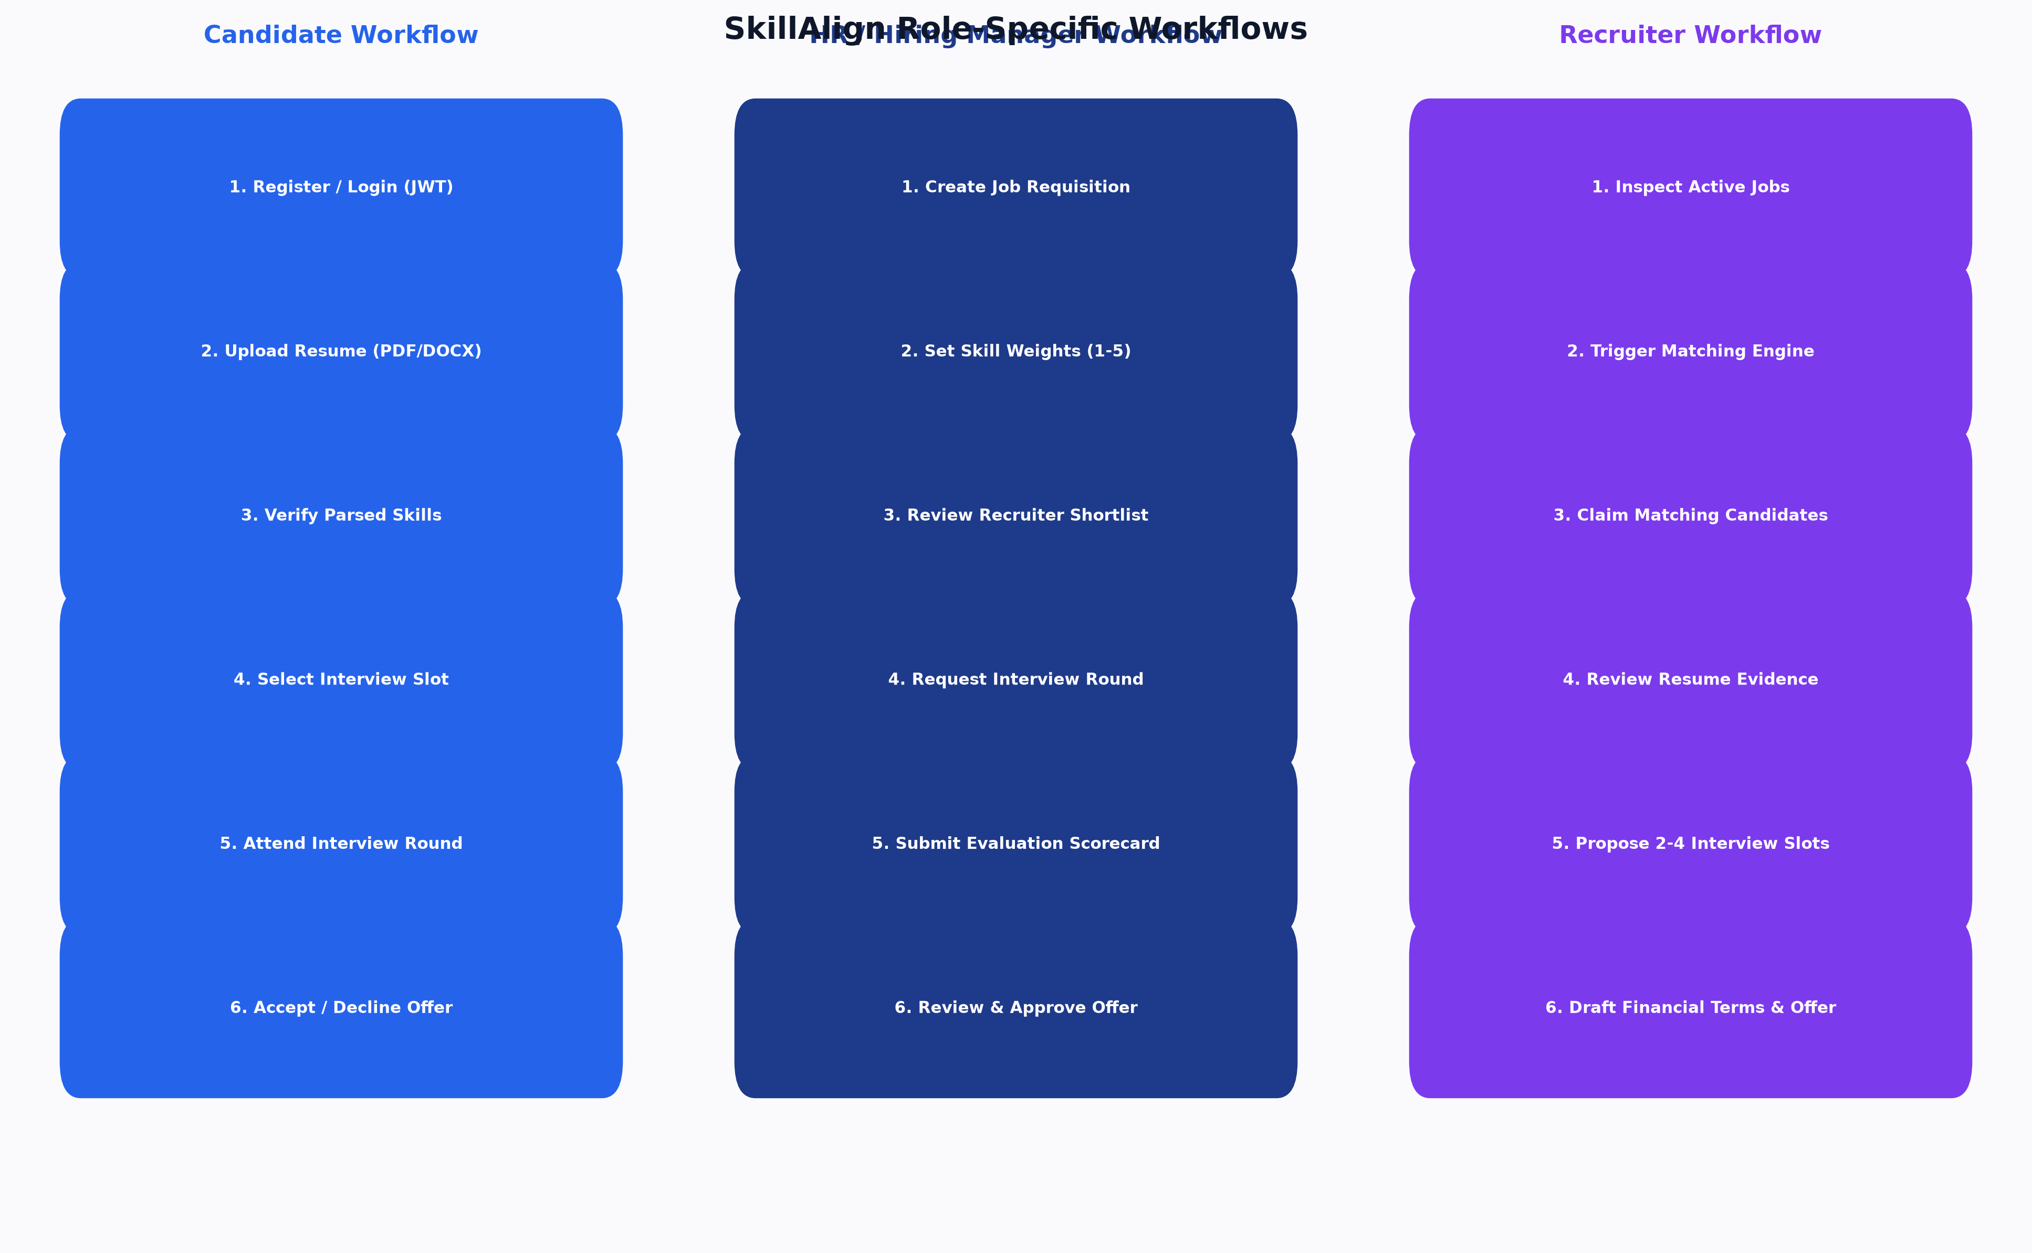
Figure: Role-Specific Recruitment Workflows
2.2 HR / Hiring Manager Workflow
Figure: Role-Specific Recruitment Workflows
2.3 Recruiter Workflow
Figure: Role-Specific Recruitment Workflows
2.4 Admin Workflow
Figure: Role-Specific Recruitment Workflows
3. Enterprise Status & State Machines
3.1 21-State Recruitment Workflow State Machine
The core candidate-job relationship is governed by the pipeline_state column on MatchResult. Every transition is verified against the VALID_TRANSITIONS dictionary in workflow_service.py:
stateDiagram-v2
[*] --> CANDIDATE_MATCHED
CANDIDATE_MATCHED --> CANDIDATE_SHORTLISTED: Recruiter Shortlists
CANDIDATE_MATCHED --> SENT_TO_HIRING_MANAGER: Direct Submission
CANDIDATE_MATCHED --> REJECTED: Reject
CANDIDATE_SHORTLISTED --> SENT_TO_HIRING_MANAGER: Submit to HM
CANDIDATE_SHORTLISTED --> REJECTED: Reject
SENT_TO_HIRING_MANAGER --> HIRING_MANAGER_REVIEW: HM Opens Candidate
SENT_TO_HIRING_MANAGER --> REJECTED: Reject
HIRING_MANAGER_REVIEW --> HIRING_MANAGER_REJECTED: HM Declines Candidate
HIRING_MANAGER_REVIEW --> INTERVIEW_REQUESTED: HM Requests Interview
HIRING_MANAGER_REVIEW --> REJECTED: Reject
HIRING_MANAGER_REJECTED --> REJECTED: Finalized
INTERVIEW_REQUESTED --> INTERVIEW_SLOTS_PROPOSED: Recruiter Adds Slots
INTERVIEW_REQUESTED --> REJECTED: Reject
INTERVIEW_SLOTS_PROPOSED --> WAITING_FOR_CANDIDATE_SLOT: Notification Sent
INTERVIEW_SLOTS_PROPOSED --> REJECTED: Reject
WAITING_FOR_CANDIDATE_SLOT --> CANDIDATE_SLOT_SELECTED: Candidate Picks Slot
WAITING_FOR_CANDIDATE_SLOT --> REJECTED: Reject
CANDIDATE_SLOT_SELECTED --> INTERVIEW_CONFIRMED: Recruiter Confirms
CANDIDATE_SLOT_SELECTED --> REJECTED: Reject
INTERVIEW_CONFIRMED --> INTERVIEW_COMPLETED: Interview Occurs
INTERVIEW_CONFIRMED --> REJECTED: Reject
INTERVIEW_COMPLETED --> WAITING_FOR_HM_FEEDBACK: Awaiting Scorecard
INTERVIEW_COMPLETED --> REJECTED: Reject
WAITING_FOR_HM_FEEDBACK --> INTERVIEW_GO: Positive Evaluation
WAITING_FOR_HM_FEEDBACK --> INTERVIEW_NO_GO: Negative Evaluation
WAITING_FOR_HM_FEEDBACK --> REJECTED: Reject
INTERVIEW_NO_GO --> REJECTED: Rejection Finalized
INTERVIEW_GO --> INTERVIEW_REQUESTED: Request Next Round
INTERVIEW_GO --> COMPENSATION_DISCUSSION: Proceed to Offer
INTERVIEW_GO --> REJECTED: Reject
COMPENSATION_DISCUSSION --> OFFER_CREATED: Recruiter Drafts Terms
COMPENSATION_DISCUSSION --> REJECTED: Reject
OFFER_CREATED --> OFFER_SENT: HR Approves & Dispatches
OFFER_CREATED --> REJECTED: Reject
OFFER_SENT --> OFFER_ACCEPTED: Candidate Accepts
OFFER_SENT --> OFFER_REJECTED: Candidate Declines
OFFER_SENT --> REJECTED: Offer Rescinded
OFFER_ACCEPTED --> HIRED: Final Onboarding
OFFER_REJECTED --> BLACKLISTED: 6-Month Cooling-Off Applied
BLACKLISTED --> [*]
HIRED --> [*]
REJECTED --> [*]

3.2 Formal State Transition Matrix
Source State (`from_state`) | Permitted Target States (`to_state`) | Required User Role | Triggering API Endpoint
CANDIDATE_MATCHED | CANDIDATE_SHORTLISTED, SENT_TO_HIRING_MANAGER, HIRING_MANAGER_REVIEW, INTERVIEW_REQUESTED, INTERVIEW_SLOTS_PROPOSED, REJECTED | Recruiter, HR, Admin | POST /api/workflow/shortlist
CANDIDATE_SHORTLISTED | SENT_TO_HIRING_MANAGER, HIRING_MANAGER_REVIEW, INTERVIEW_REQUESTED, INTERVIEW_SLOTS_PROPOSED, REJECTED | Recruiter, HR, Admin | POST /api/workflow/submit-to-hm
SENT_TO_HIRING_MANAGER | HIRING_MANAGER_REVIEW, INTERVIEW_REQUESTED, INTERVIEW_SLOTS_PROPOSED, REJECTED | HR, Admin | POST /api/workflow/hm-review
HIRING_MANAGER_REVIEW | HIRING_MANAGER_REJECTED, INTERVIEW_REQUESTED, INTERVIEW_SLOTS_PROPOSED, REJECTED | HR, Admin | POST /api/workflow/hm-reject, POST /api/workflow/request-interview
HIRING_MANAGER_REJECTED | REJECTED | HR, Recruiter, Admin | POST /api/workflow/reject
INTERVIEW_REQUESTED | INTERVIEW_SLOTS_PROPOSED, WAITING_FOR_CANDIDATE_SLOT, CANDIDATE_SLOT_SELECTED, REJECTED | Recruiter, HR, Admin | POST /api/workflow/send-slots
INTERVIEW_SLOTS_PROPOSED | WAITING_FOR_CANDIDATE_SLOT, CANDIDATE_SLOT_SELECTED, INTERVIEW_CONFIRMED, REJECTED | Recruiter, Candidate, Admin | POST /api/workflow/select-slot
WAITING_FOR_CANDIDATE_SLOT | CANDIDATE_SLOT_SELECTED, INTERVIEW_CONFIRMED, REJECTED | Candidate, Recruiter, Admin | POST /api/workflow/select-slot
CANDIDATE_SLOT_SELECTED | INTERVIEW_CONFIRMED, REJECTED | Recruiter, HR, Admin | POST /api/workflow/confirm-interview
INTERVIEW_CONFIRMED | INTERVIEW_COMPLETED, REJECTED | Recruiter, HR, Admin | POST /api/workflow/complete-interview
INTERVIEW_COMPLETED | WAITING_FOR_HM_FEEDBACK, INTERVIEW_GO, COMPENSATION_DISCUSSION, REJECTED | HR, Admin | POST /api/workflow/hm-feedback
WAITING_FOR_HM_FEEDBACK | INTERVIEW_GO, INTERVIEW_NO_GO, COMPENSATION_DISCUSSION, REJECTED | HR, Admin | POST /api/workflow/hm-feedback
INTERVIEW_GO | COMPENSATION_DISCUSSION, INTERVIEW_REQUESTED, REJECTED | Recruiter, HR, Admin | POST /api/workflow/compensation
INTERVIEW_NO_GO | REJECTED | HR, Recruiter, Admin | POST /api/workflow/reject
COMPENSATION_DISCUSSION | OFFER_CREATED, INTERVIEW_REQUESTED, REJECTED | Recruiter, HR, Admin | POST /api/workflow/create-offer
OFFER_CREATED | OFFER_SENT, OFFER_CREATED, REJECTED | HR, Recruiter, Admin | POST /api/workflow/send-offer
OFFER_SENT | OFFER_ACCEPTED, OFFER_REJECTED, REJECTED | Candidate, HR, Admin | POST /api/offers/respond
OFFER_ACCEPTED | HIRED | HR, Recruiter, Admin | Automated / Manual Transition
OFFER_REJECTED | BLACKLISTED | System Automated | Enforced via workflow_service.py
BLACKLISTED | Terminal State (No outgoing transitions) | System | N/A
HIRED | Terminal State (No outgoing transitions) | System | N/A
REJECTED | Terminal State (No outgoing transitions) | System | N/A

3.3 Supporting Sub-Entity State Machines
3.3.1 Offer Entity State Machine (`Offer.status`)
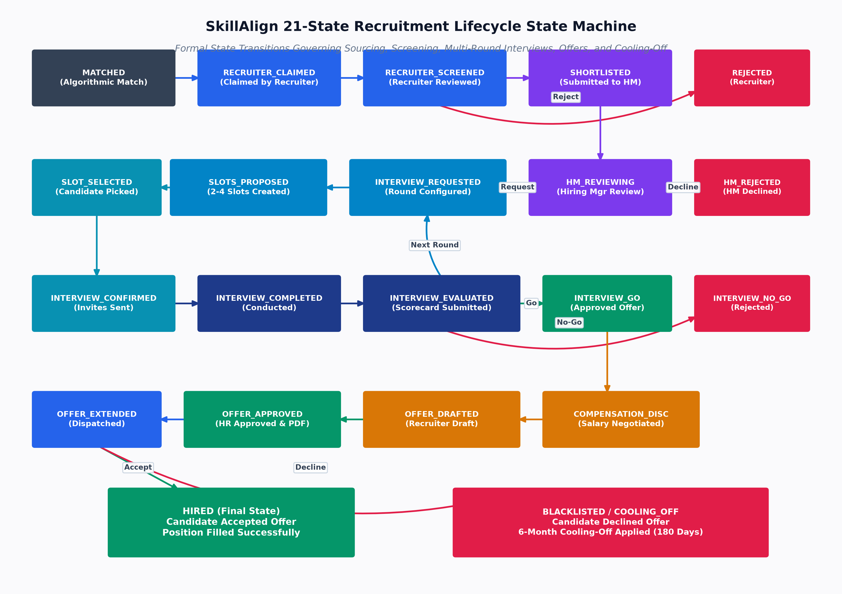
Figure: 21-State Recruitment State Machine
3.3.2 Interview Slot State Machine (`InterviewSlot.status`)
Figure: 21-State Recruitment State Machine
3.3.3 Candidate 6-Month Blacklist State Machine (`CandidateBlacklist`)
Figure: 21-State Recruitment State Machine
4. Business Rules & Governance Policies
The following business rules are strictly encoded in the application logic:
- Requisition Ownership & Skill Weighting:
- Only HR and Admin users can create or edit Job Requisitions (jobs.py).
- Every job must specify between 1 and 20 skills, each with a required integer weight from 1 (low) to 5 (critical) and requirement type (MUST_HAVE or NICE_TO_HAVE).
- Matching Engine Determinism:
- Matching is 100% deterministic and reproducible. Running matching multiple times on the same candidate and job yields the exact same floating-point score (matching_service.py).
- Candidates without a single matching skill receive an overall score of strictly 0.00.
- Resume Evidence Multiplier:
- Skills self-declared by candidates receive standard proficiency factors (Beginner = 0.40, Intermediate = 0.70, Expert = 1.00).
- Skills detected in the candidate's resume with extracted contextual evidence snippets receive a 1.15x multiplier bonus (capped at 1.00).
- Recruiter Claiming & Conflict Prevention:
- Recruiters can claim unassigned candidates for active jobs (recruiter.py).
- Claiming assigns recruiter_id on the MatchResult and creates a record in candidate_recruiter_assignments with status = 'active'.
- Interview Slot Selection:
- When proposing interview slots, recruiters must provide between 1 and 5 non-conflicting time windows.
- Candidates can select a slot via a cryptographically random public token (interview.selection_token) without requiring prior system login.
- Hiring Manager Evaluation Integrity:
- An interview cannot be marked INTERVIEW_COMPLETED without recording the completion timestamp.
- Go/No-Go feedback requires numeric ratings (1-5) across Communication, Technical Competency, and Problem Solving, accompanied by qualitative notes.
- Offer Approval Dual-Control:
- Recruiters draft offers, but cannot dispatch them directly without explicit HR Manager approval (Offer.status == 'APPROVED_BY_HR').
- Automated 6-Month Cooling-Off (Blacklisting):
- If a candidate declines a formal offer (OFFER_REJECTED / DECLINED), the system automatically creates a CandidateBlacklist record with blacklisted_until = now() + 180 days.
- Blacklisted candidates are automatically suppressed and flagged in recruiter match queries until the expiration date.
5. System Data Flow Diagrams (DFDs)
5.1 Level-1 DFD: Candidate Resume Ingestion & Profile Synchronization
flowchart LR
Candidate([Candidate]) -- "1. Uploads PDF/DOCX" --> API[Resume API Router]
API -- "2. Raw Bytes" --> StorMgr[Storage Manager]
StorMgr -- "3. Store Original" --> S3[(AWS S3 / Local Disk)]
API -- "4. Raw Bytes" --> Extractor[Text Extractor pdfplumber]
Extractor -- "5. Clean Plaintext" --> Parser[Deterministic Rule Parser]
Parser -- "6. Structured JSON" --> DB[(PostgreSQL)]
DB -- "7. Sync Skills" --> CandSkills[(candidate_skills)]
DB -- "8. Update Profile" --> CandRecord[(candidates)]

5.2 Level-1 DFD: Multi-Factor Candidate-Job Matching Flow
flowchart LR
Recruiter([Recruiter]) -- "1. Run Match(job_id)" --> MatchAPI[Matching Router]
MatchAPI -- "2. Fetch Job & Skills" --> DB[(PostgreSQL)]
DB -- "3. Job Data (Weights, Min Exp, Mode)" --> MatchEngine[Matching Service]
DB -- "4. All Candidate Records & Skills" --> MatchEngine
MatchEngine -- "5. Calculate 4 Factors" --> MathLogic[Scoring Matrix]
MathLogic -- "6. overall_score (0-100)" --> DB
DB -- "7. Persist MatchResults" --> MatchResults[(match_results)]
MatchResults -- "8. Ranked Matches" --> Recruiter

5.3 Level-1 DFD: Offer Drafting, Approval & PDF Generation Flow
flowchart LR
Recruiter([Recruiter]) -- "1. Draft Offer Terms" --> WorkAPI[Workflow Router]
WorkAPI -- "2. Create Offer (DRAFT)" --> DB[(PostgreSQL)]
HR([HR Manager]) -- "3. Review & Approve" --> WorkAPI
WorkAPI -- "4. Status: APPROVED" --> PDFEngine[ReportLab OfferPDFService]
PDFEngine -- "5. Annexure A/B Binary PDF" --> S3[(Storage Subsystem)]
WorkAPI -- "6. Send Email + Secure Token" --> SendGrid[SendGrid API]
SendGrid -- "7. Email with Token Link" --> Candidate([Candidate])
Candidate -- "8. Accept / Decline" --> OfferAPI[Offers Router]
OfferAPI -- "9. Update Status / Trigger Blacklist" --> DB

Proceed to [Volume 03: Functional Specification Document & Use Cases](file:///c:/Users/shiva/OneDrive/Desktop/SkillAlign/docs/03_FUNCTIONAL_SPECIFICATION_DOCUMENT.md) for detailed feature requirements and testable use cases.

Functional Specification Document (FSD) & Use Cases

Volume 03: Functional Specification Document (FSD) & Use Cases
This volume contains the complete engineering-grade Functional Specification Document (FSD) and Detailed Use Case Specifications for SkillAlign, verified against the active codebase.
1. Feature Inventory & Implementation Status Matrix
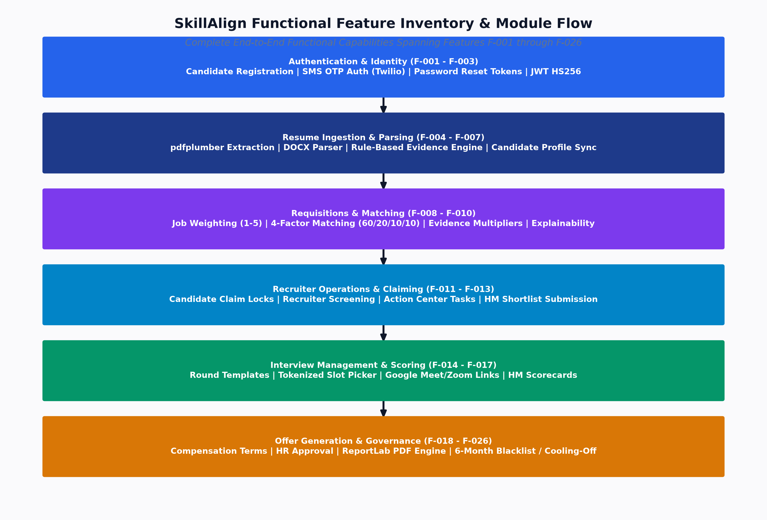
Figure: Functional Feature Map & Architecture
Feature ID | Feature Name | Primary Actor | Implementation Status | Core Implementation Files
F-001 | Candidate Self-Registration | Candidate | Implemented | auth.py, RegisterPage.tsx
F-002 | Multi-Factor Authentication (Email/Password + Phone OTP) | All Users | Implemented | auth_service.py, otp_service.py
F-003 | Password Reset via Cryptographic Token | All Users | Implemented | auth_service.py, ForgotPasswordPage.tsx
F-004 | Resume Document Upload (PDF, DOCX, DOC, TXT) | Candidate | Implemented | resume.py, resume_service.py
F-005 | Deterministic Text Extraction & Layout Preservation | System | Implemented | resume_text_extractor.py
F-006 | Rule-Based Resume Parsing & Evidence Extraction | System | Implemented | resume_txt_parser.py
F-007 | Candidate Profile & Skill Management | Candidate | Implemented | candidates.py, CandidateProfilePage.tsx
F-008 | Job Requisition Creation & Skill Weighting (1-5) | HR / Admin | Implemented | jobs.py, HRCreateJobPage.tsx
F-009 | Multi-Factor Algorithmic Candidate Matching | Recruiter / HR | Implemented | matching_service.py, matching.py
F-010 | Explainable Match Breakdown & Resume Evidence Viewer | Recruiter / HR | Implemented | matching_service.py, RecruiterCandidateDetailPage.tsx
F-011 | Recruiter Candidate Claiming & Concurrency Lock | Recruiter | Implemented | recruiter.py, candidate_recruiter_assignment.py
F-012 | Recruiter Shortlisting & Submission to Hiring Manager | Recruiter | Implemented | workflow.py, ShortlistSubmissionPage.tsx
F-013 | Hiring Manager Candidate Review & Decisioning | HR / HM | Implemented | workflow_service.py, HMCandidateReviewPage.tsx
F-014 | Multi-Round Interview Template Configuration | HR / Admin | Implemented | job_interview_round.py, jobs.py
F-015 | Interview Slot Proposal & Public Token Generation | Recruiter | Implemented | workflow_service.py, RequestInterviewModal.tsx
F-016 | Candidate Self-Service Slot Selection (Public/Authenticated) | Candidate | Implemented | SlotSelectionPage.tsx, workflow.py
F-017 | Interview Execution & Structured HM Evaluation Scorecard | HR / HM | Implemented | interview_feedback.py, HMFeedbackPage.tsx
F-018 | Compensation Discussion & Offer Drafting | Recruiter | Implemented | workflow_service.py, RecruiterOfferPage.tsx
F-019 | HR Executive Offer Approval & Revisions | HR Manager | Implemented | HMOfferReviewPage.tsx, offer.py
F-020 | ReportLab Corporate Offer Letter PDF Compilation | System | Implemented | offer_pdf_service.py
F-021 | Public Tokenized Offer Letter Acceptance / Rejection | Candidate | Implemented | CandidateOfferPage.tsx, workflow.py
F-022 | Automated 6-Month Cooling-Off Blacklisting | System | Implemented | candidate_blacklist.py, workflow_service.py
F-023 | Recruiter Action Center & Operational Tasks | Recruiter | Implemented | tasks.py, ActionCenterPage.tsx
F-024 | Multi-Channel Transactional Notifications (In-App & Email) | System | Implemented | notifications.py, email_service.py
F-025 | Admin System Console, User Management & Taxonomy | Admin | Implemented | admin.py, AdminDashboard.tsx
F-026 | Google Gemini Semantic Analysis & Fit Assessment | Recruiter / HR | Implemented | gemini_service.py, matching.py

2. Detailed Feature Specifications (FSD)
F-004: Resume Document Upload & Multi-Format Text Extraction
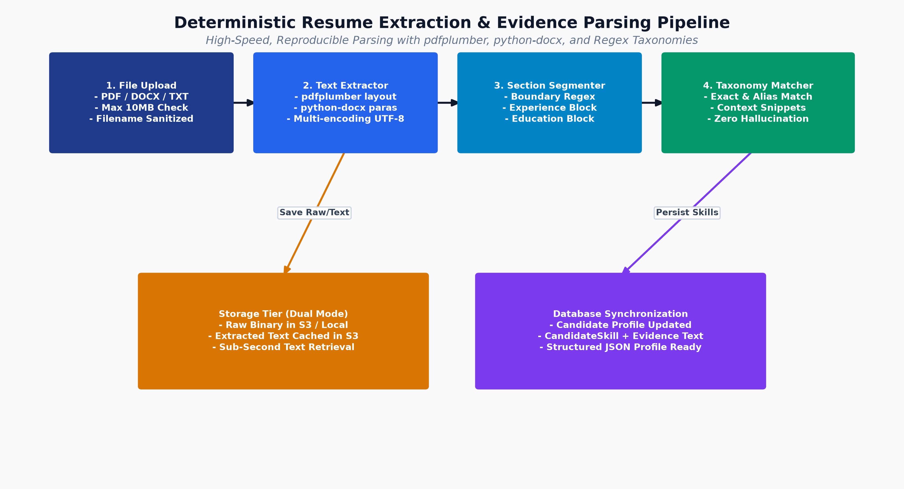
Figure: Resume Extraction Pipeline
- Feature ID: F-004
- Feature Name: Resume Document Upload & Text Extraction
- Primary Actor: Candidate
- Purpose: Allows candidates to upload resumes in PDF, DOCX, DOC, or TXT format (up to 10MB) for server-side storage and deterministic text extraction.
- Preconditions: Candidate is authenticated with a valid JWT token.
- Trigger: Candidate selects a file and clicks "Upload Resume" in the UI.
- Main Flow:
1. Frontend validates file extension (.pdf, .docx, .doc, .txt) and size (\le 10 MB).
2. Client submits multipart form-data to POST /api/candidates/me/resume.
3. API checks MIME type and calls resume_service.store_resume_and_queue().
4. Backend sanitizes filename to prevent directory traversal (sanitize_filename()).
5. File binary is uploaded to AWS S3 or Local Storage via StorageManager.
6. resume_text_extractor.extract_text_from_file() invokes pdfplumber for PDF, python-docx for DOCX, or multi-encoding decoder for TXT.
7. Plain extracted text is saved to S3 under resumes/extracted/{candidate_id}/{filename}.txt.
8. Extracted text is passed to resume_txt_parser.parse_resume_text().
9. Candidate record is updated with raw text, parsed JSON metadata, and sync timestamp.
- Alternative Flows:
- Celery Active: If Redis/Celery worker is responsive, processing is queued asynchronously under task_id with status processing.
- Celery Inactive: Fallback executes immediately in-process synchronously, returning status completed.
- Error Conditions:
- File >10 MB \to Returns 413 Request Entity Too Large.
- Invalid format (e.g. .exe, .zip) \to Returns 400 Bad Request.
- Corrupted/scanned image PDF with no text \to Returns 422 Unprocessable Entity.
- Database Dependencies: candidates, candidate_skills, skills.
- API Dependencies: POST /api/candidates/me/resume, GET /api/candidates/me/resume/status.
F-008: Job Requisition Creation & Requirement Weighting
- Feature ID: F-008
- Feature Name: Job Requisition Creation & Skill Weighting
- Primary Actor: HR Manager, Admin
- Purpose: Creates enterprise job openings with required skill criteria, weights, and interview round templates.
- Preconditions: User is logged in with HR or Admin role.
- Trigger: User fills out the job creation form at /hr/jobs/create and clicks "Publish Job".
- Main Flow:
1. User inputs Title, Department, Location, Work Mode (Remote, Hybrid, Onsite), Min Experience, Description.
2. User selects required skills from global taxonomy and assigns integer weights (1 to 5) and requirement type (MUST_HAVE or NICE_TO_HAVE).
3. User optionally defines interview rounds (e.g., Round 1: Technical Screening, Round 2: System Design).
4. Frontend sends payload to POST /api/jobs.
5. FastAPI validates request schema JobCreate.
6. Service creates Job record and associated JobSkill records within a single database transaction.
7. Returns created JobOut object.
- Error Conditions:
- Missing title or experience <0 \to Returns 422 Validation Error.
- Unauthorized role (Candidate or Recruiter) \to Returns 403 Forbidden.
- Database Dependencies: jobs, job_skills, skills, job_interview_rounds.
- API Dependencies: POST /api/jobs, GET /api/skills.
F-009: Multi-Factor Algorithmic Candidate Matching
- Feature ID: F-009
- Feature Name: Multi-Factor Algorithmic Candidate Matching
- Primary Actor: Recruiter, HR Manager, Admin
- Purpose: Evaluates all candidate profiles against a job requisition using a 4-factor scoring model.
- Preconditions: Target Job Requisition exists and contains at least one JobSkill.
- Trigger: Recruiter clicks "Run Matching Engine" on Job Detail page.
- Main Flow:
1. Client calls POST /api/matching/run/{job_id}.
2. Service queries all active candidates and their associated candidate_skills.
3. For each candidate, calculate_candidate_match_score() evaluates:
- Skill Score (60%): Weighted sum of matched skill proficiency factors (with 1.15x evidence multiplier) divided by total job skill weight.
- Experience Score (20%): Candidate experience compared against job minimum threshold.
- Education Score (10%): Degree presence evaluation.
- Work Mode Score (10%): Compatibility check between candidate preference and job mode.
4. Upserts MatchResult records with overall_score, recruiter_id, and status = 'matched'.
5. Sorts results in descending order of overall_score.
6. Returns structured MatchRunResponse with full skill breakdowns.
- Error Conditions:
- Non-existent job_id \to Returns 404 Not Found.
- Non-privileged role \to Returns 403 Forbidden.
- Database Dependencies: jobs, job_skills, candidates, candidate_skills, match_results.
- API Dependencies: POST /api/matching/run/{job_id}, GET /api/matching/job/{job_id}.
F-018: Compensation Discussion & Offer Drafting
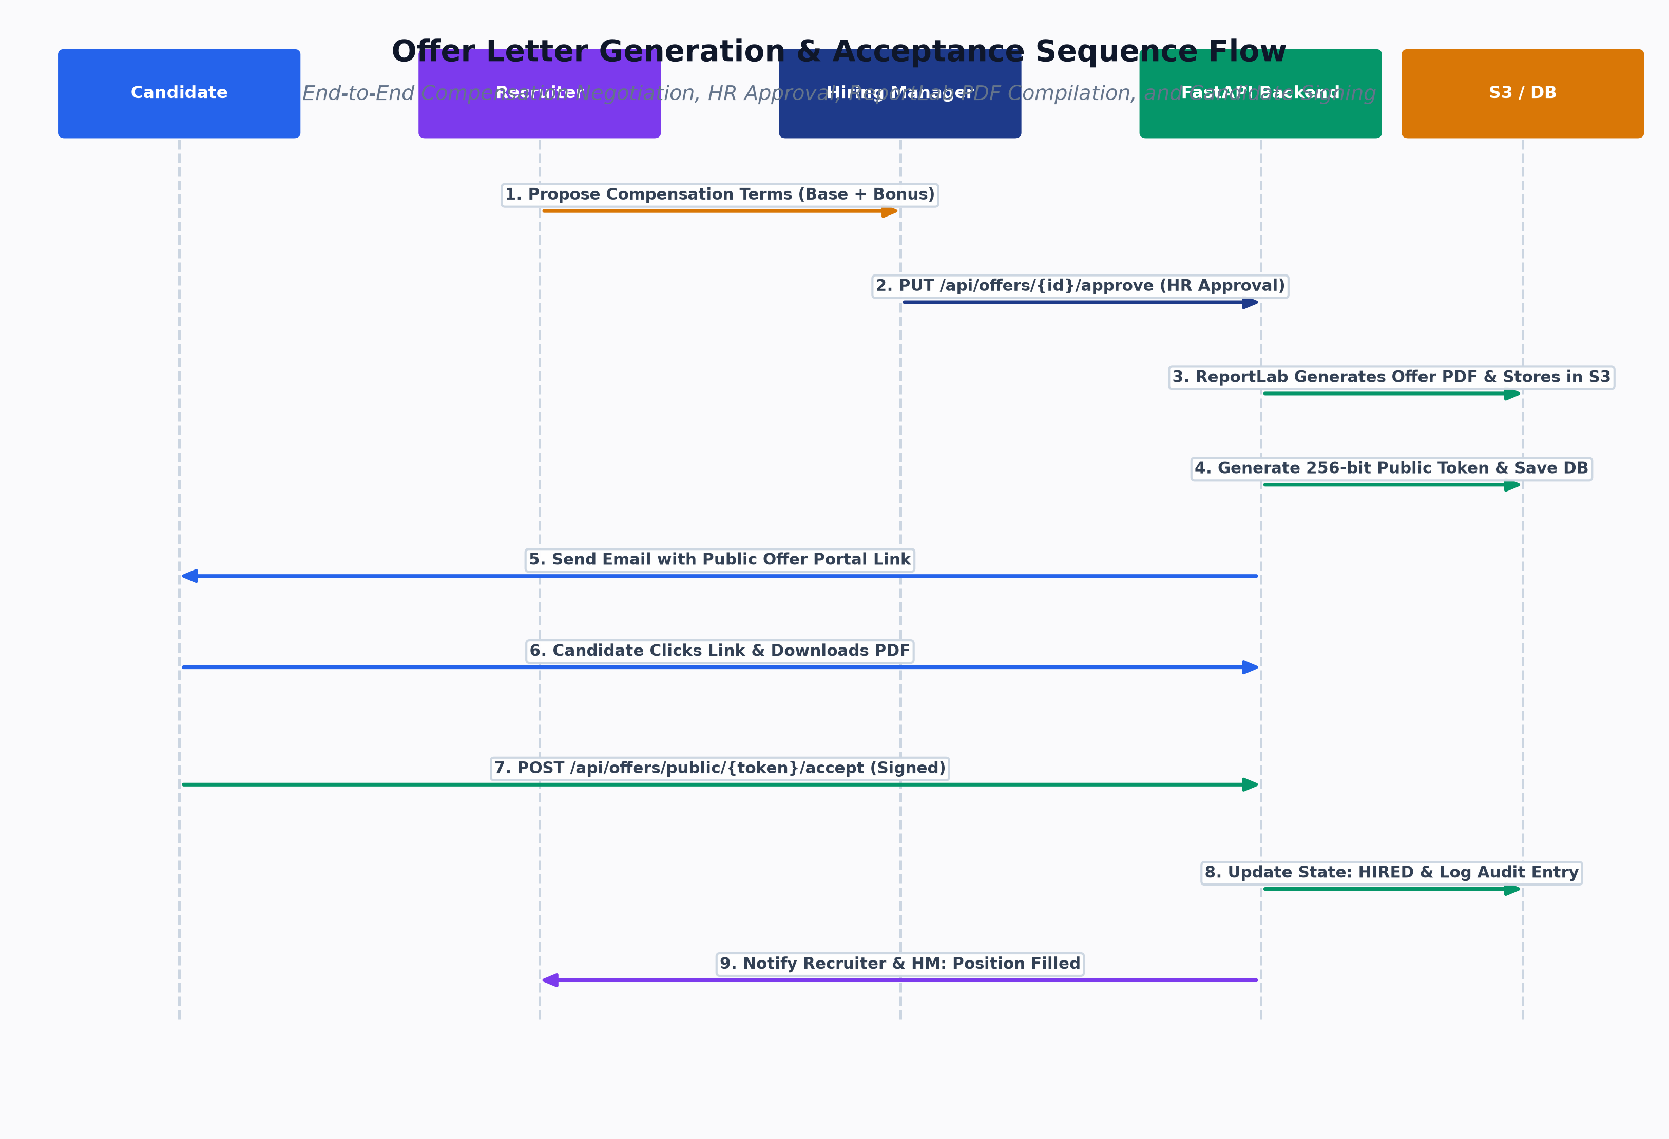
Figure: Offer Generation Flow
- Feature ID: F-018
- Feature Name: Compensation Discussion & Offer Drafting
- Primary Actor: Recruiter
- Purpose: Allows recruiters to configure structured financial and operational terms for a candidate offer.
- Preconditions: Application is in state COMPENSATION_DISCUSSION or INTERVIEW_GO.
- Trigger: Recruiter submits offer terms at /recruiter/offers/create.
- Main Flow:
1. Recruiter fills Base Salary, Performance Bonus, Signing Bonus, Relocation Allowance, Equity/Stock Options, Joining Date, Expiry Date, Work Location.
2. Recruiter enters customized terms and conditions for Annexure B.
3. Client calls POST /api/workflow/create-offer.
4. Backend verifies state transition COMPENSATION_DISCUSSION \to OFFER_CREATED.
5. Computes Total Annual CTC (Base + Bonus + Signing + Relocation).
6. Generates cryptographically secure response_token (secrets.token_urlsafe(32)).
7. Creates Offer record with status = 'DRAFT' or 'PENDING_HR_APPROVAL'.
8. Logs audit entry in audit_logs and dispatches notification to HR.
- Database Dependencies: match_results, offers, audit_logs, notifications.
- API Dependencies: POST /api/workflow/create-offer, GET /api/offers/{id}.
F-020: ReportLab Corporate Offer Letter PDF Compilation
- Feature ID: F-020
- Feature Name: ReportLab Corporate Offer Letter PDF Compilation
- Primary Actor: System (Triggered on Demand or Offer Approval)
- Purpose: Compiles a pixel-perfect, multi-page corporate PDF offer letter with dual annexures.
- Preconditions: Offer record exists with valid financial terms and associated Candidate and Job.
- Trigger: Recruiter, HR, or Candidate requests PDF download.
- Main Flow:
1. Client calls GET /api/offers/{id}/pdf.
2. OfferPDFService.generate(offer, candidate, job, recruiter, hm) is invoked.
3. ReportLab builds document canvas using standard A4 geometry and corporate color palette (#0F172A, #1D4ED8, #B45309).
4. Page 1: Official Corporate Header, Reference Number, Candidate Block, Salutation, Appointment Terms Table.
5. Page 2 (Annexure A): Structured Annual and Monthly Compensation Schedule with Total CTC.
6. Page 3 (Annexure B): Key Employment Conditions, Probation, Notice Period, Confidentiality, Dual Signature Block.
7. Two-Pass NumberedCanvas compiles dynamic running footers ("Page X of Y").
8. Binary bytes returned with header Content-Type: application/pdf.
- Database Dependencies: offers, match_results, candidates, jobs, users.
- API Dependencies: GET /api/offers/{id}/pdf.
3. Detailed Use Case Specifications
UC-001: Candidate Registration & Resume Onboarding
- Actor: Candidate
- Goal: Create an account, upload a resume, and review parsed skills.
- Preconditions: Candidate has a valid email address and a PDF/DOCX resume.
- Trigger: Candidate accesses /register.
- Main Success Scenario:
1. Candidate enters Full Name, Email, Password, and Phone Number.
2. System creates User (Role: Candidate) and linked Candidate record.
3. System returns JWT token; Candidate is redirected to /candidate/profile.
4. Candidate uploads resume.pdf.
5. System extracts text via pdfplumber and executes rule parser.
6. Candidate views extracted Education, Experience, and Skills tagged with Evidence Snippets.
- Alternative Scenarios:
- Phone OTP: Candidate enters phone number, receives 6-digit SMS code, verifies OTP, and logs in.
- Postconditions: Profile is populated and candidate is immediately discoverable by matching engine.
UC-005: Recruiter Runs Matching & Screens Shortlist
- Actor: Recruiter
- Goal: Find top-matching candidates for an active job requisition and submit them to the Hiring Manager.
- Preconditions: Job Requisition has required skills defined.
- Trigger: Recruiter clicks "Run Matching" on /recruiter/jobs/{id}.
- Main Success Scenario:
1. Matching engine evaluates all candidates and displays ranked list sorted by overall_score.
2. Recruiter claims Candidate A (POST /api/recruiter/claims).
3. Recruiter inspects Candidate A's match breakdown (Matched Skills, Missing Skills, Evidence Snippets).
4. Recruiter clicks "Shortlist" and enters submission notes (POST /api/workflow/submit-to-hm).
5. State advances to SENT_TO_HIRING_MANAGER.
6. In-app notification and email are dispatched to the assigned Hiring Manager.
- Postconditions: Candidate appears in HR's Decision Dashboard.
UC-012: Candidate Selects Interview Slot via Public Token
- Actor: Candidate
- Goal: Select a preferred interview time slot without friction.
- Preconditions: Recruiter has proposed interview slots (INTERVIEW_SLOTS_PROPOSED).
- Trigger: Candidate receives email invite with secure link /select-slot?token={selection_token}.
- Main Success Scenario:
1. Candidate opens slot selection link in browser.
2. System resolves Interview record via selection_token without requiring login.
3. System renders available time slots in candidate's local time zone.
4. Candidate selects Slot 2 (e.g., "Thursday, 2:00 PM - 3:00 PM").
5. Client calls POST /api/workflow/select-slot.
6. System marks selected slot as selected, cancels alternative slots, and transitions state to CANDIDATE_SLOT_SELECTED.
7. Recruiter receives notification to generate video meeting link.
- Postconditions: Interview time is locked; calendar confirmation is dispatched.
UC-018: Candidate Reviews Formal Offer & Decides
- Actor: Candidate
- Goal: Review compensation package and accept or decline employment offer.
- Preconditions: Offer has been approved by HR and dispatched (OFFER_SENT).
- Trigger: Candidate accesses link /offers/{id}?token={response_token}.
- Main Success Scenario (Acceptance):
1. Candidate inspects Base Salary, Bonuses, Benefits, and downloads ReportLab PDF.
2. Candidate clicks "Accept Offer", enters digital signature name, and confirms.
3. Client calls POST /api/offers/respond with decision = "ACCEPT".
4. Backend transitions Offer to ACCEPTED and application to HIRED.
5. System triggers confetti animation in UI and notifies HR & Recruiter.
- Alternative Scenario (Decline):
1. Candidate clicks "Decline Offer" and enters reason.
2. Client calls POST /api/offers/respond with decision = "REJECT".
3. Backend transitions Offer to DECLINED, application to OFFER_REJECTED, and creates a CandidateBlacklist record for 180 days.
- Postconditions: Candidate is either marked HIRED or placed on active 6-month cooling off.
Proceed to [Volume 04: Matching Engine & Resume Processing](file:///c:/Users/shiva/OneDrive/Desktop/SkillAlign/docs/04_MATCHING_ENGINE_AND_RESUME_PROCESSING.md) for complete mathematical proofs, complexity analysis, and resume parsing algorithms.

