Matching Engine, Database Design & API Inventory
Multi-Factor Scoring, Resume Pipeline, Database Schema, ERD & 54 REST API Endpoints
DOCUMENT  Matching Engine, Database Design & API Inventory | AUTHOR  SkillAlign Architecture Team | STATUS  Production Verified | VERSION  2.0 Consolidated

Volume 04: Matching Engine & Resume Processing Pipeline
This volume provides a comprehensive mathematical, algorithmic, and architectural specification of SkillAlign's Multi-Factor Matching Engine, the Deterministic Resume Processing Pipeline, and the Google Gemini AI Integration.
1. Multi-Factor Matching Engine
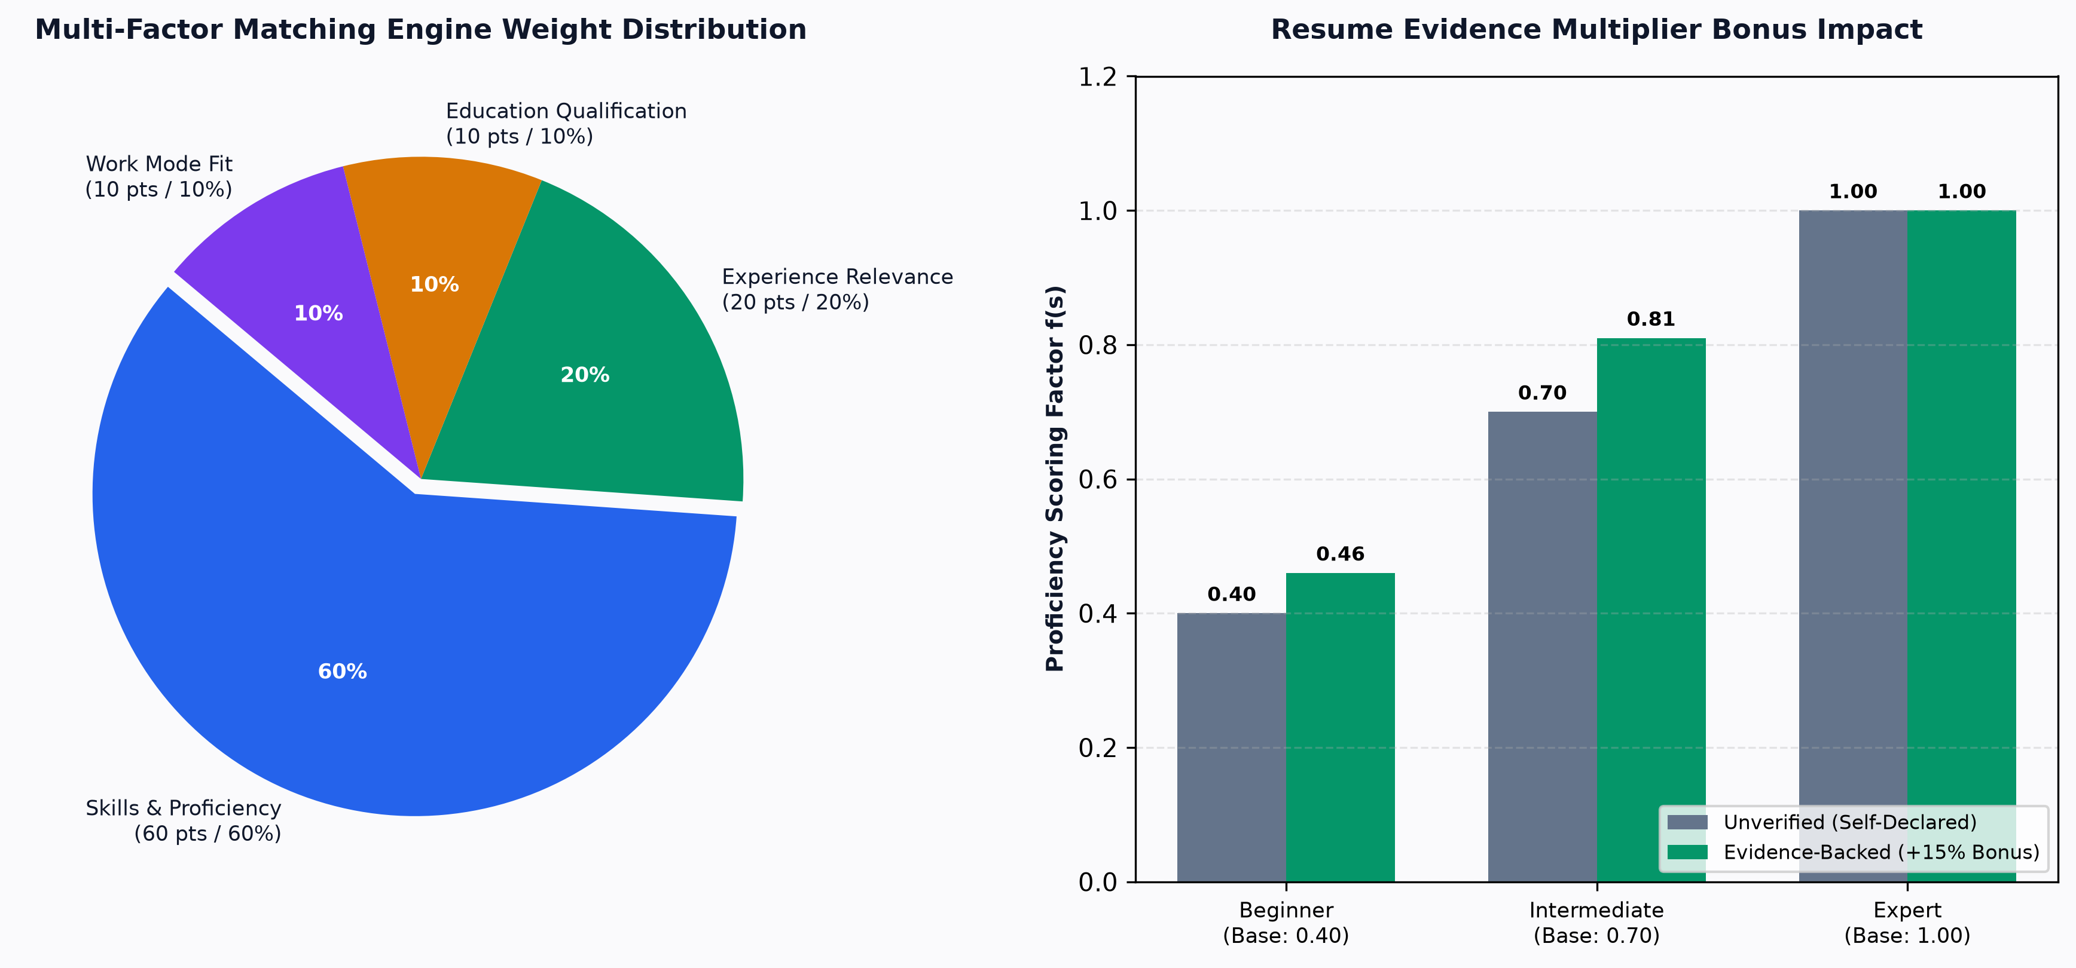
Figure: Multi-Factor Fit Scoring Weight Distribution
SkillAlign implements a transparent, explainable, and multi-criteria algorithmic scoring model in matching_service.py. Rather than relying on black-box heuristics or LLM hallucinations, candidate fit is calculated mathematically across 4 distinct dimensions.
┌────────────────────────────────────────────────────────────────────────┐
│ SkillAlign Candidate Fit Score Breakdown │
├────────────────────────────┬─────────────────────────────┬─────────────┤
│ Dimension │ Evaluation Mechanism │ Max Weight │
├────────────────────────────┼─────────────────────────────┼─────────────┤
│ 1. Skill & Proficiency │ Weighted Coverage + Bonus │ 60 pts │
│ 2. Experience Relevance │ Tenure vs Min Requisition │ 20 pts │
│ 3. Education Qualification │ Verified Degree Presence │ 10 pts │
│ 4. Work Mode Compatibility │ Remote / Hybrid / Onsite │ 10 pts │
├────────────────────────────┴─────────────────────────────┼─────────────┤
│ Total Maximum Score │ 100 pts │
└──────────────────────────────────────────────────────────┴─────────────┘

1.1 Mathematical Formulation
The Overall Fit Score S_{\text{overall}} is defined as:
S_{\text{overall}} = \min\left(100.0, \; S_{\text{skill}} + E_{\text{exp}} + D_{\text{edu}} + W_{\text{mode}}\right)
Strict Zero-Match Constraint
If a candidate has zero matching skills (\text{matched\_skills} = \emptyset), the algorithm strictly enforces:
S_{\text{overall}} = 0.00
1.2 Dimension 1: Skill & Proficiency Component ($S_{\text{skill}}$, up to 60 Points)
Let J_{\text{skills}} be the set of required skills for a job requisition, where each skill s \in J_{\text{skills}} has an integer weight W_s \in \{1, 2, 3, 4, 5\}.
The total job skill weight W_{\text{total}} is:
W_{\text{total}} = \sum_{s \in J_{\text{skills}}} W_s
For each skill s \in J_{\text{skills}}, let f(s) be the candidate's proficiency score factor:
$$f(s) = \begin{cases}
0.00 & \text{if candidate does not possess skill } s \\
0.85 & \text{if detected from resume with evidence text and proficiency is None} \\
0.80 & \text{if detected from resume without evidence and proficiency is None} \\
\min\left(1.00, \; \text{round}(\text{Base}(p) \times 1.15, 2)\right) & \text{if skill has verified resume evidence and declared level } p \\
\text{Base}(p) & \text{if skill is manually declared without resume evidence}
\end{cases}$$
Where the Base Proficiency Map \text{Base}(p) is:
$$\text{Base}(p) = \begin{cases}
0.40 & \text{if } p = \text{"Beginner"} \\
0.70 & \text{if } p = \text{"Intermediate"} \\
1.00 & \text{if } p = \text{"Expert"}
\end{cases}$$
Evidence Multiplier Bonus Matrix:
Declared Proficiency ($p$) | Unverified Factor ($\text{Base}$) | Verified with Resume Evidence ($\times 1.15$)
Beginner | 0.40 | 0.46
Intermediate | 0.70 | 0.81
Expert | 1.00 | 1.00 (Capped at 1.00)
Resume-Detected (No Level) | N/A | 0.85 (with snippet) / 0.80 (standard)

The weighted skill score sum is:
\text{WeightedSum} = \sum_{s \in J_{\text{skills}}} \left( f(s) \times W_s \right)
The Skill Component S_{\text{skill}} is then calculated as:
S_{\text{skill}} = \left( \frac{\text{WeightedSum}}{W_{\text{total}}} \right) \times 60.0
1.3 Dimension 2: Experience Relevance Component ($E_{\text{exp}}$, up to 20 Points)
Let C_{\text{exp}} be the candidate's total experience in years, and J_{\text{exp}} be the job requisition's minimum required experience in years:
$$E_{\text{exp}} = \begin{cases}
20.0 & \text{if } J_{\text{exp}} \le 0 \text{ or } C_{\text{exp}} \ge J_{\text{exp}} \\
12.0 & \text{if } C_{\text{exp}} \ge 0.70 \times J_{\text{exp}} \\
6.0 & \text{if } C_{\text{exp}} > 0 \\
0.0 & \text{if } C_{\text{exp}} = 0
\end{cases}$$
1.4 Dimension 3: Education Qualification Component ($D_{\text{edu}}$, up to 10 Points)
Evaluates whether the candidate holds a recognized tertiary degree:
$$D_{\text{edu}} = \begin{cases}
10.0 & \text{if candidate.education\_degree is present and non-empty} \\
0.0 & \text{otherwise}
\end{cases}$$
1.5 Dimension 4: Work Mode Compatibility Component ($W_{\text{mode}}$, up to 10 Points)
Let C_{\text{mode}} be the candidate's preferred work mode and J_{\text{mode}} be the job's work mode (Remote, Hybrid, Onsite):
$$W_{\text{mode}} = \begin{cases}
10.0 & \text{if } C_{\text{mode}} = \emptyset \text{ or } J_{\text{mode}} = \emptyset \text{ or } C_{\text{mode}} = \text{"hybrid"} \text{ or } J_{\text{mode}} = \text{"hybrid"} \text{ or } C_{\text{mode}} = J_{\text{mode}} \\
4.0 & \text{otherwise (e.g. Remote preferred vs Onsite required)}
\end{cases}$$
2. Worked Numerical Calculation Examples
Example 1: Senior Python Backend Developer Requisition
Job Requisition Parameters:
- Job Skills ($J_{\text{skills}}$):
1. Python (Weight = 5)
2. FastAPI (Weight = 4)
3. PostgreSQL (Weight = 3)
4. Docker (Weight = 2)
- Total Job Weight ($W_{\text{total}}$): 5 + 4 + 3 + 2 = 14.0
Candidate A Profile:
- Candidate Skills:
1. Python: Expert (Declared) + Resume Evidence Found \to f(\text{Python}) = 1.00
2. FastAPI: Intermediate (Declared) + Resume Evidence Found \to f(\text{FastAPI}) = \min(1.00, \text{round}(0.70 \times 1.15, 2)) = 0.81
3. PostgreSQL: Resume-detected with context snippet \to f(\text{PostgreSQL}) = 0.85
4. Docker: Not matched \to f(\text{Docker}) = 0.00
Step-by-Step Scoring:
- Skill Component:
$\text{WeightedSum} = (1.00 \times 5) + (0.81 \times 4) + (0.85 \times 3) + (0.00 \times 2) = 5.00 + 3.24 + 2.55 + 0.00 = 10.79
$S_{\text{skill}} = \left( \frac{10.79}{14.00} \right) \times 60.0 = 0.7707 \times 60.0 = 46.24 \text{ pts}
- Experience Component:
$C_{\text{exp}} = 5.0 \ge J_{\text{exp}} = 4.0 \implies E_{\text{exp}} = 20.00 \text{ pts}
- Education Component:
$\text{B.Tech degree present} \implies D_{\text{edu}} = 10.00 \text{ pts}
- Work Mode Component:
$J_{\text{mode}} = \text{"hybrid"} \implies W_{\text{mode}} = 10.00 \text{ pts}
- Overall Fit Score:
$S_{\text{overall}} = 46.24 + 20.00 + 10.00 + 10.00 = \mathbf{86.24\%}
Example 2: Candidate B (Zero Skill Match)
- Candidate B Profile: Sells Graphic Design skills (Photoshop, Illustrator), Experience = 3.0 yrs, Degree = B.A., Mode = Remote.
- Calculation:
- Matched skills against Python/FastAPI/PostgreSQL/Docker = 0.
- has_any_skill_match == False.
- Overall Fit Score: \mathbf{0.00\%} (Filtered out completely).
3. Algorithmic Complexity & Performance Analysis
3.1 Time Complexity
Let:
- N = Number of Candidates in Database
- S_J = Number of Required Skills in Job Requisition (\le 20)
- S_C = Average Number of Skills per Candidate (\le 30)
For a single job matching execution:
- Candidate skill map construction: O(S_C) hash-map indexing per candidate.
- Iterating job skills and scoring: O(S_J \times 1) via O(1) dictionary lookup.
- Overall Candidate Evaluation: O(N \cdot (S_C + S_J)).
- Sorting N match results: O(N \log N).
Total Time Complexity:
T(N) = O(N \cdot (S_C + S_J) + N \log N)
Since S_C \le 30 and S_J \le 20 are small constants, matching executes in $O(N \log N)$ linearithmic time.
3.2 Space Complexity
- Constructing candidate skill lookup tables: O(S_C) auxiliary memory.
- Storing match breakdown objects in memory: O(N \cdot S_J).
- Total Space Complexity: O(N \cdot S_J) auxiliary space.
3.3 Scalability Benchmarks & Bottlenecks
Candidate Count ($N$) | Execution Time (Single-Threaded) | Bottleneck | Optimization Strategy
100 Candidates | \approx 15 \text{ ms} | Negligible | In-memory execution.
10,000 Candidates | \approx 450 \text{ ms} | Database ORM object loading | Use SQLAlchemy joinedload() and selective column queries.
100,000 Candidates | \approx 4.2 \text{ seconds} | Sequential CPU execution | Offload to Celery worker with Redis chunking.
1,000,000 Candidates | \approx 35 \text{ seconds} | Full table scan | Inverted skill index in PostgreSQL (GIN index on skill tags) to pre-filter zero matches.

4. Deterministic Resume Processing Pipeline
SkillAlign avoids non-deterministic LLMs for primary data extraction, utilizing a 100% deterministic, explainable pipeline across resume_service.py, resume_text_extractor.py, and resume_txt_parser.py.
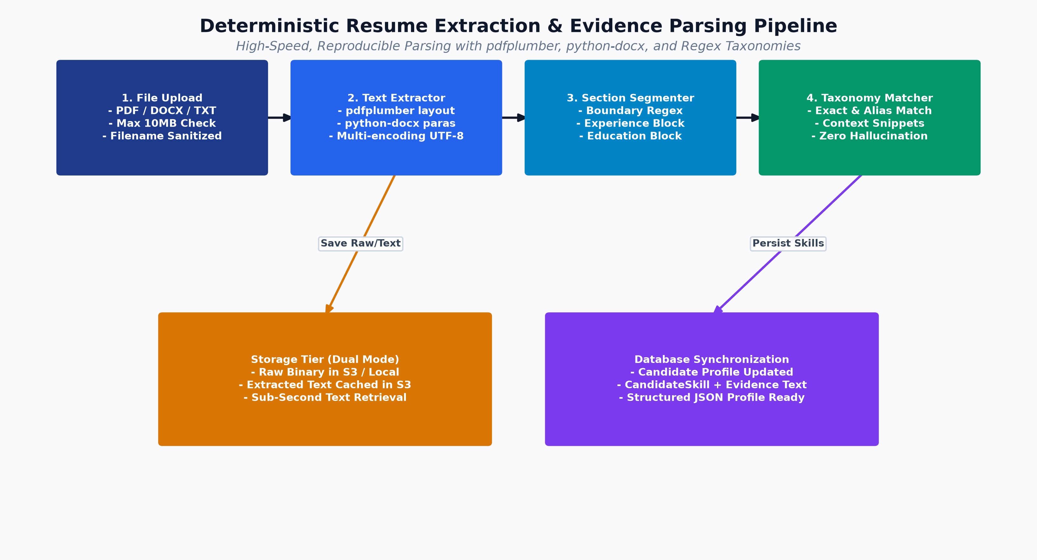
Figure: Resume Extraction Pipeline
4.1 Section Segmentation Engine
The parser uses line-anchored regular expressions to segment documents into 8 isolated sections:
- header: Contact block, candidate name, social links.
- summary: Executive career summary or professional objective.
- skills: Dedicated technical skills, tools, and competency matrices.
- experience: Employment history, company names, job titles, achievements.
- projects: Academic, technical, or personal projects.
- education: Universities, degrees, specializations, grades.
- certifications: Industry certifications (AWS, Azure, CKA, PMP).
- additional: Date of birth, career interests, geographic location.
4.2 Contextual Evidence Snippet Extraction
When a skill from the taxonomy catalog is detected, _get_evidence_snippet(raw_text, skill_name) locates the surrounding sentence in the resume text:
pattern = re.compile(r'^[•\-\*]?\s*([^\n]*?\b' + re.escape(skill_name) + r'\b[^\n]*)', re.MULTILINE | re.IGNORECASE)

This evidence sentence (e.g., "Architected high-throughput microservices using FastAPI and PostgreSQL handling 50k RPM") is persisted in candidate_skills.evidence_text and presented to recruiters to verify skill credibility.
5. AI / LLM Architecture (Google Gemini Service)
SkillAlign integrates Google Gemini API (gemini_service.py) as an optional, on-demand copilot for recruiters and hiring managers.
5.1 Architecture & Request Flow
flowchart LR
RecruiterUI[Recruiter Clicks 'AI Fit Analysis'] --> FastAPIRoute[GET /api/matching/{id}/ai-analysis]
FastAPIRoute --> GemSvc[gemini_service.analyze_candidate_job_fit]
GemSvc --> CheckKey{GEMINI_API_KEY Configured?}
CheckKey -- "No / Key Blank" --> Fallback[_build_fallback_analysis]
CheckKey -- "Yes" --> CallAPI[Call Google Gemini REST Endpoint]
CallAPI --> Models[Try: gemini-3.5-flash-lite → gemini-2.5-flash → gemini-3.5-flash]
Models -- "Success JSON" --> ParseJSON[_clean_and_parse_json]
Models -- "Network Error / Rate Limit" --> Fallback
ParseJSON --> Out[Return Semantic Fit Score, AI Summary & Skill Gaps]
Fallback --> Out

5.2 Prompt Engineering Specification
- Endpoint: https://generativelanguage.googleapis.com/v1beta/models/{model}:generateContent?key={key}
- Model Hierarchy: gemini-3.5-flash-lite \to gemini-2.5-flash \to gemini-2.5-flash-lite \to gemini-3.5-flash.
- Temperature: 0.2 (Low temperature to ensure deterministic, factual analysis).
- Response Format: Native JSON Schema (responseMimeType: "application/json").
- Expected Output JSON:
{
"semantic_fit_score": 88,
"ai_summary": "Candidate exhibits strong full-stack foundations with verified production experience in Python and PostgreSQL.",
"key_strengths": [
"5+ years hands-on microservices development",
"Direct experience in AWS cloud deployments",
"Clean resume alignment with requisition requirements"
],
"skill_gaps": [
"Verify hands-on depth in Docker container orchestration during technical interview"
]
}

Proceed to [Volume 05: Database Design, Schema & ER Diagrams](file:///c:/Users/shiva/OneDrive/Desktop/SkillAlign/docs/05_DATABASE_DESIGN_AND_ERD.md) for complete entity relational specifications.

Database Design, Schema & Entity-Relationship Diagrams

Volume 05: Database Design, Schema & ER Diagrams
This volume documents the complete relational database architecture of SkillAlign, encompassing all 23 SQLAlchemy models, column data types, primary and foreign key constraints, indexes, cascade behaviors, and a comprehensive Mermaid Entity-Relationship Diagram (ERD).
1. Database Architecture & Design Principles
The database is built on PostgreSQL 15+ utilizing SQLAlchemy 2.0 declarative ORM. The relational model adheres strictly to Third Normal Form (3NF) and Boyce-Codd Normal Form (BCNF) to eliminate redundant data and ensure referential integrity.
Key Architectural Decisions:
- Surrogate Primary Keys: All core tables use auto-incrementing integer or UUID primary keys (id).
- Referential Integrity & Cascading Rules:
- Master entity deletion (e.g. deleting a Job or Candidate) cascades deletions to dependent junction tables (job_skills, candidate_skills, match_results, interviews, offers) using ondelete="CASCADE".
- Actor references (e.g. recruiter_id, hiring_manager_id, actor_id) use ondelete="SET NULL" to preserve audit logs and historical records if a user account is deleted.
- Check Constraints: Enforce domain-level value integrity at the database engine level (e.g., overall_score >= 0 AND overall_score <= 100, weight >= 1 AND weight <= 5).
- Composite Unique Constraints: Prevent duplicate mappings (e.g., uq_match_result on (job_id, candidate_id), uq_job_skill on (job_id, skill_id)).
2. Comprehensive Entity-Relationship Diagram (ERD)
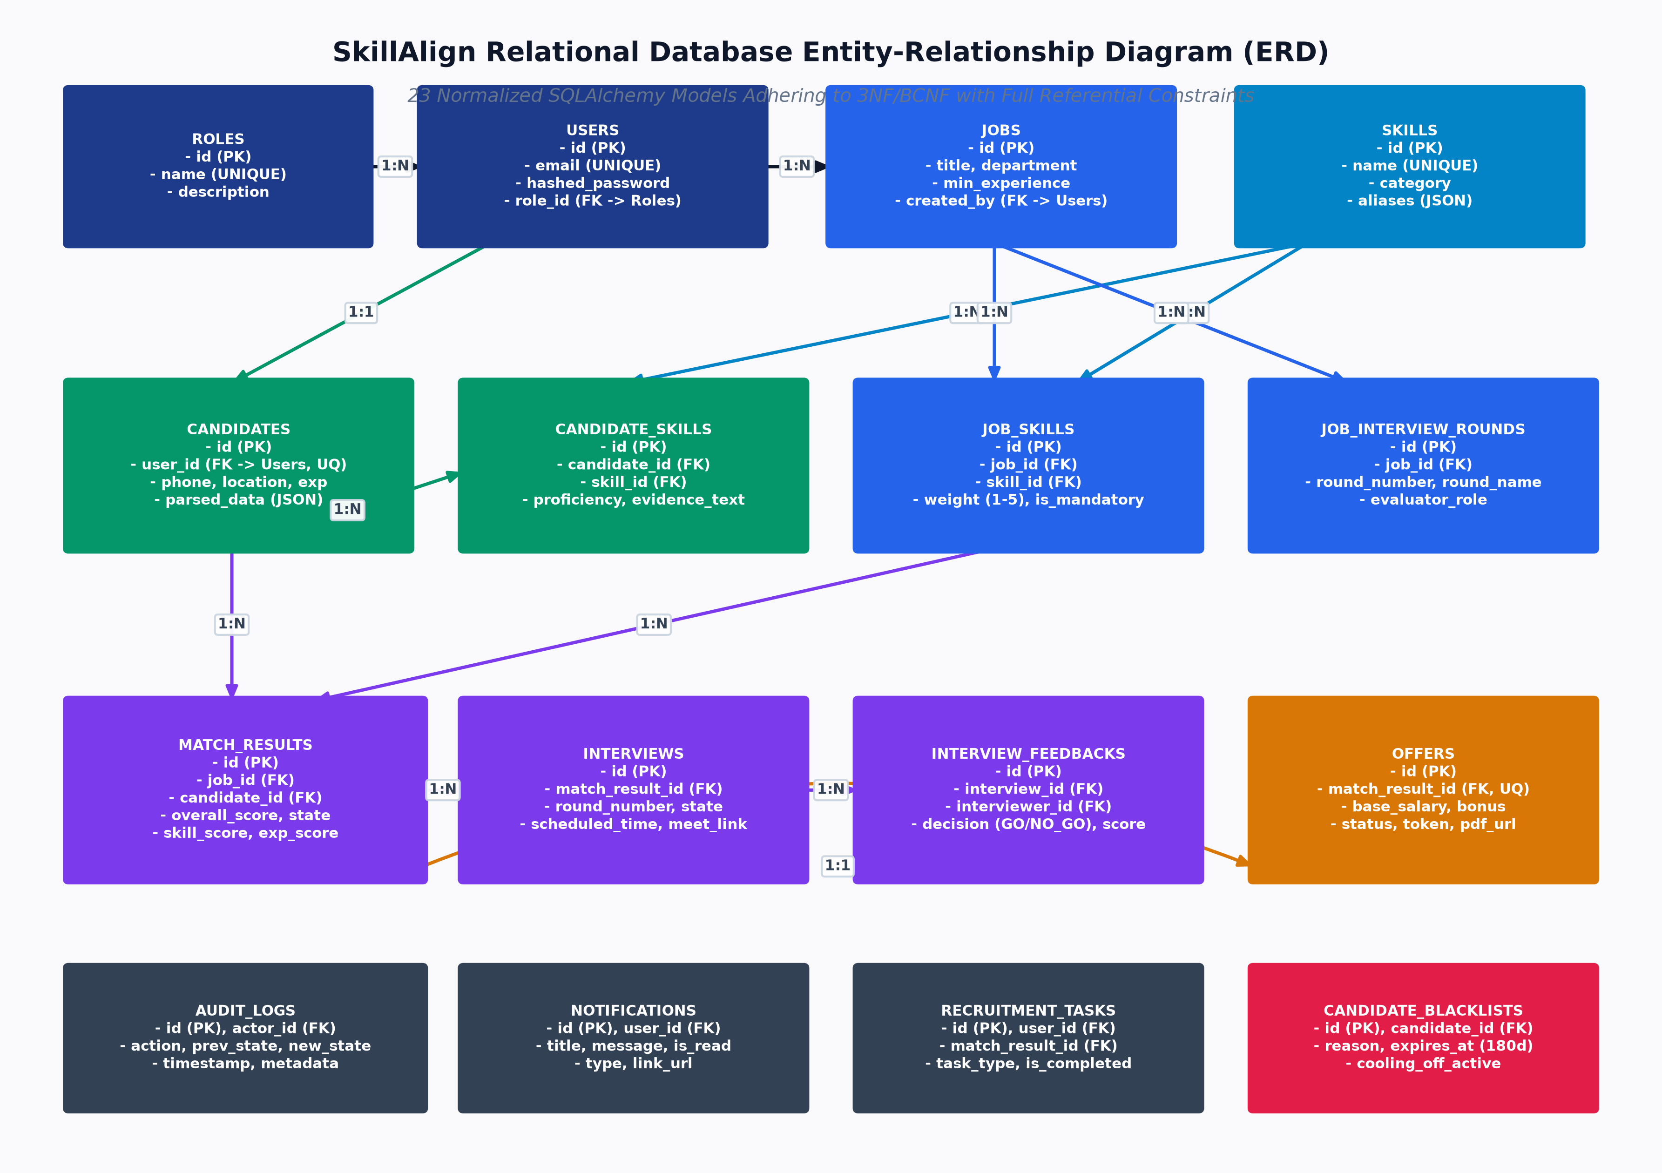
Figure: Complete Entity-Relationship Diagram
Figure: Complete Entity-Relationship Diagram (23 Models)
3. Database Table Inventory & Data Dictionary
3.1 `roles` Table
Column | Type | PK | FK | Nullable | Default | Description
id | INTEGER | ✓ | — | No | Autoincrement | Unique Role ID
name | VARCHAR(50) | — | — | No | — | Role Name (Admin, HR, Recruiter, Candidate) [UNIQUE]
description | VARCHAR(255) | — | — | Yes | NULL | Role Description

3.2 `users` Table
Column | Type | PK | FK | Nullable | Default | Description
id | INTEGER | ✓ | — | No | Autoincrement | Unique User ID
email | VARCHAR(255) | — | — | No | — | User Email Address [UNIQUE, INDEX]
hashed_password | VARCHAR(255) | — | — | No | — | Bcrypt / Argon2 Password Hash
name | VARCHAR(100) | — | — | No | — | Full Name of User
phone | VARCHAR(20) | — | — | Yes | NULL | E.164 Normalized Phone Number
role_id | INTEGER | — | roles.id | No | — | Assigned Role ID [INDEX]
is_active | BOOLEAN | — | — | No | TRUE | Account Active Status
reset_password_token | VARCHAR(255) | — | — | Yes | NULL | SHA-256 Hashed Password Reset Token
reset_password_token_expires_at | TIMESTAMPTZ | — | — | Yes | NULL | Password Reset Token Expiration Time
created_at | TIMESTAMPTZ | — | — | No | now() | Record Creation Timestamp
updated_at | TIMESTAMPTZ | — | — | No | now() | Last Update Timestamp

3.3 `skills` Table
Column | Type | PK | FK | Nullable | Default | Description
id | INTEGER | ✓ | — | No | Autoincrement | Unique Skill ID
name | VARCHAR(100) | — | — | No | — | Standard Skill Name (Python, FastAPI, Docker) [UNIQUE, INDEX]
category | VARCHAR(100) | — | — | Yes | 'General' | Skill Domain Category (Backend Frameworks, Cloud & DevOps)
description | TEXT | — | — | Yes | NULL | Skill Description
created_at | TIMESTAMPTZ | — | — | No | now() | Timestamp

3.4 `jobs` Table
Column | Type | PK | FK | Nullable | Default | Description
id | INTEGER | ✓ | — | No | Autoincrement | Unique Job ID
title | VARCHAR(150) | — | — | No | — | Job Requisition Title [INDEX]
description | TEXT | — | — | Yes | NULL | Detailed Job Description
department | VARCHAR(100) | — | — | Yes | NULL | Department Name
client_name | VARCHAR(150) | — | — | Yes | NULL | Client or Enterprise Name
location | VARCHAR(100) | — | — | Yes | NULL | Office Location / City
work_mode | VARCHAR(50) | — | — | Yes | 'hybrid' | Work Arrangement (remote, hybrid, onsite)
min_experience_years | NUMERIC(4,1) | — | — | Yes | 0.0 | Minimum Required Experience Tenure
status | VARCHAR(50) | — | — | No | 'active' | Job Status (active, closed, draft) [INDEX]
created_by | INTEGER | — | users.id | No | — | HR Manager User ID [INDEX, SET NULL on delete]
created_at | TIMESTAMPTZ | — | — | No | now() | Requisition Creation Time
updated_at | TIMESTAMPTZ | — | — | No | now() | Last Updated Time

3.5 `job_skills` Table
Column | Type | PK | FK | Nullable | Default | Description
id | INTEGER | ✓ | — | No | Autoincrement | Primary Key
job_id | INTEGER | — | jobs.id | No | — | Parent Job ID [INDEX, CASCADE on delete]
skill_id | INTEGER | — | skills.id | No | — | Required Skill ID [INDEX, CASCADE on delete]
weight | INTEGER | — | — | No | 3 | Importance Weight: 1 (Low) to 5 (Critical) [CHECK: 1-5]
requirement_type | VARCHAR(20) | — | — | No | 'MUST_HAVE' | Requirement Level (MUST_HAVE, NICE_TO_HAVE)
min_years_experience | NUMERIC(4,1) | — | — | Yes | 0.0 | Skill-Specific Minimum Tenure

Constraints: UniqueConstraint("job_id", "skill_id", name="uq_job_skill").
3.6 `candidates` Table
Column | Type | PK | FK | Nullable | Default | Description
id | INTEGER | ✓ | — | No | Autoincrement | Candidate ID
user_id | INTEGER | — | users.id | No | — | Linked User Account ID [UNIQUE, INDEX, CASCADE]
full_name | VARCHAR(150) | — | — | No | — | Candidate Full Name [INDEX]
phone | VARCHAR(20) | — | — | Yes | NULL | Phone Number
headline | VARCHAR(200) | — | — | Yes | NULL | Professional Headline / Target Title
city | VARCHAR(100) | — | — | Yes | NULL | Candidate City
address | TEXT | — | — | Yes | NULL | Full Location String
preferred_work_mode | VARCHAR(50) | — | — | Yes | 'hybrid' | Preferred Work Arrangement
total_experience_years | NUMERIC(4,1) | — | — | Yes | 0.0 | Calculated Work Tenure
education_degree | VARCHAR(150) | — | — | Yes | NULL | Highest Degree Extracted
education_institution | VARCHAR(200) | — | — | Yes | NULL | University / College Name
resume_s3_key | VARCHAR(500) | — | — | Yes | NULL | Storage Path to Original Resume File
resume_extracted_text_s3_key | VARCHAR(500) | — | — | Yes | NULL | Storage Path to Extracted Plaintext TXT
resume_filename | VARCHAR(255) | — | — | Yes | NULL | Original Uploaded Filename
resume_raw_text | TEXT | — | — | Yes | NULL | Full Plaintext Resume Extracted
extracted_data | TEXT | — | — | Yes | NULL | JSON String of Structured Parsed Sections
resume_uploaded_at | TIMESTAMPTZ | — | — | Yes | NULL | Upload Timestamp
resume_parsed_at | TIMESTAMPTZ | — | — | Yes | NULL | Parsing Completion Timestamp

3.7 `candidate_skills` Table
Column | Type | PK | FK | Nullable | Default | Description
id | INTEGER | ✓ | — | No | Autoincrement | Primary Key
candidate_id | INTEGER | — | candidates.id | No | — | Candidate ID [INDEX, CASCADE on delete]
skill_id | INTEGER | — | skills.id | No | — | Master Skill ID [INDEX, CASCADE on delete]
proficiency_level | VARCHAR(50) | — | — | Yes | NULL | Level (Beginner, Intermediate, Expert, or NULL)
years_experience | NUMERIC(4,1) | — | — | Yes | 0.0 | Skill Experience Years
source | VARCHAR(20) | — | — | No | 'manual' | Skill Origin (resume, manual, assessment)
evidence_text | TEXT | — | — | Yes | NULL | Contextual Sentence Extracted from Resume

Constraints: UniqueConstraint("candidate_id", "skill_id", name="uq_candidate_skill").
3.8 `match_results` Table
Column | Type | PK | FK | Nullable | Default | Description
id | INTEGER | ✓ | — | No | Autoincrement | Primary Key
job_id | INTEGER | — | jobs.id | No | — | Job ID [INDEX, CASCADE on delete]
candidate_id | INTEGER | — | candidates.id | No | — | Candidate ID [INDEX, CASCADE on delete]
recruiter_id | INTEGER | — | users.id | Yes | NULL | Assigned Sourcing Recruiter [INDEX, SET NULL]
matched_by | INTEGER | — | users.id | Yes | NULL | User who triggered match execution [INDEX]
overall_score | NUMERIC(5,2) | — | — | No | 0.00 | Match Score (0.00 to 100.00) [CHECK: 0-100]
status | VARCHAR(50) | — | — | No | 'matched' | Legacy Status String [INDEX]
pipeline_state | VARCHAR(60) | — | — | No | 'CANDIDATE_MATCHED' | 21-State Enterprise State Machine String [INDEX]
hiring_manager_id | INTEGER | — | users.id | Yes | NULL | Reviewing Hiring Manager [INDEX, SET NULL]
shortlist_note | TEXT | — | — | Yes | NULL | Recruiter Submission Note to HM
submitted_to_hm_at | TIMESTAMPTZ | — | — | Yes | NULL | Timestamp Submitted to HM
hm_reviewed_at | TIMESTAMPTZ | — | — | Yes | NULL | Timestamp HM Reviewed Candidate
hm_rejection_reason | TEXT | — | — | Yes | NULL | Reason Provided if HM Declined
matched_at | TIMESTAMPTZ | — | — | No | now() | Matching Run Time
updated_at | TIMESTAMPTZ | — | — | No | now() | State Update Time

Constraints: UniqueConstraint("job_id", "candidate_id", name="uq_match_result").
3.9 `interviews` & `interview_slots` Tables
- Files: interview.py, interview_slot.py
`interviews` Table:
Column | Type | PK | FK | Nullable | Default | Description
id | INTEGER | ✓ | — | No | Autoincrement | Interview ID
match_result_id | INTEGER | — | match_results.id | No | — | Application ID [INDEX, CASCADE]
round_number | INTEGER | — | — | No | 1 | Interview Round Number (1, 2, 3)
round_name | VARCHAR(100) | — | — | Yes | 'Technical Screening' | Name of Interview Stage
interview_date | TIMESTAMPTZ | — | — | Yes | NULL | Confirmed Interview Date & Time
duration_minutes | INTEGER | — | — | No | 45 | Duration in Minutes
mode | VARCHAR(50) | — | — | No | 'video' | Mode (video, in_person, phone)
meeting_link | VARCHAR(500) | — | — | Yes | NULL | Zoom / Google Meet URL
status | VARCHAR(50) | — | — | No | 'scheduled' | Status (scheduled, completed, cancelled)
selection_token | VARCHAR(255) | — | — | Yes | NULL | Cryptographic Token for Public Slot Selection [INDEX]
selection_token_expires_at | TIMESTAMPTZ | — | — | Yes | NULL | Token Expiry Timestamp
scheduled_by | INTEGER | — | users.id | No | — | Recruiter / HR Scheduler ID [SET NULL]

`interview_slots` Table:
Column | Type | PK | FK | Nullable | Default | Description
id | INTEGER | ✓ | — | No | Autoincrement | Slot ID
interview_id | INTEGER | — | interviews.id | No | — | Parent Interview ID [INDEX, CASCADE]
start_time | TIMESTAMPTZ | — | — | No | — | Slot Window Start
end_time | TIMESTAMPTZ | — | — | No | — | Slot Window End
status | VARCHAR(30) | — | — | No | 'proposed' | Slot Status (proposed, selected, confirmed, cancelled)

3.10 `interview_feedbacks` Table
Column | Type | PK | FK | Nullable | Default | Description
id | INTEGER | ✓ | — | No | Autoincrement | Feedback ID
interview_id | INTEGER | — | interviews.id | No | — | Interview ID [INDEX, CASCADE]
interviewer_id | INTEGER | — | users.id | No | — | Reviewing HM User ID [INDEX, SET NULL]
technical_score | INTEGER | — | — | No | — | Technical Rating: 1 to 5 [CHECK: 1-5]
communication_score | INTEGER | — | — | No | — | Communication Rating: 1 to 5 [CHECK: 1-5]
problem_solving_score | INTEGER | — | — | No | — | Problem Solving Rating: 1 to 5 [CHECK: 1-5]
recommendation | VARCHAR(30) | — | — | No | — | Recommendation (GO, NO_GO, STRONG_GO, NEUTRAL)
notes | TEXT | — | — | Yes | NULL | Qualitative Feedback & Notes
created_at | TIMESTAMPTZ | — | — | No | now() | Timestamp

3.11 `offers` Table
Column | Type | PK | FK | Nullable | Default | Description
id | INTEGER | ✓ | — | No | Autoincrement | Offer ID
match_result_id | INTEGER | — | match_results.id | No | — | Linked Application ID [UNIQUE, INDEX, CASCADE]
base_salary | NUMERIC(12,2) | — | — | No | — | Base Annual Salary ($/₹)
performance_bonus | NUMERIC(12,2) | — | — | Yes | 0.00 | Annual Performance Bonus
signing_bonus | NUMERIC(12,2) | — | — | Yes | 0.00 | One-Time Signing Bonus
relocation_allowance | NUMERIC(12,2) | — | — | Yes | 0.00 | Relocation Stipend
equity | VARCHAR(100) | — | — | Yes | NULL | Stock Options / RSU Details
currency | VARCHAR(10) | — | — | No | 'USD' | Currency Code (USD, INR, EUR, GBP)
joining_date | DATE | — | — | No | — | Candidate Proposed Start Date
expiry_date | DATE | — | — | No | — | Offer Acceptance Expiry Date
work_location | VARCHAR(150) | — | — | Yes | NULL | Designated Office Location
terms_and_conditions | TEXT | — | — | Yes | NULL | Custom Legal Terms for Annexure B
status | VARCHAR(30) | — | — | No | 'DRAFT' | Offer Status (DRAFT, PENDING_HR_APPROVAL, APPROVED_BY_HR, SENT, ACCEPTED, DECLINED, EXPIRED, CANCELLED)
response_token | VARCHAR(255) | — | — | Yes | NULL | Cryptographic Token for Public Candidate Response [INDEX]
pdf_s3_key | VARCHAR(500) | — | — | Yes | NULL | Storage Path to Compiled ReportLab PDF
created_by | INTEGER | — | users.id | No | — | Recruiter Drafter User ID [SET NULL]
approved_by | INTEGER | — | users.id | Yes | NULL | HR Approver User ID [SET NULL]
approved_at | TIMESTAMPTZ | — | — | Yes | NULL | HR Approval Timestamp
sent_at | TIMESTAMPTZ | — | — | Yes | NULL | Timestamp Dispatched to Candidate
responded_at | TIMESTAMPTZ | — | — | Yes | NULL | Timestamp Candidate Responded
rejection_reason | TEXT | — | — | Yes | NULL | Reason if Candidate Declined Offer

3.12 `candidate_blacklists` Table
Column | Type | PK | FK | Nullable | Default | Description
id | INTEGER | ✓ | — | No | Autoincrement | Blacklist ID
candidate_id | INTEGER | — | candidates.id | No | — | Candidate ID [INDEX, CASCADE]
reason | TEXT | — | — | No | — | Reason for Blacklist Cooling-Off
blacklisted_at | TIMESTAMPTZ | — | — | No | now() | Creation Timestamp
blacklisted_until | TIMESTAMPTZ | — | — | No | — | Cooling-Off Expiration (now() + 180 \text{ days}) [INDEX]
is_active | BOOLEAN | — | — | No | TRUE | Active Status Flag [INDEX]

3.13 Auxiliary Management & Audit Tables
- `audit_logs` (audit_log.py): Immutable log of all workflow actions (actor_id, action, from_state, to_state, details, timestamp).
- `notifications` (notification.py): In-app and email notification queue (user_id, subject, body, is_read, notification_type, action_url).
- `recruitment_tasks` (recruitment_task.py): Recruiter Action Center operational tasks (title, action_type, priority, status, due_date).
- `recruitment_messages` (recruitment_message.py): Direct recruiter-candidate messaging thread (sender_id, recipient_id, subject, body).
- `candidate_recruiter_assignments` (candidate_recruiter_assignment.py): Tracks candidate claiming ownership (job_id, candidate_id, recruiter_id, status = 'active').
- `job_recruiter_assignments` (job_recruiter_assignment.py): Maps recruiters assigned to source for specific job requisitions.
- `job_interview_rounds` (job_interview_round.py): Configurable interview round templates per job.
- `otp_verifications` (otp_verification.py): Temporary 6-digit SMS OTP tokens (phone, otp_code, attempts, expires_at).
Proceed to [Volume 06: API Inventory, Integration & Traceability](file:///c:/Users/shiva/OneDrive/Desktop/SkillAlign/docs/06_API_INVENTORY_AND_INTEGRATION_GUIDE.md) for complete REST endpoint contracts and frontend integration maps.

API Inventory, Integration & Traceability

Volume 06: API Inventory, Integration & Traceability
This volume provides a complete engineering inventory of all FastAPI REST endpoints in SkillAlign, detailed request/response schemas, frontend Axios integration architecture, the complete API-to-Database Traceability Matrix, and file-level code mappings.
1. Master API Inventory
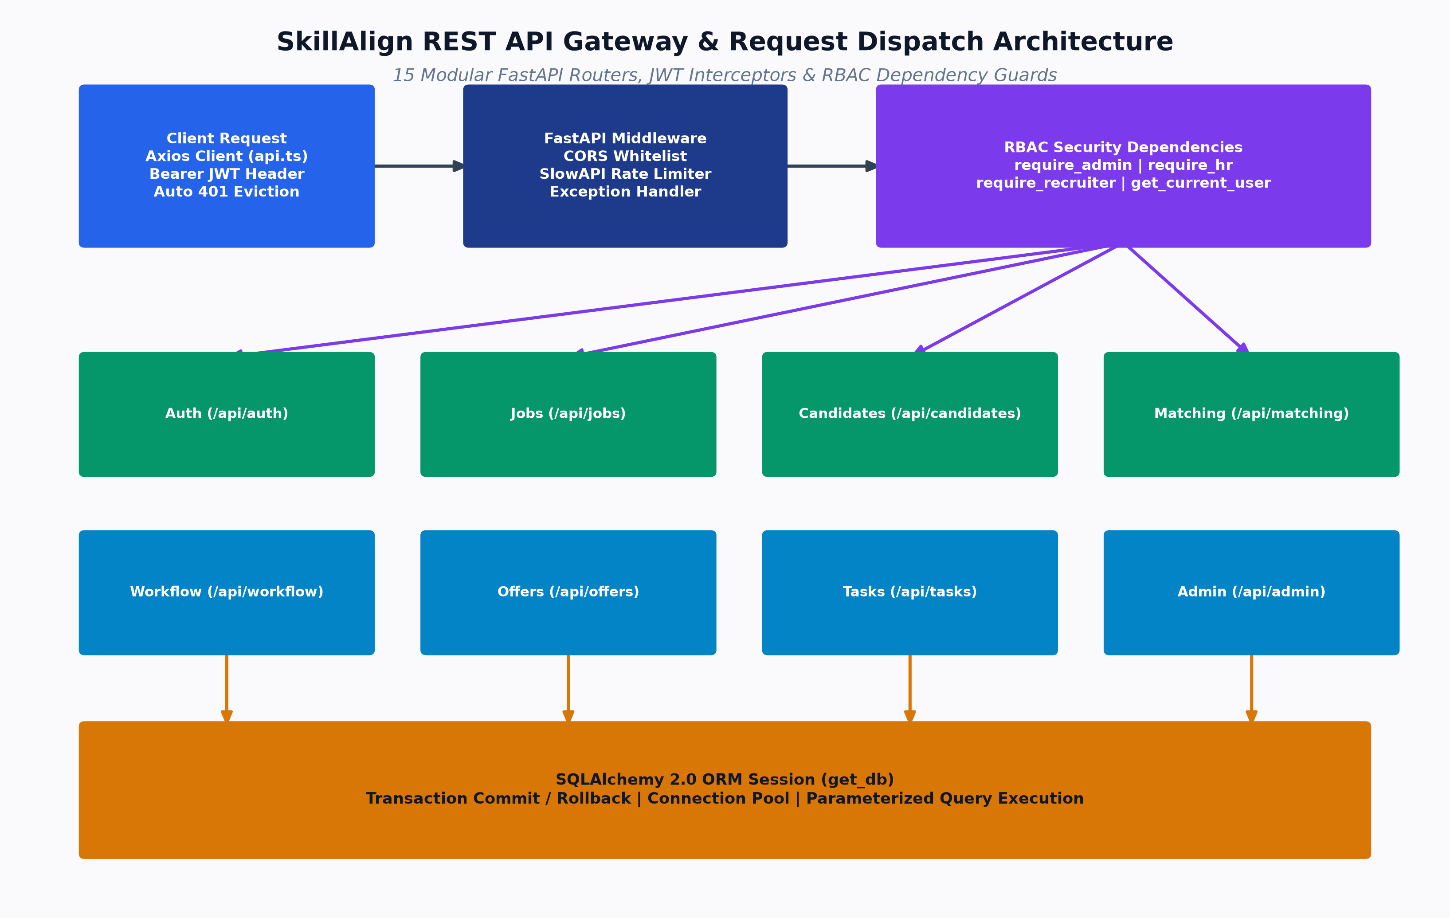
Figure: FastAPI REST API Gateway & Routing Flow
The SkillAlign backend exposes 54 distinct REST endpoints across 15 modular routers registered in main.py.
HTTP Method | Route | Purpose | Auth Required | Permitted Roles
Authentication (`/api/auth`)
POST | /api/auth/register | Candidate self-registration | Public | All
POST | /api/auth/login | Email/Password login (returns JWT) | Public | All
GET | /api/auth/me | Fetch authenticated user profile & role | Bearer JWT | All Roles
PUT | /api/auth/me | Update authenticated user profile | Bearer JWT | All Roles
POST | /api/auth/send-otp | Request 6-digit SMS OTP | Public | All (Rate limited)
POST | /api/auth/verify-otp | Verify OTP and login / create candidate | Public | All (Rate limited)
POST | /api/auth/resend-otp | Resend SMS OTP with cooldown | Public | All (Rate limited)
POST | /api/auth/forgot-password | Generate reset token & send email | Public | All (Rate limited)
POST | /api/auth/reset-password | Verify token hash & update password | Public | All (Rate limited)
Users & Admin (`/api/users`, `/api/admin`)
GET | /api/users | List system users with filtering | Bearer JWT | Admin
POST | /api/users | Create administrative/staff user | Bearer JWT | Admin
GET | /api/users/roles | Enumerate available roles | Bearer JWT | Admin, HR, Recruiter
GET | /api/admin/stats | Global system health & statistics | Bearer JWT | Admin
GET | /api/admin/audit-logs | Retrieve platform audit timeline | Bearer JWT | Admin
PUT | /api/admin/users/{id}/status | Activate / Deactivate user account | Bearer JWT | Admin
Skill Taxonomy (`/api/skills`)
GET | /api/skills | List all taxonomy skills & categories | Public / Auth | All Roles
POST | /api/skills | Add new skill to global catalog | Bearer JWT | Admin, HR
Job Requisitions (`/api/jobs`)
GET | /api/jobs | List active job requisitions | Bearer JWT | Admin, HR, Recruiter
POST | /api/jobs | Create new requisition with skills & weights | Bearer JWT | HR, Admin
GET | /api/jobs/{id} | Fetch requisition details with skills | Bearer JWT | Admin, HR, Recruiter
PUT | /api/jobs/{id} | Update requisition details & requirements | Bearer JWT | HR, Admin
DELETE | /api/jobs/{id} | Delete job requisition | Bearer JWT | HR, Admin
GET | /api/jobs/{id}/skills | List required skills for job | Bearer JWT | Admin, HR, Recruiter
POST | /api/jobs/{id}/skills | Add required skill with weight (1-5) | Bearer JWT | HR, Admin
DELETE | /api/jobs/{id}/skills/{skill_id} | Remove required skill from job | Bearer JWT | HR, Admin
Candidate Management (`/api/candidates`)
GET | /api/candidates/me | Fetch authenticated candidate profile | Bearer JWT | Candidate
PUT | /api/candidates/me | Update candidate profile & preferences | Bearer JWT | Candidate
GET | /api/candidates | List candidates with filters | Bearer JWT | Admin, HR, Recruiter
GET | /api/candidates/{id} | Get candidate details & verified skills | Bearer JWT | Admin, HR, Recruiter
POST | /api/candidates/me/skills | Add self-declared candidate skill | Bearer JWT | Candidate
DELETE | /api/candidates/me/skills/{skill_id} | Delete candidate skill | Bearer JWT | Candidate
Resume Processing (`/api/candidates/me/resume`)
POST | /api/candidates/me/resume | Upload & process resume (PDF/DOCX) | Bearer JWT | Candidate
GET | /api/candidates/me/resume/preview | Preview parsed sections & text | Bearer JWT | Candidate
GET | /api/candidates/me/resume/status | Poll async Celery processing status | Bearer JWT | Candidate
POST | /api/candidates/me/resume/reparse | Force re-parsing of stored resume | Bearer JWT | Candidate, Admin
GET | /api/candidates/{id}/resume/download | Download candidate resume file | Bearer JWT | Admin, HR, Recruiter
Matching Engine (`/api/matching`, `/api/match-results`)
POST | /api/matching/run/{job_id} | Execute multi-factor matching engine | Bearer JWT | Recruiter, HR, Admin
GET | /api/matching/job/{job_id} | Retrieve ranked match results for job | Bearer JWT | Recruiter, HR, Admin
GET | /api/matching/screened | Get HR-screened candidate list | Bearer JWT | HR, Admin
GET | /api/matching/shortlist/{job_id} | Get filtered recruiter shortlist | Bearer JWT | Recruiter, HR, Admin
GET | /api/matching/{match_id}/ai-analysis | Generate Gemini AI fit analysis | Bearer JWT | Recruiter, HR, Admin
POST | /api/matching/{match_id}/scorecards | Submit candidate scorecard | Bearer JWT | HR, Recruiter, Admin
GET | /api/match-results/{id} | Inspect single match result detail | Bearer JWT | Recruiter, HR, Admin
Enterprise Workflow (`/api/workflow`)
POST | /api/workflow/shortlist | Shortlist candidate for job | Bearer JWT | Recruiter, HR, Admin
POST | /api/workflow/submit-to-hm | Submit candidate shortlist to HM | Bearer JWT | Recruiter, HR, Admin
POST | /api/workflow/hm-review | HM opens and reviews candidate | Bearer JWT | HR, Admin
POST | /api/workflow/hm-reject | HM rejects candidate with reason | Bearer JWT | HR, Admin
POST | /api/workflow/request-interview | HM requests interview round | Bearer JWT | HR, Admin
POST | /api/workflow/send-slots | Recruiter proposes interview slots | Bearer JWT | Recruiter, HR, Admin
POST | /api/workflow/select-slot | Candidate selects preferred slot | Public Token / Auth | All
POST | /api/workflow/confirm-interview | Recruiter confirms slot & adds URL | Bearer JWT | Recruiter, HR, Admin
POST | /api/workflow/complete-interview | Mark interview completed | Bearer JWT | Recruiter, HR, Admin
POST | /api/workflow/hm-feedback | HM submits Go/No-Go evaluation | Bearer JWT | HR, Admin
POST | /api/workflow/compensation | Advance to compensation discussion | Bearer JWT | Recruiter, HR, Admin
POST | /api/workflow/create-offer | Recruiter drafts formal offer terms | Bearer JWT | Recruiter, HR, Admin
POST | /api/workflow/send-offer | HR approves & dispatches offer | Bearer JWT | HR, Admin
GET | /api/workflow/action-center | Recruiter operational action items | Bearer JWT | Recruiter, Admin
GET | /api/workflow/hm-dashboard | Hiring Manager pending review items | Bearer JWT | HR, Admin
GET | /api/workflow/{match_id}/timeline | Fetch full audit log timeline | Bearer JWT | All Roles (Scoped)
Offer Management (`/api/offers`)
GET | /api/offers/{id} | Get full offer details & breakdown | Bearer JWT | Recruiter, HR, Candidate
GET | /api/offers/{id}/pdf | Download compiled ReportLab PDF | Bearer JWT / Token | All Parties
POST | /api/offers/respond | Candidate accepts / declines offer | Public Token / Auth | Candidate
GET | /api/offers/stats | Pipeline offer metrics & counts | Bearer JWT | HR, Admin

2. Frontend-Backend Integration Architecture
The frontend communicates with the backend via a centralized, type-safe Axios client configured in api.ts.
Figure: FastAPI REST API Architecture
2.1 Request & Response Interceptors
// Token injection interceptor
api.interceptors.request.use((config) => {
const token = localStorage.getItem("token");
if (token) {
config.headers.Authorization = `Bearer ${token}`;
}
return config;
});
// Automatic 401 handling interceptor
api.interceptors.response.use(
(response) => response,
(error) => {
if (error.response?.status === 401) {
localStorage.removeItem("token");
localStorage.removeItem("user");
if (window.location.pathname !== "/login") {
window.location.href = "/login";
}
}
return Promise.reject(error);
}
);

3. API-to-Database Traceability Matrix
This matrix allows engineers to trace any functional UI action through the API, Service, and underlying Database tables:
Feature / UI Flow | Frontend Trigger File | API Route & Method | Backend Service | Database Tables Modified / Queried
Candidate Registration | RegisterPage.tsx | POST /api/auth/register | auth_service.register_candidate | users, candidates, roles
Resume Upload & Parse | CandidateProfilePage.tsx | POST /api/candidates/me/resume | resume_service.store_resume_and_queue | candidates, candidate_skills, skills
Job Requisition Creation | HRCreateJobPage.tsx | POST /api/jobs | job_service.create_job | jobs, job_skills, skills
Execute Matching Engine | JobDetailPage.tsx | POST /api/matching/run/{id} | matching_service.run_job_matching | match_results, jobs, candidates
Claim Candidate | RecruiterCandidatesPage.tsx | POST /api/recruiter/claims | candidate_assignment_service | candidate_recruiter_assignments, match_results
Submit Shortlist to HM | ShortlistSubmissionPage.tsx | POST /api/workflow/submit-to-hm | workflow_service.submit_to_hiring_manager | match_results, audit_logs, notifications
HM Interview Request | HMCandidateReviewPage.tsx | POST /api/workflow/request-interview | workflow_service.request_interview | match_results, interviews, audit_logs
Propose Interview Slots | RequestInterviewModal.tsx | POST /api/workflow/send-slots | workflow_service.send_interview_slots | interviews, interview_slots, notifications
Candidate Slot Selection | SlotSelectionPage.tsx | POST /api/workflow/select-slot | workflow_service.select_interview_slot | interview_slots, match_results, audit_logs
Submit HM Feedback | HMFeedbackPage.tsx | POST /api/workflow/hm-feedback | workflow_service.submit_hm_feedback | interview_feedbacks, match_results, audit_logs
Draft Offer Terms | RecruiterOfferPage.tsx | POST /api/workflow/create-offer | workflow_service.create_offer | offers, match_results, audit_logs
HR Approve Offer | HMOfferReviewPage.tsx | POST /api/workflow/send-offer | workflow_service.send_offer_to_candidate | offers, match_results, audit_logs
Compile Offer PDF | CandidateOfferPage.tsx | GET /api/offers/{id}/pdf | offer_pdf_service.OfferPDFService | offers, candidates, jobs, users
Candidate Offer Response | CandidateOfferPage.tsx | POST /api/offers/respond | workflow_service.respond_to_offer | offers, match_results, candidate_blacklists

4. File-Level Code Mapping Table
Domain Subsystem | Backend Router | Backend Service | SQLAlchemy Model | Frontend Component / Page
Authentication & IAM | auth.py | auth_service.py | user.py, role.py | LoginPage.tsx, RegisterPage.tsx
Matching Algorithm | matching.py | matching_service.py | match_result.py | JobDetailPage.tsx
Resume Extraction | resume.py | resume_text_extractor.py | candidate.py | CandidateProfilePage.tsx
Deterministic Parsing | resume.py | resume_txt_parser.py | candidate_skill.py | CandidateSkillsPage.tsx
Recruitment Workflow | workflow.py | workflow_service.py | match_result.py, audit_log.py | ShortlistSubmissionPage.tsx, HMCandidateReviewPage.tsx
Interview Coordination | interviews.py | workflow_service.py | interview.py, interview_slot.py | SlotSelectionPage.tsx, CandidateSlotPickerModal.tsx
Offer & PDF Engine | workflow.py | offer_pdf_service.py | offer.py | RecruiterOfferPage.tsx, CandidateOfferPage.tsx
Admin Console | admin.py | user_service.py | user.py, audit_log.py | AdminDashboard.tsx, UsersPage.tsx

Proceed to [Volume 07: Security Architecture, RBAC & Sequence Diagrams](file:///c:/Users/shiva/OneDrive/Desktop/SkillAlign/docs/07_SECURITY_ERROR_HANDLING_AND_RBAC.md) for security proofs, rate limiting, and lifecycle sequence diagrams.

