Security Architecture, RBAC & Sequence Diagrams
7-Layer Defense-in-Depth, Role-Based Access Control & Core Lifecycle Sequences
DOCUMENT  Security Architecture, RBAC & Sequence Diagrams | AUTHOR  SkillAlign Architecture Team | STATUS  Production Verified | VERSION  2.0 Consolidated

Volume 07: Security Architecture, RBAC & Sequence Diagrams
This volume details the security architecture, Role-Based Access Control (RBAC) enforcement, rate limiting, error propagation mechanisms, and 8 comprehensive Mermaid sequence diagrams representing the core operational flows of SkillAlign.
1. Role-Based Access Control (RBAC) Matrix
SkillAlign enforces role permissions at both the API Gateway layer (dependencies.py) and within domain service handlers (workflow_service.py).
System Capability / Operation | Admin | HR / Hiring Manager | Recruiter | Candidate
Candidate Self-Registration | ✗ | ✗ | ✗ | ✓
Manage Users & Role Assignment | ✓ | ✗ | ✗ | ✗
Curate Global Skill Taxonomy | ✓ | ✓ (Add only) | ✗ | ✗
Create & Edit Job Requisitions | ✓ | ✓ | ✗ | ✗
Trigger Matching Engine | ✓ | ✓ | ✓ | ✗
Claim Candidate Ownership | ✓ | ✗ | ✓ | ✗
Screen / Shortlist Candidates | ✓ | ✗ | ✓ | ✗
Review Shortlist (HM Decision) | ✓ | ✓ | ✗ | ✗
Request Interview Round | ✓ | ✓ | ✗ | ✗
Propose Interview Slots | ✓ | ✓ | ✓ | ✗
Select Preferred Interview Slot | ✓ | ✗ | ✗ | ✓ (via Token)
Conduct Interview & Submit Scorecard | ✓ | ✓ | ✗ | ✗
Draft Offer Financial Terms | ✓ | ✗ | ✓ | ✗
Approve Formal Offer Letter | ✓ | ✓ | ✗ | ✗
Accept / Decline Offer | ✗ | ✗ | ✗ | ✓ (via Token)
View Full Platform Audit Timeline | ✓ | Limited (Job scoped) | Limited (Assigned) | Limited (Self)

2. Security Architecture Deep Dive
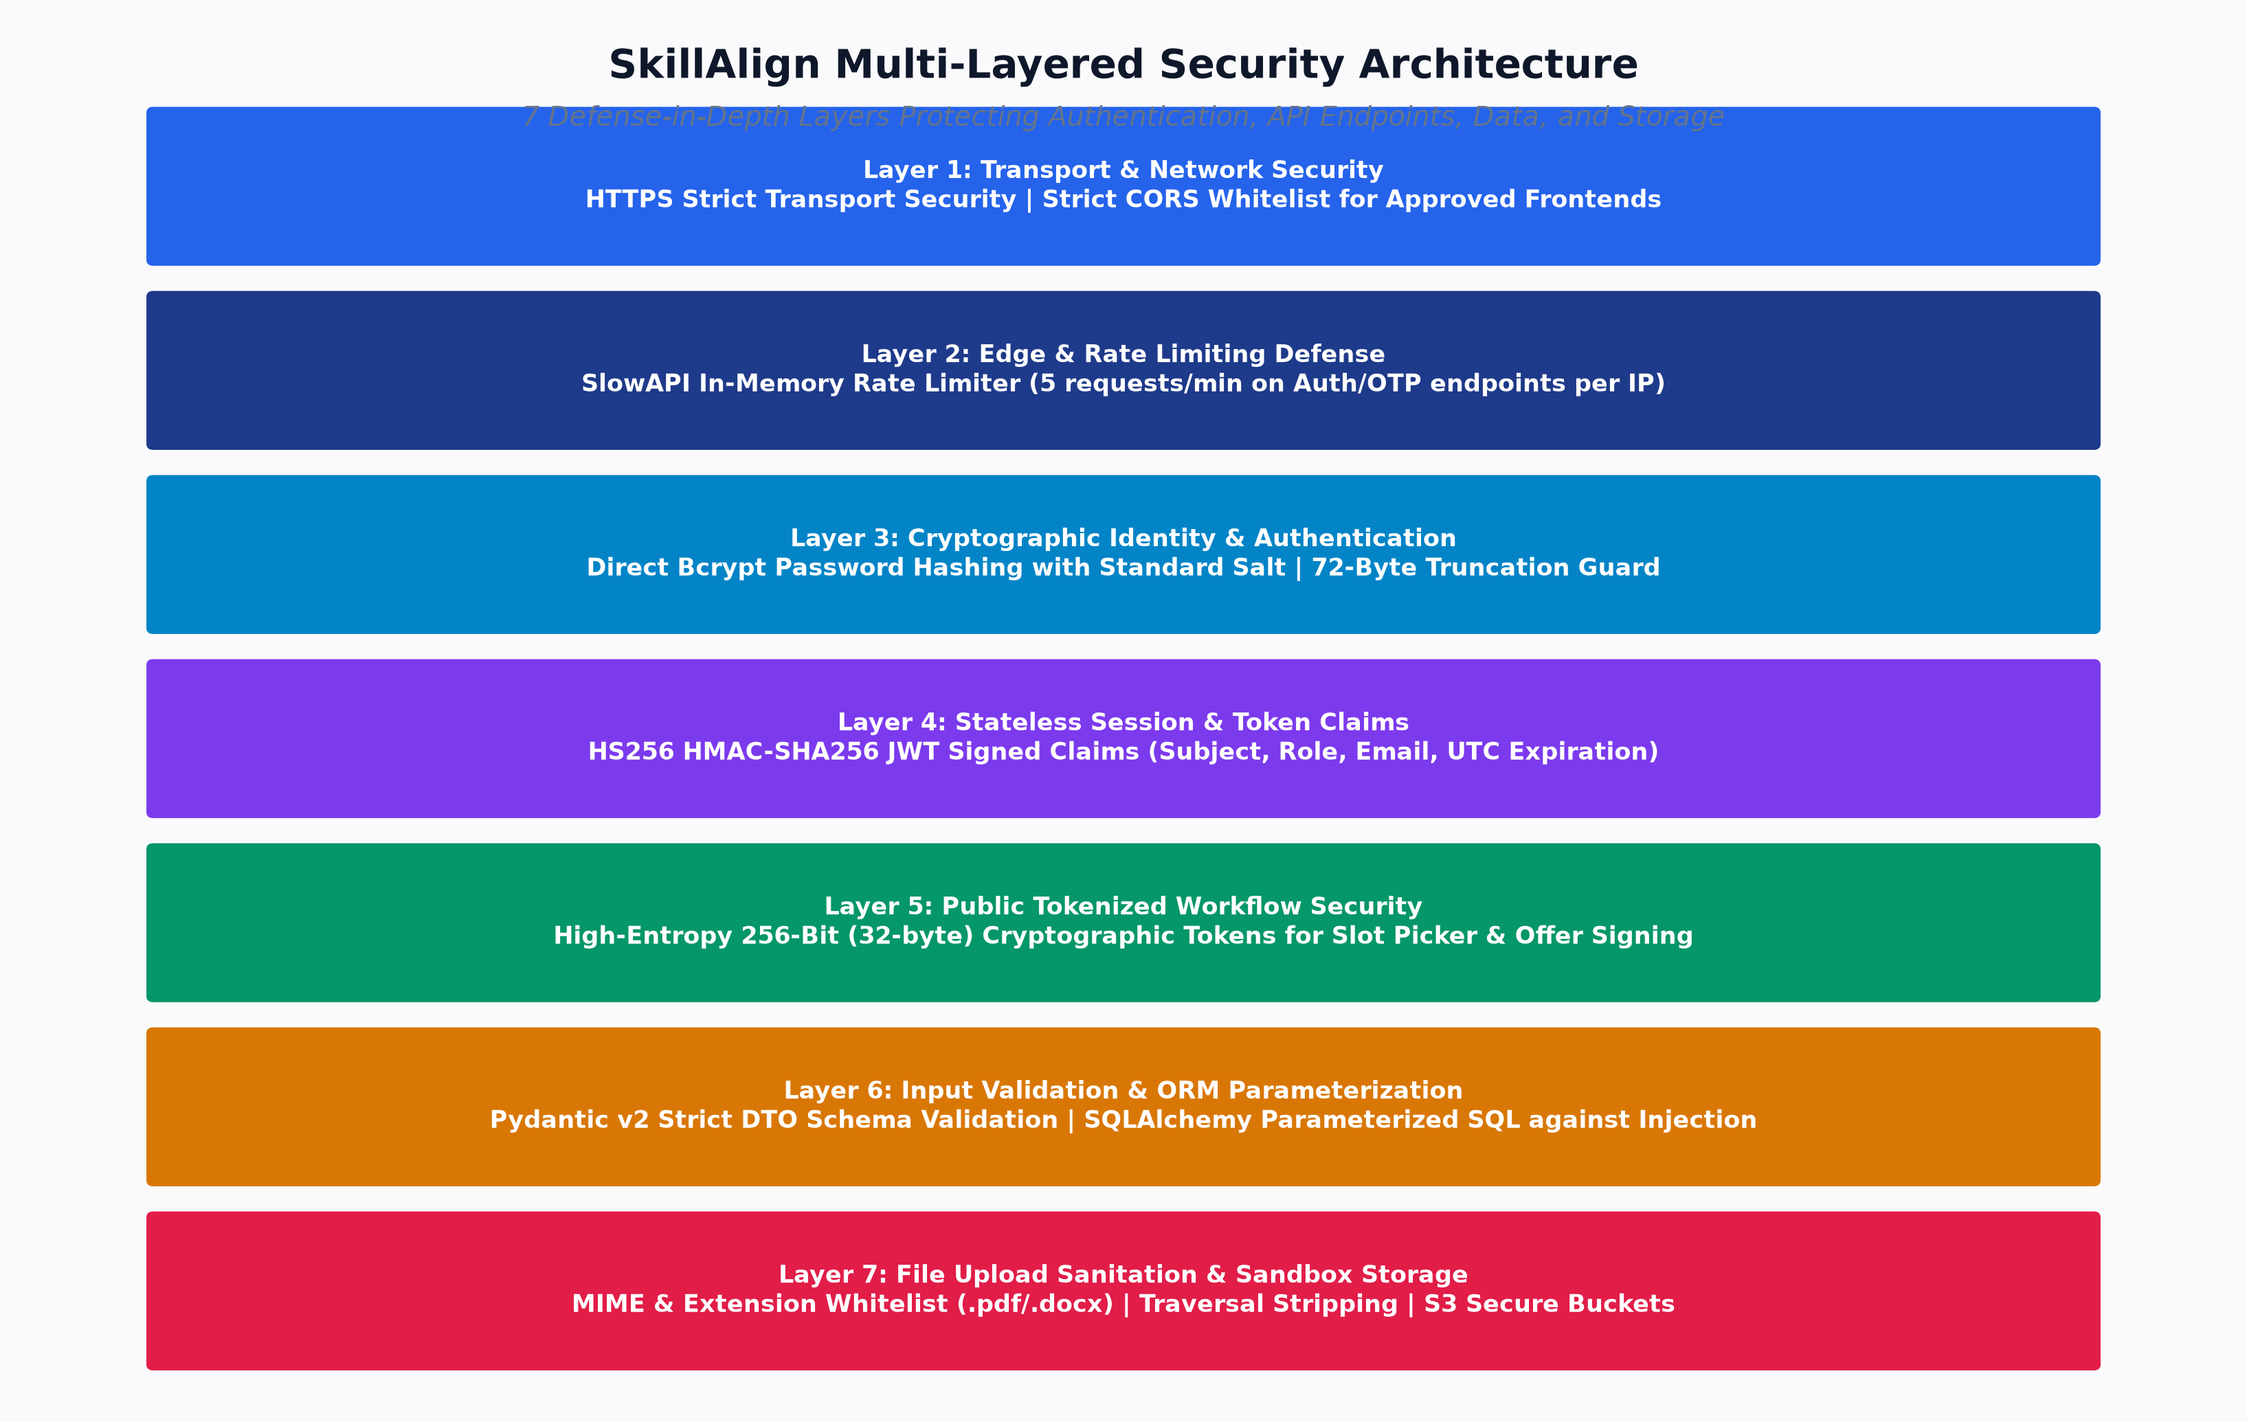
Figure: Multi-Layered Security Architecture
┌────────────────────────────────────────────────────────────────────────┐
│ Layered Security Defenses │
├────────────────────────────┬───────────────────────────────────────────┤
│ 1. Transport Security │ HTTPS Strict Transport + CORS Whitelist │
│ 2. Edge & Rate Limiting │ SlowAPI Memory Limiter (5/min on Auth) │
│ 3. Cryptographic Storage │ Bcrypt Password Hashing (Salt + 72-Byte) │
│ 4. Identity & Token Claims │ HS256 JWT Signed Claims + Expire UTC │
│ 5. Public Action Security │ High-Entropy SHA-256 Tokens (32 Bytes) │
│ 6. Input & SQL Injection │ Pydantic v2 DTOs + SQLAlchemy Params │
│ 7. File Upload Sanitation │ Extension/MIME Whitelist + Path Stripping │
└────────────────────────────┴───────────────────────────────────────────┘

2.1 Password Hashing & Token Cryptography
- Password Hashing: Implemented in security.py using bcrypt.hashpw() with standard salt generation. Truncates input strings to 72 bytes to strictly conform to bcrypt specifications.
- JWT Access Tokens: Encoded via python-jose using HMAC-SHA256 (HS256) signed with JWT_SECRET_KEY. Payloads include subject (sub), role name (role), user email (email), and UTC expiry (exp).
- Password Reset & Public Action Tokens: Generated using secrets.token_urlsafe(32) providing 256 bits of cryptographic entropy. Reset tokens stored in PostgreSQL as SHA-256 hashes (hash_reset_token()) preventing database leak exploitation.
2.2 SlowAPI Rate Limiting
Configured on sensitive public endpoints in auth.py:
- POST /api/auth/send-otp: 5/minute per client IP.
- POST /api/auth/verify-otp: 10/minute per client IP.
- POST /api/auth/forgot-password: 5/minute per client IP.
- POST /api/auth/reset-password: 5/minute per client IP.
2.3 File Upload Sanitation & Storage Security
- Allowed Extensions: Whitelist enforced (.pdf, .docx, .doc, .txt).
- MIME Validation: Checks UploadFile.content_type against application MIME headers.
- Directory Traversal Defense: Filenames sanitized using re.sub(r"[^a-zA-Z0-9._-]", "_", os.path.basename(filename)).
- Isolated Object Storage: Resumes stored under segmented paths: resumes/original/{candidate_id}/{safe_filename}.
3. Error Handling Architecture
SkillAlign implements a standardized, non-leaking exception propagation model:
flowchart TD
DBErr[Database / Integrity Error] --> SvcLayer[Service Layer Catch]
SvcLayer --> HTTPEx[Raise fastapi.HTTPException]
HTTPEx --> GlobalHandler[FastAPI Exception Middleware]
GlobalHandler --> Sanitize{DEBUG == True?}
Sanitize -- "Yes" --> DevResp[JSONResponse: Detailed Error & Stack]
Sanitize -- "No" --> ProdResp[JSONResponse: Sanitized Generic Error]
ProdResp -- "HTTP 4xx / 5xx" --> Axios[Frontend Axios Client Interceptor]
Axios -- "401 Unauthorized" --> EvictToken[Purge LocalStorage & Redirect to /login]
Axios -- "Other Errors" --> Toast[Trigger User-Facing Error Notification Toast]

4. End-to-End Sequence Diagrams
4.1 Sequence Diagram: User Authentication & JWT Issuance
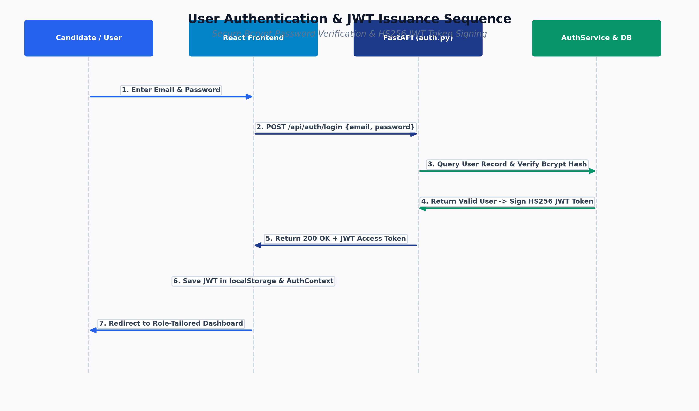
Figure: User Authentication & JWT Sequence
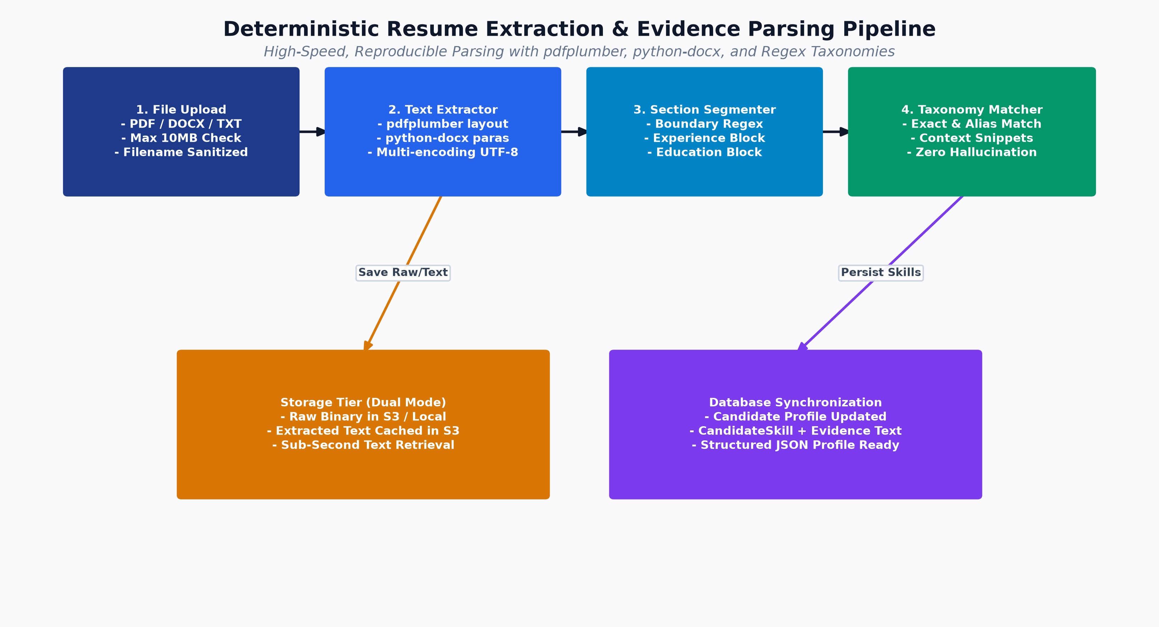
Figure: Resume Ingestion Pipeline
4.2 Sequence Diagram: Resume Upload, Text Extraction & Deterministic Parsing
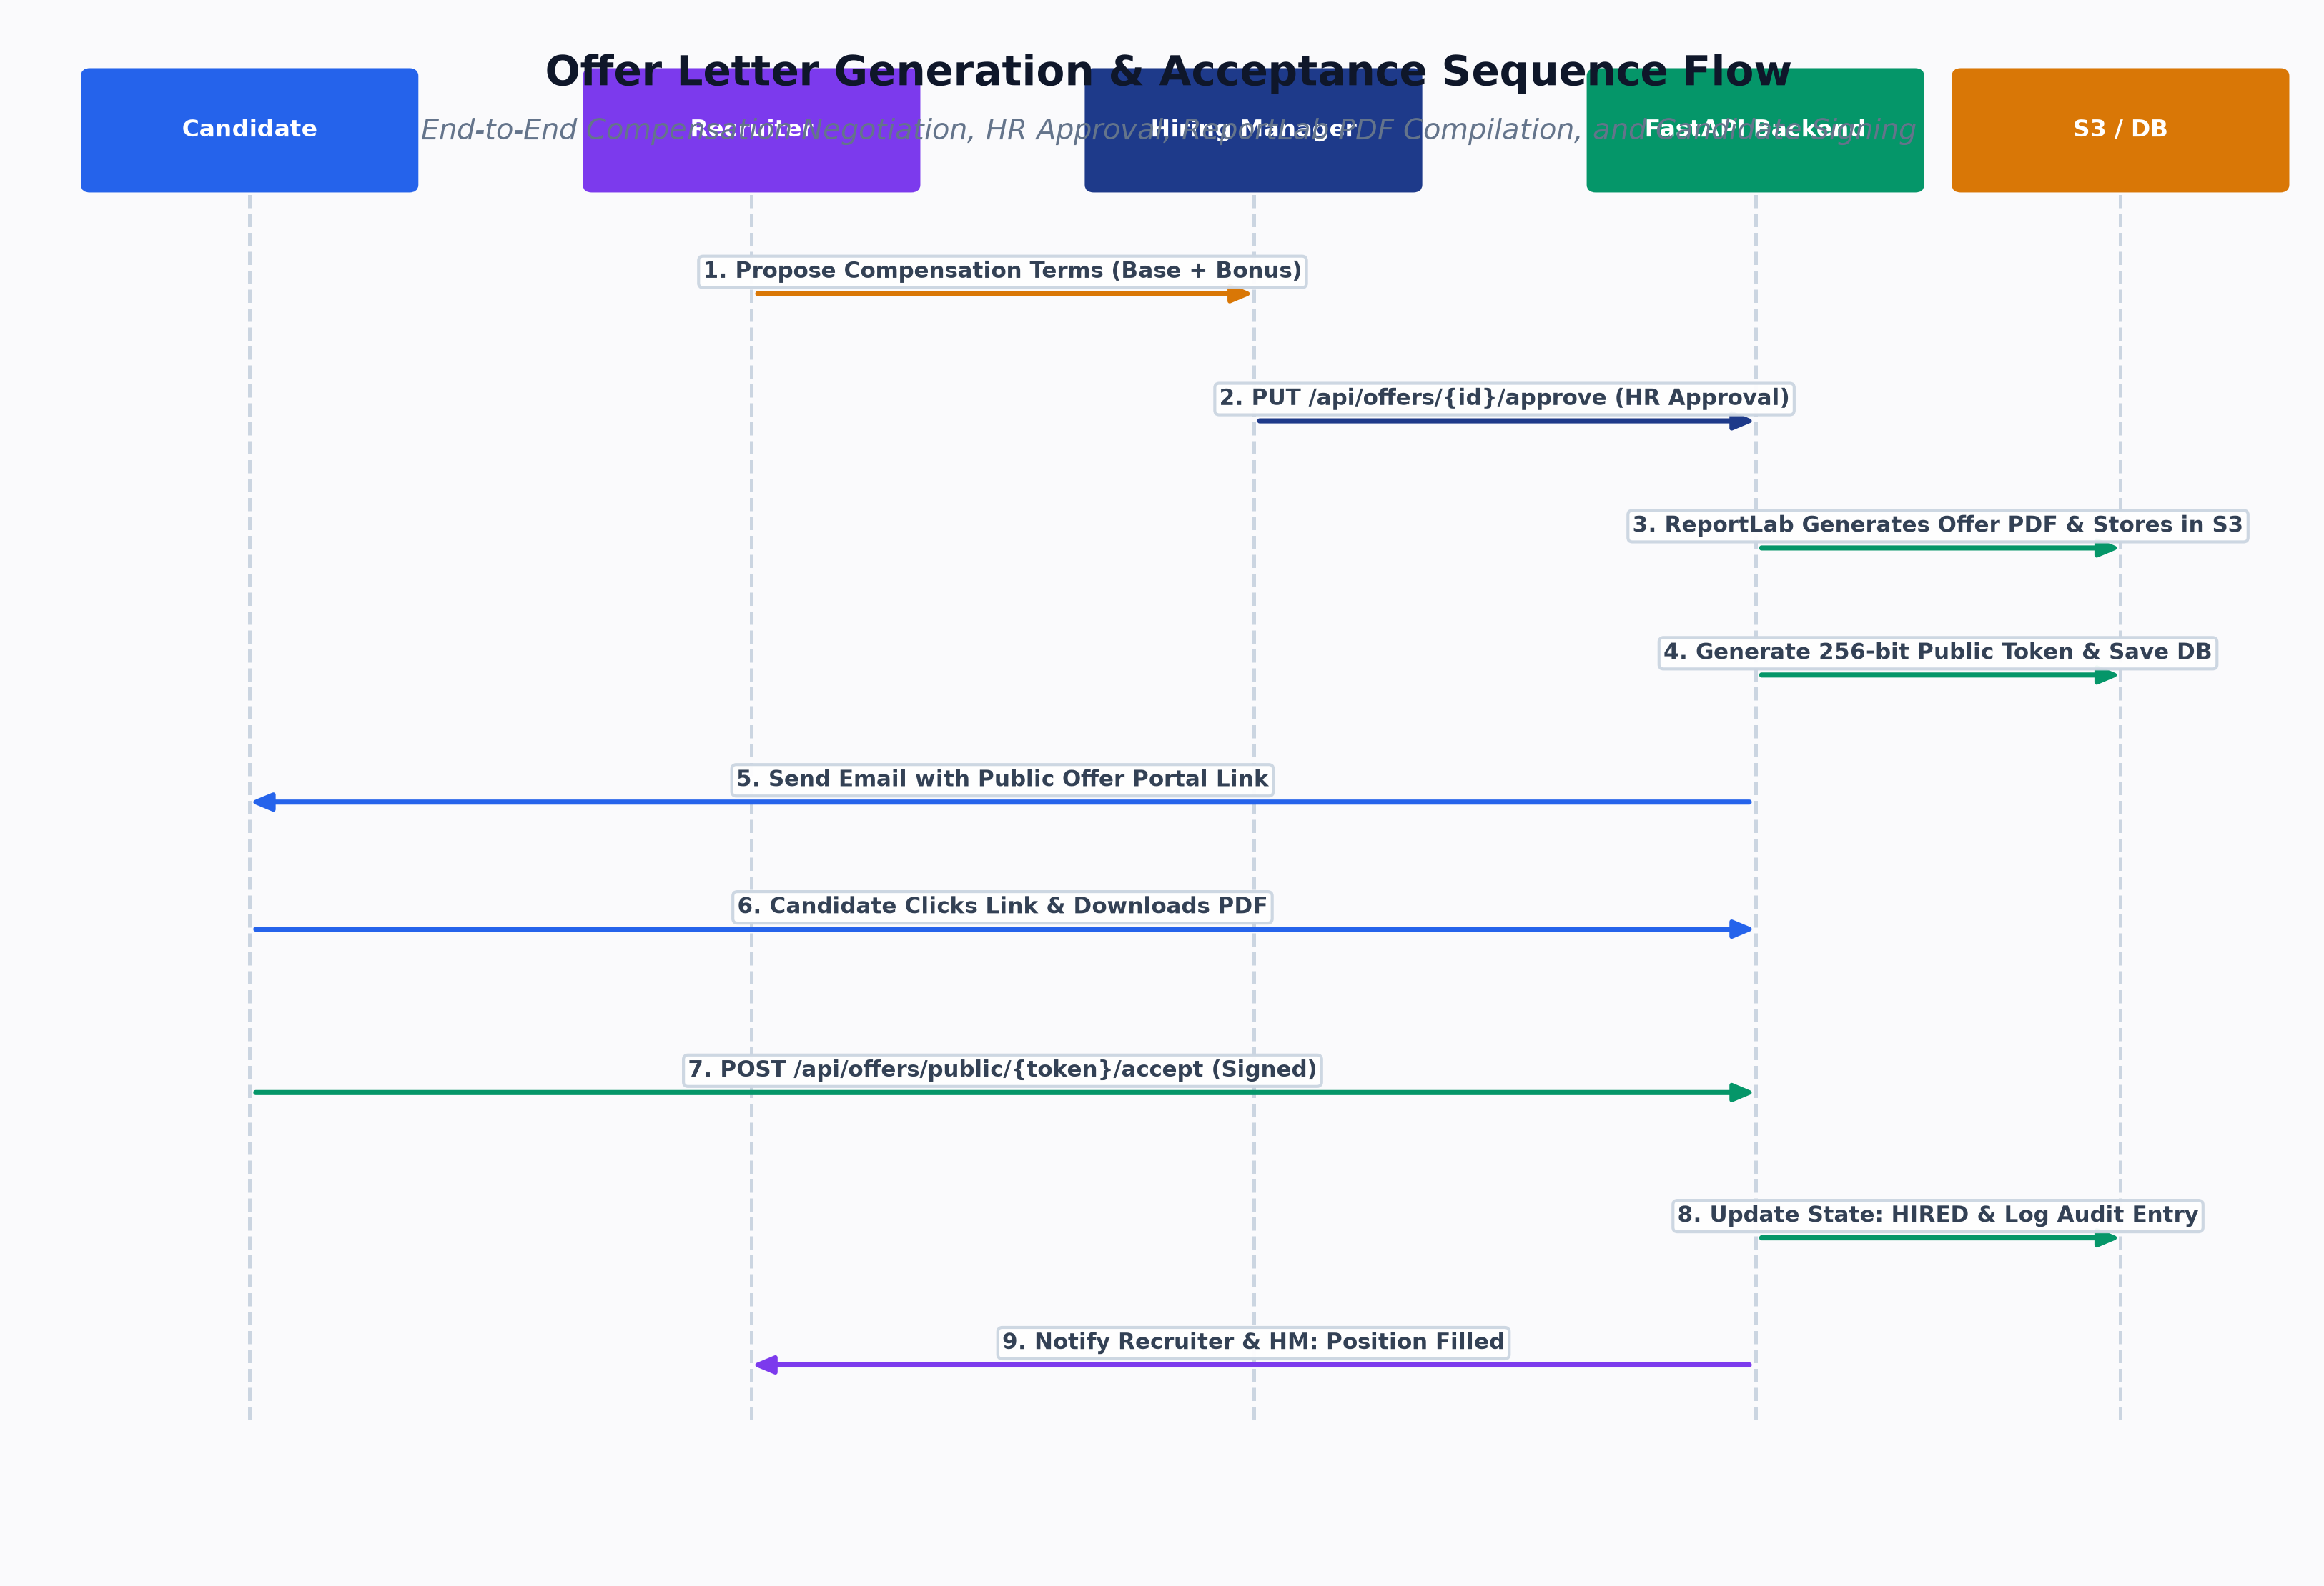
Figure: Core Lifecycle Sequence
4.3 Sequence Diagram: Multi-Factor Candidate Matching Execution
Figure: Core Lifecycle Sequence
4.4 Sequence Diagram: Interview Slot Coordination & Candidate Selection
Figure: Core Lifecycle Sequence
4.5 Sequence Diagram: Hiring Manager Evaluation & Go/No-Go Decision
Figure: Core Lifecycle Sequence
4.6 Sequence Diagram: Offer Drafting, Approval, ReportLab PDF & Acceptance
Figure: Offer Generation Sequence
Proceed to [Volume 08: Codebase Structure, Deployment & Engineering Decisions](file:///c:/Users/shiva/OneDrive/Desktop/SkillAlign/docs/08_FRONTEND_AND_BACKEND_CODEBASE_STRUCTURE.md) for codebase organization and architectural decision records.

