Software Design Description: Lumberjack
Draft - 2 July 2026
Table of Contents

1. Introduction

1.1 Purpose
This SDD describes how Lumberjack is designed to satisfy its SRS. It defines the actor topology, class hierarchy, message catalog, initialization and runtime dataflow, and the mechanisms for filtering, formatting, backpressure, configuration, and Packed Project Library (PPL) safety. Where the SRS deferred a detail to design, this document resolves it (see 9).

1.2 Scope
The design covers the runtime library only. Build, test, and documentation tooling are out of scope except where they constrain the design (for example, native JSON availability and PPL packaging).

1.3 Design principles
The design follows three principles drawn directly from the SRS:
- Control plane vs data plane. The root actor owns lifecycle and configuration (low frequency). The high-frequency log path does not pass through it. This is the central architectural decision (see 2).
- Configuration is co-located with the actor it configures. Each appender owns and validates its own configuration through its launch-time init chain (SRS-LMBR-029..031). The root never holds a schema of appender internals.
- Non-blocking under all conditions. No path blocks the caller. Under saturation the design drops, never blocks (SRS-LMBR-052, 058).

1.4 References
- Lumberjack SRS (SRS-LMBR-001 .. 064).
- NI Actor Framework documentation.
- Logger source project (predecessor).

2. Architectural Overview

2.1 Control plane and data plane
Lumberjack separates a low-frequency control plane from a high-frequency data plane.
- Control plane (message passing through the root actor): launching and stopping appenders, applying configuration, registering and unregistering appenders. These are infrequent and are handled by messages to the root actor, the Log Manager.
- Data plane (caller-side fan-out via a shared reference): the log-write hot path. A caller holds a lightweight Logger facade backed by a Notifier. The Notifier carries a read-only snapshot: the global threshold and the current array of appender enqueuers. A log call reads the current snapshot, applies the coarse global threshold locally (SRS-LMBR-012), and enqueues the statement directly to each appender. The root is not in this path.
The Log Manager is the sole poster of the Notifier snapshot. It sends an updated snapshot when the global threshold changes or the appender set changes. Callers only read, via a non-destructive read of the current notification (Get Notifier Status), which lets many caller threads read the latest snapshot concurrently. A Notifier is chosen over a Data Value Reference here precisely because a DVR read takes an exclusive in-place lock, serializing concurrent readers, whereas a Notifier is built for one-to-many broadcast of a read-mostly value. Writes are rare (control plane); reads are frequent (hot path).
This split is what lets the coarse caller-side filter of SRS-LMBR-012 work without a round trip, and it keeps a single serialization point out of the hot path, consistent with the async and fault-isolation requirements (SRS-LMBR-021, 052, 058).

2.2 Actor tree
Launch Root Actor
└── Log Manager (root actor) control plane; owns config; posts the Notifier
├── File Appender (default) nested actor; owns its file resource
├── File Appender (additional) nested actor (optional, N instances)
├── Console Appender nested actor (optional)
└── Relay Appender nested actor (optional; taps the stream)
All appenders are launched as nested actors of the Log Manager, so their lifecycle is tied to it: stopping the manager stops and flushes every appender (SRS-LMBR-002). Appenders do not know about one another; they are independent (SRS-LMBR-018, 021, 022).
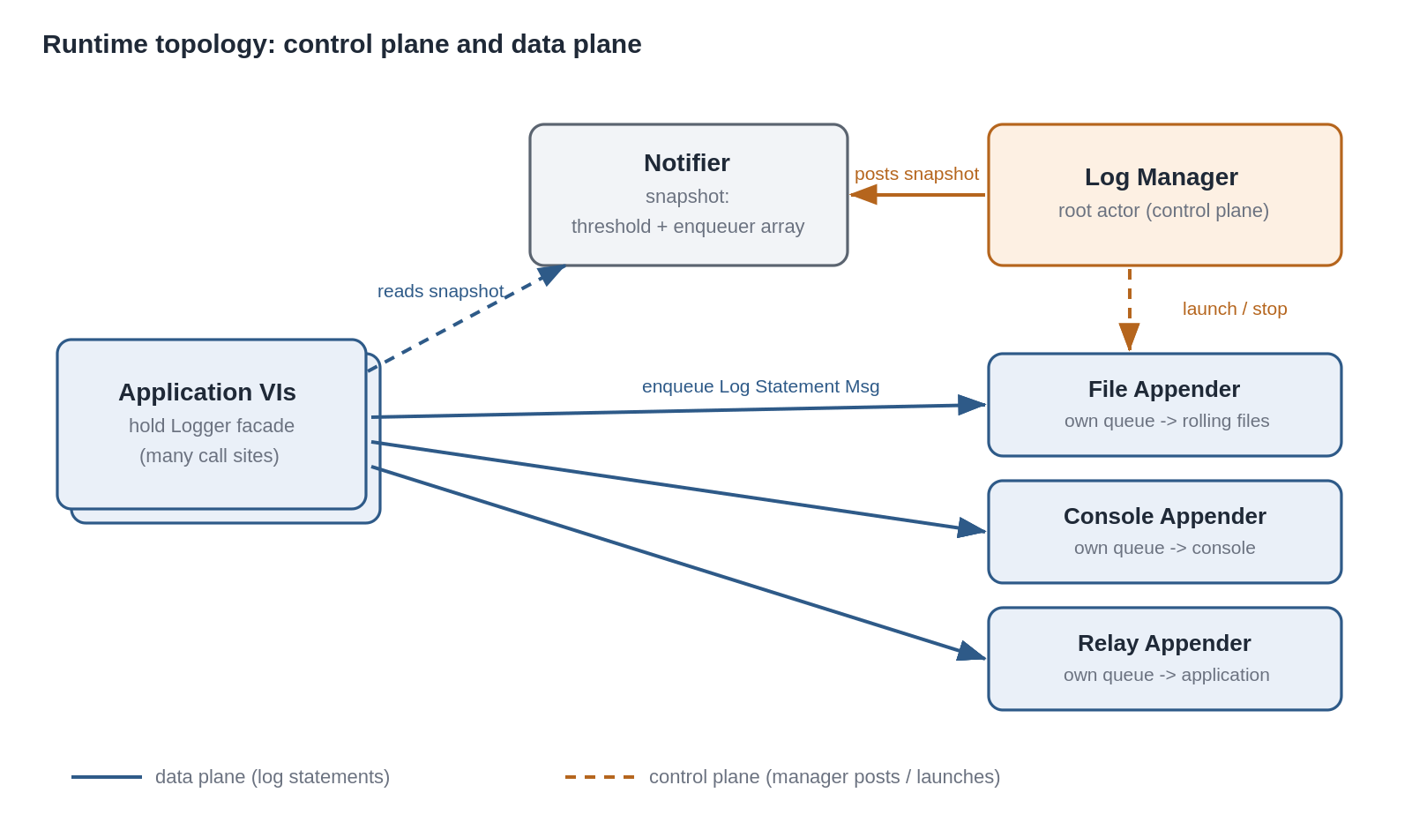
Figure 1. Runtime topology: the control plane (Log Manager posts the Notifier snapshot and launches appenders) and the data plane (callers read the snapshot and enqueue directly to each appender).

2.3 Data-plane fan-out
A single log call performs:
- Read the current Notifier snapshot (Get Notifier Status, non-destructive), obtaining the global threshold and the appender enqueuer array.
- If the statement’s severity rank exceeds the global threshold, return immediately; nothing is enqueued (SRS-LMBR-012 stage 1).
- Otherwise, build the Statement and enqueue a Log Statement Msg to each appender enqueuer (SRS-LMBR-019). The call then returns without waiting for any sink I/O (SRS-LMBR-052).
Each appender independently applies its own threshold and selection filter on receipt (SRS-LMBR-009, 026) and writes to its sink. Because the fan-out targets all current appenders and each filters for itself, callers never need to know appender configuration.

2.4 Non-actor helper objects
Two elements are deliberately not actors:
- Logger facade (by-value class wrapping the Notifier refnum and the Log Manager enqueuer). Held by callers; provides the per-level log VIs and the control operations. Being by-value and refnum-backed, copies are cheap and all share the same underlying Notifier and manager.
- Layout (by-value class). Formats a Statement into text. Not an actor because formatting is a pure, stateless transform invoked inside an appender.
Singleton and instance access. Initialize returns a Logger instance and also stores it in a process-scoped location (a named single-element queue keyed to the library). The per-level VIs take an optional logger in: when wired they use that instance; when unwired they fetch the process-default from the store. This provides Logger-style “log from anywhere without a handle” ergonomics by default, while still supporting explicit instances (and multiple independent loggers) for callers that wire logger in.

3. Class Design

3.1 Hierarchy
Actor.lvclass (framework)
├── Log Manager.lvclass root actor
└── Appender.lvclass abstract base for all sinks
├── File Appender.lvclass
├── Console Appender.lvclass
└── Relay Appender.lvclass
Message.lvclass (framework)
├── Log Statement Msg.lvclass data plane
├── Register Appender Msg.lvclass control plane
├── Unregister Appender Msg.lvclass control plane
├── Set Global Threshold Msg.lvclass control plane
└── Configure Appender Msg.lvclass control plane
Layout.lvclass by-value, stateless
├── CSV Layout.lvclass default
├── JSON Layout.lvclass
└── Text Layout.lvclass
Logger.lvclass by-value caller facade (Notifier + manager enqueuer)
Statement is a typedef cluster, not a class, because it is pure data passed between the caller and the layouts (see 5.3).
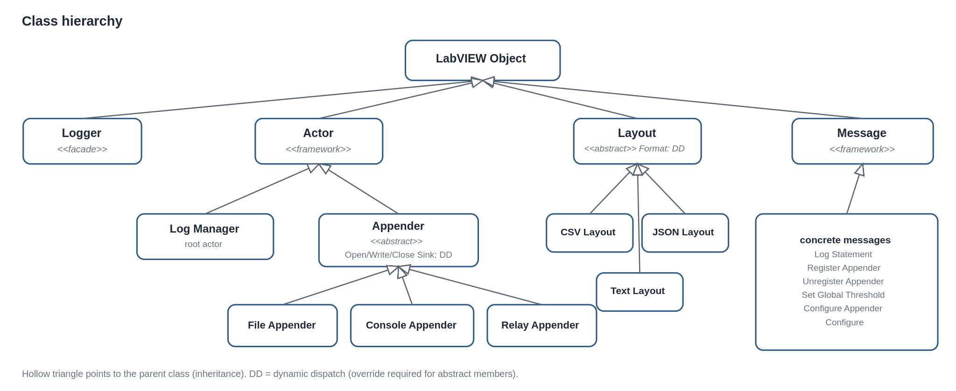
Figure 2. Class hierarchy. A hollow triangle points to the parent class; DD marks dynamically dispatched (override-required) members.

3.2 Appender base class
Appender.lvclass private data carries the common configuration every appender shares (SRS-LMBR-029):
- Appender ID (unique string).
- Level threshold (severity rank, SRS-LMBR-009).
- Selection filter: mode (mirror or routed) plus criteria (level range, source-tag prefix) (SRS-LMBR-026).
- Queue bound (0 = unbounded) and drop policy (SRS-LMBR-055..057).
- Dropped-statement counter (SRS-LMBR-059).
- Layout reference (SRS-LMBR-015).
Appender.lvclass defines dynamic-dispatch members overridden by each concrete type:
- Open Sink.vi (protected) opens the type’s resource during actor startup (for example, opens the first log file).
- Write.vi (protected) writes one already-formatted, already-accepted line to the sink.
- Close Sink.vi (protected) closes the resource during shutdown.
- Init Common.vi sets the common private data from an Appender Config cluster (called by each child’s init, see 4.4).
The base class implements, once, the receipt logic shared by all appenders: on a Log Statement Msg, evaluate the appender threshold and selection filter; if accepted, format via the layout and call Write.vi. Concrete types implement only their sink specifics.

3.3 Concrete appenders
- File Appender adds: root folder, maximum file size, maximum file count, extension, delimiter, calendar-folder-tree enable (SRS-LMBR-030, 032..040). Open Sink creates the base folder and opens the first ISO 8601-named file; Write appends a line and triggers rollover/retention (5.5).
- Console Appender adds nothing beyond common config; Write prints the formatted line.
- Relay Appender adds: delivery mode (message or queue) and, for message mode, the application-supplied enqueuer; for queue mode, an owned LabVIEW queue whose reference is exposed (SRS-LMBR-023..025, 5.6).

3.4 Configuration clusters
LabVIEW clusters do not inherit, so the common configuration is expressed by composition: a common Appender Config cluster is nested inside each type-specific config typedef.
- Appender Config (common): ID, threshold, filter mode, filter criteria, queue bound, drop policy.
- File Appender Config = Appender Config + file fields.
- Lumberjack Config (top level, the JSON/inputs boundary) = { schema version, global threshold, default File Appender Config }.
The actor classes inherit (3.1); the config clusters compose. The init chain bridges the two: a child receives its config typedef, sets its own private fields, and passes the nested Appender Config to Init Common.vi (4.4).

3.5 Message catalog
Data plane (caller -> appender enqueuer):
Message | Payload | Do.vi action
Log Statement Msg | Statement cluster | Base Appender evaluates threshold + filter; if accepted, format and Write.
Control plane (caller/Logger -> Log Manager enqueuer):
Message | Payload | Do.vi action
Register Appender Msg | a constructed, pre-configured Appender object | Launch it as a nested actor, add its enqueuer to the registry, post an updated Notifier snapshot.
Unregister Appender Msg | appender ID | Post an updated snapshot without that enqueuer, then send framework Stop to the appender and remove it from the registry.
Set Global Threshold Msg | threshold | Post an updated snapshot with the new threshold.
Configure Appender Msg | appender ID + config delta | Forward as a per-appender configure message to the target appender.
Manager -> appender (control):
Message | Payload | Do.vi action
Configure Msg | config delta | Apply to the appender’s private data (threshold/filter/backpressure/type-specific).
Stop (framework) | none | Flush and close the sink, then stop.
The Logger facade holds both the Notifier (data plane) and the Log Manager enqueuer (control plane); all control operations are convenience wrappers that enqueue the messages above.

4. Initialization, Configuration, and Launch

4.1 Configuration sources and precedence
Effective configuration is resolved once, at launch (SRS-LMBR-051), from two sources:
- Programmatic launch inputs: the global threshold and the default file appender’s File Appender Config (SRS-LMBR-044).
- An optional JSON configuration file path (SRS-LMBR-045).
Precedence is per-setting: a value present in a valid file overrides the matching launch input; any setting absent from the file falls back to the input (SRS-LMBR-046).

4.2 JSON parse, merge, validate
The pipeline is implemented with native JSON primitives (SRS-LMBR-061), and the per-key merge falls out of the primitive itself:
- Build the Lumberjack Config cluster from the launch inputs (the baseline).
- If a config-file path is supplied:
  - If the file is missing: keep the baseline, complete launch, and return a non-fatal warning naming the path (SRS-LMBR-047).
  - If present: pass the file text to Unflatten From JSON with the baseline cluster as the default-value input. Keys present in the file override; keys absent retain the baseline. This realizes SRS-LMBR-046 directly.
  - If the text cannot be parsed: fail launch with a descriptive error (SRS-LMBR-048).
- Validate the resolved cluster field-by-field in Lumberjack code (required keys present, thresholds in 0..7, drop policy is a known enum, file size/count non-negative, filter criteria well-formed). Native parsing reports only generic structural errors, so field-level validation lives here and names the offending setting (SRS-LMBR-048).
- A resource named by a valid config (root folder, path permissions) is not validated here; failure to realize it surfaces later as the appender’s own launch error (SRS-LMBR-049).
JSON schema shape (resolving the SRS-deferred detail, SRS-LMBR-050). The file is a single object carrying global settings and the default file appender only; it does not list appenders:
{
"schemaVersion": 1,
"globalThreshold": 4,
"defaultFileAppender": {
"common": {
"id": "default-file",
"threshold": 4,
"filter": { "mode": "mirror" },
"queueBound": 0,
"dropPolicy": "dropOldest"
},
"rootFolder": "",
"maxFileSize": 10485760,
"maxFileCount": 10,
"extension": "csv",
"delimiter": ",",
"calendarFolderTree": true
}
}
An empty rootFolder signals “compute the default from the host application context” (see 6). schemaVersion lets the validator reject configs it does not understand.
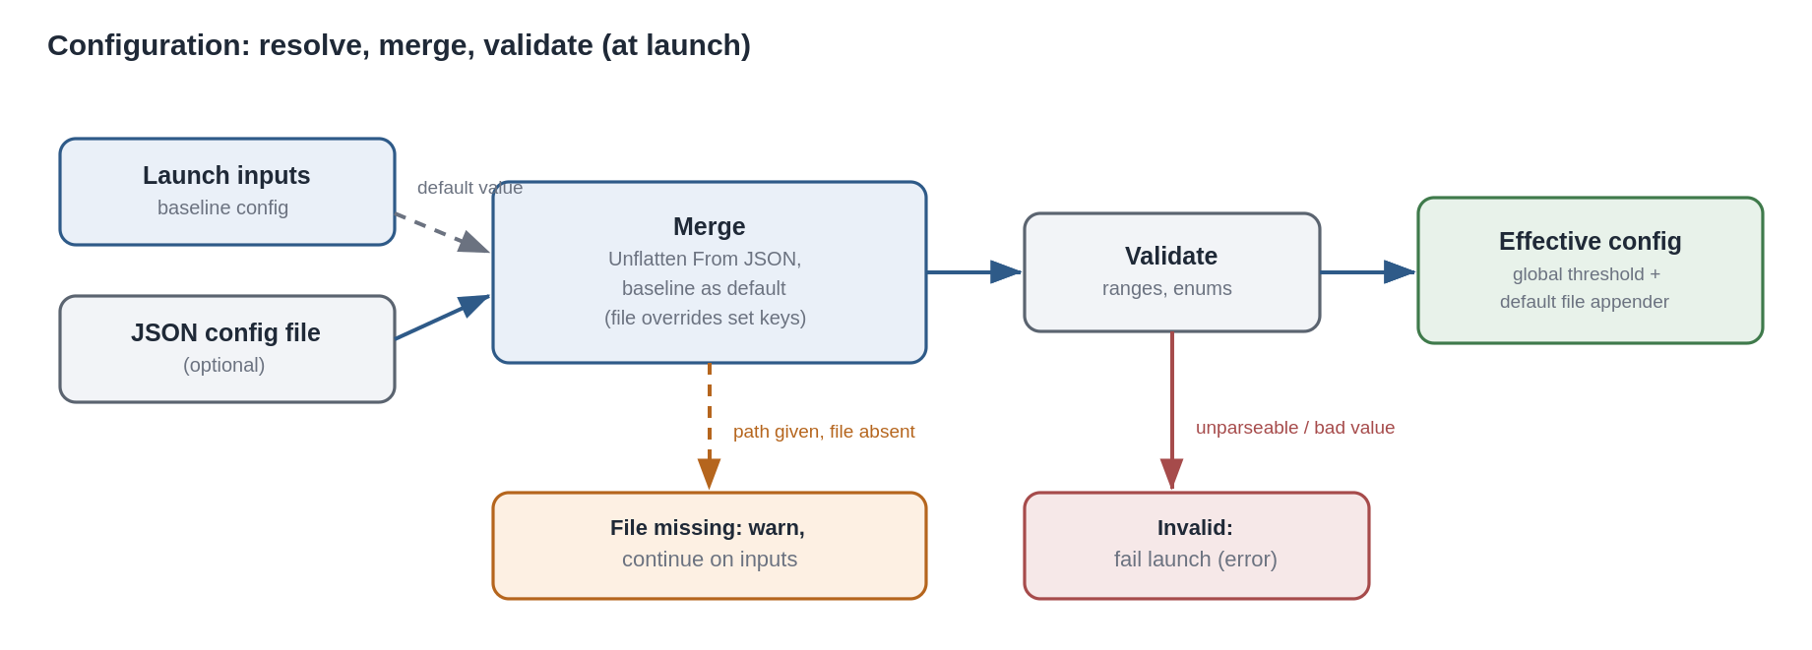
Figure 3. Configuration resolve, merge, and validate at launch. The baseline inputs act as the default value for the JSON unflatten; a missing file warns, an invalid file fails launch.

4.3 Launch sequence
- Launch Root Actor starts the Log Manager and returns its enqueuer, wrapped in a Logger facade along with a freshly created Notifier.
- The Log Manager resolves effective configuration (4.2).
- It constructs the default File Appender object, sets its configuration through the init chain (4.4), and launches it as a nested actor, obtaining its enqueuer. If the default file is disabled, this step is skipped (SRS-LMBR-038).
- It posts the initial Notifier snapshot: the global threshold and the enqueuer array (initially the default file appender only). Posting before launch returns guarantees Get Notifier Status always has a value for callers.
- Launch returns the Logger to the caller. Any non-fatal warning from 4.2 rides out on the error wire.
Additional appenders are added afterward by the application constructing and configuring an appender object and sending Register Appender Msg (SRS-LMBR-028, 031, 044).

4.4 Parent/child init chain
Each appender is configured at its own launch through a dynamic-dispatch init chain (SRS-LMBR-031):
- The application (or the manager, for the default file) calls the concrete type’s Init.vi with the type-specific config typedef.
- Init.vi sets the child’s own private fields (for example, the file appender’s root folder and rollover settings).
- Init.vi calls the parent method Init Common.vi, passing the nested Appender Config cluster, which sets the common private data (ID, threshold, filter, backpressure, layout).
- The now-configured actor object is handed to Launch Actor / Register Appender Msg. Resource opening happens later, in the actor’s startup, via Open Sink.vi.
The root never parses or holds a concrete appender’s type-specific fields; it only moves the constructed object. Adding a new appender type is a new subclass with no manager changes.

5. Runtime Behavior

5.1 Log-write hot path (sequence)
For Logger.Info("...", optional tag):
- Read the current Notifier snapshot (Get Notifier Status).
- Compare INFO’s rank (4) to the global threshold; if it exceeds it, return (no allocation, no enqueue).
- Build the Statement: ISO 8601 timestamp, level name, source tag (supplied or defaulted, 5.3), origin VI name (from the call chain), message (SRS-LMBR-010, 011, 017).
- For each enqueuer in the snapshot array, enqueue a Log Statement Msg.
- Return. No sink I/O has occurred on the caller’s thread (SRS-LMBR-052).
Each appender, on its own thread, dequeues the message, applies stage-2 filtering, formats, and writes (5.2, 5.4).

5.2 Two-stage filtering
- Stage 1, caller side (coarse): global threshold check before any enqueue (SRS-LMBR-007, 012). A global threshold of 7+ is a pass-through; 0 disables all logging.
- Stage 2, appender side (authoritative): each appender applies its own threshold (SRS-LMBR-009), then its selection filter (SRS-LMBR-026): mirror mode accepts everything above threshold; routed mode accepts a subset by level range and/or source-tag prefix (5.3). Only accepted statements are formatted and written.
Because stage 2 lives in each appender, the same statement is evaluated independently per appender, so filtering work scales with appender count. This is the accepted cost of full routing flexibility.
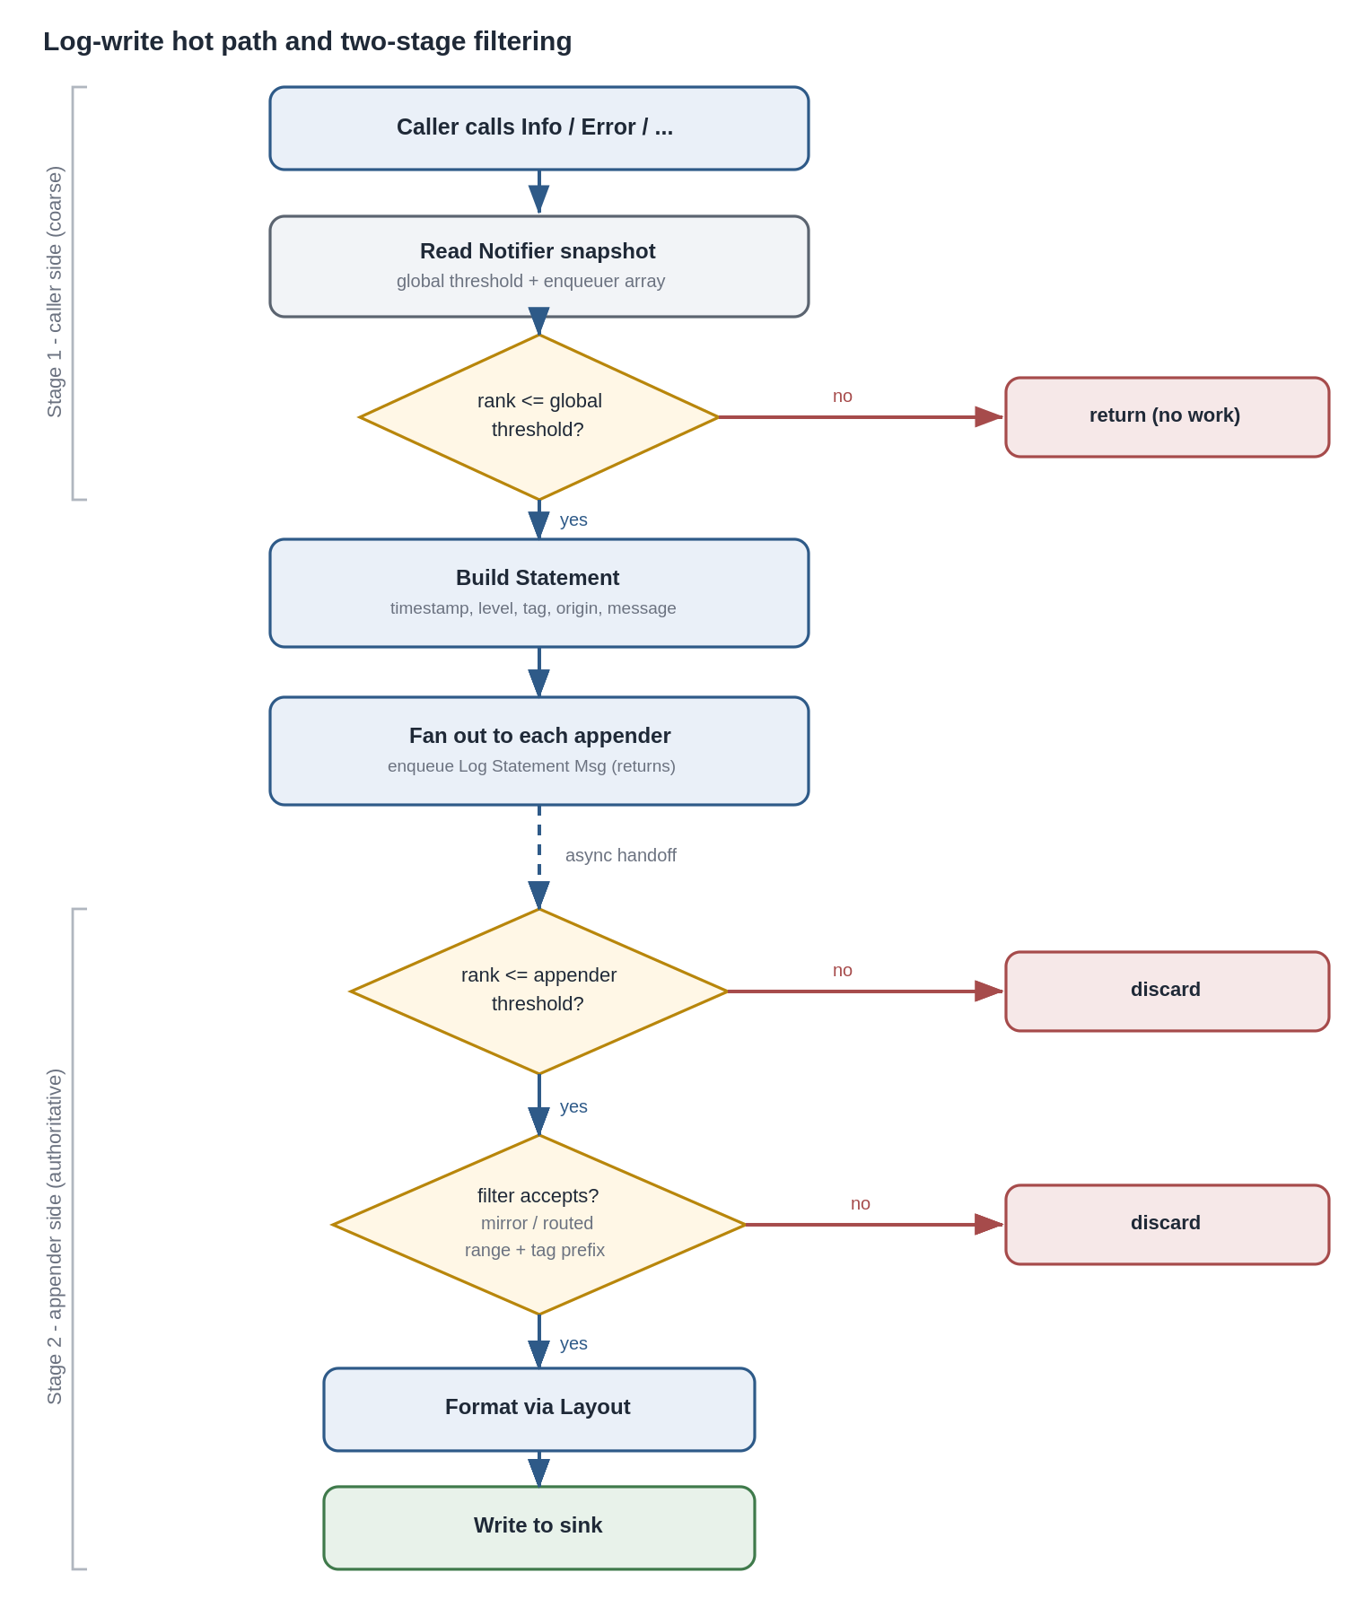
Figure 4. Log-write hot path and two-stage filtering: a coarse global gate on the caller side, then the authoritative per-appender threshold and selection filter.

5.3 Source tag and hierarchical prefix matching
Statement carries both an origin VI name (physical) and a source tag (logical), kept distinct (SRS-LMBR-010, 013).
- The tag is a dot-separated hierarchical string, log4j-style (SRS-LMBR-013).
- Default tag (SRS-deferred detail resolved): when the caller supplies no tag, it defaults to the origin VI’s base name with the .vi extension stripped, and any remaining dots in that base name are replaced with underscores before use. This prevents a VI filename that contains dots from being misread as tag hierarchy, so a default tag is always a single node.
- Prefix match (SRS-LMBR-027): a statement tag T matches a configured prefix P if T == P or T begins with P followed by the separator .. Comparison is a plain string test; no tree is built. Example: app.db matches app.db and app.db.query, not app.database.

5.4 Layout and CSV column order
Layout.Format(Statement) -> String is dynamic dispatch (SRS-LMBR-015). The default CSV Layout (SRS-LMBR-012) resolves the deferred column order as:
timestamp, level, source tag, origin VI, message
The message is last because it is free text most likely to contain the delimiter. Fields are quoted per RFC 4180: a field containing the delimiter, a quote, or a newline is wrapped in double quotes and internal quotes are doubled. The delimiter is per-file-appender configurable (SRS-LMBR-037); the column order is fixed.

5.5 File appender behavior
- Naming: every file name embeds an ISO 8601 timestamp so a new file never overwrites a prior one (SRS-LMBR-035).
- Rollover: before a write that would exceed the configured maximum size, the current file is closed and a new timestamped file is opened (SRS-LMBR-033).
- Retention: after a rollover, if the file count in the target folder exceeds the maximum, the oldest is deleted; a maximum of 0 means never delete (SRS-LMBR-034).
- Calendar tree: when enabled, files are placed in a dated sub-folder hierarchy under the root folder, based on creation date (SRS-LMBR-036).
- Each of these settings is per-instance, so multiple file appenders write to distinct locations with independent rules (SRS-LMBR-032, 039, 040).

5.6 Relay appender behavior
- Message mode (default, SRS-LMBR-024): each accepted statement is forwarded as a Log Statement Msg to the application-supplied enqueuer. The consumer is itself an actor whose inbound queue obeys the same backpressure policy as any appender (5.7).
- Queue mode (compatibility, SRS-LMBR-025): accepted statements are enqueued onto an owned LabVIEW queue whose reference is exposed for the application to Dequeue or Flush. This mode is poll-based and serves non-actor consumers; the consumer controls drain timing.
Because the relay is an appender, its threshold and filter apply, so a consumer can tap only a subset (for example, ERROR and above) (SRS-LMBR-023).

5.7 Backpressure
- Unbounded by default (SRS-LMBR-055): an appender’s inbound queue grows with memory; no loss, with documented memory-growth risk under sustained overload.
- Bounded option (SRS-LMBR-056): a per-appender maximum queue depth, the intended Real-Time/embedded mode, which also bounds memory and jitter.
- Drop-oldest default (SRS-LMBR-057): when a bounded queue is full, the oldest queued statement is discarded to admit the newest. Drop-newest and level-aware drop (never discard ERROR/FATAL) are selectable per appender.
- No blocking (SRS-LMBR-058): the enqueue path never blocks the caller; on a full bounded queue the drop policy acts immediately. This is what preserves SRS-LMBR-052 under saturation.
- Loss observability (SRS-LMBR-059): each appender keeps a dropped-statement counter and periodically emits a synthetic “N statements dropped” record into its own output so gaps are visible.
Implementation note: the drop-oldest and bound are enforced inside the appender as it manages intake, not by blocking the framework enqueue, so the caller-side enqueue always completes.

5.8 Register and unregister at runtime
- Register (SRS-LMBR-020, 028): the application constructs and configures an appender, then sends Register Appender Msg. The manager launches it, adds its enqueuer to the registry, and posts an updated Notifier snapshot. Callers pick up the new appender on their next snapshot read.
- Unregister (SRS-LMBR-020): Unregister Appender Msg with an ID causes the manager to remove the enqueuer from the snapshot first (so callers stop targeting it), then send the framework Stop to that appender, which flushes and closes before stopping.
A statement enqueued to an appender in the brief window before its removal is simply processed normally; a statement whose target has already stopped fails its enqueue harmlessly and does not affect other appenders (SRS-LMBR-021).
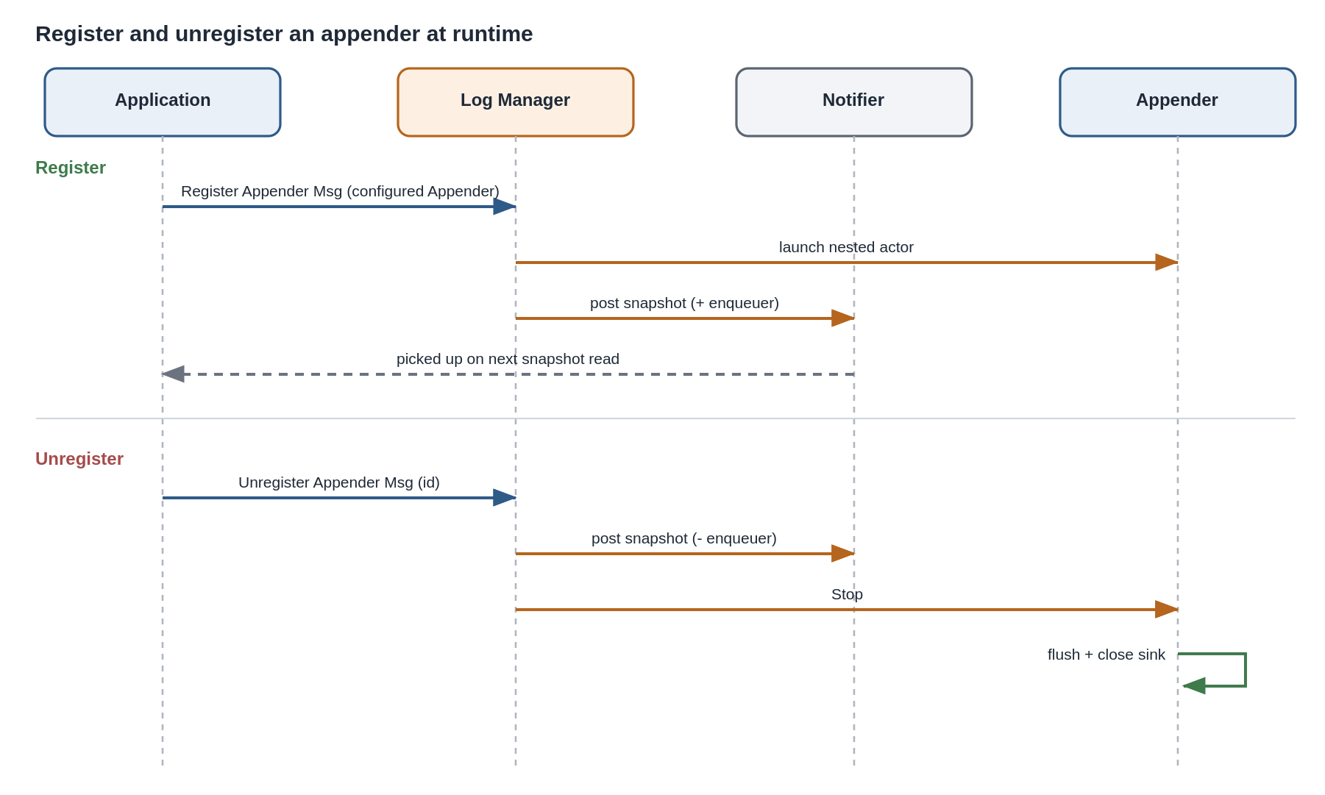
Figure 5. Registering and unregistering an appender at runtime. On unregister the snapshot is posted without the enqueuer before the appender is stopped.

5.9 Configuration changes vs in-flight statements (SRS-deferred detail resolved)
Runtime configuration is applied by messages, so ordering is well defined by message order, not retroactive:
- Global threshold: Set Global Threshold Msg posts an updated Notifier snapshot. Statements evaluated by callers after that post use the new threshold; statements already enqueued are unaffected.
- Per-appender config: Configure Appender Msg is forwarded to the target appender and takes effect for statements that appender dequeues after the configure message. Statements already ahead of it in that appender’s queue are processed under the prior configuration.
The design makes no attempt to retroactively reclassify statements already in flight; the boundary is the configuration message itself. This is stated so verification can assert it.

5.10 Shutdown
Logger.Shutdown sends the framework Stop to the Log Manager, which stops each nested appender. Each appender, on stop, drains and writes any queued statements, then closes its sink (SRS-LMBR-002). Shutdown completes its flush-and-close even if a prior error is present on the wire (SRS-LMBR-004).

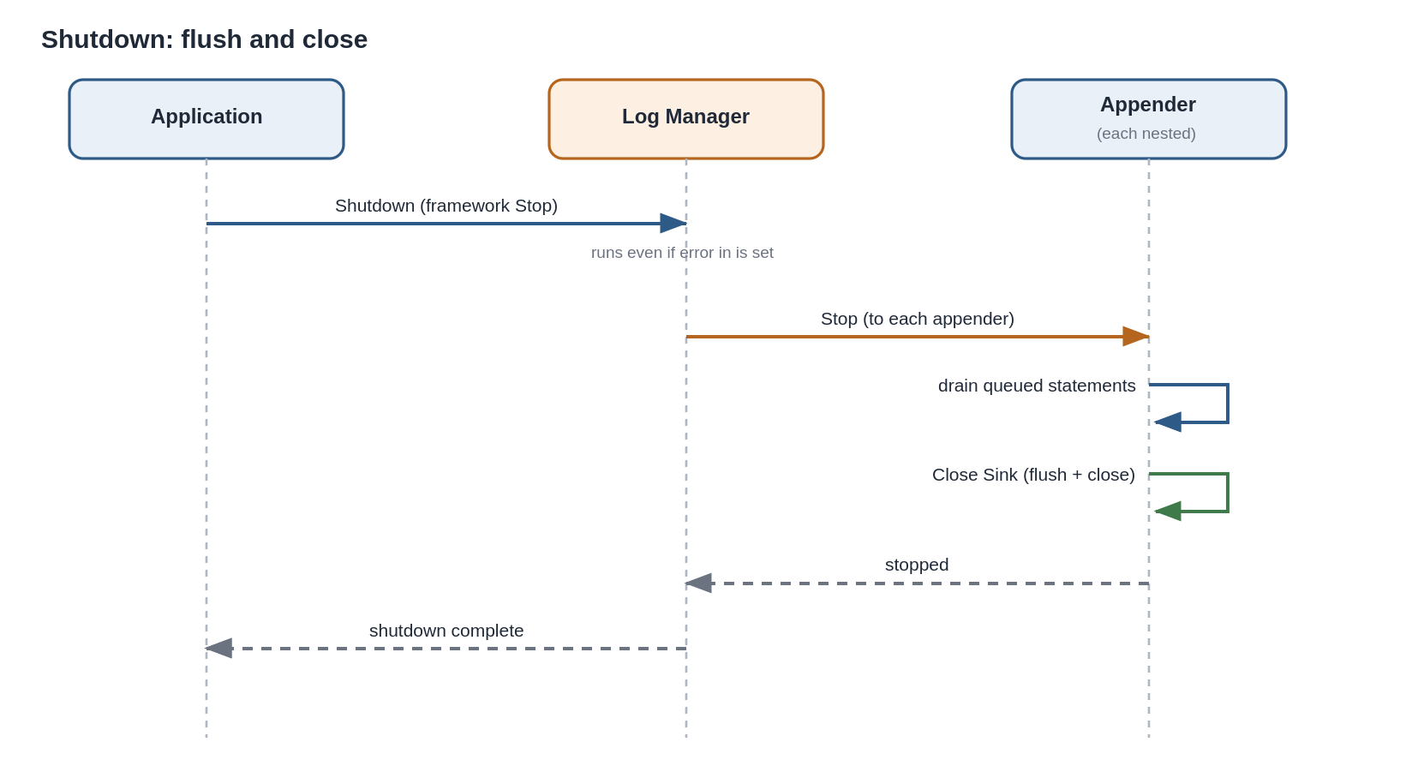
Figure 6. Shutdown: the Log Manager stops each nested appender, which drains its queue and closes its sink before confirming.

6. Path Resolution under a Packed Project Library
Lumberjack is buildable as a PPL (SRS-LMBR-063). When code runs from a PPL, Current VI's Path and Application Directory resolve to a location inside the .lvlibp, which is not the host application’s directory (SRS-LMBR-064). The design therefore never self-derives external paths:
- The file appender root folder comes from configuration or launch inputs (SRS-LMBR-039, 044).
- A relative config-file path is resolved against the host application’s directory, obtained from the top-level caller context, not from any Lumberjack library VI’s path.
- When a default root folder must be computed (empty rootFolder in config), it is derived from the host application context passed in at launch, not from the library’s own location.
No library VI calls Current VI's Path or Application Directory for the purpose of locating external resources.

7. Threading and Determinism
- Each appender runs its own Actor Core loop on its own thread, so slow sink I/O in one appender does not delay another (SRS-LMBR-022).
- Enqueue-to-delivery latency through AF queues is not deterministic (SRS-LMBR-053). Lumberjack must not be a control loop’s timing source. Determinism-sensitive callers use the bounded-queue mode (SRS-LMBR-056) to bound memory and jitter, and rely on the MFC/hardware or a Timed Loop for actual timing, not on Lumberjack delivery.
- Within one appender’s queue, order is preserved (SRS-LMBR-054). Cross-appender order is not guaranteed once queues drain concurrently.

8. Project Structure and Packaging

8.1 Three orthogonal axes
Three things are independent in LabVIEW, and only one is the API boundary:
- Disk folders organize source by concern and by class (a .lvclass is a folder holding the class and its member VIs). Organization only.
- Member access scope (public, community, protected, private) is the real membrane: it determines what a PPL exposes to adopters, per member, regardless of folder.
- The functions palette (.mnu files) curates which public entry points adopters see and how they are grouped. Discoverability only.
The public API is therefore defined by scope plus palette, not by a single folder. Folders exist for maintainers.

8.2 Folder layout
lumberjack/
Lumberjack.lvproj
README.md LICENSE.txt
docs/
configs/ Lumberjack.vipb
src/
Lumberjack.lvlib the packable library
palettes/ .mnu (see 8.4)
Public/
Logger.lvclass/ API facade
Core/
Log Manager.lvclass/ root actor
Appender.lvclass/ abstract base
Appenders/
File Appender.lvclass/
Console Appender.lvclass/
Relay Appender.lvclass/
Layouts/
Layout.lvclass/ abstract Format (DD)
CSV Layout.lvclass/
JSON Layout.lvclass/
Text Layout.lvclass/
Messages/ one class per message
Types/ typedef controls
Support/ internal helpers:
Config/ File/ Tag/
Path/ Store/ Severity/
examples/
tests/ Unit/ Integration/ Support/
Scripts/ Build, Build PPL, Package, Test
Roles and scopes are in 8.1 and the 8.3 mapping table; per-class member lists are in the Message and Class Reference. This tree shows layout only.

8.3 Element-to-path mapping
Element | Path | Scope
Logger facade | src/Public/Logger.lvclass/ | public (the API)
Log Manager | src/Core/Log Manager.lvclass/ | community
Appender base and concretes | src/Core/Appender.lvclass/, src/Core/Appenders/ | base community; Init public, sink members protected
Layouts | src/Core/Layouts/ | Create public, Format public DD
Messages | src/Messages/ | community/private (internal transport)
Type definitions | src/Types/ | public where they cross the API (Severity, config clusters, Filter); private otherwise (Snapshot)
Config / file / tag / path / store helpers | src/Support/ | private
Two placements tie to earlier decisions: the singleton process store is isolated in Support/Store/ and kept private so adopters never see the default-instance plumbing (2.4); and PPL-safe path resolution is isolated in Support/Path/, which makes SRS-LMBR-064 auditable, that one folder is the only place allowed to compute paths, and it never uses Current VI's Path.

8.4 Functions palette (.mnu)
The palette is curated, not directory-synced. A directory-synced palette (dir.mnu listing a folder’s contents) would expose internal VIs and mirror the disk layout; instead, explicit .mnu files in src/palettes/ list only public entry points, grouped by task. The grouping mirrors Logger’s palette (Action-Status, Configure, Data, Utility), modernized with an Appenders sub-palette, since the file Configure settings moved onto appender creation:
Lumberjack
Action-Status: Initialize | Trace Debug Info Warn Error Fatal | Shutdown
Appenders: Create File/Console/Relay Appender | Register/Unregister/Configure Appender
| Make Mirror Filter | Make Routed Filter | Create CSV/JSON/Text Layout
Configure: Configure Level | Configure Verbosity
Data: Get Relay Queue (queue-mode consumption)
Utility: Catch Error | Mask Errors | Create Temporary Root Folder
The .mnu files reference public VIs only; member scope still governs callability, so a VI omitted from the palette but left public is still callable, and an internal VI cannot be surfaced by the palette. The VI Package build spec (Lumberjack.vipb) places these .mnu files into the adopter’s Functions palette on install.

8.5 Packaging
The entire library lives under one Lumberjack.lvlib. Build PPL.vi packs it into a single .lvlibp; member scope decides which members survive as callable in the packed library (SRS-LMBR-063), and the isolated path handling (8.3, section 6) keeps it correct when loaded from the PPL (SRS-LMBR-064). Package.vi builds the VI Package, and Build.vi produces a plain source distribution. The runtime has only the Actor Framework dependency and targets LabVIEW 2014 or newer (SRS-LMBR-060, 061, 062).

9. Design Rationale Summary
- Caller-side fan-out over a hub: chosen to honor the caller-side coarse filter (SRS-LMBR-012) and to keep a single serialization point out of the hot path (SRS-LMBR-021, 052).
- Notifier as the shared snapshot container: the enqueuer list must live in one shared source of truth because appenders register/unregister at runtime (SRS-LMBR-020, 028), just as Logger held its list of listener queues in a global. A Notifier is used rather than a DVR because it is built for one-to-many broadcast with concurrent non-destructive reads, avoiding the exclusive read lock a DVR imposes on the hot path.
- Composition for config clusters, inheritance for actor classes: LabVIEW clusters cannot inherit; the actor classes carry the true hierarchy and the init chain bridges the two.
- Native JSON with the baseline cluster as default value: turns the per-key merge (SRS-LMBR-046) into a property of the primitive rather than hand-written merge logic.
- Relay as an appender: the read/tap mechanism inherits filtering and backpressure for free (SRS-LMBR-023).

10. Deferred Details Resolved Here
SRS reference | Deferred detail | Resolution (section)
SRS-LMBR-043 | Config application vs in-flight statements | Message-ordered, non-retroactive (5.9)
SRS-LMBR-013 | Tag separator vs VI names containing dots | Default tag is single-node; dots in VI base name replaced with _ (5.3)
SRS-LMBR-012 | CSV column order | timestamp, level, source tag, origin VI, message; RFC 4180 quoting (5.4)
SRS-LMBR-050 | JSON schema shape | Single object: global settings + default file appender; schemaVersion (4.2)
SRS-LMBR-045 | Consumer read mechanism specifics | Relay appender, message and queue modes (5.6)

11. Traceability (Design element to SRS)
Design element | Section | Satisfies
Control/data-plane split | 2.1 | 012, 021, 052, 058
Log Manager root actor | 2.2, 3.1 | 001, 002, 008, 020, 043
Actor tree, nested appenders | 2.2 | 002, 018, 028
Caller-side fan-out, Notifier snapshot | 2.1, 2.3, 5.1 | 012, 019, 052
Logger facade | 2.4, 3.1 | 016, 017
Appender base class | 3.2 | 009, 015, 018, 026, 029, 055-059
Concrete appenders | 3.3 | 023-025, 032-040
Config clusters (composition) | 3.4 | 029, 030
Message catalog | 3.5 | 019, 020, 043, 044
Config resolve/merge/validate | 4.1, 4.2 | 044-051, 061
Parent/child init chain | 4.4 | 029-031
Hot-path sequence | 5.1 | 010, 011, 017, 052
Two-stage filtering | 5.2 | 007, 009, 012, 026
Tag and prefix matching | 5.3 | 013, 027
Layout / CSV order | 5.4 | 012, 015, 037
File appender behavior | 5.5 | 033-036, 039, 040
Relay appender | 5.6 | 023-025
Backpressure | 5.7 | 055-059
Register/unregister | 5.8 | 020, 021, 028
Config vs in-flight | 5.9 | 043
Shutdown | 5.10 | 002, 004
PPL path resolution | 6 | 063, 064
Threading / determinism | 7 | 022, 053, 054
Project structure, scope, palette | 8 | 060, 063
PPL packaging, path isolation | 8.5, 6 | 063, 064

