Smart Car Kit Documentation
Author: Philippe Baetens
Email: philippe.baetens@altran.com
Date: March 25, 2019

Introduction
The smart car kit is based on an arduino board, and comes with sensors such as ultrasonic proximity sensor, bluetooth, infrared, LCD display, line tracking sensors, a servo, 4 DC motors and a motor control board. We have a charger that came with it. Batteries were bought separately, type needed is 18650. Do not buy batteries from chines brands such as ‘ultrafire’, they are crap.
In the box was also a charger with US plug, we needed an adapter to EU plug.
Also a CD with manual and demo code was provided. This info can also be found in my git repo.
I uploaded my project code to this Git repo: https://github.com/fiepfiep/smartcarproject
A template document containing black on white lines for the robot to follow is also available in the repository. Print them on A3 paper, lines are 13mm wide.
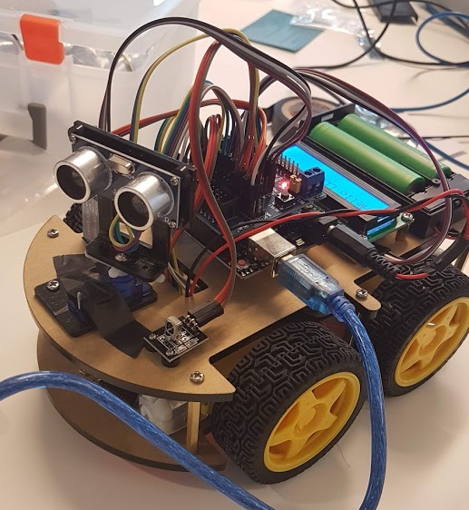

Hardware
A full hardware description can be found here in a PDF. https://github.com/fiepfiep/smartcarproject
Arduino is connected to pc over USB. USB is converted to UART on the arduino. UART is using pin 0 and 1, so do not use these when pc is connected.
Display is connected to the I²C pins on the sensor shield, which are also connected to pin A4 A5, so do not use these either.
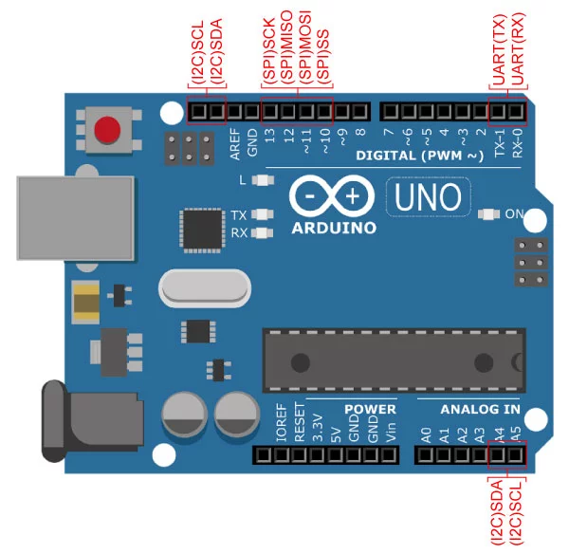
Another problem was the bluetooth module. This one also uses UART, so it is not possible to use the bluetooth module and USB at the same time. A solution could be to use software serial, and assign other pins for the bluetooth module. In this case, pins A0 and A1 were used as Tx and Rx pins.

TRIG_PIN A3 //ultrasonic
ECHO_PIN A2 //ultrasonic
tracingPin = 2,3,4,; //line tracing pins
D11 //receive pin for IR
A0 A1 used as TX,RX for SoftwareSerial UART
//motor
int IN1 = 6;
int IN2 = 7;
int IN3 = 8;
int IN4 = 9;
int ENA = 5;
int ENB = 10;
pin 11 is used for the servo.

Pin list definitions could have been changed, to be sure check code/PHILIPPE/final.ino

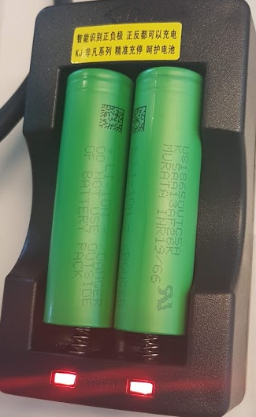
BATTERIES
Batteries of type 18650 are provided. Take care of the polarity when charging the batteries, these batteries are really dangerous!!!

Software

Installation
Download arduino studio from the internet. Set it up, probably some libraries will have to be installed first. They can be found in the libraries folder
- LiquidCrystal_PCF8574
- Irremote
- HC-SR04

Functionality
The software should be able to do the following things:
- receive bluetooth commands
- receive infrared commands
- use the LCD display
- use the line sensor
- use the ultrasoncic sensor together with servo
- drive the DC motors

Operation
The infrared remote has buttons. Each button should activate a specific function of the robot.
The OK button should halt the robot.
Mode 1: random driving with obstacle avoidance, activated with button 1
Mode 2: bluetooth controlled driving
Mode 3: Line tracking
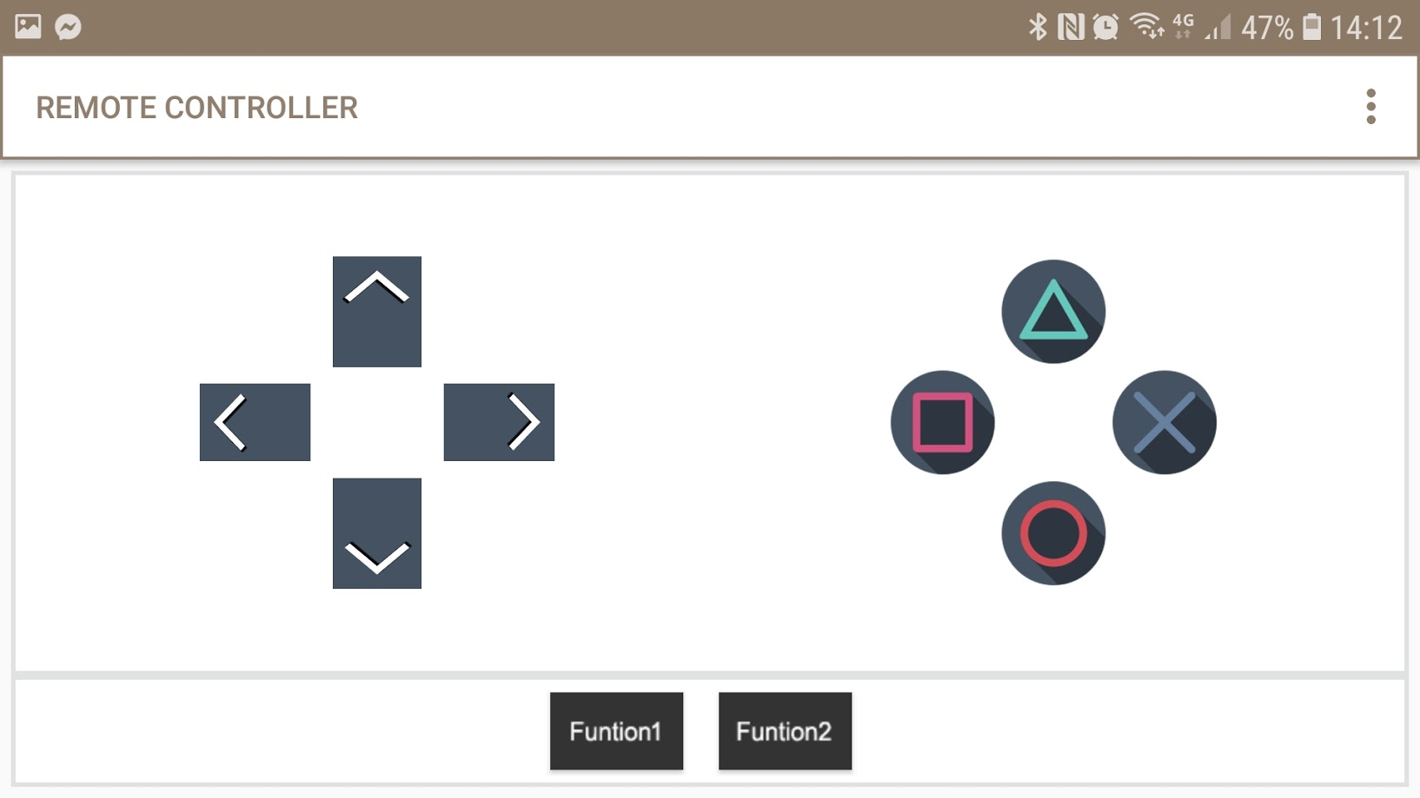
Mode 4: bluetooth assisted driving with obstacle avoidance

Pairing the phone with bluetooth controller:
In Bluetooth controlled driving, you can control the car with your phone.
Download this app on your android phone (or similar for those phones with the apple logo):

https://play.google.com/store/apps/details?id=com.satech.arduinocontroller
OR
https://play.google.com/store/apps/details?id=com.giumig.apps.bluetoothserialmonitor&hl=en

Goto bluetooth devices on your phone, connect with HC-06, pincode is 1234.

The bluetooth module has a blinking led, it means ready to connect.

Then go to the app, click refresh, then go to the playstation-like controller.
Go to options and assign the following letters:

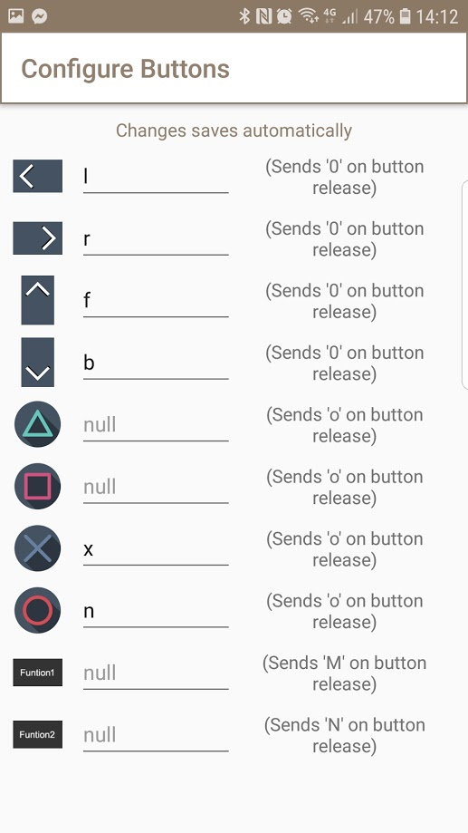

Software Design
Mode 2 will be implemented first.
Functions should be available for following things:

Functions

Basic functions
void control_motors(int leftspeed, int rightspeed); //can also be negative to go backwards
void read_infrared();
void read_bluetooth();
int get_distance();
void calibrate_ultrasonic();

Advanced functions
void drive_random(); //drive on a line
void drive_controlled(); //drive bluetooth
void follow_line(); //track a line. Stop if no line found after some time or if the path is blocked by an object.
void drive_assisted(); //drive bluetooth and avoid obstacles
The functions above should readout bluetooth and infrared every now and then to change modes.

