CardSpot® Activation Software Installation Guide

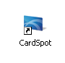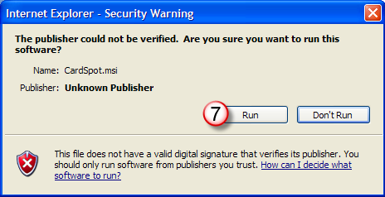

**Prior to Installation**

**Windows Vista Operating System**

**Start Menu** → **Control Panel** → **Add or Remove Programs**

* **Microsoft .NET Framework 3.5**

Please note that you may have other versions of the .NET Framework (2.0, 3.0) on your system. Do not modify these, as they may be necessary for other programs you have installed. However, the .NET Framework 3.5 must be installed for CardSpot® to operate.

To obtain the program(s) go to [**www.microsoft.com**](http://www.microsoft.com/) and search for .net Framework 3.5. Please select the link **Download details: .NET Framework 3.5** and follow the onscreen

instructions for downloading and installing the program(s).

**Windows 7 Operating Systems**

**Control Panel (All Items view)** → **Programs and Features** → **Turn Windows features on or off (left pane link)** → **Blue box should appear next to .NET 3.5.1.**

**Remove Current Version of CardSpot®**

If CardSpot® has never been installed on this computer, go to Installing New Version of CardSpot®.

If CardSpot® has been previously installed on this computer, it will need to be removed.

1. Go to *Control Panel > Add or Remove Programs*
2. Select CardPoint and select the *Remove* option
3. Follow the onscreen instructions to remove the software.

## Installing New Version of CardSpot®

1. Go to https://getmyreports.storefinancial.net/.
2. The Username is: clientsupport
3. The Password is: watermain123
4. Click on the file ending in Production Latest
5. Click on the CardSpot.msi link
6. Select Run from the File Download – Security Warning window
7. Select Run from the Internet Explorer – Security Warning window
8. Follow the onscreen instructions to install the Software through the InstallShield Wizard.

Do not alter the default install location

When complete, a new CardSpot® shortcut icon will appear on the desktop.

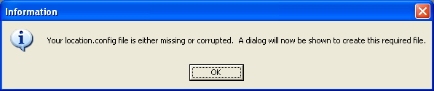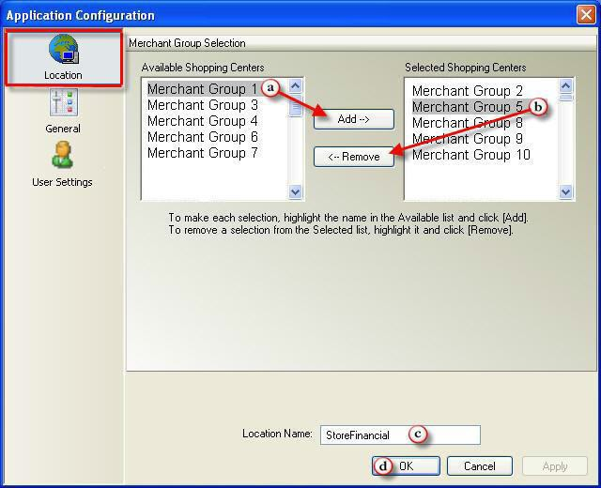

# CardSpot® Activation Software Installation Guide

## Configuring CardSpot®

To configure CardSpot® double click the CardSpot® icon on the desktop.

### Location Configuration

The first time CardSpot® is launched, a dialog box will appear stating “Your location.config file is either missing or corrupted. A dialog will now be shown to create this required file.” Click “OK” to continue configuring

CardSpot®.

### Merchant Group Selection and Location Name

To configure your dealership and location name, click on the “Location” icon (if it is not already selected).

## You will be required to enter your username and password, which was emailed to you by StoreFinancial. After entering your password provided by StoreFinancial, the system requires you to change your password immediately. Your new password must be at least 8 characters with at least one letter and one number.

* 1. Click on your property name in the Available Shopping Centers column.
  2. Click “Add”. The Add button is grayed out until your property name has been selected in the Available Shopping Centers column.
  3. Change the “Location Name” to the desired selling location name (ex-Customer Service 1).
  4. Click “OK” to save new settings.

# CardSpot® Activation Software Installation Guide

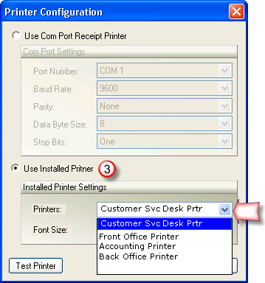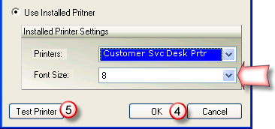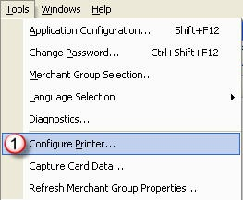

### Printer Configuration

Use this function to select the printer to print receipts.

* + 1. Select (Configure Printer) from the tools menu. The Printer Configuration dialog opens.
    2. If a serial (COM Port) printer is detected, CardSpot® uses this printer as the default.
    3. To change to a local or network printer, select the Use Installed Printer option and choose the printer from the drop-down menu. Select the font size.

To add a printer to this drop-down, the printer must be added via the standard Windows process. If you are not an administrator on the computer, you may not be able to add a printer.

* + 1. Click [*OK*] to save changes or click [*Cancel*] to make no changes and exit the dialog.
    2. Click [*Test Printer*] to verify selections are saved and that the selected printer is functioning properly. The selected printer should print a test receipt.

# CardSpot® Activation Software Installation Guide

**Compliance & Security Requirements**

StoreFinancial (SFS) provides CardSpot® software (“Software”) to its clients. The primary purpose of the Software is to sell (activate) prepaid gift cards (“Cards”). The Software is developed for use in a Payment Card Industry Data Security Standard (PCI-DSS)-compliant configuration. CardSpot® has undergone an independent, third-party assessment based upon the Payment Card Industry Payment Application Data Security Standards (PCI PA-DSS), and is a validated payment application with the PCI Council. The list of validated payment applications can be found at <https://www.pcisecuritystandards.org/>.

The StoreFinancial CardSpot® Integrated Payments PA-DSS Implementation Guide contains configuration recommendations and requirements for the CardSpot® Integrated Payments Software. The purpose of this guide is to instruct clients on the secure and PA-DSS-compliant implementation of the product.