Lab 2

Magnus Wood

September 20, 2021

# Rmarkdown to docx instructions  
# https://rmarkdown.rstudio.com/articles_docx.html  
# https://bookdown.org/yihui/rmarkdown/word-document.html  
  
# R-Markdown: The Definitive Guide  
# https://bookdown.org/yihui/rmarkdown/

9-15-21 Data collection in field Setup at organic farm at 11:54am. Site chosen near apple trees.

Station 2, .1L / 30m. 12:05pm, 12:35pm, 1:05pm applications Station 3, .5L / 30m. 12:00pm, 12:30pm, 1:00pm applications

df_names <- c("TIMESTAMP", "RECORD", "BattV_Avg", "PTemp_C_Avg", "VWC_Avg", "EC_Avg", "T_Avg", "P_Avg", "PA_Avg", "VR_Avg", "station", "water_L")  
  
# Station 2, .1L / 30m. 12:05pm, 12:35pm, 1:05pm applications  
# was cleared before collection  
station2_df <- read_csv("Lab2_data/CR300Series_2_Table1 - Copy.dat", skip=6, col_names=FALSE) %>%  
 mutate(station = 2, water_L = .1)

## Rows: 19 Columns: 10

## -- Column specification --------------------------------------------------------  
## Delimiter: ","  
## dbl (9): X2, X3, X4, X5, X6, X7, X8, X9, X10  
## dttm (1): X1

##   
## i Use `spec()` to retrieve the full column specification for this data.  
## i Specify the column types or set `show_col_types = FALSE` to quiet this message.

# Station 3, .5L / 30m. 12:00pm, 12:30pm, 1:00pm applications  
# station 3 had data from previous runs on it, needs to be filtered out  
station3_df <-read_csv("Lab2_data/CR300Series_3_Table1 - Copy.dat", skip=610, col_names=FALSE) %>%  
 mutate(station = 3, water_L = .5)

## Rows: 21 Columns: 10

## -- Column specification --------------------------------------------------------  
## Delimiter: ","  
## dbl (9): X2, X3, X4, X5, X6, X7, X8, X9, X10  
## dttm (1): X1

##   
## i Use `spec()` to retrieve the full column specification for this data.  
## i Specify the column types or set `show_col_types = FALSE` to quiet this message.

# names of columns  
names(station2_df) <- df_names  
names(station3_df) <- df_names  
  
# combine them  
my_df <- bind_rows(station2_df, station3_df)

Topic: Integration of CR310 Data Logger with soil sensors with data logger for experimentation and wireless data acquisition

Field experiment set-up: * configured

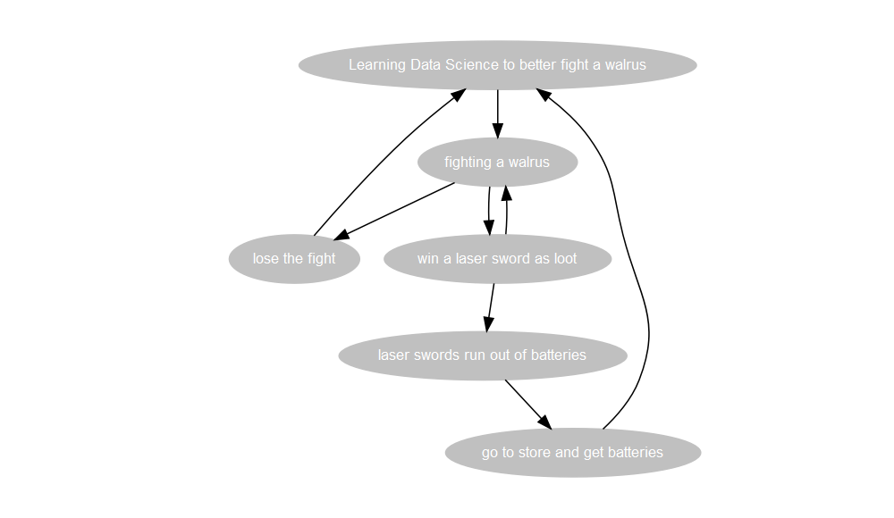

## Including External Graphic

# DiagrammeR mermaid graph  
  
mermaid("  
graph LR  
 A(Learning Data Science to better fight a walrus)-->B  
 A-->C[lose the fight]  
 C-->A  
 C-->E(taco break)  
 B[fighting a walrus]-->D{laser swords run out of batteries}  
 C-->D(go to store and get batteries)  
 D-->F  
 E-->F{win a laser sword as loot}  
")

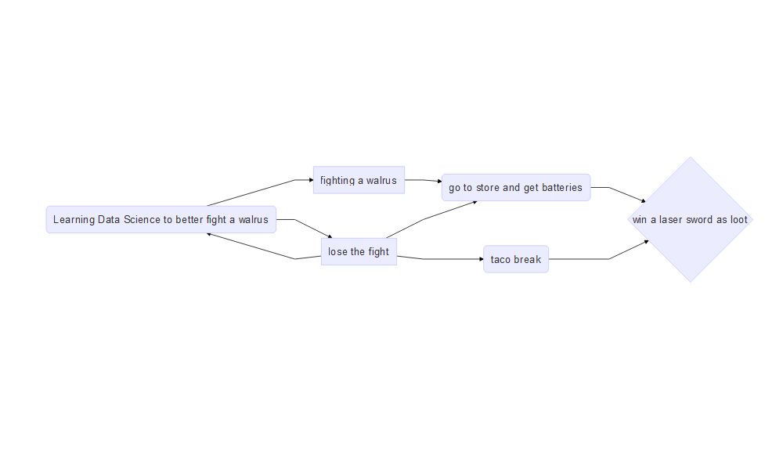

# Sequence Diagrams, as seen in "How to Draw Sequence Diagrams" report by Poranen, Makinen, and Nummenmaa   
# offers a good introduction to sequence diagrams.   
#Let's replicate the ticket-buying example from Figure 1 of this report and add in some conditionals.  
  
mermaid("  
 sequenceDiagram  
 customer->>ticket seller: ask ticket  
 ticket seller->>database: seats  
 alt tickets available  
 database->>ticket seller: ok  
 ticket seller->>customer: confirm  
 customer->>ticket seller: ok  
 ticket seller->>database: book a seat  
 ticket seller->>printer: print ticket  
 else sold out  
 database->>ticket seller: none left  
 ticket seller->>customer: sorry  
 end  
 ")

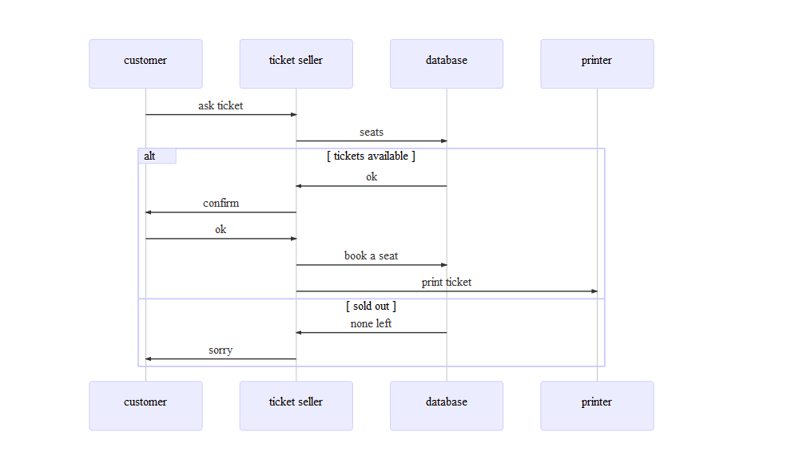

# saveNetwork(g, "g.html")  
# webshot("g.html", "g.png", vheight = 50)