Lab 2, Integration of CR310 Data Logger with soil sensors and RF data logger for experimentation and wireless data acquisition

Magnus Wood

September 20, 2021

# Introduction

Topic: Field experiment set-up: * configured

9-15-21 Data collection in field Setup at organic farm at 11:54am. Site chosen near apple trees.

Station 2, .1L / 30m. 12:05pm, 12:35pm, 1:05pm applications Station 3, .5L / 30m. 12:00pm, 12:30pm, 1:00pm applications

# Methods and Experimental Design

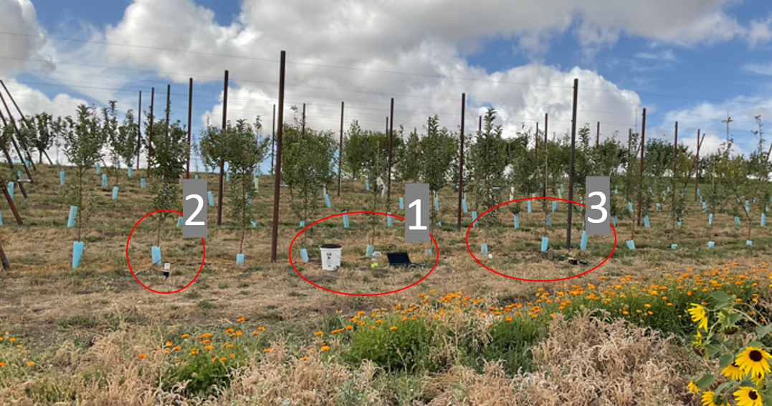

Figure 1. Field setup. Base station with laptop and RF407 at 1, CR310 datalogger and CS-650 soil moisture sensors at 2 and 3

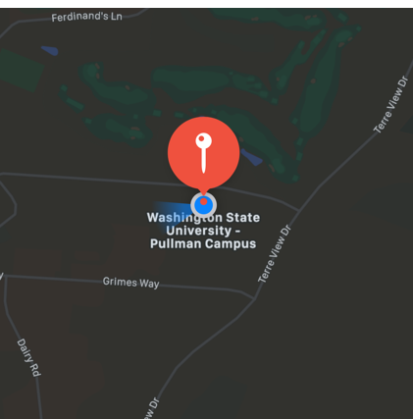

Figure 2. Field Location: Eggert Family Organic Farm, Animal Sciences Rd, Pullman, WA 99163.

# Results

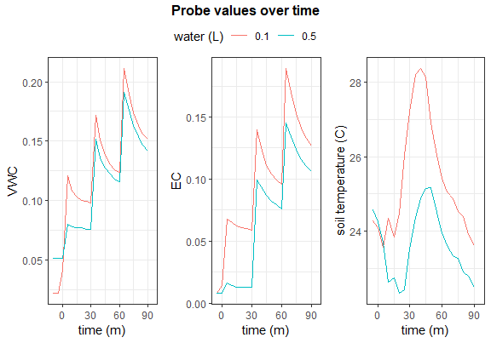

Figure 2. Raw probe values over time

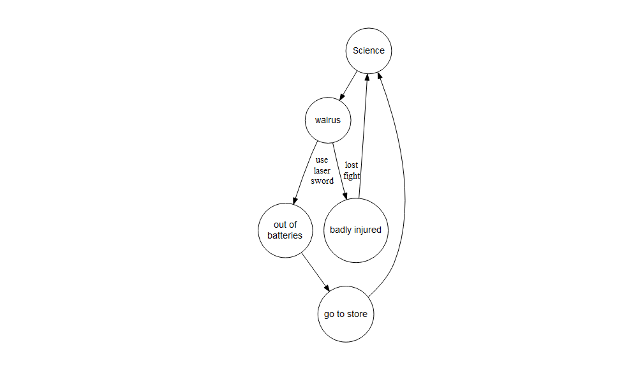

Figure 32. dragraph flow chart example

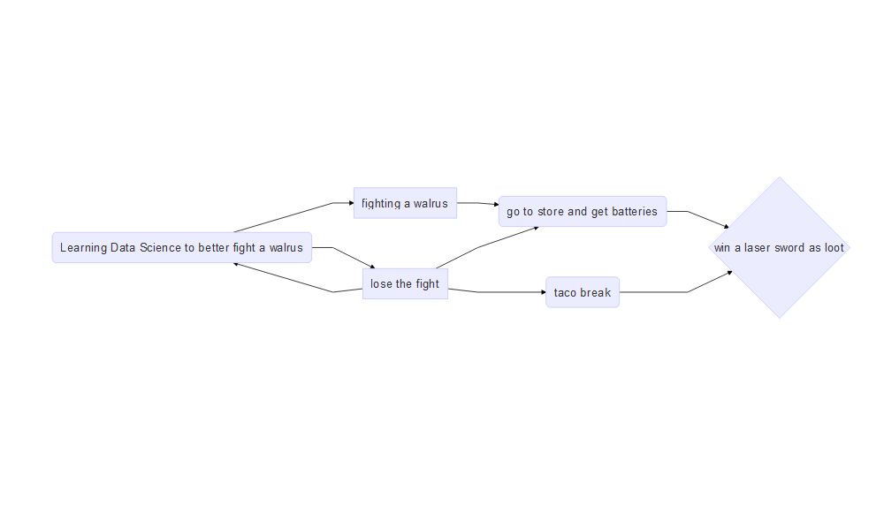

Figure 5. A mermaid graph

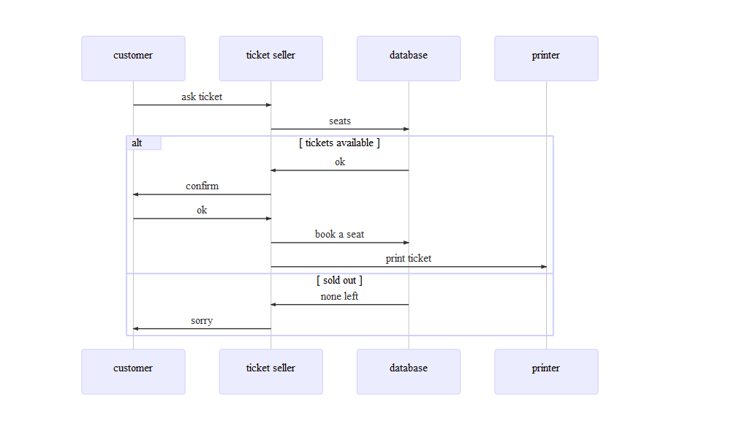

# Data Analysis and Conclusions

# References

[1] “CS-655 Water Content Reflectometers.” Campbell Scientific, Feb. 2018. [Online]. Available: <https://s.campbellsci.com/documents/es/manuals/cs650.pdf>