

NAME :

Reg No :

SECTION :

# **DATE CLASS**

1. First, we create a Date class and set class members: day, month, year.

2. The constructor Date initialises these properties.

3. dateDisplay method displays the date.

4. Check method checks conditions and returns boolean value.

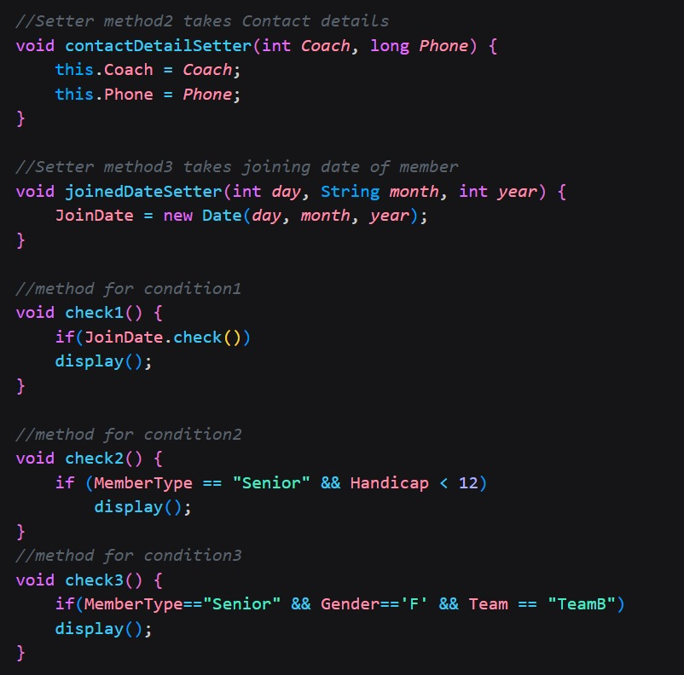**MEMBE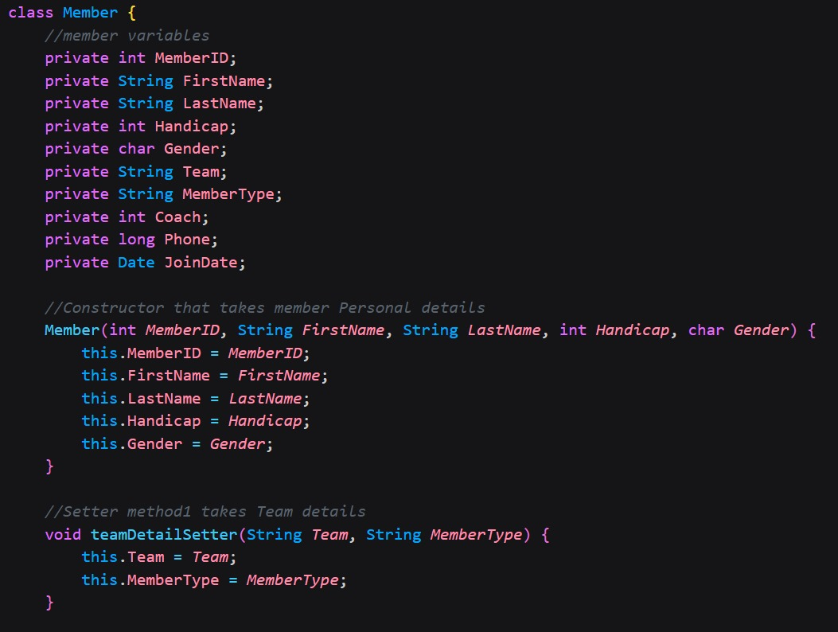R CLASS**

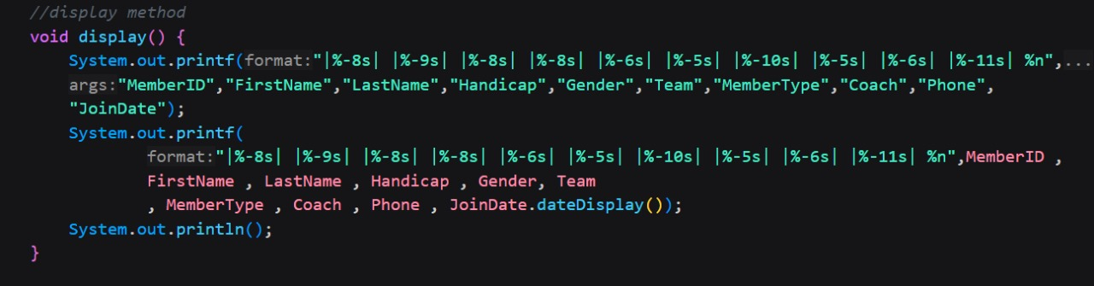

4. Secondly, we create a Member class and set class members : MemberID , FirstName,LastName,Handicap,Gender,Team,MemberType,Coach,Phone,JoinDate.

5. The Constructor Member initializes the member’s personal details only.

6. teamDetailSetter method sets the values for Team and MemberType.

7. contactDetailSetter method sets the values for Coach and Phone.

8. joinedDateSetters method sets the value of JoinDate.

9. check1 method checks condition 1 and displays accordingly.

10. check2 method checks condition 2 and displays accordingly.

11. check3 method checks condition 3 and displays accordingly.

12. display method prints the details of the member.

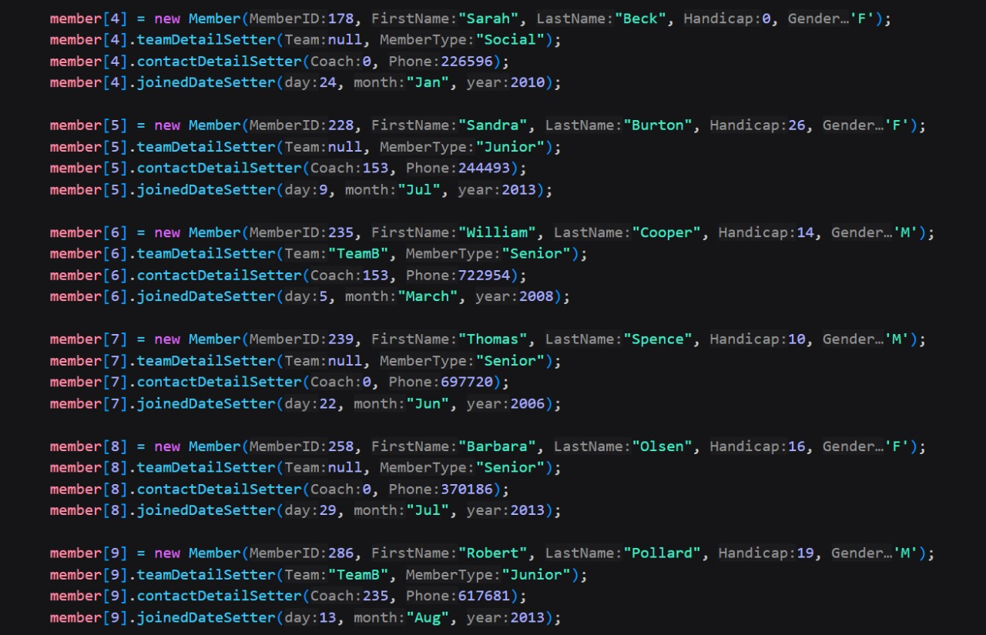**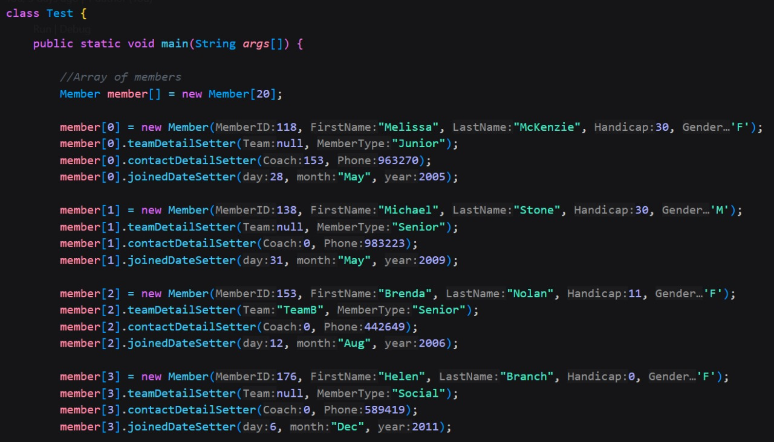TEST CLASS**

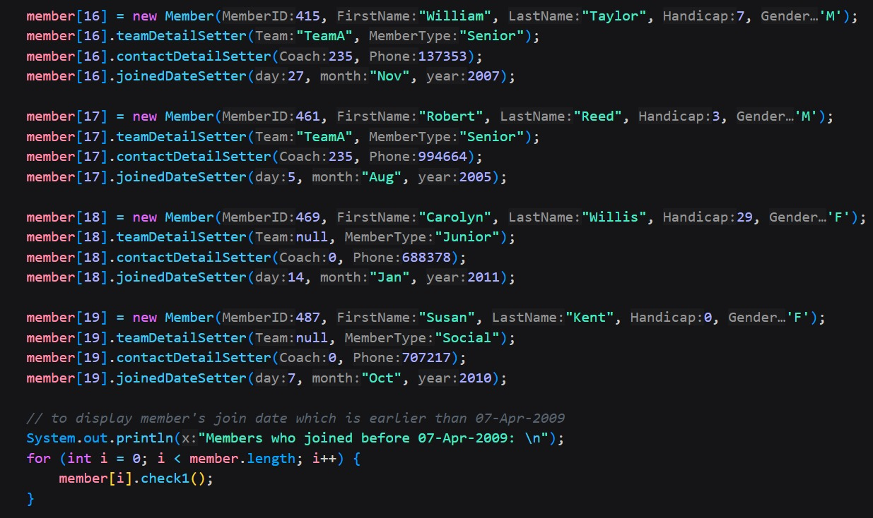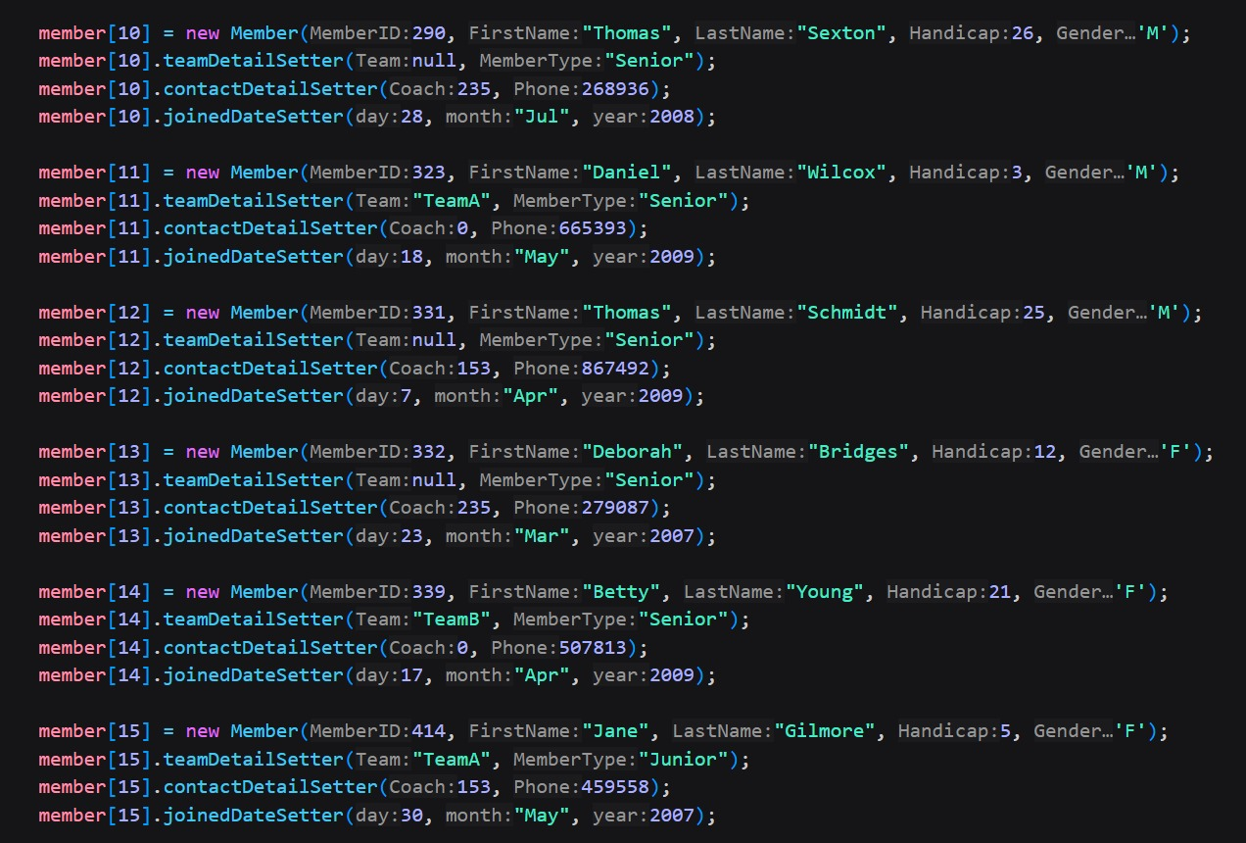

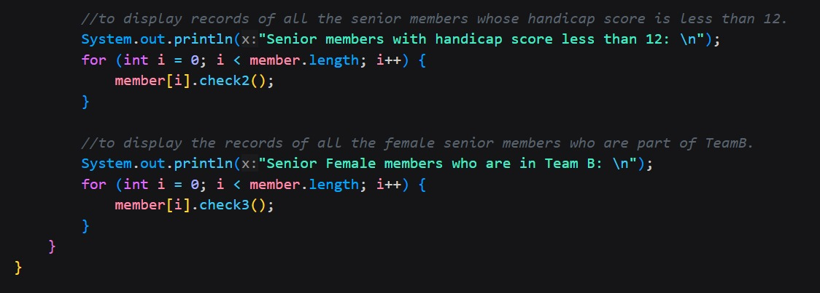

11. Finally we create a Test class to print input the data.

12. We create an array of objects size 20 representing 20 members.

13. we input the data for each member using this array and calling the appropriate method from the Member class.

14.Last but not the least , we check condition 1 , 2 , 3 individually for each member using a for loop and call the appropriate check methods for displaying the data.

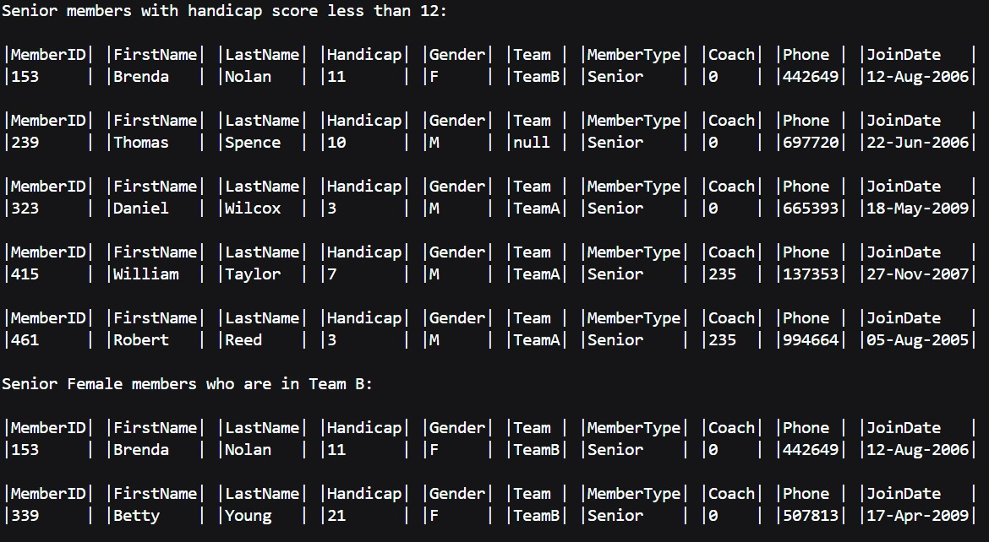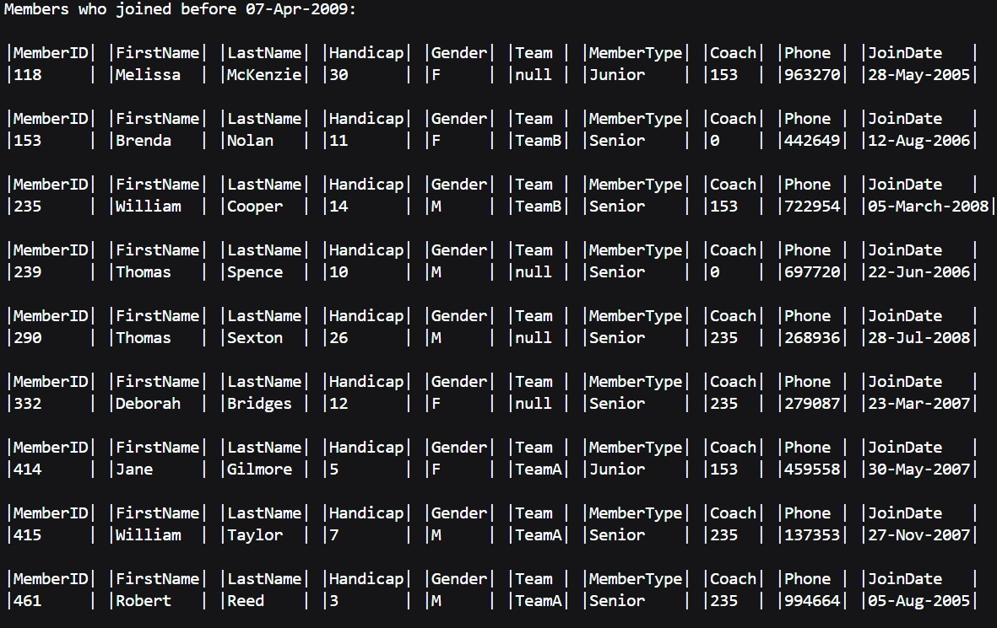**OUTPUT**