**Summary**

This document goes over the steps necessary to get a simple Amazon FreeRTOS demo to run/connect to AWS IoT Core. The full documentation is located at:<https://docs.aws.amazon.com/freertos/latest/userguide/getting_started_espressif.html>. This document’s intention is to summarize the steps and get a simple demo working fast. Please contact me on Slack if you have any questions and also let me know once you have it working so I can confirm I see the data on AWS. -Zach

**Downloading and installing the prerequisites**

1.) Log on to AWS and go to the IAM user console. Find your user account and make sure that the following policies are added under your user (this should already be done):

* AmazonFreeRTOSFullAccess policy
* AmazonIoTFullAccess policy

2.) Download and install the CP210x USB to UART Bridge VCP drivers

* <https://www.silabs.com/products/development-tools/software/usb-to-uart-bridge-vcp-drivers>

3.) Download and install the Espressif toolchain.

Note: Make sure to download it to the C:\ drive. You should end up with a directory ‘C:\msys32’

* <https://docs.espressif.com/projects/esp-idf/en/latest/get-started/windows-setup.html>

4.) Download the *amazon-freertos* repository from Github.

Note: I downloaded the repo to C:\Users\<USERNAME>\Documents\source on my local machine. The path to the location where you choose to put the repo will be referred to as BASE_FOLDER. So in my case, BASE_FOLDER is to C:\Users\<USERNAME>\Documents\source.

* <https://github.com/aws/amazon-freertos>

5.) Install python 2.7.10 or later (I have the latest version)

**Configuring the Amazon FreeRTOS Demo Application**

1.) Start **mingw32.exe**. This shell program is located under the toolchain directory (C:\msys32)

2.) Using the mingw32.exe shell, run the following command to install the AWS CLI: **easy_install awscli**

3.) Log on to the AWS IAM console: <https://console.aws.amazon.com/iam/home?#home>

4.) Select your IAM user name link

5.) Go to the **Security Credentials** tab and select **Create Access key**

6.) Record your access key AND secret access key

**Note: The secret access key is shown to you ONLY at creation or first use. If your secret access key is not displayed, perform the following steps:**

a.) Click on ‘**Create access key**’ under the **Security credentials tab.**

b.) Record the new access key AND secret access key

c.) Delete the original access key or make it inactive.

7.) Using the mingw32.exe shell, run the following command: **aws configure** After running this command you will be prompted to enter in the following:

a.) Your AWS access key

b.) Your secret AWS access key

c.) Default region name (put **us-west-2**)

d.) Default output format (put **text** for now)

8.) Using the mingw32.exe shell, run the following command **easy_install boto3**

**Configuring the ‘configure.json’ file in the demo**

1.) Open the following file in your local copy of the Amazon FreeRTOS repo: *<BASE_FOLDER>/tools/aws_config_quick_start/configure.json*

2.) Set the following parameters in the file:

“afr_sourcedir”:”<BASE_FOLDER>/amazon-freertos-master”

“thing_name”:”<A name that you want to call your IoT ‘thing’>”

“wifi_ssid”:”<Your WiFi SSID>”

“wifi_password”:”<Your WiFi password>”

“wifi_security”:”eWiFiSecurityWPA2”

**Note:** Depending on your Wi-Fi security type, enter in the corresponding value for “wifi_security”:

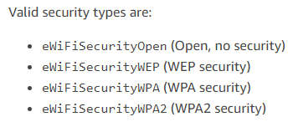

To use as a reference, my configure.json looks like this:

{

"afr_source_dir":"C:/Users/myusername/source/amazon-freertos-master",

"thing_name":"zyeung_esp32",

"wifi_ssid":"MyWifi",

"wifi_password":"MyWifiPassword",

"wifi_security":"eWiFiSecurityWPA2"

}

**Run the configuration script**

1.) From the mingw32.exe shell, change your directory to <BASE_FOLDER>/tools/aws_config_quick_start

2.) Run the command **python SetupAWS.py setup**

3.) This will do the following:

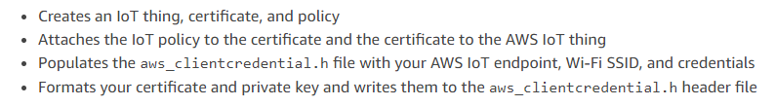

**Run the Amazon FreeRTOS Demo Project**

1.) Connect your Esp32 to your computer.

2.) Follow the steps under **To configure your board's connection for flashing the demo**  on the web page:<https://docs.aws.amazon.com/freertos/latest/userguide/getting_started_espressif.html>

Note: You can skip the section **To subscribe to the MQTT topic with the AWS IoT MQTT client**