**Ex 2.2.1:**

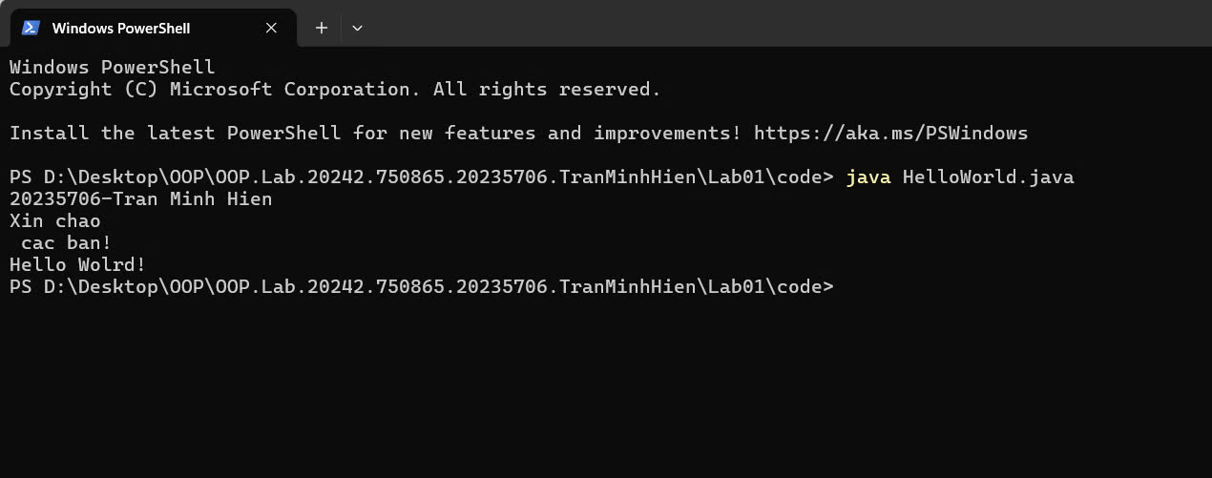

**Ex 2.2.2:**

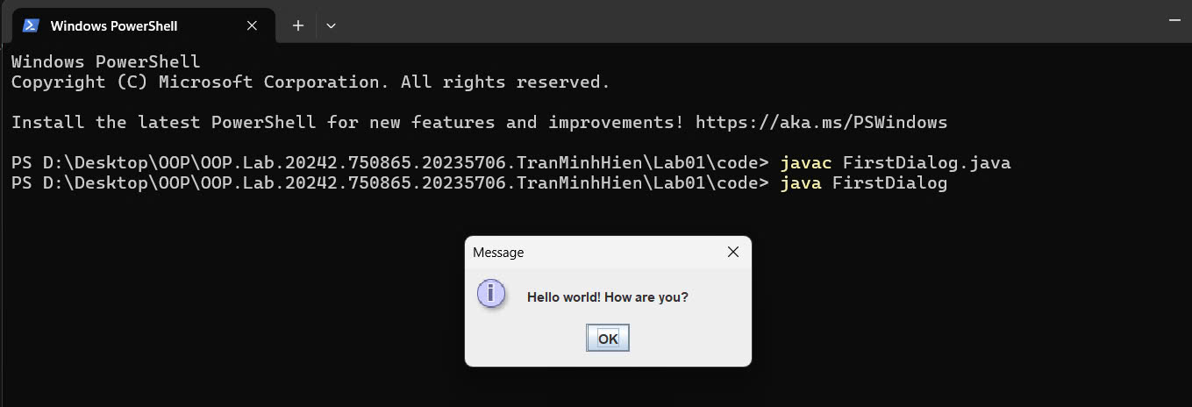

**Ex 2.2.3:**

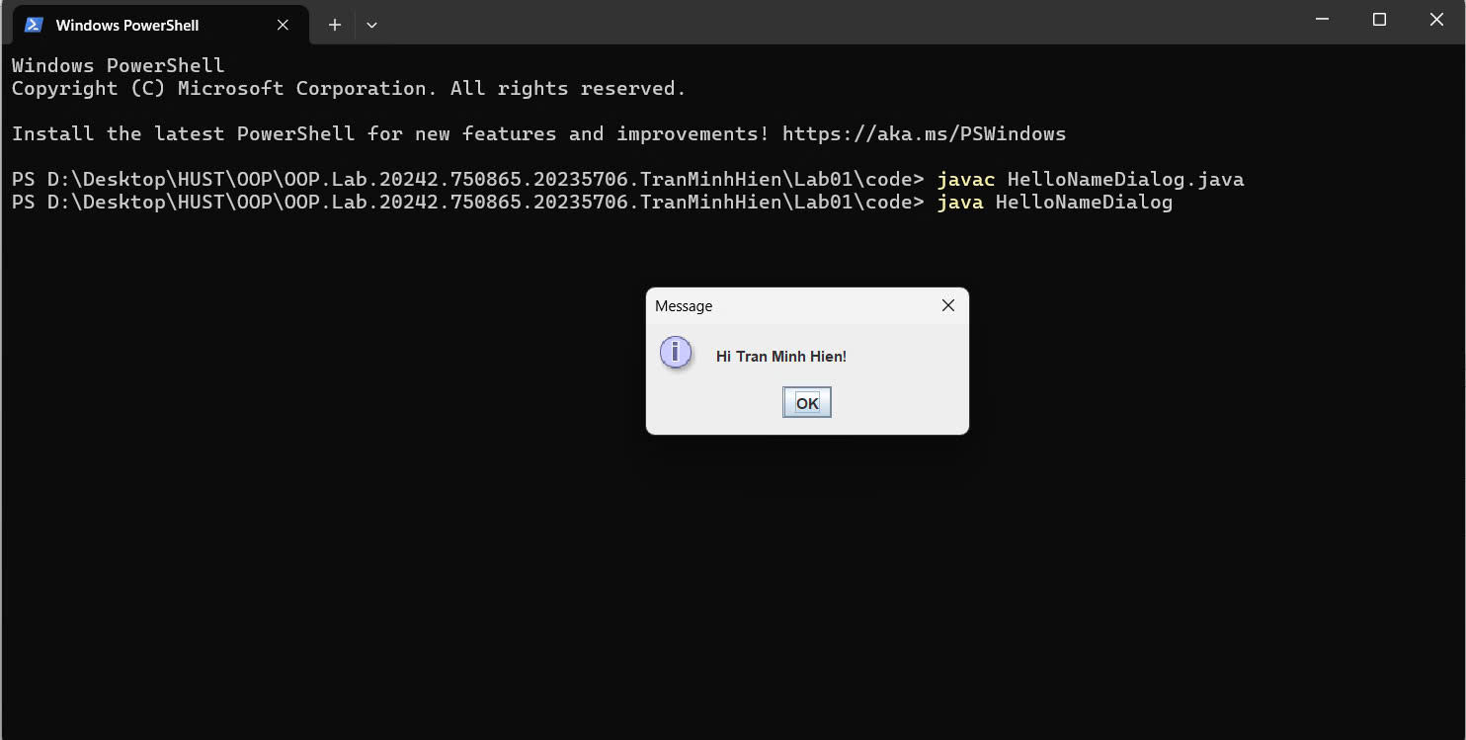

**Ex 2.2.4:**

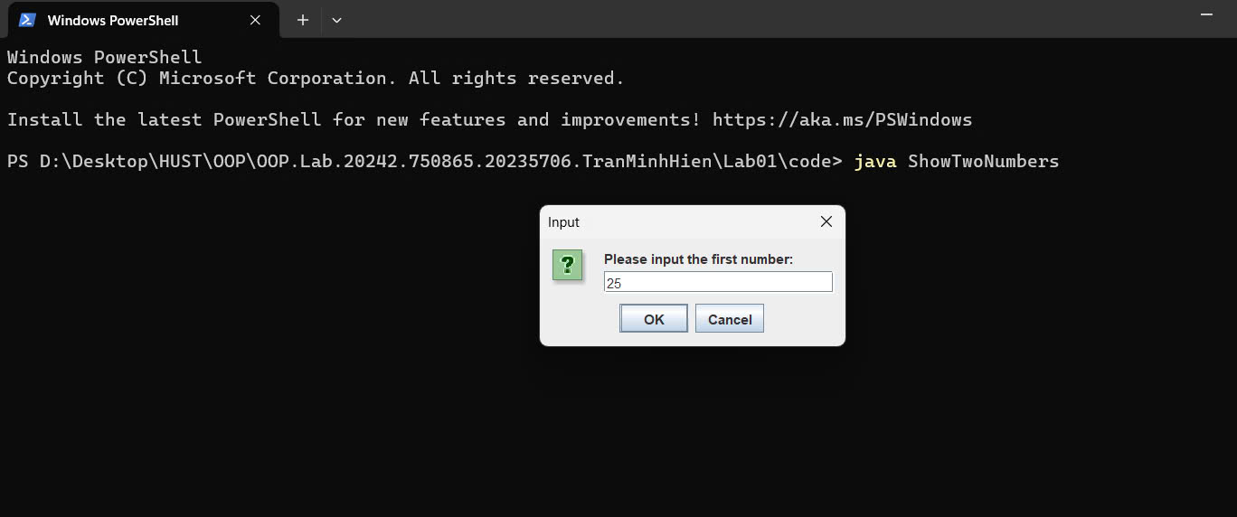

**Ex 2.2.5:**

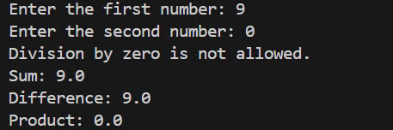

**Ex 2.2.6:**

1. 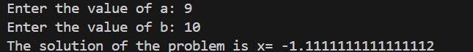

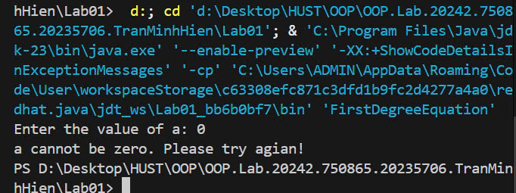

1. 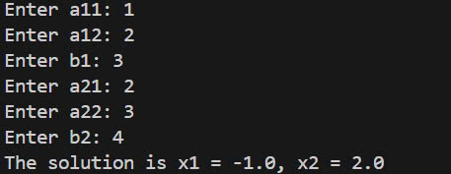
2. 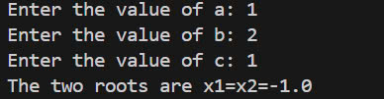

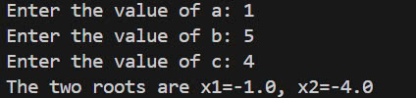

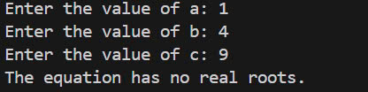

**Ex 6.1:**

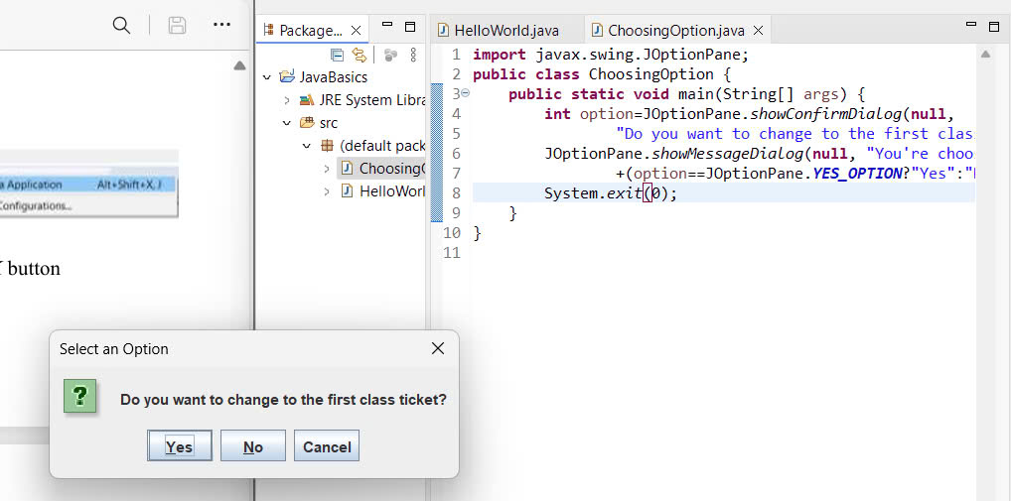

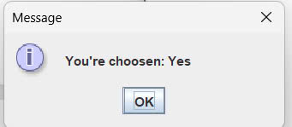

**Ex 6.2:**

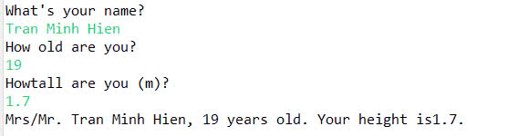

**Ex 6.3:**

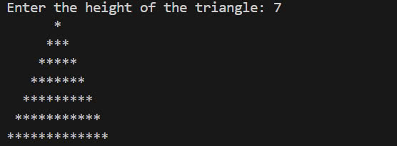

**Ex 6.4:**

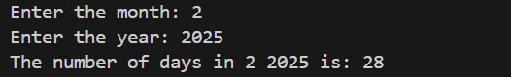

**Ex 6.5:**

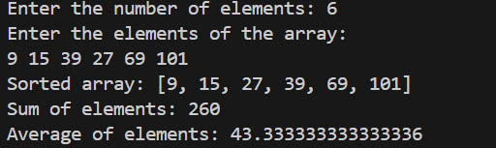

**Ex 6.6:**

