# 5 *BREVIPALPUS*-TRANSMITTED ORCHID FLECK VIRUS INFECTING THREE NEW ORNAMENTAL HOSTS IN FLORIDA

Orchid fleck virus (OFV), is the type member for the genus *Dichorhavirus*, family *Rhabdoviridae*. The virus is a bacilliform, nuclear rhabdovirus composed of two segments of single-stranded, negative-sense RNA which infects plants (Dietzgen et al. 2014, Walker et al. 2018, Amarasinghe et al. 2019). Only Flat mites (Trombidiformes: Tenuipalpidae) from the genus *Brevipalpus* are known to transmit dichorhaviruses (Maeda 1998). Plants infected with OFV exhibit chlorotic and necrotic flecks on their leaves(Kubo et al. 2009b, Kubo et al. 2009a, Dietzgen et al. 2018b). The virus was first described as infecting *Cymbidium* orchids in Japan (Doi et al. 1977). There have been reports of OFV and OFV-like rhabdoviruses infecting orchids in Asia, Africa, North America, South America, Europe, and Oceania. The prevalence of OFV and its mite vector is thought to be associated with the movement of infected orchids (Dietzgen et al. 2018a). More than fifty species of Orchidaceae (Kitajima et al. 2010, Peng et al. 2013) can naturally become infected with OFV, as well as some Asparagaceae (Nolinoidaea) (Mei et al. 2016, Dietzgen et al. 2018b), and Rutaceae, where infection causes citrus leprosis-like symptoms (Roy et al. 2015, 2020, Cook et al. 2019, Olmedo-Velarde et al. 2021). Mechanical transmission of OFV is possible under laboratory conditions to the plant families Chenopodiaceae, Aizoaceae, Fabaceae, and Solanaceae (Chang et al. 1976, Kondo et al. 2003, Peng et al. 2013).

## 5.1 Virus Detection

During June 2020, chlorotic flecks and ringspot patterns of unknown etiology were observed on Giant Lilyturf *Liriope* spp., cv. ‘Gigantea’ in a landscape of Leon County, Florida (5.1). *Liriope* belong to a group of plants in the family Asparagaceae, subfamily Nolinoidaea, comprised of grass-like monocotyledonous liliod plants native to southeastern Asia (Chase et al. 2009, Meng et al. 2021). *Liriope* and the closely related *Ophiopogon* (Asparagaceae: Nolinoidaea) are considered the most important ground cover plant in the southeastern United States (Mcharo et al. 2003). Viral infections of suspected leaf samples were initially tested at the Plant Disease Diagnostic Clinic at the North Florida Research and Education Center (NFREC) in Quincy, FL. All the samples were tested with one step conventional RT-PCR, and were found negative for begomovirus, carlavirus, potyvirus, tospovirus, cucumber mosaic virus and tobacco mosaic virus. As initial diagnostics were inconclusive, samples were taken of putatively infected plants with ringspot symptoms during July and August of 2020. Leaves were taken from *Liriope* spp. and *Ophiopogon* spp., as well as the *Aspidistra elatior* Blume (Asparagaceae: Nolinoidaea), nearby, which appeared sickly and chlorotic (5.2). Plant materials were sent to the Florida Department of Agriculture and Consumer Services (FDACS) for identification. The FDACS determined that the pathogen was OFV using previously published primers and methods to conduct RT-PCR and Sanger sequencing (Kubo et al. 2009b, Kubo et al. 2009a, Ramos-González et al. 2015). The identity of the virus was verified as OFV Orchid strain 1, (OFV-Orc1), following the methods described in Kondo et al. (2017). Nucleotide sequencing shared 98% nucleotide identity with the OFV-isolates So (Accession No. AB244418) and Br (Accession No. MK522807), which belong to orchid subgroup I (Kondo et al. 2006, 2017). These samples from FDACS were subsequently retested by the USDA-APHIS-PPQ S&T Beltsville laboratory, in conjunction with tests of fresh samples from both Alachua and Leon counties. The USDA used RT-PCR, RT-qPCR, and High Throughput Sequencing (HTS) to reconfirm the presence of OFV. Conventional RT-PCR with Generic R2-Dicho-GF and R2-Dicho-GR primers amplified ~800 nt amplicons of the L-gene (RNA2) (Roy et al. 2020), to detect both OFV-Orc1 and OFV-Orc2 in *O. intermedius* and *A. elatior* from Leon County (Kondo et al. 2017) (GenBank Accession Numbers: MZ852004, MZ852005 MZ852006, and MZ852007). 99% nucleotide sequence identity is shared between OFV-Orc1 and OFV-Orc2 for the RNA2 genome, whereas 90% sequence identity was found between these two reassortment strains. The presence of OFV-Orc1 and OFV-Orc2 in Leon and Alachua counties was reaffirmed with HTS data (??): Analysis of HTS data from Leon County found that the symptomatic *L. muscari* were coinfected with both OFV-Orc1 and OFV-Orc2, while the symptomatic *A. elatior* were solely infected with OFV-Orc1. Sequence data of symptomatic *L. muscari* from Alachua County revealed infections with OFV-Orc2 (GenBank Accession MZ852006). After the initial identification by FDACS of OFV-Orc, mite samples were collected from symptomatic Asparagaceae in Leon County. Most mites collected were Tenuipalpid mites (flat mites or false spider mites), a pest of ornamental plants, some of which are known to act as vectors for plant viruses (Childers et al. 2003b, Childers and Rodrigues 2011).

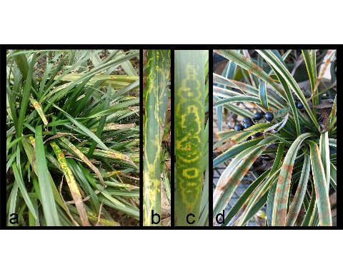

Figure 5.1: Variety of symptoms seen on spp. infected with orchid fleck virus (OFV): (a) symptoms on cv. ‘Gigantea’ (b-c) Details of symptoms on cv. Gigantea (d) rust colored spots on

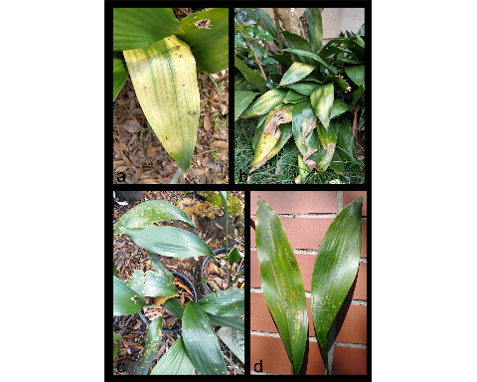

Figure 5.2: Symptoms seen on infected with OFV: (a) Detail of leaf chlorosis (b) Chlorosis appears similar to sun damage (c-d) Chlorotic flecks may indicate early symptoms of OFV

## 5.2 A comment on the the status of *Brevipalpus* in Florida

Mite taxonomy is complicated by cryptic species complexes which occur in many plant-feeding groups of the Acari (Umina and Hoffmann 1999, Skoracka and Dabert 2010, Arthur et al. 2011, Skoracka et al. 2013), including tenuipalpid mites from the genus *Brevipalpus* (Navia et al. 2013). The commonly used phase-contrast microscopy is insufficient to detect some diagnostic characters for separation of cryptic species, instead best practices recommend the combination of Differential Interference Contrast (DIC) Microscopy and Scanning Electron Microscopy along with molecular methods to separate cryptic species (Beard et al. 2015). The flat mites collected were initially suspected to belong to *B. californicus* after inspection with phase contrast microscopy. Subsequent observation via DIC microscopy at FDACS agreed with this tentative identification. Unfortunately, the *B. californicus* s.l. species group, *sensu* Baker and Tuttle (1987) is suspected to contain cryptic species (Childers and Rodrigues 2011, Rodrigues and Childers 2013). New mite samples were collected from symptomatic liriopogons and *A. elatior* in Leon County and sent to USDA-ARS’s Electron and Confocal Microscopy Unit for analysis. Three mite species were recovered and examined under cryo-scanning electron microscopy (Cryo-SEM): *B. californicus* s.l. (5.3), *B. obovatus* Donnadieu and *B. confusus* Baker. The recent report of OFV in the US is thought to be Ko et al. (1985) which describes nuclear inclusions caused by an undescribed bacilliform rhabdovirus in *Brassia* orchids. The significance of this report is their description of the spoke-wheel configurations of the viral particles (Ko et al. 1985), a sign typically associated with OFV infection (Chang et al. 1976). Unfortunately, this article made no mention of mites or further investigations of the virus. The first report of OFV in the continental US was Bratsch et al. (2015), who confirmed the presence of OFV in *Phalaenopsis* hybrids using Transmission Electron Microscopy of ultrathin sections of plant tissue as well as molecular sequence analysis. They also discuss the association of OFV with *Brevipalpus* mites, but the authors did not make a conclusive species identification beyond suggesting that the mite vector belonged to the *B. californicus* group, referring to Kondo et al. (2003)’s publication (Bratsch et al. 2015). Later reports of OFV described OFV infecting a previously undescribed Nolinoidaea hosts in Australia (Mei et al. 2016, Dietzgen et al. 2018b), including *Liriope spicata* (Thunb.) Lour, a different species of liriopogon than those identified from the Florida sites. We are not aware of any reports of OFV infecting liriopogons, *A. elatior* nor other Nolinoidaea in the US. Although Peng et al. (2013) had mentioned an association between *B. californicus* and *A. elatior*, they never reported symptoms of OFV-Orc in this plant. We believe that our findings indicate the first report of OFV-Orc infecting ornamental Nolinoidaea in Florida, and possibly the US. This publication also marks the first reports of *A. elatior* and *Ophiopogon* spp. as natural hosts of OFV-Orc. There are two orchid strains of OFV (OFV-Orc1 and OFV-Orc2), and two citrus strains (OFV-Cit1 and OFV-Cit2) (Beltran-Beltran et al. 2020, Roy et al. 2020). The OFV strains detected in Florida are identical in genome sequence to the orchid strains of OFV infecting citrus in Hawaii, Mexico, Colombia, and South Africa (Beltran-Beltran et al. 2020, Roy et al. 2020). Both OFV-Orc1 and OFV-Orc2 infect citrus (Roy et al. 2020), but none of the citrus strains have been reported from any orchid species. The *Brevipalpus* mites collected from liriopogons and *A. elatior* in Leon County were abundant on OFV-infected plants very near to citrus trees, some plants even surrounding the trunk. *B. californicus* s. l. has been reported as a pest of citrus (Childers et al. 2003b) and are often collected from citrus fruits (Baker 1949, Baker and Tuttle 1987, Vacante 2010, 2016). The proximity of these mite vectors to citrus raises the question: why these trees are not currently infected with OFV-Orc? It is important to note the uncertainty surrounding the vector for OFV-Orc. There are three mite species which have been recovered from OFV-Orc infected plants: *B. obovatus*, and *B. confusus* and *B. californicus* s.l., but only *B. californicus* has been described as a vector of OFV. Even so, the *B. californicus* which we find on liriopogons and *A. elatior* may not be the same cryptic species as those found on citrus. Transmission of OFV from populations of *B. californicus* liriopogon/*A. elatior* to citrus may be limited by host preferences, vectorial capacity, viral propagation/circulation in the vector, viral acquisition times, or feeding times required for transmission to citrus. Even so, these types of questions require future study to determine the potential of nolinoidaea to citrus transmission. Best practices for integrated pest management have not been created for controlling *Brevipalpus* mites on these ornamentals, but methods designed to control *Brevipalpus* in other systems may be applicable. The most common method used to control *Bervipalpus* are synthetic acaricides such as spirodiclofen and cyflumetofen (Andrade et al. 2010, 2019, Leeuwen et al. 2015, Vechia et al. 2018). Unfortunately, some acaricides and their residues can harm beneficial predatory mites as well (Fernández et al. 2017), even at low doses (Havasi et al. 2021), and mixing different chemistries can be detrimental for mite control (Vechia et al. 2018). Furthermore, pesticide resistance has been reported in various *Brevipalpus* populations (Alves et al. 2000, Omoto et al. 2000, Campos and Omoto 2002, Rocha et al. 2021), due to exposure to pesticides used to control other arthropod pests (Vechia et al. 2021). In addition, phytoseiid predatory mites such as *Amblyseius largoensis* (Muma) and *Galendromus helveolus* (Chant) (Chen et al. 2006, Argolo et al. 2020), entomopathogenic fungi (Magalhães et al. 2005, Rossi-Zalaf et al. 2008, Peña et al. 2015, Revynthi et al. 2019) have shown promise for controlling other *Brevipalpus* mites. Moreover, it is often possible to integrate different control techniques for improved management, such as combining predatory mites with compatible acaricides and entomopathogenic fungi (Reddy 2001, Midthassel et al. 2016, Andrade et al. 2019). In conclusion, detecting OFV in Florida represents a concern for horticulturists who grow orchids, *Liriope*, *Ophiopogon*, or other susceptible Asparagaceae species which are commonly used in landscaping. Florida is also home to a plethora of native and naturalized orchid species, many of which are threatened, including cultivated *Vanilla* in southern Florida (Chambers et al. 2019) and the famous Ghost Orchid, [*Dendrophylax lindenii* (Lindl.) Benth. ex Rolfe]. Furthermore, Citrus leprosis was present in Florida during the 1860’s and almost eradicated by the mid-1960s (Knorr 1968, Knorr et al. 1968, Childers et al. 2003b). An examination of herbarium specimens of Florida citrus found that one strain of this historical virus, Citrus leprosis dichorhavirus-N0, is distantly related to the modern isolates of OFV (Kitajima et al. 2011, Hartung et al. 2015, Roy et al. 2020). The recent detection of OFV-Orc1 in South Africa (Cook et al. 2019) in *C. sinensis* (Navel and Valencia orange) and OFV-Orc2 in Hawaii (Olmedo-Velarde et al. 2021) in *C. reticulata* (mandarin) and *C. jambhiri* (rough lemon) associated with leprosis-like symptoms highlights the potential threat of different isolates of OFV on citrus, which will be a definite concern to the US multi-billion-dollar citrus industry already impacted by the Huanglongbing disease. *B. californicus*, *B. yothersi*, and *B. obovatus* are all present in Florida (Childers et al. 2003b, Akyazi et al. 2017), and are difficult to identify by non-experts, or without advanced methodologies. DNA barcoding (Armstrong and Ball 2005) or a similarly simple and accurate method for identification of these mite complexes is vital to identify mite populations which need to be monitored or controlled. By doing so, we can determine the risk OFV-Orc represents for the native plants, agriculture and the ornamental/landscaping industries of Florida and the surrounding regions.

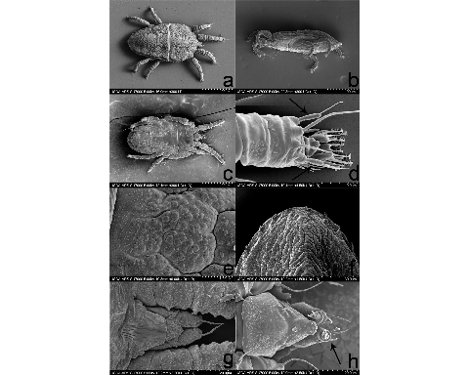

Figure 5.3: Cryo-SEM images of displaying various characters used for identification (Baker and Tuttle 1987, Beard et al. 2015) (a) Dorsum (b) Lateral view (c) Venter (d) Close up of distal end of leg 2, with arrows indicating paired solenidia, characteristic of the genus (e) Enlargement of the microplates of the mite cerotegument (f) Dorsal view of the distal portion of mite abdomen (g) Dorsal view of the mite rostrum (h) Ventral view of mite rostrum, observe 3 distal setae.