For submission to Journal of Integrated Pest Management

Category: ‘Issues’

**First report of *Orchid fleck dichorhavirus* (Mononegavirales: Rhabdoviridae) infecting various Ruscaceae in the Florida panhandle**

Austin Fife1, , Daniel Carrillo2, Gary Knox3, Kishore Dey4, Avijit Roy5, Ronald Ochoa5, Gary Bauchan5†, Mathews Paret6, Xavier Martini1*

1 University of Florida, Department of Entomology, North Florida Research and Education Center, Quincy FL 32351

2 Department of Entomology, Tropical Research and Education Center, Homestead FL 33031

3 University of Florida, Horticulture Department, North Florida Research and Education Center, Quincy FL 32351

4 DPI, FDACS, Doyle Conner Building, 1911 SW 34th street, Gainesville, FL 32608

1. USDA-APHIS, Betsville Agricultural research Center, Betsville, MD 20705

6 University of Florida, Plant Pathology Department, North Florida Research and Education Center, Quincy FL 32351

*Corresponding author

*Orchid fleck dichorhavirus* (OFV) is the type species for the genus *Dichorhavirus*, a group of plant-infecting, bacilliform, nuclear rhabdoviruses composed of two segments of single-stranded, negative-sense RNA (Dietzgen et al. 2014, Walker et al. 2018, Amarasinghe et al. 2019). Other members of this genus are: *Citrus chlorotic spot dichorhavirus*, *Citrus leprosis N dichorhavirus*, *Clerodendrum chlorotic spot dichorhavirus* and *Coffee ringspot dichorhavirus* (Dietzgen, Freitas-Astúa, et al. 2018). Flat mites from the genus *Brevipalpus* Donnadieu (Acari: Tenuipalpidae) are the only known vector for dichorhaviruses (Maeda 1998), and transmit OFV in a persistent propagative manner (Kondo et al. 2003).

OFV-infected plants exhibit various symptoms dependent on the variety of plant infected as well as the strain of the virus (Kubo et al. 2009). Symptoms initially appear as chlorotic flecks or necrotic lesions, which may ultimately coalesce into larger spots or ringspot patterns (Fig. 1).

OFV was first described infecting *Cymbidium* orchids in Japan (Doi et al. 1977). Many countries have reported OFV and OFV-like rhabdoviruses infecting orchids worldwide (Kondo et al. 2003), including Australia (Lesemann and Begtrup 1971, Lesemann and Doraiswamy 1975, Gibbs 2000), Brazil (Kitajima et al. 1974, 2001), China (Peng et al. 2017), Colombia (Kubo et al. 2009), Costa Rica (Freitas-Astúa et al. 2002), Denmark (Begtrup 1972), Fiji (Pearson et al. 1993), France (Sauvêtre et al. 2018), Germany (Petzold 1971, Lesemann and Doraiswamy 1975), Korea (Chang 1991), Paraguay (Ramos-González et al. 2015), South Africa (Blanchfield et al. 2001), the United States (Blanchfield et al. 2001, Bratsch et al. 2015) and Vanuatu (Pearson et al. 1993). The prevalence of OFV and its mite vector is thought to be associated with the movement of infected orchids (Dietzgen, Freitas-Astúa, et al. 2018).

OFV naturally infects 50+ spp of Orchidaceae (Kitajima et al. 2010, Peng et al. 2013), some Ruscaceae (Mei et al. 2016), and *Citrus* (García-Escamilla et al. 2018, Beltran-Beltran et al. 2020). Mechanical transmission of OFV is possible under lab conditions to various *Chenopodiaceae*, *Aizoaceae*, *Fabaceae*, and *Solanaceae* (Chang et al. 1976, Kondo et al. 2003, Peng et al. 2013).

On June 2020, chlorotic ringspot symptoms were observed on the liriopogon Giant Lilyturf *Liriope* spp., cv. ‘Gigantea’ (‘Giant Lilyturf’ have been traditionally classified as *Liriope gigantea* (Broussard 2007, Fantz et al. 2015), but Wang et al. (2014) and Masiero et al. (2020) consider Giant Lilyturf to be a cultivar of *Liriope muscari*) in the landscape of Leon County, Florida. Liriopogons encompasses the genera *Liriope* sp*.* and *Ophiopogon* sp*.* and are often referred to the common names: monkey grasses, Aztec grasses, lilyturf etc. Native to southeast Asia, *Liriope* sp. contains eight species of which four are commonly cultivated, and *Ophiopogon* sp. consists of about 65 species but only a handful are commonly cultivated (Lattier et al., 2014; Nesom 2010). Liripogons are the most important ground cover sold by the nursery industry in southeastern US (Mcharo et al., 2003). They are characterized by evergreen long grass-like leaves, erected flowers and berry like fruits.

Plant samples were initially tested at the Plant Disease Diagnostic Clinic at the North Florida Research and Education Center (NFREC) in Quincy, FL. The plant samples were tested for a wide range of pathogens including XXXX, but the results were inconclusive. The infected materials were subsequently sent to the Florida Department of Agriculture and Consumer Services (FDACS) that determined the pathogen to be *Orchid fleck dichorhavirus* OFV-2 via RT-qPCR with a partial sequence match, following the procedures described by Kubo et al. (2009). Further samples were taken from other *Liriope* spp., *Ophiopogon* spp., as well as *Aspidistra elatior* Blume (Asparagales: Ruscaceae) in Leon county. All symptomatic plants were tested positive for OFV.

More cases of OFV-infected ruscaceae were observed in subsequent visits to the initial site of collection (Fig. 2). After a brief search, it appears that the disease is widely distributed in Florida, with symptomatic plants found in Leon, Alachua and Duval counties.

In addition, flat mites were collected from symptomatic plants and initially identified as *Brevipalpus californicus* (Banks) *sensu lato* with phase contrast microscopy at the NFREC. *Brevipalpus* mites are widespread and known to feed on a large variety of economically-important plants (Childers et al. 2003, Akyazi et al. 2017). Identification confirmation was made by Dr. Sam Bolton at the FDACS, who verified the *B. californicus* group using Differential Interference Contrast (DIC) microscopy. Light microscopy is not considered sufficient to verify species identity in this group, so additional samples of the mites were sent to the Electron & Confocal Microscopy Unit at the United States Department of Agriculture in Beltsville, Maryland. The mites were observed with cryo-Scanning Electron Microscopy techniques. Cryo-SEM revealed that these mites may be a new subspecies in the *Brevipalpus* group, associated with ruscaceae (Fig. 3).

The earliest mention of a virus which may have been OFV is Ko et al. (1985), who detected nuclear inclusions caused by an undescribed bacilliform rhabdovirus. Ko et al. (1985) described the spoke-wheel configurations typically associated with OFV (see (Chang et al. 1976)), in *Brassia* orchids, but unfortunately made no mention of mites or further investigations of this virus.

The first certain report of OFV in the US was made by Bratsch et al. (2015), who confirmed the presence of OFV in *Phalaenopsis* hybrids in the US, using TEM of ultrathin sections of plant tissue as well as molecular sequence analysis. In addition, Bratsch et al. (2015) detected *Brevipalpus* mites and their exoskeletons associated with OFV-infected plants. It appears that Bratsch et al. (2015) did not make a conclusive species identification, but did cite Kondo et al. (2003), suggesting that they suspected *B. californicus* as their vector.

OFV has been reported in other ruscaceae in Australia (Mei et al. 2016, Dietzgen, Tassi, et al. 2018), including *Liriope spicata* (Thunb.) Lour. (Mei et al. 2016). We are not aware of any record which reports OFV infection in *Ophiopogon* plants. Unfortunately, liriopogons species are very similar in appearance and growth habit, with few useful characters used for their classification (Fantz 2008a). Furthermore, the horticultural industry has created a diverse array of cultivars of these plants, which are often mislabeled (Fantz 2008a). Aside from the horticultural confusion created by humans, natural hybrids between *Ophiopogon* and *Liriope* have created another source of confusion for phylogeny (Zhou et al. 2009). Together, these factors make it difficult to differentiate and identify species in the landscape. These sources of error may be accounted for in the future via sequence comparisons of the OFV-infected plants, but these comparisons are beyond the scope of our current report. Nonetheless, we are confident that ours is the first report of OFV infecting *Aspidistra elatior*; although (Zheng et al. 2013) mentions the association of *B. californicus* with *A. elatior* they make no mention of OFV symptoms in this plant.

Detecting OFV in Florida represents a concern for horticulturalist which grow susceptible plants of economic importance such as *Liriope*, *Ophiopogon*, and other susceptible *Asparagales* spp. which are commonly used in landscaping. Florida is also home to a plethora of native and naturalized orchid species, many of which are threatened, including the famous Ghost Orchid, *Dendrophylax lindenii* (Lindl.) Benth. ex Rolfe. Furthermore, OFV represents an obstacle to overcome for the burgeoning interest in cultivating Vanilla in southern Florida (Chambers et al. 2019). Lastly, some OFV isolates, including OFV-2, are known to be involved with nuclear types of Citrus Leprosis (Roy et al. 2015), which may be a cause for concern for the citrus industry. In fact, Kitajima et al. (2011) found that the Citrus Leprosis virus which previously affected Florida citrus was a nuclear type of citrus leprosis, which are closely related to OFV strains (Roy et al. 2013). *B. californicus* and *B. yothersi* are both known vectors of Dichorhaviruses (OFV) and Cileviruses (Citrus Leprosis) (Knorr 1968, Kondo et al. 2003, Beltran-Beltran et al. 2020) and *B. obovatus* is a suspected vector as well (Childers et al. 2003). All three mite species/complexes are present in Florida (Childers et al. 2003, Akyazi et al. 2017) (see Fig. 4), therefore it is critical to monitor the spread of Orchid Fleck Virus and its mite vector(s) to determine what risk this virus represents for plants in Florida and the surrounding regions.

**Acknowledgement:** We thank Sam Bolton for confirmation of the mite group. This research was partly funded by the USDA National Institute of Food and Agriculture, Hatch project FLA-NFC-005607.

**References:**

Akyazi, R., E. A. Ueckermann, and O. E. Liburd. 2017. New report of *brevipalpus yothersi* (prostigmata: Tenuipalpidae) on blueberry in Florida. Florida Entomologist. 100: 731–739.

Amarasinghe, G. K., M. A. Ayllón, Y. Bào, C. F. Basler, S. Bavari, K. R. Blasdell, T. Briese, P. A. Brown, A. Bukreyev, A. Balkema-Buschmann, U. J. Buchholz, C. Chabi-Jesus, K. Chandran, C. Chiapponi, I. Crozier, R. L. de Swart, R. G. Dietzgen, O. Dolnik, J. F. Drexler, R. Dürrwald, W. G. Dundon, W. P. Duprex, J. M. Dye, A. J. Easton, A. R. Fooks, P. B. H. Formenty, R. A. M. Fouchier, J. Freitas-Astúa, A. Griffiths, R. Hewson, M. Horie, T. H. Hyndman, D. Jiāng, E. W. Kitajima, G. P. Kobinger, H. Kondō, G. Kurath, I. V. Kuzmin, R. A. Lamb, A. Lavazza, B. Lee, D. Lelli, E. M. Leroy, J. Lǐ, P. Maes, S.-Y. L. Marzano, A. Moreno, E. Mühlberger, S. V. Netesov, N. Nowotny, A. Nylund, A. L. Økland, G. Palacios, B. Pályi, J. T. Pawęska, S. L. Payne, A. Prosperi, P. L. Ramos-González, B. K. Rima, P. Rota, D. Rubbenstroth, M. Shı̄, P. Simmonds, S. J. Smither, E. Sozzi, K. Spann, M. D. Stenglein, D. M. Stone, A. Takada, R. B. Tesh, K. Tomonaga, N. Tordo, J. S. Towner, B. van den Hoogen, N. Vasilakis, V. Wahl, P. J. Walker, L.-F. Wang, A. E. Whitfield, J. V. Williams, F. M. Zerbini, T. Zhāng, Y.-Z. Zhang, and J. H. Kuhn. 2019. Taxonomy of the order Mononegavirales: Update 2019. Archives of Virology 164: 1967–1980.

Begtrup, J. 1972. Structure of a bacilliform virus in *Dendrobium* as revealed by negative staining. Journal of Phytopathology 75: 268–273.

Beltran-Beltran, A. K., M. T. Santillán-Galicia, A. W. Guzmán-Franco, D. Teliz-Ortiz, M. A. Gutiérrez-Espinoza, F. Romero-Rosales, and P. L. Robles-Garcı́a. 2020. Incidence of citrus leprosis virus c and orchid fleck dichorhavirus citrus strain in mites of the genus *Brevipalpus* in Mexico. Journal of Economic Entomology 113: 1576–1581.

Blanchfield, A. L., A. M. Mackenzie, A. Gibbs, H. Kondo, T. Tamada, and C. R. Wilson. 2001. Identification of orchid fleck virus by reverse transcriptase-polymerase chain reaction and analysis of isolate relationships. Journal of Phytopathology 149: 713–718.

Bratsch, S. A., B. E. Lockhart, and C. Ishimaru. 2015. Confirmation of first report of orchid fleck virus in *Phalaenopsis* hybrid orchids in the USA. Plant Health Progress 16: 146–148.

Broussard, M. C. 2007. A horticultural study of L*liriope* and *Ophiopogon*: Nomenclature, morphology, and culture (PhD thesis).

Chambers, A. H., P. Moon, V. Edmond, and E. Bassil. 2019. Vanilla cultivation in southern Florida. EDIS 2019: 7.

Chang, M. U. 1991. Studies on the viruses in orchids in Korea. 2. *Dendrobium mosaic virus, Odontoglossum ringspot virus, Orchid fleck virus* and unidentified potyvirus. Korean J Plant Pathol 7: 118–129.

Chang, M. U., A. Kei, D. Yoji, and Y. Kiyoshi. 1976. Morphology and intracellular appearance of *Orchid fleck virus*. Japanese Journal of Phytopathology 42: 156–157.

Childers, C. C., J. C. V. Rodrigues, and W. C. Welbourn. 2003. Host plants of *brevipalpus californicus*, *b. Obovatus*, and *b. Phoenicis* (acari: Tenuipalpidae) and their potential involvement in the spread of viral diseases vectored by these mites. Experimental and Applied Acarolog 30: 29–105.

Dietzgen, R. G., J. Freitas-Astúa, C. Chabi-Jesus, P. L. Ramos-González, M. M. Goodin, H. Kondo, A. D. Tassi, and E. W. Kitajima. 2018. Dichorhaviruses in their host plants and mite vectors, pp. 119–148. *In* Advances in Virus Research. Elsevier.

Dietzgen, R. G., J. H. Kuhn, A. N. Clawson, J. Freitas-Astúa, M. M. Goodin, E. W. Kitajima, H. Kondo, T. Wetzel, and A. E. Whitfield. 2014. Dichorhavirus: A proposed new genus for *Brevipalpus* mite-transmitted, nuclear, bacilliform, bipartite, negative-strand RNA plant viruses. Archives of Virology 159: 607–619.

Dietzgen, R. G., A. D. Tassi, J. Freitas-Astúa, and E. W. Kitajima. 2018. First report of orchid fleck virus and its mite vector on green cordyline. Australasian Plant Disease Notes 13.

Doi, Y., M. U. Chang, and K. Yora. 1977. Orchid fleck virus. CMI/AAB descriptions of plant viruses.

Fantz, P. R. 2008a. Macrophytography of cultivated liriopogons and genera delineation. HortTechnology 18: 334–342.

Fantz, P. R. 2008b. Species of *Liriope* cultivated in the southeastern United States. HortTechnology 18: 343–348.

Fantz, P. R. 2009. Names and species of *Ophiopogon* cultivated in the southeastern United States. HortTechnology 19: 385–394.

Fantz, P. R., D. Carey, T. Avent, and J. Lattier. 2015. Inventory, descriptions, and keys to segregation and identification of liriopogons cultivated in the southeastern United States. HortScience 50: 957–993.

Freitas-Astúa, J., L. Moreira, C. Rivera, C. M. Rodrı́guez, and E. W. Kitajima. 2002. First report of orchid fleck virus in Costa Rica. Plant Disease 86: 1402–1402.

García-Escamilla, P., Y. Duran-Trujillo, G. Otero-Colina, G. Valdovinos-Ponce, M. T. Santillán-Galicia, C. F. Ortiz-Garcı́a, J. J. Velázquez-Monreal, and S. Sánchez-Soto. 2018. Transmission of viruses associated with cytoplasmic and nuclear leprosis symptoms by *Brevipalpus yothersi* and *B. californicus*. Tropical Plant Pathology 43: 69–77.

Gibbs, A. 2000. Viruses of orchids in Australia; their identification, biology and control. The Australian Orchid Rev 65: 10–21.

Kitajima, E. W., A. Blumenschein, and A. S. Costa. 1974. Rodlike particles associated with ringspot symptoms in several orchid species in Brazil. Journal of Phytopathology 81: 280–286.

Kitajima, E. W., C. M. Chagas, R. Harakava, R. F. Calegario, J. Freitas-Astúa, J. C. V. Rodrigues, and C. C. Childers. 2011. Citrus leprosis in Florida, USA, appears to have been caused by the nuclear type of citrus leprosis virus (CilLV-N). Virus Reviews & Research 16.

Kitajima, E. W., H. Kondo, A. Mackenzie, J. A. M. Rezende, R. Gioria, A. Gibbs, and T. Tamada. 2001. Comparative cytopathology and immunocytochemistry of Japanese, Australian and Brazilian isolates of *Orchid fleck virus*. Journal of General Plant Pathology 67: 231–237.

Kitajima, E. W., J. C. V. Rodrigues, and J. Freitas-Astua. 2010. An annotated list of ornamentals naturally found infected by *Brevipalpus* mite-transmitted viruses. Scientia Agricola 67: 348–371.

Knorr, L. C. 1968. Studies on the etiology of leprosis in citrus. *In* International Organization of Citrus Virologists Conference Proceedings.

Ko, N.-J., F. W. Zettler, J. R. Edwardson, and R. G. Christie. 1985. Light microscopic techniques for detecting orchid viruses. Acta Horticulturae 241–254.

Kondo, H., T. Maeda, and T. Tamada. 2003. Orchid fleck virus: *Brevipalpus californicus* mite transmission, biological properties and genome structure. Experimental and Applied Acarology 30: 215–223.

Kubo, K. S., J. Freitas-Astúa, M. A. Machado, and E. W. Kitajima. 2009. Orchid fleck symptoms may be caused naturally by two different viruses transmitted by *Brevipalpus*. Journal of General Plant Pathology 75: 250–255.

Lattier, J. D., T. G. Ranney, P. R. Fantz, T. Avent. 2014. Identification, nomenclature, genome sizes, and ploidy levels of *Liriope* and *Ophiopogon* taxa. HortScience 49: 145-151.

Lesemann, D., and J. Begtrup. 1971. Elektronenmikroskopischer nachweis eines bazilliformen virus in *Phalaenopsis*. Journal of Phytopathology. 71: 257–269.

Lesemann, D., and S. Doraiswamy. 1975. Bullet-shaped virus-like particles in chlorotic and necrotic leaf lesions of orchids. Journal of Phytopathology 83: 27–39.

Maeda, T. 1998. Evidence that orchid fleck virus is efficiently transmitted in a persistent manner by the mite *Brevipalpus californicus*. Abstr., 7th Int. Cong. Plant Pathol. 3.

Masiero, E., D. Banik, J. Abson, P. Greene, A. Slater, and T. Sgamma. 2020. Molecular verification of the UK national collection of cultivated *Liriope* and *Ophiopogon* plants. Plants 9: 558.

Mcharo, M., E. Bush, D. La Bonte, C. Broussard, L. Urbatsch. 2003. Molecular and morphological investigation of ornamental liriopogons. *Journal of the American Society for Horticultural Science*, *128*(4), 575-577.

Mei, Y., N. Bejerman, K. S. Crew, N. McCaffrey, and R. G. Dietzgen. 2016. First report of orchid fleck virus in lilyturf (*Liriope spicata*) in Australia. Plant Disease 100: 1028–1028.

Nesom, G. L. 2010. Overview of *Liriope* and *Ophiopogon* (Ruscaceae) naturalized and commonly cultivated in the USA. Phytoneuron 56 : 1-31.

Pearson, M. N., G. V. H. Jackson, S. P. Pone, and R. L. J. Howitt. 1993. Vanilla viruses in the South Pacific. Plant Pathology 42: 127–131.

Peng, D. W., G. H. Zheng, Q. X. Tong, Z. Z. Zheng, and Y. L. Ming. 2017. First report of orchid fleck dichorhavirus from *Cymbidium* sp. In China. Plant Disease 101: 514–514.

Peng, D. W., G. H. Zheng, Z. Z. Zheng, Q. X. Tong, and Y. L. Ming. 2013. Orchid fleck virus: An unclassified bipartite, negative-sense RNA plant virus. Archives of Virology 158: 313–323.

Petzold, H. 1971. Der elektronenmikroskopische nachweis eines bacilliformen virus an blattfleckenkranken *Dendrobien*. Journal of Phytopathology 70: 43–52.

Ramos-González, P. L., H. Sarubbi-Orue, L. Gonzales-Segnana, C. Chabi-Jesus, J. Freitas-Astúa, and E. W. Kitajima. 2015. Orchid fleck virus infecting orchids in Paraguay: First report and use of degenerate primers for its detection. Journal of Phytopathology 164: 342–347.

Roy, A., J. S. Hartung, W. L. Schneider, J. Shao, G. Leon, M. J. Melzer, J. J. Beard, G. Otero-Colina, G. R. Bauchan, R. Ochoa, and R. H. Brlansky. 2015. Role bending: Complex relationships between viruses, hosts, and vectors related to citrus leprosis, an emerging disease. Phytopathology 105: 1013–1025.

Roy, A., A. L. Stone, G. Otero-Colina, G. Wei, R. H. Brlansky, R. Ochoa, G. Bauchan, W. L. Schneider, M. K. Nakhla, and J. S. Hartung. 2020. Reassortment of genome segments creates stable lineages among strains of orchid fleck virus infecting citrus in Mexico. Phytopathology 110: 106–120.

Roy, A., A. Stone, G. Otero-Colina, G. Wei, N. Choudhary, D. Achor, J. Shao, L. Levy, M. K. Nakhla, C. R. Hollingsworth, J. S. Hartung, W. L. Schneider, and R. H. Brlansky. 2013. Genome assembly of citrus leprosis virus nuclear type reveals a close association with orchid fleck virus. Genome Announcements 1.

Sauvêtre, P., E. Veniant, G. Croq, A. D. Tassi, E. W. Kitajima, C. Chabi-Jesus, P. L. Ramos-González, J. Freitas-Astúa, and D. Navia. 2018. First report of orchid fleck virus in the orchid collection of jardin du luxembourg, Paris, France. Plant Disease 102: 2670–2670.

Walker, P. J., K. R. Blasdell, C. H. Calisher, R. G. Dietzgen, H. Kondo, G. Kurath, B. Longdon, D. M. Stone, R. B. Tesh, N. Tordo, N. Vasilakis, and A. E. Whitfield. 2018. ICTV virus taxonomy profile: Rhabdoviridae. Journal of General Virology 99: 447–448.

Wang, G.-Y., Y. Meng, J.-L. Huang, and Y.-P. Yang. 2014. Molecular phylogeny of *Ophiopogon* (asparagaceae) inferred from nuclear and plastid DNA sequences. Systematic Botany 39: 776–784.

Zheng, G. H., Z. Z. Zheng, Q. X. Tong, Y. L. Ming, and others. 2013. Orchid fleck virus: An unclassified bipartite, negative-sense rna plant virus. Archives of virology 158: 313–323.

Zhou, Q., J. Zhou, J. Chen, and X. Wang. 2009. Karyotype analysis of medicinal plant *Liriope spicata* var. *Prolifera* (liliaceae). Biologia 64.

Figure Captions

Figure 1: Variety of symptoms expressed by plants infected with *Orchid fleck dichorhavirus*: (a) ringspot symptoms on *Liriope gigantea* (b)

chlorosis on *Aspidistra elatior*.

Figure2: XXXXXXX

Fig. 3: Cryo-SEM images of *Brevipalpus californicus* sensu lato used for identification (a) Dorsum (b) Lateral view (c) Venter (d) Close up of distal end of leg 2, with paired solenidia (e) Enlargement of the microplates of the mite cerotegument (f) Dorsal view of the distal portion of mite abdomen (g) Dorsal view of the mite rostrum (h) Ventral view of mite rostrum Cryo-SEM images provided by Dr. Gary Bauchan, USDA-ARS 2021

Figure 4: Florida is home to other common pest species of *Brevipalpus* which are potential vectors of *Orchid fleck dichorhavirus*: (a) *B. yothersi*, dorsal (b) *B. yothersi*, lateral (c) *B. obovatus*, dorsal

|  |  |  |
| --- | --- | --- |
| Scientific Name | Common Names | Symptoms Observed |
| *Liriope muscari* Bailey | Lilyturf, Orchardgrass, Monkeygrass | Ringspots, Chlorotic Flecking, Necrotic Lesions |
| *Liriope gigantea*\* Hume | Giant Lilyturf | Ringspots, Chlorotic Flecking, Necrotic Lesions |
| *Ophiopogon japonicus* Ker Gawl. | Dwarf Lilyturf, Mondo Grass, Snake’s beard | Ringspots, Chlorotic Flecking, Necrotic Lesions |
| *Ophiopogon intermedius*\*\* Don | Aztec Grass, ‘Argenteomarginatus’ | Ringspots, Chlorotic Flecking, Necrotic Lesions |
| *Aspidistra elatior* Blume | Cast Iron Plant, Bar-room Plant | Chlorosis, Necrotic Lesions |

**Table 1:** List of plants with symptoms of Orchid fleck dichorhavirus found in northern Florida. * *L. gigantea* have been traditionally classified as seperate from *L. muscari* by Broussard (2007) and Fantz et al. (2015), although this distinction has been challenged by Wang et al. (2014) and Masiero et al. (2020). * * *O. intermedius* is sometimes misclassified as *Liriope muscari* ‘Variegated Evergreen Giant’ (Fantz 2008b) or ‘Grandiflora White’ (Fantz 2009).

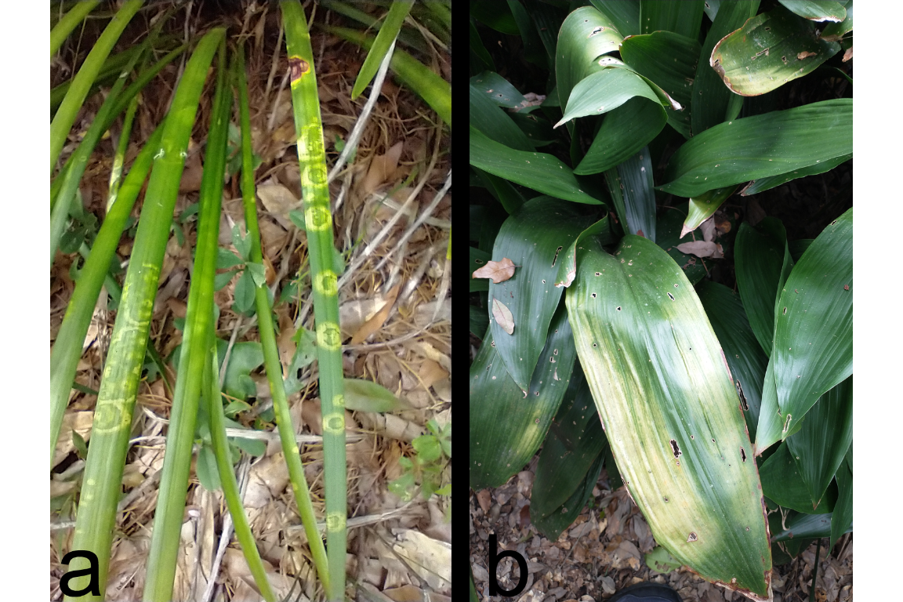

Figure 1

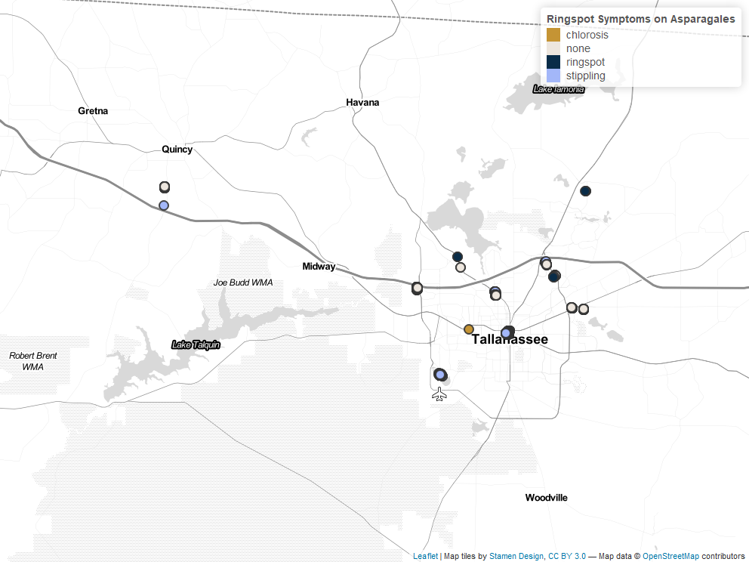

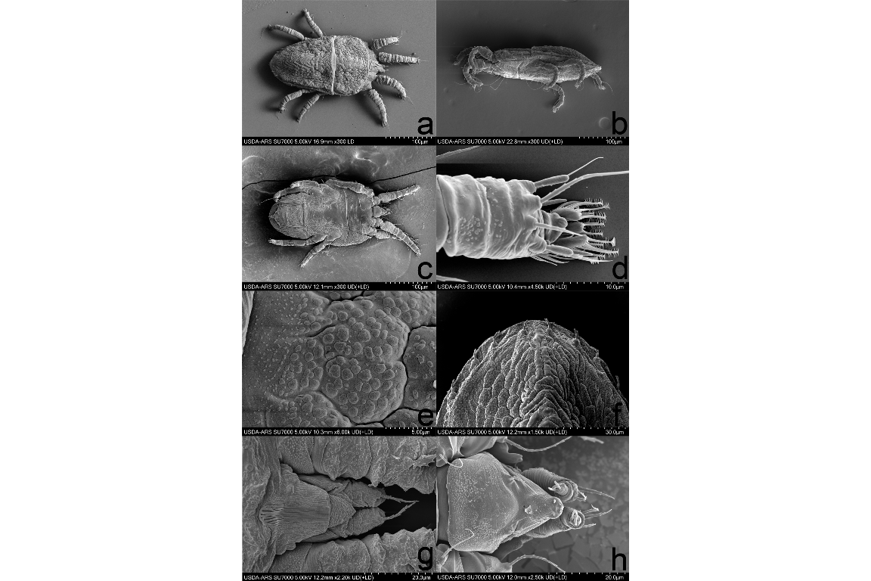

Figure 4