# Biocontrol of *Phyllocoptes fructiphilus*

**Treatments:**

1. Water - Control
2. Actigard - 100 mg/L (Full rate)
3. Ninja - Full rate
4. Kontos - Full rate
5. *A. swirskii* (one sachet per rose)
6. *A. swirskii* + Ninja (one sachet per rose, Full rate)

**Application Instructions**

* We have six treatments, with 16 roses per treatment, in a split plot design. There are four zones, A, B, C and D. We will be sampling rose flowers from the four different zone each week, rotating through rows until all rows have been sampled three times (12 sampling dates). Each zone contains 16 plants, with four plants for each treatment, which allows us to get a good subset of the overall design with each weeks’ sample. The rows are designed to minimize the spread of the predatory mites, with the mite treatments central to the other treatments, and mirrored on both sides. This design should increase the probability that mites contaminate compatible treatments rather than treatments where they should not be. It is also designed to allow for easier treatment applications for the central rows, with their treatment combinations. In order to avoid confusion, each rose pot should be labeled with a stake that has the zone, treatment abbreviations: (W, A, K, M, N, +) and plant number listed on it. Please review ‘pmite_map_2019.pdf’ for plot arrangement and spray treatments:

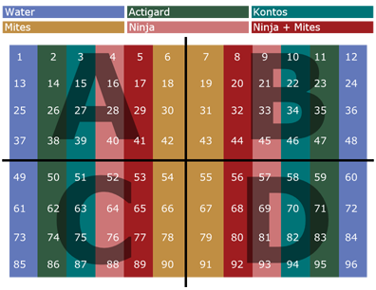

* *Phyllocoptes fructiphilus infestation*: rose cuttings ~12 cm should be taken from roses in the landscape showing symptoms of Rose Rosette Disease and placed in each rose pot on the 1st and 4th week of the experiment.
* *Amblyseius swirskii release*: mites should be applied on the 1st and 4th week of the experiment three days after infestation with *P. fructiphilus*. Using the supplied hooks, hang one sachet from the middle of each rose pot.
* Chemical applications (Ninja, Actigard, Kontos) should be done on the same day each week, weather permitting, preferably at the beginning of the week.

**Data Collection**

* will be collecting flower samples from *all* roses only twice: once before beginning the treatments and once at the end of the experiment.
* For weeks 2 through 12, we will collect from one row per week, starting with first row rotating through the rows until each rows has been sampled three times.
* We will be rating disease severity for every rose each week before we spray, rating roses according to the Horsfall-Barratt Scale as described in the ‘disease_severity_scale.docx’ file. The same people should be taking the ratings each week to avoid differences between observers.

**Sample Processing**

* 50 ml centrifuge tubes should be labeled on the side with the date, plant zone, treatment and number. The lid should be labeled with zone and plant number, then the tube filled with 15 ml of 95% ethanol.
* Take a floral cutting large enough to fill the centrifuge tubes provided (about ~10 cm) and place the flower petal side down in the tube so the entire flower is submerged in alcohol over the sepals. Make sure the lid is tight, then shake the tube vigorously for a few seconds to help dislodge any mites. Make sure that no alcohol gets on the exterior of the tubes and dissolves labels, otherwise the labels should be rewritten. These tubes should be stored vertically so that the flower and sepals remain submerged in the alcohol. These tubes can be kept at room temperature until Austin visits to count mites on the 5th and 10th week.
* Once a plant is seen with symptoms take an extra sample, and sent it to Fanny for diagnostic confirmation for RRV.

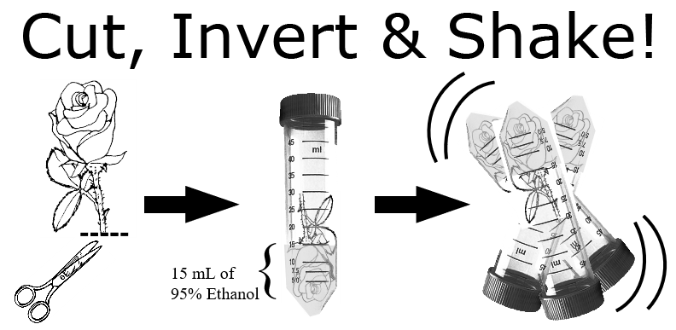

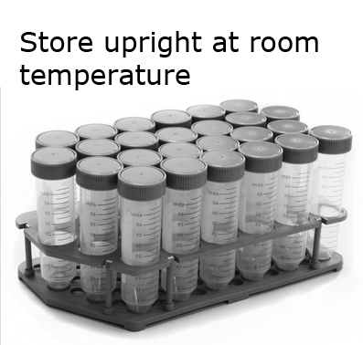

If there are any questions, comments, data loss or problems, please call or email Dr. Xavier Martini (xmartini@ufl.edu, 850-875-7160) or Austin Fife (afife@ufl.edu, 208-874-2283) as soon as possible.