# Biocontrol of *Phyllocoptes fructiphilus*

## Plot Map and Applications:

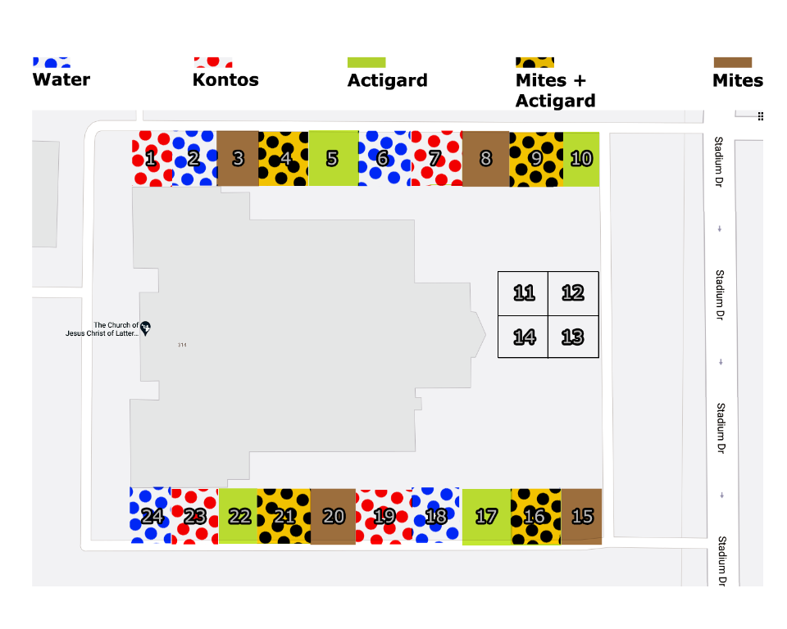

### Plot Design:

Spray applications should be done once weekly, preferably on the same day each week, weather permitting. There are five (5) treatments, divided into two (2) blocks. There are ten (10) plots on each side of the building. Each plot is delineated by the adjacent parking spaces and wooden stakes which indicate the edges of the plots. We will be only be collecting samples from the six (6) roses in the middles of each plot, while leaving a buffer of untreated roses between each plot to avoid treatment drift. This is a 12 week experiment.

Only six (6) roses will need to be sprayed in each plot. Each rose is marked with colored flags, indicating its treatment:

### Treatments & Symbols:

1. W - Blue Polka Dots = Water (Positive Control)
2. K - Red Polka Dots = Kontos (Spirotetramat) Bayer - High rate (Negative Control)
3. A - Green = Actigard 50 WG (Acibenzolar-S-methyl) Syngenta - 100 mg/L (High Rate)
4. M - Brown = *Amblyseius swirskii* (Predatory Mite) Arbico Organics - (two sachets per rose in treated plot)
5. + - Yellow with Black Polka Dots = Actigard (High Rate) + *A. swirskii*

### Mixing Ratios for Treatments:

1. Water: 2.65 L of water
2. Kontos: 2.65 L of water + 703 µL Kontos (Full Rate)
3. Actigard: 2.65 L of water + 198 mg Actigard (Full Rate)
4. Mites: 2.65 L of water
5. Actigard + Mites: 2.65 L of water + 198 mg Actigard (Full Rate)

### Sampling Supplies:

* 95% Ethanol
* 500 mL Nalgene Bottles (labeled with date, plot # and treatment)
* Pruners/Secateurs

500 ml bottles should be filled with ~15 ml of 95% ethanol. Use a china marker to label side of the bottle and the lid with the date, plot number and treatment abbreviation for future sample collection and data entry.

### Predatory Mite Applications:

Two sachets of *Amblyseius swirskii* mites should be applied to each of the six (6) flagged roses on the 1st, 5th and 9th week of the experiment. Follow the application instructions for ‘mini sachets with hooks’ given in the attached ‘Ambly-S.pdf’. These sachets contain live colonies of *A. swirskii* and a mite which they consume for food. There is a small hole at the bottom of the sachet where the mites will leave and climb on the roses searching for food, so you will want the sachet to be located inside of the rose leaves and off of the ground. The mites have optimal reproduction at ~25°C and ~75% RH, but will be find so long as they are not refrigerated or exposed to extreme heat.

* **We will still spray these mite-only plots with a water treatment every week in order to keep conditions similar to other treatments!**

### Data Collection & Sampling Plan:

**We will be sampling flower cuttings from each of the six (6) flagged roses each week:**

* Take three (3) flowers (buds if no flowers present) from each of the six (6) flagged roses, for a total of 18 flowers/buds per bottle for each plots. **Make sure to collect 18 flowers/buds from any rose in the untreated plots 11-14 for the phenology study as well.** Place the flowers/buds into the ethanol-filled bottles provided, make sure the lid is tight, then shake the bottle vigorously for a few seconds to coat the rose tissue with ethanol and help dislodge any mites.
* Use the sieves to separate mites from the plant tissues. (see *name of protocol sheet* for more information).
* Dry plant tissues in the appropriately labeled, high-tech *paper bag* and put into the oven until dry (~48 hrs at 50 °C), then weigh the rose tissue and record the dry weight (remember to tare the scale with a paper bag for slightly improved accuracy).

### If a rose shows symptoms of Rose Rosette Disease:

-Please take a sample of the infected tissue and send it to Dr. Fanny Iriarte:

Plant Disease Diagnostic Clinic  
155 Research Road  
Quincy, FL 32351  
Phone: 850-875-7140  
Fax: 352-846-6617  
fbiriarte@ufl.edu

## Spray Map

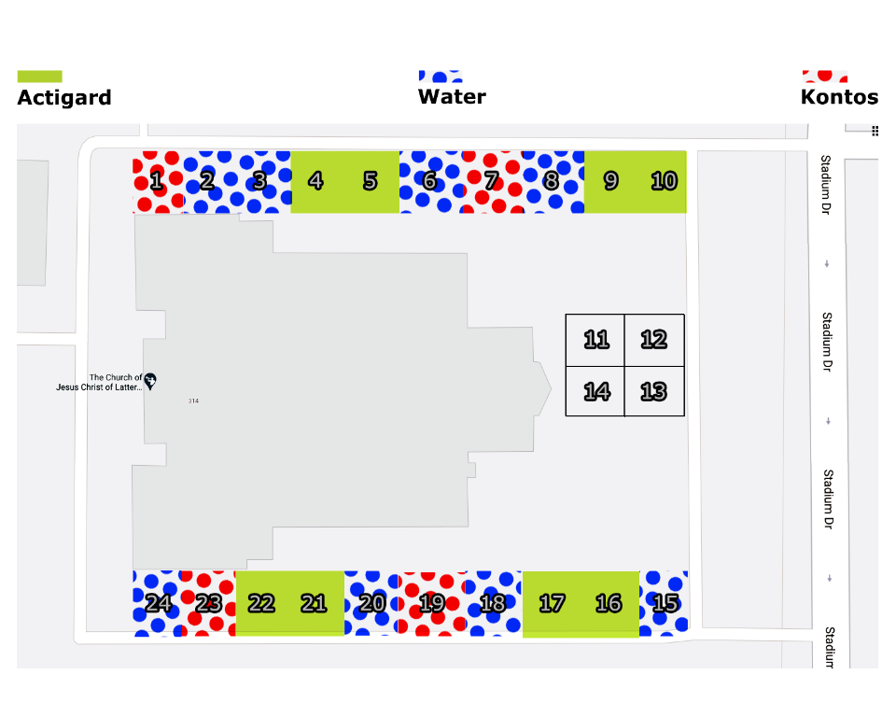

Notice that the **site flagging does not follow this map**, but instead is flagged like the first map seen above. This is only to illustrate that some mite plots are sprayed with water and other mite treatments are sprayed with actigard, so the spray treatments aren’t as complicated as the first map makes it appear to be

If there are any questions, comments, confusion, or problems, please call or email Dr. Xavier Martini (xmartini@ufl.edu, 850-875-7160) or Austin Fife (afife@ufl.edu, 208-874-2283) as soon as possible.

*last modified: 22. July 2021*