APL Logistics Profitability Intelligence
[Student Name]
Supply Chain Analytics Project

Abstract—This study analyses 180,519 APL Logistics order-line records to identify the commercial factors associated with revenue, profitability, customer value, product performance, and discounting. The dataset covers five markets, 50 product categories, and 20,652 customers. Recorded sales total $36.78M and profit totals $3.97M, producing a 10.8% overall profit margin. A Streamlit dashboard built with Python, Pandas, and Plotly presents market, customer, category, product, and discount insights. The results show strong profit concentration in Europe and LATAM, variation in customer-segment contribution, and lower margins at higher discount levels. The paper recommends discount guardrails, customer-value tiers, and routine profitability monitoring.
Index Terms—supply chain analytics, profitability, customer value, discount analysis, exploratory data analysis, Streamlit.
I. INTRODUCTION
Supply-chain decisions benefit from connecting commercial activity with financial outcomes. The APL Logistics dashboard brings sales, profit, customers, products, discounts, categories, and markets into one view. It supports descriptive exploratory data analysis (EDA) rather than causal inference, and addresses three questions: which entities create value, how discounting relates to margin, and where management attention should be directed.
II. DATA AND METHODOLOGY
The analysis uses the supplied APL_Logistics.csv data set [1]. Each record is treated as an order-line item. The source file was read with Latin-1 encoding, relevant numerical fields were standardized, and customer name, discount percentage, discount band, and profit margin were derived. Results were aggregated by market, customer segment, category, product, and discount band. The dashboard reports total revenue, total profit, profit margin, average discount, top and bottom customers, category-market profitability, and discount scenarios. No time-series analysis is presented because the supplied file has no order-date field.
Measure | Value
Order-line records | 180,519
Variables | 41
Customers | 20,652
Markets | 5
Product categories | 50
Total sales | $36.78M
Total profit | $3.97M
Profit margin | 10.8%
TABLE I
DATASET PROFILE AND BASELINE RESULTS
III. EXPLORATORY DATA ANALYSIS
A. Market Performance
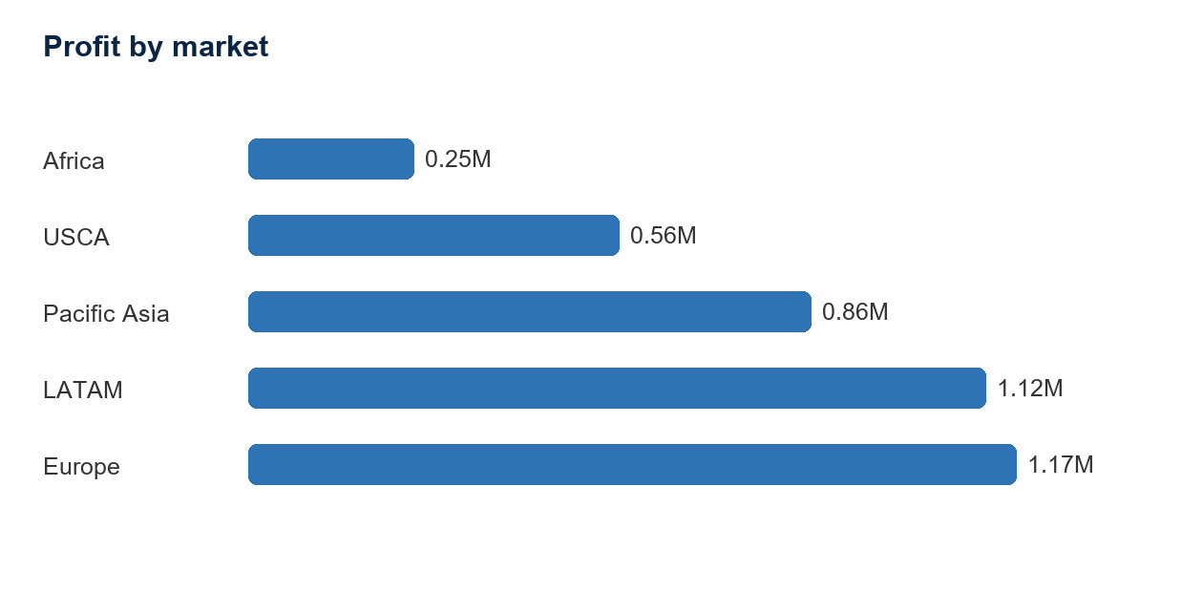
Fig. 1. Profit by market.
Europe generated the highest total profit at $1.17M, followed by LATAM at $1.12M. These markets account for a substantial share of sales and profit. Their performance should be protected while managers examine whether successful pricing, product, and customer practices can be adapted in smaller markets.
B. Customer Value
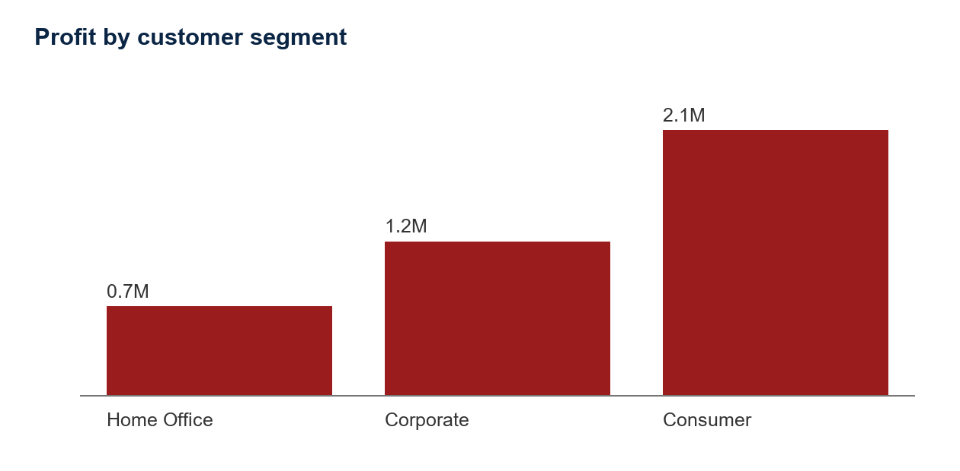
Fig. 2. Profit by customer segment.
Customer segments differ in aggregate contribution. Consumer customers generated the highest segment-level profit, while Home Office generated the lowest. The dashboard supplements this view with top and bottom customer charts and an attention table for customers with above-median revenue but margins below 10%. These measures support targeted account, retention, and pricing decisions.
C. Discount and Margin Relationship
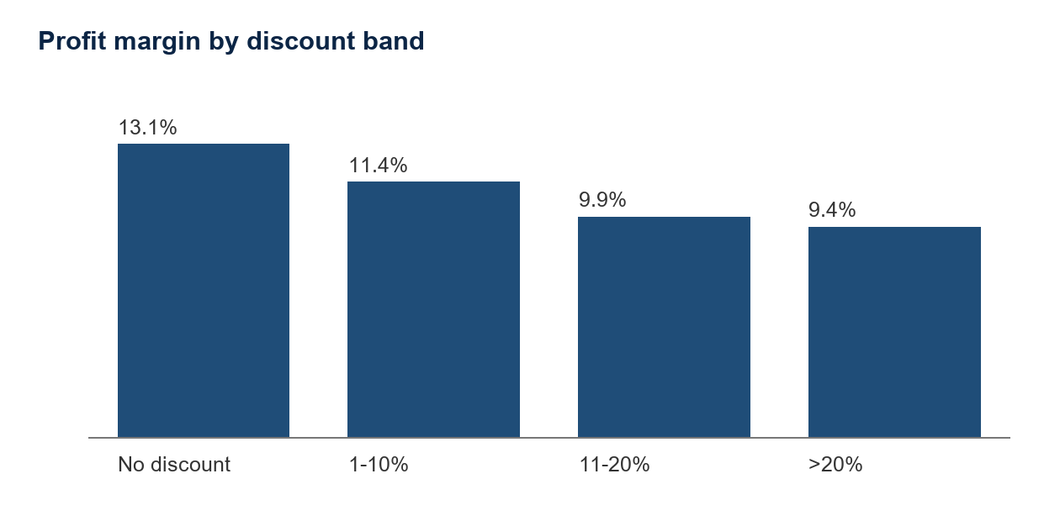
Fig. 3. Profit margin by discount band.
The average order-item discount is 10.2%. The no-discount band has the strongest aggregate margin, whereas the greater-than-20-percent band has the weakest. The dashboard exposes discount rate and profitability together and includes a what-if calculator that estimates the financial effect of a proposed uniform discount, holding observed per-line cost constant.
D. Product and Category Performance
Category | Sales | Profit
Fishing | $6.93M | $0.76M
Cleats | $4.43M | $0.49M
Camping & Hiking | $4.12M | $0.43M
Cardio Equipment | $3.69M | $0.38M
Women's Apparel | $3.15M | $0.35M
TABLE II
HIGHEST PROFIT PRODUCT CATEGORIES
Fishing is the largest profit contributor, followed by Cleats and Camping & Hiking. These categories should receive disciplined pricing, promotion, and availability monitoring. Lower-margin products can be identified through the product-level margin analysis before additional promotions are approved.
IV. RECOMMENDATIONS
First, establish category- and customer-segment-specific discount thresholds, require approval for high discounts, and review margin weekly. Second, group customers into value tiers using total profit, profit margin, and line-item volume, then adapt pricing and account-management actions by tier. Third, protect the availability and promotion discipline of high-value categories and markets. Finally, use the dashboard in a recurring management review that assigns ownership for adverse movements in profit, margin, discount, customer value, or category-market performance.
V. STAKEHOLDER IMPLICATIONS
For government and public-sector stakeholders, this dashboard demonstrates how commercial data can support transparent, margin-aware oversight. The operation covers more than 180,000 order lines and $36M in sales. Aggregated customer, category, product, market, and discount views can help frame questions about regional competitiveness, economic activity, and service strategy. These descriptive results should be combined with operational and qualitative evidence before decisions about any specific region or organization are made.
VI. LIMITATIONS AND FUTURE WORK
The analysis is descriptive and uses a single supplied data set. The lack of order dates prevents seasonal, longitudinal, and forecasting analysis. Future work should add time stamps, fulfilment cost, customer satisfaction, return data, and campaign information. These additions would support forecasting, customer-lifetime analysis, promotion measurement, and more robust predictive or causal studies.
VII. CONCLUSION
The APL Logistics dashboard converts 180,519 order-line records into a practical decision-support tool. The EDA identifies $36.78M in sales, $3.97M in profit, a 10.8% margin, value concentration in Europe and LATAM, customer-segment differences, and margin pressure associated with deeper discounts. The most immediate actions are to strengthen discount governance, use customer-value tiers, protect high-value categories, and embed profitability review in management routines.
REFERENCES
[1] APL Logistics, "APL_Logistics.csv," data set supplied for the Supply Chain Analytics Project, 2026.
[2] W. McKinney, "pandas: powerful Python data analysis toolkit." [Online]. Available: https://pandas.pydata.org/
[3] Streamlit, "Streamlit documentation." [Online]. Available: https://docs.streamlit.io/
[4] Plotly, "Plotly Python graphing library documentation." [Online]. Available: https://plotly.com/python/

