RESEARCH PAPER
APL Logistics Profitability Intelligence
Exploratory Data Analysis, Operational Insights, and Recommendations
Prepared by: [Student Name]
Project: Supply Chain Analytics Dashboard
Date: August 2026

Abstract
This applied analytics study examines 180,519 APL Logistics order-line records to identify the commercial factors associated with revenue, profitability, customer value, product performance, and discounting. The dataset contains 41 fields spanning 5 markets, 50 product categories, and 20,652 customers. Total recorded sales were $36.78M and total profit was $3.97M, producing an overall profit margin of 10.8%. The analysis was implemented as a Streamlit dashboard using Python, Pandas, and Plotly so that decision makers can interrogate the same indicators interactively. Results show strong market concentration in Europe and LATAM, variation in profit contribution across customer segments, and declining margin as discount intensity increases. The paper translates these findings into practical recommendations for pricing governance, customer strategy, and performance monitoring.
1. Introduction
Supply-chain decision making depends on connecting commercial activity with financial outcomes. A dashboard can make these relationships visible by bringing sales, profit, customer, product, discount, and market indicators into a single analytical view. This project develops an interactive profitability-intelligence dashboard for APL Logistics and uses exploratory data analysis (EDA) to frame actionable management questions.
The purpose of the study is not to establish causality. Instead, it provides a descriptive baseline that helps stakeholders prioritize investigation and commercial improvement. The core questions are: Which customers, markets, products, and categories generate the most value? How are discounts associated with margin? What actions should managers take to improve profitability while protecting customer value?
2. Data and Methodology
The analysis uses the supplied APL_Logistics.csv file. Each record is treated as an order-line item. The file was read using Latin-1 encoding, numeric fields were standardized, and derived measures were calculated for discount percentage, profit margin, and customer name. Records were aggregated by market, category, customer segment, product, and discount band.
Metric | Value
Records analysed | 180,519
Variables | 41
Customers | 20,652
Markets | 5
Product categories | 50
Total sales | $36.78M
Total profit | $3.97M
Overall profit margin | 10.8%
Table 1. Dataset profile and baseline financial results. Source: APL_Logistics.csv.
The dashboard reports total revenue, total profit, profit margin, and average discount as headline indicators. It provides market, customer, product, category, and discount analyses, including a product selector, top and bottom customer views, a category-market heatmap, and a discount scenario calculator. Because the source file does not contain an order-date field, the study does not make time-series claims or use trend forecasting.
3. Exploratory Data Analysis and Findings
3.1 Market performance
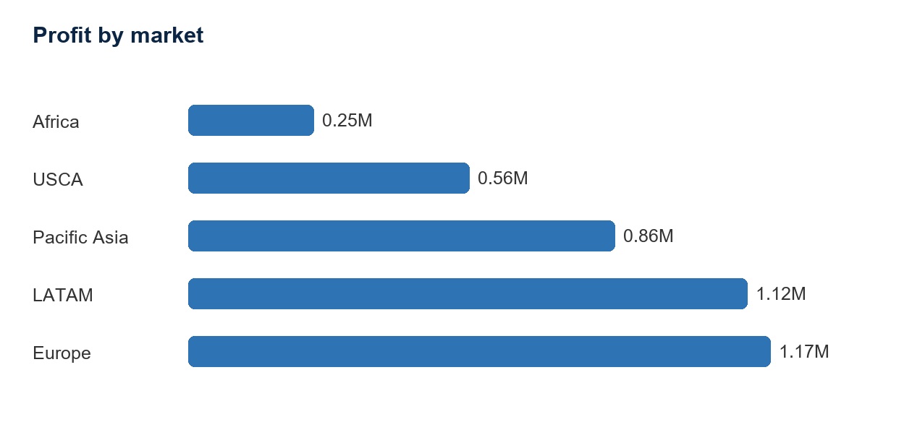
Figure 1. Profit by market. Source: APL_Logistics.csv; author calculations.
Europe generated the highest total profit at $1.17M, followed by LATAM at $1.12M. Together, these two markets account for a substantial share of overall sales and profit. This concentration creates an opportunity to protect successful commercial patterns in the leading regions while examining whether similar practices can be adapted for smaller markets.
3.2 Customer value by segment
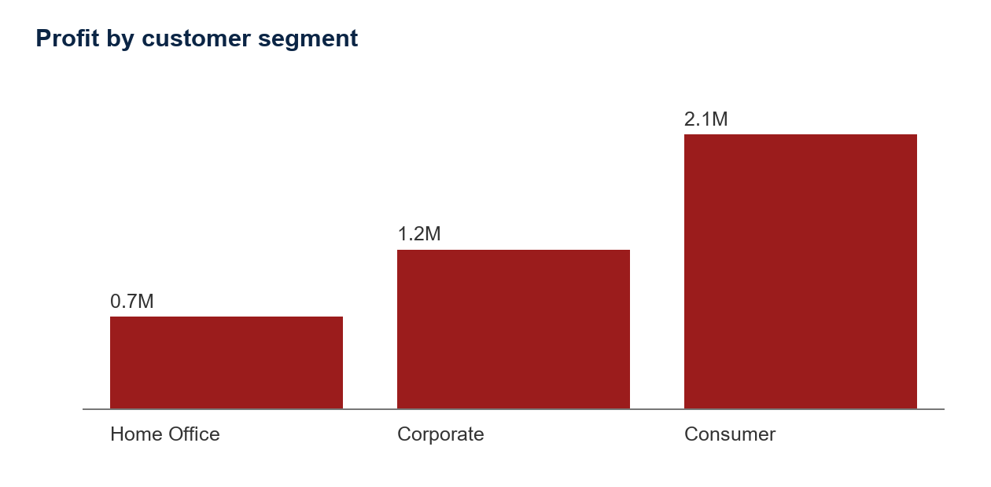
Figure 2. Profit by customer segment. Source: APL_Logistics.csv; author calculations.
Customer segments differ in their aggregate value. Consumer generated the highest segment-level profit, while Home Office generated the lowest. The dashboard complements this aggregate view with top and bottom customer charts and an attention table for customers with above-median revenue but profit margins below 10%. These views support targeted pricing, retention, and account-management decisions.
3.3 Discount and margin relationship
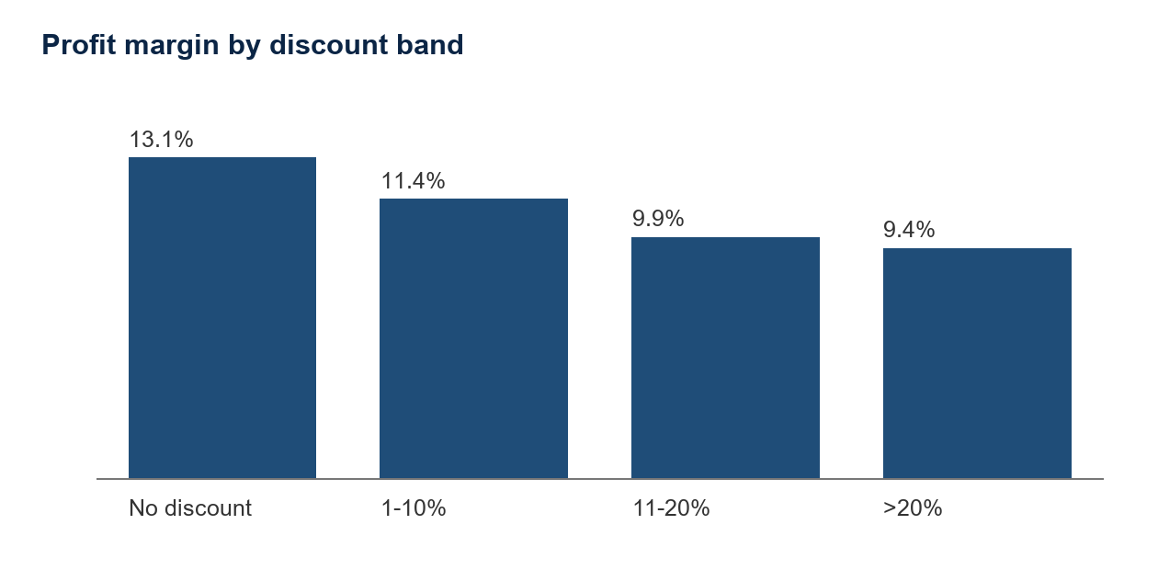
Figure 3. Profit margin by discount band. Source: APL_Logistics.csv; author calculations.
Discounting is a material commercial lever: the average order-item discount rate was 10.2%. The margin comparison indicates that the No discount band has the strongest aggregate margin, whereas the >20% band has the weakest. The dashboard therefore exposes discount rate and profitability together so commercial teams can check whether discount approvals are producing incremental value rather than simply reducing margin.
3.4 Product category performance
Category | Sales | Profit
Fishing | $6.93M | $0.76M
Cleats | $4.43M | $0.49M
Camping & Hiking | $4.12M | $0.43M
Cardio Equipment | $3.69M | $0.38M
Women's Apparel | $3.15M | $0.35M
Table 2. Five highest-profit product categories. Source: APL_Logistics.csv; author calculations.
Fishing is the largest profit contributor ($0.76M), followed by Cleats and Camping & Hiking. These categories should be treated as strategic performance segments: they need disciplined availability, pricing, and promotion monitoring. Lower-volume or lower-margin categories should be reviewed using the dashboard before additional promotional spending is approved.
4. Recommendations
Recommendation 1: Establish discount guardrails. Define category- and customer-segment-specific discount thresholds, require approval for high-discount orders, and monitor the resulting margin weekly. The objective is to preserve profitable demand while limiting margin dilution.
Recommendation 2: Use customer-value tiers. Combine total profit, profit margin, and line-item volume to identify high-value accounts to protect and low-value accounts that require revised pricing, service, or account-management strategies.
Recommendation 3: Protect high-value categories and markets. Prioritize availability and promotional discipline for Fishing, Cleats, Camping & Hiking, Europe, and LATAM. Pair this with category-level profit monitoring to prevent revenue growth that does not translate into margin.
Recommendation 4: Institutionalize dashboard governance. Publish a weekly management view of revenue, profit, margin, discount, customer value, and category-market performance. Assign owners to investigate adverse movements and document decisions in an operational review cadence.
5. Executive Summary for Government Stakeholders
Reliable logistics networks support trade, employment, consumer access, and regional competitiveness. This project demonstrates how commercial data can be converted into transparent performance indicators for policy and management conversations. The dataset shows a commercially significant logistics operation with more than 180,000 order lines and sales exceeding $36 million. Its profitability, customer, product, and market views demonstrate how decision makers can move from revenue-focused reporting to margin-aware oversight.
For public-sector stakeholders, the dashboard is relevant as a model for evidence-based oversight. Aggregated views can reveal where infrastructure constraints, service-level gaps, or market disparities warrant additional investigation. The analysis should be used alongside qualitative carrier, warehouse, and customer evidence; it does not identify individual causes of delay or justify conclusions about any region without further validation.
6. Limitations and Future Work
The study is descriptive and based on a single supplied dataset. The absence of order dates prevents seasonal, longitudinal, and forecasting analysis. Future work should add time stamps, fulfilment cost, customer satisfaction, returns, and campaign information. Those fields would support forecasting, customer-lifetime analysis, promotion measurement, and more robust causal or predictive modelling.
7. Conclusion
The APL Logistics dashboard converts 180,519 order-line records into a practical decision-support tool. EDA shows $36.78M in sales, $3.97M in profit, a 10.8% overall margin, strong value concentration in Europe and LATAM, and meaningful variation across customer segments. The most immediate actions are to strengthen discount governance, use customer-value tiers, protect high-value categories, and embed the dashboard in a recurring performance-review process.
References
APL Logistics. (2026). APL_Logistics.csv [Data set provided for the Supply Chain Analytics Project].
McKinney, W. (2024). pandas: powerful Python data analysis toolkit. https://pandas.pydata.org/
Streamlit. (2026). Streamlit documentation. https://docs.streamlit.io/
Plotly. (2026). Plotly Python graphing library documentation. https://plotly.com/python/

