# PART 3 Related to our studies

#### B_Data Mining of Web-Based Documents on Social Networking Sites That Included Suicide-Related Words Among Korean Adolescents (Journal of Adolescent Health (2016), 非Psychology, Q1, 4.5)

* **Academic pressure** appears to be the biggest contributor to Korean adolescents’ suicide risk.
* 用了RMSE，但是没有列公式，结果给的参数非常详细 （***）

#### B_Detecting Suicide Ideation from Sina Microblog (2017, 会议 SMS)

* cyber words
* IDEAS：

（构建词库：用种子方法）

ROC曲线

公认的就是LIWC

* 感觉并没有你做的复杂啊

# PART 4 与社科重大的结合点

* 群体压力, 压力群体（共同关注的大V，情感微博下的回复）
* 五个方面：
* 安全感（焦虑）

1）不是所有的群体都可以满足成员的安全感需要，只有那些具有心理意义的群体才能在人们遭遇身份不确定性或者死亡威胁的时候，帮助人们重建内心的安全感。

2）安全感是指从恐惧和焦虑中脱离出来的信心、安全和自由的感觉

3）当人们感到自身安全感被威胁的时候，会通过加入群体的方式来缓解安全感威胁

* 获得感：包含获得（收入）、感受（公平）及持续（预期）三个方面
* 公平感
* 亲环境行为（社会观、自我控制感、社会阶层、所处文化环境等）
* 具体方法：
  + 心理语义词典
  + 深度学习预测、特征学习等（文化圈心理相似性）
* PsycInfo
* 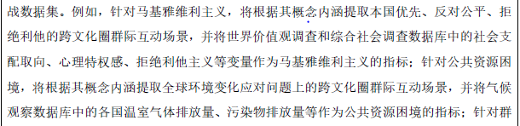

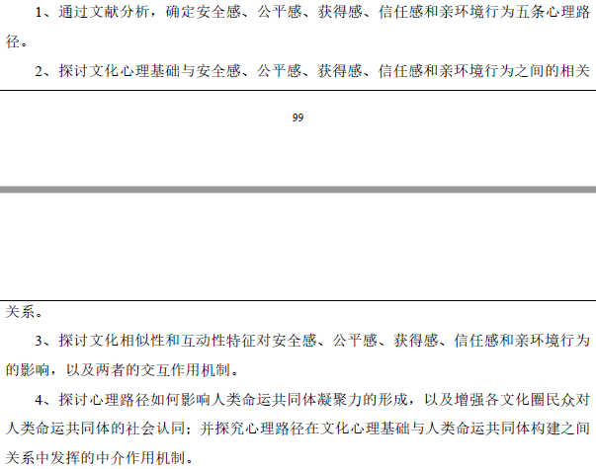

* 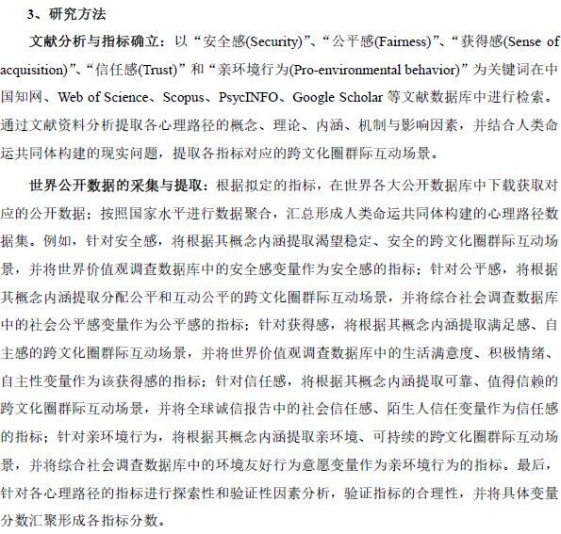
* 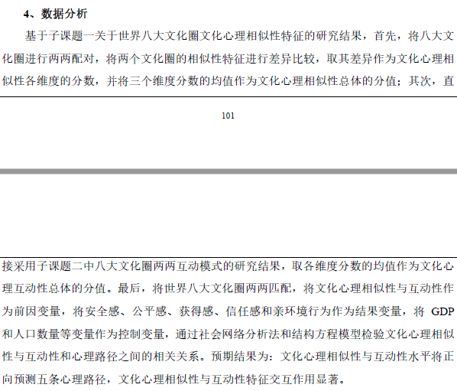

# PART 1 new papers in winter holiday

1. B_Big Data Analysis Framework for Healthcare and Social Sectors in Korea
2. 框架图

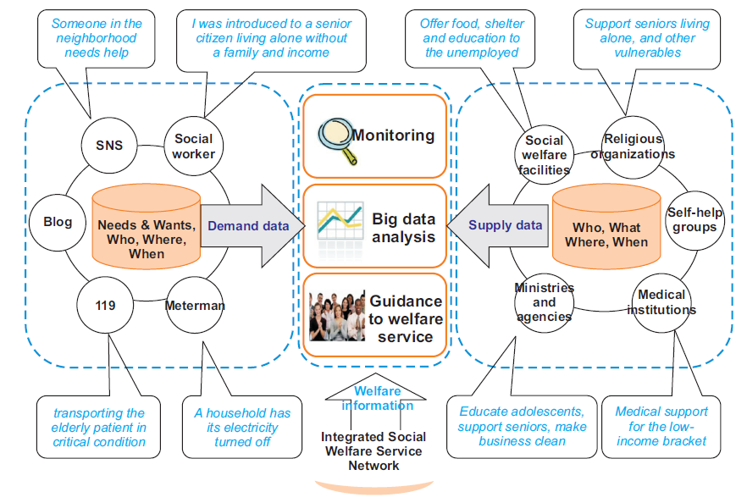

1. Keywords: private + public, social problems, 异构数据，
2. B_Discovery of Informal Topics from Post Traumatic Stress Disorder Forums（2017ICDM）
3. TOPIC：Word embedding/Association rules ：公式不多
4. **A_Perceived Change in Life Satisfaction and Daily Negative Affect: The Moderating Role of Purpose in Life（Journal of Happiness Studies, Psychology, 1.98, Q2-Q1, 2014）**

**2.2.4 Daily Stressors**

The total number of stressors experienced each day was assessed with the Daily Inventory

of Stressful Events (DISE; Almeida et al. 2002). This scale has been demonstrated as a

valid measure of stress exposure (e.g., Mroczek and Almeida 2004). Participants indicated

whether they experienced any of 7 events (e.g., had an argument, experienced a stressful

event at work or school, experienced a stressful event at home, experienced discrimination)

within the past day.

**2.2.2 Purpose in Life**

Purpose was assessed using a seven-item subscale taken from the Ryff Scales of Psychological

Well-Being (Ryff 1989). Designed to assess one’s sense of directedness（指引） and

Intentionality（意图） in life, this purpose subscale has demonstrated to have strong reliability and

predictive validity with adult samples (see Ryff and Singer 2006 for a review). Sample

items included, ‘‘I have a sense of direction and purpose in life’’, ‘‘Some people wander

aimlessly （漫无目的的）life but I am not one of them’’, and ‘‘I don’t have a good sense of what it

is that I am trying to accomplish in my life’’ (reverse scored). Response formats ranged

from 1 (Strongly Disagree) to 7 (Strongly Agree), and for the current sample Cronbach’s

alpha was .71.

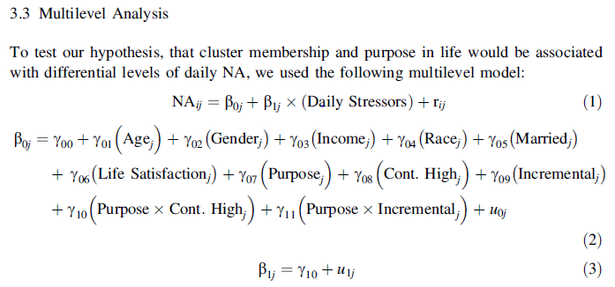

1. B_ Adult attachment and self-disclosure on social networking site: A content analysis of Sina Weibo **(Personality and Individual Differences 2019-JCR Q2-imf 1.6, Psychology)**

* **self-disclosure in SNS: six categories (***)**
* attachment theory (约翰鲍比-依恋理论（不同模式的依恋）)
* factor analysis, correlation analysis
* Conclusion: Besides, attachment anxiety and attachment avoidance show different pattern in predicting self-disclosure on SNS: individuals with high attachment anxiety disclose less personal information on their SNS profile page.

1. Analysis of User Network and Correlation for Community Discovery Based on Topic-Aware Similarity and Behavioral Influence (2018， IEEE TRANSACTIONS ON HUMAN-MACHINE SYSTEMS, Computer, Q2)

公式多，看看是否有部分可以借鉴(图、思路、公式)

Topic, Community, Similarity

1. A_A Confirmatory Factor Analysis of Facets of Psychological Flexibility in a Sample of People Seeking Treatment for Chronic Pain (ANNALS OF BEHAVIORAL MEDICINE, 2016, Q1)

Factor analysis (心理学套路)

有个层次分析法，看看

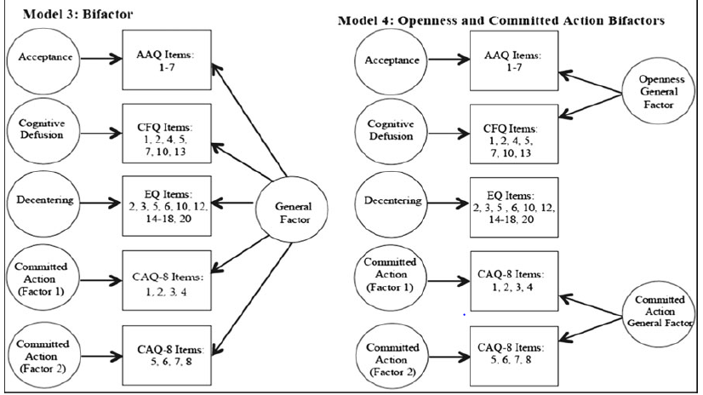

写法上：Measures：每种measure单独写一大段，值得借鉴；

1. C_Are Facebook “Friends” Helpful_ Development of a Facebook-Based Measure of Social Support (CYBERPSYCHOLOGY, BEHAVIOR, AND SOCIAL NETWORKING, Psychology, Q1 2015)

* Factor analysis (EFA): A review of the items by a panel composed of one professor of clinical psychology and four doctoral students yielded a final pool of 23 items to be examined using exploratory factor analysis (EFA). The purpose of the EFA was to (a) identify items for inclusion in the instrument, and (b) identify latent classes (factors) of items.
* 这些纯心理学套路的，常用scales(各种因素都用scale来测量)+EFA

1. C_Perceptions of Health-Related Information on Facebook: Cross-Sectional Study Among Vietnamese Youths

Conclusion: Youngs tend to pay attention to health information on Facebook (stress, .. and so on)

1. B_Visiting theories that predict college students’ self-disclosure on Facebook 2014 (**Computers in Human Behavior, Psychology, Q1, 3.5**)

**社会契约论 (social contract theory)**

**使用与满足理论（uses and gratification theory）**

Abstract: This study explores factors that may explain information disclosure behavior on Facebook and provides understanding of each factor’s contribution in explaining such behavior. Factors tested in this study are drawn from theories (e.g., **social contract theory and uses and gratification theory**) and constructs (e.g., **trust/self-disclosure relationships, time spent on Facebook, number of Facebook friends, and gender difference**). Findings suggest the potential of all the factors examined in this study as frameworks to explain self-disclosure behavior on Facebook.

(上述几个key words相关文献可以从这里找 ***)

1. A_Towards Social Big Data-Based Affective Group Recommendation (2018, Q1, Computer Science)

* 社交网络亲密关系 (social affinity)
* 公式适中 (**Affective** **Group recommending**)
* Abstract: However, three social phenomena (i.e., **social influence, emotional contagion（传染）, and conformity（相似）**) have not been applied enough in existing studies. In this paper, a novel method for **a group recommendation is proposed** based upon the affective social network from social big data

1. Seeking virtual social support through blogging: A content analysis of published blog posts written by people with chronic pain (Digital Health 2018, 但是是Biomedical)

纯文字举例；无算法；

1. A_Sharing feelings online studying emotional well-being via automated text analysis of Facebook posts (2015 **FRONTIERS IN PSYCHOLOGY, Q2**, Psychology, Multi-disciplinary, SSCI, 2.08, Beijing Normal University, 但是每年影响因子都在下降：我觉得可以改投这个试一下)

特征分析的很细；没有模型；

Conclusions:

1. Correlation analyses revealed that individuals with higher levels of depression, anxiety expressed negative emotions on Facebook more frequently.

（抑郁的人更倾向于表达在network）

1. In addition, use of emoticons expressing positive emotions correlated negatively with stress level.（正面表情越多，压力级别越低）
2. Also, the relationship between online emotional expression and self-report emotional well-being was generally stronger in the younger group.
3. C_Use of Social Media for Professional Development by Health Care Professionals: A Cross-Sectional Web-Based Survey (2016, Q1, JME, [HEALTH CARE SCIENCES & SERVICES - SCIE;MEDICAL INFORMATICS - SCIE;](http://jcr.incites.thomsonreuters.com/JCRJournalProfileAction.action?pg=JRNLPROF&journalImpactFactor=n%2Fa&year=2017&journalTitle=JMIR%20MHEALTH%20UHEALTH&edition=SCIE&journal=JMIR%20MHEALTH%20UHEALTH))

问卷(survey)如何和心理学理论联系；发放问卷途径：2000个粉丝；

1. C_The Relationship Between Perceived Stress and Adolescent Depression

(2015)

可以参考depress和stress量表；SPSS；

1. 其它图

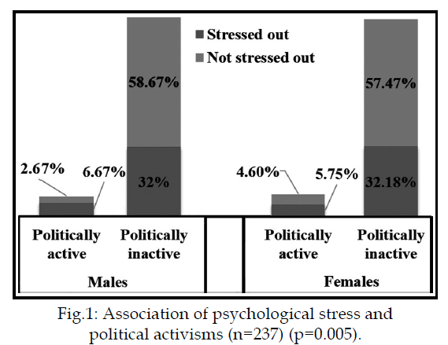

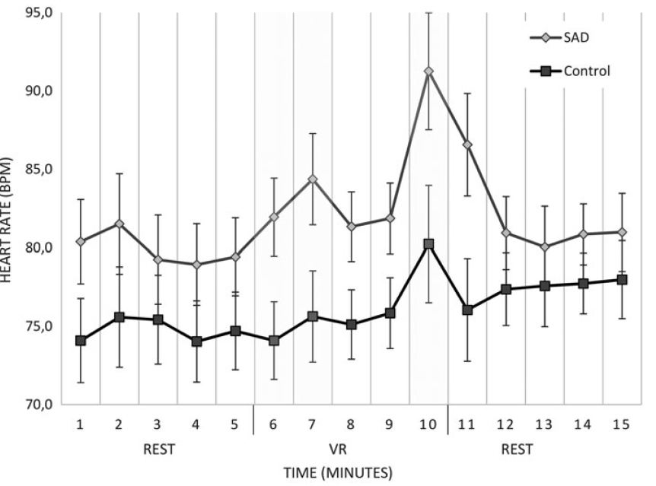

感觉能扯出道理（方方面面角度、层次+solid文献），公式也不是很重要

1. 修改JBHI：
2. 结构上：从Abstract到各个section
3. 实验结果描述上：p<0.01这些
4. 扩充Markov
5. 扩充 Group
6. 扩充 Personality
7. Age（分组实验初高中）; Gender（girls tend more to post）
8. 使用多种社交平台vs.一种
9. （多种压力源叠加：Liang写了；）
10. 针对某一个重大压力事件（升学：高三群体、初三群体；）
11. **Social rank theory (based on community)** 🡪 Attractiveness, Envy, Depression（即他人对自己的评价，自身attractiveness，与depression正相关）
12. Feelings and well-being: moderate role of culture
13. Seek emotion/social support; sharing life events
14. 周一-周五的区别；8-9窗口最佳; 重大社会公众事件（节假日/忌日）对well- being 影响
15. Social support (比如转发/emotional comment)
16. 心理学的correlation到底是啥情况（binary logistic regression; structural regression, iteration regression?）
17. Social standing (popularity)

(‘‘Which children in your class do you like the most?’’), liked least (‘‘Which children in your class do you like the least?’’), most popular (‘‘Which children in your class are the most popular?’’),

1. 举例子很重要

### Computers in Human Behavior

#### A_Do personality characteristics explain the associations between self-esteem and online social networking behavior ? (2019)

* For instance, the abovementioned meta-analysis showed that **positive self-esteem自尊** correlated with **a higher number of friends** (Liu & Baumeister, 2016).
* Moreover, the regular or even episodic use of OSNs can make one's self-esteem more positive (Gentile, Twenge, Freeman, & Campbell, 2012; Gonzales & Hancock, 2011; O'Sullivan & Hussain, 2017).
* Users with negative self-esteem may compensate their disadvantages in the offline reality (Lee, Moore, Park, & Park, 2012) and seek for happiness that can be treated as attention from others and validation from themselves.
* Thus, persons with **negative self-esteem may compensate补偿 their offline failures by increasing their OSN activities** (Eşkisu, Hoşoğlu, & Rasmussen, 2017; Lee et al., 2012).

(因为真实生活的failure 而使用SNS)

self-esteem：自负、自大；positive self-esteem/ negative self-esteem

* 五大人格：After almost a century of investigation in personality taxonomies and models of traits, researchers have come to a consensus that has been preserved for the last 20 years. **Most scholars have accepted the five-factor structural model of personality or the Big Five―this includes elements of extraversion, agreeableness, conscientiousness, neuroticism, and openness to experience** (Goldberg, 1981; McCrae & Costa,2013).
* 假设：

1. Correlations between **positive self-esteem** and OSN indicators of **popularity** are statistically eliminated when **extraversion** and attitudes toward extraversion are added as predictors to the regression model. （外倾性）

2. Correlations between **negative self-esteem** and OSN indicators of **self-validation** are statistically eliminated when **neuroticism** and attitudes toward neuroticism are added as predictors to the regression model.（神经质）

* 特征：

Five OSN indicators were used: The **total number of friends** and **median “likes”** marking a portrait by the user were treated as OSN indicators of the users' **popularity**. The number of **posts** published by the users on their walls, the number of avatars representing photographs of the users without other people or animals (termed **“portraits”**), and the number of impersonal avatars depicting **other people**, animals, or abstract figures were used as OSN indicators of **users' self-validation**.（自我验证）

IDEAS:

1. 加入五大人格特质：针对不同特质做压力检测；（new papers）
2. 学习这篇文章关于OSN五大特质的分析；
3. 将这篇的positive/negative self-esteem，换成stress，看看逻辑如何；

#### C_Extraversion, neuroticism, attachment style and fear of missing out as predictors of social media use and addiction（Personality and Individual Differences 116 (2017）)

* In the final model of a hierarchical regression, **younger age, neuroticism, and fear of missing out predicted social media use**. Only fear of missing out predicted social media addiction. **Attachment anxiety and avoidance** predicted social media addiction, but this relationship was no longer significant after the addition of FOMO.

(依恋焦虑和避免、神经质、外向型、FOMO与social media addiction的关系)

* We used **hierarchical regression**, first entering extraversion and neuroticism, then anxious and avoidant attachment, and lastly, FOMO. We hypothesized that each variable would be a significant predictor of both use and addiction at each step.

#### C_Facebook addiction among Polish undergraduate students: Validity of measurement and relationship with personality and well-being

* （参考实验方法的流程：EM补充缺失值；hierarchy regression for each two factors）
* Facebook addiction was further related to impoverished well-being (impaired general health, decreased sleep quality, and higher perceived stress), which is congruent with previous findings.(fb沉迷和压力增加睡眠变差正相关)

## A_Who discloses the most on Facebook? (2016)

(可搜集stress, adolescent相关文献在这篇；可以参考implications写法; Age也是变量 )

* （年龄和孤独是社交暴露的预测因子）

We showed that **young age** and **loneliness are predictors of disclosure on Facebook**. Moreover, junior high school students more often put private information on their Facebook profiles than senior high school and university students.

* The added value of this study lies in the fact that it considers the possible and not fully explained relationship of sharing important news on Facebook **with well-being and a higher level of stress** (Bevan,Gomez,&Sparks,2014).（分享重要消息和stress相关）

1. C_Facebook use, envy, and depression among college students: Is facebooking depressing?

(**Social rank theory of depression: 竞争失败使人有depression的倾向; Envy;** )

* This study uses the framework of **social rank theory of depression** and conceptualizes Facebook envy as a possible link between Facebook **surveillance (监控) use** and depression among college students.
* The present study aims to contribute to this growing area of important research by **examining whether or not heavy Facebook use leads to depression among college students. （FB use是不是导致college depression）**
* 针对：升学（high school -> college）

**Social rank theory of depression:**

* “Those who perceive themselves as subordinates are not necessarily depressed, but are vulnerable to depression” (Sloman et al., 2003, p. 116).
* **（Social rank theory在年轻人尤其明显）Social rank theory is particularly appropriate for examining depression among young people who are in a stage when they are acutely attuned to and affected by status**. They place greater importance on popularity than on other social factors (Lansu & Cillessen, 2012) and the changes that come with the transition to young adulthood enhance interpersonal vulnerability’’ (Abela & Hankin, 2008, p. 81).
* **（FB中，social rank体现为：1）形成了一个group/community; 2)不仅展示自己，还在意别人评价，即attractiveness; 3)本文叫做envy）**

But on Facebook, users do not just manage their own self presentations. When navigating Facebook, users are exposed to what others say about them (Hong et al., 2012; Schau & Gilly, 2003; Walther et al., 2009), and also to what other users share about themselves. Thus, users also develop perceptions of other users’ social attractiveness. Social media sites function as a community of users (e.g. Gruzd, Wellman, & Takhteyev, 2011), with individuals identifying themselves as parts of particular networks. The resource of social attractiveness is therefore shared within a group context. Thus, if Facebook users perceive their social attractiveness as lower than that of other users, they will feel subordinated and therefore outranked, consistent with the assumption of social rank theory. This feeling, which we will operationalize in this study as envy, can lead to depression.

* (**Facebook Envy的详细解释、参考文献**）

## C_Feelings on Facebook and their correlates with psychological well-being: The moderating role of culture (2018)

* (**social support, culture regulation约束, well-being** (positive, negative), life satisfaction, relationship harmony)
* Importantly, culturally fit emotions can be both positive and negative, and thus even negative emotions can be socially adaptive (Gruber, Mauss, & Tamir, 2011).
* While positive self-presentation boosts well-being directly, **honest self-presentation does so through perceived social support.**
* (不同文化对happiness的理解和规范) The theoretical framework of cultural regulation of emotion (Mesquita, De Leersnyder, & Albert, 2014) posits that we regulate our emotional experiences in order to be congruent with dominant cultural goals, because doing so results in functional outcomes that fulfill those goals, and ultimately in high levels of well-being.
* （可能的topic：不同文化的stress表达方式？）
* （可能的topic：weather？）

## A_The stress-buffering effect of self-disclosure on Facebook: An examination of stressful life events, social support, and mental health among college students (2017)

* （Stress增加SNS use in college students; SNS use moderate stress）
* This study examined the effect of self-disclosure on SNSs on young adults’

mental health.

* The results show that **people tend to open up on Facebook when in times of stress** and that **self-disclosure on Facebook moderates the relationship between stressful life events and mental health.**
* **Stressful life events: （定义、相关规律）**

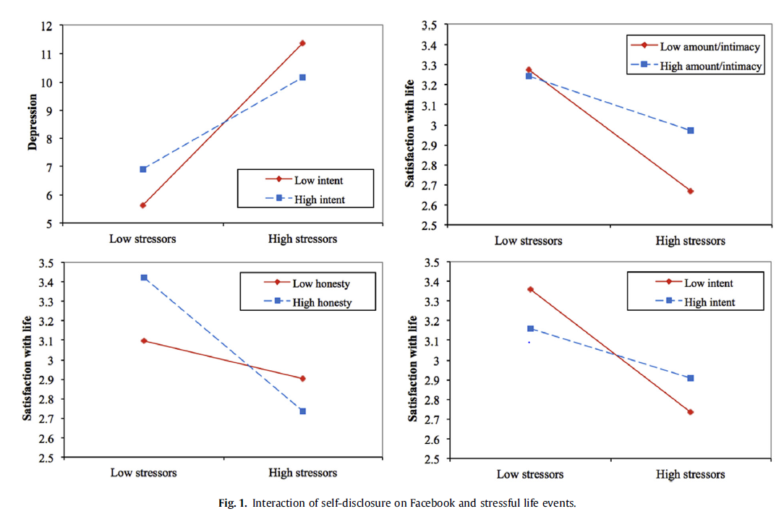

## C_Physical activity mediates the association between daily stress and Facebook Addiction Disorder (FAD) e A longitudinal approach among German students

* 发现一个2014年的压力源事件量表

Daily Stress. The **Brief Daily Stressor Screening (BDSS) (Scholten, Lavallee, Velten, Zhang, & Margraf, 2014)** was used to measure chronic daily stressful experiences over the last 12 months. The nine items rated on a 5-point Likert scale (0 = not at all, 4 = very much) assess inconveniences or difficulties in daily life (e.g., family, health, finances, study or job).

## Online social media fatigue and psychological wellbeing—A study of compulsive use, fear of missing out, fatigue, anxiety and depression (2018, International Journal of Information Management, Q1, 4.6, Computer Science)

发现两个model：**stressor-strain-outcome (SSO) model** and the **transactional theory of stress and coping (TTSC)**

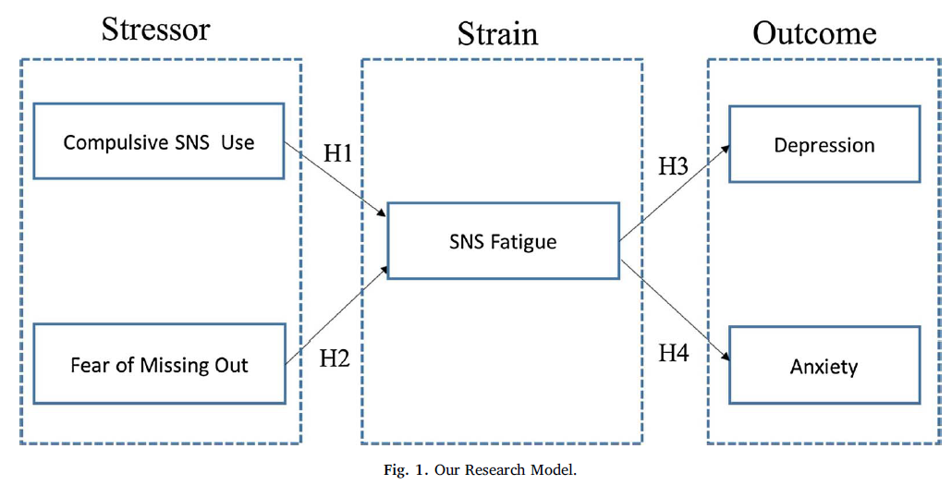

（强迫使用SNS->SNS疲劳->depression）

## Motivational, emotional, and behavioral correlates of fear of missing out (2018)

* Participants were recruited online through **Amazon’s Mechani cal Turk worker system**; each participant was compensated $0.30 each for completing the questionnaire.

### Cyberpsychology Behavior and Social Networks

## A_Associations of Self-Presentation on Facebook with Mental Health and Personality Variables: A Systematic Review (2017)

* For example, clients who present inauthentic不真实的 versions of themselves on Facebook could be experiencing social anxiety or have maladaptive personality traits such as neuroticism and narcissism, all of which could be targeted in intervention.

(不真实的表达：可能是经历anxiety或者危险的人格：神经质与自恋 🡪 需要干预)

(只要有一点创新，就能做细，就能发文章；千万杜绝粗略、杜绝只找大题目；)

（大胆表达：形式、思路上，每个人都不一样；别人的可以借鉴，但是要坚信自己有道理的就能发表；）

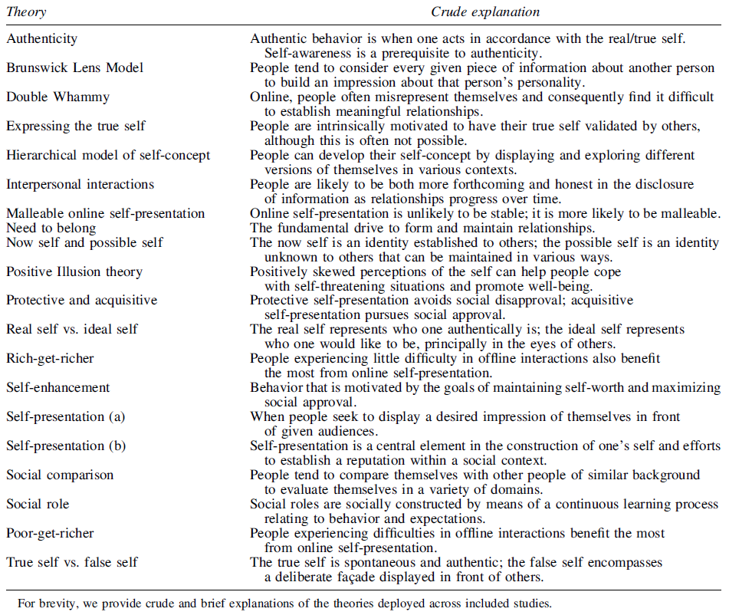

## B_Disclosure Pattern of Self-Labeled People Living with HIV/AIDS on Chinese Social Networking Site: An Exploratory Study (2016)

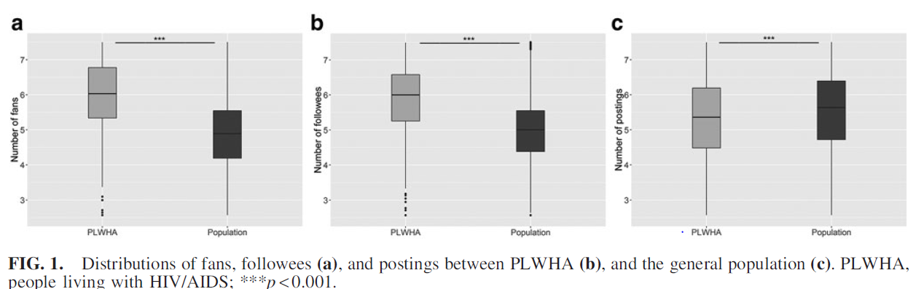

1. Data collection：先找到关键词的用户，再作为种子从其关注/粉丝扩散
2. 时间线分析：24小时
3. 粉丝数量/等各种特征的对比分析：箱状图（p<0.001）
4. In summary, we found that the majority of the self-labeled PLWHA were likely to be men who have sex with men.

**They used Weibo to share their daily life events and seek emotional support.** Implications for promoting HIV/AIDS education and prevention through Chinese social networking sites were also discussed.

**（下图是时间线）**

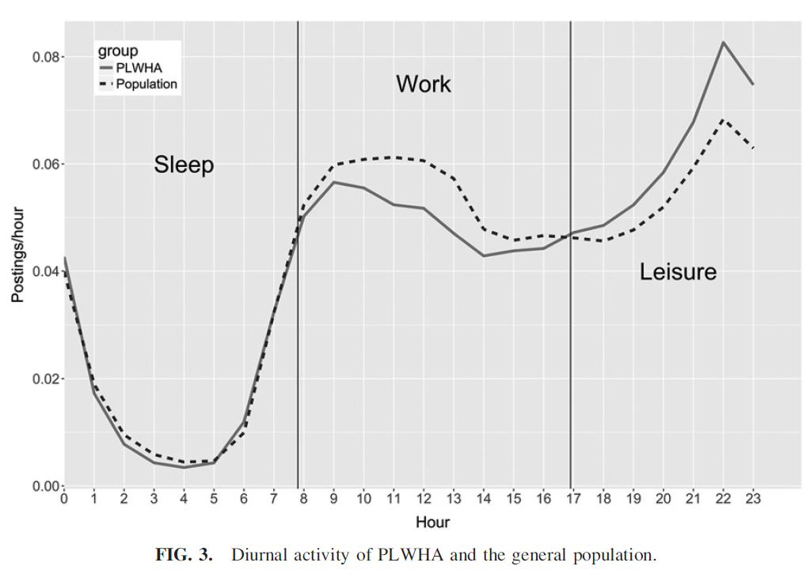

## B_Do Facebook Status Updates Reflect Subjective Well-Being?

1. （**过去9-10个月的negative emotion与life satisfaction明显相关**）It was found that positive emotional expressions on Facebook did not correlate with life satisfaction, whereas negative emotional expressions **within the past 9–10 months** (but not beyond) were significantly related to life satisfaction.
2. These findings suggest that both the type of emotional expressions and the time frame of status updates determine whether emotional expressions in Facebook status updates can effectively reflect users’ SWB (subjective well-being).
3. It was hypothesized that only **recent emotional expressions (3 months)** in Facebook status updates would be associated with SWB.
4. （节日/公众人物去世日）GNH peaked on national and cultural holidays such as Christmas and Thanksgiving, and dipped on days of national tragedies such as the death of Michael Jackson.
5. （周一/周五区别）It also followed a weekly cycle with peaks on Friday and dips on Monday.

## A_ WeChat Addiction Suppresses the Impact of Stressful Life Events on Life Satisfaction (2018)

Life satisfaction, Stressful life events（分类、举例、描述）

看一下discussion部分

(subjective well-being = affective well-being + life satisfaction)

Major life events have been found to be able to contribute to changing subjective well-being (SWB), and have very different effects on the two main components of SWB, namely, affective well-being and life satisfaction.

(moderated by support and positive expectations, mediated by humility and coping)

（减弱by支持、期待；调节by谦虚、应对）

The association between stressful life events and negative effects is moderated by emotional support7 and positive expectations,8 and mediated by humility9 and coping.10

The third variable effects are crucial for elucidating the relationship between stressful life events and deleterious outcome, and are informative in mitigating the negative relationship.

Is there a possibility for WeChat addiction to be a third variable related to both stressful life events and negative outcome?

## C_Tweeting Social Support Messages After a Non-Celebrity's Death_ The Case of the Philippines' #Fallen44

(Social support：44名警察遇难后的social support：转发、礼物、pray…可以看一下)

## C_Effects of Cyberbullying and Cybervictimization on Early Adolescents’ Mental Health: Differential Mediating Roles of Perceived Peer Relationship Stress

(peer relationship stress)

(用了几种量表:Perceived peer relationship, subjective well-being, anxiety, depression)

## C_Emotion-Related Personality Traits and Peer Social Standing: Unique and Interactive Effects in Cyberbullying Behaviors

Social standing (popularity):

(‘‘Which children in your class do you like the most?’’), liked least (‘‘Which children in your class do you like the least?’’), most popular (‘‘Which children in your class are the most popular?’’)

This study investigated the unique and interactive effects of emotion-related personality traits (i.e., callousness 麻木 and uncaring 心不在焉 traits) and peer social standing (i.e., social preference and perceived popularity) on cyberbullying behaviors in preadolescents.

## A_Facebook Friends with (Health) Benefits? Exploring Social Network Site Use and Perceptions of Social Support, Stress, and Well-Being (2013)

* **SOCIAL-SUPPORT!!!**

（好友数量 🡪 perceived social support/ 🡪 减轻stress）

* A survey of 401 undergraduate Facebook users revealed that, as predicted, number of Facebook friends associated with stronger perceptions of social support, which in turn associated with reduced stress, and in turn less physical illness and greater well-being.
* The ‘‘more-friends-the-better’’ heuristic is proposed as the most likely explanation for these findings.
* **Interpersonal network size** was computed by **adding the number of** relatives, close friends, acquaintances, fellow students, neighbors, teachers, coworkers, and religious groups with whom participants communicate at least once every 2 weeks

## A_How Are Important Life Events Disclosed on Facebook? Relationships with Likelihood of Sharing and Privacy 2015

* An online survey of 599 adult Facebook users found that when positive life events were shared, users preferred to do so indirectly, whereas negative life events were more likely to be disclosed directly.（消极事件更有可能被直接表达）
* **(IMPORTANT LIFE EVENT相关理论)** Such a study is important because experiencing ILEs can have a long term deleterious impact on subjectivewell-being,7 which could be partially abated减轻 by receiving social support from Facebook friends.（消极事件影响时间较长，被social support缓解）

## C_Personality Traits, Motivations, and Emotional Consequences of Social Media Usage

* The findings suggest that the intensity of social media usage is positively related to negative emotions. (social network use 🡪 negative emotion)
* Similarly, all four motivations for Facebook and Pinterest uses are influenced by users’ personality traits: extraversion and openness.

## C_Psychological Distress and Emotional Expression on Facebook (2017)

* (distress, interaction, express；可以找一些压力相关描述)
* Higher psychological distress was associated with displaying depression language on Facebook, with higher self-presentational concerns, and with less satisfaction with audiences’ responses and less overall satisfaction with the outcome of the interaction.

## C_Research on Social Networking Sites and Social Support from 2004 to 2015: A Narrative Review and Directions for Future Research

* （SNS Social support 定义、发展）

## C_Smartphone Applications for Mental Health

* 统计了15年之前的APP功能分类