# 后端应该提供的接口

请求方式+IP:端口/服务名/用户组/用户编号/**

不需要权限的接口

IP:PORT/{service}/everyone/null/**

需要权限的接口

IP:PORT/{service}/buyer/{buyerId}/**

IP:PORT/{service}/seller/{sellerId}/**

IP:PORT/{service}/admin/{adminId}/** 这个接口暂时不考虑

## 买家服务

登陆

POST

192.168.1.1:8080/service-buyer/everyone/null/{buyerId}/login

Requestbody: password

Return : 登陆成功/登陆失败

注册账号

POST

192.168.1.1:8080/service-buyer/everyone/null

{

"id": 1,

"password": 1,

"name": "wsx",

"sex": "man",

"birthday": "2020-05-10",

"phonenum": 1808669868,

"email": "246553278@qq.com"

}

Return : true/false

查看账号是否有效

GET

192.168.1.1:8080/service-buyer/everyone/null/{buyerId}/is/effective

Return : true/false

个人信息查询

(账号，密码，名字，性别，生日，电话号码，邮箱，vip等级)

GET

192.168.1.1:8080/service-buyer/buyer/{buyerId}

个人余额查询

GET

192.168.1.1:8080/service-buyer/buyer/{buyerId}/money

个人信息修改（账号不允许修改）

PUT

192.168.1.1:8080/service-buyer/buyer/{buyerId}

在RequestBody中携带账号信息

充值

money为充值的钱的数量

PUT

192.168.1.1:8080/service-buyer/buyer/{buyerId}/addmoney/{money}

## 卖家服务

个人信息查询

(账号，密码，名字，vip等级)

GET

192.168.1.1:8080/service-seller/seller/{sellerId}

余额查询

GET

192.168.1.1:8080/service-seller/seller/{sellerId}/money

个人信息修改

PUT

192.168.1.1:8080/service-seller/seller/{sellerId}

在RequestBody中携带信息

注册账号

POST

192.168.1.1:8080/service-seller/everyone/null

在RequestBody中携带账号信息

提现

money为提取的钱的数量

PUT

192.168.1.1:8080/service-seller/seller/{sellerId}/submoney/{money}

## 商品服务

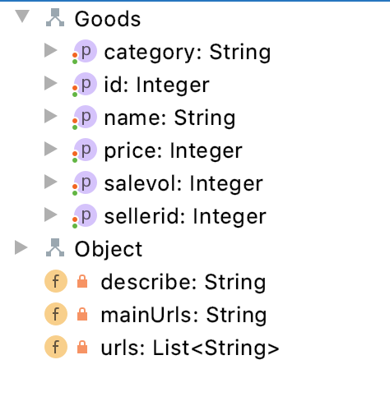

分类、编号、名字、价格、销量、卖家id、描述、主图片url、其他图片url

创建商品

（商品名字，卖家id，价格，分类，库存）

POST

192.168.1.1:8080/service-goods/seller/{sellerId}

在RequestBody中携带信息

商品修改

PUT

192.168.1.1:8080/service-goods/seller/{sellerId}

在RequestBody中携带商品信息

查询商品

GET

192.168.1.1:8080/service-goods/everyone/null/{perpage}/{pageId}

## 订单服务

买家添加订单

（买家id,卖家id，商品id，买家地址id，购买数量）

POST

192.168.1.1:8080/service-orders/buyer/{buyerId}

RequestBody中携带订单

买家取消订单

DELETE

192.168.1.1:8080/service-orders/buyer/{buyerId}/{ordersId}

买家完成订单

PUT 192.168.1.1:8080/service-orders/buyer/{buyerId}/{ordersId}/successed

买家查看自己的订单

GET

192.168.1.1:8080/service-orders/buyer/{buyerId}

卖家查看自己的订单

GET

192.168.1.1:8080/service-orders/seller/{sellerId}



## 评论服务

发布评论

POST

192.168.1.1:8080/service-comments/buyer/{buyerId}/{goodsId}/{replyId}

Requestbody:

评论内容

查看某商品的评论

GET

192.168.1.1:8080/service-comments/everyone/null/{goodsId}

Resbonsebody:

[

{

"buyerId": 1,

"data": "\n\"hello this is an comments\"",

"goodsId": 1,

"id": "5eb7d2fd36a82c0172d91331",

"replyId": 0

},

{

"buyerId": 1,

"data": "\n\"hello this is an comments\"",

"goodsId": 1,

"id": "5eb7d31636a82c0172d91332",

"replyId": 0

}

]

删除评论

DELETE

192.168.1.1:8080/service-comments/buyer/{buyerId}/{id}

ResponseBody:

{

"buyerId": 1,

"data": "hello this is an comments",

"goodsId": 1,

"id": "5eb7d2fd36a82c0172d91331",

"replyId": 0

}