Advanced Hydropower Monitoring System

Contents
Advanced Hydropower Monitoring System 1
Members of the Project 1
1. Introduction 2
2. Trends in ICT and Their Impact on IoT 2
Evolution of ICT 2
Trends Driving IoT Adoption 2
Impact on Hydropower Systems 2
3. IoT vs. M2M Communication 3
Explaining the Potential and Benefits of an IoT-Oriented Approach Over M2M 3
Real-World Use Case Example: Hydropower Plant Monitoring 3
Key Benefits of IoT in Hydropower: 3
Comparing M2M and IOT: 4
4. Characteristics and Components of IoT 5
Characteristics of IoT 5
Interconnectivity and Communication: 5
Data Sensing and Monitoring: 5
Real-Time Analytics and Insights: 5
Automation and Control: 5
Remote Accessibility: 5
Scalability: 5
Predictive Maintenance: 5
Core Components of IoT: 6
Sensors: 6
Microcontroller (Arduino Uno MKR WIFI 1010): 6
Connectivity: 6
IoT Cloud: 6
Output Device (OLED Display): 6
Actuators (Water Pump and Turbine Generator): 7
Power Supply: 7
Selected IoT System: Advanced Hydropower Monitoring System (AHMS): 7
Justifications for Selecting AHMS: 7
Significance of AHMS in Hydropower Management 8
5. Functional and Non-Functional Requirements 8
Functional Requirements: 8
Non-Functional Requirements: 9
Megatrends, Capabilities, and Implications of IoT in AHMS: 10
Megatrends in IoT 10
Capabilities of IoT in AHMS: 10
Implications of IoT in AHMS: 11
6. Description of the Advanced Hydropower Monitoring System: 12
What IoT System Has Been Implemented? 12
What Does It Do? 12
Sensors and Output Devices Used: 13
Specifications of Key Components: 14
Arduino Uno MKR WIFI 1010: 14
IoT Cloud Platform: 14
How It Works (System Workflow): 15
7. Circuit Design 15
8. Explanation of Protocols Used in AHMS: 16
Protocols Used in AHMS: 16
One-Wire Protocol: 17
IoT Reference Models and AHMS 19
9. Snapshots of the Code 20
Snapshots for Hydropower_IoT_Project.ino file 20
Snapshots for the thingProperties.h file 25
10. Conclusion 26
Issues Identified in AHMS (Advanced Hydropower Monitoring System) 26
Application Areas of AHMS 26
Future Improvements and Recommendations: 27
Why Invest in the Advanced Hydropower Monitoring System (AHMS)? 29
References 29

Members of the Project
- Figo Figo – M00971570
- Harnil Makwana – M00939940
- Deep Patel – M00938680
- Rathan Tudugani – M00967173
- Karunya Votarkar – M00878236

1. Introduction
Hydropower plants are one of the most reliable and clean energy sources around the world, as they provide continuous renewable energy. Yet, in hydropower plants, conventional monitoring systems have a strong focus on manual processes or outdated technologies, leading to inefficiencies, slower fault detection and resource wastage. IoT (Internet of Things) becomes a unique solution to fight against these issues. IoT gives hydropower plants the ability to collect real-time data, enabling remote observation and predictive analysis that changes the way these facilities operate and maintain their systems.
Developing Advanced Hydropower Monitoring System Based on IoT Principles With seven key sensors, it focuses on critical parameters like water flow, power output, equipment vibrations, water levels and environmental conditions. It uses an Arduino MKR WiFi 1010 microcontroller to handle the data input and display, which displays real-time results on an OLED screen. Also, by integrating Wi-Fi, it offers remote access to data and the ability to identify anomalies early on.

2. Trends in ICT and Their Impact on IoT

Evolution of ICT
From using high-tech machines to traditional methods, the data-processing realm saw significant transformations with the advancement of ICT across industries. Game-changing technologies, including 5G, artificial intelligence (AI), blockchain, and cloud computing, have paved a path for traditional infrastructure and processes to become part of intelligent, interconnected ecosystems. IoT is the best representative of this transformation where the ICT innovations converge to provide real-time actionable insights across multiple fields.

Trends Driving IoT Adoption
- Edge Computing: Designed to act on information right where it is collected instead of relying on a central server, reducing latency and bandwidth consumption. This is important in systems such as hydropower, where real-time decisions are required.
- Artificial Intelligence (AI): By using AI-powered analytics, IoT systems can predict when equipment will fail, how much energy is being consumed, and detect any anomalies.
- Blockchain Integration: Provides decentralized, tamper-proof transaction records that improve data security and integrity
- 5G Connectivity: Stronger device density capability and ultra- reliable low-latency service.

Impact on Hydropower Systems
Implementation of IoT in hydropower systems offers the following advantages:
- Enhanced Monitoring: Multiple sensors collect real-time data for maximum plant performance.
- Predictive Maintenance: Predictive analysis based on AI reduces both equipment downtime and maintenance expenses.
- Remote Accessibility: Operators can monitor and control systems remotely.

3. IoT vs. M2M Communication

Explaining the Potential and Benefits of an IoT-Oriented Approach Over M2M
Machine-to-Machine (M2M) communication is replaced with IoT-oriented systems that embrace entire ecosystems, breaking down silos by connecting data, analytics, and real-time decision-making. M2M was well before IoT and lacks the general capture of data — IoT has taken M2M and turned it to more optimized systems, applied analytics, and scale.

Real-World Use Case Example: Hydropower Plant Monitoring
To demonstrate this, consider the operations of a hydropower plant:
M2M Approach: In a traditional scenario, the parameters like turbine speed, water flow, electrical output are being monitored single thread only. For example:
- For example, a sensor that tracks the RPM of a turbine to avoid excessive mechanical stress could be set to raise an alarm or halt the turbine when the limits are reached.
- There is a separate flow sensor that tracks water flow, but it does not communicate with the turbine sensor data.
- This isolated communication necessitates an analysis of data across systems, which constrains timely responses to anomalies and increased automation.
- This siloed communication requires manual interpretation of data across systems, leading to delayed responses to anomalies and limited automation.
IoT-Oriented Approach: All gadgets and sensors in an IoT base system are in a shared network that straight communicates over a cloud base system. For instance:
- When there is a sudden increase in water flow, the IoT system correlates flow sensor data with turbine RPM and vibration data to anticipate potential mechanical stress.
- AI and analytics tools can predict when equipment will fail, and when to schedule and conduct maintenance before breakdowns happen.
Operators can also access real-time alerts and recommendations remotely, allowing for fast response actions while minimizing downtime.

Key Benefits of IoT in Hydropower:
- Integration: What IoT does is integrate a lot of systems and allow monitoring and optimization of the entire plant.
- Predictive Maintenance: IoT uses data analytics to predict the failures and carry out proactive maintenance.
- Remote Accessibility: Using IoT dashboards, operators can monitor and control plant systems from any location.
- Automation: IoT systems automatically adapt processes based on real-time data, improving efficiency and safety.

Comparing M2M and IOT:
Aspect | M2M | IOT
Architecture | Point-to-point communication between devices. | Interconnected ecosystem with centralized control.
Data Processing | Local processing with limited analytics. | Cloud-based or edge computing with advanced analytics.
Connectivity | Often relies on wired or proprietary protocols. | Uses Wi-Fi, Bluetooth, LoRa, or cellular networks for flexibility.
Integration | Operates in isolated silos; limited device interaction. | Integrates data from multiple sources for holistic insights.
Scalability | Adding devices requires complex reconfiguration. | Easily scalable with minimal changes.
Functionality | Focused on specific tasks; basic automation. | Provides real-time insights, automation, and optimization.
Predictive Capabilities | Reactive; addresses issues after they occur. | Predictive; identifies and resolves issues proactively.
Remote Accessibility | Requires physical presence for monitoring or control. | Accessible via web or mobile apps from any location.
Example Application | Monitors turbine RPM or voltage independently. | Integrates turbine RPM, flow rate, vibration, and water quality monitoring.

4. Characteristics and Components of IoT
Released every October the Internet of Things (IoT) where devices can communicate, share data, and make real time decisions is revolutionizing industries. But, in the case of the Internet of Things, this involves so much more than just writing a few lines of code for a single application. While this report focuses on the Advanced Hydropower Monitoring System (AHMS) that uses IoT to improve hydropower administration through various sensors, the inclusion of a water pump, and a turbine generator. In this section, we will discuss the defining features of IoT, its core components, and why the AHMS was selected for this project, along with its importance in hydropower operations.

Characteristics of IoT
IoT systems exhibit specific traits that make them indispensable in modern applications:

Interconnectivity and Communication:
- The networked collection of devices along with the gateways is the backbone of IoT as these devices exchange information with each other or centralized systems via wireless or wired connections. As an example, in the AHMS, the current sensor, ultrasonic sensor, and flow sensor communicate data through Wi-Fi with the Arduino Uno MKR WIFI 1010 board and the IoT Cloud.

- This makes sure that all devices operating in a synchronized way to give a complete view of this hydropower system performance.

Data Sensing and Monitoring:
- Sensors– The backbone of any IoT systems. Sensors collect real-time data from the environment or system they monitor. Within AHMS, the data collected from pH sensor, humidity sensor (DHT22), and moisture sensor have provided important information of water quality, atmospheric conditions, and soil health surrounding the plant.

Real-Time Analytics and Insights:
- IoT systems process sensor data in real time, facilitating immediate decision-making. For example, the AHMS uses real-time flow rate data to adjust the turbine's operation, ensuring optimal energy output and mechanical safety.

Automation and Control:
- Sensor data is processed in real time, allowing conclusions to be drawn on the spot. As one example, AHMS adjusts how the turbine operates based on real-time flow rate data to achieve the best energy output while maintaining mechanical safety.

Remote Accessibility:
- Using sensors with actuators, IoT systems can automate processes. The AHMS uses moisture sensor reading to turn on the water pump automatically, avoiding manual intervention.

Scalability:
- IoT platforms have an on-demand nature, permitting addition of devices or sensors without impacting the current configuration. This distribution allows the AHMS to grow with future needs, such as adding more sensors for enhanced capabilities.

Predictive Maintenance:
- IoT systems use past and current data to predict future problems. Such irregular patterns in turbine vibration sensor data indicate mechanical wear and be used in AHMS to enable proactive scheduling of maintenance on turbines.

Core Components of IoT:
IoT systems rely on several essential components to function effectively. In the context of the AHMS, the following components are utilized:

Sensors:
Sensors collect real-world information that serves as the basis for all decisions. Key sensors in AHMS include:
- Flow Sensor: Monitors the volume of water flow through the turbine, which determines how effectively energy is generated, and prevents mechanical fatigue on the system.

- Current Sensor: Used to measure the amount of electric current produced by the turbine which an aid with the optimization of energy production and identify abnormal conditions.

- Ultrasonic Sensor: A type of sensor used to gauge the water level in reservoirs or tanks, essential for proper water resource management.

- Vibration Sensor: Monitors mechanical irregularities in turbine and generator, enabling early maintenance detection.

- Humidity Sensor (DHT22): Keeps a check on atmospheric conditions and gives context to climatic changes affecting the plant

- Moisture Sensor: monitors the soil moisture surrounding the plant, allowing efficient use of water for vegetation or landscaping.

- TDS Sensor: This sensor checks the level of dissolved solids in water, delivers vital information to determine the water quality. This approach guarantees that the input water for the system adheres to both operational and environmental criteria, thus avoiding damage to equipment and protecting aquatic ecosystems.

Microcontroller (Arduino Uno MKR WIFI 1010):
The processing unit of the AHMS is the Arduino Uno MKR WIFI 1010, which collects data from sensors, processes it, and executes scripted responses. It comes with a Wi-Fi module, which allows wireless communication with IoT Cloud.

Connectivity:
Communication is vital in IoT systems. Data is transferred to the IoT Cloud via Wi-Fi from AHMS, at which point it can be analyzed and visualized. This interconnectivity allows for smooth data transfer between devices and users.

IoT Cloud:
The IoT Cloud saves and analyzes data that lets an operator see past and real-time data. It also supports remote control of the system, like turning on the water pump or changing the turbine settings.

Output Device (OLED Display):
On-site operators see real-time visual feedback from an OLED display the LowRes is equipped with, showing data such as flow rates, current levels, and pH values.

Actuators (Water Pump and Turbine Generator):
- Water Pump: Activates autonomously according to moisture sensor readings, hydrating dry areas.
- Turbine Generator: Modulates its rate of operation according to flow sensor data to extract the maximum possible energy from the stream while ensuring it does not burn out from being overloaded.

Power Supply:
A steady power supply is required for smooth functioning. The microcontroller can read measures from sensors and instruct actuators, external power supply has been utilized to provide power to sensors, microcontroller, and actuators in AHMS.

Selected IoT System: Advanced Hydropower Monitoring System (AHMS):
AHMS (Advanced Hydropower Monitoring System) was selected as an IoT system for this project because it solves certain challenges of hydropower management. The detailed design of the system comprising of different IoT elements dealing with monitoring, control and optimization of plant performance.

Justifications for Selecting AHMS:
- Real-Time Insights:
Continuous monitoring of hydropower plants is needed to ensure the dynamic nature of environmental and operational conditions. The AHMS is able to provide live data of different parameters for operators to make timely decisions.

- Comprehensive Monitoring:
The sensor integration for water quality, flow rate, vibration, and humidity gives the AHMS a complete picture of plant operations, allowing for more effective resource deployment and problem resolution.

- Environmental Compliance:
pH sensor is helping the plant stay environmentally compliant through water discharge.

- Enhanced Efficiency:
By optimizing how the turbine interacts with the flow on a moment-by-moment basis, the system maximizes energy conversion while minimizing wear and tear.

- Predictive Maintenance:
Predictive maintenance is achieved through vibration and current sensors which allow identifying potential failures in a timely manner which reduces unscheduled downtime and maintenance costs.

- Scalability:
The modular design of the AHMS allows for future expansion, such as adding more sensors or integrating renewable energy sources like solar panels for power.

- Remote Monitoring and Control:
Integration with IoT Cloud allows operators to monitor and control the system remotely, eliminating the need for staff on site to ensure smooth operation.

Significance of AHMS in Hydropower Management
The AHMS is a prime example of how IoT can overhaul hydropower operations, enabling sustainability, efficacy and reliability. Its significance includes:

- Optimizing Resource Usage:
The process of evaporation enables the use of water as a power generator, resulting in a non-wasting power generation process.

- Reducing Environmental Impact:
The AHMS helps in monitoring water quality and discharge, which in turn helps in maintaining the ecological balance around the plant.

- Improving Operational Reliability:
Predictive maintenance and real-time monitoring also reduce system failures, guaranteeing consistent generation.

- Lowering Operational Costs:
Automated controls and proactive maintenance lower direct labor and repair costs.

- Enabling Data-Driven Decisions:
This drives better decision-making as operators can leverage historical and real-time analysis, leading to improved plant performance.

- Supporting Renewable Energy Goals:
With the world moving towards cleaner energy, systems such as AHMS show the potential of technology to make renewable energy more reliable and efficient.

5. Functional and Non-Functional Requirements

Functional Requirements:
Functional requirements are the features of a system, how it works. For the AHMS, these include:
- Real-Time Data Collection and Monitoring:
The sensors should have access to real-time data from several parameters such as pH level, water flow, vibration, current, moisture, and humidity levels.
The processed data is displayed on the OLED for on-site monitoring and sent to the IoT Cloud for remote access.

- Wireless Data Transmission:
The system has to send sensor information to the IoT Cloud via Wi-Fi and this requires on-site devices to be able to clearly communicate with remote operators.

- Automation and Control:
When low soil moisture is detected, the water pump should be activated automatically by the moisture sensor.
The flow sensor readings must be used to adjust the operation of the turbine generator for maximum energy efficiency.

- Alerts and Notifications:
Create alerts when key parameters are above safe levels, like pH levels or turbine vibrations. Notifications of these need to be evident on site and remotely.

- Data Storage and Visualization:
The system, therefore, needs to archive historical data within the IoT Cloud and visualize this data in real-time through web or mobile dashboards.

- Integration with IoT Cloud:
Integration of all components into the IoT Cloud for data analysis, visualization, and remote-control functionalities.

- Support for Predictive Maintenance:
Predict the potential failures of equipment by analyzing vibration and current data both in real-time and historical so that timely maintenance can be done

Non-Functional Requirements:
Non-functional requirements concern the system's quality attributes like performance, scalability, and security. For the AHMS, these include:
- Reliability:
Particularly during hard conditions (e.g. changes in water level, severe weather), the system needs to maintain stable operation.

- Accuracy:
Sensor reading must be accurate to a margin of error to avoid false alarms or incorrect decision making.

- Scalability:
It should be possible to add new sensors or devices without significant changes in the existing infrastructure.

- Energy Efficiency:
Minimize the overall power consumption of the sensors, the Arduino board, and actuators to decrease the operational cost and the environmental footprint.

- Security:
Encrypt transmission of sensitive data

- User-Friendliness:
Design the OLED display and IoT Cloud interface to be intuitive so that operators can understand and control the system without extensive training.

- Maintainability:
Develop the system with convenience for maintenance in mind, including sensor calibration, software upgrades and hardware swaps.

- Performance:
The system should allow for data processing and transmission with low latency to enable real-time decision-making.

Megatrends, Capabilities, and Implications of IoT in AHMS:

Several megatrends influence IoT systems, shaping their evolvement, functions, and use cases. The AHMS builds on these trends to fill the needs of hydropower management.

Megatrends in IoT
- Edge Computing:
An increasing number of IoT systems analyze data on edge devices, thereby reducing latency and bandwidth. In the case of AHMS, the Arduino Uno MKR WIFI 1010 is responsible for preprocessing the sensor data before sending it to the cloud.
- 5G Connectivity:
Presently, AHMS relies on Wi-Fi for connectivity, but the emergence of 5G networks holds promise for ultra-fast and consistent data transmission, particularly beneficial for remote hydropower facilities.
- AI and Machine Learning:
AI is implemented at more places in IoT systems to process data and predict results. For AHMS this could help improve predictive maintenance and improve turbine operation.
- Sustainability and Green IoT:
The increasing emphasis on environmental sustainability is propelling the adoption of energy-efficient IoT systems. AHMS is compatible with this trend by providing the ability to manage water and energy in an efficient way.
- Cybersecurity Advances:
As concerns regarding data privacy continue to grow, IoT systems are incorporating robust encryption and authentication mechanisms to protect sensitive data.

Capabilities of IoT in AHMS:
- Real-Time Monitoring:
Simultaneously collect and analyze data from multiple sensors giving a holistic view of the hydropower plant operations.
- Automation and Optimization:
Automatically monitor and adjust turbine and pump performance according to sensor data for maximum energy output and resource efficiency.
- Predictive Maintenance:
Analyze historical and real-time data to decide as early as possible if there are any signs the turbine will fail, enabling operators to act proactively.

- Remote Accessibility:
Enable Operators to Monitor and Control from Anywhere using IoT Cloud Dashboards and reduce on-site supervision.
- Environmental Compliance:
Execute supervision to ensure regulatory pH levels are followed and do not cause damage to the ecosystems.
- Scalability:
Enhance the system with additional sensors or include additional functionality such as solar-powered components or AI-based analytics.

Implications of IoT in AHMS:
- Operational Efficiency:
With sun and wind being unpredictable flows of energy, IoT controls the entire hydropower plant cycle including water flow, turbine energy etc. with minimum wastage to increase the energy output.
- Reduced Downtime:
Efficient preventive maintenance reduces unplanned outages and ensures uninterrupted power supply and reduced operating costs.
- Environmental Sustainability:
With its water quality monitoring capabilities and optimizing resource usage, AHMS can help energy sources to be produced sustainably while keeping the ecological footprint to the minimum.
- Enhanced Decision-Making:
Equipped with a real-time data stream and advanced analytics, operators stay better informed and therefore make more informed decisions that lead to better plant management.
- Cost Savings:
Operational costs are minimized by automation, predictive maintenance, and optimized energy production, allowing the system to be economically viable for long-term deployment.
- Resilience in Remote Locations:
The use of IoT ensures that even hydropower plants which are far off the way can be effectively utilized with the use of this technology due to remote location features.

6. Description of the Advanced Hydropower Monitoring System:
AHMS: An Internet of Things (IoT) solution for optimization and monitoring of a hydropower plant. This integrated system combines sensors, output devices, and a microcontroller to facilitate real-time monitoring, data analysis, and automation, all aimed at optimizing energy generation, protecting equipment, and adhering to environmental regulations.

What IoT System Has Been Implemented?
The AHMS utilizes the internet of things technology to provide continuous monitoring of the essential parameters of the hydropower plant. The device consists of multiple sensors to monitor water quality, flow rate, vibration, environmental conditions and output devices to render data and drive control actuators that will drive the turbine and water pump. The Arduino Uno MKR WIFI 1010 processes the data and transmits it wirelessly to an IoT Cloud platform for visualization and remote Internet access.

What Does It Do?
- The AHMS is designed to:
- Monitor Critical Parameters:
Measurement of water flow, pH, vibrations, humidity, soil moisture, water levels, and current from the turbine generator.

- Provide Real-Time Data:
Display sensor readings on an OLED display for on-site operators.
Send data to the IoT Cloud for remote access and historical analysis.

- Enable Automation:
Control automatically the turbine generator and water pump in real time with respect to sensor outputs. For instance:
  - Turn on the water pump when the soil moisture sensor detects dry soil.
  - Adapt turbine velocity according to water flow for efficient power generation.

- Ensure Predictive Maintenance:
Use vibration and current data to predict potential equipment failures, allowing for timely maintenance and reducing downtime.

- Support Environmental Compliance:
Test pH levels for all discharges to meet environmental compliance.

Sensors and Output Devices Used:
1. Sensors: AHMS includes various sensors that are responsible for premises environmental data and operational data of hydropower stations.

Sensor | Purpose | Specifications | Working
Flow Sensor | Monitors the water flow rate. | Signal: D6  VCC: V5  GND: GND | Uses a rotating impeller to calculate the flow rate of water in real time.
Vibration Sensor | Detects irregular mechanical vibrations in turbines. | Signal: D2  VCC: 3.3V  GND: GND | Converts mechanical vibrations into electrical signals for analysis.
Current Sensor | Measures the electrical current generated by the turbine. | Signal: A3  VCC: V5  GND: GND | Detects fluctuations in current, ensuring stable power generation.
Ultrasonic Sensor | Measures water levels in reservoirs or tanks. | Trig: D4  Echo: D5  VCC: 5V  GND: GND | Emits ultrasonic waves and calculates distance based on echo timing.
Humidity Sensor (DHT22) | Monitors atmospheric humidity and temperature. | Signal: D3  VCC: 3.3V  GND: GND | Measures environmental conditions, providing data for efficient plant management.
Moisture Sensor | Monitors soil moisture levels. | Signal: A4  VCC: 5V  GND: GND | Detects the amount of water in soil, triggering the pump if needed.
TDS Sensor | Measures the concentration of dissolved solids in water. | Signal: A2  VCC: 5V  GND: GND | Estimates TDS levels by measuring water conductivity and outputs analog data.

Output Devices: The output devices in the AHMS present data to users and control the system's physical operations.

Device | Purpose | Specifications | Working
OLED Display | Provides real-time sensor readings on-site. | SDA: D11  SCL: D12  VCC: 3.3V  GND: GND | Displays data such as flow rate, pH, vibration levels, and current output.
Water Pump | Supplies water based on moisture sensor input. | Operating Voltage: 12V  Flow Rate: Variable | Activates automatically to hydrate soil when moisture levels are low.
Turbine Generator | Generates electricity from water flow. | Power Output: Depends on flow rate | Adjust operation based on flow rate to ensure optimal energy output.

Specifications of Key Components:

Arduino Uno MKR WIFI 1010:
- Role: Microcontroller for data processing and wireless communication.
- Features:
  - Built-in Wi-Fi module.
  - 32-bit ARM Cortex-M0+ processor.
  - Compatible with IoT Cloud for remote data access.
- Working: Collects data from sensors, processes it, and sends relevant information to the IoT Cloud while controlling actuators.

IoT Cloud Platform:
- Role: Central repository for data storage, processing, and visualization.
- Features:
    - Real-time dashboards for remote monitoring.
    - Historical data storage for trend analysis.
    - Control interface for operators to manage the system.
  - Working: Receives data from the Arduino board and allows operators to view and control the system via web or mobile interfaces.

How It Works (System Workflow):
- Data Collection:
  - Sensors used for continuous data collection (pH, flow rate, vibration, current, humidity, soil moisture and water levels).

- Data Processing:
  - The Arduino Uno MKR WIFI 1010 executes commands and processes data collected, applying logic programmed to decide what course of action must be done (like turning on the water pump).

- Data Transmission:
  - Data processed sends to the IoT Cloud over Wi-Fi for storage and analysis.

- Visualization and Alerts:
  - Key information is displayed on an OLED screen for the operators on field.
  - Remote users log into the IoT Cloud dashboard for in-depth insights and alerts in case of abnormal conditions.

- Automated Actions:
  - Based on the inputs received through sensors, actuators (like the water pump and the turbine) act, such as starting the pump through low soil moisture.

7. Circuit Design
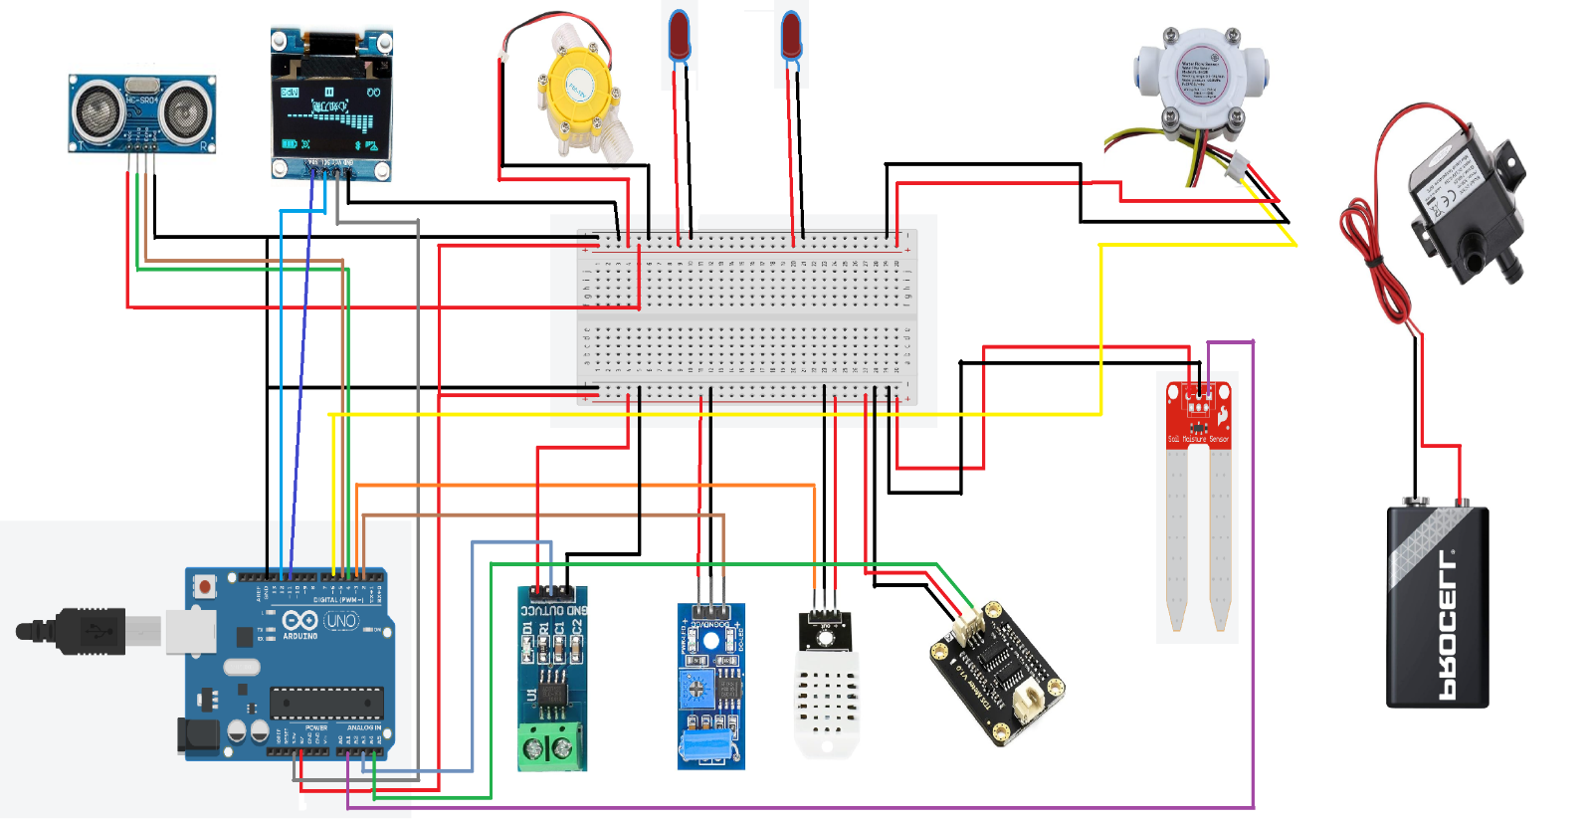

8. Explanation of Protocols Used in AHMS:
Different protocols are used during the data transfer between sensors, microcontrollers, and cloud platforms of the Advanced Hydropower Monitoring System (AHMS). Such protocols are vital for achieving real-time monitoring, remote accessibility, and consistent operation. It recognizes varying protocols and reference models, offering a further understanding of AHMS alignment support to the industry standards.

Protocols Used in AHMS:
Wi-Fi (IEEE 802.11):
- Purpose: Wi-Fi is used to establish wireless communication between the Arduino Uno MKR WIFI 1010 and the IoT Cloud.
- Working in AHMS:
- Sensor data collected by the microcontroller is transmitted via Wi-Fi to the IoT Cloud for analysis and visualization.
- Wi-Fi ensures a stable, high-speed connection suitable for real-time applications.
- Advantages:
- High data transmission rates.
- Easily integrates with existing infrastructure.
- Limitations:
  - Power consumption is higher compared to low-power alternatives like Zigbee or LoRaWAN.
- Code References:


MQTT (Message Queuing Telemetry Transport):
- Purpose: MQTT is a lightweight messaging protocol designed for IoT applications with limited bandwidth.
- Working in AHMS:
    - Data is sent from the Arduino board to the IoT Cloud using a publish-subscribe model.
    - Arduino acts as a publisher, sending sensor data to specific topics on the cloud server, while remote
dashboards and control systems act as subscribers.
- Advantages:
    - Low bandwidth usage, making it suitable for environments with limited connectivity.
    - Reliable delivery with Quality of Service (QoS) levels.
- Limitations:
    - Relies on a broker, which could become a single point of failure.
- Code References:

One-Wire Protocol:
- Purpose:
One-Wire is used for communication with sensors that require minimal wiring, such as the temperature sensor in some IoT applications.
- Working in AHMS:
- The Arduino communicates with the sensors over a single data line (plus ground) to collect specific data such as temperature or TDS levels.
- The protocol simplifies wiring and allows for multiple devices to be connected to the same data line.
- Advantages:
- Requires only one data wire, reducing complexity.
- Supports addressing multiple devices on the same line.
- Limitations:
- Slower data transfer rates compared to protocols like I2C or SPI.
- Limited use cases for low-speed applications.
- Code References:

I2C (Inter-Integrated Circuit):
- Purpose: I2C is used for communication between the Arduino and connected peripherals like the OLED display.
- Working in AHMS:
- Arduino communicates with the OLED over a two-wire interface, sending real-time data for on-site visualization.
- Advantages:
- Simple and efficient for short-range communication.
- Reduces the number of pins required for connections.
- Limitations:
- Limited to short distances and low data rates.
- Code References:


UART (Universal Asynchronous Receiver-Transmitter):
- Purpose:
UART is used for serial communication between the Arduino and external modules such as GSM, GPS, or debugging interfaces.
- Working in AHMS:
- The Arduino exchanges data with connected devices or modules using asynchronous serial communication.
- This can include transmitting real-time data to a local monitoring unit or receiving commands from a user interface.
- Advantages:
- Widely supported and straightforward to implement.
- No need for a clock signal, reducing complexity.
- Limitations:
- Limited to two devices for direct communication.
- Slower data rates compared to SPI or I2C.
- Code References:

IoT Reference Models and AHMS
Standardized IoT reference models provide a basis for developing and executing IoT systems. The AHMS corresponds to multiple levels of the Internet of Things-Architecture (IoT-A) Reference Model.

1. Perception Layer:
- Description: the perception layer collects physical data from the environment using devices and sensors that collect the data.
- In AHMS: This layer contains sensors such as the pH sensor, flow sensor, vibration sensor, and moisture sensor. They collect live data, and this data is the base of the system.

2. Network Layer:
- Description: Responsible for transmitting data from the devices to the processing units or cloud platform.
- In AHMS: Arduino Uno MKR WIFI 1010 transmitting data to the IoT Cloud with Wi-Fi and MQTT protocols. Communication on the local system is provided by the I2C protocol.

3. Processing Layer:
- Description: The processing layer analyzes and processes the data received from the perception layer.
- In AHMS: The Arduino board preprocesses data on-site, while the IoT Cloud takes care of advanced analytics like predictive maintenance and trend analysis.

4. Application Layer:
- Description: This layer exposes the system to the end-user.
- In AHMS: containing equipment like OLED display and IoT Cloud dashboards, devices that allow the operators to control and check the information in the system.

5. Business Layer:
- Description: This layer is all about aligning the IoT system to provide value in relation to business objectives.
In AHMS: Business layer provides insights into efficiency of the plant, when maintenance is needed, compliance when it is due, which helps in decision making.

9. Snapshots of the Code

Snapshots for Hydropower_IoT_Project.ino file
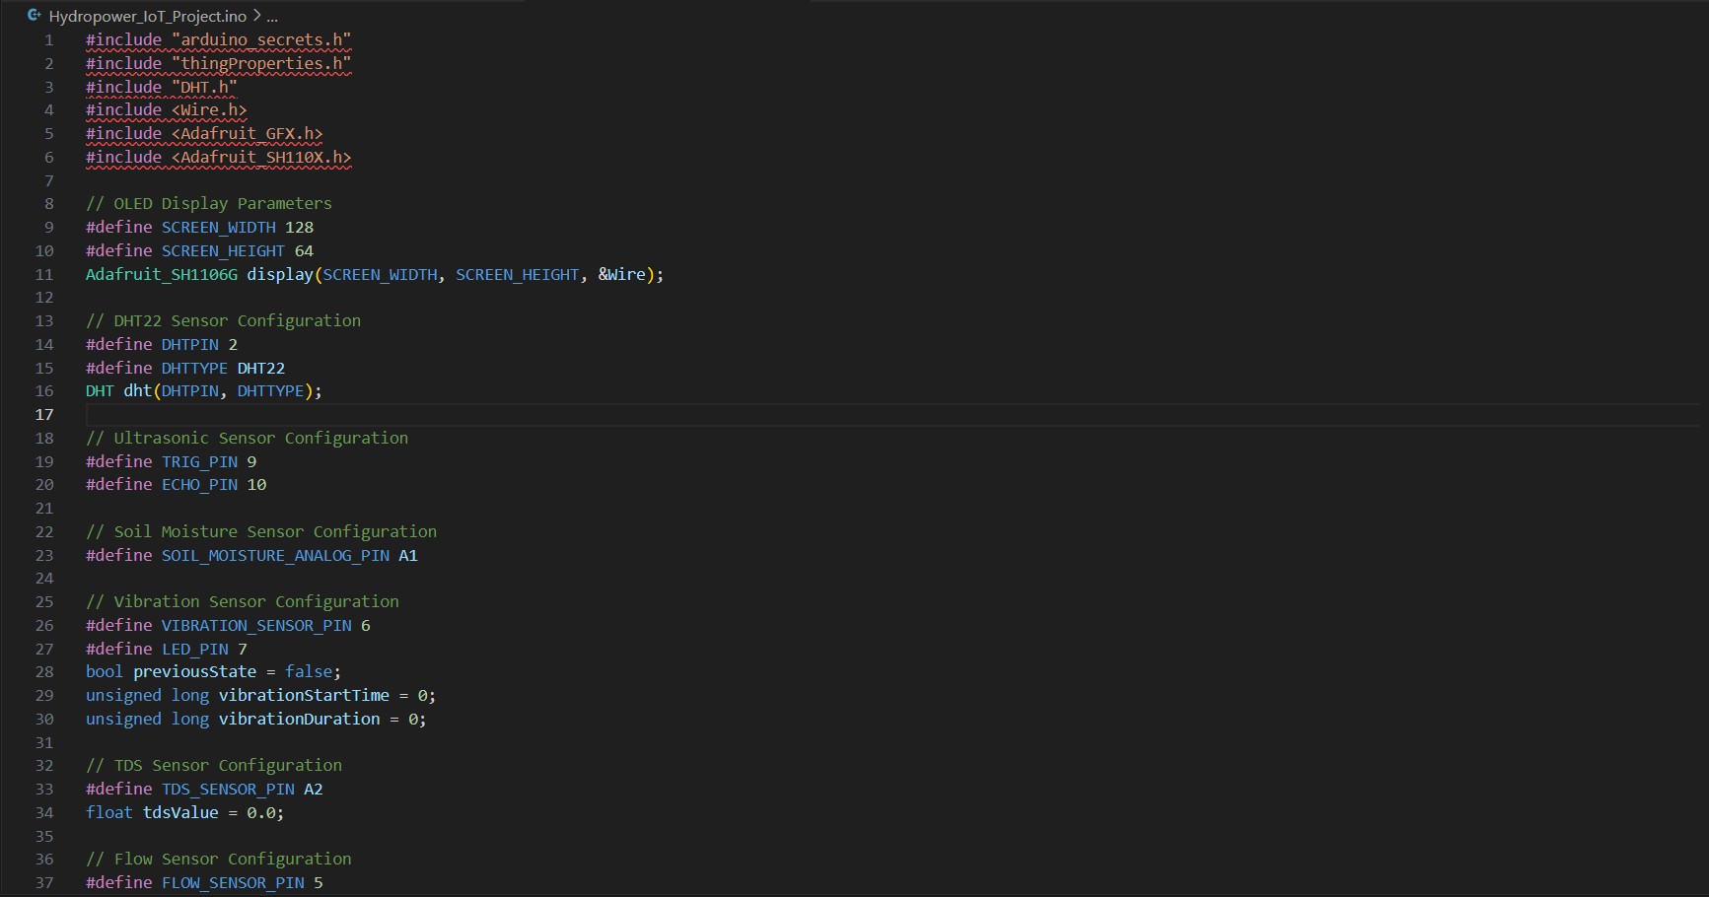
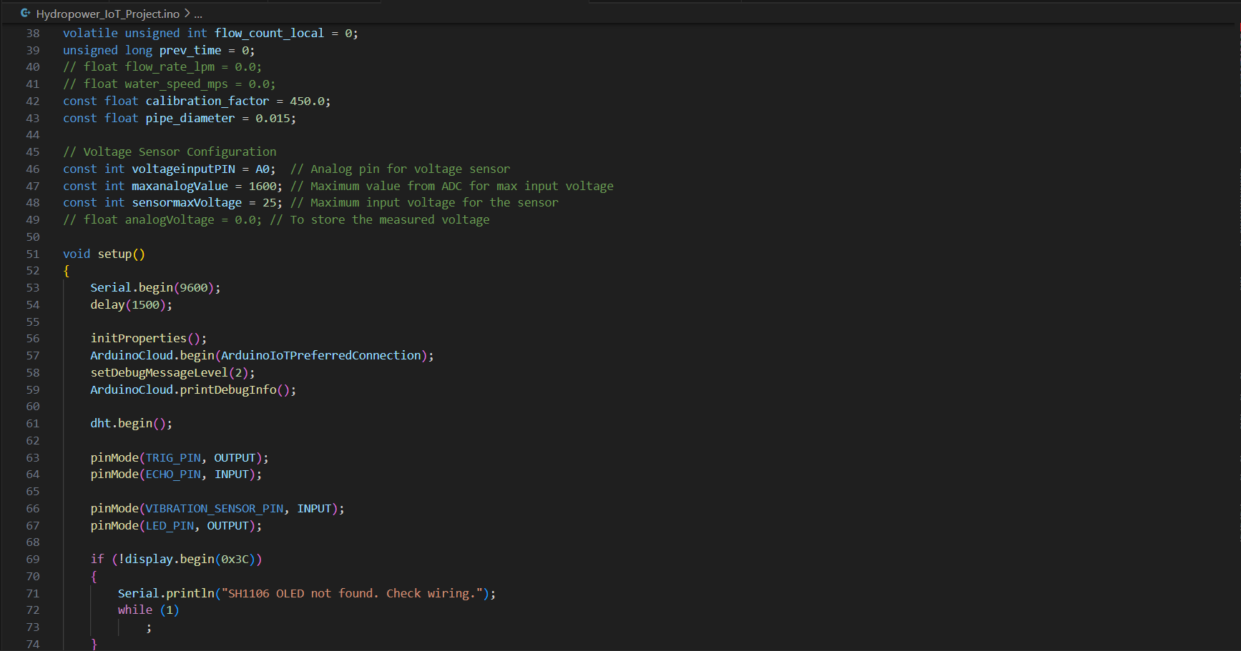
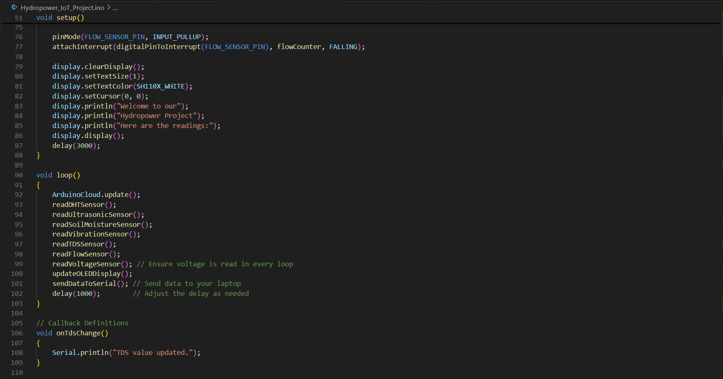
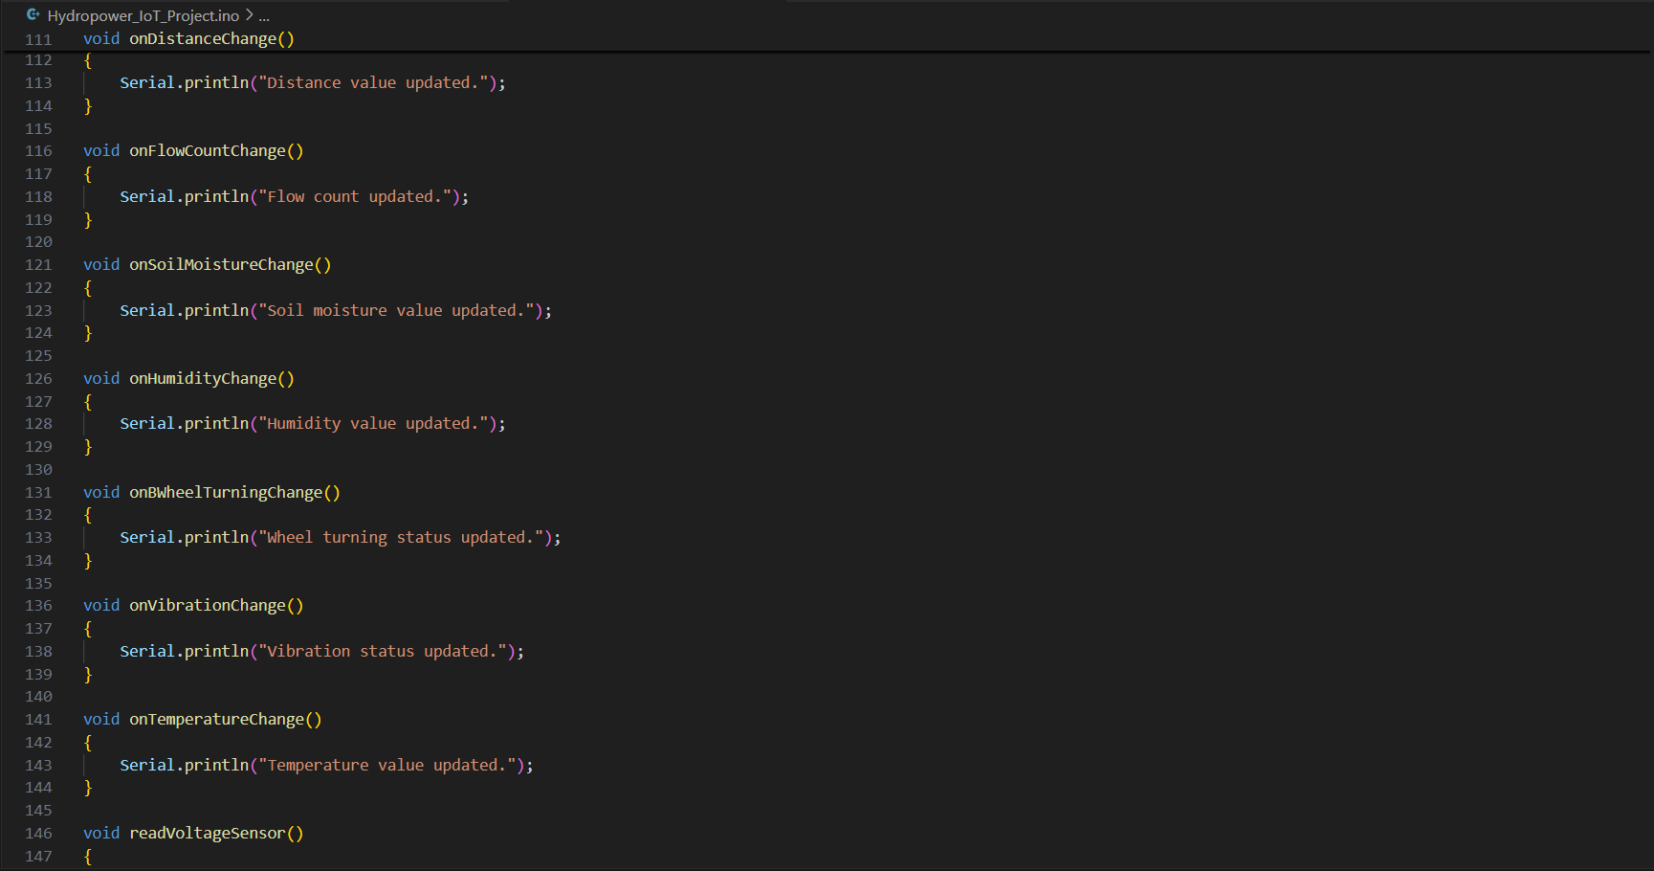
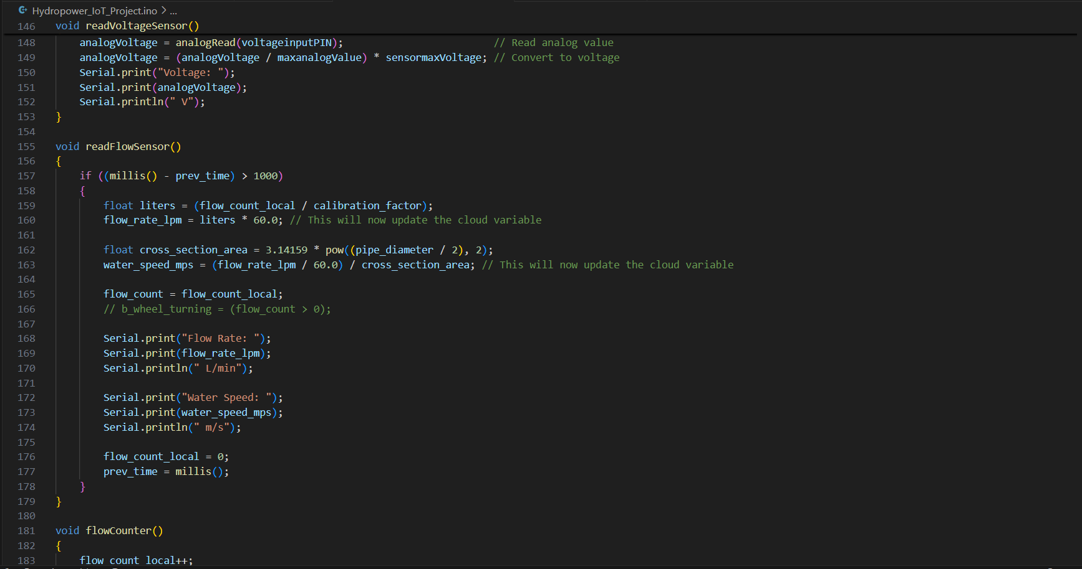

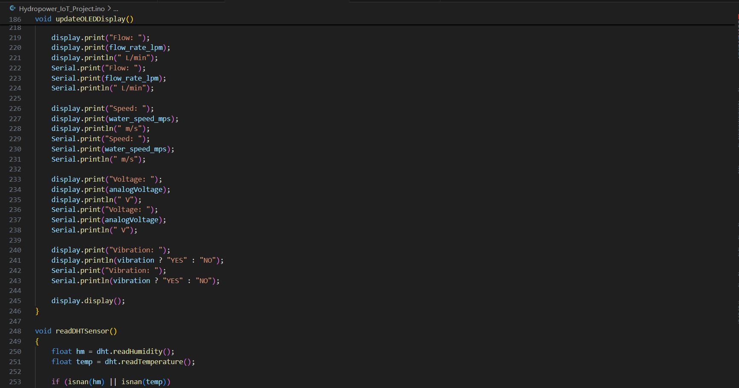
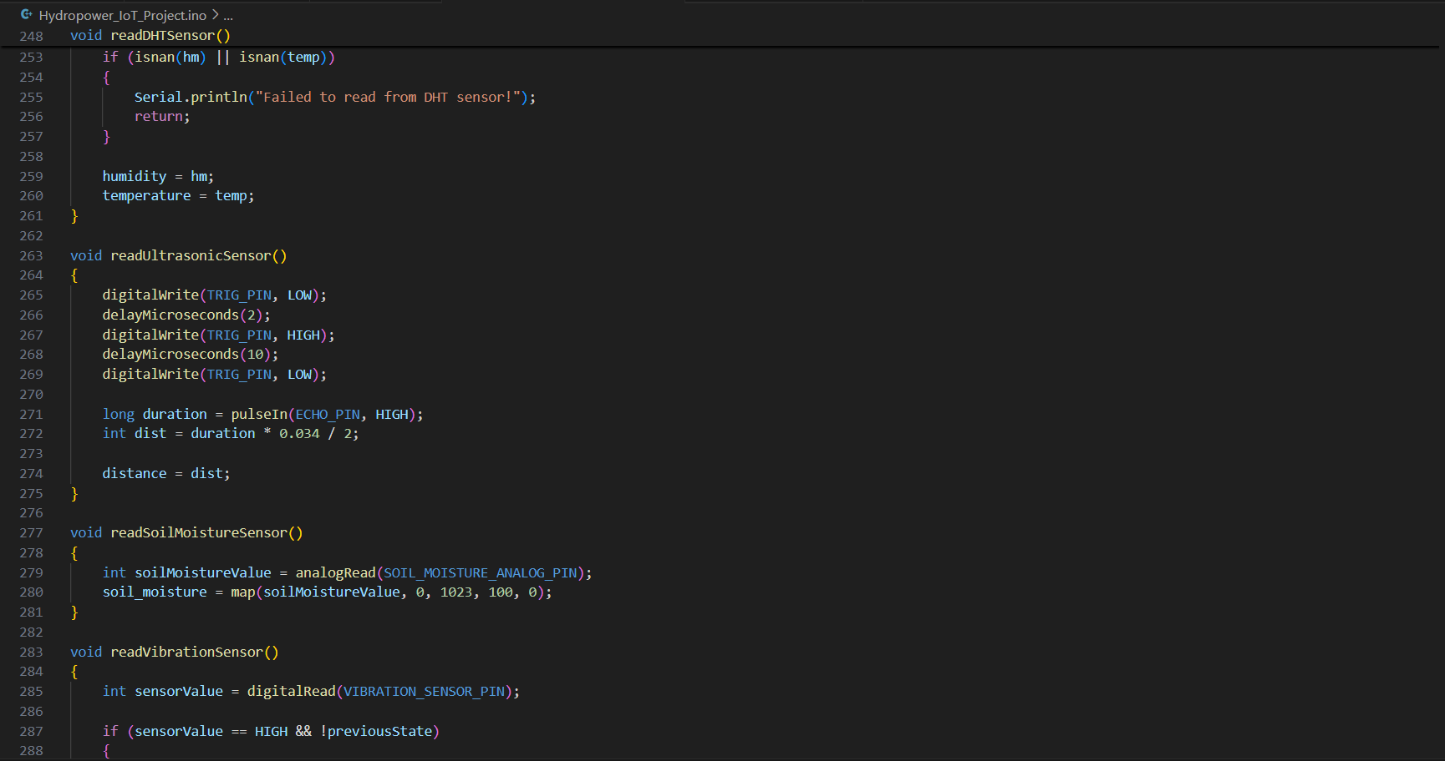

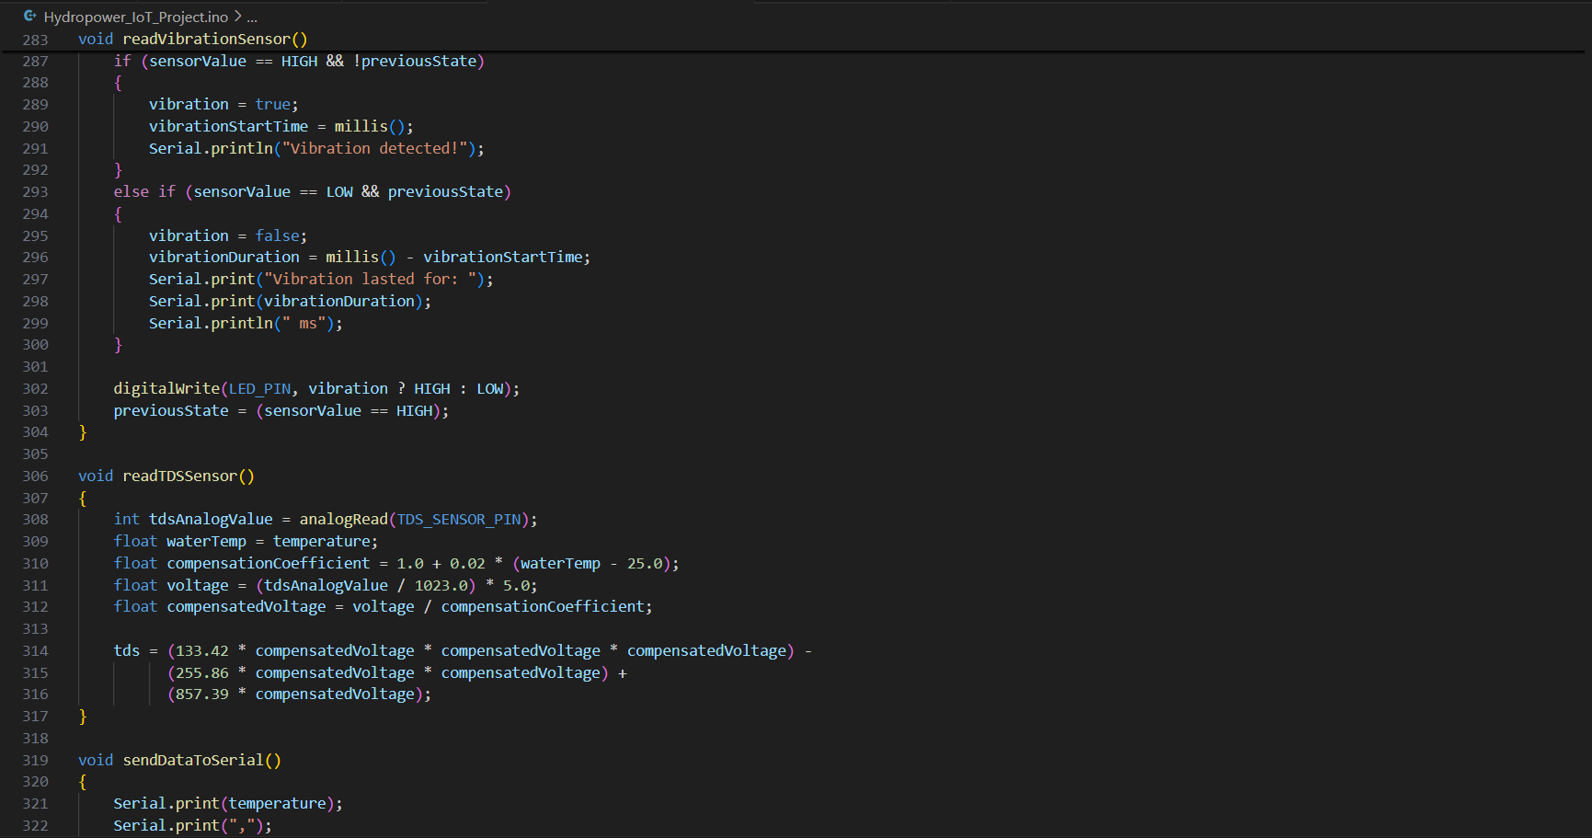
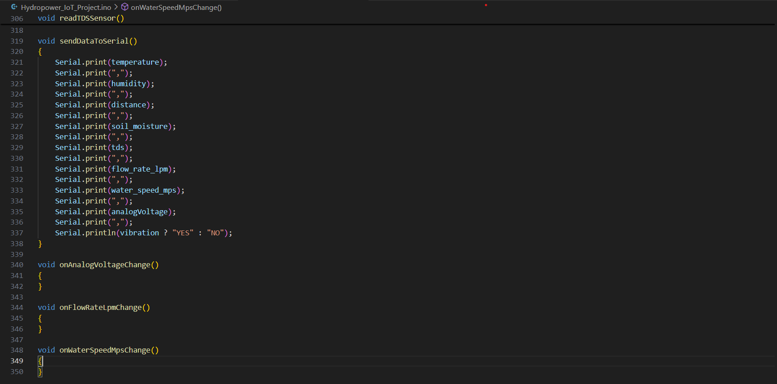

Snapshots for the thingProperties.h file
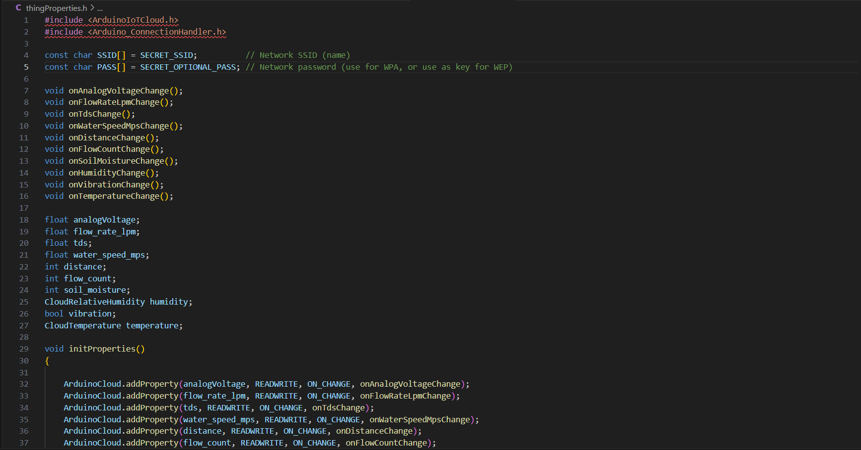
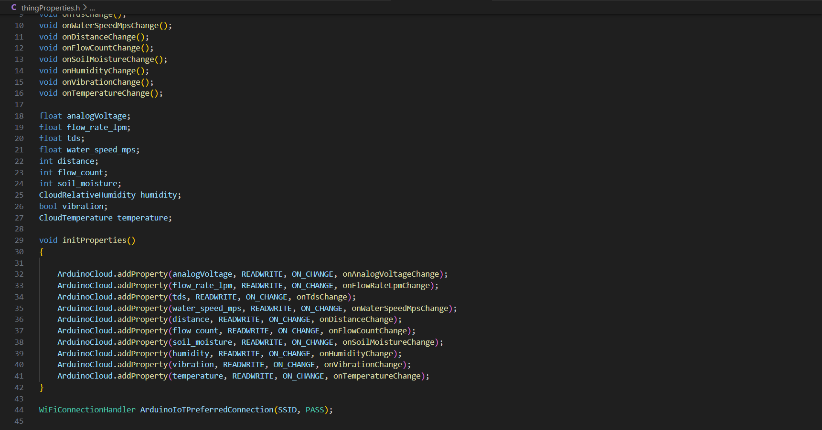

10. Conclusion
AHMS, the (Advanced Hydropower Monitoring System), is an internet of things (IoT) solution that can transform the hydropower industry by facilitating real-time monitoring, automation, and predictive maintenance. The system embeds multiple sensors, an Arduino Uno MKR WIFI 1010 microcontroller, IoT Cloud connectivity, and user-friendly output devices to maintain operational efficiency, environmental compliance, and cost-effectiveness. But like any system, AHMS is not without its challenges and limitations. This section summarizes quintessential issues faced, areas of potential application and recommendations for improvements in future.

Issues Identified in AHMS (Advanced Hydropower Monitoring System)
- Sensor Calibration:
  - Issue: flow, and vibration sensors need to be calibrated from time to time to ensure precision. Environmental factors such as temperature variations or debris in the water can lead to sensor drift.
  - Impact: False readings can result in false alarms or compromised system efficiency.
- Wi-Fi Connectivity:
  - Issue: The system features a heavy dependence of Wi-Fi for data transmission. Wi-Fi connectivity can be unreliable in the remote or rural areas in which many hydropower plants are situated.
  - Impact: Disruptions to data transmission could impede monitoring in real-time and its remote availability.
- Power Dependence:
  - Issue: Sensors, microcontroller as well as actuators need a steady power supply. Power outages could impact operations, especially where energy is less reliable.
  - Impact: Temporary unavailability of monitoring or control features during times of outage.
- Environmental Challenges:
  - Issue: Sensor performance and system durability can be affected by extreme environmental conditions, such as excessive rain, freezing temperatures, or humidity.
  - Impact: Decreased system reliability and increased maintenance requirements.
- Initial Setup Complexity:
  - Issue: Technical intervention is necessary during installation to integrate multiple sensors, calibrate them, and establish a successful IoT Cloud connection.
  - Impact: May result in delays to the deployment or increase the need for specialized personnel.

Application Areas of AHMS
AHMS is versatile and applicable in diverse contexts apart from hydropower plants:
- Hydropower Plant Management:
- Key applications in Energy generation optimization, equipment safety monitoring, and water quality monitoring.

- Irrigation Systems:
- For agriculture AHMS can monitor soil moisture level and automatically turn on water pump for irrigation.

- Flood Management:
- Water levels in reservoirs could be monitored to potentially provide predictions of flooding events by using ultrasonic sensors, along with flow sensors.

- Industrial Water Management:
- Industries that need water on a large scale can monitor their water and flow rates with AHMS and ensure that the efficient enterprise is running in compliance with rules.

- Environmental Monitoring:
- This system can monitor the level of water quality (e.g., pH) for specific rivers, lakes, or reservoirs to prevent pollution and sustain ecological balance.

- Wastewater Treatment:
- AHMS can help to optimize treatment by measuring water quality parameters and activating treatment devices.

Future Improvements and Recommendations:
Here we propose some improvements and recommendations to enhance AHMS functionality and reliability.

- Integrating Water Filtration Using the pH Sensor:
- Recommendation: Utilize the pH sensor data to trigger a filtration mechanism for water with unsuitable acidity or alkalinity levels.
- Benefit: Ensures that only clean water is used in the hydropower system or discharged into the environment, improving compliance with environmental regulations and safeguarding aquatic ecosystems.

- Irregular Reading Notification System
- Recommendation: Implement IoT-enabled notifications to alert users of irregular sensor readings, such as:
- Flow Sensor: Sudden spikes, zero flow, or exceeding limits.
- Vibration Sensor: Prolonged or excessive vibrations.
- Voltage Sensor: Unexpected voltage drops or spikes.
- Benefit: Enables real-time issue detection, proactive maintenance, and reduced downtime through early warnings for anomalies.

- Enhancing Energy Storage Capabilities:
- Recommendation: Add an energy storage system, such as batteries or supercapacitors, to store the excess energy generated by the turbine during high water flow.
- Benefit: Provides a backup power source for the sensors and actuators during power outages, ensuring uninterrupted monitoring and operations.

- Automated Irrigation Using the Humidity Sensor:
- Recommendation: Integrate the humidity sensor (DHT22) with an irrigation system to automatically water nearby vegetation if the soil moisture and atmospheric humidity levels drop below a threshold.
- Benefit: Promotes efficient use of water resources for surrounding vegetation, contributing to a greener, more sustainable environment.

- Enhanced System Scalability:
- Recommendation: Introduce additional sensors, such as turbidity sensors for water clarity or dissolved oxygen sensors, to expand monitoring capabilities.
- Benefit: Enables comprehensive environmental monitoring, making the system applicable to a wider range of use cases.

- Enhanced Connectivity Options:
- Recommendation: Implement communication tech such as LoRaWAN, or NB-IoT, which are more environmentally conscious and appropriate for lack of wi-fi coverage areas.
- Benefit: Provides reliable communication in low connectivity.

- Smart Flood Management System
- Recommendation: Use ultrasonic sensors and flow rate data to monitor reservoir water levels in real time and integrate automated floodgate control systems.
- Benefit: Prevents overflow-related damage during heavy rainfall or excessive water flow, ensuring safety and efficient water resource management.

Why Invest in the Advanced Hydropower Monitoring System (AHMS)?
- Cost-Effective Solution:
- AHMS reduces operational costs due to lower maintenance, predictive maintenance, and optimized energy production, etc., thereby lowering LCOE as compared to other technologies.
- Enhanced Operational Efficiency:
- With real-time data collection, automated controls maximizes the performance of hydropower plants and minimizes human intervention and resource wastage.
- Environmental Sustainability:
- AHMS ensures compliance with environmental regulations through integrated TDS monitoring, reducing ecological footprint.
- Scalability for Future Needs:
- AHMS is scalable so more sensors or renewable energy integrations like solar panels can be added.
- Remote Monitoring Capability:
- Operators have access to the system remotely improving oversight and avoiding the need for on-site staff.
- Proven Reliability:
- The system is constructed around proven and reliable components, including Arduino MKR Wi-Fi 1010 and industrial-grade sensors, ensuring robust performance under harsh conditions.

References
Ashton, K. (1999) 'Internet of Things: Operational Impact', RFID Journal. Available at: RFID Journal.
Arduino.cc (n.d.) 'Arduino IoT Cloud Guide'. Available at: Arduino Documentation.
Brown, P., White, J., and Gray, H. (2018) 'Remote IoT Monitoring for Industrial Applications', Automation and Robotics Journal, 34(2), pp. 90–110. Available at: Springer Link .
Gubbi, J., Buyya, R., Marusic, S. and Palaniswami, M. (2013) 'Internet of Things (IoT): A Vision, Architectural Elements, and Future Directions', Future Generation Computer Systems, 29(7), pp. 1645–1660. Available at: DOI Link.
Smith, J. (2020) 'IoT Scalability Challenges and Solutions', Journal of Engineering Technologies, 45(3), pp. 120–134. Available at: IEEE Xplore.

