

American International University-Bangladesh (AIUB)
Department of Computer Science
Faculty of Science & Technology (FST)

ShareBox: A community Donation and Lost-Found Platform
Semester: Fall 25-26

Group: 01 |  | Section: U
SL | Student Name | Student ID
1 | Fihab Ifty | 23-51180-1
2 | Nusrat Sarker Nowshin | 23-51194-1
3 | MST.Sayma Akter Rithy | 23-51201-1
4 | Anika Sultana Anu | 23-51807-2
5 | Jannat Jarin | 23-51827-2

Table of Contents

1. Project Proposal 03x
1.1 Background to the Problem 03x
1.2 Selection of Process Model 03x
2. Software Requirements Specification (SRS) / PRD 04x
2.1 User Story Table 04x
2.2 Requirements (Functional / Non-Functional) 05x
2.2.1 Functional Requirements 05x
2.3.2 Non-Functional Requirements 12x
3. Software Design 17x
3.1 System Deisgn 17x
3.2 UI Deisgn using Figma 21x
4. Git Workflow xx
5. Software Testing xx
6. Conclusion xx

1. PROJECT PROPOSAL

  - Background to the Problem
People in our community usually have extra items that others could use, such as clothing, electronics, or books. At the same time, a lot of people lose things like phones, purses, and ID cards and want urgent help in finding them. Nowadays, a lot of people handle these through group conversations or social media, which is dangerous and complicated. Because when an item is handed over, there is no safe record or proof, the posts are buried, the search is not effective, and there is no obvious match. ShareBox aims to solve this by providing a single, well-organized location for donations, need requests, and lost-found posts. To allow trusted item exchanges, this platform offers simple matching, safe and confidential communication (in-app chat), and a scheduled handoff. This reduces waste, speeds up returning lost items, and builds trust with a clear, trackable process for the community.
  - Selection of Process Model
For ShareBox, we selected the Agile Iterative (Scrum-based) process model. In Agile, the project is developed in small cycles (iterations/sprints). In each sprint, we plan tasks, collect/confirm requirements, design screens, review with the team, and update the backlog. This process repeats until the product becomes complete.

Visualization (Agile Sprint Cycle)
Requirements / Backlog
→ Sprint Planning
→ Design (UI + Diagrams)
→ Implementation (Future)
→ Testing (Future)
→ Review & Feedback
→ Backlog Update (requirement changes)
→ Next Sprint (repeat)

Why we chose Agile
- Requirements changed during design: While building the Figma screens, we found usability gaps and updated some requirements. Agile supports change easily because we can make changes to the backlog and continue in the next sprint.
- Prototype-first approach: Our project took about three months to create and improve processes till it reached the Figma prototype stage. Agile is a good fit since it promotes early prototypes and continuous improvement.
- Team collaboration and tracking: We used Trello to update tasks and progress on a regular basis, and GitHub workflow was used to keep project materials and updates. This aligns with Agile's iterative tracking and transparency.
We arranged regular meetings to take updates, reviewed what was done, and decided what to do next. After each discussion, we updated Trello tasks and kept documentation and design progress organized, so requirement changes during the 3-month design phase were handled in a controlled way.

2. SOFTWARE REQUIREMENTS SPECIFICATIONS (SRS) / PRODUCT REQUIREMENTS DOCUMENT (PRD)
2.1 User Story Table
ID | Actor | User Goal | Benefit | Acceptance (Done when…) | Feature Area
US1 | Donor | Post a donation | Someone who needs it can find it | I add title, category, condition, one plus photo, area. Then item appears in Donation list. | Listings
US2 | Seeker | Search and filter donations | I quickly find useful items | Filters by category and area work and show matching results | Search/Filter
US3 | User | Post a lost item with details | Others can help me find it | I add one plus photo, area, date. Then item appears in Lost list | Listings
US4 | Finder | Post a found item | The owner can contact me safely | Owner can chat inside the app. My phone/email stay hidden | Listings/Chat
US5 | User | See match suggestions | I can act fast | Items show Strong/Possible with short reason tags for example same category, nearby. | Matching
US6 | Donor / Receiver | Book a handoff (meet in person) | We meet safely | Venue + time saved. App creates PIN/QR. Status becomes scheduled. | Handoff
US7 | Donor / Receiver | Complete a handoff | There is proof of completion | Correct PIN/QR is entered then status becomes completed | Handoff
US8 | Seeker / Receiver | Choose Delivery instead of meeting | I can receive it without meeting in person | App shows fixed delivery fee and that I pay then I tick “I agree to pay” | Delivery
US9 | Moderator | Review reported posts | The platform stays safe | I can dismiss/warn/remove. All actions are logged | Moderation

2.2 Requirements (Functional / Non-functional)
2.2.1 Functional Requirement
Phase | Item No | Specification [Role] | Screen Definition | User Story | Acceptance Criteria
Feature: 1
Authentication Feature
phase 1 | 1 | User Registration [Donor][Seeker][Finder] | A signup form will appear when the user clicks the register button. It will have fields for name, email, phone, password, confirm password, and location dropdown. After filling form, the user clicks register to create an account. | As a new user, I want to create an account so that I can use the ShareBox platform. | - System should accept a unique email only  - Password should be at least 8 characters with a special symbol  - Phone number should have 11 digits  - User must select a location from the list  - Confirmation email should be sent after registration
phase 1 | 2 | User Login [All Roles] | The login form will be available on the homepage header. The user can enter an email or phone number with a password. There will be a login button, a remember me option, and a forgot password link. | As a registered user, I want to log in to my account so that I can access my dashboard. | - User should log in with email or phone  - The system should check the password against the database  - Successful login should go to the dashboard  - Wrong password should show an error message
phase 1 | 3 | Profile Management [All Roles] | The user profile page will show current information with an edit button. Clicking edit will open a form with name, phone, location preferences, and bio fields. The save button will update the information. | As a user, I want to update my profile information so that my details remain current. | - User should be able to change name and phone  - Phone format should be correct  - At least one location should be selected  - Changes should save immediately when saved
Feature: 2
Item Listing & Management
phase 1 | 4 | Donation Posting [Donor] | The donation form will have a title field, category dropdown, sub-category dropdown, condition selection, location choice, image upload area, and description box. The post button will submit the donation. | As a donor, I want to post items for donation so that others can use them. | - Title should be 5 to 100 characters  - Category must be selected  - At least one image should be uploaded  - Location should be chosen from the list  - The post should go for moderation before showing
phase 1 | 5 | Need Request Posting [Seeker] | Need request form will contain the title, category dropdown, urgency level selection, location choice, and description area. The post button will publish the need request. | As a seeker, I want to post what I need so that donors can help me. | - Urgency level should be selected  - Description should explain why needed  - The post should go for moderation  - User should be able to edit or delete their own posts
 | 6 | Lost Item Reporting [Owner] | The lost item report form will have an item name field, category selection, lost location dropdown, date lost field, image upload, and description area. The report button will submit the lost item report. | As an owner, I want to report lost items so that finders can return them to me. | As an owner, I want to report lost items so that finders can return them to me.
 | 7 | Found Item Reporting [Finder] | The found item report form will include item name, category selection, found location dropdown, date found field, image upload, and description. The report button will submit the found item. | As a finder, I want to report found items so that owners can get them back. | The found date should not be a future date  - Found location must be specified  - Finder should have an anonymous option  - Report should appear in the found items list
phase 1 | 8 | Item Search & Filtering [All Roles] | The search bar will be on top of item listing pages. Below it, filter options for category, location, condition, and date range will be available. The Apply filters button will show filtered results. | As a user, I want to search and filter items so that I can find what I need quickly. | - Search should check the title and description  - Multiple filters should work together  - Results should show basic item information  - No results message should show when nothing is found
Feature: 3
Matching & Communication
phase 1 | 9 | Smart Matching System [All Roles] | The match suggestions section will show on the user dashboard. It will display strong matches and possible matches as cards. Each card will have reason tags explaining why matched. | As a user, I want to see match suggestions so that I don't have to search manually. | - System should suggest matches by category, location, and date  - Strong matches should show first  - Each match should show a brief reason  - User should be able to ignore or act on suggestions
 | 10 | In-App Messaging [All Roles] | The chat interface will open when users connect. It will show message history, text input box, send button, and attach image button. Messages will appear in real-time. | As a user, I want to message others so that we can communicate without sharing personal contacts. | - Users should message without phone/email sharing  - Messages should deliver instantly  - File and image attachments should work  - Chat history should save for completed transactions
phase 1 | 11 | Notification System [All Roles] | Bell icon will be on the top navigation bar. Clicking it will open the notification panel showing all notifications. Red dot will indicate unread notifications. | As a user, I want to get notifications so that I don't miss important updates. | - User should get new message notifications  - Match suggestions should send notifications  - Handoff updates should notify users  - Notifications should be markable as read
Feature: 4
Handoff Management
Phase 1 | 12 | Handoff Scheduling [Donor][Receiver] | The handoff scheduling form will have a meeting location dropdown, meeting date picker, time slot selection, and an additional instructions box. The schedule button will confirm the meeting. | As a user, I want to schedule handoff meetings so that we can exchange items safely. | - Meeting date should not be past date  - Location should be from the safe public places list  - Time slots should be 30 minutes each  - Both users should get a confirmation notification
Phase 1 | 13 | PIN/QR Code Generation [System] | After scheduling, the system will show the QR code and PIN number on the screen. The Regenerate button can create new codes. Mark complete button will finish the handoff. | As a user, I want secure codes for handoff so that we can verify the exchange. | - A unique PIN and QR should be generated for each handoff  - PIN should be 6 digits  - QR should contain handoff details  - Codes should expire after meeting time plus 2 hours
phase 1 | 14 | Handoff Completion [Donor][Receiver] | The handoff completion screen will have a PIN input field, a verify button, and a QR scan button. Both users need to verify for successful completion. | As a user, I want to complete the handoff properly so that we have proof of exchange | - The correct PIN should be entered by both parties  - QR scan should auto-verify handoff  - Status should change to completed after verification  - Both users should be able to rate the experience
Feature: 5
Delivery System
phase 1 | 15 | Delivery Request [Receiver] | The delivery options section will show during handoff scheduling. It will have to meet in person or use delivery options. The delivery fee will be shown, and agree to pay checkbox. | As a receiver, I want a delivery option so that I don't have to meet in person. | - Delivery fee should be calculated by item size and distance  - The user should agree to pay the delivery fee  - Delivery should be for certain categories only  - The receiver should not change to delivery after scheduling
phase 1 | 16 | Delivery Tracking [Receiver] | The delivery tracking screen will show delivery status with a progress bar, estimated delivery time, and a contact delivery person button. Status will update in real-time. | As a receiver, I want to track delivery so that I know when my item will arrive. | - Delivery status should update regularly  - The estimated time should be based on the distance  - The receiver should contact the delivery person through the app  - Delivery completion should require recipient confirmation

Feature: 6

Moderation & Admin
phase 1 | 17 | Content Moderation [Moderator] | The moderator dashboard will show the reported posts list. Each post can be approved, warned, or removed. Moderation notes can be added for each action. | As a moderator, I want to moderate content so that the platform remains safe for everyone. | - The moderator should view the reported posts' details  - Actions should require a reason selection  - All actions should be logged with time  - The user should get a notification of the moderation action
 | 18 | Prohibited Items Management [Moderator] | The Banned items management section will have an add new item field, a banned categories list, add category and remove category button. Changes will update immediately. | As a moderator, I want to manage prohibited items so that inappropriate items are not posted. | -Found date should not be a future date  - Found location must be specified  - Finder should have an anonymous option  - Report should appear in the found items list

Feature: 7

Reports & Analytics
 | 19 | Impact Dashboard [Moderator][Admin] | The impact dashboard will show monthly metrics with cards for successful donations, returned items, active users, and category distribution charts. Filters will be available. | As an admin, I want to see platform impact so that I can track performance. | -System should track monthly successful donations  - The returned lost items count should show with the success rate  - User engagement metrics should display  - Data should filter by date range and Location
 | 20 | User Feedback System [All Roles] | Feedback form will appear after transaction completion. It will have star rating, comments box, anonymous feedback checkbox and submit button. | As a user, I want to give feedback so that platform can improve based on our experience. | -Users should rate transactions with 1-5 stars  - Feedback comments should be optional  - Anonymous feedback option should be available  - Feedback should be used for user reputation system

2.2.2 Non-Functional Requirements
Phase | Item no | Specification [Role] | Screen Definition | User Story | Acceptance Criteria

Feature: 1

Performance
 | 1 | System Response [System] | All pages should load within 3 seconds on normal internet. Search results should show within 2 seconds. System should handle 1000 users at the same time. | As a user, I want the system to respond quickly so I don’t have to wait. | - Pages should load within 3 seconds- Search should respond in 2 seconds  - Up to 1000 users should be supported  - Performance slowdowns could be monitored
 | 2 | Database Speed [System] | The database should respond within 1 second for most queries and work smoothly with at least 10,000 items. | As a developer, I want fast queries so users get smooth experience. | - Queries should finish in 1 second  - DB should handle 10,000+ records  - Timeouts could be reduced with indexing- Backups could avoid blocking queries

Feature: 2

Security
 | 3 | Data Protection [Security] | All passwords and personal data should be encrypted, and the whole site should use HTTPS. | As a user, I want my information safe. | - Passwords should be encrypted- HTTPS should be enforced  - Sensitive data should not appear in logs  - Extra encryption could be used
 | 4 | User Safety [Security] | Accounts should lock after failed logins and sessions should expire automatically. | As a user, I want account protection. | - Lockout should occur after 5 failed attempts  - Sessions should expire in 30 minutes  - Contact details should remain hidden  - Suspicious attempts could trigger alerts
 | 5 | Privacy Control [Security] | Users should control visibility of personal info, and location should be approximate. | As a privacy-conscious user, I want control. | - Users should manage visibility  - Only approximate location should show  - Privacy complaints could be submitted

Feature: 3

Usability
 | 6 | Easy to Use [User] | The system should be easy to understand without training. | As a new user, I want simplicity. | - New users should complete tasks easily- Navigation should be clear  - Errors could guide users  - Common actions should take few steps
 | 7 | Mobile Friendly [User] | The system should work well on mobile and tablet. | As a mobile user, I want comfort. | - Layout should be responsive  - Buttons should be touch-friendly- Text should be readable  - Orientation changes could maintain usability
 | 8 | Accessibility [User] | People with disabilities should be able to use the system. | As an accessibility user, I want support. | - Screen readers should work  - Keyboard navigation should be available  - Contrast should meet standards

Feature: 4

Reliability
 | 9 | System Uptime [System] | The system should be available 99.5% of the time yearly | As a user, I want stable service. | - Uptime should reach 99.5%- Downtime should stay under 44 hours/year  - Backup features could keep core functions alive  - Recovery should follow a documented plan
 | 10 | Data Backup [System] | Data should be backed up daily and recoverable quickly. | As an admin, I want data safety. | - Daily backups should run  - Backups should store 30 days of data  - Recovery could occur within 4 hours
 | 11 | Error Handling [System] | System should not crash from user errors and should log issues | As a user, I want safe error handling. | - User mistakes should not crash system- Clear error messages should show  - Technical logs could store errors  - Auto-recovery should occur where possible

Feature: 5

Scalability
 | 12 | User Growth [System] | System should scale from 100 to 10,000 users. | As an owner, I want scalable growth. | - Performance should remain stable  - DB should support 100k records  - Resources could be added easily
 | 13 | Storage Growth [System] | System should support growing image/file storage. | As an admin, I want scalable storage. | - System should store 50,000 images  - Storage could scale automatically  - Users should not face space issues  - Storage usage could be monitored

Feature:6

Maintainability
 | 14 | Code Quality [Developer] | Code should be clean, modular, and documented | As a developer, I want maintainable code. | - Structure should follow standards  - Documentation should exis  - New devs could understand quickly
 | 15 | Easy Updates [Admin] | Updates should be quick with rollback options. | As an admin, I want smooth updates | - Rollback should restore previous version  - Users could receive maintenance notices  - Updates should not break data

Feature : 7

Compatibility
 | 16 | Browser Support [User] | System should support major browsers. | As a user, I want browser choice. | - Chrome/Firefox/Safari/Edge should be supported  - Features should behave consistently  - Mobile browsers could be tested
 | 17 | Device Support [User] | System should work on phones, tablets, and desktops. | As a user, I want multi-device use. | - Layout should be responsive  - Touch & mouse should both work  - All key features could be available

Feature: 8

Operations
 | 18 | Monitoring [Operator] | System should have monitoring, alerts, and logs. | As an operator, I want early issue detection. | - Monitoring should track performance  - Alerts should trigger on failures  - Logs could store 90 days of activity
 | 19 | Documentation [Admin/User] | User and admin documentation should be available. | As a user, I want help when stuck. | - User guides should cover workflows  - Admin manuals should be complete  - Support team could receive training  - Help pages should be easy to find
 | 20 | Compliance [Legal] | The system should follow data and privacy laws. | As a platform owner, I want legal compliance. | - Data laws should be followed  - Privacy policy should be clear  - User rights tools could be available

3. SOFTWARE DESIGN
3.1 System Design: Draw the system design for your project using Draw.io or LucidChart.
- Use Case Diagram
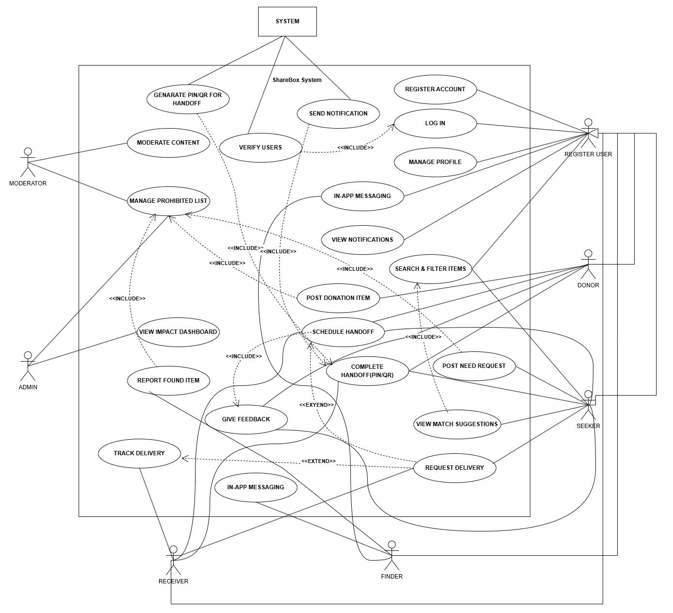

- Class Diagram
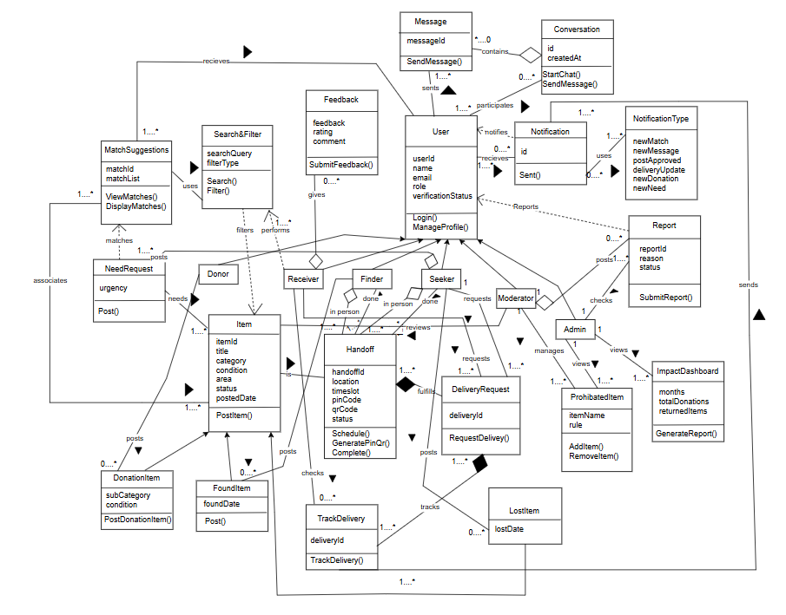

Activity Diagram
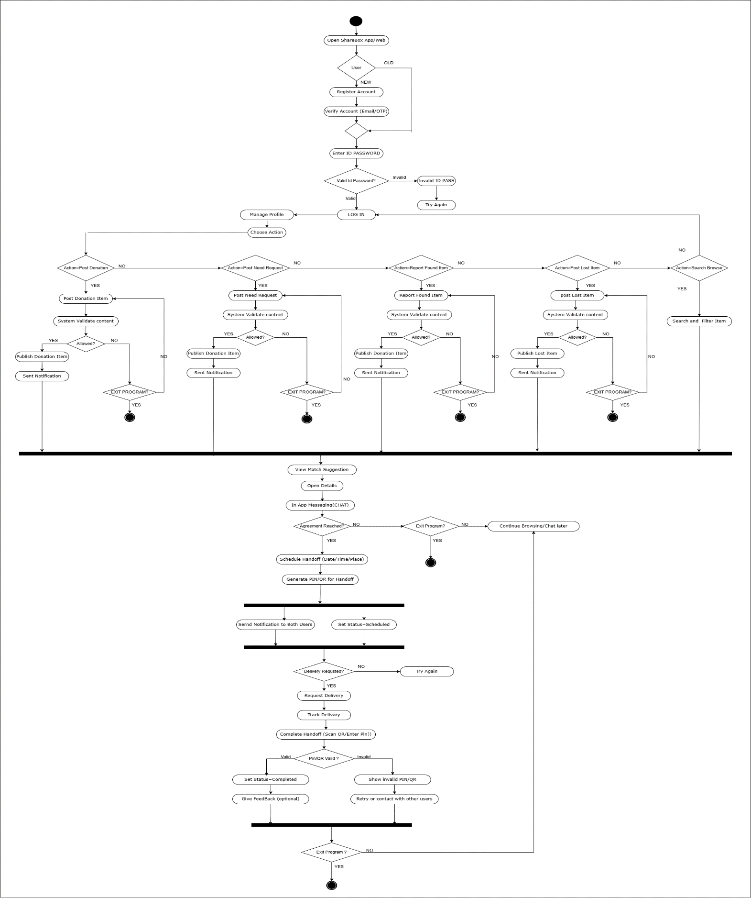
Sequence Diagram
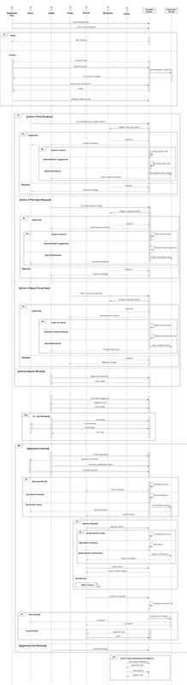

UI / Wireframe Design using Figma
Trello workplace link : https://trello.com/invite/b/693e658c258f0c717a8aed25/ATTIc35fde687ea77e66d7813ab5e1f8cc8c65F344F6/sharebox-a-community-donation-and-lost-found-platform
Users [Doner,Need,Lost,Found]
Authentication part
Frame:1  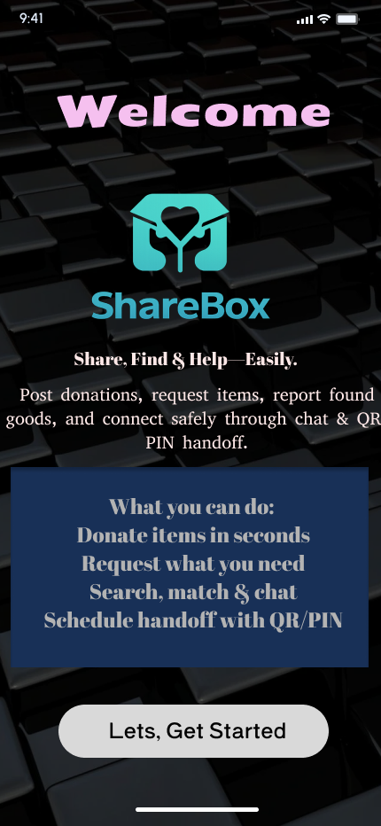 |  | Frame:2  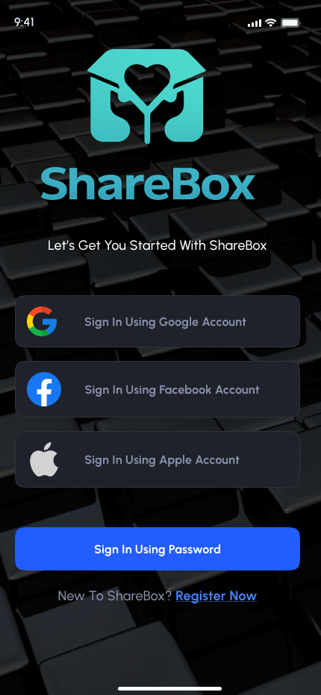 |  | Frame: 3  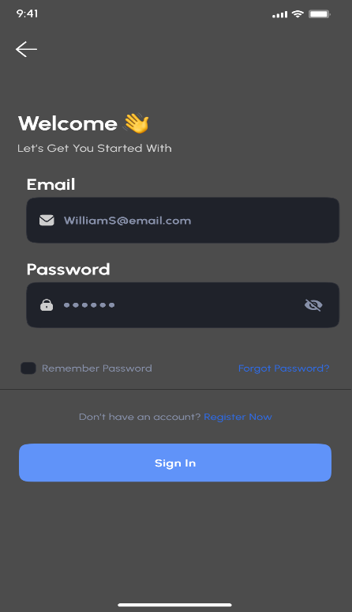
Frane: 4  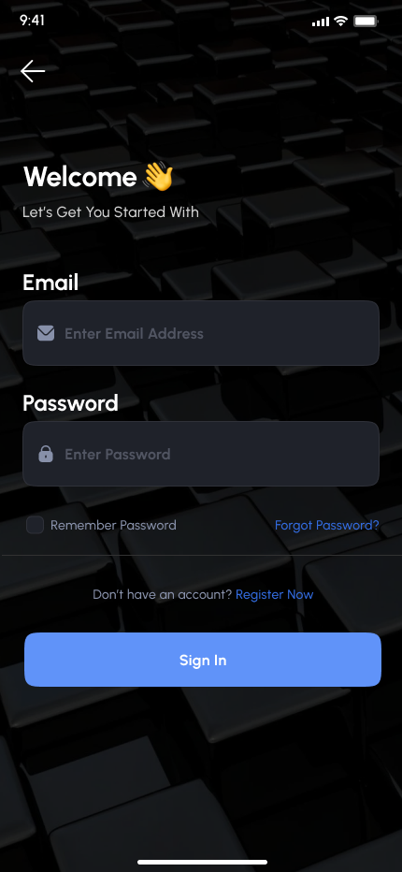 |  | Frame: 5  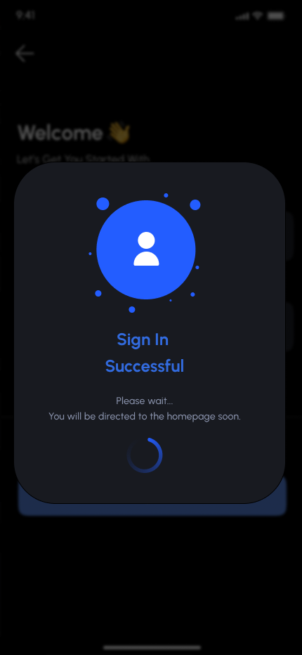 |  | Frame: 6  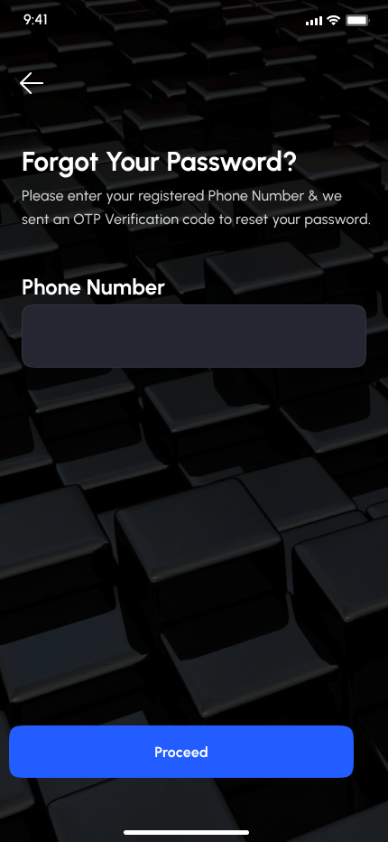
Frame 7:  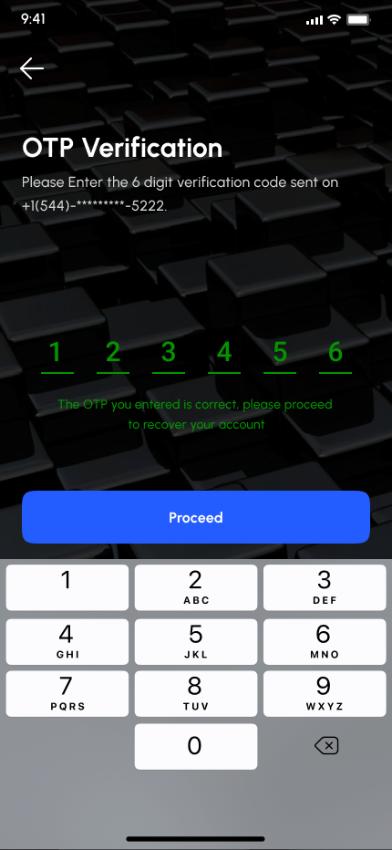 | Frame8:  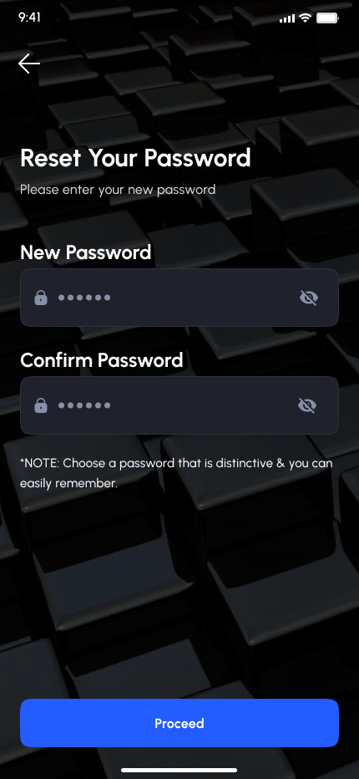 |  | Frame 9 ;  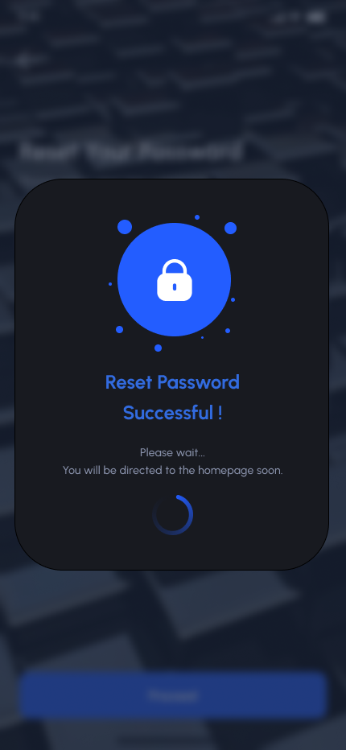
Action
Frame 12 ;  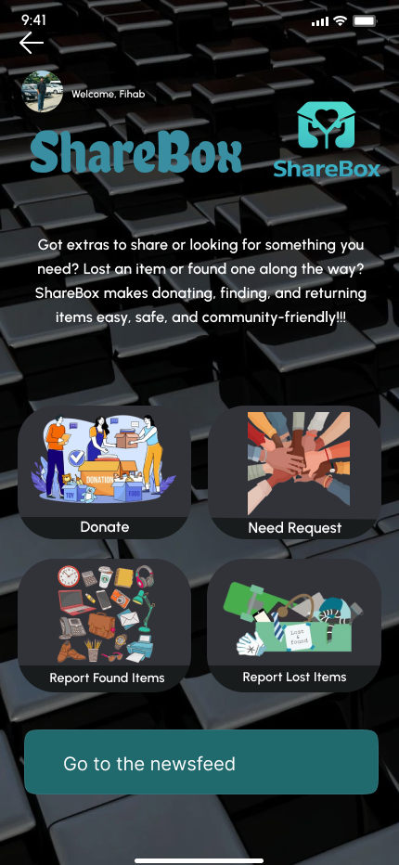 |  |  | Frame 13 :  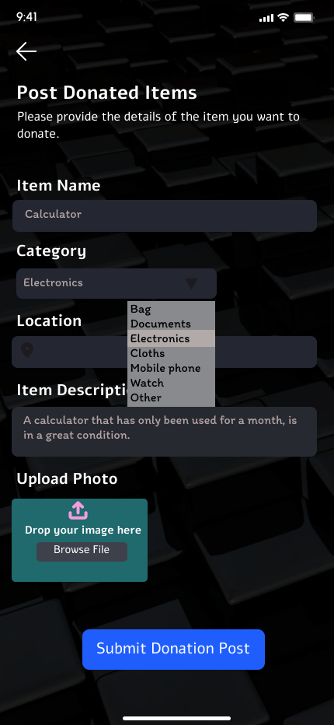 |  |  |  |  | Frame 14:  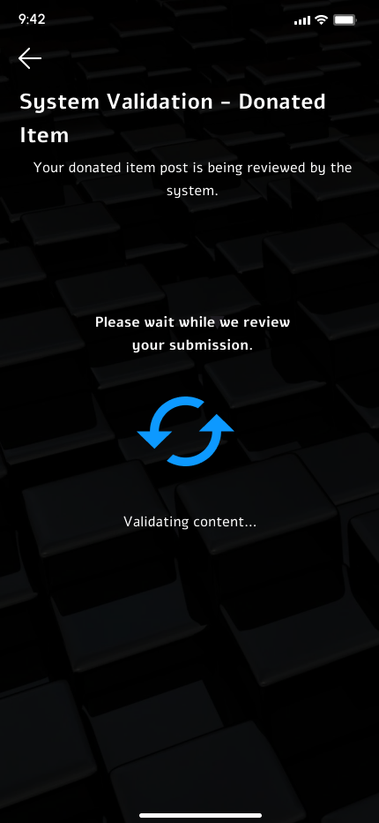
Frame 15  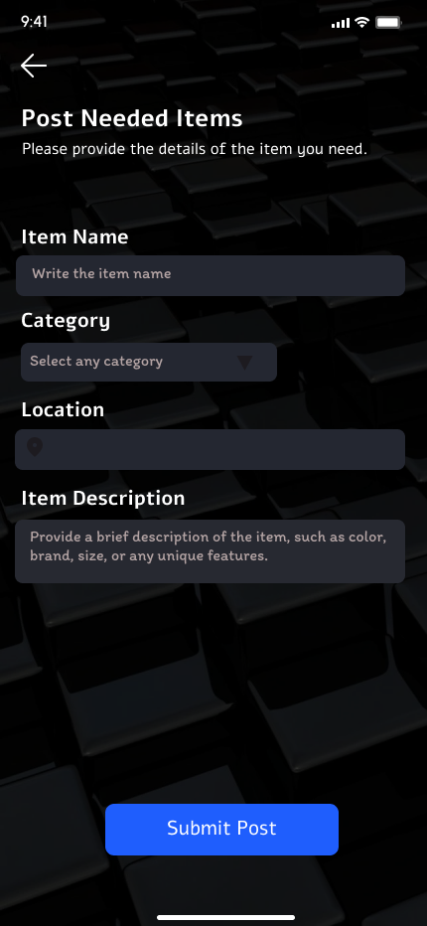 |  |  | Frame 16:  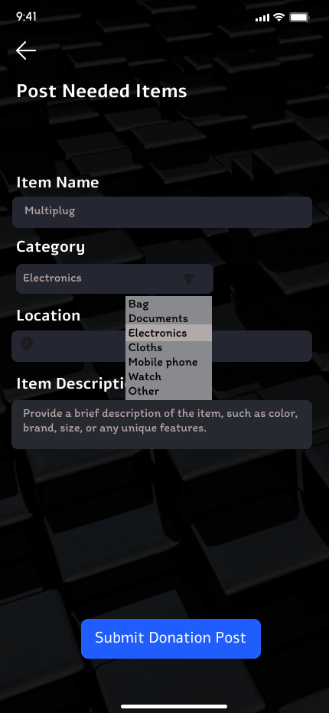 |  |  |  |  | Frame 17:  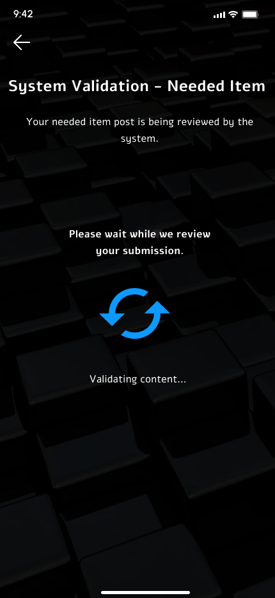
Frame 18 :  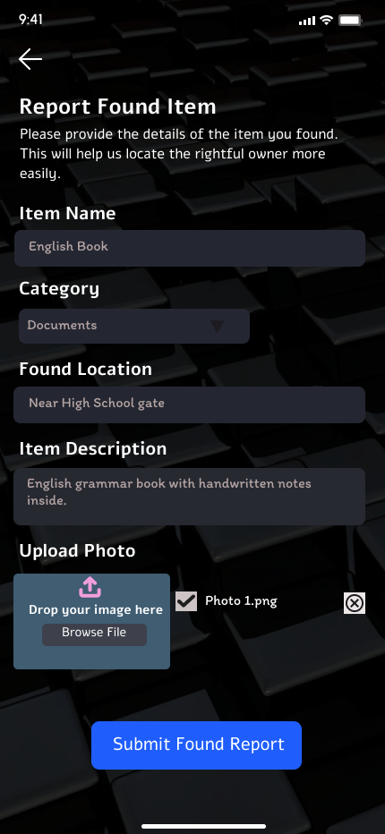 |  |  |  | Frame 19 :  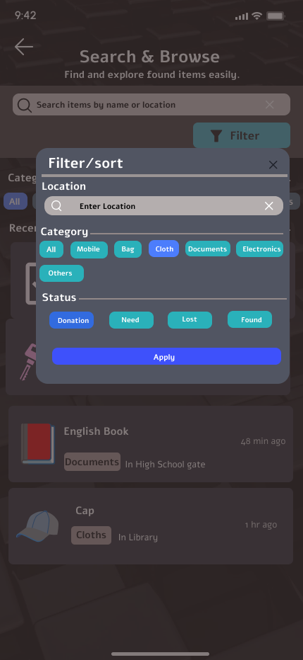 |  | Frame 20 :  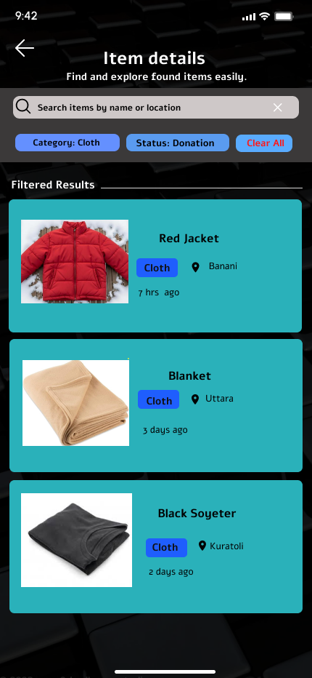
Frame 21:  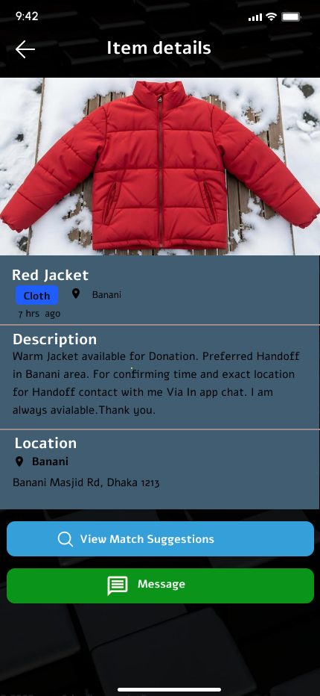 |  |  |  | Frame 22 :  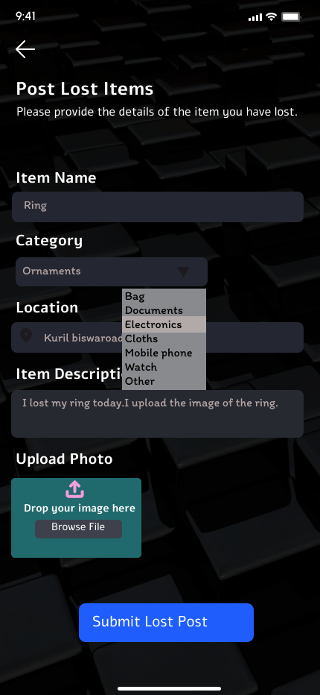 |  | Frame 23 :  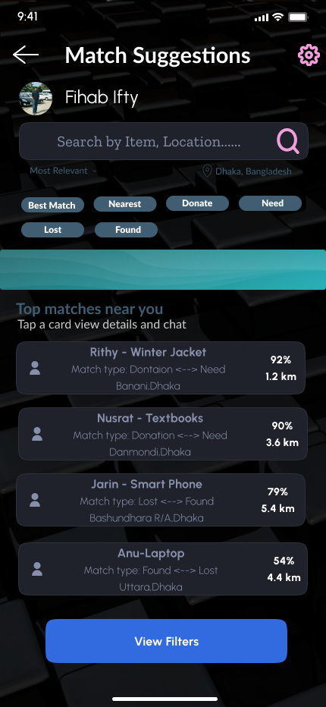
Frame 24 :  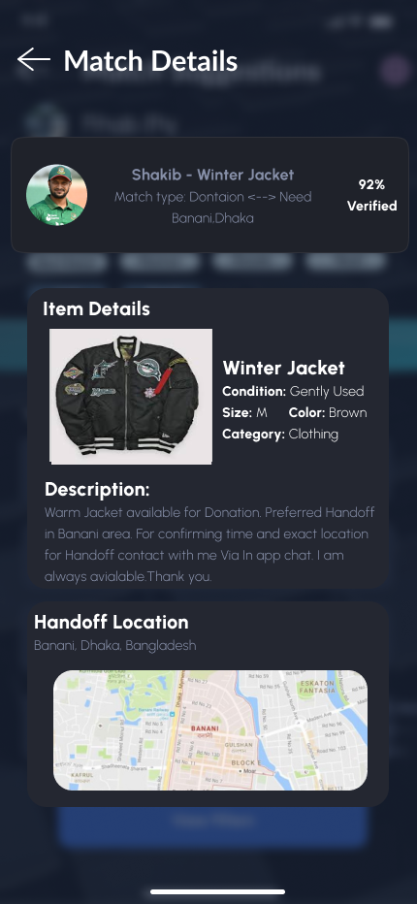 |  | Frame 25 :  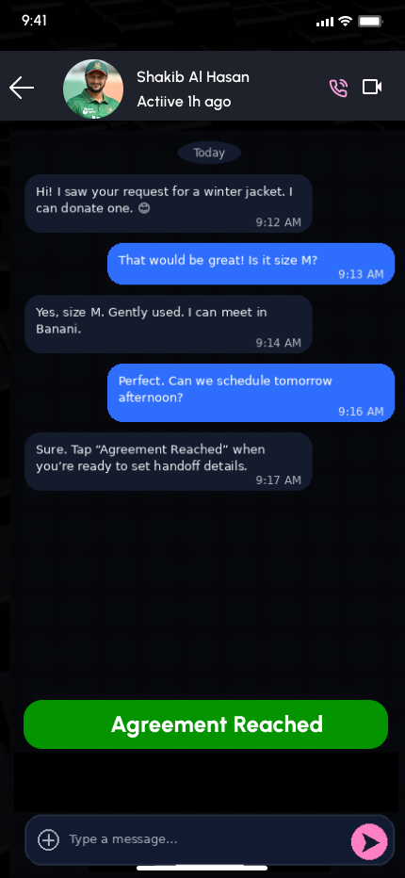 |  |  | Frame 26 :  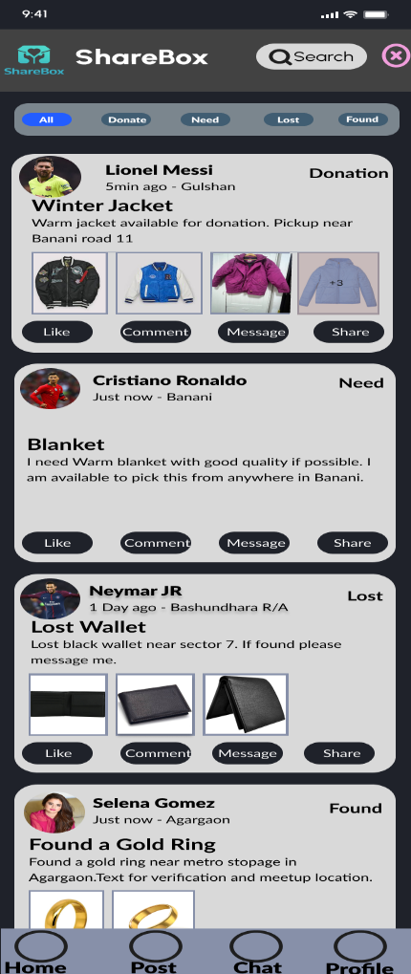
Frame 27 :  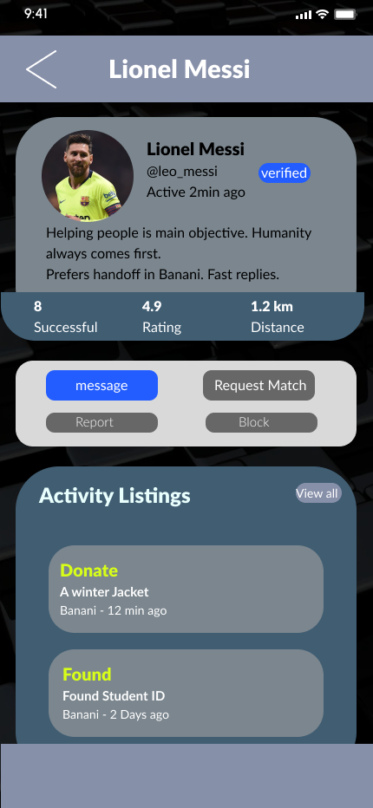 |  | Frame 28 :  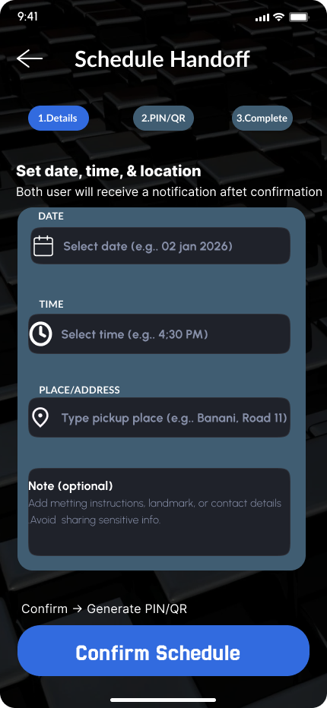 |  |  | Frame 29:  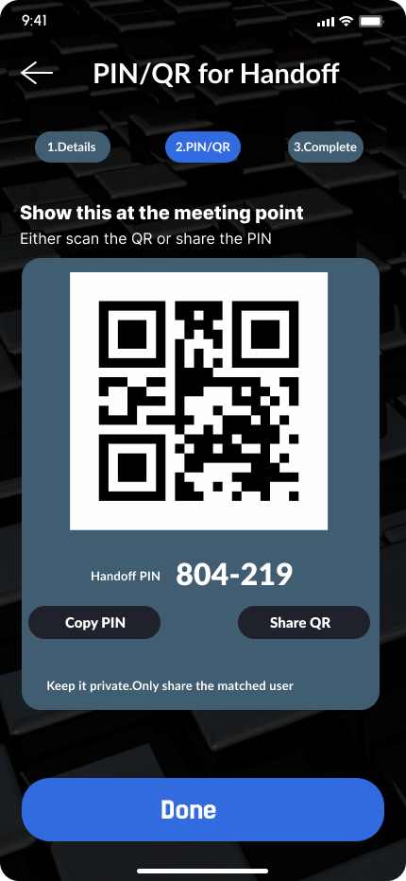
Frame 30 :  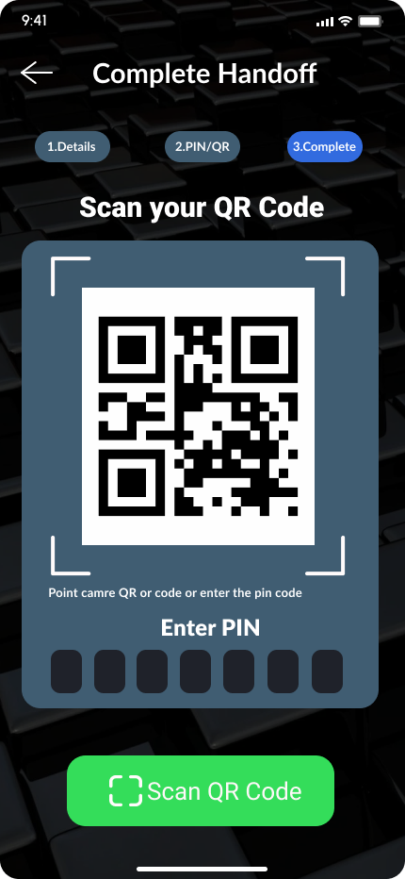 |  | Frame 31 :  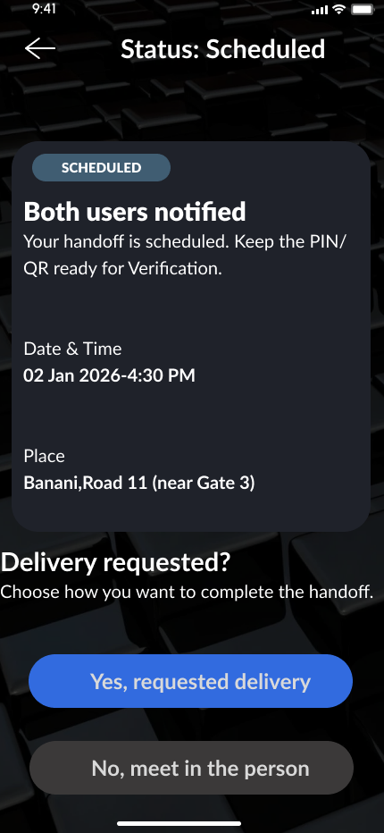 |  |  |  |  | Frame 32 :  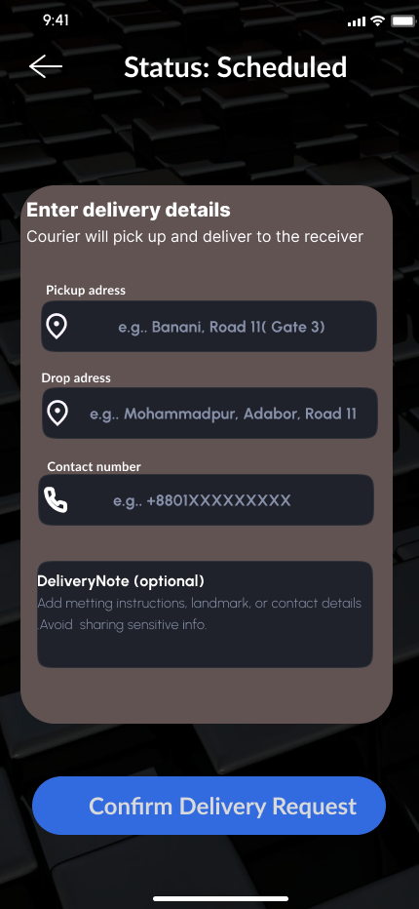
Frame 33 :  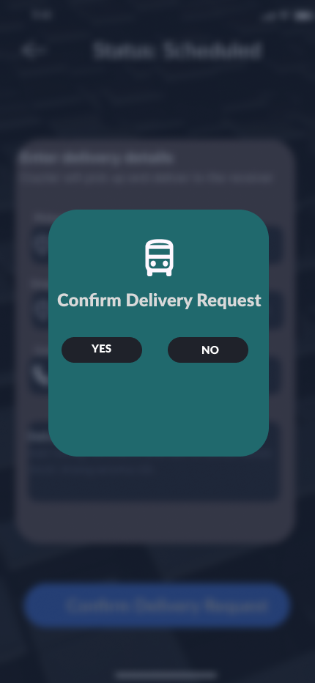 |  | Frame 34 :  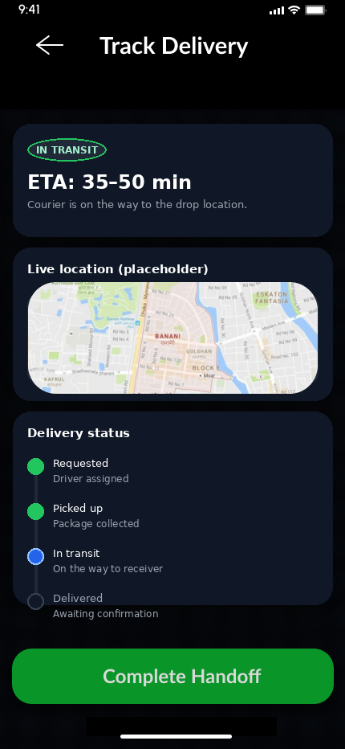 |  |  |  |  | Frame 35 :  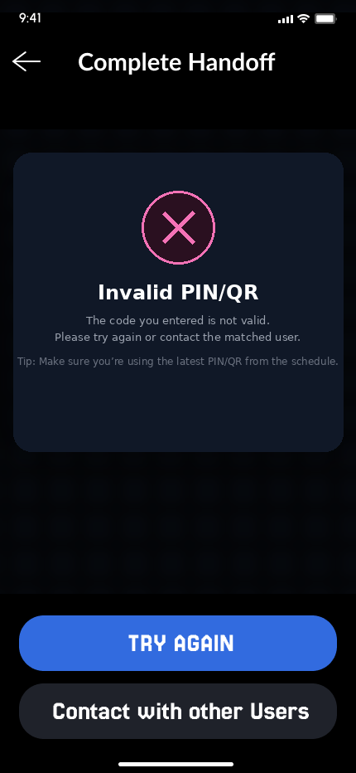
Frame 36 :


User [Admin,Moderator]
Frame 1:  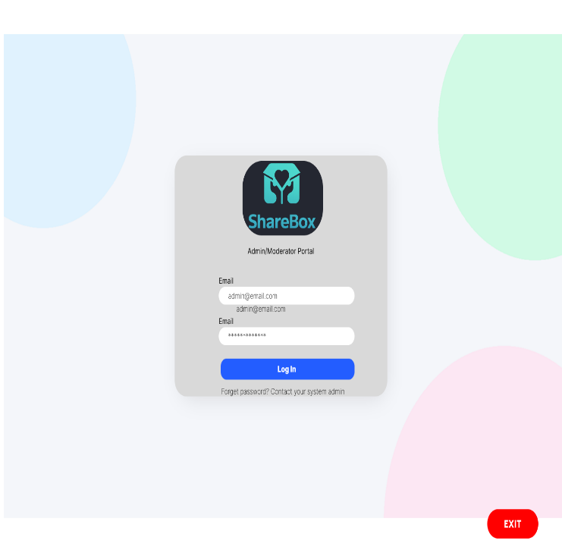 | Frame 2 :  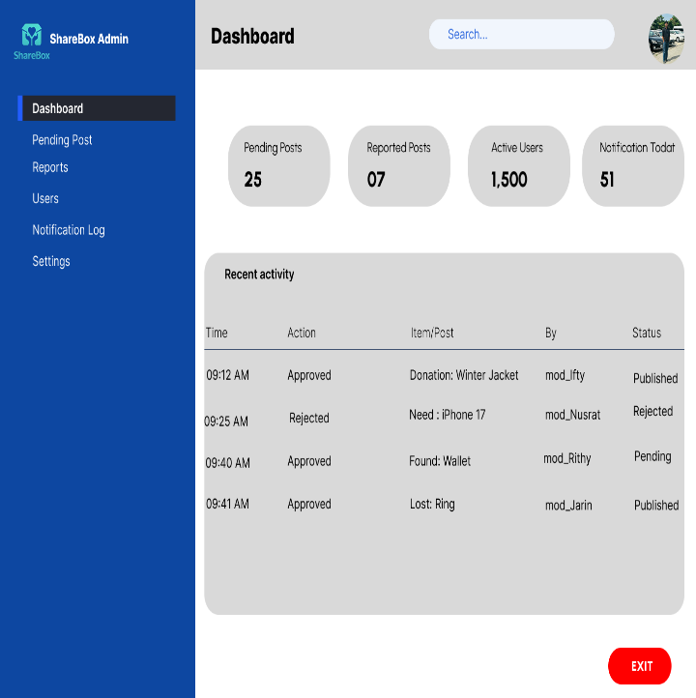

Frame 3 :  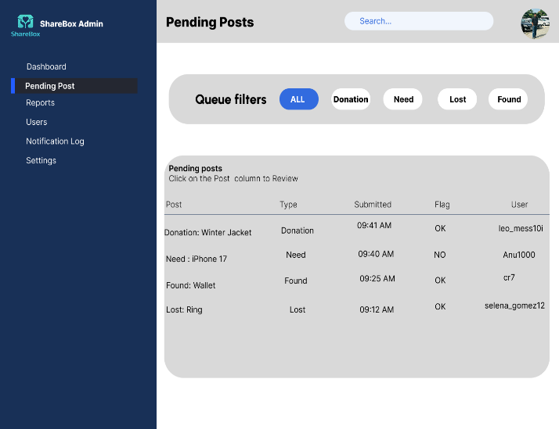 | Frame 4 :  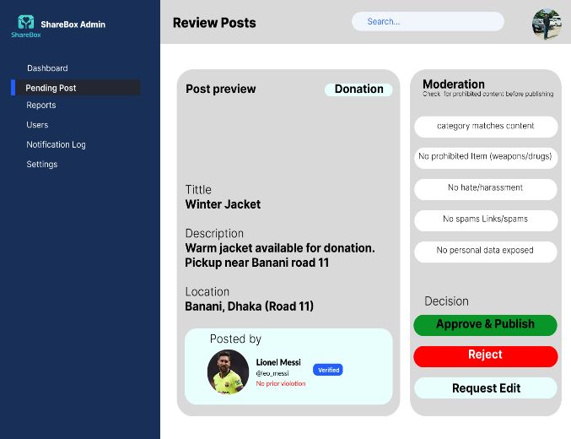
Frame 5 :  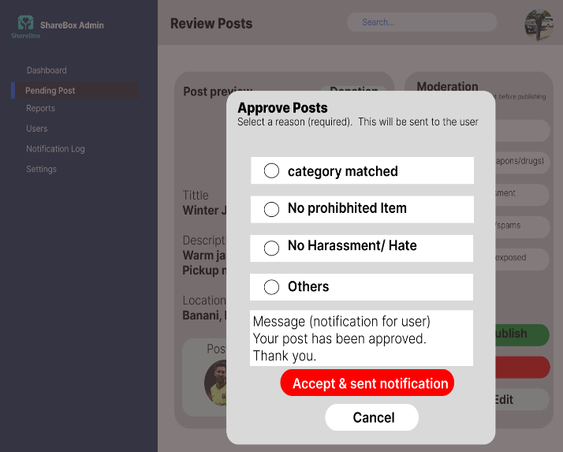 | Frame 6 ;  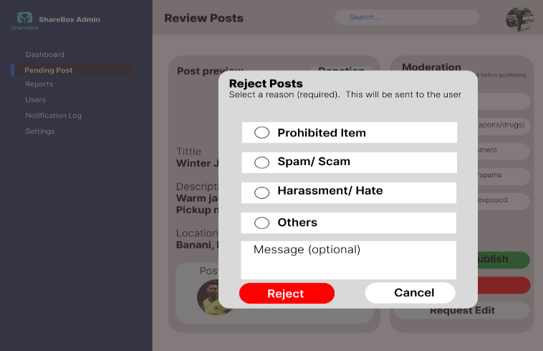
Frame 7 :  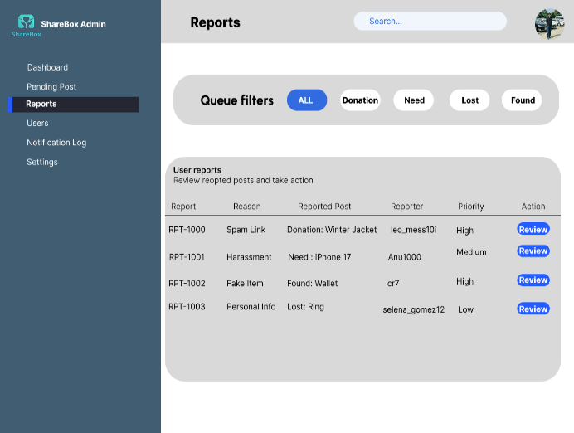 | Frame 8:  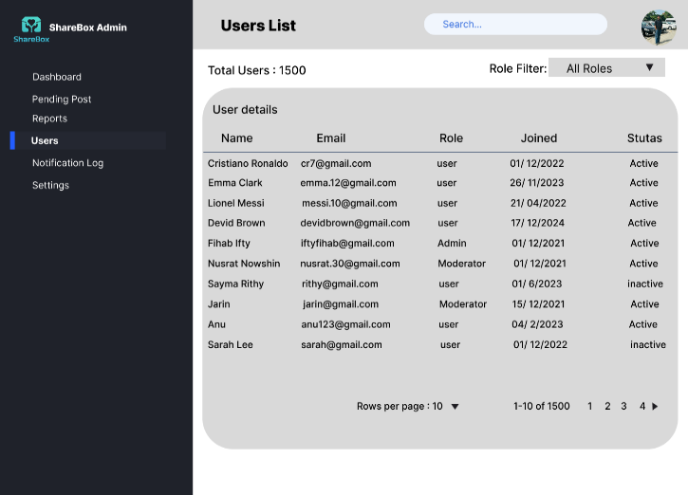
Frame 9 :  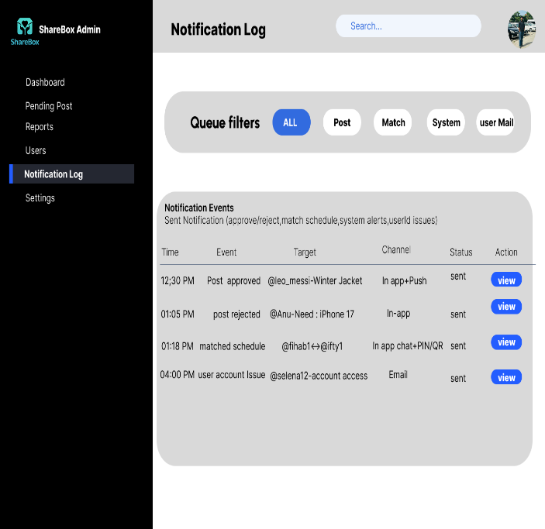 |  | Frame 10:  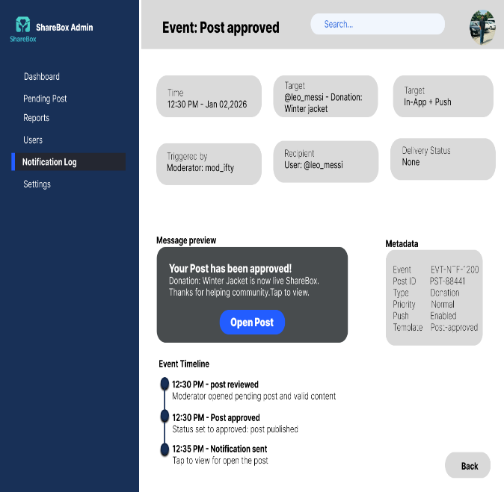
Frame 11 :
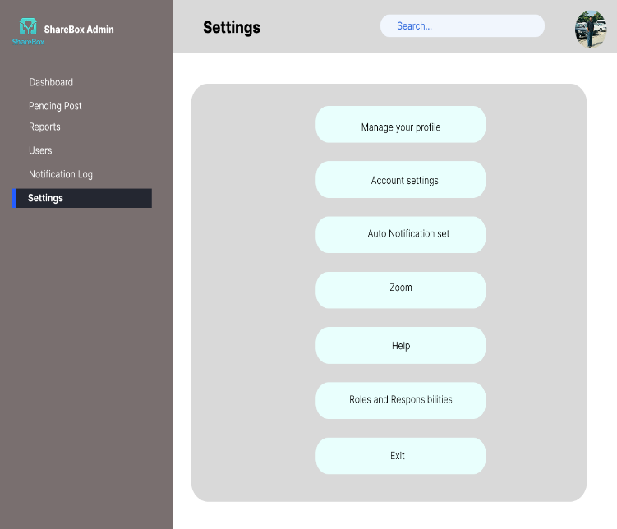

4. GIT WORKFLOW
- Create a central repository for the project on GitHub and set the master (or main) branch as the primary branch for integration.
- Each member should clone the repository and create their own feature branches for assigned tasks. Work on new features or fixes within these branches.
- Add files, stage them and commit changes with clear messages that describe the purpose of each update.
- Push commits from the feature branches to the remote repository so other members can see progress.
- Use pull to fetch and integrate changes from the remote repository into local copies, ensuring everyone stays updated.
- Merge feature branches into the master/main branch only after the work is tested and reviewed, resolving any conflicts that occur.
- Show evidence of collaboration by maintaining a clear commit history (using logs) with multiple commits, merges and contributions from all group members.
- Keep the repository organized with a clean history that tracks the project workflow from initialization to completion.
GITHUB Repo link: https://github.com/fihabefty114/ShareBox.git

5. SOFTWARE TESTING

Test Case 01
Project Name: ShareBox | Test Designed by: Fihab Ifty
Test Case ID: TC-01 | Test Designed date: 31/12/2025
Test Priority (Low, Medium, High): High | Test Executed by: (QA1)
Module Name; Authentication (Registration) | Test Execution date: In future
Test Title: Verify user registration with valid data
Description: Test signup form validation and account creation
Precondition: User is on Register page
Dependencies: Email service (verification)

Test Steps | Test Data | Expected Results | Actual Results | Status (Pass/Fail)
1. Go to Register page2. Enter valid name, email, phone, password3. Select location4. Click Register | Name: Ifty  Email:ifty@gmail.com  Phone: 01740479936  Password: 1234  Location: Dhaka | Account should be created successfully.System should accept unique email.Confirmation email should be sent. |  | In future

Test Case 02
Project Name: ShareBox | Test Designed by: Fihab Ifty
Test Case ID: TC-02 | Test Designed date: 31/12/2025
Test Priority (Low, Medium, High): High | Test Executed by: (QA1)
Module Name: Authentication (Registration) | Test Execution date: In future
Test Title: Verify registration fails for duplicate email
Description: Test unique email constraint
Precondition: An account already exists with the same email
Dependencies: User database

Test Steps | Test Data | Expected Results | Actual Results | Status (Pass/Fail)
1. Go to Register page2. Enter existing email3. Fill other fields valid4. Click Register | Email:ifty@gmail.com (existing) | System should not allow duplicate email.Error message should show for already used email. |  | In future

Test Case 03
Project Name : ShareBox | Test Designed by: Fihab Ifty
Test Case ID: TC_03 | Test Designed date: 31/12/2025
Test Priority (Low, Medium, High): High | Test Executed by: QA1
Module Name: Authentication (Login) | Test Execution date: In future
Test Title: Verify login with valid email and password
Description: Test successful login and dashboard redirect
Precondition: User has a valid account
Dependencies: Auth service + database

Test Steps | Test Data | Expected Results | Actual Results | Status (Pass/Fail)
1. Go to Login page2. Enter email and password3. Click Login | Email: ifty@mail.com  Password: 1234 | User should log in successfully.System should redirect user to dashboard. |  | In future

Test Case 04
Project Name | ShareBox | Test Designed by | Nusrat Sarker Nowshin
Test Case ID | TC_04 | Test Designed date | 03/01/2026
Test Priority (Low, Medium, High) | Medium | Test Executed by | (TBD)
Module Name | Authentication (Login) | Test Execution date | (TBD)
Test Title | Verify user cannot log in with wrong password
Description | Validate login error for incorrect password
Precondition | User has a valid account
Dependencies | Auth service

Test Steps | Test Data | Expected Results | Actual Results | Status (Pass/Fail)
1. Go to Login page  2. Enter valid email  3. Enter an incorrect password  4. Click Login | Email: nusrat01@gmail.com  Password: wrongpass123 | .  User should not be logged in.  Error message should be shown for incorrect password. | TBD | Not Executed

Test Case 05
Project Name | ShareBox | Test Designed by | Nusrat Sarker Nowshin
Test Case ID | TC_04 | Test Designed date | 03/01/2026
Test Priority (Low, Medium, High) | Medium | Test Executed by | (TBD)
Module Name | Profile Management | Test Execution date | (TBD)
Test Title | Verify profile update with valid phone and location
Description | Edit profile with valid phone number and location, then save changes.
Precondition | User is logged in
Dependencies | Profile service, database

Test Steps | Test Data | Expected Results | Actual Results | Status (Pass/Fail)
1. Open Profile page  2. Click Edit  3. Update phone number and location  4. Click Save | Phone: 01812345678  Location: Dhaka | Profile changes  should be saved immediately.  The phone number should be validated.  At least one location should be selected. | TBD | Not Executed

Test Case 06
Project Name | ShareBox | Test Designed by | Nusrat Sarker Nowshin
Test Case ID | TC_04 | Test Designed date | 03/01/2026
Test Priority (Low, Medium, High) | High | Test Executed by | (TBD)
Module Name | Listings (Donation Posting) | Test Execution date | (TBD)
Test Title | Verify donation post submits with required fields
Description | Verify that a donation post should be successfully created with all mandatory fields and should go to moderation pending.
Precondition | Donor is logged in
Dependencies | Listing service and moderation queue

Test Steps | Test Data | Expected Results | Actual Results | Status (Pass/Fail)
1. Go to Home page and click Donate  2. Enter title, category, description.  3. Upload at least 1 image  4. Select location  5. Click Submit Donation Post | Title: Calculator  Category: Electronics  Location: Mirpur 10  Item Description: A calculator that has only been used for a month, is in a great condition.  Photo1.png | . Post should be submitted successfully.  System should require category and at least one image.  Post should be sent for moderation before becoming publicly visible. | TBD | Not Executed

Test Case 07
Project Name | ShareBox | Test Designed by | Jannat Jarin
Test Case ID | TC_07 | Test Designed date | 03/01/2026
Test Priority (Low, Medium, High) | Medium | Test Executed by | (TBD)
Module Name | Listings (Found Item) | Test Execution date | (TBD)
Test Title | Verify the found item report rejects future dates
Description | Test date validation for found items
Precondition | Finder is logged in and on the Found Item form
Dependencies | Listing service

Test Steps | Test Data | Expected Results | Actual Results | Status (Pass/Fail)
1. Go to the Found Item form  2. Enter details and set future date  3. Click Report | Item: Wallet  Date Found: 10/01/2026 (future)Location: Banani | System should not accept a future found date. Error message should show for invalid date. | TBD | Not Executed

Test Case 08
Project Name | ShareBox | Test Designed by | Jannat Jarin
Test Case ID | TC_08 | Test Designed date | 03/01/2026
Test Priority (Low, Medium, High) | High | Test Executed by | (TBD)
Module Name | Search & Filtering | Test Execution date | (TBD)
Test Title | Verify search and multiple filters work together
Description | Test search by keyword + filter by category and location
Precondition | Items exist in database
Dependencies | Search service

Test Steps | Test Data | Expected Results | Actual Results | Status (Pass/Fail)
1. Open Donation list page  2. Search keyword  3. Apply Category and Location filters  4. Click Apply | Keyword: “backpack”  Category: Bags  Location: Dhaka | Search should check title and description. Multiple filters should work together. Results should show matching items only. | TBD | Not Executed

Test Case 09
Project Name | ShareBox | Test Designed by | Jannat Jarin
Test Case ID | TC_09 | Test Designed date | 03/01/2026
Test Priority (Low, Medium, High) | Medium | Test Executed by | (TBD)
Module Name | Matching | Test Execution date | (TBD)
Test Title | Verify match suggestions show Strong before Possible
Description | Test ordering and reason tags on match cards
Precondition | User has at least one post and matching items exist
Dependencies | Matching engine

Test Steps | Test Data | Expected Results | Actual Results | Status (Pass/Fail)
1. Login  2. Open Dashboard  3. Go to Match Suggestions section | User lost post: Lost “Phone” in Dhaka | System should show Strong matches first.Each match should show reason tags (category, nearby, date). | TBD | Not Executed

Test Case 10
Project Name | ShareBox | Test Designed by | Anu
Test Case ID | TC_10 | Test Designed date | 03/01/2026
Test Priority (Low, Medium, High) | High | Test Executed by | (TBD)
Module Name | In-App Messaging | Test Execution date | (TBD)
Test Title | Verify users can send messages without exposing phone/email
Description | Test chat sends and privacy rule
Precondition | Two users have an active chat thread
Dependencies | Users are connected through a match (TC_09)

Test Steps | Test Data | Expected Results | Actual Results | Status (Pass/Fail)
1.Open an item post  2.Click Chat or Message  3.Type message  4.Click Send | Message: Hi, is this item available? | - Messages should be sent instantly.  - Phone number and email should not be shown on the chat screen.  - Chat history should be saved so users can see past messages. | TBD | Not Executed

Test Case 11
Project Name | ShareBox | Test Designed by | Anu
Test Case ID | TC_11 | Test Designed date | 03/01/2026
Test Priority (Low, Medium, High) | Medium | Test Executed by | (TBD)
Module Name | Notifications | Test Execution date | (TBD)
Test Title | Verify notifications can be marked as read
Description | Test bell panel and read/unread state
Precondition | User has at least 1 unread notification
Dependencies | Notification service

Test Steps | Test Data | Expected Results | Actual Results | Status (Pass/Fail)
1. Log in to the app with a valid account  2. Click bell icon  3. Open an unread notification 4. Mark the notification as read | Notification type: New message | - Notification panel should open  - Unread indicator should update after marking as read  - Notifications should remain in the log | TBD | Not Executed

Test Case 12
Project Name | ShareBox | Test Designed by | Anu
Test Case ID | TC_12 | Test Designed date | 03/01/2026
Test Priority (Low, Medium, High) | High | Test Executed by | (TBD)
Module Name | Handoff Scheduling | Test Execution date | (TBD)
Test Title | Verify handoff scheduling with valid future date and safe location
Description | Test the schedule form to make sure all inputs are correct. Show simple error messages if any field is empty or wrong. After successful submission, confirm the schedule and send a confirmation notification.
Precondition | Donor and Receiver agreed to handoff
Dependencies | Handoff service + notification

Test Steps | Test Data | Expected Results | Actual Results | Status (Pass/Fail)
1. Open Handoff scheduling2. Select safe location3. Select future date and time slot4. Click Schedule | Location: “Police Plaza” Date:07/01/2026  Time: 3:00 PM | - Meeting date should not be a past date  - Time slots should be 30 minutes each  - Both users should receive a confirmation notification | TBD | Not Executed

Test Case 13
Project Name | ShareBox | Test Designed by | Rithy
Test Case ID | TC_13 | Test Designed date | 03/01/2026
Test Priority (Low, Medium, High) | High | Test Executed by | (TBD)
Module Name | PIN/QR Generation | Test Execution date | (TBD)
Test Title | Verify system generates unique 6-digit PIN and QR after scheduling
Description | Test PIN length, uniqueness, and QR availability
Precondition | A handoff is scheduled
Dependencies | Code generator service

Test Steps | Test Data | Expected Results | Actual Results | Status (Pass/Fail)
1. Schedule a handoff2. Open handoff details3. View PIN and QR | Handoff ID: (auto) | System should generate a unique PIN for each handoff.PIN should be 6 digits.QR should be visible and should contain handoff details. | TBD | Not Executed

Test Case 14
Project Name | ShareBox | Test Designed by | Rithy
Test Case ID | TC_14 | Test Designed date | 03/01/2026
Test Priority (Low, Medium, High) | High | Test Executed by | (TBD)
Module Name | Handoff Completion | Test Execution date | (TBD)
Test Title | Verify handoff completes when both users enter correct PIN
Description | Test completion proof and status update
Precondition | Handoff is scheduled and PIN is active
Dependencies | Handoff + verification service

Test Steps | Test Data | Expected Results | Actual Results | Status (Pass/Fail)
1. Donor opens Complete Handoff2. Enters correct PIN3. Receiver enters correct PIN4. Verify completion | PIN: 123456 | System should verify PIN for both users.Status should change to completed after verification.Rating option should appear after completion. | TBD | Not Executed

Test Case 15
Field (Left) | Value | Field (Right) | Value
Project Name | ShareBox | Test Designed by | Rithy
Test Case ID | TC_15 | Test Designed date | 03/01/2026
Test Priority (Low, Medium, High) | High | Test Executed by | (TBD)
Module Name | Moderation | Test Execution date | (TBD)
Test Title | Verify moderator removes a reported post and action is logged
Description | Test approve/warn/remove flow with reason and notification
Precondition | A post is reported by users
Dependencies | Moderator dashboard + logs + notification

Test Steps | Test Data | Expected Results | Actual Results | Status (Pass/Fail)
1. Moderator logs in2. Opens Reported Posts list3. Opens a reported post details4. Selects Remove + reason5. Confirms action | Reason: “Prohibited item” | Moderator should be able to remove the post.System should require a reason for the action.Action should be logged with time.User should receive moderation notification. | TBD | Not Executed

6. CONCLUSION
We completed ShareBox: A Community Donation and Lost-Found Platform's main planning and design work. We started by creating the project proposal and outlining the problem, its goals, and scope. User stories, functional requirements, and non-functional requirements were then included in the SRS/PRD. The necessary design diagrams (use case, class, activity, and sequence) that describe how the system will function were then made. In the end, we combined the screens to create a clickable prototype after designing the entire user interface in Figma based on the requirements. Additionally, we created a manual testing plan with test cases for future implementation and built a Git workflow plan for teamwork.
In the future, in the Web Technology course, we can use this project as a complete foundation for real development. The Figma prototype will help us in creating pages with proper navigation and flexible layouts, while the PRD will direct the frontend and backend functionalities. Using recent web frameworks and databases, we can build admin/moderator dashboards, chat, handoff scheduling, posting, authentication, and search/filter. Additionally, the Git workflow will enable us to collaborate, use branches, and make changes professionally.
By making donation and lost–found activities more organized and trusted, this project can create a positive impact on society. It can reduce waste by encouraging people to donate usable items instead of throwing them away. At the same time, it can also help return lost items faster by keeping posts searchable and structured. With safer communication, moderation, and handoff verification, people can feel more confident to help others and build a stronger community support system.

