1. Project Proposal
Title: ShareBox: A Community Donation and Lost–Found Platform
Group-1:
SL | NAME | ID
14 | Fihab Ifty | 23-51180-1
15 | Nusrat Sarker Nowshin | 23-51194-1
16 | Mst.Sayma Akter Rithy | 23-51201-1
27 | Anika Sultana Anu | 23-51807-2
29 | Jannat Jarin | 23-51827-2
Course: Software Engineering Sec:U
Supervisor: MD. RAIHAN MAHMUD

1.1 Background to the Problem
People in our community often have extra items (books, clothes, devices) that others could use. At the same time, many people lose important things (ID cards, phones, bags) and need quick help to get them back. Today most people use social media or group chats to handle these needs. This is messy and risky: posts get buried, search is poor, there is no clear matching, and there is no safe record or proof when an item is handed over.
ShareBox aims to solve this by giving one organized place for donation, need requests, and lost–found posts. The platform encourages safe and private contact (in-app chat), simple matching, and a planned handoff so people can exchange items with confidence. This reduces waste (more reuse), speeds up returning lost items, and builds trust with a clear, trackable process for the community.

1.2 Solution to the Problem and Process Model Selection

1.2.1 Project scope and main features
- User types: Donation, Need, Lost, Found.
- Rule-based matching: Match by category, sub-category, area/distance, date window, and condition.
- Search & filters: Category, area, condition, date.
- In-app messaging: Talk without sharing phone or email.
- Handoff scheduler: Pick a safe place and time slot and confirm with PIN/QR.
- Delivery (optional): If both cannot meet, a delivery person can carry the item. The beneficiary (receiver/owner) pays a fixed fee set by the company or moderator based on item size (Small/Medium/Bulky) and the item’s value. The platform does not pay.
- Location: Pick your area/ward. When user type a place, the app shows suggestions (Google Places). For privacy, we only save the places’ id and map coordinate. Do not save users’ full address.
- Impact report: Monthly counts of successful donations and returned items.

1.2.2 User Story Table
ID | Actor | User Goal | Benefit | Acceptance (Done when…) | Feature Area
US1 | Donor | Post a donation | Someone who needs it can find it | I add title, category, condition, one plus photo, area. Then item appears in Donation list. | Listings
US2 | Seeker | Search and filter donations | I quickly find useful items | Filters by category and area work and show matching results | Search/Filter
US3 | User | Post a lost item with details | Others can help me find it | I add one plus photo, area, date. Then item appears in Lost list | Listings
US4 | Finder | Post a found item | The owner can contact me safely | Owner can chat inside the app. My phone/email stay hidden | Listings/Chat
US5 | User | See match suggestions | I can act fast | Items show Strong/Possible with short reason tags for example same category, nearby. | Matching
US6 | Donor / Receiver | Book a handoff (meet in person) | We meet safely | Venue + time saved. App creates PIN/QR. Status becomes scheduled. | Handoff
US7 | Donor / Receiver | Complete a handoff | There is proof of completion | Correct PIN/QR is entered then status becomes completed | Handoff
US8 | Seeker / Receiver | Choose Delivery instead of meeting | I can receive it without meeting in person | App shows fixed delivery fee and that I pay then I tick “I agree to pay” | Delivery
US9 | Moderator | Review reported posts | The platform stays safe | I can dismiss/warn/remove. All actions are logged | Moderation

1.2.3User Story Board (Trello)
- Tool: Trello
- Board name: ShareBox (https://trello.com/invite/b/690613acd38433f585590321/ATTIcababeda1273bece713585ffeaf7e43b3A520131/sharebox)
- Columns: BackLog - ToDo - InProgess - InReview - Testing - Done
- Example cards on the board: “Decide project scope”, “Break work into small tasks”, “Make timeline and deadlines”, “Set team roles”, “Decide meeting plan”, “Set Trello rules”, “Make risk list”, “Write quality rules (Definition of Done)”, “Plan testing”, “Prepare tools & folders”, “Plan slides & final report outline”.
- Current ToDo: Project proposal.
Definition of Done:
Checklist ✓, text clear, and any needed screen/wireframe attached.
ScreenShot:
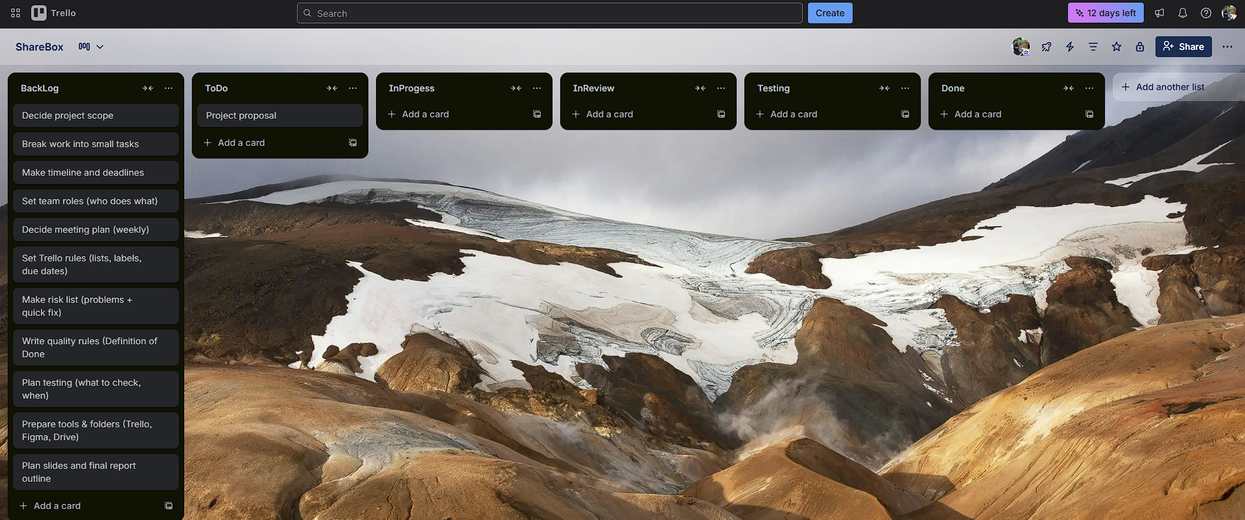

1.2.4 Existing software solutions
- Facebook groups / Messenger and other social media platform: Easy to start, but posts get buried. No safe handoff. Weak rules.
- Generic classified sites: Focus on selling, not designed for donation or lost–found. No PIN/QR handoff.
- Gap: none combine simple matching + safe handoff + privacy + moderation for donation and lost–found in one place. ShareBox can fills this gap.

1.2.5 Select one software development process model
(To be decided later by team & supervisor)

1.2.6 Analysis of project environment & requirement nature
- Users: All type.
- Devices: Mostly mobile phones; some desktop use in labs.
- Connectivity: Sometimes weak → design simple, low-data pages.
- Requirements stability: Mostly stable (course project), but some changes may come from supervisor feedback. We will keep the backlog to manage small changes.

1.2.7 How selected model supports team size, communication, and coordination
(To be added later when we pick the model.)

1.2.8 Flexibility of the model for scope/tech/user changes
(To be added later when we pick the model.)

1.2.9 Creative solution
- Safety by design: In-app chat (no phone/email), PIN/QR proof at handoff.
- Privacy first maps: Choose area/venue with autocomplete. Save place_id and rounded coordinates.
- Clear rules, no confusion: Fixed delivery fee by size or according the item. Prohibited items list. Quick moderation.
- Explainable matching: Show short reason tags like “same category”, “nearby area”.

1.2.10 Target users & how they benefit
- Donors: Give items easily. Feel likes helping someone. Reduce waste.
- Seekers/Needers: Find needed items quickly with filters and matches.
- People who lost/found items: Faster reunion with proof of completion.
- Moderators/Admins: Keep the platform clean with simple tools.

1.2.11 Contribution to documented results
- We will document which features users use most, common categories, time taken from post to completion, and which rules help matching.

1.2.12 Evidence to support argument for model selection
(To be added later.)

1.2.13 How the process model manages risks & uncertainties
(To be added later.)

1.2.14 Relate the process model to the schedule (timely delivery)
(To be added later.)

1.2.15 Final justification: why the chosen model is better
(To be added later.)

1.3 Project Role Identification and Responsibilities

1.3.1 Roles (development + management)
- Product Lead (PL): Owns the vision and scope, final say on features. Talks to the supervisor and keeps the team aligned.
- Project Coordinator (PC): Plans weekly tasks, tracks Trello board, sets deadlines, follows up on progress.
- Business Analyst (BA): Writes user stories and acceptance criteria; prepares simple policies (prohibited items, delivery fees).
- UI/UX Designer (UIX): Makes wireframes and simple flows, checks accessibility and clarity.
- System Designer (SD): Designs ERD/data tables, components, API list, adds privacy notes.
- QA Lead (QA): Creates test/checklist, verifies that acceptance criteria are met, compiles final report & slides.

1.3.2 Responsibilities across key (SDLC)
1) Planning
- PL: define goals, scope, and success criteria.
- PC: make weekly plan and Trello setup.
- All roles: agree on MVP and timeline.
2) Requirements Analysis
- BA (lead): write user stories and acceptance criteria.
- PL: approve scope; align with supervisor feedback.
- UIX: note required screens and basic flows.

3) Design
- SD (lead): ERD, components, API list, privacy notes.
- UIX: Start with simple sketches of the main screens, then make clear final mockups.
- BA: check that each story has a matching screen/flow.
- PL/PC: review and sign-off.
4) Development (future plan)
- We describe how features would be built later.
5) Testing
- QA (lead): checklist per story; verify wireframes meet acceptance criteria.
- All: peer review; fix gaps.
6) Deployment (future plan)
- We propose a simple web app with role-based access for future.
7) Maintenance (future plan)
- We note bug tracking, policy updates, and small UI fixes for future.

1.3.3 Decision Making, Quality, and Resource Management
Decision making
- PL decides the scope and feature trade-offs after team discussion.
- Supervisor feedback is respected and recorded by PC.
Quality assurance
- QA checks every user story has: (a) clear acceptance criteria, (b) a matching screen/flow, (c) privacy/safety note if needed.
- “Done” = acceptance checklist ticked + screen/wireframe attached.
Resource management
- PC assigns tasks based on skills:
  - Good writers: BA / Documentation
  - Visual thinkers: UIX
  - Structured thinkers: SD
  - Organizers: PC
  - Everyone: Supports PL for reviews and presentation

