
AMERICAN INTERNATIONAL UNIVERSITY-BANGLADESH
Faculty of Science and Technology
Department of Computer Science
CSC 3215: Web Technologies
Group Project Proposal Semester: Summer 2025-26 Total Marks: 10
Course & Group Information
Course Title: Web Technology | Course Code: 3215 | Section: H | Group No.: 9
Group Members
SL. | Student ID | Name | Role | Signature
1 | 23-51609-2 | Safiha Ayman | Member
2 | 23-54217-3 | Al Musabbir Amin Rafi | Member
3 | 23-54242-3 | Md. Zahid Hasan | Member
Project Title
ChaJoy - Bangladesh

Evaluation:
Evaluation Rubrics
Problem Relevance & Target-User Context (2) | Feature Completeness & Distinction (2) | Clarity of System / Short Description (2) | Total Marks (6)
Group Formation & Role Clarity (1) | Fair Distribution of Tasks (1) | Completeness & Format Adherence (2) | Total Marks (4)

Grand Total
Faculty Approval
Decision | Faculty Comments | Signature & Date
☐ Approved ☐ Revise & Resubmit ☐ Rejected

GitHub Link:

ChaJoy-Bangladesh
Short Description
The ChaJoy Bangladesh is an online web application that enables customers to manage their cafe orders through a user-friendly website.
The system provides features such as:
- User registration and login
- Menu browsing
- Searching ice-cream and drinks products
- Viewing product details and prices
- Checking product availability
- Adding products to the cart
- Online ordering
- Customer information management
- Viewing order history
- Order status tracking
- Viewing ChaJoy outlet locations
- Admin management of products, categories, users, managers, orders, and outlets
- Employee management of assigned outlet activities and customer orders
Introduction
The ChaJoy Bangladesh is a web-based application developed using HTML, CSS, JavaScript, PHP, and MySQL to provide a convenient and efficient platform for cafe ordering and management.
The system is designed to allow customers to browse food and beverage products, view product information, check prices and place orders through a web interface.
In traditional cafe systems, customers may need to visit a cafe outlet to check the available menu, product prices, and other information. This can be time-consuming, especially during busy periods. The proposed web-based system provides an alternative by allowing customers to perform major ordering activities online from any device with internet access.
The frontend of the system will be developed using HTML, CSS, and JavaScript, providing the structure, visual design, and interactive features of the website. PHP will be used for server-side processing, handling user requests, authentication, product management, cart operations, and order processing. MySQL will be used to store and manage customer, manager, product, category, order, and outlet information.
The system will have three types of users: Admin, Employee, and Customer.
The admin will manage the overall system, including employees, categories and outlet information.
The Employee will manage activities related to the assigned cafe outlet, including customer orders, order status, accept and reject orders, change item availability, and outlet-related activities.
The Customer will be able to browse items, search for drinks and ice creams, add items to order, place orders, view order history, and track order status.
The main goal of the project is to create a simple, user-friendly, efficient, and reliable online cafe ordering and management platform that reduces manual effort and makes the cafe ordering process more convenient.
Background Study
With the increasing use of web-based services, online ordering systems have become an important part of modern businesses. Cafe ordering involves managing a large amount of information, including ice-cream and drinks products, categories, customer details, orders, product availability, and outlet information. A web-based system can make these processes more accessible and convenient for customers.
In a traditional cafe ordering process, customers often have to visit a cafe outlet to view the menu, check items prices, and place an order. This may involve waiting in queues and spending additional time selecting items. Furthermore, maintaining product and order information manually can create difficulties in managing large numbers of customers and orders.
A web-based Cafe Ordering and Management System addresses these problems by providing an online platform where customers can perform ordering-related activities from their browser. Customers can browse the menu, search for items, view ice-cream and drinks information, add items to cart, and place orders without physically visiting the cafe first.
The system will also support cafe management activities. Admin users will manage the overall system, while employee will manage activities related to their assigned outlets.
The system follows a client-server architecture. The user's browser provides the interface through HTML, CSS, and JavaScript, while PHP processes requests on the server. MySQL maintains the application's persistent data. When a customer searches for a items or places an order, PHP communicates with the MySQL database to retrieve or update the required information.
The proposed system provides several benefits:
- Convenience: Customers can browse items and place orders through a website.
- Time Efficiency: It reduces the need to visit a cafe outlet before checking the menu.
- Easy Product Searching: Customers can find ice-cream and drinks items easily.
- Online Ordering: Customers can select items and place orders online.
- Database Interaction: Product, customer, and order information can be retrieved from the database.
- Organized Management: Customer, items, and order records can be maintained systematically.
- User-Friendly Interface: HTML, CSS, JavaScript and PHP provide a simple and interactive interface.
- Administrative Control: Admin users can manage customers, employee, items, categories, orders, and outlets.
- Outlet Management: Employee can monitor orders and activities related to their assigned outlets.
- Reduced Manual Work: Digital records minimize dependency on manual ordering and documentation.
Overall, the project demonstrates how web technologies such as HTML, CSS, JavaScript, PHP, and MySQL can be integrated to develop a practical cafe ordering and management application. The system aims to provide a convenient experience for customers while making product, order, and outlet management easier for administrators and employee.
ER Diagram
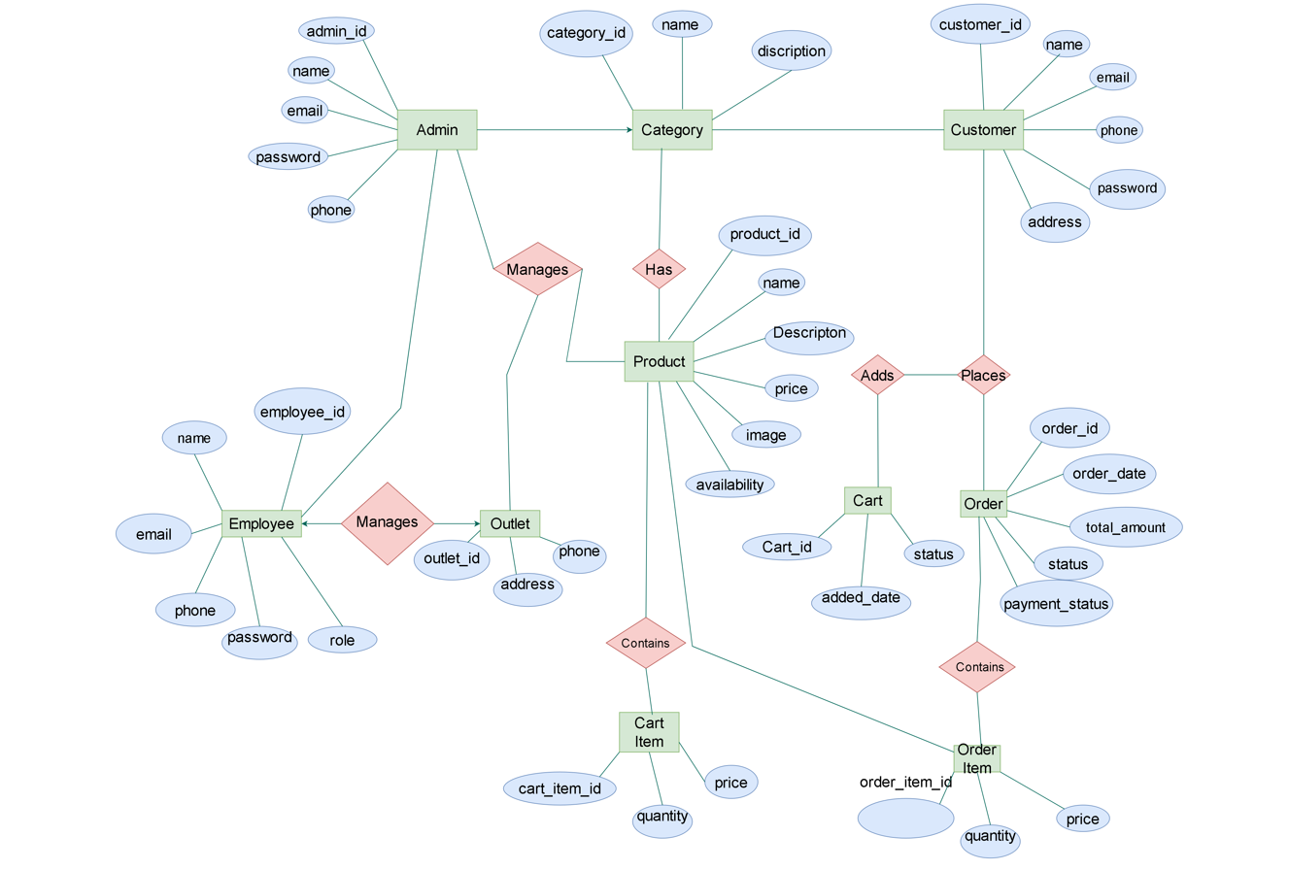
Activity Diagram for Admin
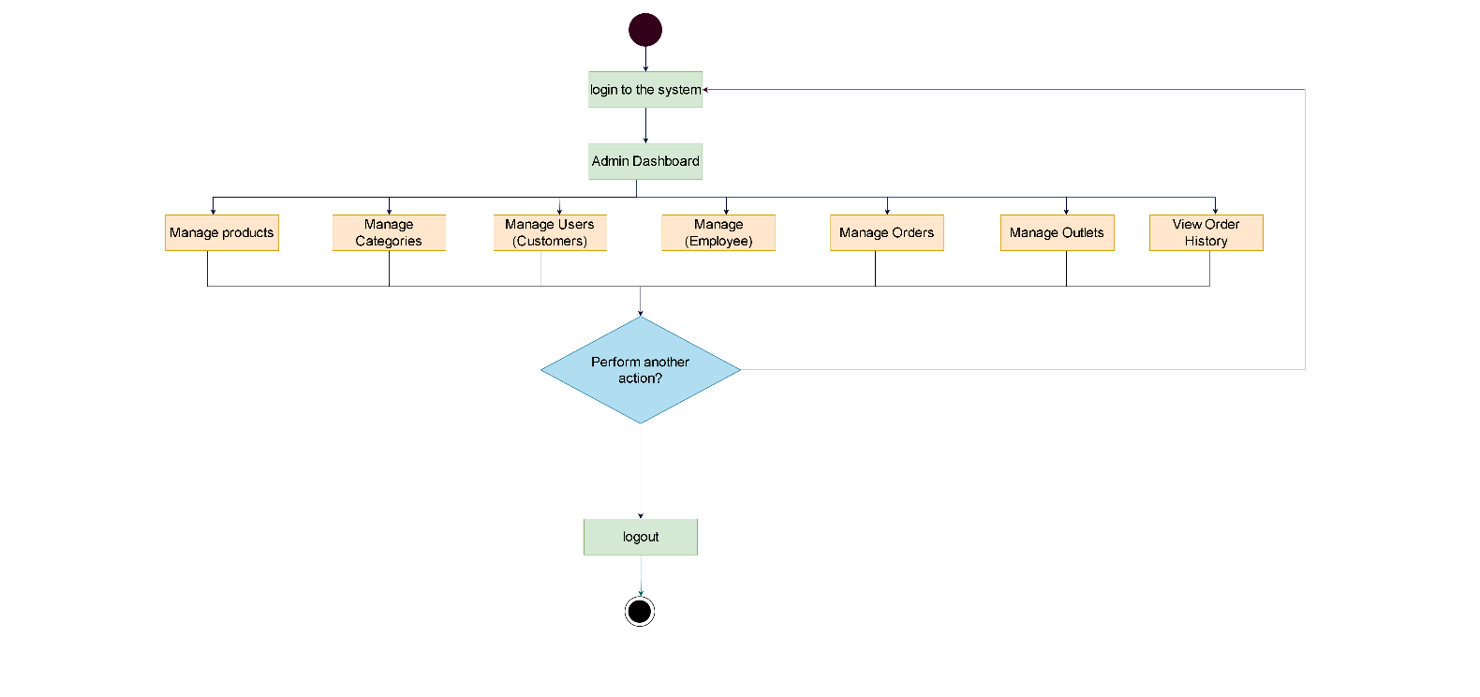

Activity Diagram for Employee
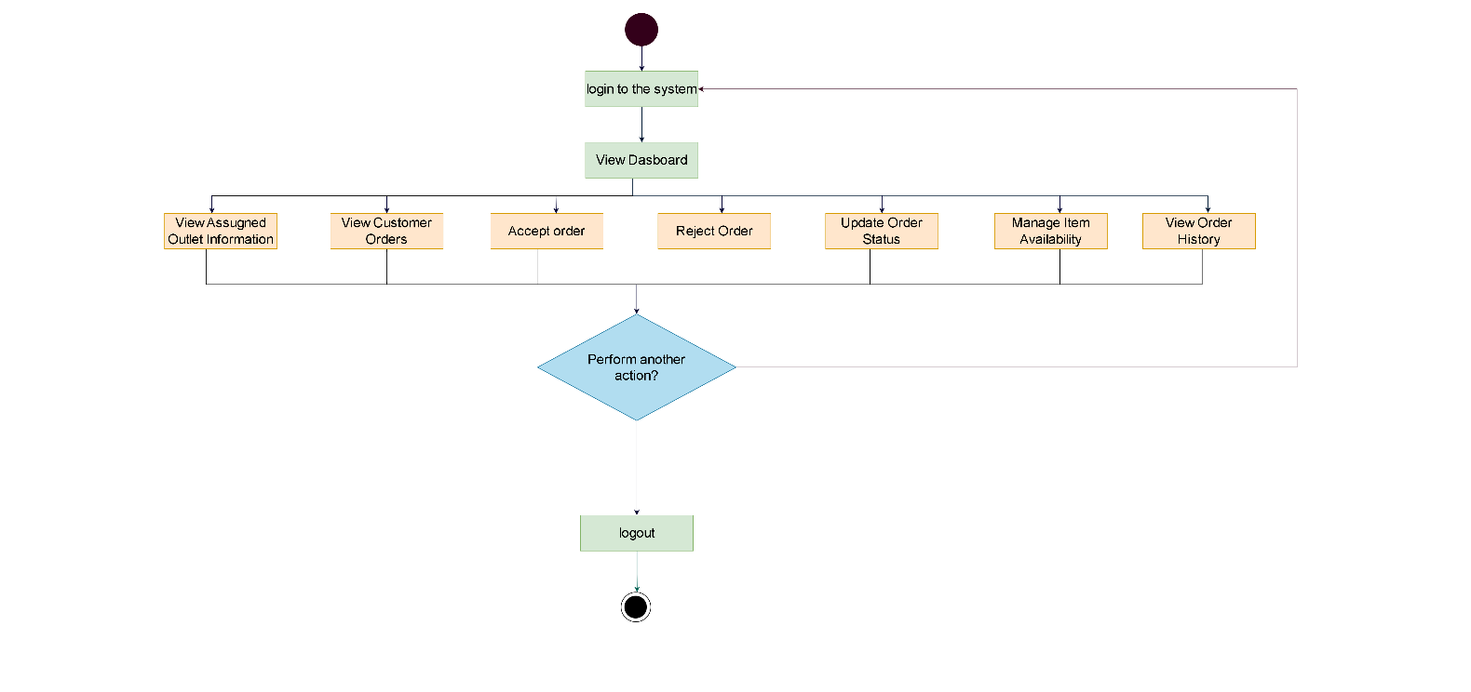
Activity Diagram for Customer/User
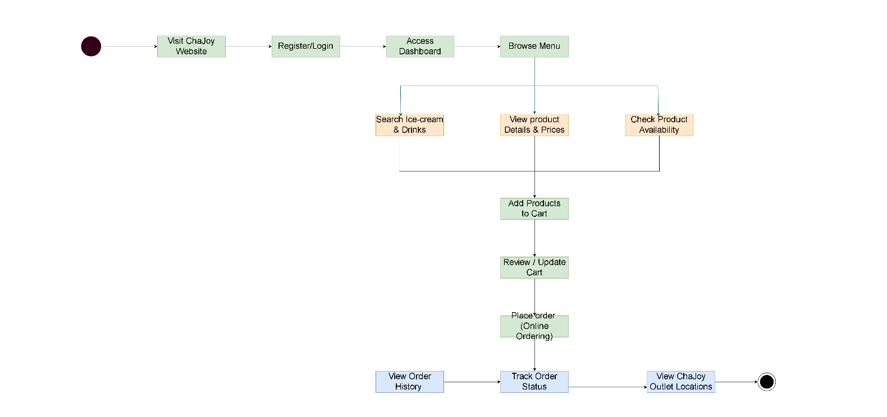

Conclusion
The ChaJoy Bangladesh successfully demonstrates the development of a functional web-based cafe ordering platform using HTML, CSS, JavaScript, PHP, and MySQL.
The system provides customers with a convenient way to browse ice-cream and drinks items, view items details and prices, add items to cart, place orders, view order history, and track order status through an online interface.
The project reduces dependency on traditional manual cafe ordering processes and makes cafe services more accessible and time-efficient. The use of PHP enables effective server-side processing, while MySQL provides reliable storage and management of customer, employee, item, category, order, and outlet information. HTML, CSS, and JavaScript contribute to creating a simple, interactive, and user-friendly interface.
The system also provides management functionality for both Admin and Employee users. The Admin can manage customers, employee, items, categories, orders, and outlets. The employee can monitor orders, update order status, manage item availability, and manage activities related to the assigned outlet.
Overall, this project demonstrates how different web technologies can be integrated to develop a practical, organized, and efficient online cafe ordering and management system.
In the future, the system can be further improved by adding features such as online payment integration, email/SMS notifications, real-time order notifications, QR-based order collection, advanced product recommendations, customer reviews, loyalty programs, and responsive mobile optimization.

Type of User: 1. Admin 2. Employee 3. Customer/User
Common Features (Available to All Users)
- Authentication
- Login to the system
- Logout from the system
- User registration
- Account Management
- Change or reset password
- Manage profile information (view, edit, delete)
- Dashboard
- Access a personalized dashboard after login
Specific Features by User Type
- Features of Admin
- Manage overall system activities, including customers, employee, items, categories, orders, and outlets.
- CRUD access to own profile – create, view, update, and delete profile information.
- CRUD access to other users – manage customer and Employee accounts.
- Manage products – add, view, update, and remove ice-cream and drinks products.
- Manage product categories – create, view, update, and delete item categories.
- Manage customer orders – view and monitor all orders placed by customers.
- Manage order status – monitor and update order information when required.
- Manage outlet information – add, view, update, and remove ChaJoy outlet information.
- Manage Managers – add, view, update, and remove employee accounts.
- Assign Employee to specific outlets.
- Manage user roles and permissions – control access according to Admin, Employee, and Customer roles.
- View system statistics and reports – monitor total users, items, orders, and outlets.
- Monitor overall system activities and maintain the proper operation of the platform.

- Features of Employee
- CRUD access to own profile – manage personal account information.
- View assigned outlet information.
- View items available at the assigned outlet.
- Manage items availability for the assigned outlet.
- View customer orders related to the assigned outlet.
- View detailed customer order information.
- Update order status, such as Pending, Processing, Completed, or Cancelled.
- Monitor pending customer orders.
- Monitor processing customer orders.
- Monitor completed customer orders.
- View daily order information.
- Monitor outlet-related activities through the Manager dashboard.
- View basic outlet and order-related statistics.

- Features of Customer/User
- CRUD access to own profile – view, update, or delete personal information.
- Register and log in to the system.
- Browse and search available ice-cream and drinks items.
- View item details, including item name, description, category, price, and availability.
- View available item categories.
- Add items to the shopping cart.
- Update item quantity in the cart.
- Remove items from the cart.
- Select a preferred ChaJoy outlet.
- Place orders online through the website.
- View order confirmation after successfully placing an order.
- View current order status.
- View order history and previously placed orders.
- View ChaJoy outlet locations.
- Access a personalized dashboard to manage orders and account information.

