Spring Machine SDK Description Document
SDK Integration Steps
(Step 1: Provide SDK)

Development Preparation

Environment setup:
1. After creating a new project in Android studio, copy the package under the libs path in the demo to the target project directory.

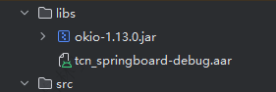

2. After copying, add a reference to the build.gradle file of the corresponding Module and synchronize it:
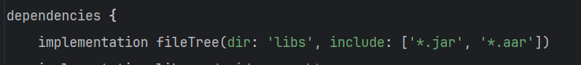

3. The three important components VendService.java, VendIf.java, and BootBroadcastRaceiver.java in the dome project should also be added to the target project. Don't forget that the components need to be declared in Androidmanifest.xml.

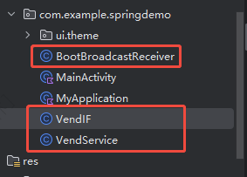

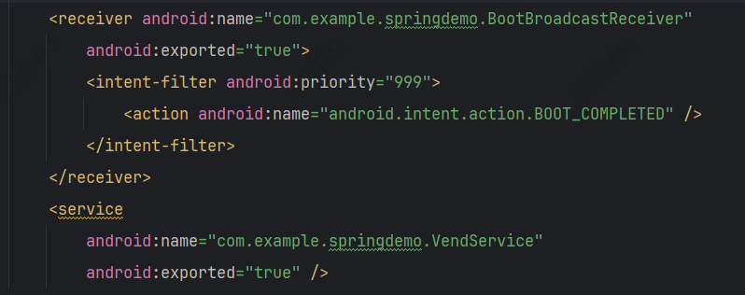

At this point, the development environment is complete.

Actual development

initialization
After the development environment is set up, it needs to be initialized in the custom application.
Create a class that inherits Application and override the onCreate method.
Initialize the SDK framework in the onCreate method
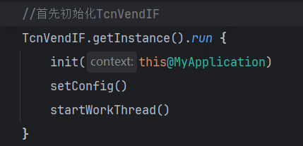

Set the motherboard serial port (according to the actual situation, the serial port that the channel is connected to will be initialized and changed)

Business Development
All business interfaces of the vending machine are integrated in TcnVendIF.java and called through a singleton.
The process and results of the business are callback through TcnVendIF.VendEventListener
TcnVendIF.VendEventListener needs to be registered through TcnVendIF.getInstance().registerListener(listener).
TcnVendIF.getInstance().unRegisterListener(listener) is to unregister the listener.
example:
In Activity, according to actual development needs, you can register business listeners in the onCreate or onResume cycle phase, and unregister them in the onPause or onDestryed phase.

The business messages of after-sales machines are all encapsulated into VendEventInfo instances. In VendEventInfo, different business results are identified by this parameter:
m_iEventID: business code, all business codes can be queried in TcnVendEventID
m_lParam1,2,3,4,5 The result of the operation.

4. Required permissions
SDK permissions required: (The provided SDK already includes the following permissions)
<uses-permission android:name="android.permission.ACCESS_WIFI_STATE" />
2. <uses-permission android:name="android.permission.CHANGE_WIFI_STATE" />
3. <uses-permission android:name="android.permission.WAKE_LOCK" />
<!-- Add permission to access phone location-->
4. <uses-permission android:name="android.permission.ACCESS_COARSE_LOCATION"/>
<!-- Add permission to access phone status-->
5. <uses-permission android:name="android.permission.READ_PHONE_STATE"/>
6. <uses-permission android:name="android.permission.CHANGE_NETWORK_STATE" />
7. <uses-permission android:name="android.permission.INTERNET" />
8. <uses-permission android:name="android.permission.RECEIVE_BOOT_COMPLETED" />
9. <uses-permission android:name="android.permission.RESTART_PACKAGES" />
10. <uses-permission android:name="android.permission.WRITE_EXTERNAL_STORAGE" />
11. <uses-permission android:name="android.permission.READ_EXTERNAL_STORAGE" />
12. <uses-permission android:name="android.permission.ACCESS_NETWORK_STATE" />
<!-- Allow CWJ account group to access low-level information-->
13. <uses-permission android:name="android.permission.CWJ_GROUP" / >
<!-- Allow mTweak users to access advanced system permissions-->
14. <uses-permission android:name="android.permission.MTWEAK_USER" />
<!-- Allow sound wave payment permission if sound wave related hardware is connected -->
14. <uses-permission android:name="android.permission.RECORD_AUDIO"/>
14. <uses-permission android:name="android.permission.MODIFY_AUDIO_SETTINGS" />
14. <uses-permission android:name="android.permission.GET_TASKS" />
14. <uses-permission android:name="android.permission.SYSTEM_ALERT_WINDOW" />

5. SDK authorization
5.1 Scan the QR code with your mobile phone and a prompt will appear. Fill in the authorization form as required.
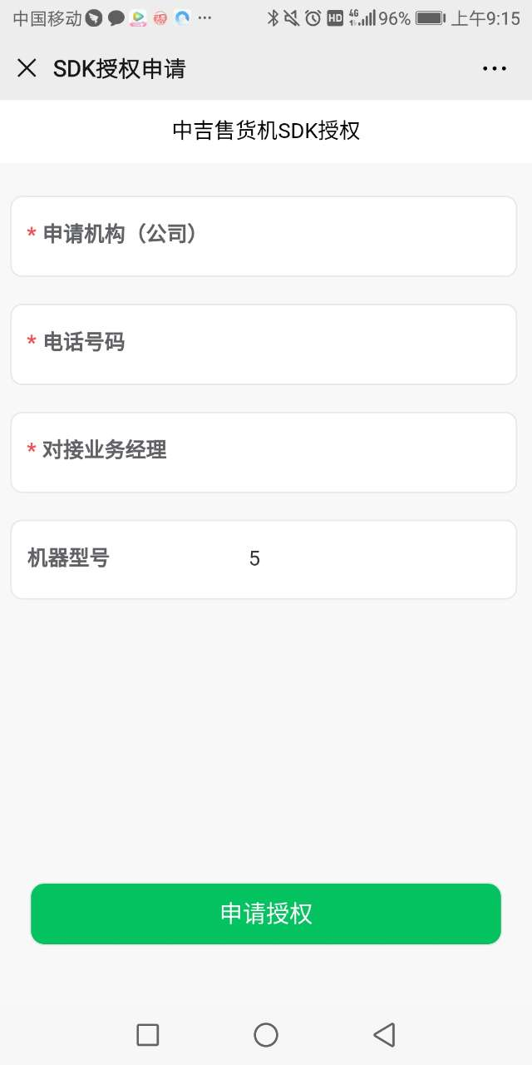

Detailed instructions for using SDK functions
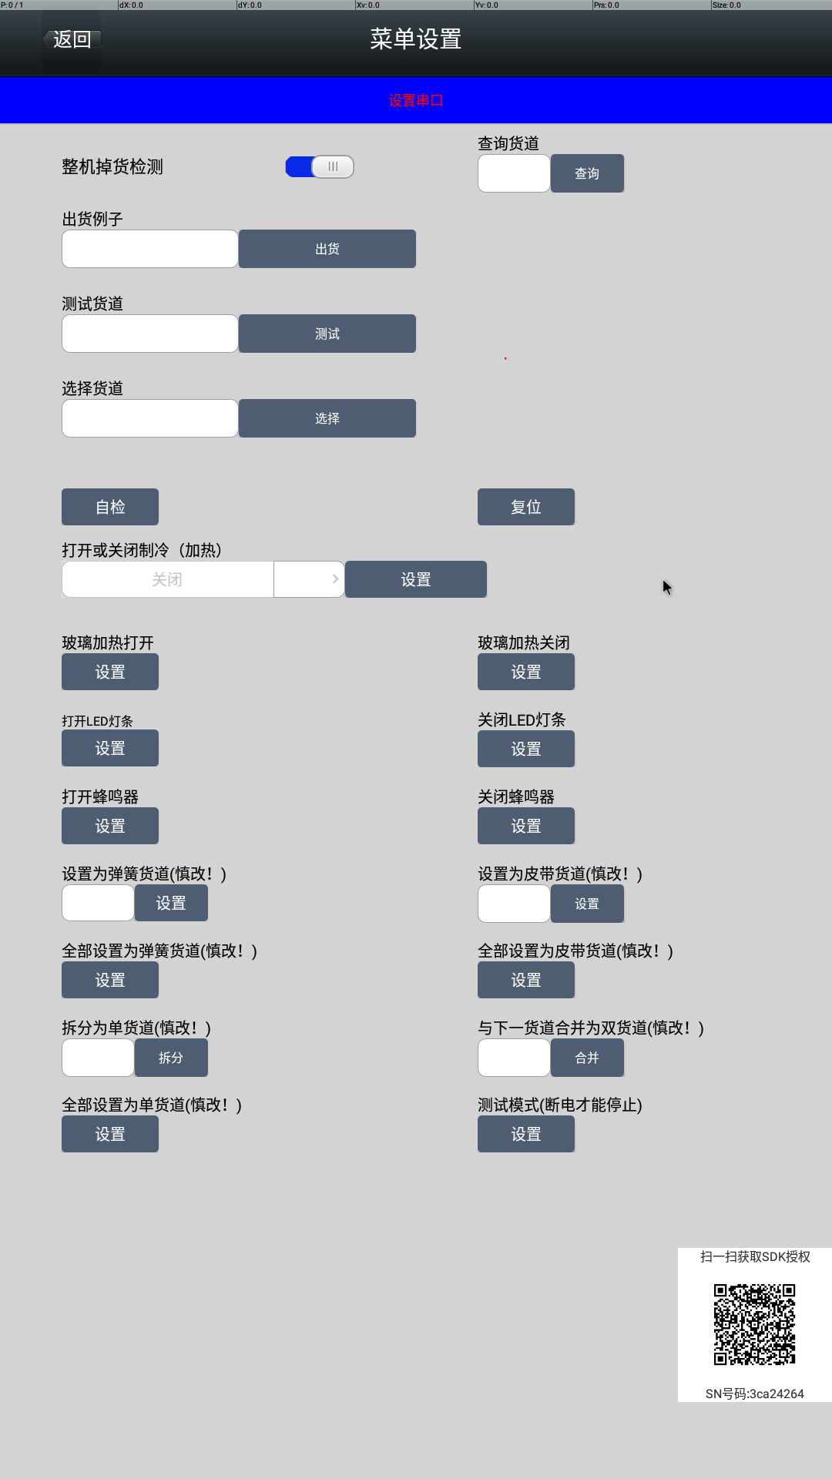
- Whole machine drop detection: This switch is mainly used to turn on the detection function of whether goods and cargo fall into the delivery port .

The control function is in the com.tcn.sdk.springdemo.MainAct class, search for menu_spr_light_check
TcnShareUseData.getInstance().setDropSensorCheck(isSwitchOn); //Set the switch status interface
TcnShareUseData.getInstance().isDropSensorCheck() //Get the switch status interface

Interface Description
Parameter name | Parameter Description
isSwitchOn | True turns on the switch
isSwitchOn | False turns off the switch

- Check the cargo channel: Check whether the cargo channel is faulty

The control function is in the com.tcn.sdk.springdemo.MainAct class, search for menu_spr_query_slot
Enter the channel number and click query
TcnVendIF.getInstance().reqQuerySlotStatus(Integer.valueOf(strParam)); //Query method
Interface Description
Parameter name | Parameter Description
strParam | Enter the channel number

- Shipping example: simulate a normal purchase and shipment (including channel number, amount, order number, etc.)
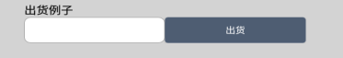
The control function is in the com.tcn.sdk.springdemo.MainAct class, search for menu_spr_ship_slot
Enter the channel number and click Ship.
TcnVendIF.getInstance().reqShip(slotNo,shipMethod,amount,tradeNo);//Test shipping interface

Shipping interface description
Parameter name | Parameter Description
slotNo | Cargo lane number
shipMethod | Payment Methods
amount | Payment amount
tradeNo | Order Number

- Test cargo channel: Enter the cargo channel number to enable shipment from that channel.
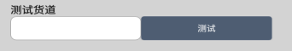

The control function is in the com.tcn.sdk.springdemo.MainAct class, search for menu_spr_ship_slot_test
Enter the channel number and click Test
TcnVendIF.getInstance().reqShipTest(Integer.parseInt(strParam)); //Shipping channel interface
Interface Description
Parameter name | Parameter Description
strParam | Enter the channel number

- Select aisle: Enter the aisle number to simulate a goods selection function.
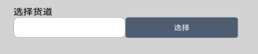
The control function is in the com.tcn.sdk.springdemo.MainAct class, search for menu_spr_reqselect
Enter the channel number and click Select
TcnVendIF.getInstance().reqSelectSlotNo(Integer.valueOf(strParam)); //Selection method
Interface Description
Parameter name | Parameter Description
strParam | Enter the channel number

- Self-examination.


7. Reset: The position used by the machine is restored.

The control function is in the com.tcn.sdk.springdemo.MainAct class, search for menu_spr_reset;
TcnVendIF.getInstance().reqReset(UIComBack.getInstance().getGroupSpringId(strParam)) reset method
Interface Description
Parameter name | Parameter Description
strParam | The parameters have been defined, just click the button

8. Control the hot and cold switches: select cooling, heating or off settings.
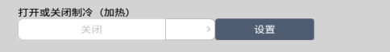
The control function is in the com.tcn.sdk.springdemo.MainAct class, search for menu_spr_set_heat_cool;
TcnVendIF.getInstance().reqHeatSpring(-1,Integer.parseInt(temp),Integer.parseInt(startTime),Integer.parseInt(endTime));
Interface Description
Parameter name | Parameter Description
-1 | Fixed value does not need to be modified
temp | Enter the set temperature value
startTime | Start time
endTime | End Time

9. Glass heating on: turn on glass heating.
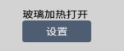
The control function is in the com.tcn.sdk.springdemo.MainAct class, search for menu_spr_glass_heat_enable;
TcnVendIF.getInstance().reqSetGlassHeatEnable( -1 ,true); //Glass heating method
Interface Description
Parameter name | Parameter Description
-1 | Fixed value does not need to be modified
true | Turn on the glass heating

10. Glass heating off: turn off glass heating.
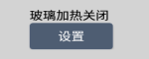
The control function is in the com.tcn.sdk.springdemo.MainAct class, search for menu_spr_glass_heat_disable;
TcnVendIF.getInstance().reqSetGlassHeatEnable( -1 , false ); //Disable heating interface
Interface Description
Parameter name | Parameter Description
-1 | Fixed value does not need to be modified
false | Turn off glass heating

11. Turn on the LED light strip
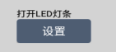
The control function is in the com.tcn.sdk.springdemo.MainAct class, search for menu_spr_open_led;
TcnVendIF.getInstance().reqSetLedOpen( -1 ,true); //Open the LED light interface
Interface Description
Parameter name | Parameter Description
-1 | Fixed value does not need to be modified
true | Turn on the LED light strip

12. Turn off the LED light strip
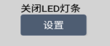
The control function is in the com.tcn.sdk.springdemo.MainAct class, search for menu_spr_close_led;
TcnVendIF.getInstance().reqSetLedOpen( -1 , false ); //Close the LED light interface
Interface Description
Parameter name | Parameter Description
-1 | Fixed value does not need to be modified
False | Turn off LED light strip

13. Turn on the buzzer
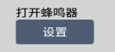

The control function is in the com.tcn.sdk.springdemo.MainAct class, search for menu_spr_buzzer_open;
TcnVendIF.getInstance().reqSetBuzzerOpen( -1 ,true); //Open the buzzer interface
Interface Description
Parameter name | Parameter Description
-1 | Fixed value does not need to be modified
true | Turn on the buzzer

14. Turn off the buzzer
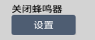
The control function is in the com.tcn.sdk.springdemo.MainAct class, search for menu_spr_buzzer_close;
TcnVendIF.getInstance().reqSetBuzzerOpen( -1 , false ); //Method to close the buzzer
Interface Description
Parameter name | Parameter Description
-1 | Fixed value does not need to be modified
False | Turn off the buzzer

15. Set the spring channel: Set the channel as the spring channel for shipping
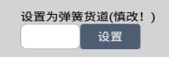
The control function is in the com.tcn.sdk.springdemo.MainAct class, search for menu_spr_set_slot_spring
Enter the channel number you want to modify and click Set.
TcnVendIF.getInstance().reqSetSpringSlot(Integer.valueOf(data1)); //Set the spring channel interface
Interface Description
Parameter name | Parameter Description
data1 | Enter the channel number

16. Set the belt channel: Set the channel as the delivery mode of the belt channel
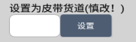
The control function is in the com.tcn.sdk.springdemo.MainAct class, search for menu_spr_set_slot_belts
Enter the channel number you want to modify and click Set.
TcnVendIF.getInstance().reqSetBeltsSlot(Integer.valueOf(data1)); //Set the belt channel method
Interface Description
Parameter name | Parameter Description
data1 | Enter the channel number

17. Set all to spring channels: Set all channels to the spring channel shipping method
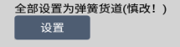
The control function is in the com.tcn.sdk.springdemo.MainAct class, search for menu_spr_set_slot_spring_all
TcnVendIF.getInstance().reqSpringAllSlot(-1); //Set up the interface
Interface Description
Parameter name | Parameter Description
-1 | Fixed value does not need to be modified

18. Set all as belt lanes: Set all lanes as belt lanes for shipment
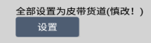
The control function is in the com.tcn.sdk.springdemo.MainAct class, search for menu_spr_set_slot_belts _all
TcnVendIF.getInstance().reqBeltsAllSlot(-1); //Set the belt channel method
Interface Description
Parameter name | Parameter Description
-1 | Fixed value does not need to be modified

19. Split into single lanes: Split the merged lanes into single lanes
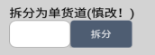
The control function is in the com.tcn.sdk.springdemo.MainAct class, search for menu_spr_set_single_slot
Enter the channel number you want to split and click Split.
TcnVendIF.getInstance().reqSingleSlot(Integer.valueOf(data1)); //Call method
Interface Description
Parameter name | Parameter Description
data1 | Enter the channel number

20. Merge with the next channel:
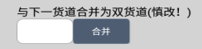

The control function is in the com.tcn.sdk.springdemo.MainAct class, search for menu_spr_set_double_slot
Enter a channel number, it will merge with the next channel to form a double channel
TcnVendIF.getInstance().reqDoubleSlot(Integer.valueOf(data1));//Merge method
Interface Description
Parameter name | Parameter Description
data1 | Enter the channel number

21. Set all to single channel
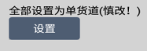
The control function is in the com.tcn.sdk.springdemo.MainAct class, search for menu_spr_set_single_slot_all
TcnVendIF.getInstance().reqSingleAllSlot(-1); //Set single channel method
Interface Description
Parameter name | Parameter Description
-1 | Fixed value does not need to be modified

22. Test mode: All channels will ship one product.
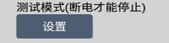
The control function is in the com.tcn.sdk.springdemo.MainAct class, search for menu_spr_test_mode
TcnVendIF.getInstance().reqTestMode(-1); //Simulation test
Interface Description
Parameter name | Parameter Description
-1 | Fixed value does not need to be modified

SDK return parameter monitoring description
Register VendListener for monitoring
Main parameter description:

- TcnVendEventID.CMD_QUERY_SLOT_STATUS: Query the failure of the cargo lane
- Through the query interface TcnVendIF.getInstance().reqQuerySlotStatus(Integer.valueOf(strParam)); ( strParam : represents the channel number.)
Receive the returned fault in TcnVendEventID.CMD_QUERY_SLOT_STATUS in the com.tcn.sdk.springdemo.MainAct directory
Return Value | Parameter Description
cEventInfo.m_lParam4 | 0 represents normal, and other values will display corresponding prompts.
- TcnVendEventID.CMD_SELF_CHECK: Query the self-check status
1. Click the self-check query button to call the TcnVendIF.getInstance().reqSelfCheck(-1) interface ;
Receive the return status in TcnVendEventID.CMD_SELF_CHECK in the com.tcn.sdk.springdemo.MainAct directory
Return Value | Parameter Description
cEventInfo.m_lParam4 | Return error code word prompt

- TcnVendEventID.CMD_RESET: Query reset status
- Click the Self-check Query button to call
TcnVendIF.getInstance().reqReset(UIComBack.getInstance().getGroupSpringId(strParam)) reset interface
Receive the return status in TcnVendEventID . CMD_RESET in the com.tcn.sdk.springdemo.MainAct directory
Return Value | Parameter Description
cEventInfo.m_lParam4 | Return error code text prompt

- TcnVendEventID.SET_SLOTNO_SPRING: Set the spring channel
- Set the spring slot through the TcnVendIF.getInstance().reqSetSpringSlot(Integer.valueOf(data1)); interface
Receive the return result in TcnVendEventID.SET_SLOTNO_SPRING in the com.tcn.sdk.springdemo.MainAct directory
Return Value | Parameter Description
cEventInfo.m_lParam4 | Return error code text prompt

- TcnVendEventID.SET_SLOTNO_BELTS: Set the crawler cargo lane
1. Set the belt lane through TcnVendIF.getInstance().reqSetBeltsSlot(Integer.valueOf(data1)); interface
Receive the return result in TcnVendEventID.SET_SLOTNO_BELTS in the com.tcn.sdk.springdemo.MainAct directory
Return Value | Parameter Description
cEventInfo.m_lParam4 | Return error code text prompt

- TcnVendEventID.SET_SLOTNO_ALL_SPRING: Set all lanes to spring lanes
- Set all channels to spring channels through the TcnVendIF.getInstance().reqSpringAllSlot(-1); interface
Receive the returned result in TcnVendEventID. SET_SLOTNO_ALL_SPRING in the com.tcn.sdk.springdemo.MainAct directory

Return Value | Parameter Description
cEventInfo.m_lParam4 | Return error code text prompt

- TcnVendEventID.SET_SLOTNO_ALL_BELT: Set all cargo lanes to track cargo lanes
1. Set the track lane through the TcnVendIF.getInstance().reqBeltsAllSlot(-1); interface
Receive the returned result in TcnVendEventID. SET_SLOTNO_ALL_BELT in the com.tcn.sdk.springdemo.MainAct directory
Return Value | Parameter Description
cEventInfo.m_lParam4 | Return error code text prompt

- TcnVendEventID.SET_SLOTNO_SINGLE: Set a single channel
1. Set a single channel through the TcnVendIF.getInstance().reqSingleSlot(Integer.valueOf(data1)) interface
Receive the returned result in TcnVendEventID. SET_SLOTNO_ALL_BELT in the com.tcn.sdk.springdemo.MainAct directory

Return Value | Parameter Description
cEventInfo.m_lParam4 | Return error code text prompt

- TcnVendEventID.SET_SLOTNO_DOUBLE: Set double lanes
1. Set up dual channels through the TcnVendIF.getInstance().reqDoubleSlot(Integer.valueOf(data1)) interface
Receive the returned result in TcnVendEventID. SET_SLOTNO_DOUBLE in the com.tcn.sdk.springdemo.MainAct directory

Return Value | Parameter Description
cEventInfo.m_lParam4 | Return error code text prompt

- TcnVendEventID.SET_SLOTNO_ALL_SINGLE: Set all lanes to single lane
1. Set all lanes to single lane through TcnVendIF.getInstance().reqSingleAllSlot(-1) interface
Receive the returned result in TcnVendEventID. SET_SLOTNO_ALL_SINGLE in the com.tcn.sdk.springdemo.MainAct directory

Return Value | Parameter Description
cEventInfo.m_lParam4 | Return error code text prompt

- TcnVendEventID.CMD_SET_COOL : Set cooling
1. Set cooling through TcnVendIF.getInstance().reqHeatSpring(-1,Integer.parseInt(temp),Integer.parseInt(startTime),Integer.parseInt(endTime)); interface
Receive the returned result in TcnVendEventID. SET_SLOTNO_ALL_SINGLE in the com.tcn.sdk.springdemo.MainAct directory
Return Value | Parameter Description
cEventInfo.m_lParam4 | Return error code text prompt

- TcnVendEventID.CMD_SET_HEAT: Set heating
1. Set heating through TcnVendIF.getInstance().reqHeatSpring(-1,Integer.parseInt(temp),Integer.parseInt(startTime),Integer.parseInt(endTime)); interface.
Receive the return result in TcnVendEventID. CMD_SET_HEAT in the com.tcn.sdk.springdemo.MainAct directory

Return Value | Parameter Description
cEventInfo.m_lParam4 | Return error code text prompt

- TcnVendEventID.CMD_SET_GLASS_HEAT_OPEN: Glass heating is turned on
1. Turn on the glass heating through the TcnVendIF.getInstance().reqSetGlassHeatEnable( -1 , true) interface
Receive the return result in TcnVendEventID. CMD_SET_GLASS_HEAT_OPEN in the com.tcn.sdk.springdemo.MainAct directory

Return Value | Parameter Description
cEventInfo.m_lParam4 | Return error code text prompt

- CMD_SET_GLASS_HEAT_CLOSE: Glass heating is turned off
- Turn off glass heating through the TcnVendIF.getInstance().reqSetGlassHeatEnable( -1 , false ) interface
Receive the return result in TcnVendEventID. CMD_SET_GLASS_HEAT_OPEN in the com.tcn.sdk.springdemo.MainAct directory

Return Value | Parameter Description
cEventInfo.m_lParam4 | Return error code text prompt

- TcnVendEventID.CMD_SET_LIGHT_OPEN: Turn on the LED light
- Through the TcnVendIF.getInstance().reqSetLedOpen( -1 , true) interface, turn on the LED light
Receive the return result in TcnVendEventID. CMD_SET_LIGHT_OPEN in the com.tcn.sdk.springdemo.MainAct directory

Return Value | Parameter Description
cEventInfo.m_lParam4 | Return error code text prompt

- TcnVendEventID.CMD_SET_LIGHT_CLOSE: Turn off the LED light
1. Turn off the LED light through the TcnVendIF.getInstance().reqSetLedOpen( -1 , false ) interface.
Receive the return result in TcnVendEventID. CMD_SET_LIGHT_CLOSE in the com.tcn.sdk.springdemo.MainAct directory

Return Value | Parameter Description
cEventInfo.m_lParam4 | Return error code text prompt

- CMD_SET_BUZZER_OPEN : Turn on the buzzer
1. Turn on the buzzer through the TcnVendIF.getInstance().reqSetBuzzerOpen( -1 , true) interface.
Receive the return result in TcnVendEventID. CMD_SET_BUZZER_OPEN in the com.tcn.sdk.springdemo.MainAct directory

Return Value | Parameter Description
cEventInfo.m_lParam4 | Return error code text prompt

- CMD_SET_BUZZER_CLOSE : Turn off the buzzer
1. Turn off the buzzer through the TcnVendIF.getInstance().reqSetBuzzerOpen( -1 , false ) interface.
Receive the return result in TcnVendEventID. CMD_SET_BUZZER_ CLOSE in the com.tcn.sdk.springdemo.MainAct directory

Return Value | Parameter Description
cEventInfo.m_lParam4 | Return error code text prompt

- TcnVendEventID.COMMAND_SELECT_GOODS //Goods selection successful
1 Select the product and call TcnVendIF.getInstance().reqSelectSlotNo(Integer.valueOf(strParam)); product selection interface ( strParam : represents the channel number.)
2. In com.tcn.sdk.springdemo.MainAct, TcnVendEventID.COMMAND_SELECT_GOODS receives the successful selection method.

- TcnVendEventID.COMMAND_INVALID_SLOTNO //Invalid channel
1. Select the product and call TcnVendIF.getInstance().reqSelectSlotNo(Integer.valueOf(strParam)); product selection interface ( strParam : represents the channel number.)
2. TcnVendEventID.COMMAND_INVALID_SLOTNO in com.tcn.sdk.springdemo.MainAct receives this invalid channel method.

- TcnVendEventID.COMMAND_SOLD_OUT: Whether the channel is sold out

Return Value | Parameter Description
cEventInfo.m_lParam1 | Return value > 0 means it is not sold out

- Test shipment through the test channel TcnVendIF.getInstance().reqShipTest(Integer.parseInt(strParam)) interface.
2. If the channel is empty, COMMAND_SOLE_OUT in com.tcn.sdk.springdemo.MainAct receives this method.

- TcnVendEventID.COMMAND_FAULT_SLOTNO: Cargo lane failure
- Test shipment through the test channel TcnVendIF.getInstance().reqShipTest(Integer.parseInt(strParam)) interface.
2. If there is a fault in the cargo channel, COMMAND_FAULT_SLOTNO in com.tcn.sdk.springdemo.MainAct receives the return result.

Return Value | Parameter Description
cEventInfo.m_lParam4 | Prompt cargo channel failure + description

- TcnVendEventID.COMMAND_SHIPPING: Shipping in progress

1. Test shipment through the test channel TcnVendIF.getInstance().reqShipTest(Integer.parseInt(strParam)) interface.
2. In com.tcn.sdk.springdemo.MainAct, COMMAND_SHIPPING receives the result returned by "shipping in progress".

Return Value | Parameter Description
cEventInfo.m_lParam1 | Cargo lane number
cEventInfo.m_lParam4 | "Shipping" text prompt

- TcnVendEventID.COMMAND_SHIPMENT_SUCCESS: Shipment successful
1. Test shipment through the test channel TcnVendIF.getInstance().reqShipTest(Integer.parseInt(strParam)) interface.
Receive the result of shipping in COMMAND_SHIPMENT_SUCCESS in com.tcn.sdk.springdemo.MainAct .
- TcnVendEventID.COMMAND_SHIPMENT_FAILURE : Shipping failed
1. Test shipment through the test channel TcnVendIF.getInstance().reqShipTest(Integer.parseInt(strParam)) interface.
Receive the result of "shipping in progress" in COMMAND_SHIPMENT_FAILURE in com.tcn.sdk.springdemo.MainAct .

- TcnVendEventID.CMD_READ_DOOR_STATUS: Door action
- Get the status through door open and door closed.
Receive the main door status return result in CMD_READ_DOOR_STATUS in com.tcn.sdk.springdemo.MainAct .
Return Value | Parameter Description
cEventInfo.m_lParam1 | 1: Door open
cEventInfo.m_lParam1 | 2: Door closed

- TcnVendEventID.MDB_RECIVE_PAPER_MONEY: Throwing paper money
- MDB_RECIVE_PAPER_MONEY in com.tcn.sdk.springdemo.MainAct receives the banknote balance.
Return Value | Parameter Description
cEventInfo.m_lParam4 | Amount invested

- TcnVendEventID.MDB_RECIVE_COIN_MONEY: coin toss
Receive the coin balance in MDB_RECIVE_COIN_MONEY in com.tcn.sdk.springdemo.MainAct .
Return Value | Parameter Description
cEventInfo.m_lParam4 | Amount invested

- TcnVendEventID.MDB_BALANCE_CHANGE //Balance change
- There are many ways to change the balance, such as throwing paper money and coins. Each time you throw it, it will be received in the MDB_BALANCE_CHANGE method in com.tcn.sdk.springdemo.MainAct. Get the balance through TcnVendIF.getInstance().getBalance()

- TcnVendEventID.MDB_PAYOUT_PAPERMONEY: Find banknotes
1. After the purchase is completed, click on the refund button in the TcnVendIF.getInstance().reqSelectCancel() method.
2. Receive the return result in the MDB_PAYOUT_PAPERMONEY method in com.tcn.sdk.springdemo.MainAct.
Return Value | Parameter Description
cEventInfo.m_lParam1 | -1 Refund in progress
cEventInfo.m_lParam1 | 0
cEventInfo.m_lParam4 | Coin refund status + amount display

- TcnVendEventID.MDB_PAYOUT_COINMONEY: Find coins
1. After the purchase is completed, click on the refund button in the TcnVendIF.getInstance().reqSelectCancel() method
2. Receive the return result in the MDB_PAYOUT_COINMONEY method in com.tcn.sdk.springdemo.MainAct.

Return Value | Parameter Description
cEventInfo.m_lParam1 | -1 Refund in progress
cEventInfo.m_lParam1 | 0
cEventInfo.m_lParam4 | Coin refund status + amount display

- TcnVendEventID.MDB_SHORT_CHANGE_PAPER: Insufficient banknotes
1. Click on the coin refund button in the TcnVendIF.getInstance().reqSelectCancel() method. If the machine detects that the banknotes are insufficient,
Receive the return result in the MDB_SHORT_CHANGE_PAPER method in com.tcn.sdk.springdemo.MainAct .
Return Value | Parameter Description
cEventInfo.m_lParam4 | Insufficient banknotes

- TcnVendEventID.MDB_SHORT_CHANGE_COIN: Insufficient coins
1. Click on the coin refund button in the TcnVendIF.getInstance().reqSelectCancel() method if it is detected that the machine has insufficient coins .
2. Receive the return result in the MDB_SHORT_CHANGE_COIN method in com.tcn.sdk.springdemo.MainAct.

Return Value | Parameter Description
cEventInfo.m_lParam4 | Insufficient coins

- TcnVendEventID.MDB_SHORT_CHANGE: Insufficient change
1. Click to return the money in TcnVendIF.getInstance().reqSelectCancel() method, if it is detected that the machine does not have enough money
2. Receive the return result in the MDB_SHORT_CHANGE method in com.tcn.sdk.springdemo.MainAct.
Return Value | Parameter Description
cEventInfo.m_lParam4 | Insufficient change

- TcnVendEventID.CMD_CARD_PAY_FINISH: Card payment
- Report the consumption amount when swiping the card TcnVendIF.getInstance().upLoadMoneyToCard(soltNo,price,tradeNo);
2. Receive the return result in the CMD_CARD_PAY_FINISH method in com.tcn.sdk.springdemo.MainAct.

Return Value | Parameter Description
cEventInfo.m_lParam1 | 0 means the card deduction is successful , otherwise the card deduction fails
cEventInfo.m_lParam2 | Cargo lane number

- TcnVendEventID.CMD_CASH_PAYOUT_NORSP_CONTIN: Continue to purchase or return the currency
- After the consumption is completed, the result is returned in CMD_CASH_PAYOUT_NORSP_CONTIN of com.tcn.springboard.vend.VendControl .

Return Value | Parameter Description
cEventInfo.m_lParam4 | Continue to purchase prompt

- TcnVendEventID.CMD_STOPING_CARD_PAY: Stop card swiping
1. Receive the return result in the CMD_STOPING_CARD_PAY method in com.tcn.sdk.springdemo.MainAct.

Return Value | Parameter Description
cEventInfo.m_lParam4 | Stop card swipe prompt

