1. Membuat statistik di dashboard

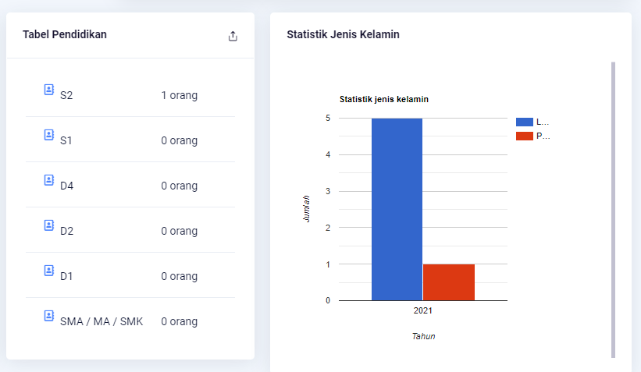

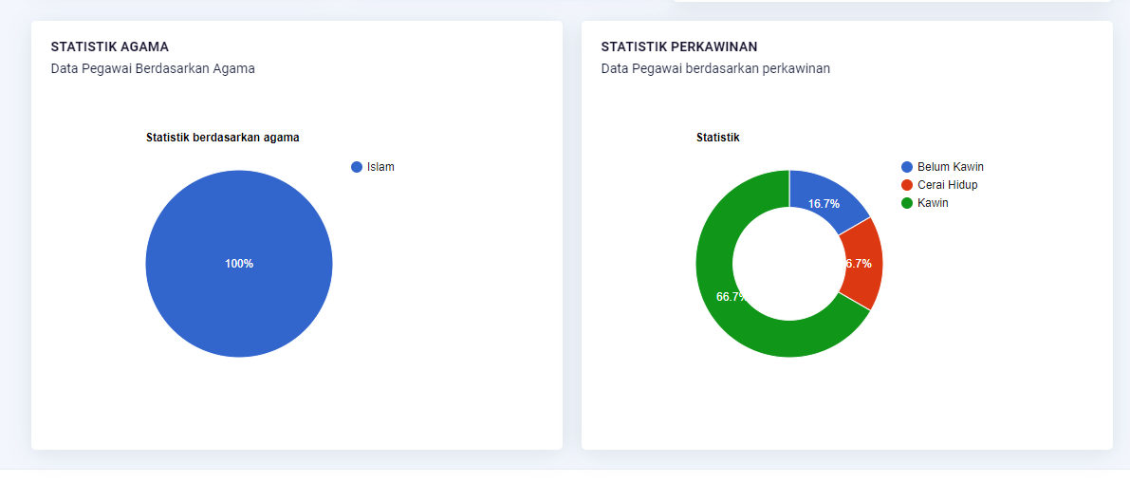

1. Membuat list disposisi keluar

|  |  |  |  |  |  |  |  |
| --- | --- | --- | --- | --- | --- | --- | --- |
| No | No surat masuk | Pengirim | Tanggal srt masuk | Tanggal disposisi | Admin | Disposisi |  |
| 1 | IV/12/2021 | Dedi | 20/02/2021 | 22/02/2021 | Admin | Adi, ani, budi |  |
| 2 | V/12/2021 | Dudi | 21/02/2021 | 23/02/2021 | admin | Deni, dodi |  |