Fiker Zewdie

7/31/2019

Graphs and Explanations of Analysis

This graph shows the median temperatures of Ardsley and Times Square during 1950-2016. There is a slight difference in the temperatures between Times Square and Ardsley. The shape of the plotted lines may seem the same because of the variability that remains consistent in both cities. Due to the urban heat island effect, Times Square’s temperatures remain a few degrees higher than Ardsley’s temperatures throughout.



This graph shows the upward trend in the number of extreme heat days, especially increasing in the early 2000s. Around 2010, Times Square temperatures reached higher than any other year recorded in the graph. This is an indication of the effects of global warming on Times Square’s temperatures. Throughout time, the number of extreme heat days remains similar for both locations., but a few areas Times Square had slightly more heat days than Ardsley. This can be seen around 1965, 1975, and especially 2010. For both locations, there is evidence of an increase in the number of heat days, expecially in more recent years.

This graph compares temperature distributions from 1951 to 1980 in order to understand how the extremes are defined in Ardsley vs in Times Square. In this graph, there are more days above the 90th and 95th percentile threshold for Times Square than in Ardsley, an indication of the Urban Heat Island effect increasing temperatures in Times Square, an urban area of Manhattan in comparison to Ardsley, a suburban area in Westchester, NY.

Over the two 30-year periods, there is a directional shift in the temperature distribution. Though this shift may be a slight difference in the mean, this may cause for a shift in the tails of the distribution as well, redefining what extremes were at the earlier time period. This also means that there is an increase in the number of days that fall above the 90th and 95th percentiles.

Times Square’s temperatures also shifted and similar to Ardsley, the number of days above the 90th percentile increased. This directional shift in the distribution caused an increase in the severity of the extreme temperatures and caused the extremes of 1951-1980 to become more frequent.

For the temperatures in Ardsley, a linear regression model was used as a predictive method to determine an estimate of the number of heat days from a given temperature. The model was proven to be statistically significant and for every degree of warming, it predicted about 8.56 additional days of extreme heat above the 90th percentile threshold.

For the temperatures in Times Square, a linear regression model was also used to estimate the likely number of heat days from a given temperature in Celcius. The linear regression model was proven to be statistically significant. For every degree of warming, it predicted about 8.02 additional days of extreme heat, which is defined as a day above the 90th percentile threshold.

This graph shows the difference in temperatures between Times Square and Ardsley for a given day in the year based off of the data provided from the years 1950-2016.

3

During the years 1950 to 2018, maximum temperatures increased in both due to global warming’s effect on temperatures and due to the Urban Heat Island effect, as variablity remained similar across the two locations, Times Square maximum temperatures remained a few degrees higher over most years.m

For both Times Square and Ardsley, the hottest day of the year increased across the years, and closer to more recent years, there is an increase in temperatures and due to the Urban Heat Island effect, temperatures in Times Square had more of an increase in more recent years.









The above graph is the same as the one right before it, it just different in terms of which location is stacked on top of which.

In both Times Square and Ardsley when using the 90th percentile threshold, the number of extreme heat days for both locations seems similar and the increase in number of days above this threshold is present in both locations as well.

As time passes, especially closer to the earlier years, there is a great increase in the hottest day of the year for each given year. For both locations, there is a warming trend for the hottest temperature for the year, but Times Square remains the hotter location and variability remains similar for both locations.

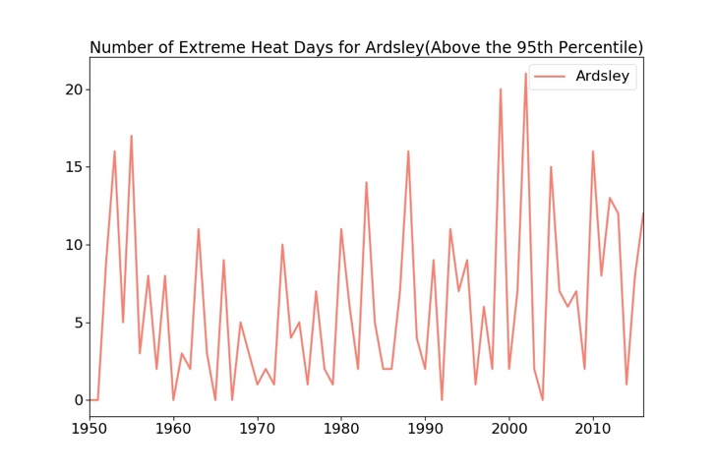

In both locations, there is an increase in the number of days above the 95th percentile. Since the 95th percentile of temperatures from the first 30 years in Ardsley was used as an arbitrary threshold, there is less of a visible change in the number of days above this baseline set to the extremes.

If the plotted line falls above the baseline, the temperatures are above the average temperatures of the location. For both Times Square and Ardsley, most of the temperatures that fell above the average temperature between 1950 and 1980,are in the latter 1900s to early 2000s.

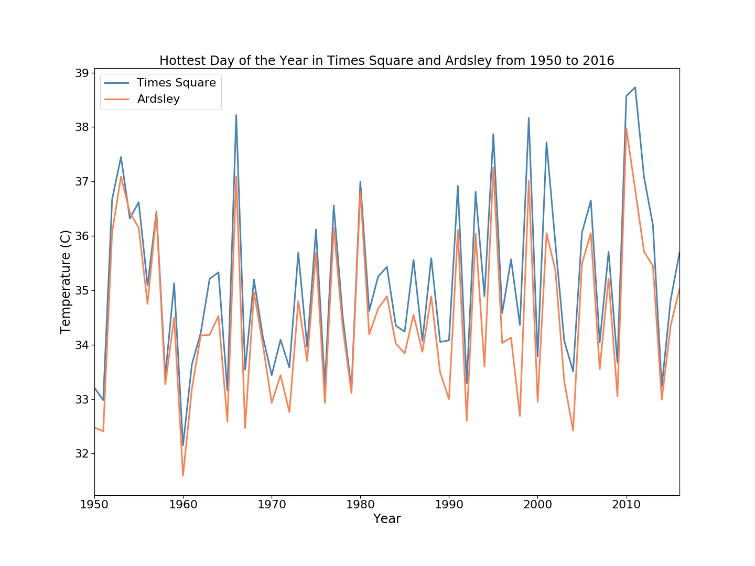

The temperatures above the 90th percentile increased steadily overtime and due to the UHI effect, the temperatures in Times Square were higher as variability remained very similar.

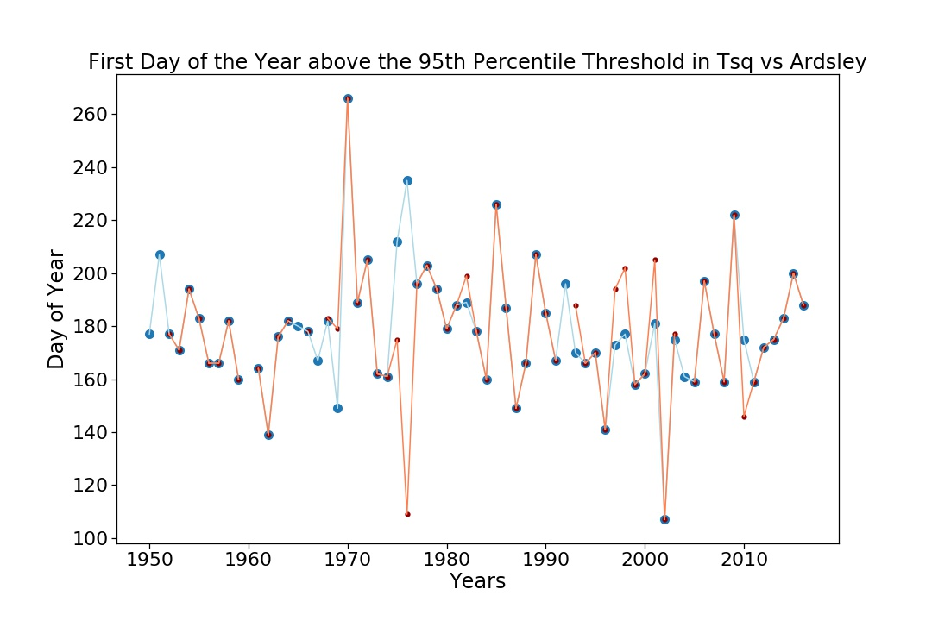

The trend of these graphs are inconsistent, likely because the 95th percentile threshold is too high of a threshold to anticipate that a day of every year will fall above it.

This graph is the same data as the above three tables, but the limitations on the Y axis are different.

In both Times Square and Ardsley, it seems as though the first day of the year is getting earlier overtime, but the statistical significance of this graph is questionable because of the outliers all over the graph.