Fiker Zewdie

Edited Full Review

Introduction:

Climate change is the global phenomenon that says that global temperatures are increasing with due to increased release of CO2 in our atmosphere and the continuous release of harmful gasses. Climate change has the potential to impact many of the earth’s natural processes, including extreme heat events. Due to climate change, there is an expected increase in the intensity, duration, and frequency of heat waves. In the latter half of the 1900s, there has been a sharp increase in temperatures worldwide due to global warming (Alexander et al. 2006). Furthermore, this warming has increased the risk of heat extremes and heat waves in many regions (Kovats 2008). Heat waves are responsible for more deaths than any other extreme weather event combined (source).

Impacts from heat waves are amplified by urbanization, a phenomenon known as the Urban Heat Island (Voogt et al. 2003). The urban heat island is the idea that urban areas are warmer than their surrounding suburban areas. This occurs because anthropogenic heat release from urban activity, low surface albedo (absorbing more light and heat energy from the sun), and better retention of heat by urban infrastructure (which can then release that heat back to the evironment) (Rizwan). Other studies have found that areas with a higher concentration of people in an area could have a higher relative temperatures than their surrounding rural areas (Chapman). Because of UHI, many people in urban areas are subject to higher temperatures than their surrounding suburban areas, especially during extreme heat events.

Extreme heat is a major health hazard during summer in many regions around the world (Lowe 2015). A prime example of a heat-related mortality event was the 2003 heat wave in Europe during July of 2003, which killed as many as 70,000 people (Robine et al. 2008). Recent studies have shown that extreme heat, [drought](https://www.sciencedirect.com/topics/social-sciences/drought) and other climate-related events are projected to increase([Handmer et al., 2012](https://www.sciencedirect.com/science/article/pii/S0264275118311934" \l "bb0355)). As climate change projections show that there is an increase in the frequency and severity of extreme weather events, health impacts are expected to get worse ([Austin et al., 2015](https://www.sciencedirect.com/science/article/pii/S0264275118311934" \l "bb0070)) In the US, there are an estimated 670 - 1300 deaths annually.(Berko Heat events are expected to have a more detrimental impact on older populations aged 65 and over (Flynn et al. 2005). Recent research estimates that the world population of people above 65 will only increase, subsequently increasing the population that is susceptible to health impacts. Climate change’s impacts have not only affected health but have also created an impact on food security in developing nations (Ropo et al., 2017). Another highly susceptible group to this change in the frequency of extreme heat events would be low-income residents of urban areas. In areas such as these where the urban heat island interacts with global warming, the population of people that are not able to gain access to proper air conditioning systems and comfortable living conditions would be worst affected by the heat. Those who live in more heat-prone areas may not be able to afford the costs of running air conditioning as well (Sheridan 2007). Recent studies have studied the urban heat island and climate change’s interaction, but have failed to include NYC as a part of their study (Habeeb et al., 2014). These concerns prompt current research about urban areas like NYC and its surrounding suburban areas to understand the susceptibility of urban populations to a warming temperatures.

Methods:

Results:

Over the course of one year, the graph of median maximum temperatures in Ardsley and Times Square give an overview of what a typical year looks like in Times Square and Ardsley. Given that the two locations are in the northeast, they experience their coldest temperatures in the winter and their warmest temperatures in the summer with more moderate temperatures in the spring and fall.

For a given year, the difference between Ardsley and Times Square (Times Square minus Ardsley) temperatures was graphed. Positive values indicated times of the year when maximum temperatures are generally warmer in Times Square compared to Ardsley; negative values indicate the time of year when maximum temperatures are cooler., it indicates that Times Square is warmer for the most part. Times Square is shown to be about half a degree cooler during the spring months, especially April. The most likely reason for this could be low energy consumption during spring months in Times Square.

In the Ardsley distribution, the slight shift in the mean temperatures caused a large shift in the extremes. Over the latter time period the number of temperatures that fall above the 90th percentile threshold increased, indicating an increase in the average number of extreme heat days from XX (1951-1980) to YY (1987-2016).

Times Square temperatures shifted very slightly in the median, but this seemingly small shift created a large shift in the tails, making the extremes on the warmer end of temperatures more common.

In Times Square, the summer median temperature shifted slightly meaning the frequency for days to fall above Ardsley’s 90th and 95th percentiles is higher in Times Square than in Ardsley. This shift in the distribution indicates that Times Square experiences warmer summers.

In both Times Square and Ardsley, mainly because both locations were standardized with respect to their own temperature thresholds. Due to the two locations being in close proximity to each other, the variability trends are similar. In this graph, temperatures in Times Square are predicted to increase .



When the number of extreme heat days for each year was graphed, it remained true that the urban heat island effect and the increase in global warming caused an increase in the temperature for the hottest day of the year. Due to the standardization of both locations to their respective thresholds, the variability of both locations remains very similar. This increase in the number of extreme heat days in both locations is a good indicator that global warming has caused for unusually warmer weather than before.

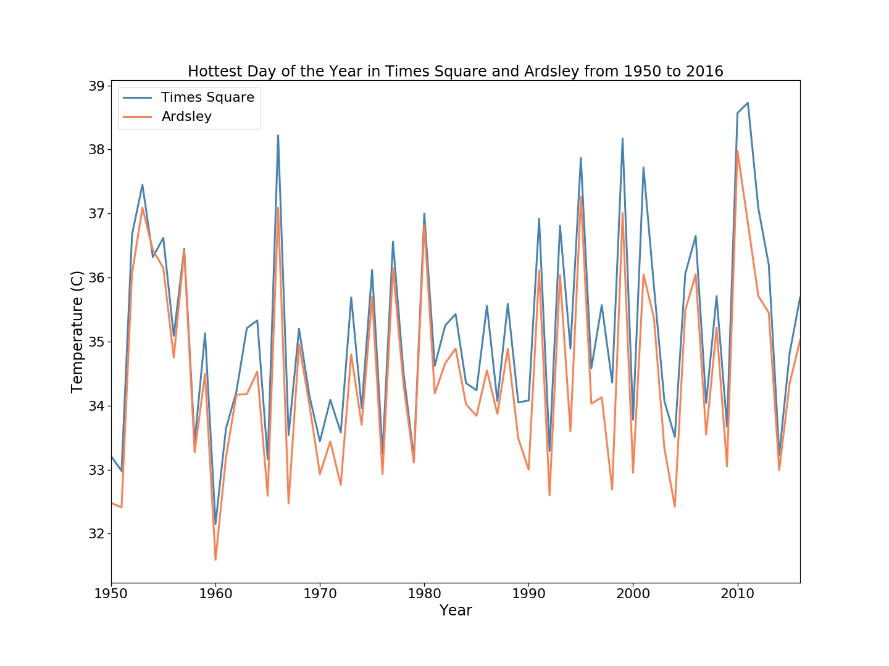

When graphing the maximum temperature of each year, variability of both Times Square and Ardsley remain similar for the first half of the timeframe. This changes after 1980 and the average temperatures increase at a faster rate in Times Square than in Ardsley.

In Ardsley, the first day of the year above the 90th percentile threshold (for the years between 1951-1987) falls earlier over time. A statistically significant linear relationship was drawn using a linear regression model, which estimated that for every year, the first day of the year above the 90th percentile threshold would fall about half a day earlier.

In Times Square as well, the first day of the year above the 90th percentile threshold (for the years between 1951-1987) falls earlier overtime. The linear regression model drew a weaker, but helpful model that predicted that temperatures would fall above the 90th percentile threshold 0.2 days earlier each year.

A linear regression line was drawn to predict two probable trends for average summer temperatures. The first trend takes into account the temperatures of all years given, but the second trend takes into account the temperature data after 1980 because there was a drastic increase in the trend after 1980. The second trend may be more reliable if the trend after 1980 were to continue. Though statistically this may be considered a weak trend, this is mainly because of the natural variability from the temperature data over a much smaller time series and is the more likely trend to follow if it was assumed that the trend from 1980 forward would continue.

The trend using all data from 1950-2016 estimates that by 2050, the temperatures will reach 29.4 degrees Celsius, while the trend considering temperatures from after 1980 estimates 28.8 degrees Celsius.

The trend using all data from 1950-2016 estimates that by 2050, the temperatures will reach 29.4 degrees Celsius, while the trend considering temperatures from after 1980 estimates 30.1 degrees Celsius.

For each year in Times Square, the average temperature for that year and the number of days in that fell above the 90th percentile threshold was plotted. A linear relationship was drawn to estimate the number of extreme heat days for a given temperature. This given temperature was a sample average temperature for all of the years between 1950-2016. The scatter plot’s points are sample yearly mean temperatures and their corresponding number of extreme heat days. These data points were used to draw a statistically significant line of best fit using a linear regression model that predicted on average about 8 additional extreme heat days for a degree increase in temperature.

Similarly, in Ardsley a statistically significant linear relationship was drawn that estimates about 8.6 more extreme heat days for every degree increase.