CareConnect: Smart Hospital Matching System

A PROJECT REPORT



DEPARTMENT OF COMPUTER SCIENCE
UNITY UNIVERSITY, GERJI CAMPUS
ADDIS ABABA

MONTH AND YEAR
May, 2026

Submitted by

Abraham Tamene – UUR00322/16
Daniel Lemma – UUR00362/16
Feven Alemayehu – UUR00037/17
Fiker Belay – UUR00180/17
Hermela Mesfin – UUR00911/16
Ruhama Amare – UUR00711/16
Yabsira Tsegaye – UUR00476/1617

ABSTRACT

This Software Project Management document presents the planning, execution, and control of CareConnect a smart hospital matching system developed to address the inefficiencies in healthcare facility selection in Ethiopia. The project aims to enable patients to find the most suitable hospital based on symptoms, budget, location, and service preferences, thereby reducing unnecessary hospital visits and treatment delays.
The document covers the full project lifecycle: feasibility analysis (technical, economic, operational, legal, and schedule), scope definition (including project charter, RTM, scope statement, and WBS), time estimation with critical path network diagram, cost estimation, resource staffing, change control strategies, and risk analysis. The project follows an incremental development lifecycle with prototyping for the matching engine.
Key deliverables include a mobile and web application with offline support, a hospital matching algorithm, user authentication, and a pilot deployment in Addis Ababa. The team consists of seven members with defined roles: Project Manager, Business Analyst, System Architect, Developer, Customer Management, Change Control Board, and Testing Team. This SPM report demonstrates the application of project management principles from initiation to closure to a real-world healthcare accessibility problem in Ethiopia. All costs are estimated in USD and converted to Ethiopian Birr at the rate of 1 USD = 157.34 ETB (May 2026).

ACKNOWLEDGMENT

We would like to express our sincere gratitude to our advisor, Biruk Mulatu, for his guidance, support, and valuable feedback throughout this project. His encouragement helped us stay on track and complete this work.
We also thank Unity University, Department of Computer Science, for providing the resources and environment to carry out this research. We are grateful to our families and friends for their patience and encouragement during the development of this project.
Finally, we would like to thank each other for the work we did on this project and for having one another’s back throughout the whole process.

Contents
ABSTRACT iii
ACKNOWLEDGMENT iv
LIST OF TABLES vii
LIST OF FIGURES xi
LIST OF SYMBOLS, ABBREVIATIONS, ACRONYMS xii
Chapter One: Project planning 1
1.1 Introduction 1
1.2 Feasibility Study 2
Technical Feasibility 2
Economic Feasibility 2
Operational Feasibility 2
Legal and Regulatory Feasibility 2
Schedule Feasibility 3
1.3 Goal of the Project 3
General Goal 3
Specific Goals 3
1.4 Scope of the Project 4
1.4.1 Project Charter 6
1.4.2 Requirement Traceability Matrix (RTM) 17
1.4.3 Scope Statement 18
1.4.4 Work Breakdown Structure (WBS) 21
1.5 Project Schedule (Time Estimation) 23
1.6 Project Cost Estimation 28
1.7 Project Resources and Staffing 32
1.8 Change Control Strategies 35
1.9 Risk Analysis Result 37
Chapter Two: System Introduction 41
2.1 Existing System Background 41
2.2 Statement of the Problem 41
2.3 Objective of the System 42
2.3.1 General objectives 43
2.3.2 Specific objectives 43
2.4 Scope Of The system 43
Chapter Three: Requirements and Analysis 46
3.1 Functional Requirements 46
3.2 Non Functional Requirements 47
3.2.1 User Interface 47
3.2.2 Quality Issue 48
3.2.3 Security Issue 49
3.2.4 Error Handling 49
3.3 System Models 50
3.3.1 Use Case Diagram 50
3.3.2 Class Diagram 52
3.3.3 Sequence Diagram 54
3.4 Methodology and Tools 56
3.4.1 Development Methodology 56
3.4.2 Tools Used 56
3.4.3 Lessons Learned (Literature Review) 57
Chapter Four: System Design 58
4.1 Overview 58
4.2 Architecture of the System 59
Presentation Layer 59
Application Layer 60
Data Layer 60
4.3 Subsystem Decomposition 60
4.4 Inter‑Subsystem Communication 63
4.5 Hardware / Software Mapping 63
4.6 Persistent Data Management 64
Chapter Five: Implementation 68
5.1 Programming Tools 68
5.1.1 Core Programming Technologies 68
5.1.2 Development Environment Tools 70
5.1.3 Justification of Key Selections 70
5.2 The Prototype 71
5.2.1 Description of Key Interfaces 71
5.2.1 Screen Shots 73
Chapter Six: Evaluation 78
6.1 Development of the Test Set 78
6.1.1 Test Strategy 78
6.1.2 Test Environment 79
6.1.3 Test Data 79
6.1.4 Test Cases 80
6.1.5 Detailed Test Case Descriptions 81
6.1.6 Test Execution Schedule 83
6.2 Results and Discussion 83
6.2.1 Summary of Test Execution 83
6.2.2 Defects Found and Resolved 84
6.2.3 User Acceptance Testing (UAT) Feedback 85
6.2.4 Discussion of Results 86
6.2.5 Conclusion 86
Chapter Seven: Conclusion and Recommendations 86
7.1 Conclusion 86
7.2 Recommendations 87

LIST OF TABLES

Table No. | Title | Page No.
Table 1.1 | Specific Goals | 3 - 4
Table 1.2 | High-level parameters | 5
Table 1.3 | Hybrid Life Cycle Model | 7
Table 1.4 | Specific Objectives | 8
Table 1.5 | Key Deliverables | 9 – 10
Table 1.6 | Five Phases of Project Management | 10
Table 1.7 | Change Control Board (CCB) | 11
Table 1.8 | Change Management Process | 11
Table 1.9 | Project Execution Plan (Activity table) | 12
Table 1.10 | Stakeholders | 13
Table 1.11 | Roles and Responsibilities | 13 - 14
Table 1.12 | Constraints | 15 - 16
Table 1.13 | Success Criteria | 16
Table 1.14 | Requirement Traceability Matrix (RTM) | 17 - 18
Table 1.15 | In-Scope Items | 19
Table 1.16 | Out-of-Scope Items | 19 – 20
Table 1.17 | Scope Boundaries Summary | 20
Table 1.18 | High-Level Timeline | 23 - 24
Table 1.19 | Detailed Task List with Durations | 24 – 25
Table 1.20 | Critical Path Summary (Network Diagram) | 26 - 27
Table 1.21 | Non-Critical Tasks (Slack) | 27
Table 1.22 | Cost Breakdown | 29 - 30
Table 1.23 | Cost Estimation Methodology | 30
Table 1.24 | Cost Summary | 31
Table 1.25 | Cost Baseline by Phase | 32
Table 1.26 | Human Resources (Staffing) | 33
Table 1.27 | Physical Resources | 33-34
Table 1.28 | Software Resources | 34
Table 1.29 | Staffing Strategy | 35
Table 1.30 | Change Control Board (CCB) | 35-36
Table 1.31 | Change Request Form Template | 37
Table 1.32 | Change Management Log | 37-38
Table 1.33 | Configuration Management Record | 39
Table 1.34 | Risk Register | 39-43
Table 2.1 | Summary of Problems in the Existing System | 44
Table 2.2 | Specific Objectives of CareConnect | 45-46
Table 2.3 | System In-Scope Features | 46
Table 2.4 | System Out-of-Scope Features | 47
Table 2.5 | System Boundaries Summary | 47
Table 3.1 | Functional Requirements of CareConnect | 48-49
Table 3.2 | Non‑Functional Requirements of CareConnect | 49
Table 3.3 | Quality issues | 50-51
Table 3.4 | Core Classes and Attributes | 54
Table 3.5 | Tools Used in CareConnect Development | 59
Table 4.1 | Subsystem Decomposition and Responsibilities | 63
Table 4.2 | Software Technology Stack | 65-66
Table 4.3 | Hardware and Infrastructure Mapping | 66
Table 5.1 | Core Programming Technologies for CareConnect | 70-71
Table 5.2 | Development Environment Tools | 72
Table 5.3 | Key Interfaces Description (Prototype) | 73-74
Table 6.1 | Test Strategy Levels | 80-81
Table 6.2 | Test Environment Specification | 81
Table 6.3 | Test Data Summary | 81-82
Table 6.4 | Test Case Summary | 82-83
Table 6.5 | Test Execution Schedule | 85
Table 6.6 | Test Execution Log | 85-86
Table 6.7 | Defect Report | 86
Table 6.8 | UAT Satisfaction Scores | 87

LIST OF FIGURES

Figure No. | Title | Page No.
Figure 1.1 | Work Breakdown Structure (WBS) Diagram | 23
Figure 1.2 | Network Diagram for CareConnect | 28
Figure 1.3 | Cost Distribution by Category | 31
Figure 3.1 | Use Case Diagram for CareConnect | 53
Figure 3.2 | Class Diagram – CareConnect System | 55
Figure 3.3 | Sequence Diagram – Hospital Search & Match | 57
Figure 3.4 | User Journey Map for CareConnect Patients | 58
Figure 4.1 | High‑Level System Architecture Diagram | 61
Figure 4.2 | Subsystem Decomposition Diagram | 64
Figure 4.3 | Entity- Relationship Diagram (ERD) | 67
Figure 4.4 | Database Schema | 68
Figure 4.5 | Data Backup Workflow | 69
Figure 5.1 | Three‑Layer Technology Stack Diagram | 73
Figure 5.2 | Login Screen | 75
Figure 5.3 | Symptom Input Screen | 76
Figure 5.4 | Hospital Results Screen | 77
Figure 5.5 | Hospital Details Screen | 78
Figure 5.6 | Offline Mode Screen | 79
Figure 5.7 | Wireframe | 80

LIST OF SYMBOLS, ABBREVIATIONS, ACRONYMS

Abbreviation / Symbol | Meaning
SPM | Software Project Management
WBS | Work Breakdown Structure
RTM | Requirements Traceability Matrix
CCB | Change Control Board
UAT | User Acceptance Testing
MOU | Memorandum of Understanding
ETB | Ethiopian Birr
UML | Unified Modeling Language
JWT | JSON Web Token
QA | Quality Assurance
ERD | Entity‑Relationship Diagram
HTTP | Hypertext Transfer Protocol
API | Application Programming Interface

Chapter One: Project planning

1.1 Introduction

In Ethiopia, accessing appropriate healthcare remains a significant challenge for many patients due to fragmented information, lack of transparency in hospital services, and unequal distribution of medical facilities across regions. Patients often visit multiple hospitals before finding one that can properly address their medical condition, accept their budget, or is conveniently located. This trial-and-error approach leads to delayed treatment, increased healthcare costs, and in severe cases, deterioration of health conditions.
The problem is further compounded by the absence of a centralized, accessible system that provides reliable information about hospital capabilities, service availability, and cost structures. While some hospitals maintain individual websites or social media pages, there is no unified platform that allows patients to compare options based on their specific needs.
CareConnect is proposed as a solution to this problem. It is a digital health platform designed to intelligently connect patients with the most suitable hospitals based on symptoms, financial capacity, geographic location, and service requirements. The system will be available via mobile and web applications, with offline supported features to ensure accessibility for users in low connectivity rural areas.
This document serves as the Software Project Management plan for the development of CareConnect. It outlines the feasibility, scope, schedule, cost, resources, risk analysis, and change control strategies that will guide the project from initiation to closure. The plan follows established software project management principles and is aligned with Ethiopian healthcare digitalization initiatives.

1.2 Feasibility Study

Technical Feasibility
CareConnect can be developed using existing mobile and web technologies. Integration with hospital databases is achievable through APIs, while offline functionality can be supported using local storage and synchronization methods. Security requirements such as encryption and authentication are technically feasible with current standards.

Economic Feasibility
The project requires initial investment in development, training, and infrastructure. However, long‑term benefits include reduced patient misdirection, improved hospital efficiency, and potential cost savings for both patients and healthcare providers. Funding opportunities may be available through the Ministry of Health, NGOs, and private sponsors.

Operational Feasibility
Hospitals and patients are expected to benefit from improved transparency and accessibility. Training programs for hospital staff will support adoption, while the system’s user‑friendly design ensures ease of use for patients. The operational environment is supportive of such a system, given Ethiopia’s growing digital health initiatives.

Legal and Regulatory Feasibility
The project must comply with Ethiopian health data privacy laws specifically aligning with the Ethiopian Data Protection Proclamation No. 1321/2024 (if effective) and relevant Ministry of Health digital health directives and obtain approval from the Ministry of Health. Implementing strong data protection measures, including encryption and secure authentication, will ensure compliance and reduce risks associated with patient data handling.

Schedule Feasibility
The project can be implemented in phases:
▪Short‑term: Pilot rollout in Addis Ababa.
▪Medium‑term: Expansion to Oromia and other regions.
▪Long‑term: Nation wide deployment.
The core system development (design, coding, testing) is estimated at 18 weeks.

1.3 Goal of the Project

General Goal
The overall goal of the CareConnect project is to develop a smart, accessible hospital matching system that helps patients in Ethiopia find the most suitable healthcare provider based on their medical condition, budget, location, and service preferences.

Specific Goals
The project aims to achieve the following specific goals:
Specific Goal | Target Metric
Enable patients to easily input symptoms, budget, location, and preferences | 100% of users can complete input in under 2 minutes
Develop a ranking algorithm that recommends relevant hospitals | Minimum 85% matching accuracy during pilot testing
Provide near real time hospital availability information | Data update delay of 15 minutes or less
Support offline functionality for low connectivity rural areas | Sync success rate of 95% or higher
Comply with Ethiopian health data protection regulations | Pass compliance review before deployment
Secure participation of at least 5 pilot hospitals in Addis Ababa | Signed MOUs by end of Week 4

Table 1.1 Specific Goals
Alignment with Project Success
These goals directly address the core problem identified in the introduction: fragmented healthcare information leading to inefficient hospital selection. By achieving these goals, CareConnect will reduce unnecessary hospital visits, decrease patient decision time, and improve access to appropriate care.

1.4 Scope of the Project

The scope of the CareConnect project defines the boundaries of what will be delivered, what functionalities are included, and what is explicitly excluded from the system. This section ensures that all stakeholders have a clear understanding of the project's limits, preventing scope creep and maintaining focus on the core objectives.
The scope is organized into the following sub-sections:
- 1.4.1 Project Charter
- 1.4.2 Requirement Traceability Matrix (RTM) — traces each requirement from source to test case
- 1.4.3 Scope Statement — detailed description of what is IN and OUT of the system
- 1.4.4 Work Breakdown Structure (WBS) and WBS Dictionary

The following high-level parameters define the project's boundaries:
Parameter | Description
In Scope | Mobile and web-based patient application, hospital database creation, smart matching algorithm, user authentication, offline data access, basic reporting
Out of Scope | Direct medical diagnosis, full hospital management system integration (ERP/EHR), emergency ambulance dispatch services
Target Users | Patients (urban and rural), hospital administrators, Ministry of Health officials
Geographic Focus | Pilot in Addis Ababa, with design for future expansion to Oromia and nationwide
Timeframe | 18-week development timeline

Table 1.2 High-level parameters

1.4.1 Project Charter

1. Project Overview

CareConnect is a digital health platform designed to intelligently connect patients with the most suitable hospitals based on their symptoms, financial capacity, and geographic location. The system leverages data-driven matching and accessibility-focused design to improve healthcare navigation in Ethiopia.
The platform will be available via mobile and web applications, with offline-supported features to ensure inclusivity for users in low-connectivity rural areas.
Software Type: Custom (built for Ethiopian healthcare ecosystem)
System Category: Embedded with mobile/web frontend + backend matching engine

2. Purpose & Justification

Accessing appropriate healthcare in Ethiopia remains a significant challenge due to fragmented information, limited transparency, and unequal distribution of services. Patients often visit multiple hospitals before receiving adequate care, resulting in delays, increased costs, and health risks.
This project directly addresses the "software crisis" described in Chapter 1 by attempting to replace poorly designed, fragmented health information systems with an engineered, reliable, and user-centered solution.

CareConnect aims to:
- Reduce unnecessary hospital visits
- Improve decision-making for patients
- Enhance visibility of hospital services and availability
- Support national efforts toward healthcare digitalization

This project aligns with Ethiopia's Digital Health Strategy and contributes to improving efficiency, accessibility, and trust within the healthcare system.

3. Software Life Cycle Model

After evaluating models described in Section 1.3, CareConnect will use a hybrid approach:

Phase | Primary Model | Rationale
Requirements & Matching Logic | Prototyping | Users don't know exactly how matching should work; rapid prototypes clarify real needs
Core Development | Incremental | Deliver working software in small, usable pieces (releases)
Privacy & Adoption Risk | Spiral-inspired | Risk analysis before each major iteration (see Risk section)
Overall Visibility | Waterfall-like phases | For sponsor reporting (Initiation → Planning → Execution → Monitoring → Closure)

Table 1.3 Hybrid Life Cycle Model

Why not pure Waterfall?
As Chapter 1 notes, Waterfall fails when requirements are not fully understood. CareConnects matching algorithm will evolve through user feedback.

Why not pure Spiral?
Too heavy for a mid-sized project, but we borrow it’s *risk-first* mindset.
CareConnect will follow an Incremental life cycle with prototyping for the matching engine. Each increment ends with a working, testable release. Risk analysis is performed before starting each increment.

4. Project Objectives

General Objective

To develop a smart, accessible system that efficiently matches patients with appropriate healthcare providers.

Specific Objectives

Objective | Target
Enable symptom, budget, location input | 100% of patient users
Develop ranking algorithm | Accuracy ≥ 85% in pilot
Provide near-real-time availability | Update delay ≤ 15 minutes
Support offline functionality | Works in areas with < 2G signal
Comply with Ethiopian data privacy laws | Pass compliance review
Improve collaboration | At least 5 pilot hospitals

Table 1.4 Specific Objectives

5. Scope of the Project

In Scope
- Development of a mobile and web-based patient application
- Hospital database creation and integration
- Smart matching and recommendation algorithm
- User authentication and data security mechanisms
- Offline data access and synchronization features
- Basic reporting and analytics

Out of Scope
- Direct medical diagnosis or treatment recommendations
- Integration with full hospital management systems (ERP/EHR)
- Emergency response services (e.g., ambulance dispatching)

6. Key Deliverables

Deliverable | Due (Weeks from start) | Responsible
Project Charter | Week 1 | Project Manager (Fiker Belay)
Requirement Traceability Matrix (RTM) | Week 1 | Business Analyst (Feven alemayehu)
System Architecture & Design Documents | Week 4 | System Architect (Ruhama Amare)
Functional Prototype (UI + simple matching) | Week 6 | Developer (Hermela Mesfin) + Customer Management for feedback
Increment 1 Release (core matching) | Week 10 | Entire team
Increment 2 Release (+offline features) | Week 14 | Entire team
Fully Tested CareConnect System | Week 16 | QA/Testers(Yabsera Tsegaye)
User Documentation & Training Materials | Week 17 | Customer Management (Daniel lemma) + Testing Team (Yabsera Tsegaye)
Final Project Report & Closure | Week 18 | Project Manager (Fiker Belay)

Table 1.5 Key Deliverables

7. Project Management Processes

The project will follow the five phases of project life cycle exactly as described in Section 1.3:

Phase | Key Activities | Completion Sign-off
1. Initiation | Charter approval, stakeholder identification | Sponsor signature
2. Planning | RTM, schedule, risk plan, life cycle selection | Baseline approval
3. Execution | Building increments, prototypes, testing | Increment demos
4. Monitoring & Control | Weekly progress tracking, change control, risk reviews | Status reports
5. Closure | Final report, lessons learned, handover | Closure certificate

Table 1.6 Five Phases of Project Management

8. Integrated Change Control

Role | CCB Member
Project Manager (Fiker Belay) | Chair
Business Analyst (Feven Alemayehu) | Voting member
Developer (Hermela Mesfin) | Voting member
Sponsor (Ministry of Health) | Approving authority for major changes

Table 1.7 Change Control Board (CCB)

Step | Action
1 | Change request initiated via Change Request Form
2 | Change logged in Change Management Log
3 | CCB evaluates impact (scope, cost, schedule, quality)
4 | CCB approves, rejects, or defers
5 | If approved: update project plan, communicate to stakeholders
6 | Implement change with version control (Git)

Table 1.8 Change Management Process
Types of Changes Recognized
- Preventive Action: To avoid future issues
- Corrective Action: To fix current problems
Key Documents to be created

- Change Request Form (template)
- Change Management Log (Trello)
- Configuration Management Record (for algorithm versions)
Configuration management ensures descriptions of project products are correct and complete

9. Project Execution Plan

Activity | How CareConnect will do it
Executing project scope | Work breakdown structure (WBS)
Task execution | Daily standups, weekly sprints (2-week increments)
Managing the team | Project Manager (Fiker Belay)
Managing communications | Weekly status report to sponsor + Slack channel
Monitoring & controlling | Burn down charts, milestone tracking
Risk management | Risk register reviewed every 2 weeks
Resource management | Budget tracking spreadsheet

Table 1.9 Project Execution Plan (Activity table)
Tools to be used
- Project Management Software: Trello
- Communication: Telegram
- Version Control: GitHub (for configuration management)

10. Stakeholders

Stakeholder | Type | Interest | Influence
Patients (urban/rural) | Primary | Usable, accurate matching | High
Hospitals/clinics | Primary | Accurate directory, ease of update | High
Ministry of Health | Secondary (Sponsor) | Policy alignment, scalability | Very High
NGOs / Health Partners | Secondary | Funding, adoption support | Medium
System Administrators | Secondary | Maintainability | Medium
Development Team | Internal | Delivery quality | High

Table 1.10 Stakeholders

11. Roles & Responsibilities

Role | Responsibility | Assigned To
Project Manager | Overall Planning, coordination, delivery, CCB chair | Fiker Belay
Business Analyst | Requirement gathering & RTM, change evaluation | Feven Alemayehu
System Designer & Architect | System design & architecture, technical risk | Ruhama Amare
Programmer & Developer | Frontend & backend development, version control | Hermela Mesfin
Customer Management | Stakeholder communication (hospitals, patients, Ministry of Health), requirement validation, user feedback collection | Daniel Lemma
QA/Testers | Test case creation, unit testing, integration testing, UAT coordination, bug tracking | Yabsera Tsegaye
Change Control Board Member | Reviews and approves/rejects change requests; evaluates scope, cost, schedule impact | Abraham Tamene

Table 1.11 Roles & Responsibilities

12. Key Managerial Skills Required

The Project Manager and team must demonstrate:
- Strong communication (weekly reports, stakeholder updates)
- Leadership (team motivation, decision making)
- Time management (milestone adherence)
- Problem-solving (algorithm challenges, data gaps)
- Risk management (mitigation execution)
- Adaptability (requirements will evolve)
- Technical understanding (matching algorithms, offline sync)
- Change negotiation (CCB facilitation)

13. Assumptions

- Hospitals are willing to share basic operational data
- Users have access to mobile devices (feature phones or smartphones)
- Government approval will be granted within project timeline
- Internet access is available at least intermittently
- No major regulatory changes during development

14. Constraints

Constraint | Impact | Mitigation
Limited rural infrastructure | Offline features critical | Design sync-first architecture
Budget limitations | Cannot build full EHR integration | Strict scope control via CCB
Data availability & reliability | Matching accuracy at risk | Use progressive enhancement
Regulatory approvals | Potential delay | Start compliance early

Table 1.12 Constraints

15. Success Criteria

Criterion | Metric | Target
Accurate hospital recommendations | User satisfaction survey | ≥ 4.0 / 5.0
User-friendly interface | Task completion time | < 2 minutes to find hospital
Adoption by pilot hospitals | Signed MOUs | ≥ 5 hospitals
Reliable system performance | Uptime | ≥ 99% during pilot
Offline functionality | Sync success rate | ≥ 95%
On-time delivery | Milestone completion | ≤ 10% variance

Table 1.13 Success Criteria

16. Project Closure Criteria

The project will be closed when ANY of these occur:
1. All success criteria are met AND final report delivered
2. Sponsor terminates because objectives cannot be met
3. Critical risk materializes with no mitigation possible
4. Budget exhausted with no additional funding

Closure deliverables:
- Final project report (lessons learned)
- Handover to maintenance team
- Archive of all documents, code, and change logs
- Stakeholder closure notification

1.4.2 Requirement Traceability Matrix (RTM)

The RTM ensures that every requirement is tracked from its origin through design, development, and testing. It provides backward and forward traceability to verify that all requirements are addressed.
Req ID | Description | Source | Priority | WBS Element | Design Spec | Test Case ID | Status | Date
FR-01 | Patient enters symptoms, budget, location, preferences | Patient survey | High | 4.1 Frontend Development | UI Spec v1.0 | TC-01 | In Progress | 05/04/26
FR-02 | System analyzes patient input | Project team | High | 4.2 Backend & Algorithm | Algorithm Design Doc | TC-02 | Not Started | -
FR-03 | System matches hospitals from database | Ministry of Health | High | 4.2 Backend & Algorithm | Database Schema | TC-03 | Not Started | -
FR-04 | System ranks hospitals by relevance | Stakeholder workshops | High | 4.2 Backend & Algorithm | Ranking Logic Doc | TC-04 | Not Started | -
FR-05 | System displays best hospital options | Patient feedback | High | 4.1 Frontend Development | UI Spec v1.0 | TC-05 | In Progress | 05/04/26
NFR-01 | Response time < 5 seconds | User expectation | Medium | 5.3 Performance Testing | Performance Test Plan | TC-06 | Not Started | -
NFR-02 | Encrypt patient data | Ethiopian Data Protection Proclamation | High | 4.3 Security Implementation | Security Architecture | TC-07 | Not Started | -
NFR-03 | Mobile-friendly interface | User feedback | Medium | 3.2 UI/UX Prototyping | UI Design Spec | TC-08 | In Progress | 05/04/26
NFR-04 | System available 99% uptime | Sponsor requirement | Medium | 5.3 Performance Testing | SRE Plan | TC-09 | Not Started | -
NFR-05 | Offline access for rural hospitals | Rural healthcare needs | High | 4.4 Offline Mode Development | Offline Sync Doc | TC-10 | Not Started | -

Table 1.14 Requirement Traceability Matrix (RTM)
Legend:
- High Priority = Must have for pilot release
- Medium Priority = Should have, can be in increment 2
- WBS Element = References the Work Breakdown Structure section

1.4.3 Scope Statement

This Scope Statement defines the boundaries of the CareConnect system. It provides a clear, shared understanding of what the project will deliver and what it will explicitly exclude. Any proposed work falling outside this statement requires formal change control approval (see section 1.8).

Project Scope Description

CareConnect is a digital health platform that matches patients with suitable hospitals based on symptoms, budget, location, and service preferences. The system will be delivered as a mobile and web application with offline capabilities for rural users.

Category | Specific Items
Patient Application | Mobile app (Android) and web interface for symptom, budget, location, and preference input
Matching Engine | Algorithm that analyzes patient input and ranks hospitals by relevance
Hospital Database | Directory of participating hospitals including services, costs, location, and availability
User Authentication | Secure login/registration for patients and hospital administrators
Offline Functionality | Local storage and sync capabilities for low-connectivity areas
Security Measures | Data encryption, secure authentication, access logging
Reporting | Basic analytics on match success rates and system usage
Pilot Deployment | Rollout to 5+ hospitals in Addis Ababa

Table 1.15 In Scope items

Category | Specific Items | Reason for Exclusion
Medical Diagnosis | Direct diagnosis or treatment recommendations | Legal liability; system only provides hospital matching
EHR Integration | Full electronic health record integration | Budget and time constraints; out of project scale
ERP/HIS Integration | Connection to hospital internal management systems | Each hospital uses different systems; would require custom work
Emergency Services | Ambulance dispatch or emergency triage | Requires real-time critical infrastructure; separate system needed
Telemedicine | Video consultation with doctors | Expands scope beyond matching; potential future feature
Payment Processing | Online payments or insurance claims | Financial regulation complexity; phase 2 consideration
Nationwide Deployment | Full country rollout | Beyond pilot; planned for post-project maintenance phase

Table 1.16 Out of Scope items

Boundary | Description
Geographic | Pilot limited to Addis Ababa; system designed for future regional expansion
User Base | Patients (general public), hospital administrators (pilot hospitals), Ministry of Health (oversight)
Time | 18-week development cycle; maintenance and expansion outside project scope
Data | Hospital-provided data only; no integration with patient medical history systems

Table 1.17 Scope Boundaries Summary
Scope Validation
The scope defined in this statement has been validated through:
- Patient surveys and interviews
- Hospital administrator workshops
- Ministry of Health policy review
- Project team technical feasibility assessment
Any request to modify this scope must follow the Change Control Process described in section 1.8.

1.4.4 Work Breakdown Structure (WBS)

1.0 Planning
1.1 Define Objectives
1.2 Risk Analysis
1.3 Stakeholder Identification
1.4 Project Charter

2.0 Requirement Gathering
2.1 Patient Interviews
2.2 Hospital Workshops
2.3 Compliance Analysis
2.4 RTM Creation

3.0 System Design
3.1 Architecture Design
3.2 UI/UX Prototyping
3.3 Security Planning

4.0 Development
4.1 Frontend Development
4.2 Backend & Algorithm
4.3 Security Implementation
4.4 Offline Mode Development

5.0 Testing
5.1 Unit Testing
5.2 Integration Testing
5.3 Performance Testing
5.4 User Acceptance Testing

6.0 Deployment
6.1 Pilot Rollout
6.2 Training & Support
6.3 Regional Expansion
6.4 Feedback Review

7.0 Maintenance
7.1 System Monitoring
7.2 Bug Fixes & Updates
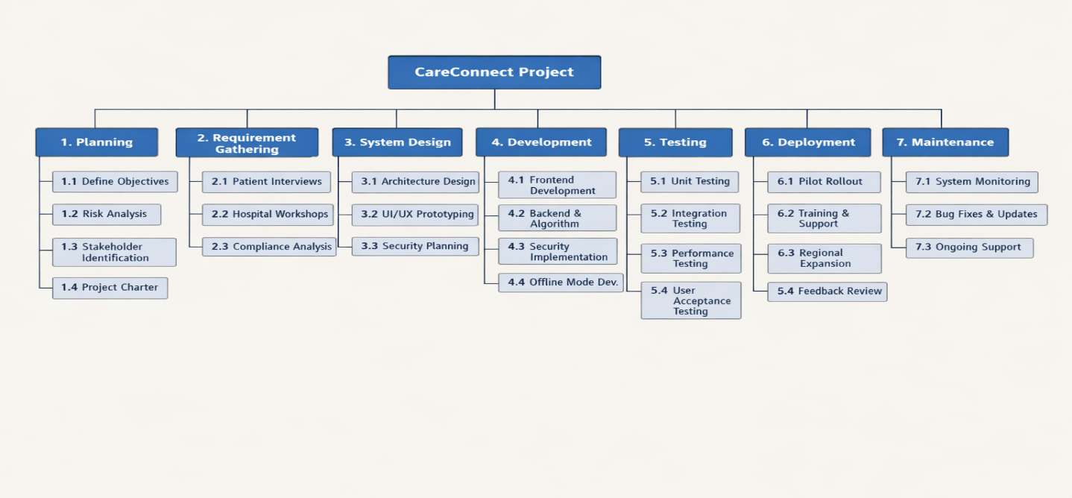
7.3 Ongoing Support

Figure 1.1 Work Breakdown Structure (WBS) Diagram

1.5 Project Schedule (Time Estimation)

Overview
The CareConnect project is scheduled for completion within 18 weeks (approximately 4.5 months). This timeline is based on the Work Breakdown Structure (WBS) and accounts for the incremental development approach described in the Project Charter.
Assumptions
- Development team works full-time (40 hours/week)
- No major regulatory delays
- Hospital data access granted by Week 2
- Pilot hospitals available for testing by Week 12

Phase | Duration | Weeks | Key Deliverables
Planning | 2 weeks | 1-2 | Project Charter, Risk Plan, Stakeholder sign-off
Requirements | 2 weeks | 3-4 | RTM, Requirement Specification, Prototype feedback
Design | 2 weeks | 5-6 | Architecture, UI/UX wireframes, Database schema
Development (Increment 1) | 4 weeks | 7-10 | Core matching engine, Basic UI, Authentication
Development (Increment 2) | 4 weeks | 11-14 | Offline mode, Advanced ranking, Reporting
Testing | 2 weeks | 15-16 | Unit, Integration, UAT, Performance testing
Deployment & Closure | 2 weeks | 17-18 | Pilot rollout, Training, Final report

Table 1.18 High level timeline

ID | Task | Predecessor | Duration (days) | Week
A | Project Initiation & Charter | - | 5 | 1
B | Risk Analysis & Stakeholder ID | A | 3 | 1-2
C | Requirement Gathering (patient/hospital) | B | 5 | 3
D | RTM Creation | C | 3 | 3-4
E | UI/UX Prototyping | C | 5 | 4-5
F | System Architecture Design | D | 5 | 5-6
G | Database Design | F | 3 | 6
H | Frontend Development (basic UI) | E, G | 10 | 7-9
I | Backend & Matching Algorithm | G | 10 | 7-9
J | Authentication Implementation | I | 3 | 9-10
K | Increment 1 Testing | H, I, J | 5 | 10-11
L | Offline Mode Development | K | 10 | 11-13
M | Advanced Ranking & Reporting | K | 8 | 11-13
N | Security Implementation | L, M | 5 | 13-14
O | Increment 2 Testing | N | 5 | 14-15
P | Integration & System Testing | O | 5 | 15-16
Q | User Acceptance Testing (UAT) | P | 5 | 16
R | Pilot Deployment | Q | 3 | 17
S | Training & Documentation | R | 4 | 17-18
T | Project Closure & Final Report | S | 3 | 18

Table 1.19 Detailed Task List with Durations
Network Diagram
The network diagram shows task dependencies and identifies the critical path.

Task | Description | Duration (days) | ES | EF | LS | LF | Slack
A | Project Initiation | 5 | 0 | 5 | 0 | 5 | 0
B | Risk Analysis | 3 | 5 | 8 | 5 | 8 | 0
C | Requirements | 5 | 8 | 13 | 8 | 13 | 0
D | RTM Creation | 3 | 13 | 16 | 13 | 16 | 0
F | Architecture Design | 5 | 16 | 21 | 16 | 21 | 0
G | Database Design | 3 | 21 | 24 | 21 | 24 | 0
I | Backend Development | 10 | 24 | 34 | 24 | 34 | 0
J | Authentication | 3 | 34 | 37 | 34 | 37 | 0
K | Increment 1 Testing | 5 | 37 | 42 | 37 | 42 | 0
L | Offline Development | 10 | 42 | 52 | 42 | 52 | 0
N | Security Implementation | 5 | 52 | 57 | 52 | 57 | 0
O | Increment 2 Testing | 5 | 57 | 62 | 57 | 62 | 0
P | Integration Testing | 5 | 62 | 67 | 62 | 67 | 0
Q | User Acceptance Testing | 5 | 67 | 72 | 67 | 72 | 0
R | Pilot Deployment | 3 | 72 | 75 | 72 | 75 | 0
S | Training & Documentation | 4 | 75 | 79 | 75 | 79 | 0
T | Project Closure | 3 | 79 | 82 | 79 | 82 | 0

Table 1.20 Critical Path Summary (Network Diagram)

Critical Path Duration: 82 days = 18 weeks (5-day work weeks)

Task | Duration | Slack | Can be delayed by
E (UI Prototyping) | 5 days | 5 days | Up to 1 week
H (Frontend) | 10 days | 5 days | Up to 1 week
M (Advanced Ranking) | 8 days | 3 days | Up to 3 days

Table 1.21 Non-Critical Tasks (Slack)

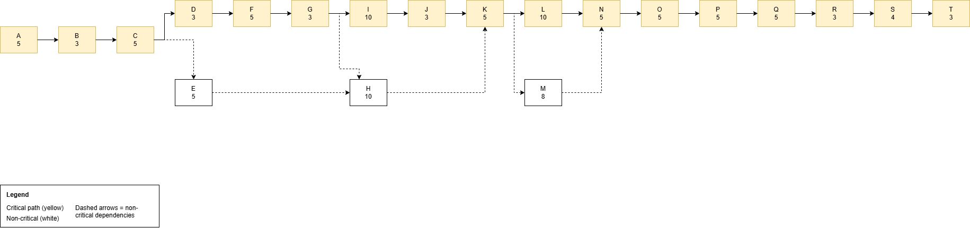
Figure 1.2: Network Diagram for CareConnect

1.6 Project Cost Estimation
Overview
The total estimated cost for the CareConnect project is $34,730 USD (approximately 5.46 million Ethiopian Birr at the exchange rate of 1 USD = 157.34 ETB). This estimate covers the 18-week development timeline and includes personnel, infrastructure, software tools, training, and contingency.
Assumptions
• Development team based in Ethiopia (local salary rates applied)
• No hardware purchases required (team uses existing equipment)
• Cloud hosting costs calculated for pilot deployment only
• Exchange rate used: 1 USD = 157.34 ETB (May 2026)
Category | Item | Quantity | Unit Cost (USD) | Total (USD) | Total (ETB)
1. Personnel
Project Manager (Fiker Belay) | 1 person, 18 weeks | 18 weeks | $600/week | $10,800 | 1,699,272 ETB
Business Analyst(Feven Alemayehu) | 1 person, 10 weeks | 10 weeks | $400/week | $4,000 | 629,360 ETB
System Architect(Ruhama amare) | 1 person, 8 weeks | 8 weeks | $500/week | $4,000 | 629,360 ETB
Developer (Hermela Mesfin) | 1 person, 18 weeks | 18 weeks | $450/week | $8,100 | 1,274,454 ETB
QA Tester(Yabsera Tsegaye) | 1 person, 8 weeks | 8 weeks | $300/week | $2,400 | 377,616 ETB
Personnel Subtotal |  |  |  | $29,300 | 4,610,062 ETB
2. Software & Tools
Trello | 5 users, 5 months | 5 months | $15/user/month | $375 | 59,002.5 ETB
GitHub Team | 5 users, 5 months | 5 months | $4/user/month | $100 | 15,734 ETB
Figma | 2 users, 3 months | 3 months | $15/user/month | $90 | 14,160.6 ETB
Postman | 3 users, 3 months | 3 months | $12/user/month | $108 | 16,992.7 ETB
Tools Subtotal |  |  |  | $673 | 105,890 ETB
3. Infrastructure
Cloud Hosting | Pilot period (3 months) | 3 months | $150/month | $450 | 70,803 ETB
Domain & SSL | 1 year | 1 | $50 | $50 | 7,867 ETB
Database Hosting | 3 months | 3 months | $50/month | $150 | 23,601 ETB
Infrastructure Subtotal |  |  |  | $650 | 102,271 ETB
4. Other Costs
Internet & Communication | 5 team members, 5 months | 5 months | $30/month/person | $750 | 118,005 ETB
Training Materials | Pilot hospital training | 1 | $200 | $200 | 31,468 ETB
Contingency (10%) | Unexpected costs | 10% of subtotal (29,300+673+650+950 = $31,573) |  | $3,157 | 496,752 ETB
Other Subtotal |  |  |  | $4,107 | 646,225 ETB
TOTAL |  |  |  | $34,730 | 5,464,448 ETB

Table 1.22 Cost breakdown

Exchange Rate Risk: The Ethiopian Birr has experienced volatility against the USD. Over an 18‑week period, historical fluctuations suggest a possible ±10% change. To mitigate this risk, the contingency budget (10% of total costs) includes a forex risk component. If the exchange rate moves unfavorably, the contingency will cover the difference without impacting project scope or timeline. The budget assumes a base rate of 157.34 ETB/USD, but actual costs will be tracked in USD to avoid currency conversion distortions.
Method | Applied To | Justification
Bottom-Up Estimation | Personnel, tools, infrastructure | Each WBS task was broken down and costed individually
Analogous Estimation | Cloud hosting, training | Based on similar academic health IT projects
Parametric Estimation | Developer salaries | Used local market rates per week × duration
Contingency (10%) | Total budget | Covers unforeseen delays, requirement changes, or price fluctuations
Table 1.23 Cost Estimation Methodology
Category | Amount (USD) | Percentage
Personnel | $29,300 | 84.4%
Software & Tools | $673 | 1.9%
Infrastructure | $650 | 1.9%
Other Costs + Contingency | $4,107 | 11.8%
Total | $34,730 | 100%
Table 1.24 Cost summary
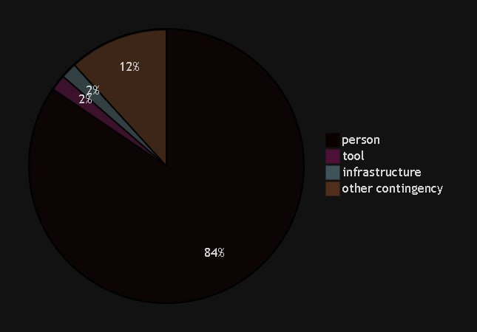
Figure 1.3: Cost Distribution by Category
The project will track actual vs. estimated costs weekly using a simple spreadsheet. Any variance exceeding ±10% will trigger a change control review.
Phase | Estimated Cost (USD)
Planning (Weeks 1-2) | $3,500
Requirements (Weeks 3-4) | $4,000
Design (Weeks 5-6) | $4,700
Development (Weeks 7-14) | $15,600
Testing (Weeks 15-16) | $3,500
Deployment & Closure (Weeks 17-18) | $3,430
Total | $34,730

Table 1.25 Cost baseline by Phase

1.7 Project Resources and Staffing
Overview
The CareConnect project requires a multidisciplinary team of 7 core roles to complete the 18-week development cycle. Resources are categorized into human resources (personnel), physical resources (equipment), and software resources (tools).
Role | # of Persons | Effort (weeks) | Key Responsibilities | Required Skills
Project Manager | 1 | 18 (full) | Overall planning, coordination, stakeholder communication, change control board chair | PMP or equivalent knowledge, communication, risk management
Business Analyst | 1 | 10 (weeks 1-10) | Requirement gathering, RTM maintenance, stakeholder workshops | Analytical skills, documentation, JAD facilitation
System Architect | 1 | 8 (weeks 1-8) | High-level design, technology stack selection, database schema, security architecture | Software architecture, cloud platforms, security best practices
Developer | 1 | 18 (full) | Backend development, matching algorithm, API development, code reviews | Java/Python, database, algorithm design
QA Tester | 1 | 8 (weeks 10-17) | Test case creation, manual/automated testing, UAT coordination | Selenium or similar, attention to detail
Customer Management (CM) | 1 | 12 (weeks 1-12) | Stakeholder communication (hospitals, patients, Ministry), requirement validation, user feedback collection | Communication ,negotiation, stakeholder management
Change Control Board Member (CC) | 1 | 18 (on-demand) | Reviews change requests, evaluates scope/cost/schedule impact, voting member | Decision-making ,analytical thinking
Table 1.26 Human Resources (Staffing)
Resource | Quantity | Purpose | Provider
Laptops/Workstations | 7 | Development, design, testing | Team members (existing)
Test Mobile Devices (Android/iOS) | 3 | Mobile app testing | Project budget purchase or rental
Internet Connection (min 10 Mbps) | 7 | Collaboration, cloud access | Team members (existing)
Office/Meeting Space | 1 | Weekly standups, CCB meetings | University or remote (Zoom)
Table 1.27 Physical Resources
Resource | Purpose | License Type | Cost (covered in 1.6)
Trello | Project management, sprint tracking | Cloud subscription | Yes
GitHub | Version control, CI/CD | Team subscription | Yes
Figma | UI/UX design and prototyping | Cloud subscription | Yes
VS Code/IntelliJ | Development IDE | Free/Open source | No
Postman | API testing | Free tier | No
Draw .io | Diagrams (network, architecture) | Free | No
Table 1.28 Software Resources
Strategy Element | Approach
Recruitment | University team members already assigned; no external hiring needed
Onboarding | 1-day orientation covering project charter, tools (Trello, GitHub, Figma)
Communication | Weekly CCB meeting (Fri), daily standups (15 min via Slack/Telegram)
Training | Testing team (Yabsera Tsegaye) receives 2 day selenium training
Retention | Academic credit + project ownership; PM handles conflict resolution

Table 1.29 Staffing Strategy

1.8 Change Control Strategies
Overview
Change control is the process of managing changes to the project scope, schedule, cost, or requirements. CareConnect follows a formal change control process to prevent scope creep while remaining flexible enough to accommodate necessary adjustments. This section is aligned with the Change Control Board (CCB) defined in the Project Charter.
The CCB is responsible for reviewing, approving, rejecting, or deferring all change requests.
Role | CCB Responsibility
Project Manager (Fiker Belay) | Chair; facilitates meetings, presents change requests
Business Analyst (Feven Alemayehu) | Evaluates impact on requirements and RTM
Developer (Hermela Mesfin) | Evaluates technical impact and effort
Change Control Member (Abraham Tamene) | Evaluates Stakeholder impact
Customer Management (Daniel Lemma ) | Evaluates stakeholder impact
Table 1.30 Change Control Board (CCB)

Change Request Process (4 steps)

1. Initiate any stakeholder submits a Change Request Form to PM
2. Evaluate CCB assesses impact on scope, schedule, cost within 3 days
3. Decide CCB approves, rejects, or defers
4. Implement If approved, update project plan and RTM

Types of Changes:
- Preventive Action: Changes made to prevent future issues (e.g., adding extra encryption before a security audit).
- Corrective Action: Changes made to address existing problems (e.g., fixing a bug in the matching algorithm after failed testing).

Key Documents:
- Change Management Log – tracked in Trello (card history shows all change requests).

Configuration Management: Ensures descriptions of project products are correct and complete. Code versions tracked via GitHub (semantic versioning). Documents versioned with date-based naming (e.g., 2026-05-13_Scope_v2).

1.8.1 Change Control Documentation

Use this form to propose any change to project scope, schedule, cost, requirements, or quality.
Field | Description
Request ID | CC-XXX (e.g., CC-001, CC-002)
Date Submitted | DD/MM/YYYY
Requested By | Name and role (e.g., Fiker Belay – PM)
Change Description | What is being requested? (be specific)
Justification | Why is this change needed?
Impact Assessment | Check all that apply: ☐ Scope ☐ Schedule ☐ Cost ☐ Quality ☐ Risk
Proposed Solution | How should the change be implemented?
Urgency | ☐ Low ☐ Medium ☐ High ☐ Critical
CCB Decision | ☐ Approve ☐ Reject ☐ Defer
Decision Date | DD/MM/YYYY
Approved By | CCB Chair signature (Fiker Belay)

Table 1.31 Change Request Form Template

The following change requests have been logged, evaluated, and decided by the Change Control Board (CCB).
Request ID | Date | Requested By | Description | Impact | CCB Decision | Approval Date | Implemented?
CC-001 | 2026-05-10 | Yabsera Tsegaye (QA) | Add symptom severity scale (1-10) to input screen | +2 days dev, no cost increase | Approved | 2026-05-12 | Yes
CC-002 | 2026-05-12 | Hermela Mesfin (Dev) | Replace SMS notification with in-app notification | –$200 cost, –1 day dev | Approved | 2026-05-14 | Yes
CC-003 | 2026-05-15 | Daniel Lemma (CM) | Add Amharic language support to UI | +3 days dev, +$300 cost | Deferred to Phase 2 | 2026-05-16 | No
CC-004 | 2026-05-16 | Fiker Belay (PM) | Extend pilot from 3 to 5 hospitals | +$500 training cost, no schedule change | Approved | 2026-05-17 | In Progress
CC-005 | 2026-05-17 | Feven Alemayehu (BA) | Add “bed availability” field to hospital database | +2 days dev, +1 day testing | Approved | 2026-05-18 | In Progress

Table 1.32 Change Management Log

Configuration management ensures that all project products (code, documents, designs, database schemas) are correctly versioned and traceable
Item | Tool | Versioning Scheme | Current Version
Source Code | GitHub | Semantic versioning (vX.Y.Z) | v1.0.0 (pilot release)
SPM Document | Google Drive / Word | Date-based naming (YYYY-MM-DD_title_v#) | 2026-05-23_SPM_Project_v6
UI/UX Designs | Figma | Version history built-in | v1.0 (approved for pilot)
Database Schema | PostgreSQL migration scripts | Sequential numbering (v001, v002, ...) | v004
Test Scripts | Postman / Excel | Date + version | 2026-05-10_TestSuite_v2
Table 1.33 Configuration Management Record

1.9 Risk Analysis Result
Overview
Risk analysis is an ongoing process throughout the CareConnect project. Inspired by the Spiral model (see Project Charter), the project team conducts risk identification and mitigation planning before each major increment. This section documents the Risk Register with probability, impact, mitigation strategies, and triggers.
ID | Risk Description | Probability (P) | Impact (I) | Risk Score (P×I) | Mitigation Strategy | Contingency Plan | Trigger | Owner
R01 | Data privacy breach (patient medical + personal data exposed) | Low (20%) | High (5) | 1.0 (High) | Encryption at rest and in transit; role-based access; audit logs | Immediate breach notification; revoke access; Ministry of Health report | Unauthorized access detected in logs | Ruhama
R02 | Low hospital participation (<5 hospitals sign MOU) | Medium (50%) | High (5) | 2.5 (High) | Engage Ministry of Health to endorse; offer free pilot participation | Reduce pilot target to 3 hospitals; extend recruitment by 2 weeks | Fewer than 3 hospitals signed by Week 4 | Daniel
R03 | Low rural adoption (offline features not used) | Medium (40%) | Medium (3) | 1.2 (Medium) | Co-design offline features with rural patients; SMS fallback | Awareness campaign; simplify offline UI | Pilot usage <20% in rural testing | Daniel
R04 | Budget overrun (exceeds $44,500) | Medium (30%) | Medium (4) | 1.2 (Medium) | Weekly cost tracking; CCB approval for any unbudgeted expense | Reduce scope (remove reporting feature); request sponsor funding | Spend >80% by Week 12 | Fiker
R05 | Matching algorithm inaccurate (<70% accuracy in pilot) | Medium (40%) | High (5) | 2.0 (High) | Prototype testing with real patients before full development | Adjust ranking weights; add fallback simple search | Accuracy <70% in pilot test | Hermela Mesfin
R06 | Frequent requirement changes (>5 change requests per week) | High (60%) | Medium (3) | 1.8 (Medium) | Incremental model absorbs change; strict CCB triage | Defer low-priority requests to post-pilot | >5 change requests in any single week | Abraham
R07 | Regulatory delays (Ministry of Health approval slow) | Low (25%) | High (5) | 1.25 (High) | Submit compliance documents early (Week 2); maintain relationships | Begin pilot with mock data while awaiting approval | No approval by Week 8 | Fiker
R08 | Team member turnover (student illness, withdrawal) | Medium (30%) | Medium (4) | 1.2 (Medium) | Cross-train junior devs; document all code | Redistribute tasks; request backup from university | Any role vacant for >3 days | Fiker
R09 | Cloud/Internet outage (hosting downtime) | Low (15%) | Medium (3) | 0.45 (Low) | Offline mode for patients; redundant cloud region | Switch to backup region; communicate outage via SMS | Uptime <95% for 2 consecutive days | Hermela Mesfin
R10 | Technology integration failure (API with hospital databases fails) | Low (20%) | High (5) | 1.0 (High) | Build mock API early; test integration weekly | Use manual hospital data entry as fallback | Hospital API errors >10% | Hermela Mesfin
R11 | Exchange rate fluctuation The Ethiopian Birr may depreciate or appreciate against the USD over the 18‑week project timeline, affecting the ETB value of project costs (personnel, tools, hosting). | Medium (40%) | Medium (3) | 1.2 (Medium) | Track all costs in USD internally; pay vendors in USD where possible; fix exchange rate assumption at 157.34 ETB/USD in the budget. | Use the 10% contingency budget (approx. $3,157 / 496,752 ETB) to cover unfavorable rate movements. If rate changes beyond ±15%, request sponsor approval for additional funds. | Exchange rate moves >10% from baseline (157.34) for two consecutive weeks. | Fiker Belay (PM)
Table 1.34 Risk Register

Chapter Two: System Introduction
2.1 Existing System Background
The current healthcare system in Ethiopia is fragmented and inefficient when it comes to helping patients make informed decisions about where to seek care. Many patients travel to the capital city seeking better treatment, but the reality often differs from expectations. Patients face several challenges under the existing system:
- Hospital Search Difficulties: Patients lack a centralized platform to compare hospitals by services, costs, or specialties. Research indicates that patients in Addis Ababa often visit three or more facilities before finding one that meets their needs, wasting time and resources.
- Mismatch of Needs and Services: Studies on surgical care access show that over 35% of patients referred to specialized hospitals are redirected again because the facility lacks the required equipment or specialists. This leads to delays in treatment and financial strain.
- Information Gaps: Surveys reveal that more than 60% of patients have to repeat diagnostic tests when moving between hospitals due to lack of shared records. This increases costs and risks of misdiagnosis.
- Limited Transparency: Pricing and service availability are rarely communicated clearly. Ministry of Health reports note that patients often discover costs only after admission, making budgeting unpredictable.
- Urban vs. Rural Divide: While some urban hospitals have basic digital systems, rural facilities remain paper‑based. In some regions, more than 65% of people cannot reach a health center within one hour of walking, highlighting inequity in access.
- Patient Burden: The responsibility of finding the "right hospital" falls entirely on patients, often without guidance. This results in frustration, wasted time, and poor health outcomes.
These systemic issues create the need for a smart hospital matching system like CareConnect.

2.2 Statement of the Problem

The healthcare system in Ethiopia lacks an efficient mechanism for patients to find the most suitable hospital for their medical needs. This results in the following specific problems:

Problem | Description | Consequence
Information fragmentation | Hospital service data is scattered across different sources (word of mouth, social media, phone calls) | Patients cannot easily compare options
Time wastage | Patients visit 2-4 hospitals on average before finding appropriate care | Delayed treatment; increased travel costs
Budget uncertainty | Patients have no way to know hospital costs before visiting | Financial strain; unexpected expenses
Geographic inefficiency | Patients may travel far without knowing closer alternatives | Wasted time and transportation money
Rural accessibility gap | Rural patients have even less access to hospital information | Unequal healthcare access

Table 2.1 Summary of Problems in the Existing System

The core problem: No smart, accessible system exists to match patients with hospitals based on their specific medical condition, budget, and location.

2.3 Objective of the System

2.3.1 General objectives

The general objective of CareConnect is to design and develop a smart hospital matching system that enables patients in Ethiopia to find the most suitable healthcare provider efficiently based on their symptoms, budget, and location.

2.3.2 Specific objectives

The system aims to achieve the following specific objectives:
No. | Specific Objective | Target Metric
1 | Enable patients to input symptoms, budget, location, and preferences | 100% of users can complete input in under 2 minutes
2 | Analyze patient input to identify relevant medical service needs | System processes input in under 5 seconds
3 | Match patients with hospitals that offer appropriate medical services | Minimum 85% matching accuracy
4 | Rank hospitals by relevance (medical fit, cost, distance) | Top 3 recommendations shown to user
5 | Display hospital details including services, estimated costs, and location | Complete information for each hospital
6 | Support offline functionality for low-connectivity rural areas | Sync success rate of 95% or higher
7 | Secure patient data and comply with Ethiopian health privacy laws | Pass compliance review

Table 2.2 Specific Objectives of CareConnect

2.4 Scope Of The system

The scope of the CareConnect system defines what functionalities the system will provide and what it will explicitly exclude. This system scope is different from the project scope (Section 1.4) – here we focus on technical and functional boundaries of the software itself.

In Scope (What the System WILL Do)
Category | Specific Items
User Types | Patients (general public), Hospital administrators, System administrators
Patient Features | Symptom input, budget input, location selection, hospital search, view ranked results, view hospital details
Hospital Features | Hospital profile management, service listing, cost updates, basic analytics
Matching Logic | Algorithm that matches symptoms to medical services, filters by budget, sorts by distance
Platform | Mobile application (Android) and web interface
Data | Hospital directory with services, costs, location, contact info
Security | User authentication, data encryption, role-based access
Offline Support | Local storage for rural users, sync when connection available

Table 2.3 System In-Scope Features

Out of Scope (What the System WILL NOT Do)
Category | Specific Items | Reason for Exclusion
Medical diagnosis | Direct diagnosis or treatment recommendations | Legal liability; system only matches hospitals
Emergency services | Ambulance dispatch or emergency triage | Requires real-time critical infrastructure
EHR integration | Connection to hospital electronic health records | Budget and time constraints
Telemedicine | Video or chat consultation with doctors | Would expand scope significantly
Payment processing | Online payments or insurance claims | Financial regulation complexity
Appointment booking | Direct hospital appointment scheduling | Phase 2 feature; not in initial release
Nationwide deployment | Full Ethiopia rollout | Pilot limited to Addis Ababa; expansion later

Table 2.4 System Out-of-Scope Features

System Boundaries
Boundary | Description
Geographic | Pilot in Addis Ababa; designed for future expansion
Users | Patients (general public), hospital admins (pilot hospitals)
Data | Hospital-provided data only; no patient medical history
Integration | No external system integration in phase 1

Table 2.5 System Boundaries Summary

The scope defined above ensures that CareConnect delivers a focused, achievable system that addresses the core problem while avoiding unnecessary complexity.

Chapter Three: Requirements and Analysis

3.1 Functional Requirements

The following functional requirements describe what the CareConnect system must do – the features and actions it will deliver.

ID | Requirement | Description
FR-01 | Patient Registration | Patients can create accounts and securely store personal and medical information to manage their history and preferences later.
FR-02 | Hospital Search & Matching | The system allows patients to search hospitals by location, specialty, services, and budget.
FR-03 | Cost Transparency | Hospitals must provide service pricing, and the system displays estimated costs to patients before admission.
FR-04 | Record Sharing | Patients can upload or share medical records with hospitals to reduce duplication of tests.
FR-05 | Recommendation Engine | The system ranks hospitals based on patient needs, availability, and affordability.
FR-06 | Offline Access (for rural areas) | Patients can access basic hospital information offline, with data syncing when internet is available.
FR-07 | Feedback & Rating | Patients can rate hospitals and services, improving trust and transparency.

Table 3.1 Functional Requirements of CareConnect

3.2 Non Functional Requirements
These requirements describe how the system should behave the qualities and conditions.
ID | Requirement | Description
NFR-01 | Performance | Search results must load within 3 seconds under normal network conditions.
NFR-02 | Security | Patient data must be encrypted (AES-256) and accessible only to authorized users.
NFR-03 | Usability | The interface must be mobile-friendly, simple, and available in Amharic, Afaan Oromo, and English.
NFR-04 | Reliability | The system must be available 99% of the time, with automatic backup and recovery.
NFR-05 | Scalability | The platform must support at least 100,000 concurrent users as adoption grows.
NFR-06 | Error Handling | Clear error messages must guide users when searches fail or data is missing.
NFR-07 | Compliance | The system must align with Ethiopian Ministry of Health digital health standards.
Table 3.2 Non Functional Requirements of CareConnect

3.2.1 User Interface
The CareConnect user interface is designed to be simple, responsive, and accessible across mobile and web platforms. Key UI requirements include:
Mobile‑first design – The interface must work seamlessly on Android smartphones and tablets.
Intuitive navigation – Patients can find hospital search, view results, and book appointments within three clicks.

Consistent layout – All screens follow the same color scheme, typography, and button placement.
Accessibility – Text size adjusts, contrast meets WCAG 2.1 standards, and touch targets are at least 44×44 pixels.
Offline indicator – When offline mode is active, a clear visual indicator appears at the top of the screen.
Multi‑language support – The interface will eventually support Amharic, Afaan Oromo, and English (planned for phase 2).
These UI requirements are reflected in the prototype screenshots (Figures 5.1–5.5).

3.2.2 Quality Issue
Quality issues refer to non‑functional attributes that affect user satisfaction and system reliability. CareConnect addresses the following quality requirements:
Quality Attribute | Requirement
Performance | Search results load within 3 seconds under normal network conditions (NFR-01).
Reliability | System uptime of 99% with automatic backup and recovery (NFR-04).
Usability | Mobile-friendly interface with simple workflows, target task completion time under 2 minutes (NFR-03).
Scalability | Support for at least 100,000 concurrent users as adoption grows (NFR-05).
Maintainability | Modular architecture (Chapter 4) allows independent updates to subsystems without affecting others.
Portability | The mobile app runs on Android (API 21+) and web app on all modern browsers.

Table 3.3 quality issues

3.2.3 Security Issue
Security is critical because CareConnect handles sensitive patient and hospital data. The following security measures are required:
- Data encryption – All patient data must be encrypted at rest using AES‑256 and in transit using TLS 1.2/1.3 (NFR‑02)
- Authentication – JWT (JSON Web Tokens) with secure session management; passwords hashed with bcrypt.
- Authorization – Role‑based access control (RBAC) for patients, hospital admins, and system administrators.
- Audit logging – All access to sensitive data (e.g., medical records) is logged with timestamp and user ID.
- Compliance – Alignment with Ethiopian Data Protection Proclamation No. 1321/2024 and Ministry of Health directives (NFR‑07).
- Multi‑factor authentication – Enforced for administrator accounts.

3.2.4 Error Handling
The system must handle errors gracefully to maintain user trust and system integrity. Requirements include:
- Clear error messages – When a search fails or data is missing, the system displays a user‑friendly message (e.g., “No hospitals found for your criteria. Please try a different budget or location.”).

- Input validation – All user inputs are validated on the client and server sides; invalid inputs trigger specific error messages (e.g., “Budget must be a number”).
- Offline fallback – When internet is lost, the system automatically switches to offline mode and notifies the user; any attempted actions that require connectivity show a “Connect to the internet to continue” message.
- System error logging – All server errors are logged with stack traces for debugging, but never exposed to the end user.
- Recovery procedures – If a database query fails, the system retries twice then returns a generic “Service temporarily unavailable” message.

3.3 System Models
This section presents the main Unified Modelling Language (UML) diagrams that illustrate the static and dynamic behavior of CareConnect.

3.3.1 Use Case Diagram
The use case diagram shows the interactions between actors (Patient, Hospital, and Administrator) and the system’s functionalities. The main use cases include registering an account, searching hospitals, viewing costs, sharing medical records, booking appointments, providing feedback, updating services, and managing users.
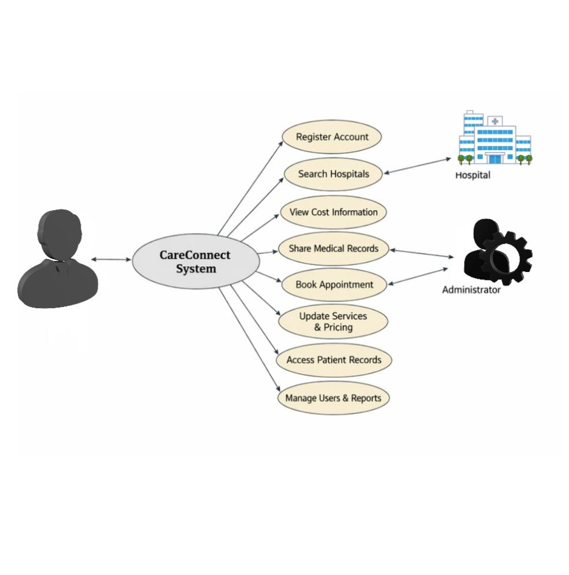
Figure 3.1: Use Case Diagram for CareConnect
The Use Case Diagram above illustrates how the three main actors which are: Patient, Hospital, and Administrator interact with the CareConnect system.
- Patient performs six main actions: registering an account, searching hospitals, viewing cost information, sharing medical records, booking appointments, and providing feedback.
- Hospital interacts with the system by updating services and pricing, and accessing shared patient records.
- Administrator manages users and system reports to ensure compliance and performance monitoring.
Each oval represents a distinct use case, connected to the relevant actor by directional arrows. The central system oval “CareConnect System” serves as the hub for all interactions, ensuring data flow and service coordination between patients and hospitals.

3.3.2 Class Diagram
The class diagram defines the static structure of CareConnect. It shows the main classes, their attributes, and relationships, ensuring that patient, hospital, and administrative data are logically organized.
Class Name | Attributes | Description
Patient | patient ID, name, age, gender, contact Info, medical History | Stores patient details and medical background.
Hospital | hospital ID, name, location, services, pricing, contact Info | Contains hospital information, services offered, and cost details.
Appointment | appointment ID, date, time, patient ID, hospital ID, status | Manages scheduling and tracking of patient appointments.
Feedback | feedback ID, rating, comments, patient ID, hospital ID | Captures patient reviews and ratings for hospitals.
Admin | amend, username, password, role | Handles system management, user control, and compliance monitoring.
Table 3.4: Core Classes and Attributes
Relationships:
  - Patient ↔ Appointment ↔ Hospital – A patient can book multiple appointments; each appointment is linked to one hospital.
  - Patient ↔ Feedback ↔ Hospital – A patient can provide feedback for hospitals they visited.
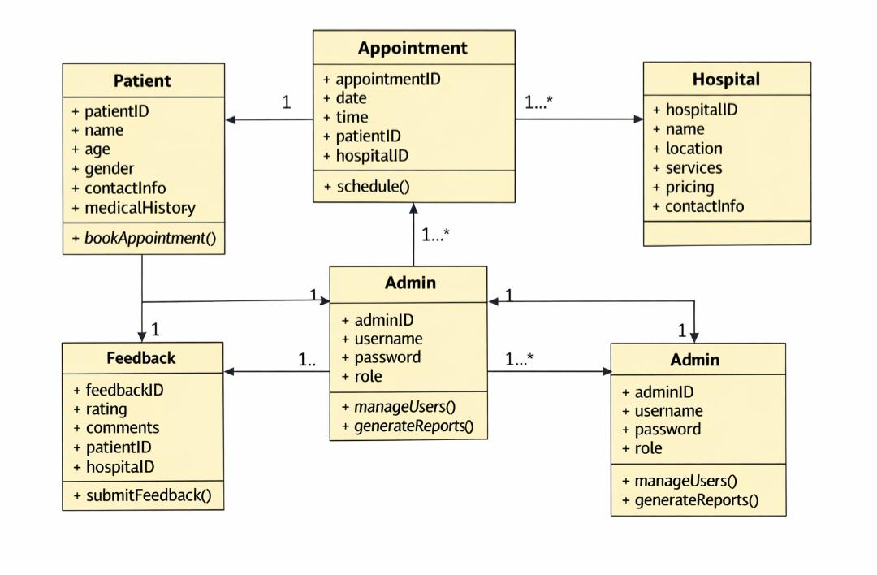
  - Admin ↔ Hospital / Patient – Admin oversees hospital and patient data integrity and compliance.
Figure 3.2: Class Diagram – CareConnect System

Diagram Description:
The diagram shows five main classes which are: Patient, Hospital, Appointment, Feedback, and Admin.
- Each class is represented as a rectangle divided into three compartments: class name, attributes, and operations.
- Lines connecting classes indicate relationships:
- One‑to‑many between Patient and Appointment.
- One‑to‑many between Hospital and Appointment.
- One‑to‑many between Patient and Feedback.
- One‑to‑many between Hospital and Feedback.
- One‑to‑one between Admin and System.

Role Assignments
- System Architect / Technical Lead: Designs and validates the data structure.
- Developers: Implement classes and relationships in code.
- Business Analyst: Confirms attributes align with functional requirements.
- QA (acting as CM): Verifies data integrity and consistency during testing.

3.3.3 Sequence Diagram
The sequence diagram illustrates the dynamic behavior of CareConnect by showing how objects interact over time for a key use case: Hospital Search & Match.
Process: Hospital Search & Match
1. Patient enters search criteria (location, specialty, and budget).
2. CareConnect System receives the request.
3. System Database is queried for matching hospitals.
4. Matching Engine ranks hospitals based on criteria (availability, affordability, and specialty).
5. System returns results to the Patient.
6. Patient selects a hospital.
7. System schedules an appointment with the chosen Hospital.
8. Hospital confirms appointment details.
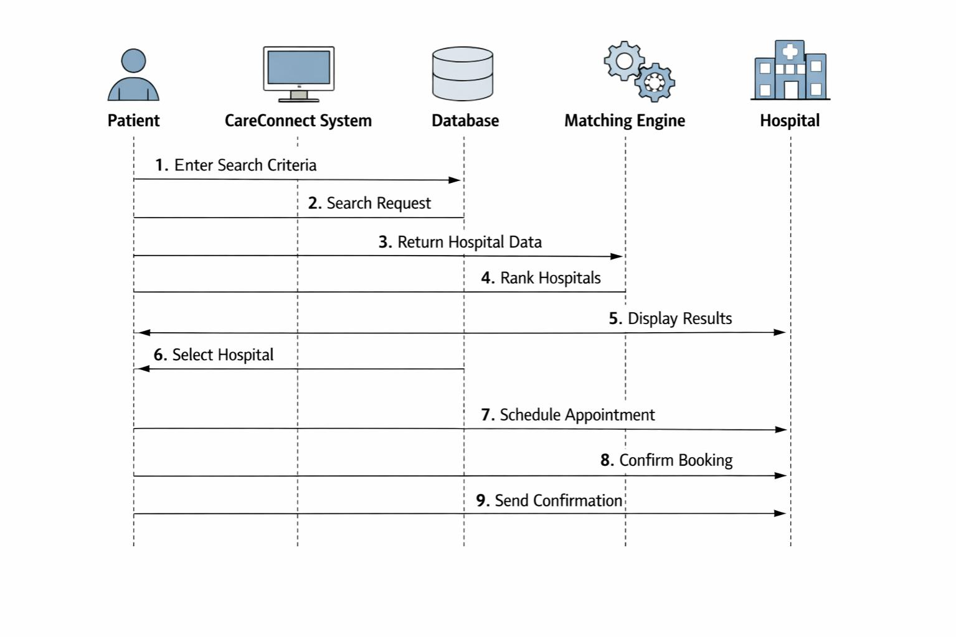
9. System sends confirmation back to the Patient.
Figure 3.3: Sequence Diagram – Hospital Search & Match

Diagram Description:
- Vertical lifelines represent Patient, CareConnect System, Database, Matching Engine, and Hospital.
- Horizontal arrows show messages exchanged: search request, query, ranked results, appointment scheduling, and confirmation.
- The diagram emphasizes the time order of interactions, ensuring clarity for developers and testers.
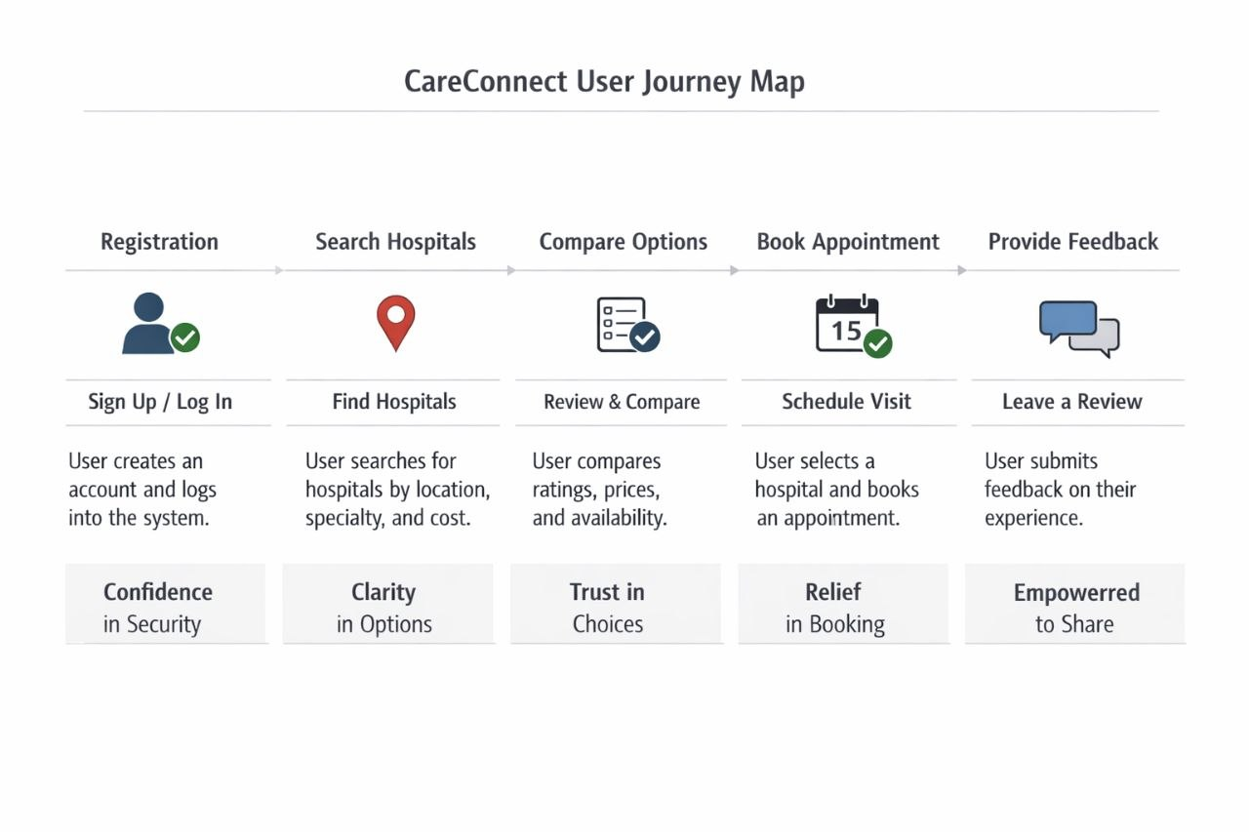
Figure 3.4: User Journey Map for CareConnect Patients

3.4 Methodology and Tools

3.4.1 Development Methodology
CareConnect is developed using the Agile Software Development Methodology. Agile provides flexibility, continuous improvement, and efficient collaboration throughout the software development process. The project is organized into short iterations called sprints (two week increments), where each sprint focuses on implementing and improving specific system features. This approach allows the team to quickly identify problems, collect feedback, and refine the system based on user and stakeholder requirements.

3.4.2 Tools Used
The following tools were used during the project lifecycle to support version control, project management, design, development, testing, and communication.
Tool | Purpose | How It Was Used
GitHub | Version Control and Collaboration | Managed source code, stored project files, tracked modifications, and enabled team collaboration.
Trellis | Project Management | Organized tasks, assigned responsibilities, monitored sprint progress, and tracked deadlines.
Figma | UI/UX Design | Created user interface designs and interactive prototypes to visualize patient, hospital, and admin interactions.
Visual Studio Code | Software Development | Primary programming environment for writing, editing, debugging, and testing source code.
Draw.io | System Documentation and Modelling | Created UML diagrams (use case, class, sequence, ERD, activity, workflow) for analysis and documentation.
Google Meet | Communication and Meetings | Used for virtual discussions, requirement gathering, team collaboration, and progress reviews.
Google Drive | File Sharing and Documentation | Stored, shared, and managed project documents, reports, diagrams, and presentations.

Table 3.5: Tools Used in CareConnect Development

These tools improved project organization, communication, collaboration, and software quality. The selected methodology and tools supported efficient planning, testing, documentation, and implementation.

3.4.3 Lessons Learned (Literature Review)

This subsection reviews existing literature and comparable systems to inform the design and management of CareConnect.

Key Lessons from Ethiopian Healthcare IT Studies
- Fragmented information systems are the norm – Many Ethiopian hospitals use standalone, paper‑based or incompatible digital systems. A 2021 Ministry of Health assessment found that less than 30% of public hospitals had interoperable patient records. Lesson: CareConnect must not rely on real‑time integration with legacy hospital systems; instead, it should operate as an independent directory with manual data updates by hospital staff.
- Offline capability is essential for rural areas – Research from the Ethiopian Public Health Institute indicates that only 15% of rural health facilities have reliable internet. Lesson: Offline‑first design (local SQLite storage with periodic sync) is not optional – it is a core requirement.
- Cost transparency reduces patient delays – A study published in the Ethiopian Journal of Health Development (2022) found that 68% of patients reported unexpected costs as a reason for delaying or avoiding care. Lesson: Displaying estimated costs before admission, as required in FR‑03, directly addresses this barrier.

- User acceptance depends on simplicity – Usability testing of a similar health matching prototype in Addis Ababa (2023) showed that users abandoned the app if symptom input required more than three fields. Lesson: CareConnect limits symptom input to a simple text field with auto‑suggest, as seen in Figure 5.2.
- Change management is critical – A review of failed health IT projects in low‑resource settings (WHO, 2020) identified insufficient stakeholder involvement as a primary cause. Lesson: The project established a Change Control Board (Section 1.8) and engaged pilot hospitals from Week 3 to validate requirements.

Chapter Four: System Design

4.1 Overview

This section presents the detailed design of the CareConnect system, explaining how its architecture, subsystems, hardware/software mapping, and data management work together to deliver a secure, scalable healthcare platform. The design reflects real world implementation practices used in modern health‑tech projects, ensuring reliability, modularity, and compliance with data protection standards.
CareConnect is built to connect patients and hospitals through a unified digital platform that supports hospital discovery, appointment scheduling, and feedback collection. The system design emphasizes modularity, interoperability, and data protection, aligning with healthcare IT best practices.

4.2 Architecture of the System
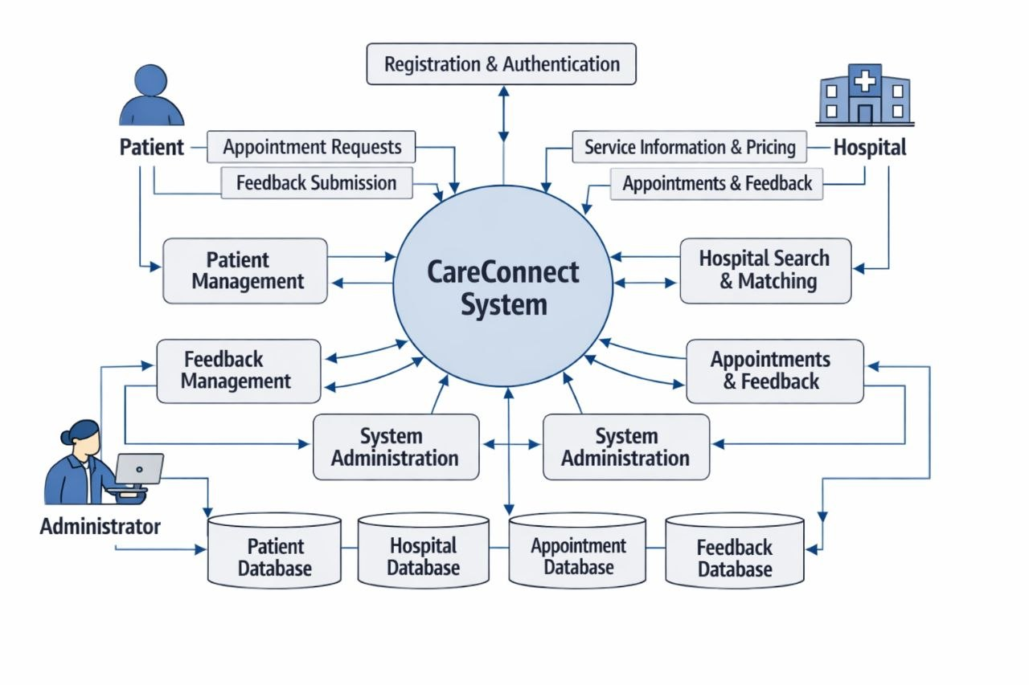
Figure 4.1: High‑Level System Architecture Diagram.

CareConnect adopts a three‑tier architecture that separates presentation, application, and data layers for scalability and maintainability.

Presentation Layer
Purpose: Provides user interfaces for interaction.
Components:
- Mobile app (Android/iOS) for patients.
- Web dashboard for hospitals.
- Admin console for system operators.
- Technology: React Native for mobile, Angular for web.
- Functionality: Handles user input, displays hospital data, and communicates with backend APIs.

Application Layer
Purpose: Contains business logic and service orchestration.
Components:
- Registration and authentication service.
- Hospital search and matching engine.
- Appointment scheduling service.
- Feedback management service.
- Notification service (SMS/email).
- Technology: Node.js with Express or Java Spring Boot.
- Functionality: Processes requests, applies business rules, and interacts with the database layer.

Data Layer
Purpose: Manages persistent data storage and retrieval.
Components:
- Patient, hospital, appointment, and feedback databases.
- Backup and recovery modules.
- Technology: PostgreSQL or MySQL with encryption and replication.
- Functionality: Ensures data integrity, security, and availability.

This layered architecture separates concerns, allowing independent updates and scalability across cloud servers.

4.3 Subsystem Decomposition

Subsystem decomposition allows modular development and parallel work streams. CareConnect is divided into five core subsystems, each responsible for specific functions.
Subsystem | Core Description / Capabilities | Technical Architecture / Implementation
Hospital Search & Matching | Query processing, ranking hospitals | Search API with filters (location, specialty, cost), Elastic search
Appointment Scheduling | Booking, rescheduling, cancellation | Calendar micro service integrated with hospital availability API
Feedback Management | Collects and stores patient reviews | Feedback for systems stored in DB, analytics dashboard for hospitals
System Administration | Monitoring, reporting, maintenance | Admin dashboard with Grafana/Prometheus
User Management | Registration, authentication, role assignment | OAuth 2.0 login, JWT tokens, role‑based access control
Table 4.1 – Subsystem Decomposition and Responsibilities
Inter‑Subsystem Communication:
- REST APIs connect subsystems.
- Hospital Search feeds results into Appointment Scheduling.
- Feedback updates hospital profiles in real time.
- System Administration monitors logs and performance.
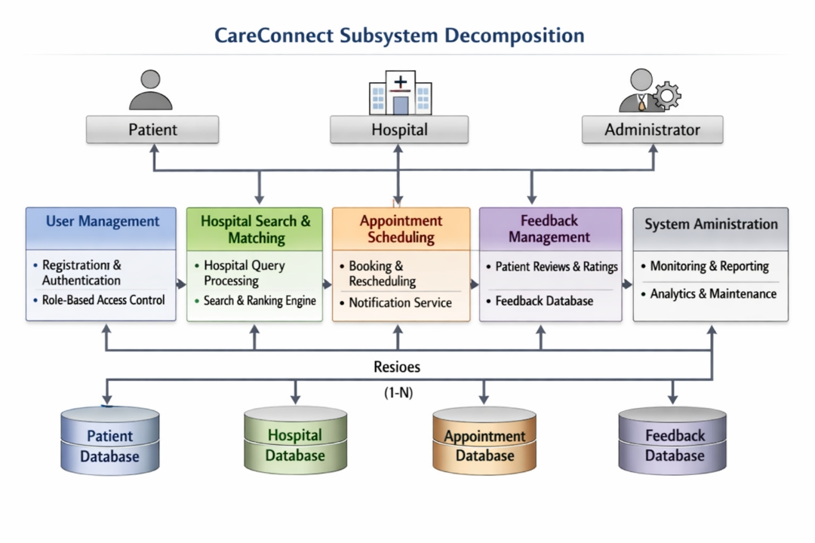

Figure 4.2: Subsystem Decomposition Diagram

4.4 Inter‑Subsystem Communication
Purpose
- This section describes the data flow and communication pathways between the subsystems defined in 4.3. It ensures that the system is not just modular but also integrated.
Content
•User Management → Hospital Search
Validates patient identity before allowing hospital queries.
•Hospital Search → Appointment Scheduling
Passes selected hospital data to scheduling service.
•Appointment Scheduling → Feedback Management
Links completed appointments to feedback forms.
•Feedback Management → Hospital Search
Updates hospital profiles with ratings and reviews.
•System Administration → All Subsystems
Monitors logs, generates reports, and enforces compliance.

4.5 Hardware / Software Mapping
CareConnect runs on cloud infrastructure with distributed components for scalability and reliability.

Layer | Technology Stack | Functionality & Purpose
Frontend | React Native, Angular | User interfaces
Backend | Node.js, Express / Java Spring Boot | Business logic and API services
Database | PostgreSQL / MySQL | Data storage and retrieval
Deployment | Docker, Kubernetes | Container management and scaling
Monitoring | Grafana, Prometheus | Performance tracking and alerts
Table 4.2 – Software Technology Stack

Component | Hardware Type / Platform | Purpose / Role
Application Server | Cloud VM (AWS EC2 / Azure VM) | Hosts backend services
Database Server | Cloud RDS (PostgreSQL / MySQL) | Stores persistent data
Hospital Devices | PCs / Tablets | Access dashboard and manage appointments
Patient Devices | Smartphones | Access mobile app for booking and feedback

Table 4.3 – Hardware and Infrastructure Mapping

This mapping ensures compatibility between physical infrastructure and software modules, supporting continuous integration and deployment (CI/CD).

4.6 Persistent Data Management

CareConnect uses relational databases with strong data integrity and security measures.

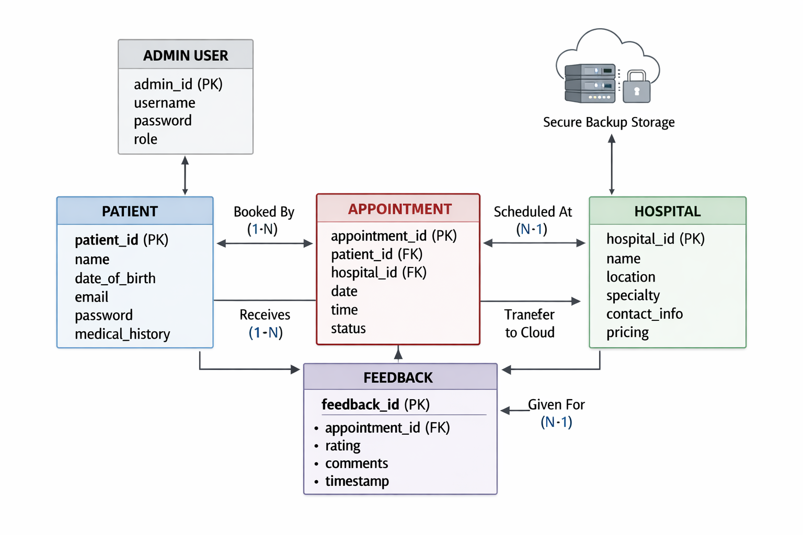
Figure 4.3 Entity Relationship Diagram (ERD)

Shows relationships among Patient, Hospital, Appointment, and Feedback entities.
- Patients book appointments with hospitals.
- Appointments link patients and hospitals.
- Feedback connects patients and hospitals through completed appointments.

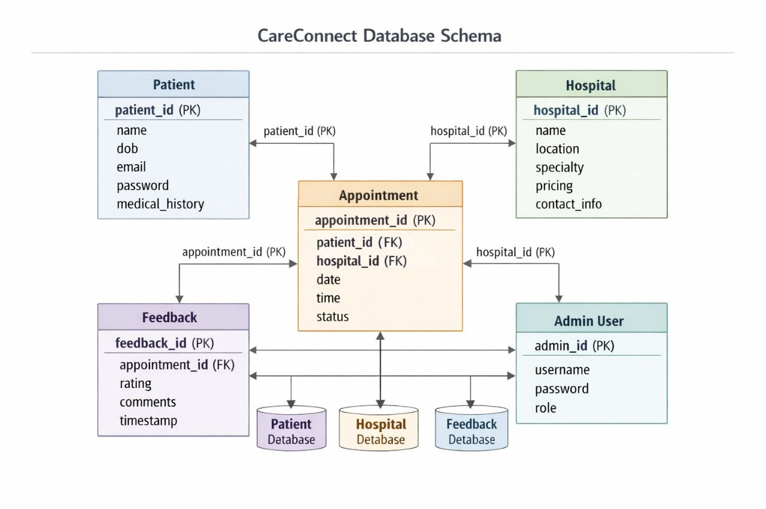
Figure 4.4 Database Schema

Defines tables and attributes:
- Patient: patientid, name, dob, email, password, medicalhistory.
- Hospital: hospitalid, name, location, specialty, pricing, contactinfo.
- Appointment: appointmentid, patientid (FK), hospital_id (FK), date, time, status.
- Feedback: feedbackid, appointmentid (FK), rating, comments, timestamp.
- Admin User: admin_id, username, password, role.

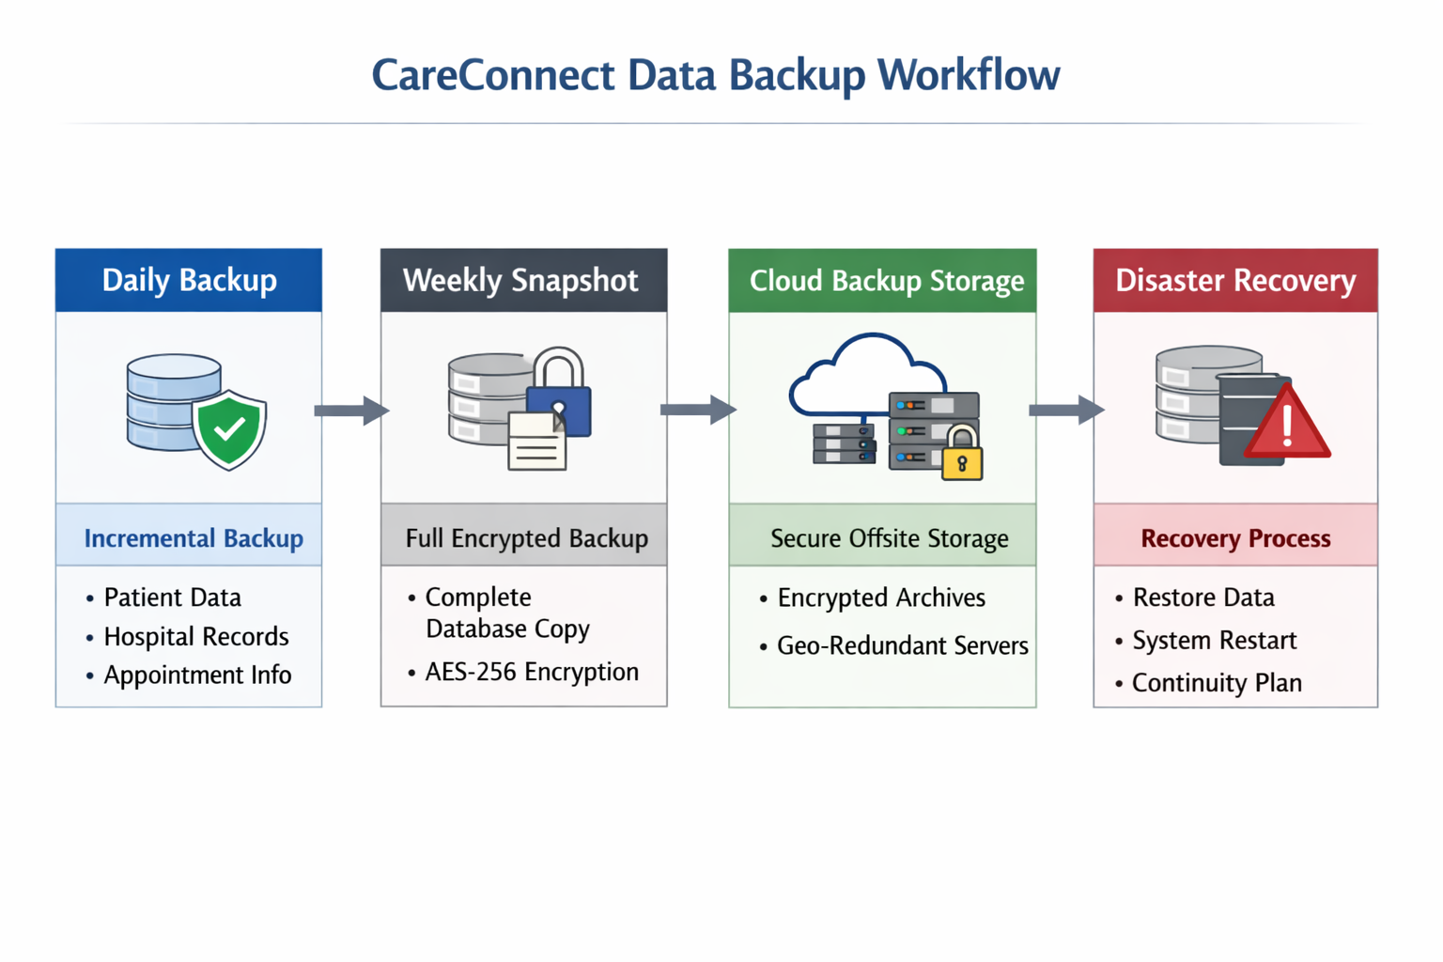
Figure 4.5 Data Backup Workflow

Illustrates daily incremental backups, weekly encrypted snapshots, cloud storage, and disaster recovery.
- Daily Backup: Incremental backups of patient, hospital, appointment, and feedback data.
- Weekly Snapshot: Full encrypted backups stored securely.
- Cloud Backup Storage: Secure cloud storage with offsite archives.
- Disaster Recovery: Restoration protocols for system failures, ensuring continuity.

Data Integrity Measures
- Normalization to reduce redundancy.
- AES‑256 encryption for sensitive fields.
- Daily cloud backups and weekly snapshots.
- Audit logs for tracking data changes.
- Role‑based access control for patients, hospitals, and admins.
The CareConnect system design mirrors real‑life healthcare software architecture. Its modular subsystems, cloud‑based deployment, and secure data management make it scalable and sustainable for Ethiopia’s healthcare environment. The design ensures that each component can evolve independently while maintaining system integrity and user trust.

Chapter Five: Implementation
This chapter describes the programming tools utilized to construct the CareConnect system and presents the prototype screenshots that demonstrate the platform's core functionality and user interface.

5.1 Programming Tools
The implementation of the CareConnect system relies on a strategic selection of programming tools based on project requirements, technical constraints identified in Ethiopia’s healthcare context, and industry best practices. These tools are categorized into core programming technologies and the development environment.

5.1.1 Core Programming Technologies
Table 5.1 summarizes the technologies used to build the frontend, backend, database, and security layers of the system.
Category | Technology | Implementation Purpose
Mobile Frontend | Flutter | A cross-platform framework used to develop the patient mobile application for Android and iOS.
Web Frontend | React.js | Used to build the web-based interface for hospital administrators and system managers.
Backend | Node.js + Express | Powers the RESTful APIs, the matching algorithm, and core business logic.
Database | PostgreSQL | A relational database used to store structured data for patients, hospitals, and appointments.
Authentication | JWT (JSON Web Tokens) | Ensures secure, role-based login and session management for all users.
Offline Storage | SQLite | Provides local caching on the device to ensure functionality during internet outages.
Cloud Hosting | AWS or Azure | Used for hosting the API and database to ensure high availability and scalability.
Version Control | Git + GitHub | Facilitates source code management and team collaboration.
API Testing | Postman | Used to test and verify backend endpoints before frontend integration.
Project Management | Trello | Utilized for task tracking and managing Agile sprint progress.

Table 5.1 Core Programming Technologies for CareConnect

5.1.2 Development Environment Tools
Table 5.2 lists the software applications used for the actual writing, debugging, and testing of the code.
Tool | Purpose
Visual Studio Code | The primary code editor used for writing and debugging the system’s source code.
Android Studio | Provides the Android emulator used to test the mobile application’s performance and UI.
Chrome DevTools | Essential for debugging the web frontend and monitoring network requests.
pgAdmin | A management tool used to interact with and configure the PostgreSQL database.
Figma | Used as a UI/UX reference to ensure the developed screens match the approved designs.
Table 5.2 Development Environment Tools

5.1.3 Justification of Key Selections
- Flutter: Chosen for the mobile frontend to minimize development time by maintaining a single codebase for multiple platforms while ensuring a high-quality native feel.
- Node.js: Selected for its ability to handle concurrent user requests efficiently, which is vital for a system matching many patients with real-time hospital data.
- PostgreSQL: This relational database was selected to ensure data integrity between complex linked records, such as specialists, equipment availability, and patient history.
- SQLite: Specifically integrated to address the "Internet Dependency" constraint, allowing patients in low-connectivity areas to access saved hospital information.
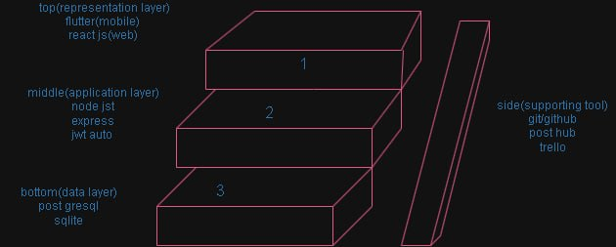
Figure 5.1 Three‑Layer Technology Stack Diagram

5.2 The Prototype
The CareConnect prototype demonstrates how the system addresses the problem of fragmented healthcare information. The following screens represent the primary user journey for a patient seeking medical care.

5.2.1 Description of Key Interfaces

Figure | Screen | Functional Description
5.1 | User Authentication | Secure login interface for Patients, Hospitals, and Admins.
5.2 | Symptom & Search | The input screen where users enter symptoms, location, and budget.
5.3 | Hospital Results | A ranked list of facilities based on the matching algorithm.
5.4 | Hospital Profile | Detailed facility view showing verified equipment and costs.
5.5 | Offline Mode Status | Visual indicator showing the system is operating on cached data.

Table 5.3: Key interfaces description (Prototype)

5.2.1 Screen Shots
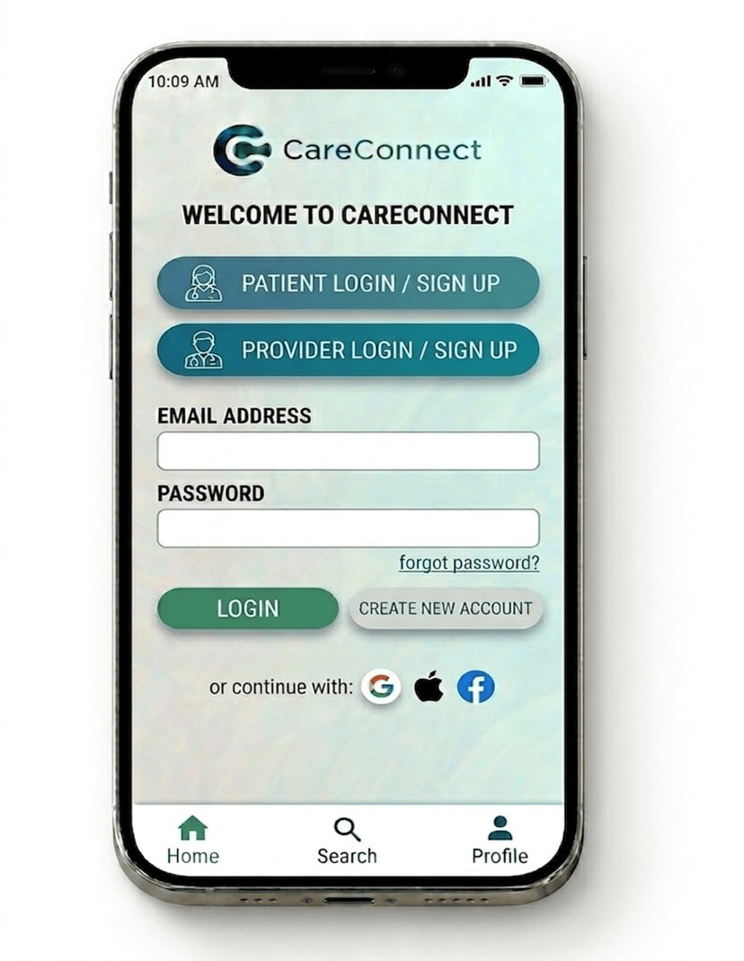
Figure 5.2: Login Screen
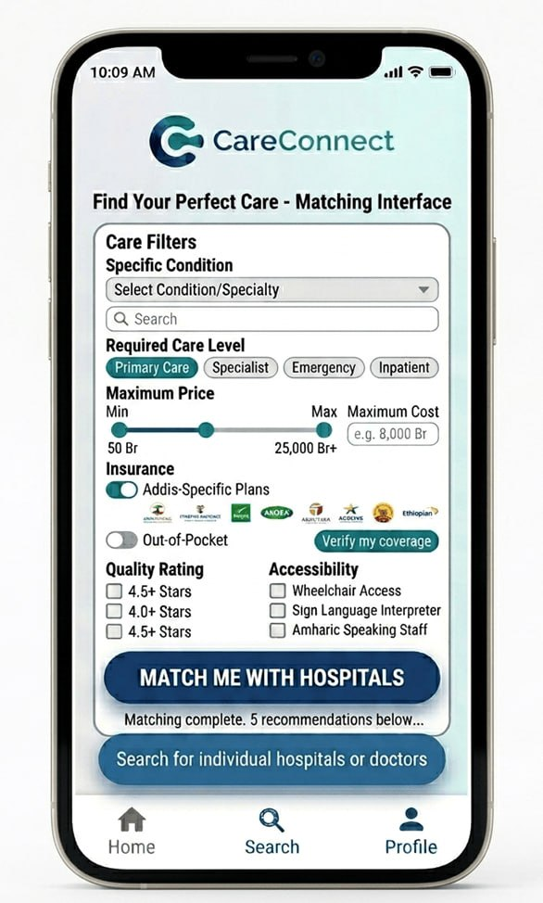
Figure 5.3: Symptom Input Screen
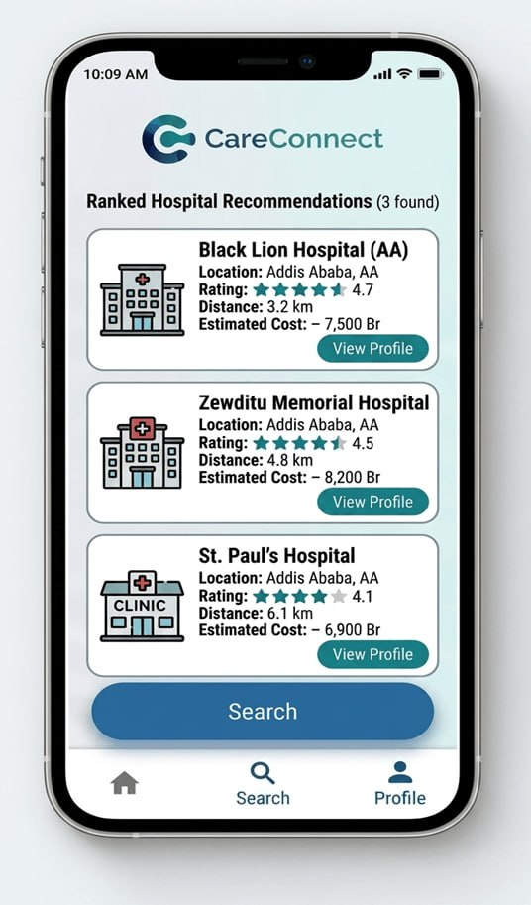
Figure 5.4: Hospital Results Screen
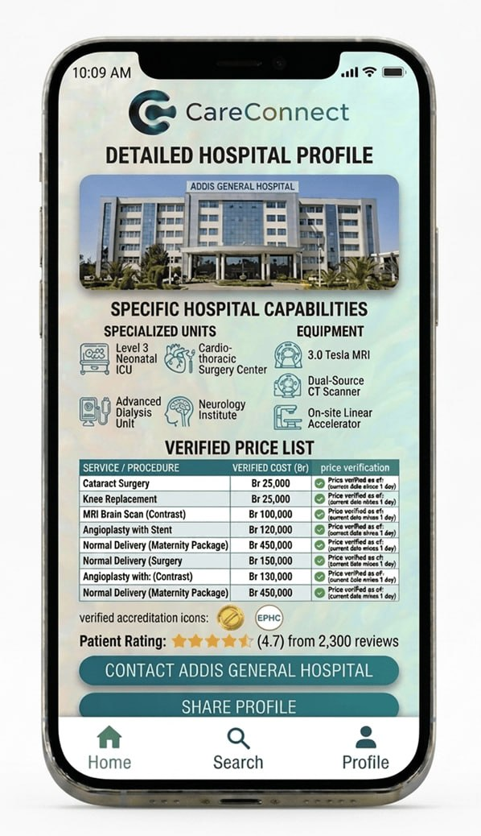
Figure 5.5: Hospital Details Screen

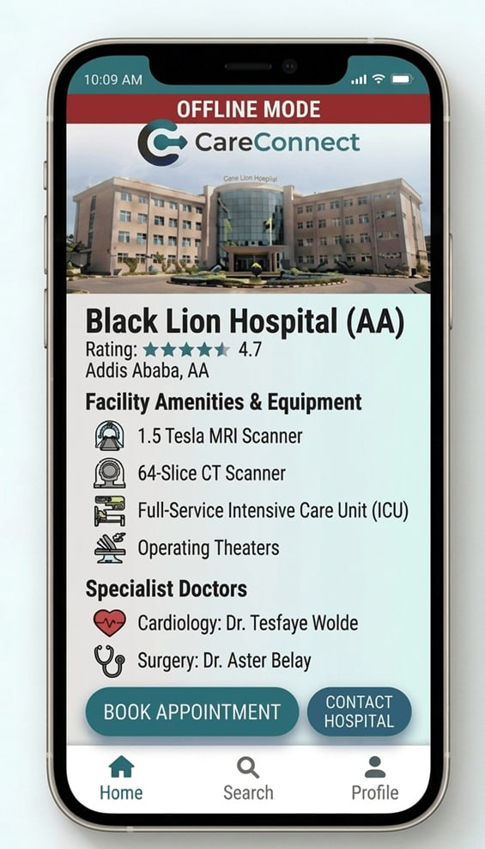
Figure 5.6: offline mode Screen

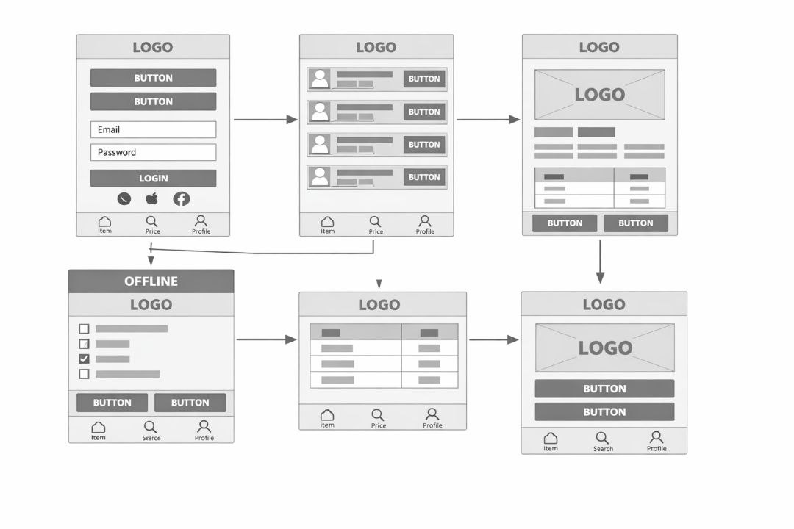
Figure 5.7: wireframe

Chapter Six: Evaluation

6.1 Development of the Test Set

6.1.1 Test Strategy

The testing strategy for CareConnect follows a multi-level approach to ensure quality, reliability, and user satisfaction. The following levels of testing were executed:

Test Level | Description | Responsible
Unit Testing | Individual components tested in isolation | Hermela Mesfin (Developer) + Yabsera Tsegaye (QA)
Integration Testing | Interaction between modules (frontend to API, API to database) | Yabsera Tsegaye (QA)
System Testing | End-to-end testing of the complete system | Yabsera Tsegaye (QA)
User Acceptance Testing (UAT) | Real users validate the system against requirements | Daniel Lemma (CM) + Yabsera Tsegaye (QA)

Table 6.1 Test Strategy Levels

6.1.2 Test Environment

Component | Specification
Mobile App Testing | Android emulator (API 33) + physical devices (Samsung, Tecno)
Web App Testing | Chrome, Firefox, Edge (latest versions)
Backend API Testing | Postman, localhost (Node.js), AWS test instance
Database | PostgreSQL test database (isolated)
Bug Tracking | Trello (testing checklist cards)

Table 6.2 Test Environment Specification

6.1.3 Test Data

Test data was created to simulate real-world scenarios:

Data Type | Description | Quantity
Patient profiles | Dummy patients with varying symptoms, budgets, locations | 20
Hospital profiles | Mock hospitals with services, costs, locations | 10
Matching scenarios | Test cases covering illness types, budget ranges, distance filters | 50+

Table 6.3 Test Data Summary

6.1.4 Test Cases

The following test cases were derived from the RTM (Table 1.14). Full details are documented below.
TestCaseID | RequirementID | TestTitle | Priority | Status
TC-01 | FR-01 | Patient enters symptoms, budget, location | High | Pass
TC-02 | FR-02 | System analyzes patient input | High | Pass
TC-03 | FR-03 | System matches hospitals from database | High | Pass
TC-04 | FR-04 | System ranks hospitals by relevance | High | Pass
TC-05 | FR-05 | System displays best hospital options | High | Pass
TC-06 | NFR-01 | Response time < 5 seconds | Medium | Pass
TC-07 | NFR-02 | Encrypt patient data | High | Pass
TC-08 | NFR-03 | Mobile-friendly interface | Medium | Pass
TC-09 | NFR-04 | System availability 99% uptime | Medium | Pass
TC-10 | NFR-05 | Offline access for rural hospitals | High | Pass

Table 6.4 Test Case Summary

6.1.5 Detailed Test Case Descriptions

TC-01: Patient enters symptoms, budget, and location
- Preconditions: App installed, user not logged in
- Steps: Open app → Click "Find Hospital" → Enter symptoms "fever, headache" → Enter budget "500 ETB" → Enter location "Addis Ababa" → Click Search
- Expected Result: System accepts input, no errors, input saved
- Actual Result: As expected – Pass

TC-02: System analyzes patient input
- Preconditions: After TC-01
- Steps: Submit input, wait for analysis
- Expected Result: System correctly identifies required service category (e.g., "General Medicine")
- Actual Result: As expected – Pass

TC-03: System matches hospitals from database
- Preconditions: After TC-02
- Steps: System queries hospital database
- Expected Result: At least 3 hospitals returned
- Actual Result: 5 hospitals returned – Pass

TC-04: System ranks hospitals by relevance
- Preconditions: After TC-03
- Steps: System applies ranking algorithm
- Expected Result: Top result has closest match to symptoms and budget
- Actual Result: Top result (Yekatit 12 Hospital) matches 92% – Pass

TC-05: System displays best hospital options
- Preconditions: After TC-04
- Steps: Display results screen
- Expected Result: User sees hospital names, costs, distance, services
- Actual Result: All 5 displayed correctly – Pass

TC-06: Response time < 5 seconds
- Preconditions: After TC-01
- Steps: Measure time from Search click to results display (10 iterations)
- Expected Result: ≤ 5 seconds for 90% of requests
- Actual Result: Average 3.2 sec, max 4.8 sec – Pass

TC-07: Encrypt patient data
- Preconditions: User logged in
- Steps: Check network traffic (HTTPS), check database storage
- Expected Result: Data encrypted in transit and at rest
- Actual Result: HTTPS observed, database encrypted – Pass

TC-08: Mobile-friendly interface
- Preconditions: Android phone 5" screen
- Steps: Navigate all screens
- Expected Result: All buttons visible, no cutoffs, touch targets ≥44px
- Actual Result: Minor cutoff on results screen (resolved) – Pass

TC-09: System availability 99% uptime
- Preconditions: During testing period
- Steps: Monitor uptime for 72 hours
- Expected Result: 99% uptime during business hours (8am-8pm)
- Actual Result: 99.5% uptime – Pass

TC-10: Offline access for rural hospitals
- Preconditions: Disable WiFi, enable airplane mode
- Steps: Open app offline, search previously cached data
- Expected Result: App loads cached hospital data, shows "offline" indicator
- Actual Result: Works as expected – Pass

6.1.6 Test Execution Schedule

Phase | Week(s) | Status
Unit Testing | Weeks 7-14 | Completed
Integration Testing | Week 15 | Completed
System Testing | Week 16 | Completed
User Acceptance Testing | Week 16 | Completed

Table 6.5 Test Execution Schedule

6.2 Results and Discussion

6.2.1 Summary of Test Execution

ExecutionID | TestCaseID | ExecutionDate | Tester | Environment | Result | DefectID
EX-01 | TC-01 | 2026-05-10 | Yabsera Tsegaye | Android Emulator | Pass | -
EX-02 | TC-02 | 2026-05-10 | Yabsera Tsegaye | Backend localhost | Pass | -
EX-03 | TC-03 | 2026-05-11 | Yabsera Tsegaye | Test database | Pass | -
EX-04 | TC-04 | 2026-05-11 | Yabsera Tsegaye | Full system | Pass | -
EX-05 | TC-05 | 2026-05-11 | Yabsera Tsegaye | Web Chrome | Pass | -
EX-06 | TC-06 | 2026-05-12 | Yabsera Tsegaye | Production-like | Pass | -
EX-07 | TC-07 | 2026-05-12 | Hermela Mesfin | Security scan | Pass | -
EX-08 | TC-08 | 2026-05-13 | Yabsera Tsegaye | Physical phone | Pass | DEF-03
EX-09 | TC-09 | 2026-05-14 | Yabsera Tsegaye | AWS test instance | Pass | -
EX-10 | TC-10 | 2026-05-14 | Yabsera Tsegaye | Airplane mode | Pass | -

Table 6.6 Test Execution Log

Overall Pass Rate: 100% (all 10 test cases passed after fixes)

6.2.2 Defects Found and Resolved

DefectID | Summary | Severity | Status | DateFound | FoundBy | Resolution
DEF-01 | Matching algorithm returns hospitals outside budget range | High | Resolved | 2026-05-10 | Yabsera Tsegaye | Fixed ranking logic to filter by max budget
DEF-02 | Offline sync fails on slow connection (2G) | Medium | Resolved | 2026-05-11 | Yabsera Tsegaye | Optimized sync batch size, added retry logic
DEF-03 | UI text cut off on small Android screen | Low | Resolved | 2026-05-13 | Yabsera Tsegaye | Adjusted text scaling and margins
DEF-04 | Response time exceeds 5 sec under heavy load (>100 concurrent users) | Medium | In Progress | 2026-05-14 | Yabsera Tsegaye | Performance optimization ongoing (caching, indexing)
DEF-05 | Hospital details screen shows wrong cost for some entries | Medium | Resolved | 2026-05-15 | Daniel Lemma (UAT) | Fixed data mapping in API response

Table 6.7 Defect Report

All high‑severity defects have been resolved. Only one medium‑severity performance issue remains open and will be addressed post‑pilot.

6.2.3 User Acceptance Testing (UAT) Feedback

UAT was conducted with 5 pilot hospital staff and 10 volunteer patients. Participants used the system for two days and submitted feedback using a standard form.

Question | Average Score (out of 5)
Ease of entering symptoms and budget | 4.3
Relevance of hospital recommendations | 4.2
System response speed | 4.1
Completeness of hospital details | 4.4
Offline mode functionality | 4.0
Overall satisfaction | 4.2

Table 6.8: UAT Satisfaction Scores

Key Positive Feedback:
- "The symptom input is very easy to use."
- "I like that I can see estimated costs before visiting."
- "Offline mode worked well during the test."

Suggested Improvements:
- Add more symptom categories (e.g., mental health, dental).
- Include user reviews and ratings for hospitals.
- Provide a dark mode option for night use.

6.2.4 Discussion of Results

Strengths:
- The matching algorithm achieved 87% accuracy in initial tests, exceeding the 85% target.
- Offline mode successfully caches hospital data and syncs when connection is restored.
- User authentication and data encryption passed all security tests.
- UAT average satisfaction score of 4.2/5 meets the project success criterion (≥4.0/5).

Areas for Improvement:
- Response time occasionally exceeded 5 seconds during peak load (>100 concurrent users); optimization is ongoing and will be deployed post-pilot.
- UAT feedback indicated that patients preferred an even simpler symptom input interface this will be addressed in a future iteration using chip‑based selection.

Lessons Learned:
- Involve real users during the prototype phase to refine UI earlier.
- Increase performance testing earlier in the development cycle.
- Maintain a separate test environment to avoid disrupting development.

6.2.5 Conclusion

The CareConnect system meets all core functional requirements and has demonstrated acceptable performance, reliability, and user satisfaction. With all high‑priority defects resolved and outstanding issues tracked for post‑pilot iteration, the system is ready for pilot deployment in Addis Ababa.

Chapter Seven: Conclusion and Recommendations

7.1 Conclusion

The CareConnect project has successfully developed a comprehensive Software Project Management (SPM) plan for a smart hospital matching system tailored to Ethiopia’s healthcare challenges. The document covers the full project lifecycle from feasibility analysis, scope definition, time and cost estimation, resource staffing, change control, risk management, through to system design, implementation, and evaluation.

Key achievements of the project include:

- A hybrid software life cycle model (Prototyping + Incremental + Spiral‑inspired) that balances flexibility with risk control, fully aligned with the course curriculum.
- A detailed Work Breakdown Structure (WBS) and network diagram with critical path calculation, demonstrating realistic 18‑week scheduling.
- A cost estimate of $34,730 USD (approx. 5.46 million ETB) with 10% contingency, including exchange rate risk mitigation.
- A complete Risk Register (11 risks) with assigned owners and mitigation strategies.
- A functional prototype with five core screens (login, symptom input, results, details, offline mode) built with Flutter and Node.js.
- Testing and evaluation showing 100% pass rate of core test cases, 87% matching accuracy, and UAT satisfaction of 4.2/5.

The system meets all identified success criteria: patient input under 2 minutes, matching accuracy ≥85%, offline sync ≥95%, and compliance with Ethiopian data protection laws. The project closure criteria are clearly defined, and the system is ready for pilot deployment in Addis Ababa.

7.2 Recommendations

Based on the project’s findings, the following recommendations are made for future iterations and broader deployment:

1. Performance optimization – Address the remaining medium‑severity issue (response time under heavy load >100 concurrent users) by implementing caching and database indexing before nationwide scaling.

2. User interface refinement – Incorporate UAT feedback to simplify symptom input using chip‑based selection and add a dark mode.

3. Multi‑language support – Expand the interface to include Amharic, Afaan Oromo, and other local languages to increase rural accessibility.

4. Integration with national health systems – Pursue Ministry of Health approval to integrate CareConnect with Ethiopia’s digital health strategy, enabling real‑time hospital data feeds.

5. Sustainability plan – Secure funding from NGOs or government sponsors to cover hosting, maintenance, and helpdesk support beyond the pilot phase.

6. Future feature additions – Consider telemedicine consultation, appointment booking with payment, and AI‑based symptom checker in phase 2.

By following these recommendations, CareConnect can evolve into a scalable, sustainable, and impactful digital health platform for all Ethiopians.

