1. **Fikir Walle 610120**

way to improve software Qualities

A, **performance**

1 Compressed data can improve the application’s speed

Compression can significantly improve application performance. In fact, can reduce the HTML, CSS, JavaScript, and other text-based contents’ required bandwidth by more than 30 percent and reduce application load-time as an effect.

2 Distribute Traffic with a Load Balancer

A load balancer works by distributing traffic across servers. In fact, load balancers can improve user experience on poorly written web apps that might have problems with scaling with growing traffic, without any alterations to the app or servers.

3 Deliver Content Faster by Caching

Caching makes your app content delivery faster.

Using faster devices to store your content,

Making content available faster when demanded,

Using content delivery networks (CDN) to store content closer to your users

B Scalability

**Offload the database** – stay away from the database as much as possible. That means don’t open connections to it and don’t start transactions unless you have to.

**C Availability**

1 Implement Geographic Redundancy  
Host the application in at least two different geographies, preferably close to where your customers or end-users are.

2 Provide excellent support  
Always take care of your customers well. When an organization outsources, one of the biggest hesitations is the fear that all control will be lost, and that support will be extremely painful and time consuming.

3Ensure Automatic Failover  
Hopefully it goes without saying that the redundant hardware in point #1 should be configured active/active or N+1 and continue working flawlessly if a component or even a link between them fails

**D Maintainability**

Refactor code to improve its understandability

Relevant documentation helps developers understand the software

Automated build makes the code easy to compile

Automated tests make it easy to validate changes

**E Reliability**

Failover

Monitor the health of a system

2 context Diagram

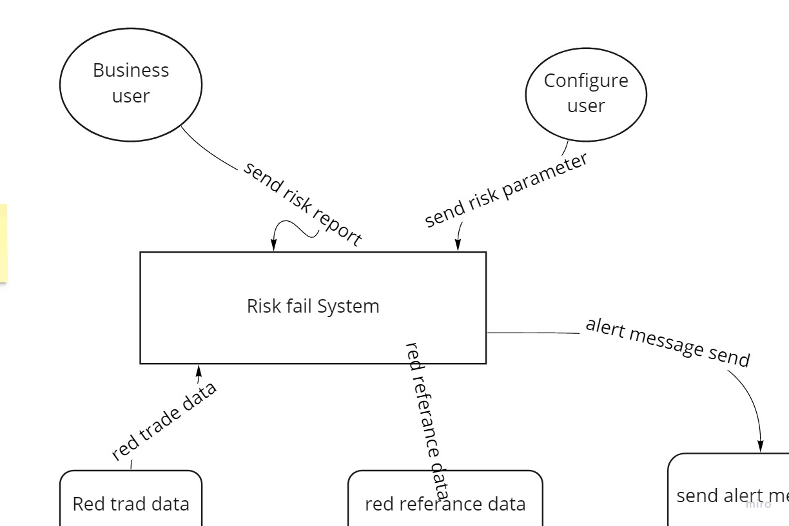

B Component Diagram

