Fikir Walle 610120

1. Service layer



Data Access layeer

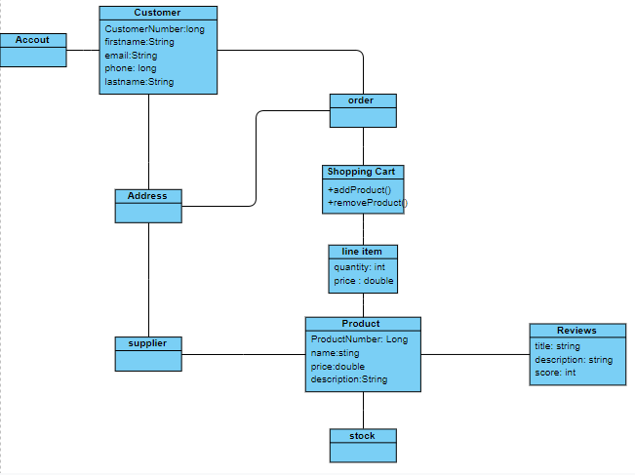

1. The state can be stored

**It stored in client**

Advantages

High scalability

Less network and more reactive

Disadvantage

Not long time persist

**It stores in the server.**

**Dis avatage**

low performance low scalable

Not long time persist

**Database**

**Advantage**

High scalable Long time persist

**Disadvantage**

Low performance

High coupling

File based integration

High coupling

Database integration

High coupling

Serialized objects over HTTP

No standard Synchronous

simple

REST

Complex Synchronous

Have standard security ,transaction and interface description

SOAP

Need middleware

Have buffer Asynchronous Low coupling

Messaging (JMS)

High coupling Synchronous

RMI

**Disadvantage**

**Advantage**

Integration type

Low performance

DIS

P

Advantage and disadvantage of distributed System

**Disadvantag**e

It will be complex

Security is more complex

Transactions are more complex

***Advantage***

More Resources Available