Fikir Walle ID 610120

My Activemq snapshot

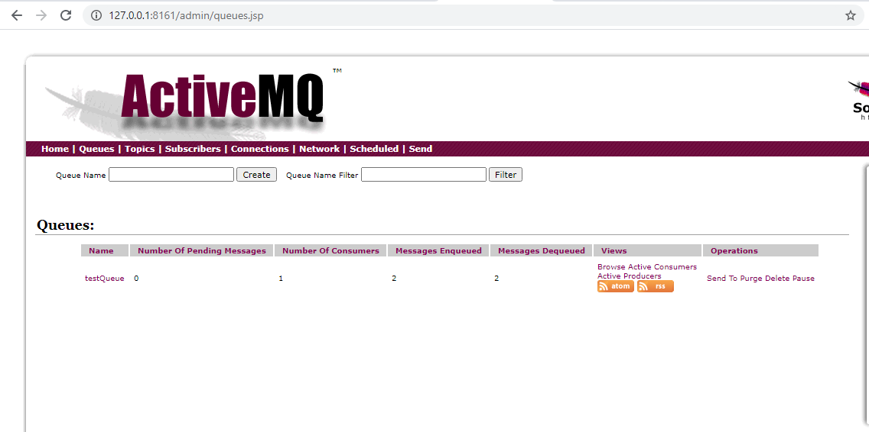

1 <https://github.com/fikirWalle/SoftwareArchtecturelabs/tree/master/WebShopComponents/src/main/java/shop>

2