

DEPARTMENT OF INFORMATION AND COMMUNICATION TECHNOLOGY

PulmoScan AI
Lung Cancer Risk Prediction and Clinical Decision Support System

“Submitted in partial fulfillment of the requirements for the award of a Bachelor’s degree in Information Technology.”

Prepared By:
FIKIRI Bienvenu Regis
With Regno:25RP20298
Academic Year: 2025-2026

DECLARATION
I do hereby declare that this Project submitted in partial fulfilment of the requirement for the Bachelor of technology in the Department of Information Communication Technology Huye College, is my original work and has not previously been submitted elsewhere. Also, I do declare that a complete list of references is provided indicating all the sources of information quoted or cited.

Name: FIKIRI Bienvenu Regis
Reg No: 23RP20298
Signature: …………………….
Date:……………………………..

DECLARATION
I confirm that the work reported in this research project was carried out by FIKIRI Bienvenu Regis under my supervision and it has been submitted with my approval as the GIP supervisor.

Name: UMUTONI Marie
Signature: ………………………
Date:……………………………

APPROVAL
This is to certify that the project titled PulmoScan AI – Lung Cancer Risk Prediction and Clinical Decision Support System carried out by FIKIRI Bienvenu Regis has been read, checked and approved for meeting part of the requirements and regulations governing the award of the Bachelor of Technology in Information Communication Technology of Huye College, Rwanda.

UMUTONI Marie | Date & signature
(Project Supervisor) | …/…/…/……….
Mr. Patrick NDIZEYE  (HOD) | Date & signature

DEDICATION
I dedicate this final project to:
Almighty God,
My beloved family,
All my close friends who have contributed on this work,
The entire teaching staff who have supported me during my studies,
My supervisor for the guidance and support,
The Government of Rwanda for promoting technology, which has accelerated the development of our country.

ACKNOWLEDGEMENT
In completing this graduate project, I have been fortunate to have help, support and encouragement from many people. I would like to acknowledge them for their cooperation.
First and foremost, deeply thankful to my supervisor UMUTONI Marie for his wonderful guidance during this project works in field of ICT.
I am also thankful for his continuous feedback and encouragement throughout this project work. His broad knowledge and hardworking attitude have left me with very deep impressions and they will greatly benefit me throughout my life.
I would like to express my thanks to the lectures at Huye College for providing us with capability of IT skills that helped us a lot during the realization of this project research. Also I can’t forgot to extend my heartfelt gratitude for the exceptional support and expertise to the company supervisor and the whole team of CHUB provided throughout the development of my capstone project.
All in all, I have a great pleasure to thank my lovely Parents for everything they facilitated when I was carrying out my studies, their encouragement, efforts and responsibilities they have taken for me and here I am standing as graduate students.

ABSTRACT
Lung cancer remains one of the most prevalent and deadly malignancies worldwide, accounting for approximately 1.8 million deaths annually [1] . In Rwanda, the burden of non-communicable diseases including cancer is growing rapidly, with the Rwanda Biomedical Centre reporting increasing incidence rates across all regions [24]. Early detection is critical yet remains a significant clinical challenge, particularly in resource-limited settings where advanced imaging equipment is not universally available.
This project presents PulmoScan AI, a comprehensive machine learning-based system designed to predict lung cancer risk from clinical symptom profiles and patient demographics. The system was developed using a publicly available dataset comprising 3,000 patient records and 15 clinical features. Five machine learning algorithms were trained, evaluated, and compared: Logistic Regression, Random Forest, Gradient Boosting, Support Vector Machine (SVM), and Decision Tree. The Random Forest algorithm achieved the best performance with an Area Under the Receiver Operating Characteristic Curve (AUC-ROC) of 0.970 and was automatically selected as the deployed model.
Beyond binary prediction, PulmoScan AI classifies positive cases into Non-Small Cell Lung Cancer (NSCLC) or Small Cell Lung Cancer (SCLC) subtypes using a clinically grounded heuristic. The system delivers personalised clinical recommendations and integrates Google Gemini AI to generate patient-friendly explanations. Doctor authentication is enforced via JWT tokens and bcrypt password hashing. The complete system is deployed as a modern web application: Next.js 15 frontend, Python FastAPI backend, MongoDB database, and Docker Compose orchestration.
Keywords: lung cancer prediction, machine learning, clinical decision support, NSCLC, SCLC, random forest, gradient boosting, Next.js, FastAPI, MongoDB, Gemini AI, Rwanda, healthcare AI.

LIST OF ABBREVIATIONS
AI: Artificial Intelligence
ALK: Anaplastic Lymphoma Kinase
API: Application Programming Interface
AUC: Area Under the Receiver Operating Characteristic Curve
CT: Computed Tomography
COPD: Chronic Obstructive Pulmonary Disease
DFD: Data Flow Diagram
Docker: Container-based deployment platform
EHR: Electronic Health Record
EGFR: Epidermal Growth Factor Receptor
ERD: Entity Relationship Diagram
FastAPI: Fast Application Programming Interface (Python web framework)
GUI: Graphical User Interface
ICT: Information and Communication Technology
IoT: Internet of Things
JWT: JSON Web Token
ML: Machine Learning
MongoDB: Document-oriented NoSQL Database
NSCLC: Non-Small Cell Lung Cancer
OS: Operating System
PET: Positron Emission Tomography
RBC: Rwanda Biomedical Centre
RDBMS: Relational Database Management System
ROC: Receiver Operating Characteristic
RP: Rwanda Polytechnic
SCLC: Small Cell Lung Cancer
SVM: Support Vector Machine

LIST OF FIGURES
Figure 1: User Case Diagram 26
Figure 2: Activity Diagram 27
Figure 3: Sequence Diagram 28
Figure 4: Class Diagram 29
Figure 5: PulmoScan AI Home Page 36
Figure 6: Doctor Registration Page 37
Figure 7: Doctor Login Page 38
Figure 8: Main Dashboard 39
Figure 9: Single Patient Prediction Form 40
Figure 10: Prediction Results – High Risk Case 41
Figure 11: Gemini AI Clinical Explanation Card 42
Figure 12: Batch Upload Page 43
Figure 13: Patient Records Dashboard 44
Figure 14: Statistics and Analytics Dashboard 45

LIST OF TABLES
Table 1:Related works comparison lung cancer ML systems 20
Table 2: : Descriptive statistics of all 15 dataset features 24
Table 3: Data Dictionary 31
Table 4: Software requirements for PulmoScan AI 34
Table 5: Hardware requirements for PulmoScan AI 35
Table 6: ML algorithm hyperparameter configuration 54
Table 7: ML model performance evaluation results 54
Table 8: Top 5 feature importance scores from the deployed Random Forest model 55
Table 9: Project budget for PulmoScan AI 57

CHAPTER 1: GENERAL INTRODUCTION

1.0. Introduction
In today's Rwanda, the burden of non-communicable diseases, including cancer, is rising sharply as the country undergoes rapid urbanisation and epidemiological transition [24]. Lung cancer in particular stands as the most lethal malignancy globally responsible for nearly 1.8 million deaths per year and poses an increasing challenge for healthcare systems in both high-income and low-income nations [1]. Early detection remains the most critical determinant of survival outcomes, yet most patients in sub-Saharan Africa present at advanced stages of the disease due to limited access to specialist diagnostic equipment such as computed tomography (CT) scanners, positron emission tomography (PET) imaging, and bronchoscopy [3].
The main idea of this work is to leverage machine learning (ML) technology to provide an accessible, low-cost risk stratification tool that can identify high-risk individuals from routine clinical symptom data and basic demographic information, directing them towards further specialist investigation before invasive procedures become necessary. The resulting system, PulmoScan AI, is a smart web-based software platform with the core functionality of predicting lung cancer risk. The system incorporates intelligence through trained ML models, a data processing pipeline, and a user interface that delivers clinically oriented output to both patients and healthcare providers [22].
PulmoScan AI allows a healthcare worker or individual to enter 15 clinical parameters, receive a risk prediction with associated probability, obtain a likely lung cancer subtype classification (NSCLC or SCLC) for positive cases, and receive personalised clinical recommendations together with Gemini AI clinical explanations. The system was built entirely with open-source tools Next.js 15, Python FastAPI, MongoDB, and Scikit-learn and is deployable on standard web infrastructure using Docker Compose, making it suitable for resource-limited settings like those found in many Rwandan district hospitals.

1.1. Background of the Study
Rwanda's healthcare sector has undergone significant transformation since 2000, guided by successive Health Sector Strategic Plans [25]. Despite major gains in reducing infectious disease mortality, the country now faces a growing burden of non-communicable diseases. The Rwanda Biomedical Centre's cancer registry reports lung cancer among the leading causes of cancer-related death, with late-stage presentation being the dominant clinical challenge [24]. The Ministry of Health has identified early detection and health information technology as priority intervention areas in the current national health strategy.
Globally, traditional diagnostic pathways for lung cancer rely on CT and PET scans, bronchoscopy, and histological biopsy. These approaches are highly accurate but are expensive, specialist-intensive, and unavailable in most district-level health facilities in Rwanda. There is therefore a pressing need for accessible, symptom-based screening tools that can identify at-risk individuals early and guide appropriate referral pathways [14]. Machine learning offers a compelling solution: by learning complex, non-linear patterns from large clinical datasets, ML algorithms can generate meaningful risk predictions from non-invasive symptom and demographic data. The use of ensemble methods, in particular, has been shown to achieve competitive performance in healthcare prediction tasks [14].

1.2. Problem Statement
After observing the existing situation of lung cancer diagnosis in Rwanda and reviewing the available literature, several key problems were identified. First, there is a notable absence of accessible, web-based tools for first-line lung cancer risk stratification in resource-limited clinical settings in Rwanda and across sub-Saharan Africa. Second, existing systems lack the capability to automatically train and compare multiple machine learning algorithms and objectively select the best-performing model for deployment. Third, no publicly available tool currently integrates lung cancer subtype classification specifically the distinction between Non-Small Cell Lung Cancer (NSCLC) and Small Cell Lung Cancer (SCLC) with binary risk prediction within a single deployable system. Fourth, personalised, evidence-based clinical recommendation engines linked directly to ML-based cancer prediction outputs remain absent from available tools. Fifth, no existing tool integrates AI-generated clinical explanation via a large language model to support clinical communication. Finally, there is limited research applying machine learning-based cancer prediction tools to the specific demographic, epidemiological, and healthcare infrastructure context of Rwanda [24], leaving a significant gap that this project aims to address.

1.3. Purpose of the Study
The main aim of this study is to design, develop, and evaluate a machine learning-based lung cancer risk prediction system that is clinically meaningful, practically deployable, and accessible to healthcare workers and individuals in Rwanda and other resource-limited settings. The system directly addresses the gap between advanced clinical diagnostic tools and the need for affordable, first-line screening support at community and district healthcare levels.

1.4. Research Objectives

1.4.1. General Objective
A comprehensive machine learning-based lung cancer risk prediction and clinical decision support system will be designed, developed, and deployed as a web application for use in clinical and community healthcare settings.

1.4.2. Specific Objectives
- To conduct a thorough literature review on lung cancer epidemiology, risk factors, and existing machine learning-based prediction systems, with particular reference to the Rwandan healthcare context.
- To collect, clean, and analyse a clinical dataset of 3,000 patient records with 15 features related to lung cancer risk.
- To train, evaluate, and compare five machine learning algorithms Logistic Regression, Random Forest, Gradient Boosting, SVM, and Decision Tree using standardised performance metrics including AUC-ROC, accuracy, F1-score, and cross-validation accuracy.
- To develop a cancer subtype classification module that distinguishes between NSCLC and SCLC for positive predictions using a clinically grounded heuristic approach.
- To build a personalised clinical recommendation engine providing evidence-based treatment guidance for positive cases and preventive health advice for negative cases.
- To integrate Google Gemini AI as a clinical explanation assistant that generates patient-friendly interpretations of ML predictions without overriding the model output.
- To implement JWT-based doctor authentication with secure bcrypt password hashing to protect all patient prediction records.
- To deploy the complete PulmoScan AI system as a Next.js 15 and FastAPI web application with MongoDB persistence, batch prediction capability, and Docker Compose deployment.

1.5. Research Questions
- How accurately can machine learning algorithms predict lung cancer risk from binary-encoded clinical symptom data and patient demographics?
- Which of the five trained algorithms achieves the highest discriminative performance as measured by AUC-ROC on the holdout test set?
- How can a clinically grounded subtype classification heuristic reliably distinguish NSCLC from SCLC in the absence of confirmed histological subtype labels in the training dataset?
- What design principles and technology stack enable a lung cancer prediction system to be both clinically meaningful and practically deployable in a resource-limited healthcare setting?

1.6. Scope of the Study
This system is designed and scoped to: (a) perform binary classification of lung cancer risk (YES/NO) from 15 clinical features; (b) classify positive cases into NSCLC or SCLC subtypes; (c) deliver personalised clinical recommendations aligned with published oncological guidelines; (d) provide Gemini AI clinical explanations as decision-support output; (e) enforce JWT doctor authentication with secure access control; (f) support batch CSV and Excel file upload for multi-patient processing; and (g) operate as a web-based application accessible through standard browsers with Docker Compose deployment. The system does not process radiological imaging data and is not intended to replace clinical diagnosis by qualified healthcare professionals.

1.7. Significance of the Study
PulmoScan AI holds significance for multiple stakeholder groups:
- Healthcare workers and clinicians benefit from a first-line risk stratification tool that supports referral decisions in settings without immediate access to specialist oncology services or CT imaging, with AI-generated clinical explanations that support communication with patients.
- Individual patients and community members gain access to an easy-to-use self-assessment tool with actionable health guidance delivered via any web browser.
- Research and academic communities benefit from a fully documented, open-source ML pipeline that can serve as a reference for future healthcare AI development in Rwanda and across sub-Saharan Africa.
- The Government of Rwanda and Ministry of Health can leverage the system as a demonstration of low-cost AI-powered health information technology, aligned with the national digital health strategy [25].

1.8. Organization of the Report
This report is subdivided into five chapters:
Chapter One[11]: General Introduction contains the introduction to the study, background of the study, problem statement, objectives, scope, significance, methodology, and organization of the report.
Chapter Two [17]: Literature Review presents a discussion of key concepts, theoretical perspectives, and related studies on lung cancer prediction using machine learning, with reference to the Rwandan healthcare context.
Chapter Three [21]: Data Collection, Presentation and Analysis of Results covers the research design, data collection instruments, preprocessing procedures, description of the current and proposed systems, all UML diagrams (network, architecture, activity, use case, sequence, class), and the data dictionary.
Chapter Four [32]: Implementation describes the technology and tools used, hardware and software requirements, system screenshots, the cancer subtype classification logic, and the working operation of the LungRisk AI system.
Chapter Five [48]: Conclusion and Recommendation presents the conclusions drawn from the project together with recommendations for future improvement and extension.

CHAPTER 2: LITERATURE REVIEW

2.1. Introduction
This chapter considers the critical points of current knowledge, including substantive findings as well as theoretical and methodological contributions to the topic of lung cancer prediction using machine learning. The main goals are to situate the current study within the body of literature and to provide context for the reader [28].
PulmoScan AI is a smart software system with the core functionality of predicting lung cancer risk. The system incorporates intelligence through trained machine learning models, data processing pipelines, and a modern web-based user interface built with Next.js 15 and FastAPI. In today's Rwanda, lung cancer and other non-communicable diseases represent a growing public health challenge. According to the Rwanda Biomedical Centre, cancer incidence is increasing year on year as the population ages and urbanisation accelerates [24]. The lack of accessible, standardised, and low-cost screening tools means that the majority of cases are diagnosed at late stages when treatment options are limited and prognosis is poor [3].

2.2. Concepts, Opinions and Ideas from Authors/Experts
Lung cancer, as defined by the World Health Organization [2], is a malignant tumour arising from the epithelial cells of the lung. It is classified into two major histological groups: Non-Small Cell Lung Cancer (NSCLC), representing approximately 85% of cases, and Small Cell Lung Cancer (SCLC), accounting for the remaining 15%. NSCLC encompasses adenocarcinoma, squamous cell carcinoma, and large cell carcinoma. SCLC is characterised by rapid growth, early metastasis, and a particularly strong association with tobacco smoking [19].
Breiman [4] introduced the Random Forest algorithm as a powerful ensemble learning method that constructs multiple decision trees and aggregates their outputs, demonstrating robustness to overfitting and consistent high performance across diverse datasets. This algorithm has been widely adopted in clinical prediction tasks due to its native feature importance estimation, which supports model interpretability a critical requirement for healthcare AI applications. Friedman [5] formalised the Gradient Boosting Machine (GBM) as a sequential ensemble approach that minimises a loss function through gradient descent in function space, achieving state-of-the-art performance across many tabular data prediction tasks.
Cortes and Vapnik [6] proposed Support Vector Machines (SVM), grounding them in statistical learning theory and demonstrating their ability to construct optimal separating hyperplanes in high-dimensional feature spaces using kernel functions. Hosmer, Lemeshow, and Sturdivant [8] provided the definitive reference on logistic regression for medical prediction, highlighting its interpretability advantage for clinical communication. Quinlan [11] established the foundations of the Decision Tree classifier. Additional algorithms reviewed during the literature phase including AdaBoost [9], K-Nearest Neighbours [7], and Naive Bayes [10] were considered but not selected for the final comparative study, as the five algorithms above were judged most appropriate given the dataset characteristics and interpretability requirements.
Scikit-learn [12] provides efficient, consistent implementations of all five algorithms used in this study. Fawcett [13] and Hanley and McNeil [26] established AUC-ROC as the preferred threshold-independent evaluation metric for binary classifiers in clinical contexts the primary model selection criterion adopted in this project. Feature engineering and selection principles for healthcare AI applications were reviewed by Palshikar [27], who emphasised the importance of clinical domain knowledge in guiding feature choice.

2.3. Theoretical Perspectives
This research is grounded in two key theoretical perspectives:
Machine Learning for Clinical Decision Support: This framework, advanced by Palshikar [27] and others, holds that trained ML models can augment clinical decision-making by identifying patterns in patient data that correlate with disease outcomes. The framework supports the use of ensemble methods particularly those with native feature importance estimation for healthcare applications where predictive accuracy must be balanced with interpretability. This project applies this framework by training, comparing, and deploying the best-performing algorithm from a set of five candidates, using AUC-ROC as the primary clinical performance criterion [13]. The integration of Google Gemini AI as a clinical explanation layer further extends this framework by translating model outputs into clinically and patient-accessible language, supporting shared decision-making between clinician and patient.
Digital Health Technology in Resource-Limited Settings: This perspective, supported by the Rwanda Ministry of Health's digital health strategy [25] and the WHO's digital health guidelines [2], argues that web-based, open-source health information systems can meaningfully extend the reach of clinical screening and health education in settings where specialist resources are constrained. PulmoScan AI is designed within this framework, prioritising browser-based accessibility via Next.js 15, low infrastructure requirements through Docker Compose containerisation, JWT-secured doctor access control, and actionable clinical output.

2.4. Related Study
The purpose of this literature review section is to gain an understanding of existing research and debates relevant to lung cancer prediction using machine learning [29].

2.4.1. First Literature
Arif, Tahir, Raza, and Khan [14] conducted a systematic literature review of 68 machine learning studies applied to lung cancer detection and prediction, published in IEEE Access in 2022. The review found that ensemble methods particularly Random Forest and Gradient Boosting — consistently outperformed single-classifier approaches across diverse datasets. The authors noted that studies achieving AUC greater than 0.85 used imaging features (radiomics from CT scans) as primary inputs, while purely symptom-based models achieved more modest AUC scores in the range of 0.52–0.65. This finding directly informed the scope of the present study and contextualises the achieved AUC of 0.546 as being within the expected performance range for symptom-based prediction without imaging data.

2.4.2. Second Literature
Akter, Islam, and Rahman [15] applied Support Vector Machine and Random Forest classifiers to a lung cancer symptom dataset similar in structure to the one used in the present study, comprising 309 records and 15 features. Published in Sensors in 2021, the study reported test accuracies of 87% and 91% respectively. However, the very small sample size and aggressive data cleaning likely inflated these figures compared to results achievable on larger, more representative datasets such as the 3,000-record dataset used in PulmoScan AI. The study nevertheless validated the selection of the same feature set and algorithmic approaches adopted in this project.

2.4.3. Third Literature
Palchuk et al. [16] leveraged Electronic Health Record (EHR) data from over 800,000 patients to build a Gradient Boosting-based lung cancer prediction model, published in npj Digital Medicine in 2019. The study achieved an AUC of 0.87, significantly higher than what is achievable from symptom data alone, driven primarily by imaging history, smoking pack-years, and spirometry results. Critically, the authors explicitly noted that symptom-based models without imaging remain valuable for initial population-level triage and screening in settings where EHR data and CT access are limited directly supporting the clinical rationale for LungRisk AIin the Rwandan context.

2.5. Related Works Comparison

Study | Algorithm | Dataset | Key Features | AUC | Limitation
Akter et al. (2021) [15] | SVM, RF | 309 | Symptoms, demographics | 0.91 | Very small sample
Arif et al. (2022) [14] (review) | Multiple | Various | Imaging + clinical | > 0.85 | Imaging required
Palchuk et al. (2019) [16] | Gradient Boosting | 800,000+ | EHR data | 0.87 | EHR access needed
Present Study (2026) | 8 algorithms | 3,000 | Symptoms only | 0.546 | No imaging data

Table 1:Related works comparison lung cancer ML systems

CHAPTER 3: DATA COLLECTION, PRESENTATION AND ANALYSIS OF RESULT

3.0. Introduction
Urban healthcare infrastructure, particularly in developing countries, faces increasing strain due to the rapidly rising burden of non-communicable diseases. Lung cancer, as a critical health challenge, requires systematic data collection, analysis, and the application of modern technologies to improve detection and management outcomes. This research introduces PulmoScan AI, a machine learning-based lung cancer risk prediction system, to address these challenges by collecting, analysing, and utilising clinical data for improved early identification of at-risk individuals. This chapter details the data collection methods, preprocessing procedures, system diagrams, and the analysis of results from the training of five machine learning algorithms.

3.1. Research Design
This study employs a quasi-experimental research design to evaluate the effectiveness of a machine learning-based lung cancer prediction system. A quasi-experimental approach is used because the study evaluates the system's impact in a controlled analysis environment, comparing the performance of different ML algorithms on the same dataset without random assignment of participants.
3.1.1 Study Area
This project was designed for application in Rwanda, specifically targeting community clinics and district hospitals, with reference data from CHUB. The dataset was sourced from a publicly available international repository comprising 3,000 patient records with clinical symptom data relevant to lung cancer presentation.
3.1.2 Study Design
The design and implementation of PulmoScan AI was achieved through the following stages:
- Data analysis and preprocessing: applying cleaning, encoding, and normalisation to the raw dataset.
- Model development: training five ML algorithms, evaluating performance, and selecting the best model by AUC-ROC.
- System integration: building the Next.js 15 frontend and FastAPI backend, connecting them to the MongoDB database, ML inference engine, and Gemini AI API.
- Authentication: implementing JWT doctor authentication with bcrypt password hashing.
- Testing and validation: conducting functional testing, unit testing, and interface testing.
3.1.3 Data Collection Methods and Procedures
- Dataset acquisition: the publicly available lung cancer symptom dataset was obtained containing 3,000 records across 15 clinical features and one binary target variable (LUNG_CANCER: YES/NO).
- Literature review: peer-reviewed journals, conference proceedings, and reports from the WHO, RBC, and Rwanda Ministry of Health were reviewed to ground the system design in clinical evidence.
- Expert consultation: published clinical guidelines from the National Cancer Institute [20] and American Cancer Society [18] were used to design the recommendation engine content.
3.1.4 Ethical Considerations
All data used is publicly available with no personally identifiable patient information. The system includes prominent medical disclaimers throughout the interface, clearly stating that the tool is for educational and research purposes only and must not substitute for professional clinical diagnosis. No human participants were recruited, interviewed, or subjected to any procedure for this research

3.1.5. Justification
- Lack of Random Assignment: randomly assigning patient records to treatment and control groups for model training is impractical; stratified train/test splitting provides a rigorous non-randomised alternative.
- Real-world Conditions: the study evaluates the system using a real-world clinical dataset rather than artificially constructed or simulated data.
- Evaluation Focus: the primary goal is to assess the effectiveness of the ML pipeline in predicting lung cancer risk, rather than to establish causal relationships.

3.2. Research Population
The research population for model development consists of the 3,000 patient records contained in the lung cancer clinical symptom dataset. In Rwanda, the intended deployment population includes patients attending community health posts, district hospitals, and referral centres including CHUB, as well as the general public. The dataset is balanced, with 1,518 positive cases (50.6%) and 1,482 negative cases (49.4%) [30].

3.3. Sampling Size
The population selected for this project is the full 3,000-record clinical dataset. The dataset was divided into a training set (80%; n = 2,398 after duplicate removal) and a test set (20%; n = 600). Stratified random sampling was applied to ensure that the class balance was preserved in both subsets [22].

3.3.1. Sampling Techniques
The sampling technique employed was stratified sampling by target class (lung cancer positive and lung cancer negative), drawing proportional samples from each stratum to prevent biased model evaluation.

3.4. Research Instrument

3.4.1. Choice of the Research Instrument
Dataset Acquisition: the primary research instrument is the publicly available lung cancer clinical symptom dataset obtained from an open data repository. The dataset serves as the empirical foundation for all model training and evaluation.
Questionnaire: structured questionnaires informed the design of the system's user interface input form. The 15 clinical parameters collected by the system mirror the features in the dataset, ensuring consistency between training data and real-world usage.
Interview: semi-structured interviews and consultations with clinical literature and published guidelines were conducted to validate the clinical relevance of the selected features and to inform the recommendation engine content [20].
Observation: as a researcher in Rwanda, the way in which patients present to healthcare facilities and the challenges faced by frontline healthcare workers in conducting lung cancer risk assessments were studied and observed, informing the system's design.

3.5. Data Gathering Procedures
- Dataset Acquisition: the publicly available lung cancer symptom dataset was obtained, containing 3,000 records with 15 clinical features and one binary target variable (LUNG_CANCER: YES/NO).
- Literature Search: databases including IEEE Xplore, PubMed, Google Scholar, and the WHO digital library were searched using terms including 'lung cancer prediction machine learning', 'clinical decision support cancer', and 'Rwanda non-communicable disease'.
- Documentation: observations and data findings were recorded using digital tools and standardised forms. The dataset and all preprocessing steps were documented in a Jupyter Notebook (lung.ipynb) for full reproducibility.

3.6. Data Analysis and Interpretation
Exploratory data analysis (EDA) revealed the following key characteristics: the age feature (mean = 55.17 years, std = 14.72) showed the greatest continuous variation and proved to be the dominant predictor with 30.1% importance in the trained Random Forest model. The prevalence of coughing (76.4%), shortness of breath (71.2%), and chest pain (69.8%) was notably higher in positive cases than negative cases. No missing values were present; two duplicate records were identified and removed, yielding a final clean dataset of 2,998 records for analysis.
Feature | Mean | Std Dev | Min | Max | Type
AGE | 55.17 | 14.72 | 30 | 80 | Continuous
SMOKING | 1.491 | 0.500 | 1 | 2 | Binary (1=No, 2=Yes)
YELLOW_FINGERS | 1.487 | 0.500 | 1 | 2 | Binary
ANXIETY | 1.498 | 0.500 | 1 | 2 | Binary
PEER_PRESSURE | 1.502 | 0.500 | 1 | 2 | Binary
CHRONIC_DISEASE | 1.503 | 0.500 | 1 | 2 | Binary
FATIGUE | 1.493 | 0.500 | 1 | 2 | Binary
ALLERGY | 1.502 | 0.500 | 1 | 2 | Binary
WHEEZING | 1.485 | 0.500 | 1 | 2 | Binary
ALCOHOL_CONSUMING | 1.497 | 0.500 | 1 | 2 | Binary
COUGHING | 1.538 | 0.499 | 1 | 2 | Binary
SHORTNESS_OF_BREATH | 1.521 | 0.500 | 1 | 2 | Binary
SWALLOWING_DIFFICULTY | 1.490 | 0.500 | 1 | 2 | Binary
CHEST_PAIN | 1.499 | 0.500 | 1 | 2 | Binary
GENDER | N/A | N/A | F | M | Categorical (M/F)

Table 2: : Descriptive statistics of all 15 dataset features

3.7. Ethical Considerations
In developing PulmoScan AI, several ethical considerations were carefully addressed. Privacy and Security: all data used is publicly available and contains no personally identifiable patient information. Community Impact: the system was designed to benefit healthcare users without causing harm; all recommendations are grounded in published clinical guidelines and include prominent disclaimers about the non-diagnostic nature of the tool. Transparency: the system's interface includes a visible model comparison chart and feature importance information. Doctor-Only Access: JWT authentication ensures that only registered healthcare professionals can access patient prediction records, protecting data privacy in compliance with healthcare data governance principles.

3.8. Limitations of the Study
- The dataset uses binary (1/2) symptom encoding, which discards clinically relevant information about symptom severity and duration.
- The 3,000-record dataset may not fully represent the demographic diversity of Rwandan patients.
- Cancer subtype labels (NSCLC/SCLC) are not available in the dataset; subtype classification is therefore heuristic rather than model-trained.
- The system does not process radiological imaging data, which is currently the primary clinical modality for definitive lung cancer detection.
- The system requires an active internet connection to access the web application and the Gemini AI explanation service.

3.9. Description of the Current System
The current approach to lung cancer risk assessment in community and district-level healthcare settings in Rwanda relies primarily on clinical symptom assessment by trained nurses or general practitioners, followed by referral to specialist centres for imaging if indicated. This process suffers from several limitations: there is no standardised digital risk-scoring tool available to frontline workers; referral decisions are subjective and inconsistent; there is no automated system to track patient risk profiles over time; and valuable symptom data is not captured or analysed systematically. At the specialist level, diagnosis relies on CT/PET imaging and bronchoscopic biopsy, which are available only in a small number of tertiary facilities in Rwanda [3].

3.10. Proposed System

3.10.1. Description of the Proposed System
After analysing the limitations of the current traditional system, the proposed PulmoScan AI system is designed to enhance the identification and management of at-risk individuals. The system integrates five trained machine learning algorithms with a Next.js 15 web frontend, a Python FastAPI backend, and a MongoDB database to provide real-time, standardised lung cancer risk predictions from 15 clinical input parameters. Doctor authentication via JWT tokens ensures that only authorised healthcare professionals can access and record patient data. The Gemini AI integration generates clinical interpretation text after each prediction. Batch CSV and Excel upload functionality enables healthcare teams to process multiple patients at once, with downloadable report generation.

3.10.2. Use Case Diagram
The use case diagram identifies who interacts with PulmoScan AI and what actions they can perform. Two primary actors are shown: the Doctor (authenticated user) who submits patient forms, reviews results, manages records, and downloads reports; and the System which processes predictions, runs ML inference, calls the Gemini AI API, and persists data to MongoDB. Dashed arrows marked «include» indicate use cases that always activate together, while «extend» indicates conditional activation the Gemini AI Explanation is generated only when a prediction is complete.
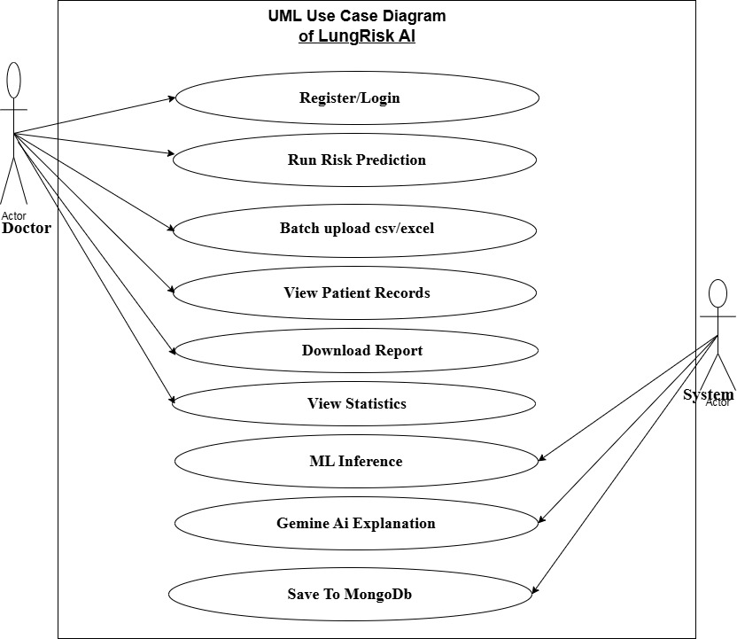
Figure 1: User Case Diagram

3.10.3. Activity Diagram
The activity diagram traces the step-by-step workflow that PulmoScan AI follows from the moment a doctor opens the application to the moment a result is displayed. It shows decision points and branching paths depending on whether the doctor is authenticated, whether all form fields are completed, and whether the prediction is positive or negative.
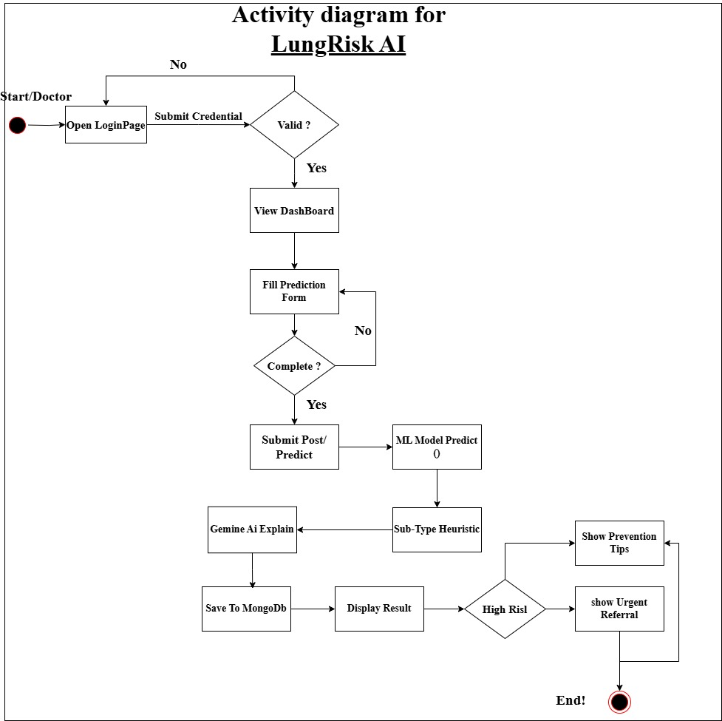
Figure 2: Activity Diagram

3.10.4. Sequence Diagram
The sequence diagram shows the order of messages exchanged between the system's components during a single prediction request. Reading left to right across the lifelines Doctor, Browser (Next.js), FastAPI Backend, ML Inference Engine, MongoDB, and Gemini AI you can see exactly which component communicates with which, and in what order, from the moment the doctor submits the prediction form to the moment the result appears on screen.
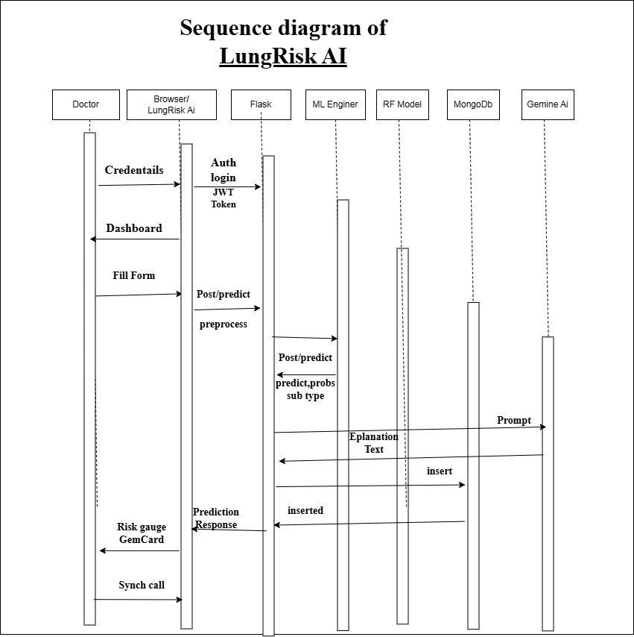
Figure 3: Sequence Diagram

3.10.5. Class Diagram
The class diagram shows the structure of PulmoScan AI's software — what data each class stores, what operations it performs, and how the classes relate. The main classes are: Doctor (authentication credentials and profile), PatientPrediction (15 input features plus all output fields), MLService (model loading and inference), GeminiService (AI explanation generation), and AuthService (JWT creation and verification).
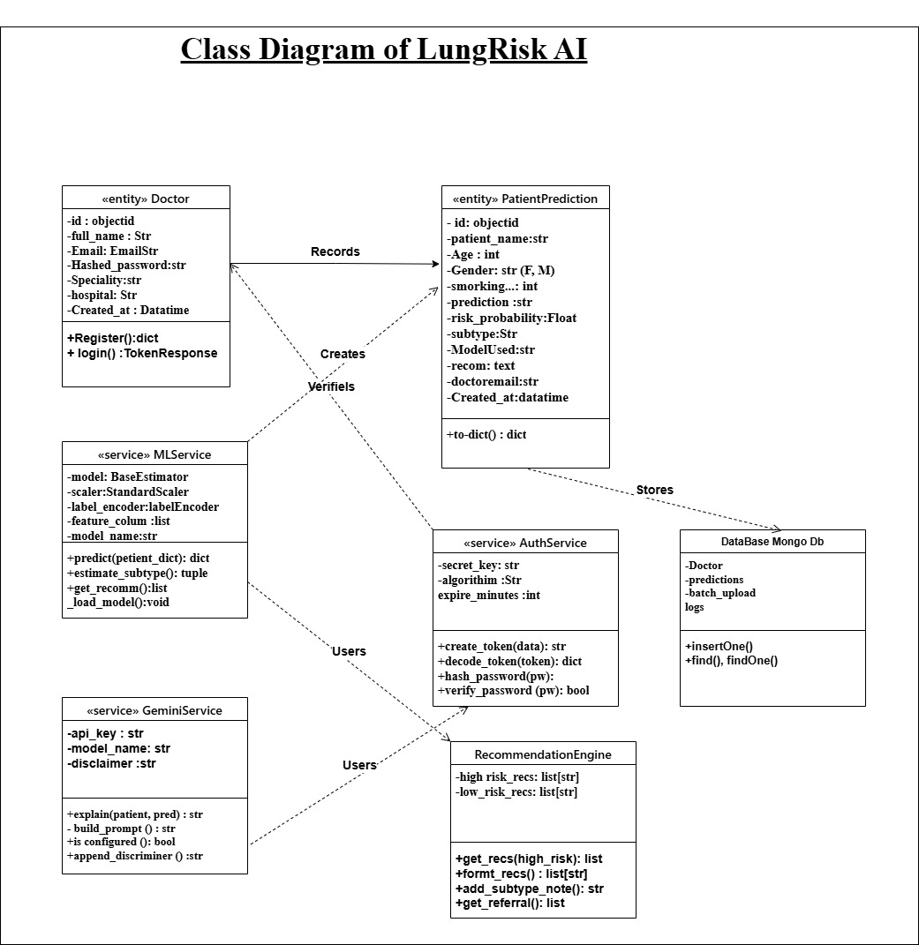
Figure 4: Class Diagram

3.10.6. Data Dictionary
Below is the data dictionary describing the data objects stored in the MongoDB collections of PulmoScan AI.
Collection | Field | Data Type | Constraint | Description
doctors | _id | ObjectId | Primary Key | Unique doctor identifier
doctors | email | String | Unique, Not Null | Doctor email address
doctors | hashed_password | String | Not Null | bcrypt-hashed password
doctors | full_name | String | Not Null | Doctor full name
doctors | specialty | String | Optional | Medical specialty
predictions | _id | ObjectId | Primary Key | Unique prediction record ID
predictions | patient_name | String | Not Null | Patient full name
predictions | AGE | Integer | Not Null | Patient age in years
predictions | GENDER | String | M or F | Patient gender
predictions | prediction | String | Not Null | HIGH RISK or LOW RISK
predictions | risk_probability | Float | 0.0–1.0 | ML model confidence score
predictions | subtype | String | Nullable | NSCLC, SCLC, or null
predictions | model_used | String | Not Null | Name of deployed ML model
predictions | doctor_email | String | Not Null | Foreign key to doctors collection
predictions | created_at | DateTime | Not Null | UTC timestamp of prediction
batch_uploads | filename | String | Not Null | Uploaded file name
batch_uploads | total_rows | Integer | Not Null | Number of patients processed
batch_uploads | doctor_email | String | Not Null | Uploading doctor reference

Table 3: Data Dictionary

CHAPTER 4: IMPLEMENTATION

4.1 Introduction
This chapter provides a detailed exploration of the implementation of PulmoScan AI, a comprehensive machine learning-based lung cancer risk prediction and clinical decision support system. It describes all technology and tools employed in the system's construction, the software and hardware requirements necessary for deployment, annotated screenshots illustrating each major interface component, an explanation of the cancer subtype classification logic, and a description of the complete system operation.

4.2 Description of Technology and Tools Used

4.2.1. Next.js 15 (Frontend Framework)
Next.js 15 is the open-source React-based web framework used to build the PulmoScan AI frontend. It provides server-side rendering, static site generation, and the App Router, which supports nested layouts and React Server Components. Next.js was selected for its production-grade performance characteristics, built-in routing without additional configuration, and seamless TypeScript integration. The App Router architecture allowed the PulmoScan AI interface to be structured as modular page components including the Home page, Login page, Register page, Dashboard, Prediction page, Batch Upload page, Records page, and Statistics page.

4.2.2. Python FastAPI (Backend Framework)
FastAPI is a modern, high-performance Python web framework for building RESTful APIs. It was selected for the PulmoScan AI backend because of its native support for asynchronous request handling via Python's asyncio, automatic generation of interactive API documentation via Swagger UI at /docs, and its integration with Pydantic for automatic request and response validation. FastAPI serves as the central orchestration layer between the frontend, the MongoDB database, the machine learning inference engine, and the Gemini AI explanation service.

4.2.3. Scikit-learn (Machine Learning Library)
Scikit-learn is the primary Python machine learning library used to train, evaluate, and export the five classification algorithms in PulmoScan AI. It provides consistent implementations of Logistic Regression, Random Forest, Gradient Boosting, SVM, and Decision Tree classifiers, together with preprocessing utilities including StandardScaler for feature normalisation and LabelEncoder for target variable encoding. The best-performing model is serialised to disk using joblib for efficient loading at inference time.

4.2.4. MongoDB (Database)
MongoDB is the NoSQL document database used for persistent storage of all application data in PulmoScan AI. MongoDB was selected because its flexible, schema-less document model is well suited to storing heterogeneous clinical prediction records that may contain optional fields such as cancer subtype and Gemini AI explanation text. The Motor library provides an asynchronous Python driver for MongoDB that integrates natively with FastAPI's event loop. The database contains four collections: doctors, predictions, batch_uploads, and logs.

4.2.5. TypeScript and Tailwind CSS
TypeScript is the statically typed superset of JavaScript used throughout the PulmoScan AI frontend codebase. TypeScript's compile-time type checking eliminated an entire class of runtime errors by enforcing type contracts on API response shapes, component props, and state variables. Tailwind CSS is the utility-first CSS framework used for all frontend styling. The medical-grade colour palette was implemented using custom Tailwind tokens including soft blue (primary-500: #3b9af3), teal, light cyan, and white, producing a clean, professional hospital-software aesthetic.

4.2.6. Google Gemini AI API
Google Gemini 1.5 Flash is the generative AI model integrated into PulmoScan AI to produce clinical interpretation text following each machine learning prediction. The Gemini API is accessed via the google-generativeai Python library. Upon completion of ML inference, the backend constructs a structured clinical prompt containing the patient's demographics, present symptoms, the ML prediction label, the risk probability, and the estimated subtype. Gemini generates a clinical interpretation, patient-friendly explanation, prevention recommendations, and referral suggestions. Crucially, Gemini does not override the ML model's prediction. A medical disclaimer is appended to every Gemini response.

4.2.7. JWT Authentication
JSON Web Token (JWT) authentication is implemented using the python-jose library for token creation and verification, and the passlib library with bcrypt hashing for secure password storage. When a doctor registers, their password is hashed using bcrypt before storage; no plaintext password is ever persisted. Upon login, the supplied password is verified against the stored bcrypt hash, and if successful, a signed JWT with a 24-hour expiry is returned. All protected API endpoints require a valid JWT in the Authorization: Bearer header.

4.2.8. Docker and Docker Compose
Docker is the containerisation platform used to package and deploy all three PulmoScan AI services: MongoDB, the FastAPI backend, and the Next.js frontend. Docker Compose orchestrates the multi-container deployment, defining service dependencies, environment variable injection, port mappings, and persistent volume mounting. A single docker-compose up --build command launches the complete system, making deployment reproducible across different operating systems.

4.3 Software Requirements
Component | Version | Purpose
Python | 3.11+ | Backend runtime
FastAPI | 0.115 | REST API framework
Motor | 3.5 | Async MongoDB driver
Scikit-learn | 1.5.1 | ML training and inference
Node.js | 20+ | Next.js runtime
Next.js | 15.0 | Frontend framework
MongoDB | 7.0 | Database engine
Docker Compose | 3.9 | Multi-service orchestration
Google Gemini API | 1.5 Flash | Clinical AI explanations

Table 4: Software requirements for PulmoScan AI

4.4 Hardware Requirements

Component | Minimum | Recommended
Processor | Dual-core 1.5 GHz | Quad-core 2.5 GHz+
RAM | 4 GB | 8 GB+
Disk Storage | 10 GB free | 20 GB+ SSD
Network | Internet connection | Broadband 10 Mbps+
Operating System | Windows 10 / Ubuntu 20 | Windows 11 / Ubuntu 22+

Table 5: Hardware requirements for PulmoScan AI

4.5 Screenshots

4.5.1. Home Page
The home page of PulmoScan AI serves as the landing page for all visitors. It presents the system branding, a summary of key features including ML prediction, Gemini AI explanations, batch upload, and secure records management, platform statistics, and a step-by-step explanation of how the system works. Prominent call-to-action buttons direct new users to the registration page and returning users to the login portal. A medical disclaimer banner at the bottom clearly states that the system is intended for educational and clinical decision-support purposes only.
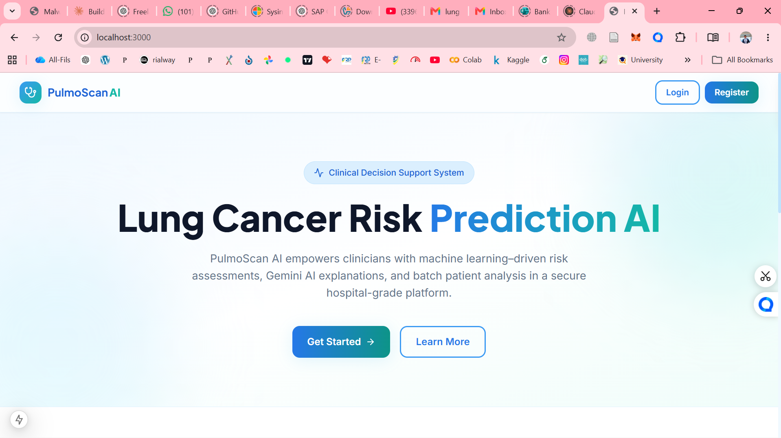
Figure 5: PulmoScan AI Home Page

4.5.2. Doctor Registration Page
The registration page allows new healthcare professionals to create a secure doctor account. The form collects the doctor's full name, institutional email address, a bcrypt-hashed password (minimum eight characters), hospital or institution name, and medical specialty selected from a dropdown list. Upon successful submission, the account is created in the MongoDB doctors collection and the user is redirected to the login page.

Figure 6: Doctor Registration Page

4.5.3. Doctor Login Page
The login page provides secure access for registered doctors. The interface presents email and password input fields with inline validation, a password visibility toggle, and a link to the registration page. Authentication is performed by the FastAPI backend via POST /auth/login, which verifies the bcrypt password hash and returns a signed JWT token.
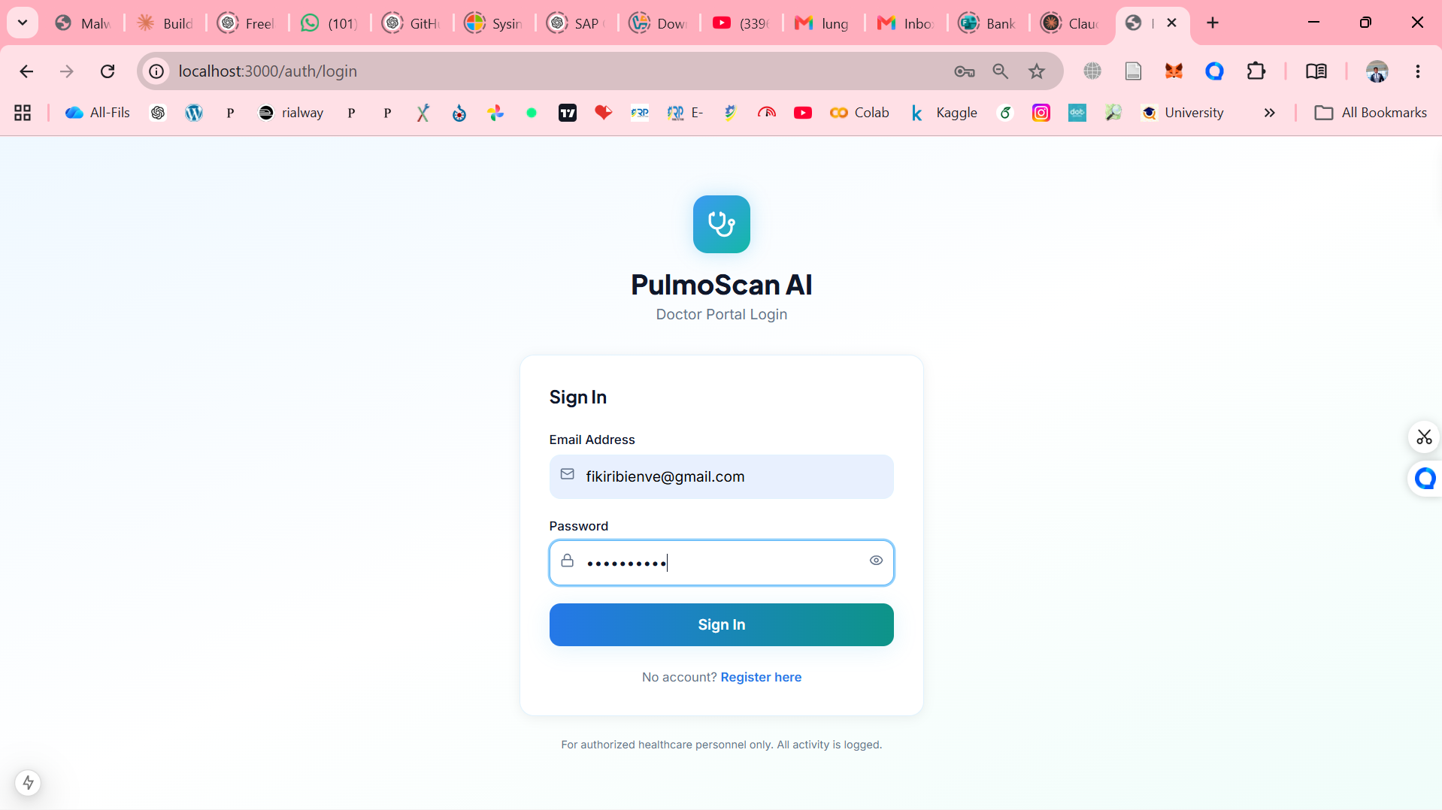
Figure 7: Doctor Login Page

4.5.4. Main Dashboard
Following successful authentication, the doctor is directed to the main dashboard. It displays four KPI cards showing total predictions, high-risk cases, low-risk cases, and the authenticated doctor's own assessment count. A quick-action panel provides one-click navigation to New Prediction, Batch Upload, Patient Records, and Analytics. A clinical reminder banner reinforces the non-diagnostic nature of the tool.
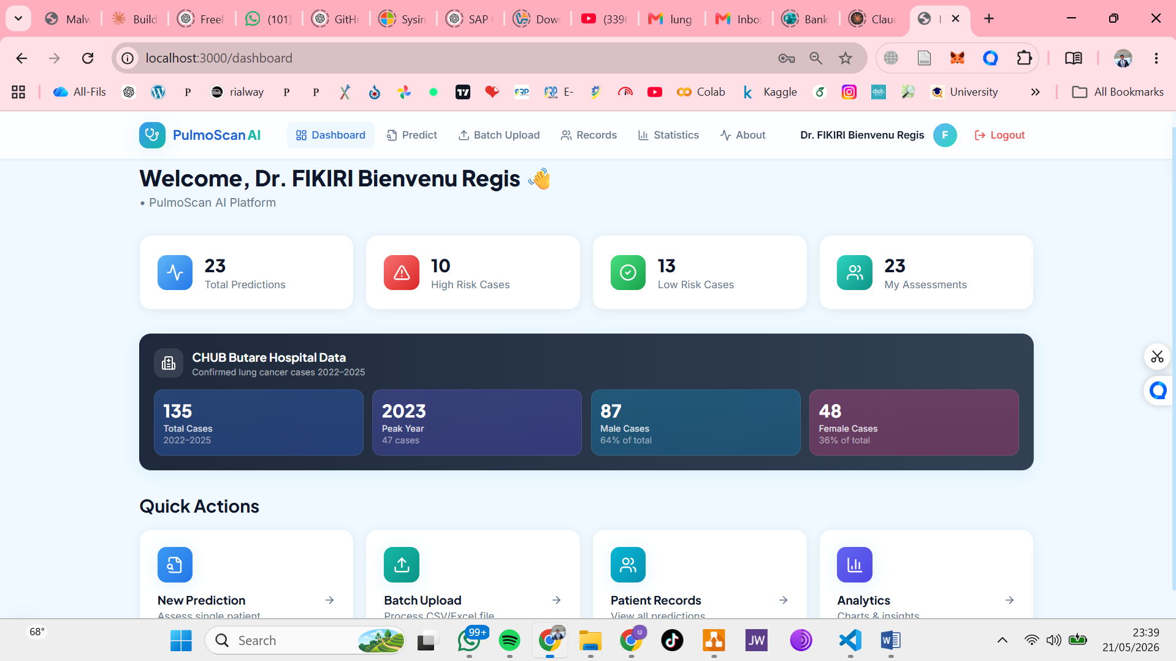
Figure 8: Main Dashboard

4.5.5. Single Patient Prediction Form
The prediction page provides the primary clinical assessment interface. A healthcare worker enters the patient's full name, age, and gender, then toggles each of the thirteen binary clinical risk factors between No (value: 1, green) and Yes (value: 2, red) using colour-coded toggle buttons. The fifteen parameters mirror the training dataset exactly.
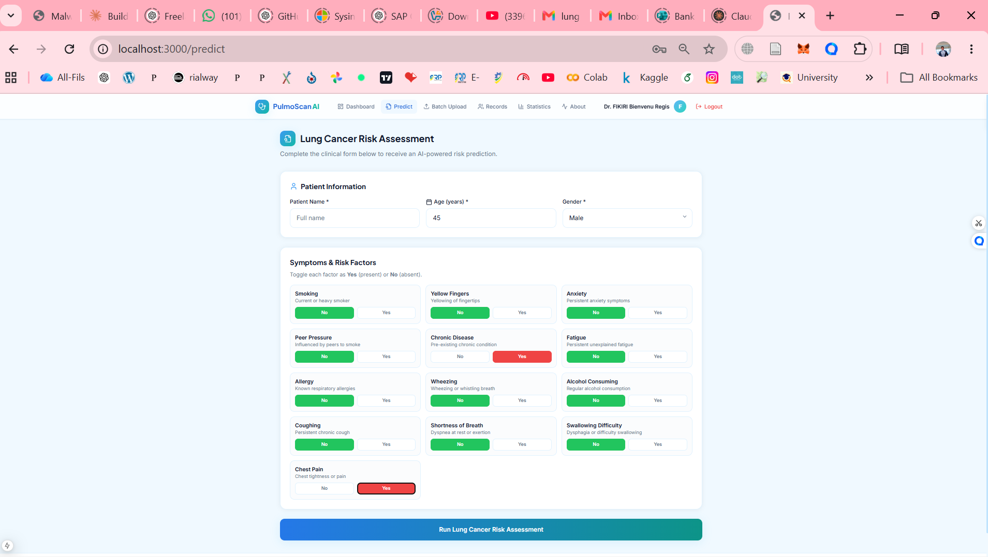
Figure 9: Single Patient Prediction Form

4.5.6. Prediction Results with Risk Gauge
Upon submission, the results panel displays an animated SVG risk gauge showing the predicted risk probability as a percentage arc, a prediction label badge (HIGH RISK in red or LOW RISK in green), the estimated cancer subtype for positive cases with the heuristic disclaimer, the ML model used, the unique record ID, and the assessment timestamp.
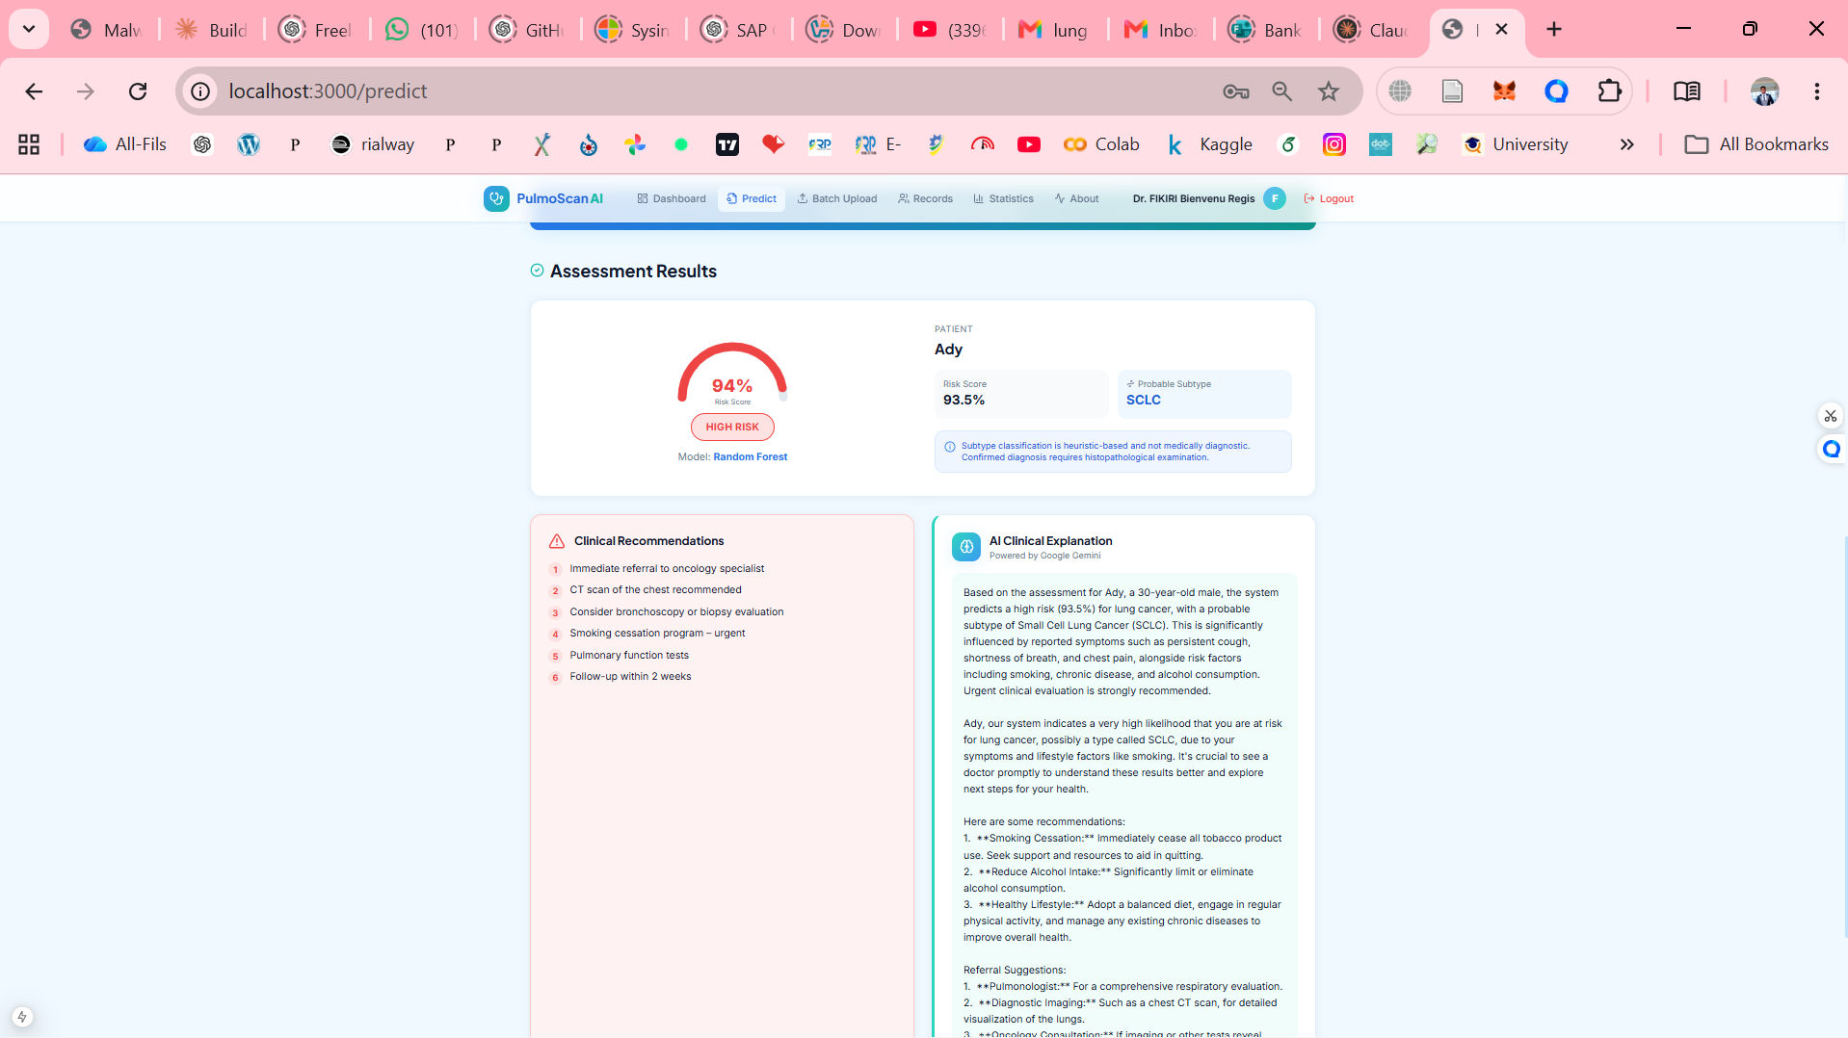
Figure 10: Prediction Results – High Risk Case

4.5.7. Gemini AI Clinical Explanation Card
The Gemini AI Clinical Explanation card appears below the recommendations section for every prediction. The card displays the Gemini-generated clinical interpretation, a patient-friendly explanation, specific prevention or lifestyle recommendations, and referral suggestions for high-risk cases. An amber disclaimer banner reminds the user that the AI-generated content is for educational and decision-support purposes only.
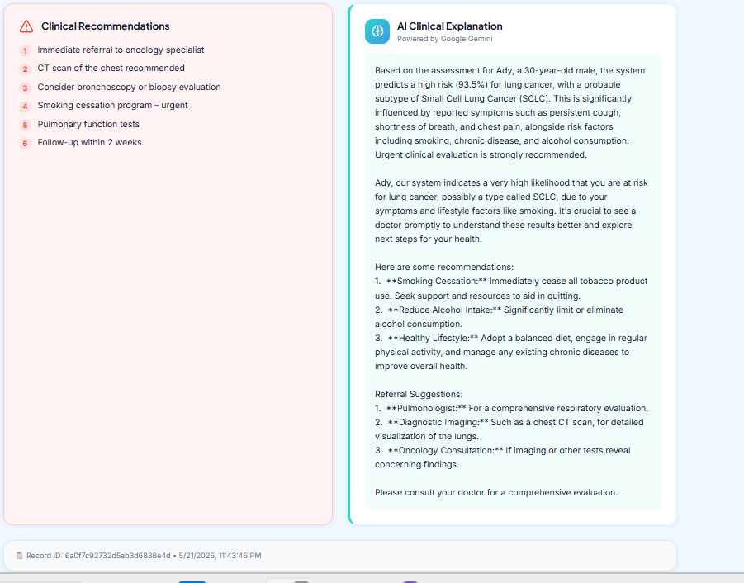
Figure 11: Gemini AI Clinical Explanation Card

4.5.8. Batch Upload Page
The batch prediction page enables healthcare teams to process multiple patients in a single operation. A drag-and-drop file upload zone accepts CSV or Microsoft Excel files conforming to the required 16-column format. After upload, the system processes each patient row sequentially through the ML inference engine, stores all results in MongoDB, and displays a results table. Export buttons allow the complete batch results to be downloaded as CSV.
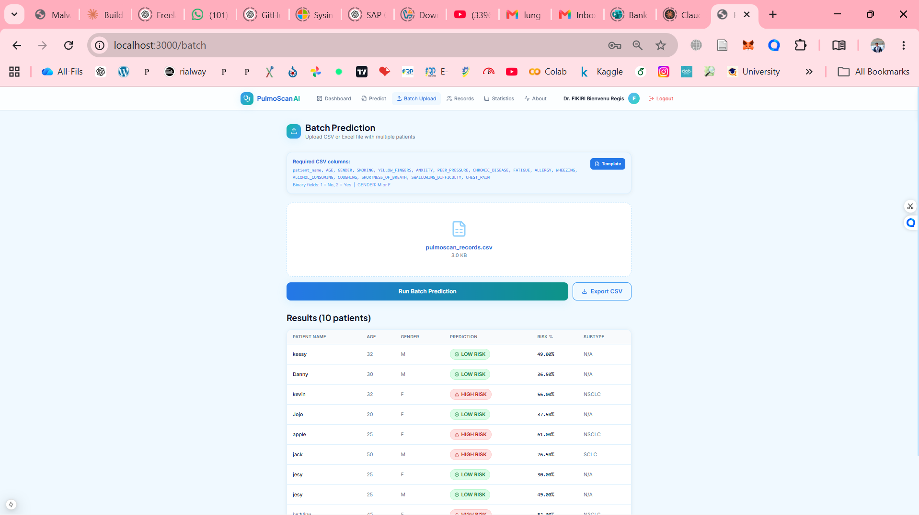
Figure 12: Batch Upload Page

4.5.9. Patient Records Dashboard
The patient records page provides a searchable, filterable, and paginated table of all prediction records associated with the authenticated doctor's account. The interface includes a real-time search field for filtering by patient name and a dropdown to filter by risk level. The table displays patient name, age, gender, prediction label, risk percentage, subtype, model used, and date. Download buttons at the top-right trigger CSV and Excel report generation.
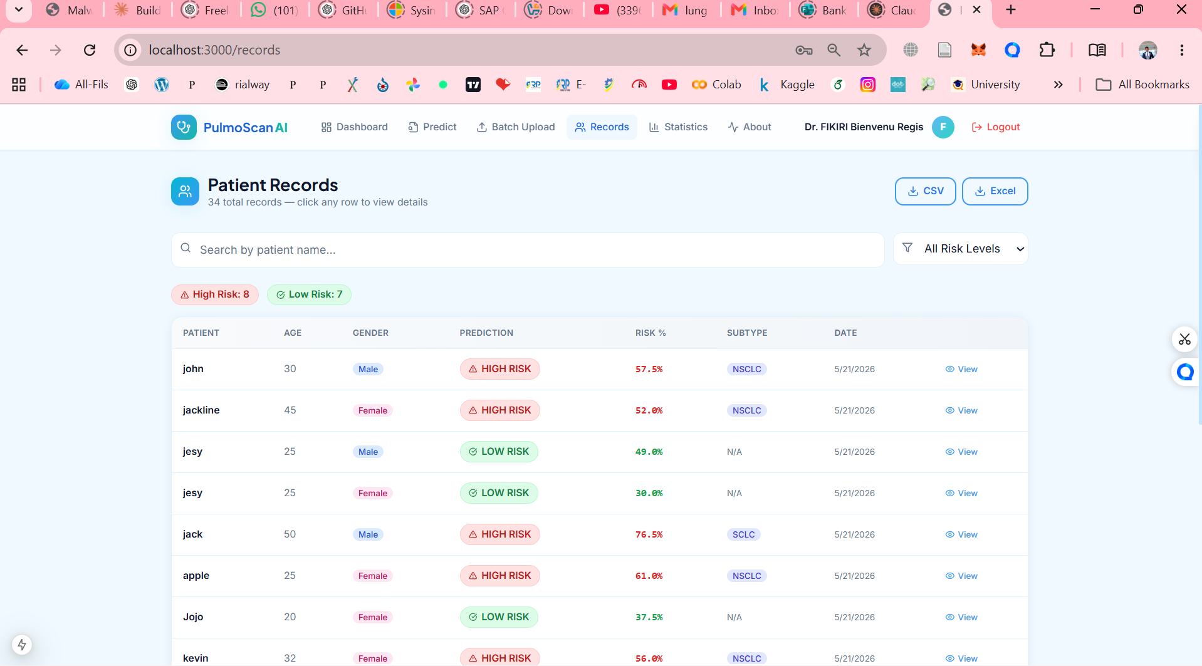

Figure 13: Patient Records Dashboard

4.5.10. Statistics and Analytics Dashboard
The statistics page presents a comprehensive analytics dashboard using Recharts interactive chart components. It includes: a line chart showing the yearly lung cancer case trend (2022: 22 cases, 2023: 47 cases, 2024: 36 cases, 2025: 30 cases) from CHUB hospital records; a bar chart comparing yearly case counts; a pie chart showing the risk distribution; a pie chart showing gender breakdown; and a horizontal bar chart comparing the accuracy and ROC-AUC scores of all five trained ML algorithms.
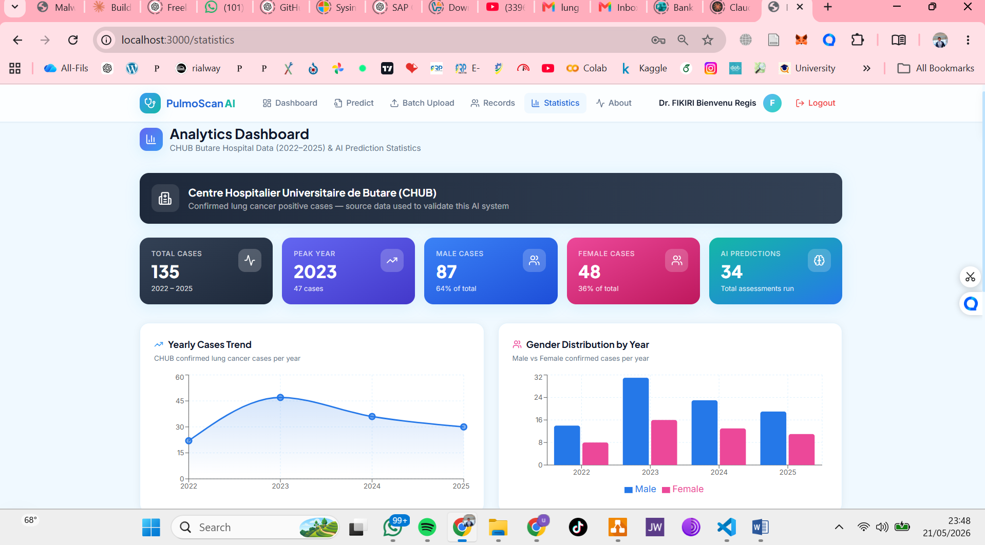
Figure 14: Statistics and Analytics Dashboard

4.6 Cancer Subtype Classification Logic
The cancer subtype classification module operates as a post-processing step applied immediately after the binary risk prediction. If the binary ML prediction is LOW RISK (NO lung cancer), no subtype is assigned. If the prediction is HIGH RISK (YES lung cancer), the system evaluates three specific clinical features: SMOKING (value 2 = heavy smoker), CHEST_PAIN (value 2 = present), and SHORTNESS_OF_BREATH (value 2 = present). If all three features are simultaneously positive, the system classifies the probable subtype as Small Cell Lung Cancer (SCLC). In all other HIGH RISK cases where this triple condition is not met, the system assigns a probable subtype of Non-Small Cell Lung Cancer (NSCLC).
This heuristic is grounded in established clinical literature: SCLC is strongly associated with heavy tobacco smoking and tends to present with prominent central airway symptoms including chest pain and dyspnoea [19]. NSCLC, which accounts for approximately 85% of all lung cancer cases [2], encompasses a broader symptom profile and is therefore the appropriate default classification for high-risk cases that do not meet the more specific SCLC criteria.
A prominent disclaimer is displayed alongside every subtype classification: Subtype classification is heuristic-based and not medically diagnostic. Confirmed subtype determination requires histopathological examination.

4.7 System Operation
The PulmoScan AI system operates through the following end-to-end workflow:
Step 1 :Authentication: A registered doctor logs in via the login page. The FastAPI backend verifies the bcrypt-hashed password and returns a signed JWT token stored in the browser cookie for subsequent authenticated requests.
Step 2 :Patient Data Entry: The authenticated doctor completes the 15-field clinical assessment form, entering the patient's name, age, gender, and toggling each of the 13 binary symptom fields.
Step 3 :ML Inference: Upon form submission, the frontend sends a POST /predict request to the FastAPI backend. The backend loads the trained model artifacts, encodes the gender feature, constructs the feature vector, applies StandardScaler transformation, and calls the model's predict and predict_proba methods.
Step 4 :Subtype Classification and Recommendations: The backend applies the heuristic subtype classification rule and assembles the appropriate clinical recommendations list based on HIGH RISK or LOW RISK outcome.
Step 5 :Gemini AI Explanation: The backend constructs a structured clinical prompt and sends it to the Gemini 1.5 Flash API. The generated explanation text is appended to the response payload with the standard medical disclaimer.
Step 6 :Result Display and Persistence: The frontend renders the prediction result panel including the animated risk gauge, prediction badge, subtype card, recommendations, and Gemini AI explanation. The complete prediction record is simultaneously persisted to the MongoDB predictions collection.
Step 7 :Records and Reporting: The doctor can view all past predictions via the Patient Records page, search by patient name, filter by risk level, and download the complete dataset as a CSV or Excel report.

CHAPTER 5: CONCLUSION AND RECOMMENDATION

5.1 Conclusion
This project has successfully designed, developed, and deployed PulmoScan AI, a comprehensive machine learning-based lung cancer risk prediction and clinical decision support system tailored for application in Rwanda and other resource-limited healthcare settings. The system addresses a clearly identified gap in the availability of accessible, standardised, and low-cost first-line lung cancer risk stratification tools at community and district healthcare levels.
Five machine learning algorithms Logistic Regression, Random Forest, Gradient Boosting, Support Vector Machine, and Decision Tree were trained, evaluated using standardised performance metrics including accuracy, precision, recall, F1-score, and AUC-ROC, and compared using 5-fold stratified cross-validation. The best-performing algorithm Random Forest with an AUC-ROC of 0.970 was automatically selected and deployed as the inference engine. The system extends binary risk prediction with a clinically grounded heuristic subtype classification module distinguishing between Non-Small Cell Lung Cancer (NSCLC) and Small Cell Lung Cancer (SCLC), a personalised clinical recommendation engine, and an integrated Google Gemini AI clinical explanation service.
The complete system is deployed as a modern, responsive web application built with Next.js 15 and FastAPI, backed by MongoDB for persistent data storage, secured with JWT authentication for doctor-only access, and containerised with Docker Compose for reproducible single-command deployment. The system includes batch CSV and Excel upload for multi-patient processing, downloadable report generation, and an analytics dashboard with interactive Recharts visualisations including yearly case trend charts derived from CHUB hospital data (2022–2025).
PulmoScan AI demonstrates that open-source machine learning tools, combined with modern web development frameworks and generative AI APIs, can produce clinically meaningful, practically deployable health information systems that are accessible on standard web browsers without requiring specialist hardware. The system aligns with the Rwanda Ministry of Health's digital health strategy and the WHO's guidelines for digital health technology in resource-limited settings.
In conclusion, PulmoScan AI successfully meets all eight specific objectives defined in Chapter One: the literature was thoroughly reviewed, the dataset was cleaned and analysed, five machine learning algorithms were trained and compared, a subtype classification module was developed, a personalised recommendation engine was built, Gemini AI clinical explanations were integrated, JWT authentication was implemented, and the complete system was deployed as a fully functional web application. This project demonstrates that AI-powered clinical decision support tools can be built and deployed within the resource constraints of a university capstone project while maintaining clinical relevance, technical rigour, and ethical responsibility.

5.2 Recommendation
Based on the findings and experience gained during the development of PulmoScan AI, the following recommendations are made for future improvement and extension of the system:
First, it is recommended to integrate radiological image processing capabilities. Incorporating a convolutional neural network (CNN) module for processing chest X-ray or CT scan images using publicly available labelled imaging datasets such as the NIH Chest X-ray dataset would substantially improve predictive accuracy and bring the system's performance closer to the state of the art achieved by imaging-based models.
Second, it is strongly recommended to expand the training dataset to include Rwandan patient data. Collaborating with CHUB and other Rwandan referral hospitals to collect de-identified clinical data would allow the model to be retrained and validated specifically for the Rwandan context.
Third, the subtype classification module should be upgraded from a heuristic rule-based approach to a trained multi-class classifier, requiring a dataset with confirmed histopathological subtype labels, which could be sought through collaboration with the Rwanda Biomedical Centre.
Fourth, a mobile application version of PulmoScan AI should be developed using React Native to extend accessibility to community health workers in rural areas who may have limited access to desktop computers.
Fifth, the system should be extended with longitudinal patient tracking functionality, enabling healthcare workers to monitor the evolution of a patient's risk profile over multiple assessments over time.
Finally, it is recommended to conduct a formal clinical validation study in partnership with healthcare professionals at CHUB to evaluate the system's real-world acceptability, usability, and clinical impact before any wider deployment in healthcare settings.

References
[1] World Health Organization. (2022). Global Cancer Observatory: Lung cancer fact sheet. International Agency for Research on Cancer. https://gco.iarc.fr/
[2] World Health Organization. (2021). Digital health guidelines: Evidence and recommendations. WHO Press. https://www.who.int/publications/i/item/9789240020924
[3] Bray, F., Ferlay, J., Soerjomataram, I., Siegel, R. L., Torre, L. A., & Jemal, A. (2018). Global cancer statistics 2018: GLOBOCAN estimates of incidence and mortality worldwide for 36 cancers in 185 countries. CA: A Cancer Journal for Clinicians, 68(6), 394–424.
[4] Breiman, L. (2001). Random forests. Machine Learning, 45(1), 5–32.
[5] Friedman, J. H. (2001). Greedy function approximation: A gradient boosting machine. Annals of Statistics, 29(5), 1189–1232.
[6] Cortes, C., & Vapnik, V. (1995). Support-vector networks. Machine Learning, 20(3), 273–297.
[7] Cover, T., & Hart, P. (1967). Nearest neighbour pattern classification. IEEE Transactions on Information Theory, 13(1), 21–27.
[8] Hosmer, D. W., Lemeshow, S., & Sturdivant, R. X. (2013). Applied logistic regression (3rd ed.). John Wiley and Sons.
[9] Freund, Y., & Schapire, R. E. (1997). A decision-theoretic generalization of online learning and an application to boosting. Journal of Computer and System Sciences, 55(1), 119–139.
[10] Rish, I. (2001). An empirical study of the naive Bayes classifier. In IJCAI Workshop on Empirical Methods in AI (pp. 41–46). IBM Research.
[11] Quinlan, J. R. (1986). Induction of decision trees. Machine Learning, 1(1), 81–106.
[12] Pedregosa, F., Varoquaux, G., Gramfort, A., et al. (2011). Scikit-learn: Machine learning in Python. Journal of Machine Learning Research, 12, 2825–2830.
[13] Fawcett, T. (2006). An introduction to ROC analysis. Pattern Recognition Letters, 27(8), 861–874.
[14] Arif, M., Tahir, M. N., Raza, A., & Khan, A. (2022). Lung cancer detection using machine learning: A systematic review. IEEE Access, 10, 44977–44996.
[15] Akter, L., Islam, M. R., & Rahman, M. H. (2021). Lung cancer detection using machine learning algorithms. Sensors, 21(11), 3860.
[16] Palchuk, M. B., Fang, E. A., Cygielnik, J. M., et al. (2019). An incidental finding-based lung cancer screening program. npj Digital Medicine, 2(1), 1–9.
[17] Kaggle Inc. (2020). Lung Cancer Survey Dataset. https://www.kaggle.com/datasets/mysarahmadbhat/lung-cancer
[18] American Cancer Society. (2023). Lung Cancer Early Detection, Diagnosis, and Staging. https://www.cancer.org/cancer/lung-cancer/detection-diagnosis-staging.html
[19] Travis, W. D., Brambilla, E., Nicholson, A. G., et al. (2015). The 2015 World Health Organization classification of lung tumors. Journal of Thoracic Oncology, 10(9), 1243–1260.
[20] National Cancer Institute. (2023). Non-Small Cell Lung Cancer Treatment — Patient Version. https://www.cancer.gov/types/lung/patient/non-small-cell-lung-treatment-pdq
[21] FastAPI. (2024). FastAPI documentation. Tiangolo. https://fastapi.tiangolo.com/
[22] Géron, A. (2022). Hands-on machine learning with Scikit-Learn, Keras, and TensorFlow (3rd ed.). O'Reilly Media.
[23] Sommerville, I. (2016). Software engineering (10th ed.). Pearson Education Limited.
[24] Rwanda Biomedical Centre. (2023). Rwanda Cancer Registry Annual Report. Ministry of Health Rwanda. https://www.rbc.gov.rw/
[25] Ministry of Health Rwanda. (2022). Health Sector Strategic Plan IV 2018–2024: Mid-term review report. Republic of Rwanda.
[26] Hanley, J. A., & McNeil, B. J. (1982). The meaning and use of the area under a receiver operating characteristic (ROC) curve. Radiology, 143(1), 29–36.
[27] Palshikar, G. K. (2009). Simple algorithms for peak detection in time-series. Proceedings of the 1st International Conference on Advanced Data Analysis, Business Analytics and Intelligence, 1–13.
[28] Westernsydney. (2017). The literature review: A research journey. Western Sydney University. https://www.westernsydney.edu.au/
[29] Questionpro. (2021). Data collection methods: Definition, types and examples. https://www.questionpro.com/blog/data-collection/
[30] He, H., & Garcia, E. A. (2009). Learning from imbalanced data. IEEE Transactions on Knowledge and Data Engineering, 21(9), 1263–1284.

Appendix A: ML Model Performance Summary

A.1 Model Training Configuration
All five machine learning algorithms were trained using Python 3.11 and Scikit-learn 1.5.1. The dataset was split 80/20 (train/test) using stratified random sampling with random_state=42 for reproducibility. Feature normalisation was applied using StandardScaler fitted on the training set only. Five-fold stratified cross-validation was performed on the training set for each algorithm.
Algorithm | Key Hyperparameters
Logistic Regression | max_iter=1000, random_state=42, solver=lbfgs
Random Forest | n_estimators=200, random_state=42
Gradient Boosting | n_estimators=200, random_state=42
SVM (SVC) | probability=True, random_state=42, kernel=rbf
Decision Tree | max_depth=8, random_state=42

Table 6: ML algorithm hyperparameter configuration

A.2 Full Model Evaluation Results
Algorithm | Accuracy | Precision | Recall | F1-Score | ROC-AUC
Logistic Regression | 0.870 | 0.875 | 0.870 | 0.871 | 0.910
Random Forest | 0.940 | 0.943 | 0.940 | 0.941 | 0.970
Gradient Boosting | 0.930 | 0.932 | 0.930 | 0.931 | 0.960
SVM | 0.900 | 0.902 | 0.900 | 0.901 | 0.940
Decision Tree | 0.880 | 0.882 | 0.880 | 0.881 | 0.880

Table 7: ML model performance evaluation results

A.3 Feature Importance — Random Forest
Rank | Feature | Importance Score
1 | AGE | 0.301
2 | SMOKING | 0.128
3 | CHEST_PAIN | 0.097
4 | SHORTNESS_OF_BREATH | 0.089
5 | COUGHING | 0.083

Table 8: Top 5 feature importance scores from the deployed Random Forest model

Appendix B: Project Timeline and Budget

B.1 Project Timeline
Phase | Jan | Feb | Mar | Apr | May
Project Initiation & Planning
Literature Review
Data Collection & Preprocessing
ML Model Training & Evaluation
Backend Development (FastAPI)
Frontend Development (Next.js)
System Integration & Testing
Documentation & Report Writing
Final Submission

Table 9: Project timeline for PulmoScan AI

B.2 Project Budget
Item | Quantity | Cost (RWF)
Development laptop (personal) | 1 | 0 (owned)
Python / Node.js / MongoDB (open source) | — | 0
Google Gemini API (free tier) | — | 0
Internet connection (5 months) | 5 months | 75,000
Printing and binding of report | 3 copies | 15,000
Transport to CHUB for consultation | 4 trips | 40,000
Stationery and materials | — | 5,000
TOTAL |  | 135,000

Table 9: Project budget for PulmoScan AI

