**Q13 Text Mining:**

word freq

smart smart 55

grid grid 50

power power 42

energy energy 33

systems systems 26

system system 26

standards standards 15

renewable renewable 15

control control 15

design design 13

technologies technologies 12

electric electric 11

engineering engineering 11

development development 10

distribution distribution 10

integration integration 10

applications applications 9

electrical electrical 9

management management 9

communication communication 8

new new 8

synchro synchro 8

iot iot 8

case case 8

electronics electronics 8

security security 8

grids grids 7

analysis analysis 7

operation operation 7

reliability reliability 7

grid\u0094 grid<U+0094> 7

generation generation 7

storage storage 7

technology technology 7

microgrids microgrids 6

\u0093smart <U+0093>smart 6

studies studies 6

including including 5

planning planning 5

quality quality 5

based based 5

ieee ieee 5

automation automation 5

implementation implementation 5

aspects aspects 5

cybersecurity cybersecurity 4

data data 4

research research 4

fundamentals fundamentals 4

practices practices 4

project project 4

economic economic 4

higher higher 4

principles principles 4

current current 4

sources sources 4

demand demand 4

ethics ethics 4

knowledge knowledge 4

microgrid microgrid 4

sustainability sustainability 4

peer peer 4

metering metering 4

communications communications 4

learning learning 4

equipment equipment 3

der der 3

future future 3

high high 3

maintenance maintenance 3

cost cost 3

perform perform 3

synchronous synchronous 3

working working 3

supply supply 3

customer customer 3

harmonics harmonics 3

issues issues 3

wind wind 3

battery battery 3

load load 3

models models 3

blockchain blockchain 3

optimization optimization 3

practical practical 3

safety safety 3

concepts concepts 3

standard standard 3

interconnection interconnection 3

protection protection 3

projects projects 3

things things 3

market market 3

stability stability 3

techniques techniques 3

impact impact 3

real real 3

focus focus 3

simulation simulation 3

work work 3

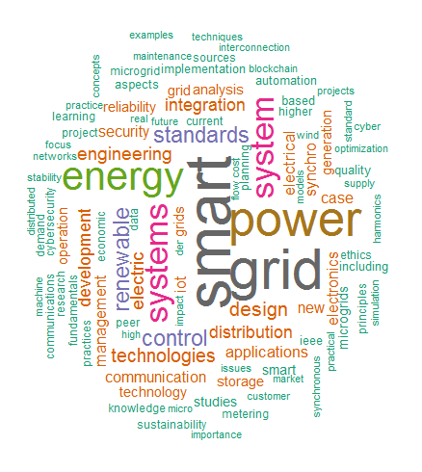

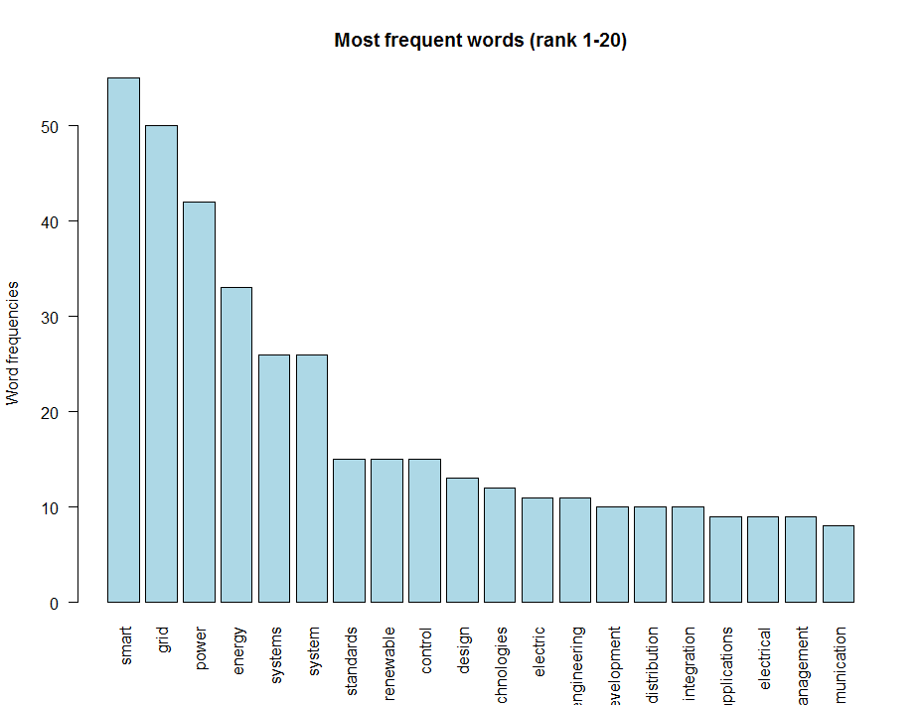

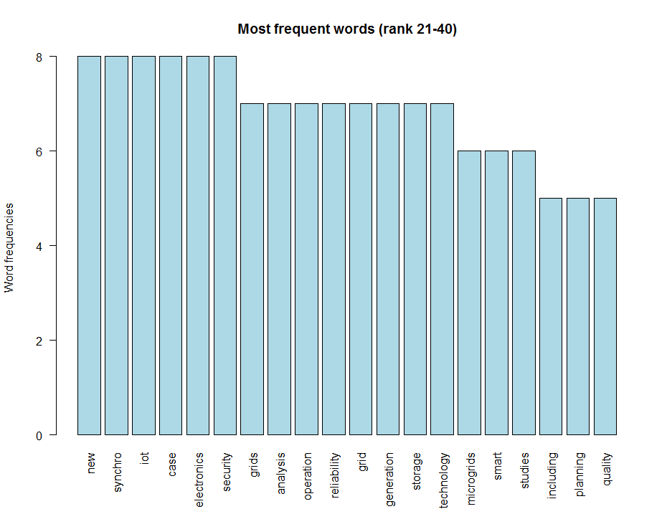

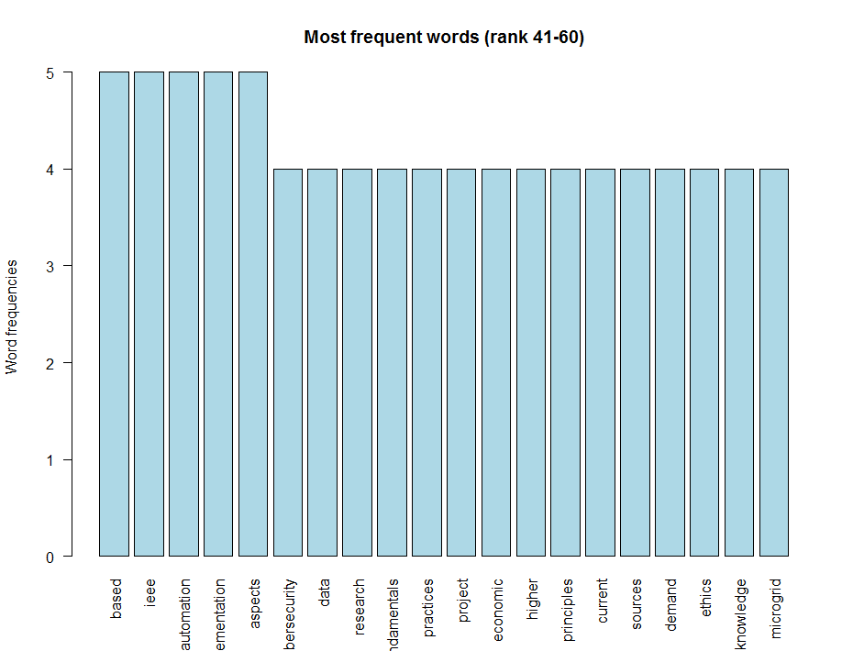

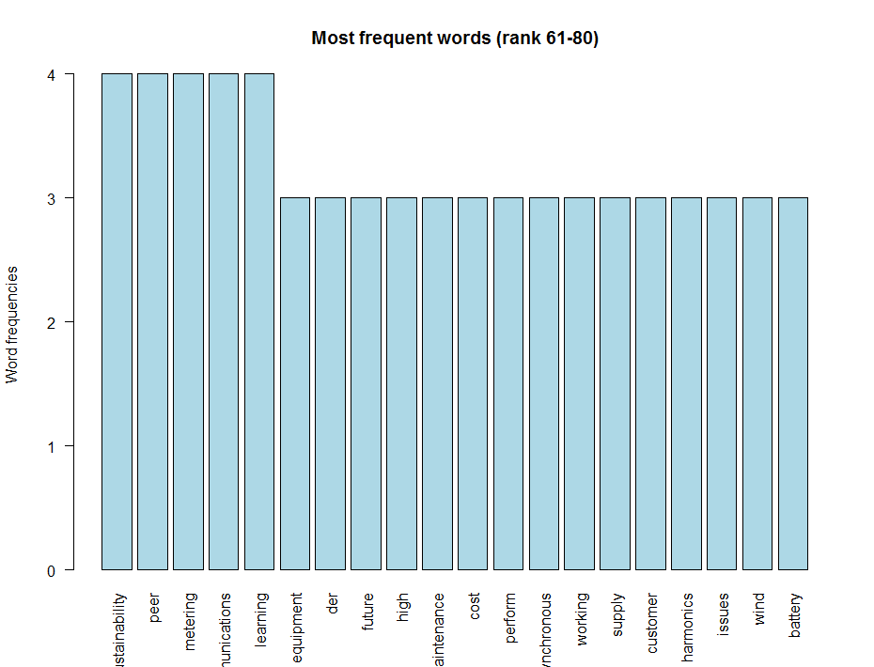

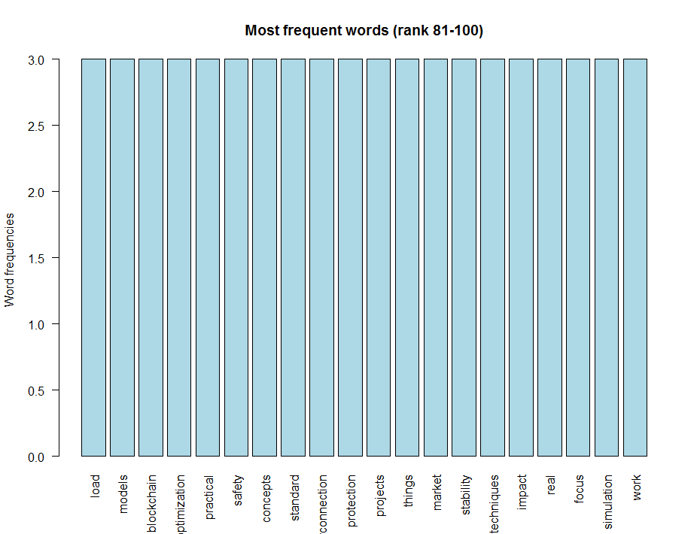

Redo with a few words removed:

"just", "many", "etc", "smart", "grid", "power", "energy", "system", "systems", "grids", "new", "yes", "including"

