**Q13 & 21 Text Mining:**

Removed: "just", "many", "etc", "smart", "grid", "power", "energy", "system", "systems", "grids", "new", "yes", "including"

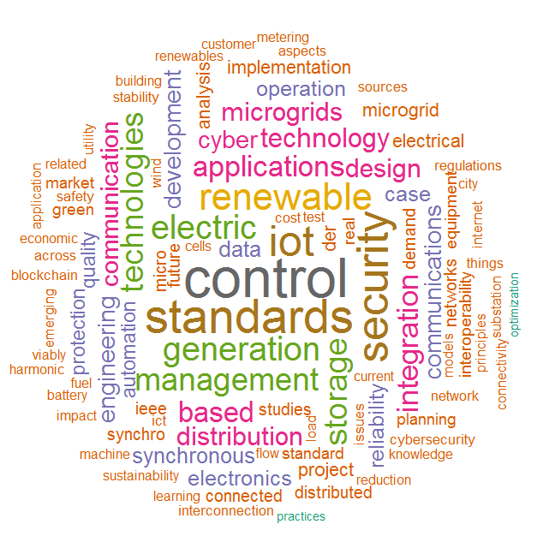

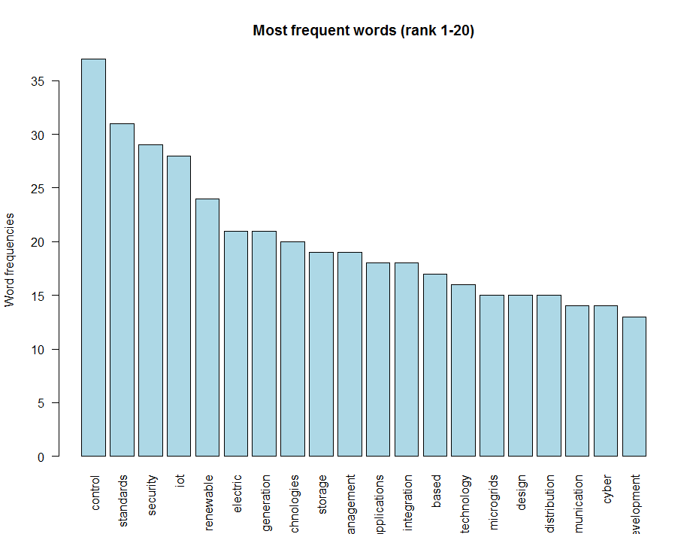

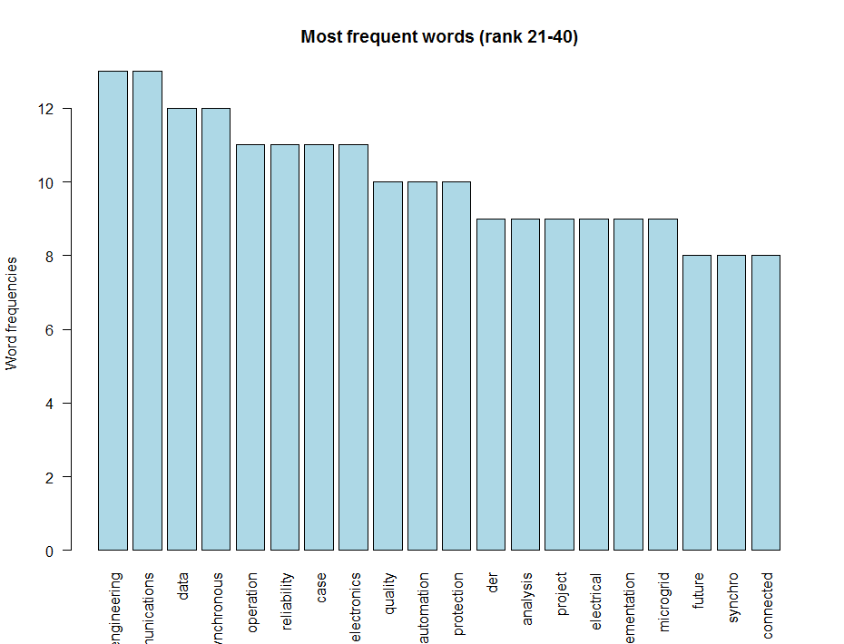

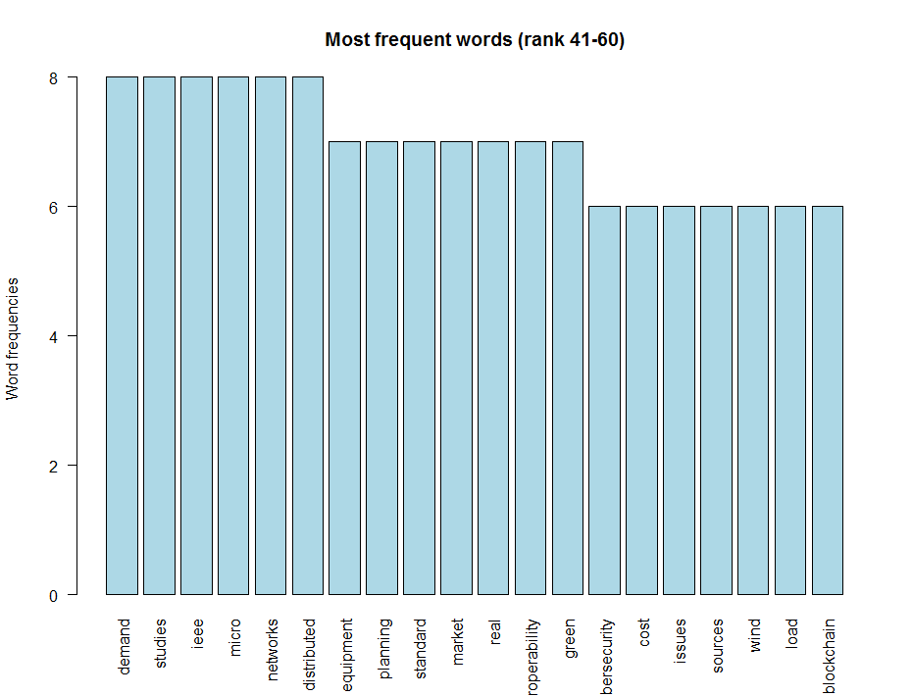

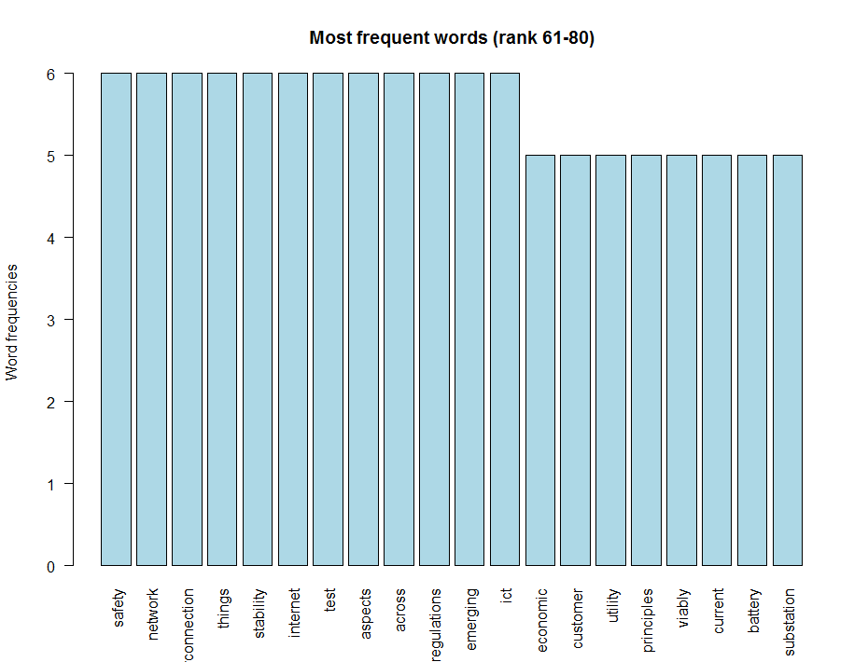

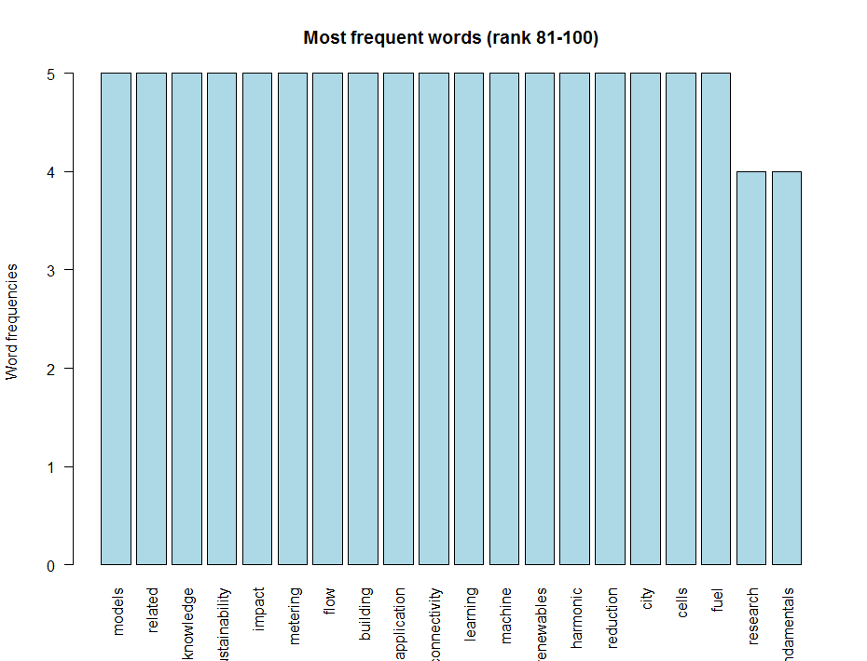

word freq

control control 37

standards standards 31

security security 29

iot iot 28

renewable renewable 24

electric electric 21

generation generation 21

technologies technologies 20

storage storage 19

management management 19

applications applications 18

integration integration 18

based based 17

technology technology 16

microgrids microgrids 15

design design 15

distribution distribution 15

communication communication 14

cyber cyber 14

development development 13

engineering engineering 13

communications communications 13

data data 12

synchronous synchronous 12

operation operation 11

reliability reliability 11

case case 11

electronics electronics 11

quality quality 10

automation automation 10

protection protection 10

der der 9

analysis analysis 9

project project 9

electrical electrical 9

implementation implementation 9

microgrid microgrid 9

future future 8

synchro synchro 8

connected connected 8

demand demand 8

studies studies 8

ieee ieee 8

micro micro 8

networks networks 8

distributed distributed 8

equipment equipment 7

planning planning 7

standard standard 7

market market 7

real real 7

interoperability interoperability 7

green green 7

cybersecurity cybersecurity 6

cost cost 6

issues issues 6

sources sources 6

wind wind 6

load load 6

blockchain blockchain 6

safety safety 6

network network 6

interconnection interconnection 6

things things 6

stability stability 6

internet internet 6

test test 6

aspects aspects 6

across across 6

regulations regulations 6

emerging emerging 6

ict ict 6

economic economic 5

customer customer 5

utility utility 5

principles principles 5

viably viably 5

current current 5

battery battery 5

substation substation 5

models models 5

related related 5

knowledge knowledge 5

sustainability sustainability 5

impact impact 5

metering metering 5

flow flow 5

building building 5

application application 5

connectivity connectivity 5

learning learning 5

machine machine 5

renewables renewables 5

harmonic harmonic 5

reduction reduction 5

city city 5

cells cells 5

fuel fuel 5

research research 4

fundamentals fundamentals 4