**Q21 Text Mining:**

word freq

word freq

smart smart 58

grid grid 54

power power 32

energy energy 30

control control 22

security security 21

yes yes 21

iot iot 20

systems systems 18

standards standards 16

generation generation 14

based based 12

new new 12

storage storage 12

system system 11

cyber cyber 11

electric electric 10

management management 10

renewable renewable 9

synchronous synchronous 9

grids grids 9

microgrids microgrids 9

applications applications 9

technology technology 9

data data 8

integration integration 8

communications communications 8

technologies technologies 8

microgrid microgrid 7

protection protection 7

interoperability interoperability 6

connected connected 6

der der 6

communication communication 6

quality quality 5

harmonic harmonic 5

reduction reduction 5

city city 5

future future 5

ict ict 5

networks networks 5

distribution distribution 5

distributed distributed 5

across across 5

emerging emerging 5

cells cells 5

fuel fuel 5

project project 5

automation automation 5

green green 5

network network 4

operation operation 4

operating operating 4

viably viably 4

conjuncgion conjuncgion 4

reliability reliability 4

implementation implementation 4

demand demand 4

renewables renewables 4

regulations regulations 4

test test 4

real real 4

standard standard 4

equipment equipment 4

internet internet 4

connectivity connectivity 4

market market 4

development development 3

services services 3

load load 3

substation substation 3

dynamic dynamic 3

safety safety 3

cost cost 3

education education 3

related related 3

electronics electronics 3

utility utility 3

issues issues 3

micro micro 3

intelligence intelligence 3

case case 3

electronic electronic 3

stability stability 3

use use 3

things things 3

wind wind 3

interconnection interconnection 3

ieee ieee 3

blockchain blockchain 3

converters converters 3

center center 3

open open 3

better better 3

operations operations 3

lighting lighting 3

building building 3

good good 3

application application 3

sustainable sustainable 2

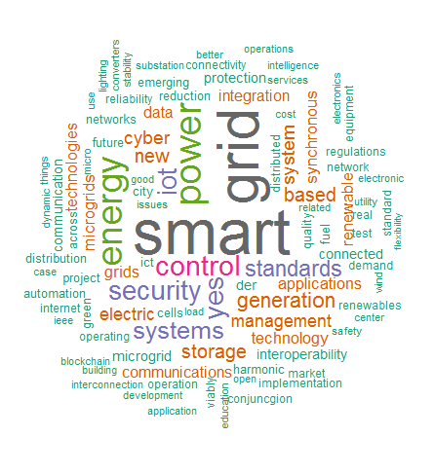

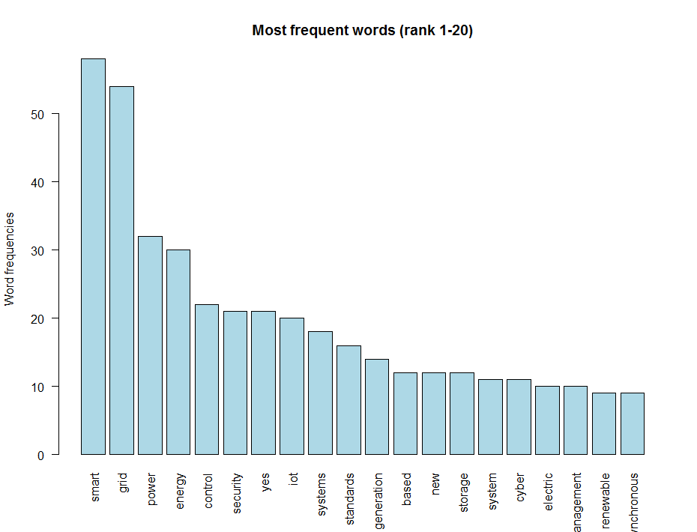

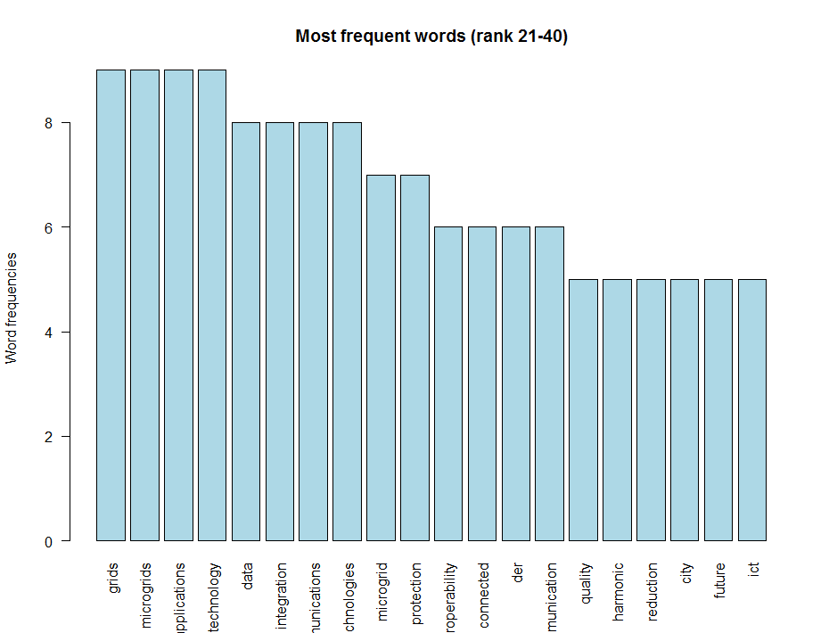

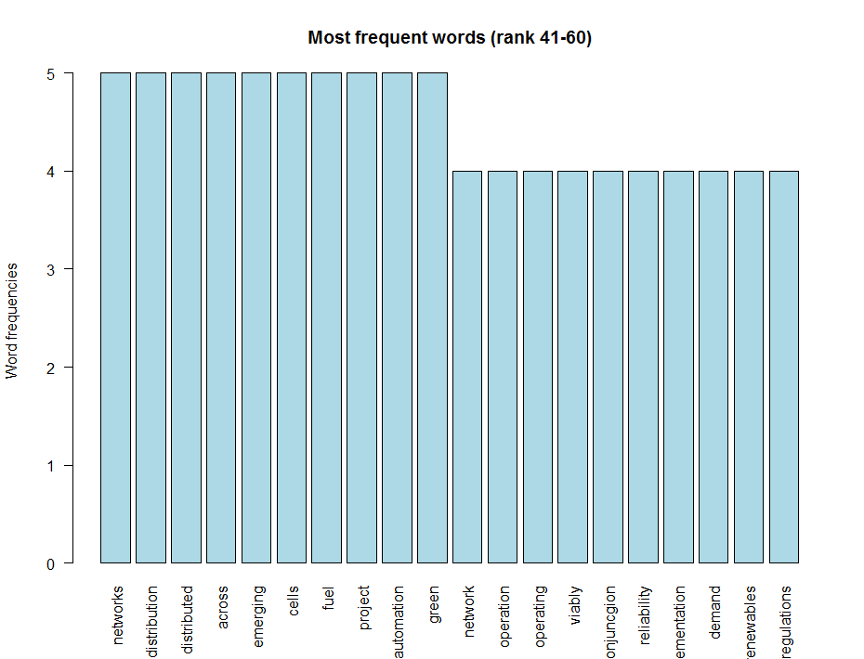

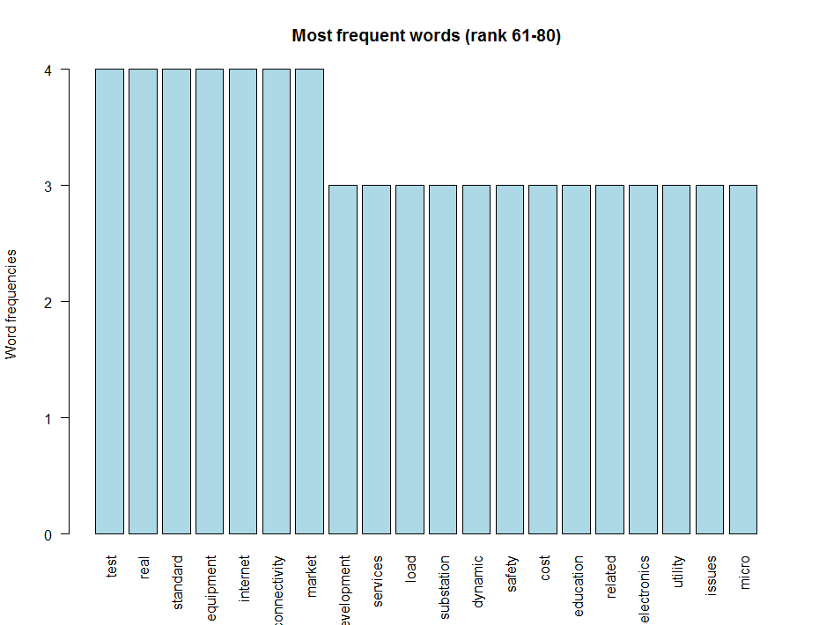

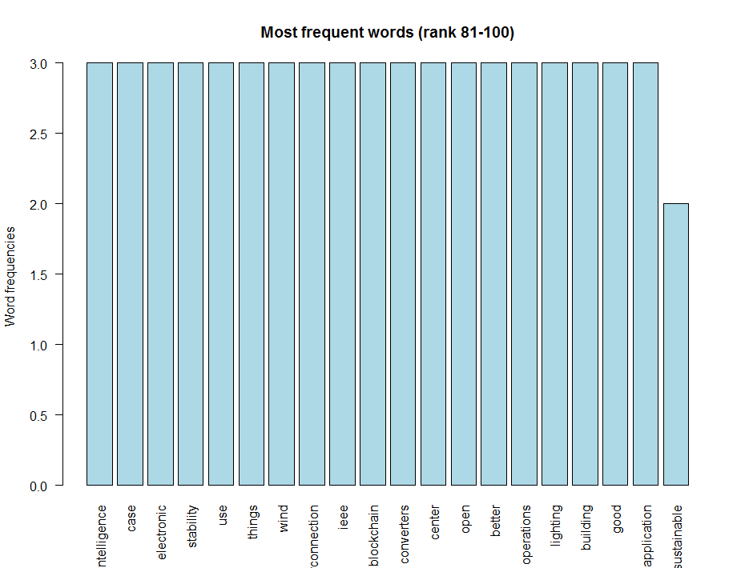

Redo with a few words removed:

"just", "many", "etc", "smart", "grid", "power", "energy", "system", "systems", "grids", "new", "yes", "including"

