**View the Lesson (Command Line Basics)**

**What is the "Shell"?**

* Shell is an interface between an end-user and the Linux system.
* In other words, Shell is a program that receives commands from the user, relays them to the operating system to process and displays the output. Shell is one of the main parts of Linux OS. Each Linux distro comes with a GUI (Graphical User Interface), but essentially Linux has a CLI (Command-Line Interface).

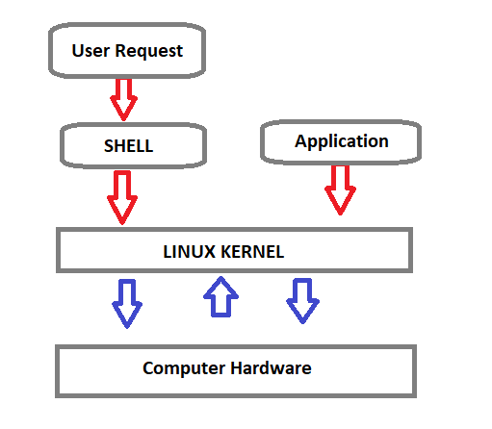

Shell Types

**C Shell :** If you are using a C-type shell, the % character is the default prompt.

* C shell (csh)
* TENEX/TOPS C shell (tcsh)

**Bourne Shell :** If you are using a Bourne-type shell, the $ character is the default prompt.

* Bourne shell (sh)
* Korn shell (ksh)
* Bourne Again shell (bash)
* POSIX shell (sh)

An enhanced version of SH is called BASH (which stands for **B**ourne **A**gain **SH**ell) and serves as the main shell program on the most Linux systems.

* The standard Linux shell (BASH) is both a command-line interpreter and a programming language.

The most common interpreter is BASH or the Bourne Again Shell, but there are others available as well and some of them does not use the dollar sign.

**Command Prompt**

The command prompt at the beginning of the command line is a short text string. The command prompt for Linux generally shows the current **user**, the current **host**, and the appropriate **directory**.

The command prompt is easily modified to display as desired with more or less information. At the end of the prompt list, the $(dollar sign) signifies the current user being unprivileged.

* Dollar sign ($) means you are a normal user and indicates you are logged in with the normal permissions.
* Hash (#) means you are the system administrator (root) and indicates you are logged in with root privileges.
* The "root" account on a Linux computer is the account with full privileges.
* Root access is often necessary for performing commands in Linux, especially commands that affect system files. Because root is so powerful, it's recommended to only request root access when necessary, as opposed to logging in as the root user.

**Basic Shell Commands**

This is a list of most frequently used Linux commands.

* The **~ (tilde)** symbol stands for your home directory.
* The **pwd** (stands for print working directory) command will allow you to know in which directory you're located.
* The **ls** command will show you the list of folders and files in your current directory.
* The **cp** command will make a copy of a file.
* The **cd** command will allow you to change directories.
* The **rm** command removes or deletes a file in your directory.
* The **rmdir** command will delete an empty directory.
* The **mkdir** command will allow you to create directories
* The **mv** command will move a file to a different location or will rename a file.
* cd - Navigate to the last directory you were working in.
* cd ~ or just cd Navigate to the current user's home directory.
* cd .. Go to the parent directory of current directory (mind the space between cd and ..)

**Quoting**

Quoting is used to disable special treatment of certain characters and words, as well as to prevent parameter expansion and preserve what is quoted.

The bash shell knows rare, special characters like $ (dollar sign), which is used to extend the value of the element. For example $PATH is used to extend the value of PATH element which is predefined variable in bash to hold system paths as shown below.

clarusway@f85a0c1549f4:~$ echo $PATH

/usr/local/sbin:/usr/local/bin:/usr/sbin:/usr/bin:/sbin:/bin:/usr/games:/usr/local/games

The special character $ can also be used with the user's custom element. For example, in the bash shell, the user can define an element like greeting="Hello from Clarusway" and extend the value of this element as shown below.

clarusway@f85a0c1549f4:~$ greeting="Hello from Clarusway"

clarusway@f85a0c1549f4:~$ echo $greeting

Hello from Clarusway

**There are three types of quotes:**

1. **Double Quotes** : The double quote " preserve the literal value of most characters contained within the quotes, exceptions include $ (for variables), ' (for single quoting), \ (for escaping a character) .

clarusway@f85a0c1549f4:~$ echo $SHELL

/bin/bash

clarusway@f85a0c1549f4:~$ echo "$SHELL"

/bin/bash

clarusway@f85a0c1549f4:~$ echo "path to shell $SHELL"

path to shell /bin/bash

1. **Single Quotes**: The single quote ( 'quote' ) protects everything enclosed between single quotation marks.

clarusway@f85a0c1549f4:~$ echo $SHELL

/bin/bash

clarusway@f85a0c1549f4:~$ echo '$SHELL'

$SHELL

clarusway@f85a0c1549f4:~$ echo 'path to shell $SHELL'

path to shell $SHELL

1. **Backslash**: Use the backslash to change the special meaning of the characters or to escape special characters within the text such as quotation marks.

clarusway@f85a0c1549f4:~$ echo "\$SHELL"

$SHELL

clarusway@f85a0c1549f4:~$ echo "path to shell \$SHELL"

path to shell $SHELL

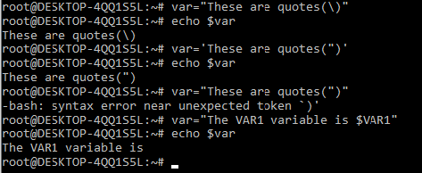

**File Permission**

**Linux File Ownership**

Each file and directory on Linux system has 3 types of owners assigned,

* **User :** A user is the owner of the file.
* **Group :** A user- group can contain multiple users.
* **Other/All :** Any other user who has access to a file.

Permission

Each file and directory on your Linux system has 3 permissions defined for all the 3 owners.

* **Read :** The read permission gives you the authority to open and read a file.
* **Write :** The write permission gives you the authority to modify the contents of a file.
* **Execute :** In Linux, you cannot run a program unless the execute permission is set.

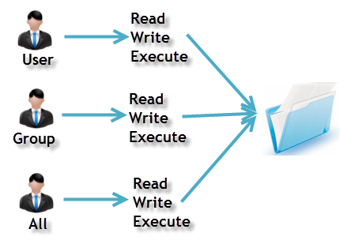

ls

ls -a

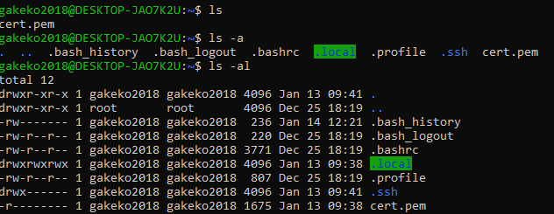

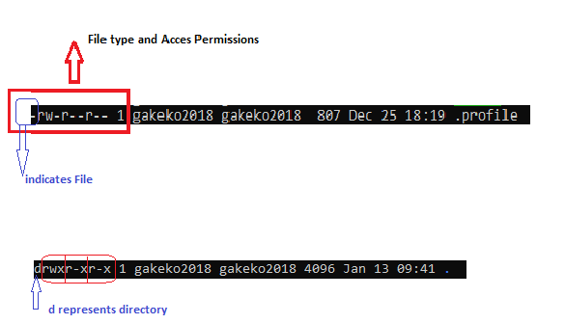

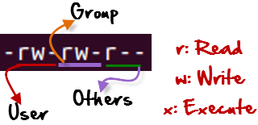

**r** = read permission

**w** = write permission

**x** = execute permission

**-** = no permission

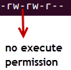

Changing Permission with chmod Command

We can use the chmod command which stands for **change mode**.

Using the command, we can set permissions (read, write, execute) on a file/directory for the owner, group and the world.

chmod permissions filename

The table below gives for all for permissions types.

| **Symbol** | **Permission Type** |
| --- | --- |
| --- | No Permission |
| --x | Execute |
| -w- | Write |
| -wx | Execute+Write |
| r-- | Read |
| r-x | Read+Execute |
| rw- | Read+Write |
| rwx | Read+Write+Execute |

Example

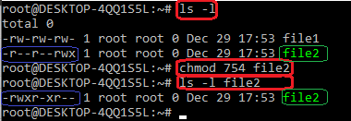

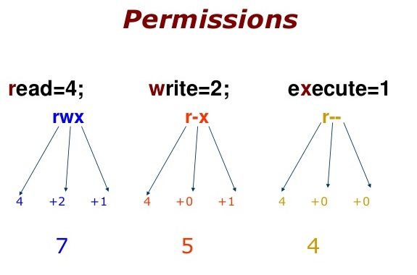

754 code says;

* Owner can read, write and execute
* Usergroup can read and execute
* Other can only read

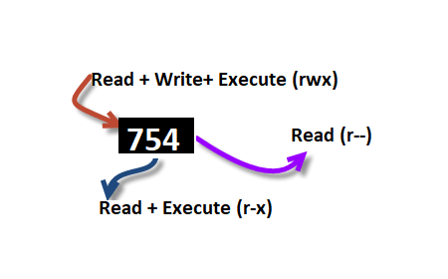

**Ping & SSH Command**

**Ping Command**

Ping or Packet Internet Groper is a network administration utility used to check the connectivity status between a source and a destination computer/device over an IP network. It also helps you assess the time it takes to send and receive a response from the network.

ping host-name/IP

**Example**

ping 54.93.34.220

Press CTRL+C (in MacOS => CMD+C) to exit.

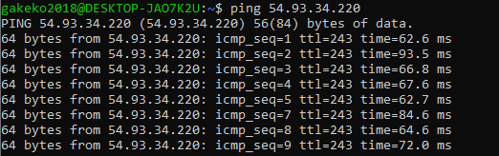

SSH

* ssh stands for “Secure Shell”.
* It is a protocol used to securely connect to a remote server/system.
* ssh is secure in the sense that it transfers the data in an encrypted form between the host and the client

ssh user@host(IP/Domain_name)

**Example**

ssh -i cert.pem ec2-user@54.93.34.220

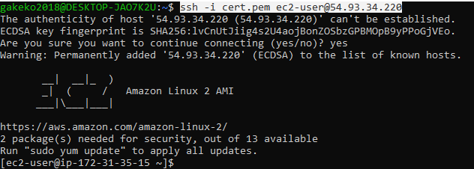

**whoami Command**

Displays user, group and privileges information for the user who is currently logged on to the local system.

* whoami command is used both in Lunix Operating System and as well as in Windows Operating System.
* It is basically the concatenation of the strings “who”,”am”,”i” as whoami.

whoami

Example:

clarusway@f85a0c1549f4:~$ whoami

clarusway

**Man Pages**

* A man page (short for manual page) is a form of software documentation usually found on a Unix or Unix-like operating system.
* Man pages are the traditional package documentation for application usage. What that means is that they're typically installed when you install a package. So if we install a package to do some task, the man page for that package will typically be installed at the same time. This gives us the ability to take a look at that documentation and make sure that we're using it in a manner consistent with its design.

**Usage**

The man page for a particular command is invoked by preceding the command with man.

man <command>

man ls

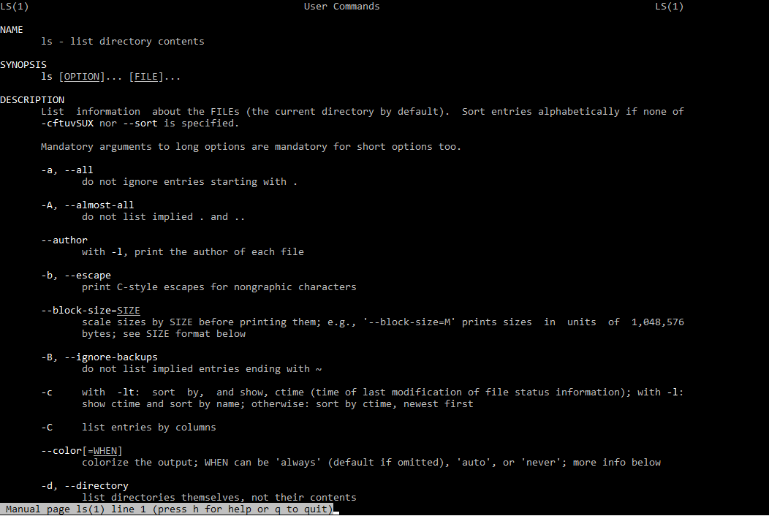

**NAME**

Program or Function name(s) followed by descriptions of functionality.

SYNOPSIS

A short overview of available options

**DESCRIPTION**

Detailed information about arguments and options.

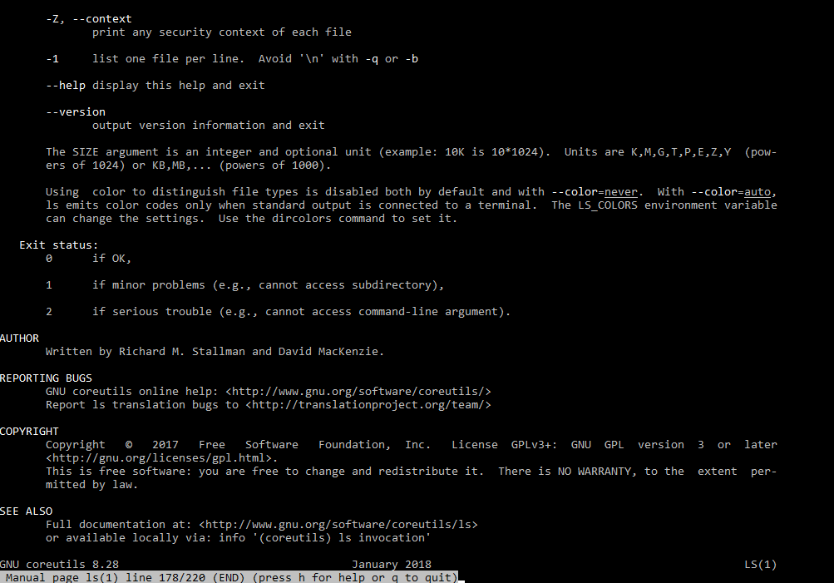

Formun Üstü

Formun Altı

**Info Pages**

Info pages are additional documentation with more robust capability in detail. Info Page normally provides more detailed information about a command than its respective man page. Additionally, Info uses a structure for linking these pages together, and they may be assembled into a larger collection.

**Usage**

The info page for a particular command is invoked by preceding the command with info.

info <command>

info echo

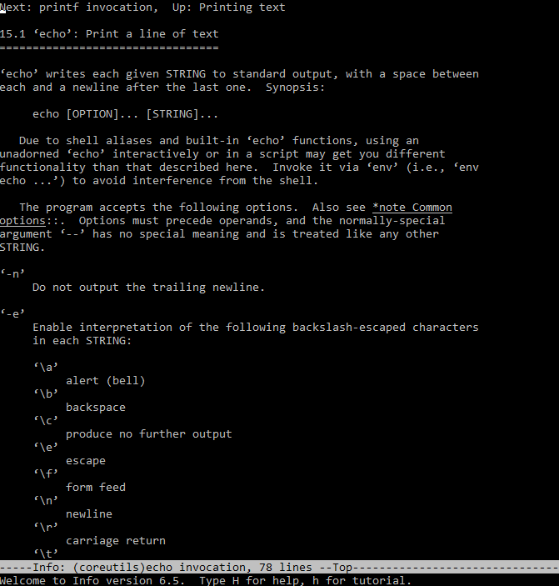

The main difference between Man and Info is the amount of content that they have; Info contains a whole lot more than Man does.

If no info page exists, info can pull documentation from the man page.

**Files and Directories**

The file system hierarchy standard (FHS) defines the structure of the file systems on Linux.

* In the FHS, all files and directories appear under the root directory / , even if they are stored on different physical or virtual devices.
* Most of these directories exist in all UNIX operating systems and are generally used in much the same way; however, the descriptions here are those used specifically for the FHS, and are not considered authoritative for platforms other than Linux.

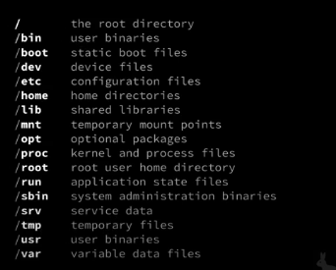

1. **/ (Root) :** Primary hierarchy root and root directory of the entire file system hierarchy. Every single file and directory starts from the root directory.
2. **/bin :** Essential command binaries that need to be available in single user mode.
3. **/boot :** Boot loader files.
4. **/dev :** Essential device files.
5. **/etc :** Host-specific system-wide configuration files.
6. **/home :** Users’ home directories, containing saved files. Home directories for all users to store their personal files
7. **/lib :** Libraries essential for the binaries in /bin/ and /sbin/
8. **/mnt :** Temporarily mounted filesystems.
9. **/opt :** Optional application software packages.
10. **/proc :** Contains information about system process.
11. **/sbin :** Essential system binaries, e.g., fsck, init, route.
12. **/srv :** Site-specific data served by this system, such as data and scripts for web servers, data offered by FTP servers, and repositories for version control systems. srv stands for service.
13. **/tmp :** Temporary files. Often not preserved between system reboots, and may be severely size restricted.
14. **/usr :** Secondary hierarchy for read-only user data; contains the majority of (multi-)user utilities and applications.

**Hidden Files and Directories**

Files and directories can be hidden from the basic listing. Files and directories in Linux may be set as hidden by preceding their name with a . (a single period).

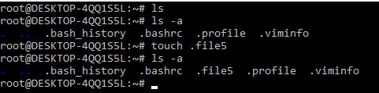

Hidden files can be listed via ls using the -a option (meaning show all files).

**Home Directories**

User home directories contain files specific to users. A directory under /home is typically created for every ordinary user on the Linux system.

**cd (change directory) without a specified path**

~ used to represent the user's home directory

$HOME environment variable used to store home directory path

To navigate to your home directory, use cd or cd ~

**Absolute and Relative Paths**

The path is the unique location of a file or directory.

The path to a file or directory location can be specified as an absolute path (starts with a /), or a relative path. Below is the pwd command show the absolute path of current working directory

[cloud_user@ip-10-0-1-10 ~]$ pwd

/home/cloud_user

**Relative Path**

Below, the cat command is used to show the content of file1 specified with a relative path.

[cloud_user@ip-10-0-1-10 ~]$ cat file1

Good Day

**Absolute Path**

Below, the cat command is used to show the content of same file1 specified with a absolute path.

[cloud_user@ip-10-0-1-10 ~]$ cat /home/cloud_user/file1

Good Day

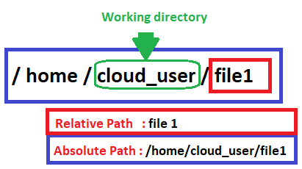

Creating, Moving, Deleting

Creating, moving, and deleting files and directories.

touch - create a file

rm - delete the file

cp - used to copy file or folder

mv - used to move file or folder

mkdir - create a folder

rmdir - delete folder

Working with directories

Create a new directory mkdir <NAME>

Copy a directory cp -r <SOURCE> <DESTINATION>

Move a directory mv <SOURCE> <DESTINATION>

Delete a directory rm -r <DIRECTORY>

Delete an empty directory rmdir <DIRECTORY>

Working with files

Create a new file touch filename

Removing Files rm -option filename

**Option** -r includes the contents of a directory and the contents of all subdirectories when you remove a directory.

**Option** -i prevents the accidental removal of existing files or directories.

**Example:**

**Case Sensitivity**

Most of the common Linux file systems are case sensitive; this is something to keep in mind when creating and moving directories and files.

**Using Case Sensitivity**

Lower-case and upper-case letters have different ASCII representation.

**Example;**

touch newfile

touch Newfile

The commands above will create two different files.

Formun Üstü

**View the Lesson (Creating, Moving, and Deleting Files)**

**Simple Globbing**

Globbing is primarily used to match patterns in filenames or text by using a wildcard character to create the pattern.

? (Question mark) : Match any single character

* (Asterisk) : Match any number of character(s)

[] (Brackets) : Match character from a range

^ (Caret) : Used to match starting character

$ (Dollar sign) : Used to match ending character

{} (Curly brace) : Used to match more than one pattern

| Pipe : Used for applying more than one condition

Example :

clarusway@f85a0c1549f4:~$ ls

all file1 file2 file3 file4 happiness loneliness reverse

clarusway@f85a0c1549f4:~$ ls file?

file1 file2 file3 file4

clarusway@f85a0c1549f4:~$ ls ?????

file1 file2 file3 file4

clarusway@f85a0c1549f4:~$ ls ????1

file1

clarusway@f85a0c1549f4:~$ ls file*

file1 file2 file3 file4

clarusway@f85a0c1549f4:~$ ls *

all file1 file2 file3 file4 happiness loneliness reverse

clarusway@f85a0c1549f4:~$ ls *ness

happiness loneliness

clarusway@f85a0c1549f4:~$ ls *[1-4]

file1 file2 file3 file4

clarusway@f85a0c1549f4:~$ ls *[2-3]

file2 file3

clarusway@f85a0c1549f4:~$ ls *[[:digit:]]

file1 file2 file3 file4

* [[:upper:]] or [[A-Z]] - match upper-case character
* [[:lower:]] or [[a-z]] - match lower-case character
* [[:digit:]] or [[0-9]] - match digits
* [[:alpha:]] or [[a-zA-Z]] - match either case character
* [[:alphanum:]] or [[a-zA-Z0-9]] - match alphanumeric

etc

**Why should I use an editor?**

It is very important to be able to use at least one text mode editor. The first step toward independence is learning how to use an editor on your system.

We need to master an editor because we need it to edit files that affect our environment. You might want to start writing scripts, or books, creating websites or new programs as an advanced user. Mastering an editor will boost your productivity and your skills tremendously.

**Which editor should I use?**

Our focus for text editors is on the ones which can also be used in terminal windows and in systems without a graphical environment. The further advantage of mastering a text editor is its use on remote computers. Because you don't need to move the whole graphical environment over the network, working with text editors greatly enhances network speed.

**Using the Vim editor**

**What’s Vim:**

Vim stands for “Vi Improved”. Vim is a highly configurable text editor for efficiently creating and changing any kind of text. It is included as "vi" with most UNIX systems and with Apple OS X.

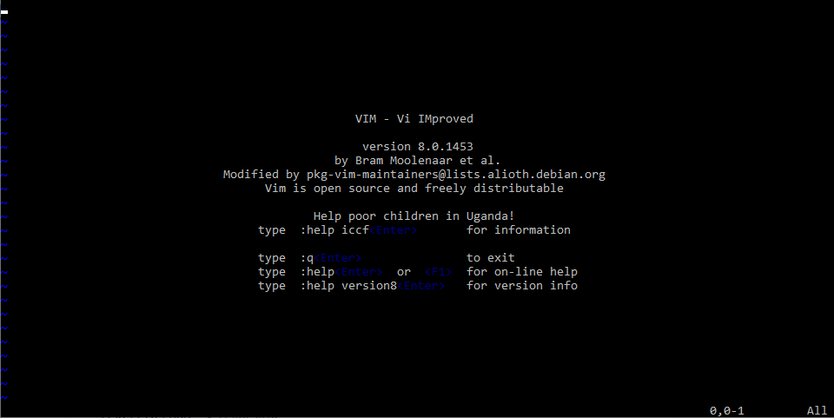

Vim can operate in two modes: command mode and insert mode.

The editor always starts in command mode. When you run vim filename command to edit a file, Vim starts out in command mode. It means that, instead of adding those characters, all alphanumeric keys are bound to commands. For example, Typing h won’t insert the character “h”, it will move the cursor to the left.

To enter the insert mode, type i for (“insert”) and now the keys will act the way you would expect. In the insert mode, you can type, move through the text, search, replace, mark blocks and perform other editing tasks. After pressing Escape, you are back in command mode.

Basic commands

Commands that switch the editor to insert mode

| **Vim Command** | **Description** |
| --- | --- |
| a | append: it moves the cursor one position to the right before switching to insert mode |
| i | insert |
| o | insert a blank line under the current cursor position and move the cursor to that line. |

Moving through the text

Moving through the text is usually possible with the arrow keys. If not, use:

| **Vim Command** | **Description** |
| --- | --- |
| h | move the cursor one character to the left. |
| j | move the cursor down one line. |
| k | move the cursor up one line. |
| l | move the cursor one character to the right. |
| 0 | move the cursor to the beginning of the line. |
| $ | move the cursor to the end of the line. |
| w | move forward one word. |
| b | move backward one word. |
| G | move to the end of the file. |
| gg | move to the beginning of the file. |

Basic operations

| **Vim Command** | **Description** |
| --- | --- |
| ndd | delete n lines starting from the current cursor position. |
| ndw | delete n words at the right side of the cursor. |
| x | delete the character on which the cursor is positioned |
| :n | move to line n of the file. |
| u | undo the last operation. |
| Ctrl-r | redo the last undo. |
| :w | save (write) the file |
| :q | exit the editor. |
| :q! | force the exit when you want to quit a file containing unsaved changes. |
| :wq | save and exit |
| :w newfile | will save the text to newfile. |
| :wq! | override read-only permission (if you have the permission to override permissions, for instance when you are using the root account. |
| :recover | will recover a file after an unexpected interruption. |

Searching And Replacing

| **Vim Command** | **Description** |
| --- | --- |
| /text | search the text in the file and position the cursor on the first match below its position. |
| n | move the cursor to the next instance of the text from the last search. This will wrap to the beginning of the document. |
| N | move the cursor to the previous instance of the text from the last search. |
| ?text | search for text in the document, going backward. |
| :%s/text/replacement text/g | search through the entire document for text and replace it with the replacement text. |
| :%s/text/replacement text/gc | search through the entire document and confirm before replacing text. |

Copying And Pasting

| **Vim Command** | **Description** |
| --- | --- |
| v | highlight one character at a time. |
| V | highlight one line at a time. |
| Ctrl-v | highlight by columns. |
| y | yank text into the copy buffer. |
| p | paste text after the current line. |
| P | paste text on the current line. |
| np | paste it n times. |

**Using the nano editor**

**What’s nano:**

GNU nano is a small and friendly text editor. Besides basic text editing, nano offers features like undo/redo, syntax coloring, interactive search-and-replace, auto-indentation, line numbers, word completion, file locking, backup files, and internationalization support.

Opening and Creating Files

To open an existing file or to create a new file, type nano followed by the file name:

nano filename

nano screen

The default screen of nano consists of five areas. From top to bottom these are the title bar, a blank line, the edit window, the status bar, and two help lines.

**The title bar** consists of three sections: left, center and right. The section on the left displays the version of nano being used. The center section displays the current filename, or "New Buffer" if the file has not yet been named. The section on the right displays "Modified" if the file has been modified since it was last saved or opened.

**The status bar** is the third line from the bottom of the screen. It shows important and informational messages.

**The two help lines** at the bottom of the screen show some of the most essential functions of the editor. These two lines are called the Shortcut List.

Editing Files

Unlike vi, nano is a modeless editor, which means that you can start typing and editing the text immediately after opening the file.

Shortcut List

In both the toolbar and in the help text within the editor, key combos appear with standard Linux shortcut codes. All commands are prefixed with either ^ or M character. The caret symbol (^) represents the Ctrl key. For example, the ^G commands mean to press the Ctrl and G keys at the same time. The letter M represents the Alt key.

| **Command** | **Meaning** | **Description** |
| --- | --- | --- |
| Ctrl G | Get Help | display a complete list of commands and associated hotkeys. |
| Ctrl X | Exit | Close the program. You'll be prompted to save the current buffer or to exit without saving. |
| Ctrl O | Write Out | Save the current buffer to the filesystem. |
| Ctrl R | Read File | Open a file from the filesystem. |
| Ctrl W | Where Is | Search for a text string. |
| Ctrl \ | Replace | Replace one text string for another. |
| Ctrl K | Cut Text | Remove the current line of text. |
| Ctrl U | Uncut Text | Uncut from the cutbuffer into the current line |
| Ctrl J | Justify | Justify the current paragraph |
| Ctrl T | To Spell | Spell-check the current buffer. |
| Ctrl C | Cur Pos | Display the position of the cursor relative to the contents of the buffer as a whole. |
| Alt U | Undo | Undo the last operation |
| Alt E | Redo | Redo the last undone operation |
| Alt M | Mark Text | Mark text starting from the cursor position |
| Alt 6 | Copy Text | Copy the current line and store it in the cutbuffer |

Formun Altı

Formun Altı

Formun Üstü

Formun Altı