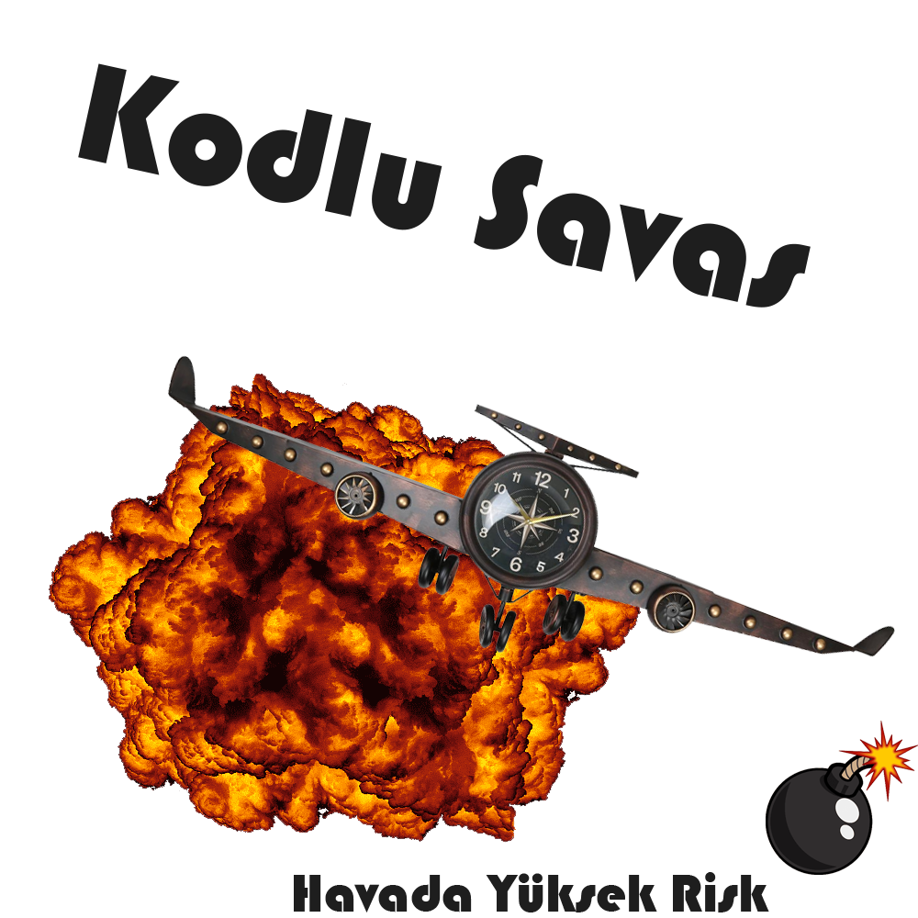

|  |
| --- |
| C:\Users\zulka\AppData\Local\Microsoft\Windows\INetCache\Content.Word\Başlıksız-1 kopya.png |

