**E-PATI**

**ABOUT E-PATİ**

- What does e-pati provide for us?

E-pati is a system that helps animals gain identity like people. In today's digital world, it offers animals identity, the right to life and protection.

We aim to identify stray animals in all state-affiliated/independent shelters and stray animals in districts. We also offer animal owners the opportunity to apply for our identity system. We aim to be near all stray animals with our in-house veterinary clinics and transportation team. We observe the location tracking of animals with our digitized collars and earrings and the health control stages with our information system.

**ANTICIPATED BUSINESS BENEFITS:**

* Thanks to the e-pati systems, access to the help of our animal friends proceeds quickly and systematically.
* With this system, you can give your pet an ID and access all his information.
* E-pati is a systemic software and all information is stored in our large database area. With the start of the implementation of this project in the country, we aim to help and own stray animals more quickly.
* After working with the government and installing our digital earrings on stray animals, we quickly provide access to their location and calls for help through our application.
* Our systems are active 24/7 and we maintain location analysis for our friends who have every digital earring, and we allow you to access weekly, monthly and annual reports.
* After entrusting the animal friends we help to our veterinarians in our clinics, we register the information of our friends in our system.

**CONFIRM THE FEASIBILITY**

Economic Feasibility

* Through the website, our customerss will be able to see the IDs. Of the animals they have. They will have access to information about IDs. Contacting customers and informing them is a good performance for our company.
* Instant location shares are one of the most important topics for us. Being able to do this allows you to have more interest in our system. This means an increase in earnings.
* The up-to-date information entered into the database owned by our system can also be ensured by frequent visits to our website by users.
* We planed that we are going to have benefit 1 year 1 month and 28 day later. According to calculations we can say that end of five year the firm will have 16.150.325TL benefit.

Organizational and Cultural Feasibility

* The training of employees will not be difficult, since our system has a simple and easy operation.
* Turkish and English language options are avaliable for our website for now but over time, additions will be made according to the interest in other countries.
* Animal love is one of the common feeling that all people have regardless of country and culture. The fact that our system provides these opporunities to animals gives us the belief that our World will support this Project.

Technological Feasibility

* We will use internet database warehouse for backup operations.
* Digital earrings or necklaces belonging the animal will be designed for every customer who wants location information.
* We will give all of our customers id’s to log in to our system and see their information, and we will ask them to download our application.

Schedule Feasibility

We are planning to deliver Project between ----- days (--- months --- days)- ------ days

Resource Feasibilty

10 Technicians, 10 programmer, 4 project organizer and 1 project manager we need during this Project.

tablo içeren bir resim

Açıklama otomatik olarak oluşturuldu

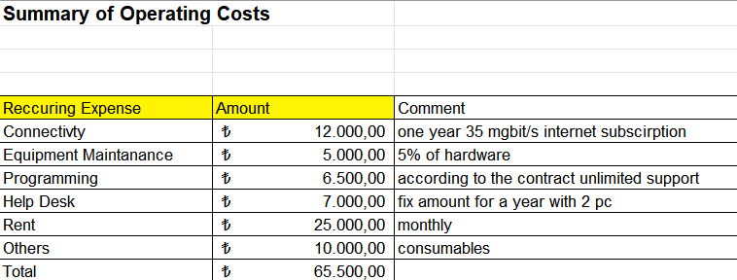

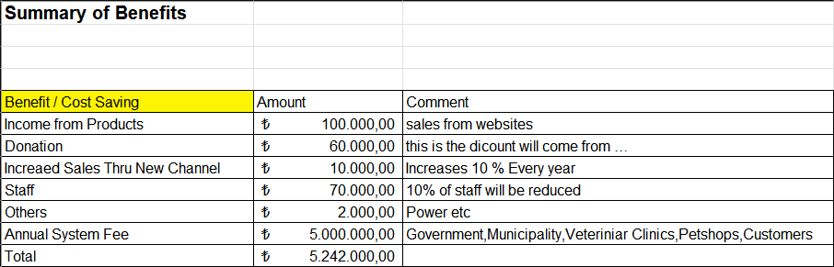

**tablo içeren bir resim

Açıklama otomatik olarak oluşturuldu**

**STAFFING THE PROJECT**

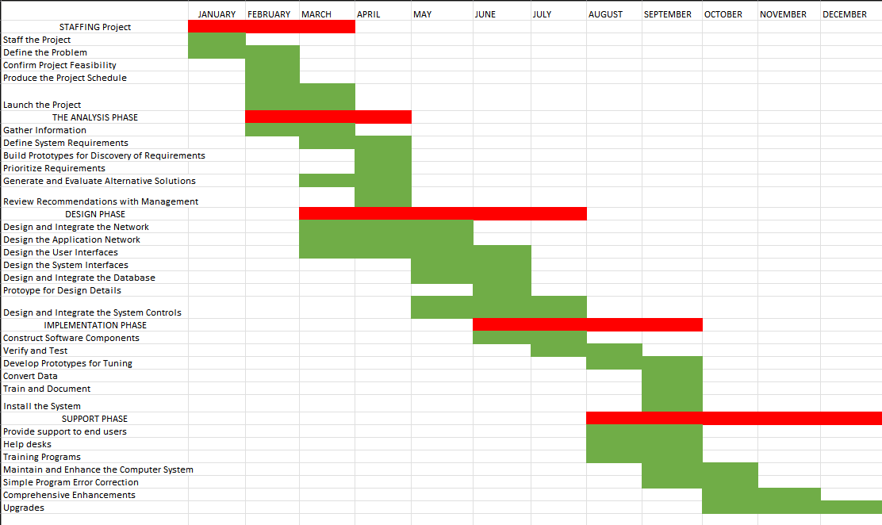

**Project Manager**

The responsibility of the project manager is responsible for the functioning of the team, for example, organizing and directing people to achieve a planned result within a predetermined schedule and budget. He leads the team, analyzes the system and its needs. Gives approval to the tasks performed by employees. He must make sure that everything is going well, and therefore the project is goal-oriented.

**Project Organizer**

In the broadest sense, project managers are answerable for designing, organizing, and directive the completion of specific comes for a corporation whereas making certain these comes are on time, on budget, and inside scope.

**System Analyst**

A analyst could be a one who uses analysis and style techniques to resolve business issues mistreatment data technology. Systems analysts might function amendment agents who agency establish the structure enhancements required, style systems to implement those changes, and train and encourage other to use the system.

**Programmers**

Programmers write code for computer programs and mobile applications. They are also involved in maintaining, debugging and troubleshooting systems and software to ensure that everything runs smoothly.

**IT Specialists**

IT Networking Specialist analyze, troubleshoot and evaluate electronic network issues, additional advanced IT execs is also chargeable for building and planning communication networks moreover. They play a vital role in maintaining an organization’s network and keeping them safe and secure through each hardware configuration and end-user coaching. He desing and build native local networks (LANs), wide space networks (WANs), and Intranets. Couinting on the scale of the corporate, these roles is also combined.

Organizational Structure of E-PATI

Project Organizer

Project Manager

Preliminary Accounting

Technician

Contact Team

Veterinarian

Drivers

Graphic Designer

System Analyst

Data Expert

Programmers

Accounting Manager

Operational Manager

Data Manager

General Manager

The Owners of E-Pati

**Product Designer**

A product designer is a person who designs products on a web page belonging to our company. It is also the person who creates designs according to the person's pets. Among the designs made, he is responsible for the design of collars, clothes, toys, and food containers belonging to cats and dogs

**Driver**

He is the one who is assigned to reach the specified location as soon as possible on incoming emergency calls. It is the employee who helps the animals to start their treatment in a short time by taking them from their current position and taking them to the nearest clinics.

**Programmer**

It plays a role in creating the visual content of our website and application with the most trending colors and designs. It allows you to change the designs according to the feedback received from users. He is also responsible for designing the internal faces of the same website and applications. When you enter your information on the website, the application receives this information and stores it in a database installed on a server. To create the backend part of the web, PHP, Ruby, Python, etc. Software languages and databases such as MySQL, PostgreSQL and Oracle are used. A back-end developer is a technical person who prepares the environment necessary for these components to work in harmony.

**Advertising Expert**

it makes sure that all the ads to be made on the e-pati will be made in the most appropriate location and platform. It uses social media in the most efficient way for the audiences we can appeal to and reach to get to know us.

**Graphics Designer**

It creates poster designs for E-PATI ads and ad posts to be created on e-pati instagram account. It decodes the images on the interface according to the trend. Thanks to advertising posters with stunning and beautiful content, it plays a big role in enabling E-PATI to reach more people and gain value where it is located.

**Veterinarian**

It performs health checks of all our animal friends who come to our clinics, records their latest status in our systems and plays a big role in creating an identity for them.

**System Anlyst**

A system analyst is a person who performs analysis to solve business problems using information technologies. It works to make the system available by applying small changes to the systems. If it is not possible to use the system effectively, it performs an analysis to ensure that the system is rescheduled.

• Designing the system to meet the company's requirements,

• Keeping the process under control without skipping any details during the analysis by paying attention to details.

**Databese Expert**

A database specialist is a person who creates, designs database systems that physically hold information, queries the database, and conducts work to ensure its security.

• Preparing and designing the database of information systems,

• Creating and configuring a security method for the databas.

**Contact Team**

By creating a record of all incoming help calls through the system, they take part in the beginning of the operations so that the relevant team can reach the designated location as soon as possible. They also record the orders of the products on our web page in our system.

**Techician**

He is responsible for the annual maintenance of all technological tools belonging to our company and works as a support team in case of failure. They keep reports on a monthly and annual basis.

**Accountant**

**A**nalyzing the company's financial information, the tax of the institution it serves, etc. he is responsible for keeping track of his legal obligations and keeping a record of his financial activities.

• To create a balance sheet, profit and loss statement by analyzing the current financial situation,

• Preparing periodic reports to be submitted to the management units,

**Marketing**

It monitors the marketing of products on our web page and the delivery of created orders to the correct addresses.He is also responsible for stock status.It ensures the supply of products that the product designer will use with each new personal design.It follows the trends in the field of marketing and sales and makes the marketing of products accordingly.

**INTERVIEWS**

Questions to the **Employees :**

1. Which difficulties you have when you use current program?
2. I recognized that you look databases and modify anything manually, does it not caused a lot of errors?
3. How do you communicate with all the branches?
4. What kind of records you have got about buses?
5. Can you give back up of your bus plan?

Questions to the Public**Relations:**

1. What is the cultural level of computer use within the community?

2. What are the common problems occurring in the current system?

3. What do you expect from such as a system?

4. Is the current system loose customers’ reliance?

1. How do you think the system should be reconfigured?
2. How should your user interface be designed?
3. Do you need and do you agree with training? Why or why not?
4. What are you thinking about adapting?
5. How do you feel about implementing this system?

Questions to the IT**Department:**

1. Which programs do you use?
2. What are the most common problems you face up with current system?
3. Do you have any security problem in the current system?
4. Do you need training? Why or why not?
5. What do you think about the personnel’s’ adaptation to the new system?
6. Do you have necessary tools to maintain the new system?
7. What is your expectation from new system?
8. Which route you have?
9. How many navigations you have in a week?
10. How many hours drivers work in a day?
11. How many vehicle you have?
12. How many driver and assistant you have?
13. What is your critizition on hiring your employers such as drivers or assistants you are looking for while accepting their appointment?
14. In emergency situation do you have any ready-act driver and also assistant?
15. At what conditions must have been on your employers in order to continue?
16. How do you communicate with all the branches?

**INTERVIEW REPORT**

The company has few branches now because it has just opened. Due to the shortage of the number of employees and the system, there are disruptions in communication and transportation. In the contact team, because employees and customers communicate by phone, the lines can be very busy, and there is dissatisfaction because customers are waiting too long. Many of the company's contact team members have difficulty using SQL as an information recording system. Therefore, education should be given about the systems. During the meeting with the IT Department,; I don't think they need training, unlike the contact team. Because they have a lot of information about the programs they use. And then I asked the most frequently asked questions. Manually entering the data saves the team a lot of time. It also takes time to find the data when it is requested. In addition, they know that customers want to make processes easy and fast. When the Customer gives up the use of digital earrings, the data must be manually deactivated for cancellation operations. When talking with drivers; They said they had difficulty getting to the location where the call was made because there were no transit priorities, such as an ambulance or a fire department. This leads to disruptions in early intervention.

**OBSERVATION**

What we observe and where:

* **Employees in Contact Team**
* **Drivers**

**Employees:** Most employees have difficulty using SQL server, which is used as registration system. At the same time, they are insufficient both in terms of obtaining customer information, sending drivers to the necessary locations, and providing information to the manager.

**Drivers:** Although the drivers seem to be staying in the background, they are actually the most important employees of the company. Their biggest task is to reach the points where the call is made, and to bring the animals to the clinic carefully along the way. But since they do not have any priorities on the roads, such as the police, fire department, or ambulance, it becomes difficult to bring our dear friends to the clinic as soon as possible.

**HARD DATA**

**Quantitative Documents**

Online sales: we will sell the accessories we have designed through our website.

E-invoice: e-invoice is prepared for internet sales with government approval.

Clinics: pet owners who come to our clinics will pay extra for another stray pet. "suspended treatment" is the same as in Turkey.

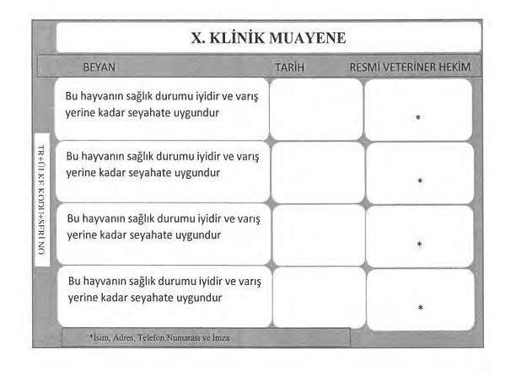

Treatment: Some special treatments are paid for. like neutering etc.

Records: A special ID will be prepared for each animal that comes to the clinic for the digital earring.

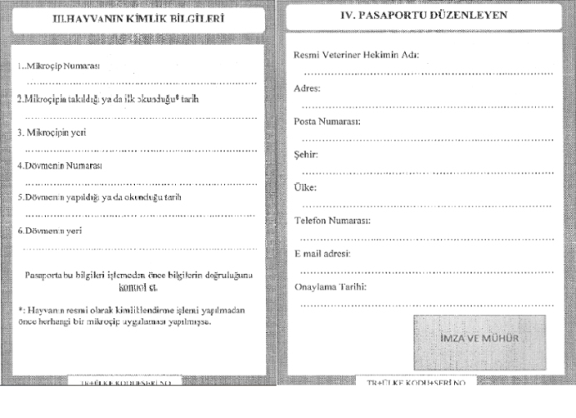

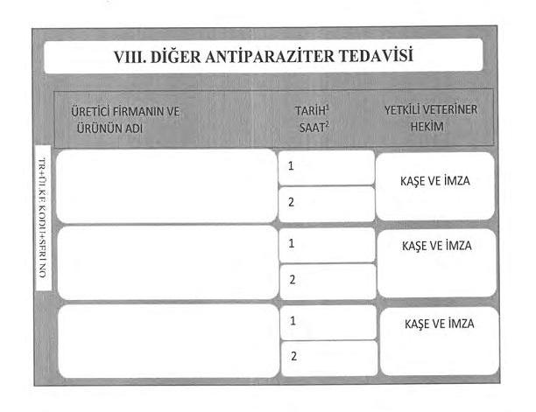

Navigation information: we use it to learn the location of the animal.

Driver: we use the driver to reach the animals.

Donate: people who care about animals donate for the project.

**THE REQUIREMENTS**

1. Phisical
2. Interfaces
3. Security
4. User and Human Factors
5. Documentation

**Phisical**

* ***Server* :** A server is necessary for providing all of the services required throughout a network, whether it is for e-Pati users.
* ***Network Restructuring:*** A LAN and WAN network must be setup in order for the system to function. Fiber optic cable technology can thus eliminate data loss within the system.
* ***Network Maintenance:*** A network management protocol's goal is to address the objectives necessary for a network's optimal operation. NMP is used by network managers and administrators to examine and troubleshoot host-client device connections.

**Interfaces**

* ***Application:*** Users will be able to easily access their information using the application. On the map, it will show the Animal Care Centers that are closest to you. Additionally, people with digital earrings will be able to track the locations of the animals they own 24/7
* ***Website: Clothes or items designed specifically for animals can be found here. There will also be a lot of new and sweet shares for animals and animal owners on our block.***
* ***Digital Earrings:*** The locations of the animals will always be traceable.

**Security**

* **User security :** In a computing context, network security is critical for protecting data and information from unauthorized users. It should be able to withstand password attacks like Dictionary attacks, Rainbow Tables, and Brute-force attacks.
* **Virtual keyboard :** Keystroke logging is less likely with virtual keyboards.

It is more difficult for malware to spy on the data entered by users while using a virtual keyboard. Since our customers make purchases on our website, this should be done in order to protect their card information.

**User and human factors**

* **Customers:** Customers should be informed about how to use the application.
* **Instruction**

**an instructional brochure explaining the criteria to look for in animals wearing a digital earring**

**STAKEHOLDERS**

**INTERNAL STAKEHOLDERS:**

**Owners/ Project Team.**

The founders who are project team members are the owners of the organization. it is the team that is responsible for planning the project and generating new ideas according to the needs.

**Managers.**

Managers play a substantial role in determining the strategy of the organization. Managers are also accountable for the decisions made and act as a point of contact between shareholders, the board of directors, and the organization itself.

**Employees.**

Employees are the team that works to develop the vision and mission of the company.

**EXTERNAL STAKEHOLDERS:**

**Government.**

With the government, we can store the information of animals and create their records in our system with the IDs given to them by the government.

**Customers.**

Our customers are directly connected with the company. they are the most critical stakeholder because we will provide the purpose of our project with the data we receive from them.

**Investors.**

Investors keep our team financially viable and make projects possible by providing funds.

**Technical service.**

They are responsible for the maintenance of the tools belonging to our company, who is the person who keeps monthly and annual reports.

**CURRENT DATA FLOW DIAGRAM**

1. A person sees an animal outside, whose life is in danger or which has been damaged.
2. Through the application or our call center is called.
3. Since E-PATI is available 24/7, the customer is connected without waiting.
4. The e-pati contact team asks the id of the animal.
5. With id, the animal's identity information and instant location are accessed.
6. An emergency call is created for the team closest to the location.
7. The driver, who is a veterinarian, sets out to reach the animal.
8. When the team goes to the animal, it is first placed in the vehicle for first aid.
9. After the first aid, they are on their way to be delivered to the nearest clinic.
10. After the animal is delivered to the clinic, all developments and interventions by the veterinarian must be registered in our system.

Updating the new data flow

Sending current information about the patient

Confirming data& taking the road

Response& saving call information in data

Making emergency calls

**PROTOTYPE**

Sending the received data to the team

Prototyping is always important for such projects, since there may be some differences in the results of empirical observations and interviews. Before implementing the actual system, we implemented a basic working prototype with a small test database. Thanks to this, we can get enough feedback from the system. For the developed program, we have created a small database with a small amount of data and a single interface.

We have direct access to all applications. They want to check the procedure step by step so that they can shop safely. The official workspace will be used for managers, not for employees. After observing that the result of our prototype was almost successful, we customized some updated october details and were right when implementing the prototype to get accurate feedback.

**PROPOSAL DATA FLOW**

1. The customer registers his/her information in the e-Pati system.

2. The client also saves his pet's information.

3. Animal Information is verified through our information processing system from the connected veterinarian.

4. Digital Earrings or Digital Leash are selected by the customer.

5. The digital product is attached to the animal by the technical team.

6. It is ensured that the product runs smoothly.

7. The client pays the necessary fees.

8.Customers can check the required vaccination dates or the locations of their animals by logging in to our phone application or website.

9.For stray animals, if a call is left on our phones by a citizen. Our drivers arrive at the specified location as soon as possible and repeat the steps to give the animal an identity.

**THE DATABASE OF THE SYSTEM**

**1- DEPARTMENS**

metin içeren bir resim

Açıklama otomatik olarak oluşturuldu

Everyone working under E-pati is very valuable to us. We have a department database for all assignments. This gives us convenience in the business area.

**2-EMPLOYEES**

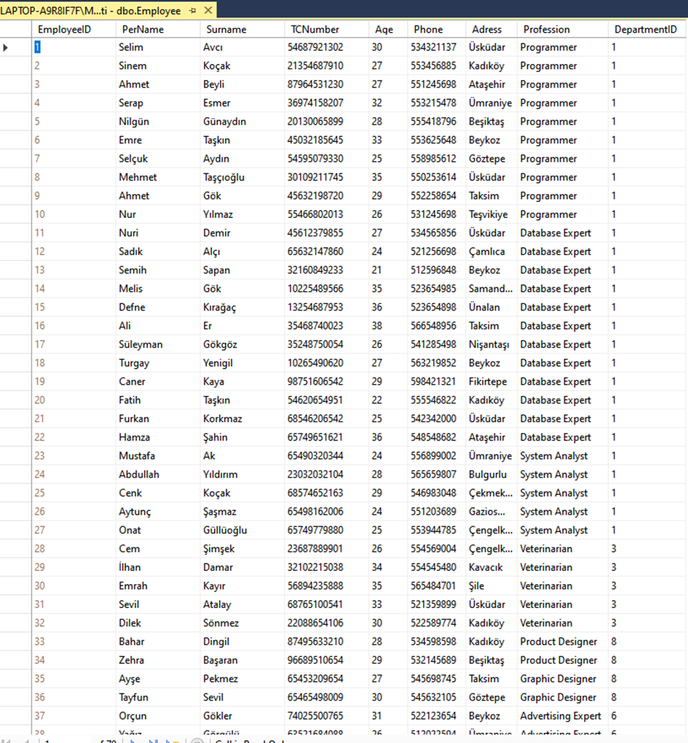

tablo içeren bir resim

Açıklama otomatik olarak oluşturuldu

tablo içeren bir resim

Açıklama otomatik olarak oluşturuldu

We take care to keep all the information of everyone working with us within E-pati. All our employees are very valuable to us.

**3-VEHICLES**

tablo içeren bir resim

Açıklama otomatik olarak oluşturuldu

We follow our vehicles and try to be in contact with our employees at all times.

**4-ANIMALS**

tablo içeren bir resim

Açıklama otomatik olarak oluşturuldu

We keep our friends protected under our company in our database with barcode numbers. We can access vaccination dates and locations more easily.

**5-CUSTOMERS**

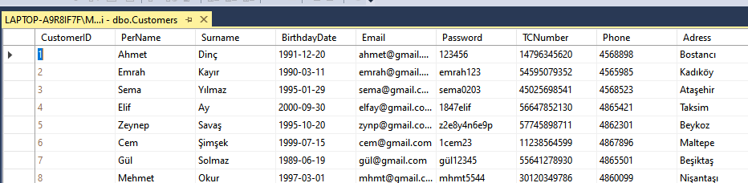

We store all the information of our customers in our database. We update our database monthly and annually to avoid any problems.

**6-CATEGORIES**

tablo içeren bir resim

Açıklama otomatik olarak oluşturuldu

We divide the products sold under the name of E-pati into categories for the convenience of our customers and store them in our database.

**7-PETS**

tablo içeren bir resim

Açıklama otomatik olarak oluşturuldu

We keep the vaccination days and locations of all your pets, which have an ID under the name of E-pati, in our database, and we do not want you to encounter any problems.

**8-PET OWNERS**

tablo içeren bir resim

Açıklama otomatik olarak oluşturuldu

It is our duty to closely follow you who join E-pati and give identity to your pets.

**9-PRODUCTS**

tablo içeren bir resim

Açıklama otomatik olarak oluşturuldu

We can check stock status and price updates from our database of all our products.

**10- ORDERS**

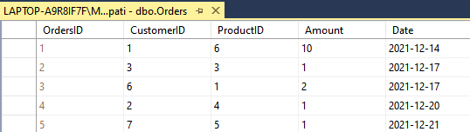

We store all incoming orders in our database so that we can follow all the steps from the formation of the order to its delivery. We update it monthly.

**11-RELATIONS**

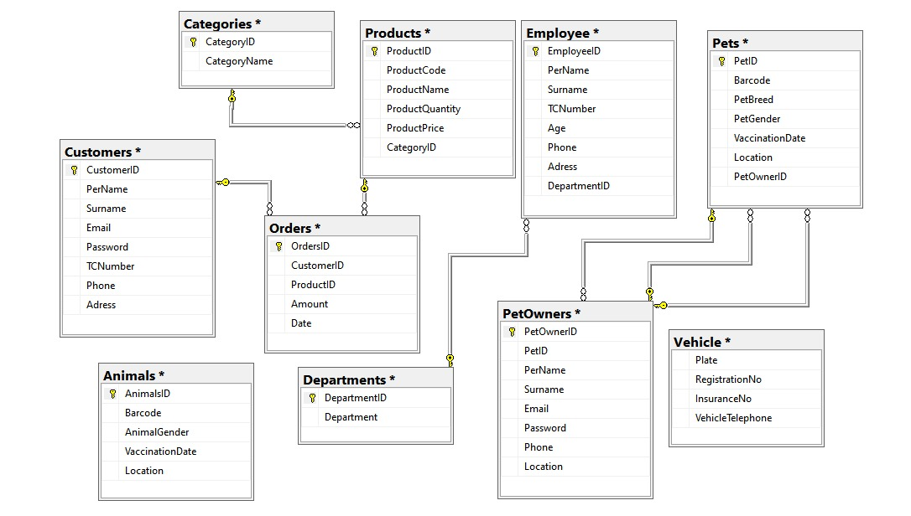

**CONCLUSION**

All in all, after long hours on work, we finally came to the end of this Software Engineerng and Database Management System project. During this project, we had a bit of a hard time coupling in the process. We try to be a connected and continual co-group as most of the parts need powerful and patient teamwork. Although we had some differences of opinion, we tried to find a middle ground and found it. Also, we had no previous experience, we are proud of the project we are creating now.