Fikru Abasori

Nov30,2021

IT FDN 110A

Assignment 08

## Intro:

In module, I have learned about, the difference between a class and the objects made from a class, components that make up the standard pattern of a class, purpose of a class constructor, When to use the keyword "@staticmethod , how fields and attributes and property functions related, difference between a property and a method , docstring in a class, difference between Git and GitHub and GitHub Desktop.

## Step4a: Create a Folder

Fig1. Showing Assignment 08 in the correct folder location

## Step4b: Create a new Project in PyCharm

Fig2. Showing a new project in PyCharm

## Step4c: Add Code to the Script

Create a class called product

Fig3. Code to create class product

*Add Code to the Product class*

Fig 4. Code to set name and price for a new object

Fig 5. Code to define properties of product_name and product_price

Create a class called File Processor:

Fig.6 Code to create a class called FileProcessor

*Add Code to process data from a file*

Fig7. Code to process data from a file

*Add Code to process data to a file*

Fig8. Code to process data from a file

*Add docstring*

Fig 9. Code to Add docstring

*Add code to show menu to user*

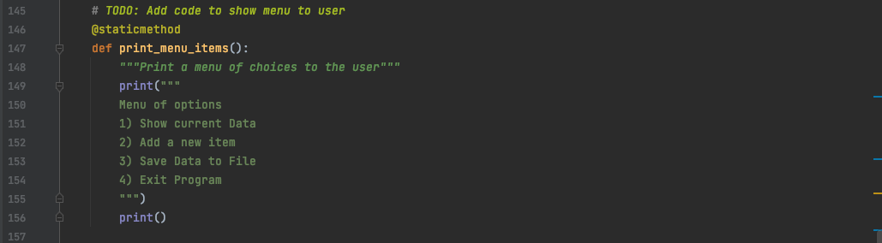

Fig 10. Code to show a menu of options to the user

*Add code to get user's choice*

Fig 11. code to get user's choice

*Add code to show the current data from the file to user*

Fig12. code to show the current data from the file to user

*Add code to get product data from user*

Fig13. code to get product data from user

*Add Data Code to the Main body*

Fig 14. Showing code added to the main body

*Run script:*

Fig 15. Showing script running in PyCharm

Fig 16. Showing script running in IDLE

**Summary**

In general in this module I have learned about the difference between a class and the objects made from a class, components that make up the standard pattern of a class, purpose of a class constructor, When to use the keyword "@staticmethod , how fields and attributes and property functions related, difference between a property and a method , docstring in a class, difference between Git and GitHub and GitHub Desktop. In addition , performing this assignment has helped me strengthen my knowledge.