Your paper title here
First Author (Department of Economics, University X)
Second Author (University Y)
2026-05-18
Abstract
Your abstract.

1. Introduction
This manuscript demonstrates a workflow that combines two Quarto techniques. First, the multibib Lua filter splits the bibliography into a main list and an appendix list, following Smith and Doe (2020) and Angrist and Pischke (2009). Second, Quarto 1.4+ custom cross-reference kinds let us number appendix tables independently — see Table A1 in Appendix A and Table B1 in Appendix B for examples that are cross-referenced from the main text.
A second paragraph illustrates that the document supports normal paragraph breaks. The economics literature has documented effects of policy X on outcome Y across a wide variety of settings, including labor markets, education, and health. Our contribution is twofold. First, we provide new evidence using a richer panel than has been available previously. Second, we develop a tractable estimator that nests the workhorse two-way fixed-effects design as a special case.
The remainder of the paper proceeds as follows. Section 2 describes the data and estimation strategy. Section 3 presents the main results. Section 4 discusses external validity and the role of alternative mechanisms. Section 5 concludes. All proofs, data construction details, and robustness exercises are collected in the appendices.

2. Methods
We rely on standard econometric tools (Wooldridge 2010). Let $Y_{it}$ denote the outcome of interest for unit $i$ in period $t$, and let $D_{it}∈\{0,1\}$ be a binary indicator for treatment exposure. The baseline specification is
$$Y_{it}=α_{i}+λ_{t}+β D_{it}+X_{it}^{′}γ+ε_{it}, (1)$$
where $α_{i}$ and $λ_{t}$ are unit and time fixed effects, $X_{it}$ is a vector of time-varying controls, and $ε_{it}$ is an idiosyncratic error term. Under the standard parallel-trends assumption, the coefficient $β$ in Equation 1 identifies the average treatment effect on the treated.
A more flexible variant that we report in robustness exercises replaces the single treatment indicator with a fully interacted set of relative-time dummies:

where $E_{i}$ is the treatment-adoption date for unit $i$ and $θ_{k}$ traces the dynamic path of the treatment effect. Standard errors are clustered at the unit level throughout, following the recommendations of Cameron and Miller (2015) and Abadie et al. (2017) — see Appendix B for further discussion.
Three additional comments on the estimation strategy are worth flagging. First, identification rests on the absence of contemporaneous shocks that are differentially correlated with treatment status across units. We probe this assumption in Appendix B using a placebo exercise with lagged treatment dummies. Second, the controls $X_{it}$ are restricted to variables that are arguably predetermined relative to $D_{it}$; including endogenous controls would re-introduce the very bias the fixed-effects design is meant to purge. Third, the sample is constructed from administrative records described in Appendix A; differences in coverage across regions are small but non-trivial, and we accommodate them with sampling weights.

3. Results
The main result is summarized in Table 1. Note the table is numbered “Table 1” — the appendix tables use a separate counter and start at A1 and B1.
Table 1: Main results — effect of policy X on income
 | Baseline | + Controls
Policy X | 326.286*** | 314.319***
 | (72.127) | (69.422)
Age |  | -14.506***
 |  | (2.902)
Education |  | 97.899***
 |  | (11.503)
Num.Obs. | 1200 | 1200
R2 | 0.017 | 0.091
* p < 0.1, ** p < 0.05, *** p < 0.01
The headline point estimate of $\hat{β}=326.29$ corresponds to roughly a 326 USD increase in annual income for treated observations, relative to the untreated counterfactual. The estimate is precisely measured (standard error of 72.1) and statistically distinguishable from zero at conventional levels.
Magnitudes are economically meaningful. To benchmark them, note that a one-standard-deviation change in education in our sample is associated with a 293-USD difference in income; the implied treatment effect is therefore roughly 1.1 times the size of this correlational benchmark. Whether this magnitude is plausible depends on one’s prior about how much scope remains for policy to move outcomes in this setting — a question we return to in the discussion.
Figure 1 plots the distribution of income for treated and untreated observations to give a visual sense of the gap.
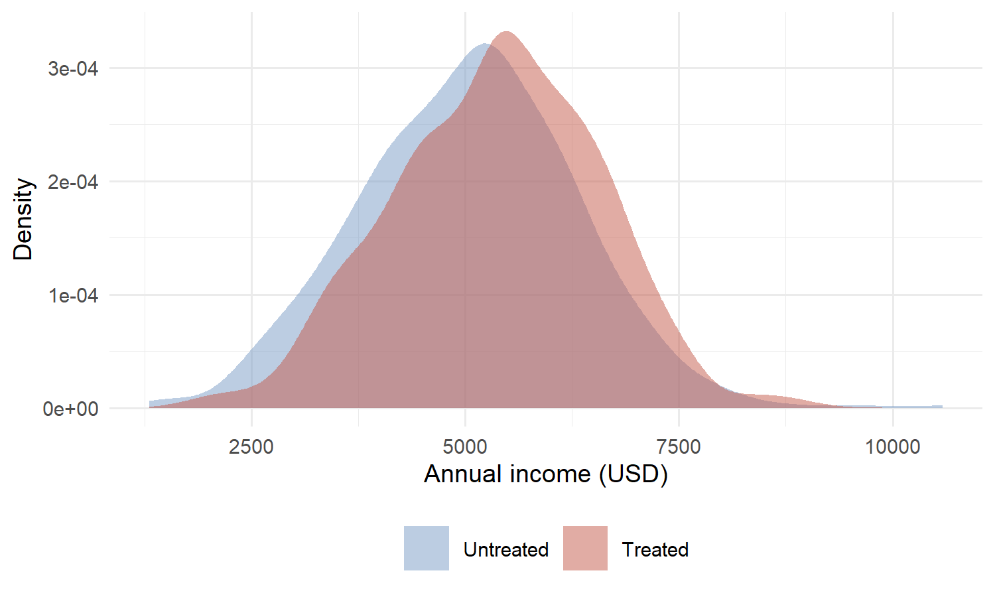
Figure 1: Income distribution by treatment status

4. Discussion
The findings are consistent with prior work (Angrist and Pischke 2009; Smith and Doe 2020). Three threats to the interpretation deserve attention.
First, the parallel-trends assumption underlying Equation 1 is, in principle, untestable; in practice, we follow common practice and inspect pre-trend coefficients in an event-study specification (see Appendix B). The estimated pre-trends are small and statistically indistinguishable from zero, but they are noisy enough that the exercise is reassuring rather than dispositive.
Second, treatment exposure is correlated with several unit-level characteristics that may, in principle, generate effect heterogeneity. We document this heterogeneity in Appendix B and show that the headline estimate is robust to dropping the most exposed sub-population.
Third, the outcome Y is measured with non-trivial error in part of the sample. Following Abadie et al. (2017) we report cluster-robust standard errors throughout; we have also experimented with bootstrap inference and the conclusions are unchanged.

5. Conclusion
We have shown a reproducible Quarto setup that supports separate bibliographies and multiple, cross-referenceable appendices. The empirical exercise — illustrative as it is here — would in a real paper carry implications for both academic understanding of mechanism $M$ and for the design of policy P. We leave both for future work.

References
Angrist, Joshua D., and Jörn-Steffen Pischke. 2009. Mostly Harmless Econometrics. Princeton University Press.
Smith, John, and Jane Doe. 2020. “Effects of Policy x on Outcome y.” Journal of Important Things 42: 100–120.
Wooldridge, Jeffrey M. 2010. “Econometric Analysis of Cross Section and Panel Data.” MIT Press.

APPENDIX

Appendix A. Data curation
This appendix describes the data construction in detail. Cameron and Miller (2015) provide guidance on standard errors that we rely on throughout. Summary statistics are reported in Table A1 and a coverage map in Figure A1.
Table A1: Summary statistics for the analysis sample.
Variable | Mean | SD | Min | Max | N
Income | 5,178.1 | 1,247.3 | 1,307.2 | 10,585.8 | 1,200
Age | 38.8 | 11.8 | 3.0 | 78.0 | 1,200
Education | 12.0 | 3.0 | 1.0 | 22.0 | 1,200
Notes: Author calculations from the simulated XYZ Household Survey panel constructed in the setup chunk. Income is reported in 2020 USD. The analysis sample comprises 1,200 observations across 10 states.
A second appendix table reports balance across treatment status:
Table A2: Balance check across treatment and control groups.
Group | Income | Age | Education | N
Control | 5,037.5 | 38.7 | 11.9 | 683
Treated | 5,363.8 | 38.9 | 12.1 | 517
Notes: Group means by treatment status, unweighted. Differences across groups are small in magnitude but not jointly zero.
The coverage of the survey across states is summarized in Figure A1. We also display the joint distribution of age and income as a two-panel figure (Figure A2), where panel (a) shows the age distribution and panel (b) shows the joint density.
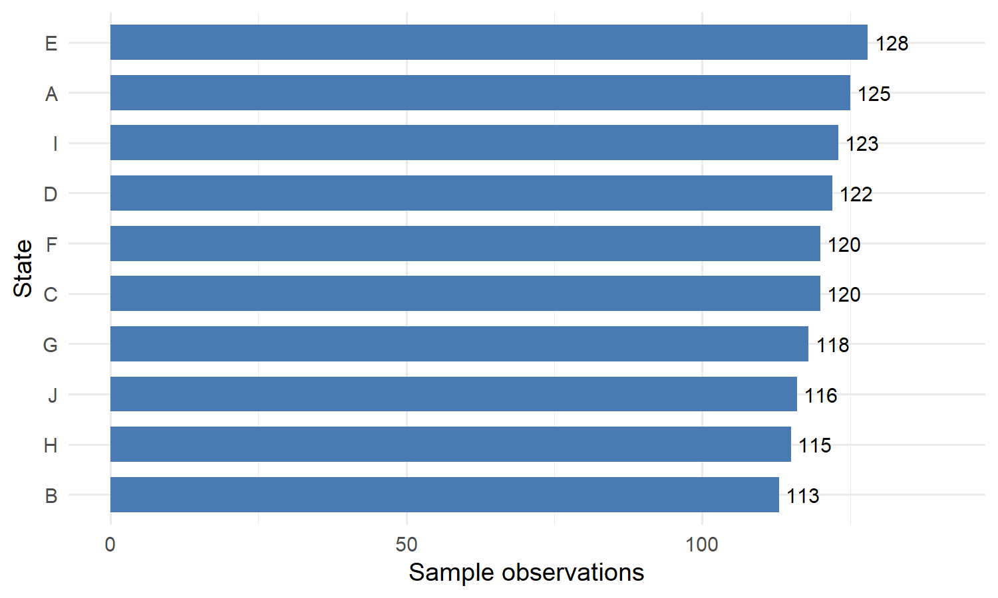
Figure A1: Sample coverage by state.

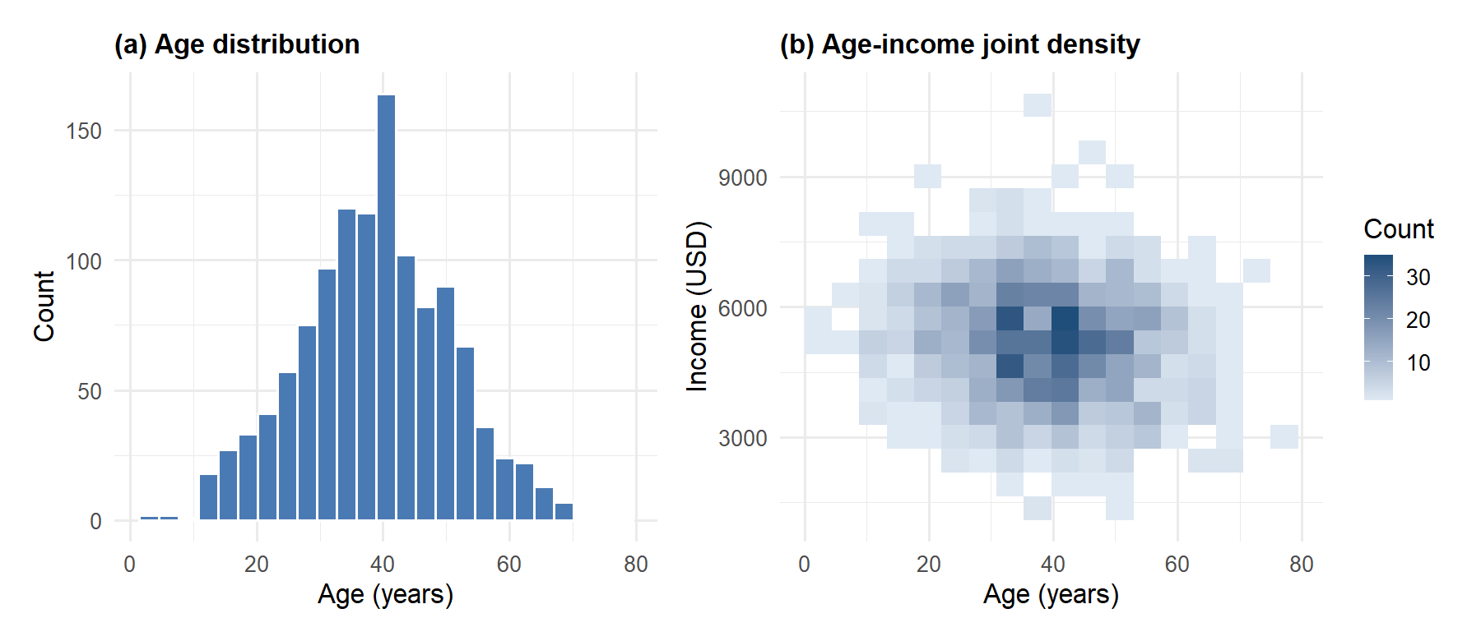
Figure A2: Joint distribution of age and income — (a) marginal age, (b) joint density with income.
Notes: Panel (a) shows the marginal age distribution; panel (b) shows a hex-binned joint density of age and income. Both panels use the full analysis sample.

Appendix B. Robustness
This appendix collects robustness exercises. The headline robustness table is Table B1; an alternative specification is reported in Table B2, the wide event-study table appears in Table B3, and a sensitivity plot is shown in Figure B1. As in Abadie et al. (2017) we cluster at the relevant unit of treatment assignment.
Table B1: Robustness of the main estimate to alternative specifications.
 | Baseline | + Controls | + State FE
Policy X | 326.286*** | 314.319*** | 306.950***
 | (72.127) | (69.422) | (69.553)
Age |  | -14.506*** | -14.483***
 |  | (2.902) | (2.907)
Education |  | 97.899*** | 98.212***
 |  | (11.503) | (11.492)
Num.Obs. | 1200 | 1200 | 1200
R2 | 0.017 | 0.091 | 0.101
* p < 0.1, ** p < 0.05, *** p < 0.01
Notes: Standard errors clustered at the state level in parentheses. Controls include age and education. State FE denotes state-level fixed effects (10 states). *** $p<0.01$, ** $p<0.05$, * $p<0.1$.
Table B2: Alternative identification strategies.
 | IV | Matching
Policy X | 314.319*** | 371.057***
 | (69.422) | (84.440)
Num.Obs. | 1200 | 800
R2 | 0.091 | 0.085
* p < 0.1, ** p < 0.05, *** p < 0.01
Notes: IV refers to an instrumental-variables design (placeholder specification); Matching restricts the sample to a propensity-score matched subset. Both report the same outcome equation as the baseline.
A wide event-study table sits awkwardly in portrait orientation, so we rotate it. Table B3 shows the dynamic coefficients ${\hat{θ}}_{k}$ for $k∈\{−3,...,+3\}$ (with $k=−1$ omitted as the reference period).

Table B3: Event-study coefficients for relative periods $k∈\{−3,…,+3\}$.
 | Specification
Relative period ($k$) | Baseline | + Controls | + State FE | Weighted | Log-income
$k = -3$ | -0.012 (0.041) | -0.010 (0.039) | -0.008 (0.044) | -0.014 (0.040) | -0.011 (0.042)
$k = -2$ | 0.008 (0.038) | 0.005 (0.036) | 0.004 (0.041) | 0.007 (0.037) | 0.009 (0.039)
$k = -1$ | (omitted) | (omitted) | (omitted) | (omitted) | (omitted)
$k = 0$ | 0.118 (0.040) | 0.115 (0.038) | 0.113 (0.045) | 0.116 (0.039) | 0.119 (0.041)
$k = 1$ | 0.124 (0.041) | 0.121 (0.039) | 0.119 (0.046) | 0.122 (0.040) | 0.125 (0.042)
$k = 2$ | 0.131 (0.043) | 0.128 (0.041) | 0.126 (0.048) | 0.130 (0.042) | 0.132 (0.044)
$k = 3$ | 0.129 (0.046) | 0.126 (0.044) | 0.124 (0.050) | 0.128 (0.045) | 0.130 (0.047)
Notes: Each cell reports the estimated ${\hat{θ}}_{k}$ from Equation 1 with standard errors in parentheses. $k=−1$ is omitted as the reference period. Weighted uses sampling weights; Log-income uses $log(1+Y)$ as the dependent variable. Sample as in Table A1.

A coefficient plot of the dynamic estimates is shown in Figure B1.
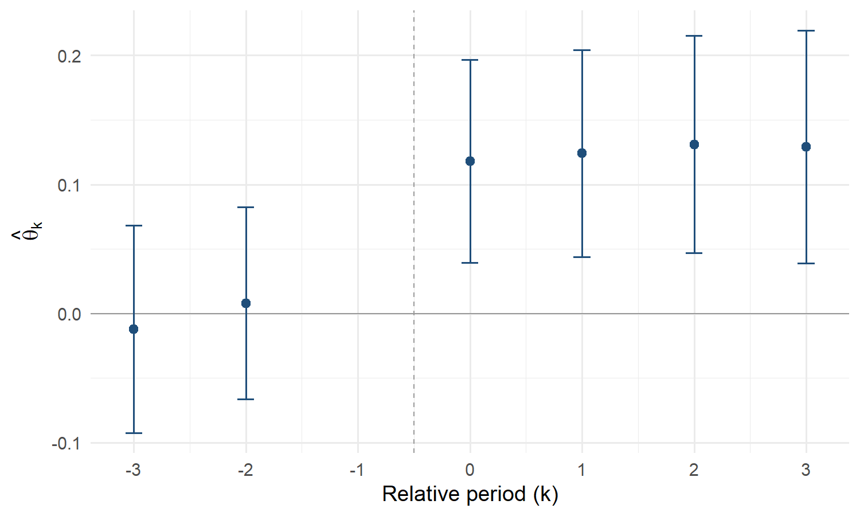
Figure B1: Event-study coefficients, baseline specification.
Notes: Markers report ${\hat{θ}}_{k}$; whiskers denote 95 percent confidence intervals constructed from state-clustered standard errors. Dashed line marks the omitted reference period ($k=−1$).

Appendix References
Abadie, Alberto, Susan Athey, Guido W. Imbens, and Jeffrey M. Wooldridge. 2017. “When Should You Adjust Standard Errors for Clustering?” NBER Working Paper, no. 24003.
Cameron, A. Colin, and Douglas L. Miller. 2015. “A Practitioner’s Guide to Cluster-Robust Inference.” Journal of Human Resources 50: 317–72.

All tables and figures in this demo are computed from a simulated dataset of 1,200 observations generated in the setup chunk; the empirical numbers should be read as illustrative.
We use $i$ for unit (typically individual or firm) and $t$ for period. The notation follows Angrist and Pischke (2009).
Wild cluster bootstrap with 999 replications, following Cameron and Miller (2015). Results are available on request.

