**CHAPTER I**

**INTRODUCTION**

*Overview of the Current State of Technology*

Lorem ipsum dolor sit amet, consectetur adipiscing elit. Donec suscipit tellus a felis ultrices scelerisque. Aliquam porttitor dictum nisi, at posuere lorem molestie at. Pellentesque quis quam justo. Phasellus sit amet laoreet ligula, sed congue dolor. Lorem ipsum dolor sit amet, consectetur adipiscing elit. Suspendisse porttitor metus est, sed tempus odio consectetur sit amet. Nam in odio sapien. In molestie, ante efficitur ultrices vulputate, ex odio pulvinar massa, in maximus sapien sem vitae nunc. Cras finibus urna lorem, id placerat ex consequat ac. Vestibulum vitae nisi eu metus eleifend bibendum. Curabitur vel iaculis urna. Donec vitae mi dolor.

Sed commodo massa a pellentesque scelerisque. Fusce sit amet tellus sagittis, dignissim purus sed, tincidunt felis. Nulla diam nunc, porta vitae lectus eu, feugiat finibus purus. Sed eget pellentesque dui. Morbi tincidunt ante in sollicitudin auctor. Nulla feugiat lobortis fermentum. Aenean sed malesuada eros. Nulla elementum libero et risus feugiat, iaculis pulvinar nisl dapibus. Cras malesuada nibh ut mauris laoreet, nec ultrices enim scelerisque.

Donec pulvinar lacus vitae diam euismod rhoncus. Suspendisse ac pretium lacus. Maecenas tincidunt nibh quis eros pretium vulputate. Nulla gravida augue neque, ut malesuada dolor interdum vel. Cras iaculis ac velit sit amet porta. Nam sollicitudin sodales nunc quis consectetur. Quisque pretium ornare blandit. Praesent dolor felis, accumsan vitae cursus et, lobortis quis arcu.

*Desired State of Technology*

Lorem ipsum dolor sit amet, consectetur adipiscing elit. Donec suscipit tellus a felis ultrices scelerisque. Aliquam porttitor dictum nisi, at posuere lorem molestie at. Pellentesque quis quam justo. Phasellus sit amet laoreet ligula, sed congue dolor. Lorem ipsum dolor sit amet, consectetur adipiscing elit. Suspendisse porttitor metus est, sed tempus odio consectetur sit amet. Nam in odio sapien. In molestie, ante efficitur ultrices vulputate, ex odio pulvinar massa, in maximus sapien sem vitae nunc. Cras finibus urna lorem, id placerat ex consequat ac. Vestibulum vitae nisi eu metus eleifend bibendum. Curabitur vel iaculis urna. Donec vitae mi dolor.

Sed commodo massa a pellentesque scelerisque. Fusce sit amet tellus sagittis, dignissim purus sed, tincidunt felis. Nulla diam nunc, porta vitae lectus eu, feugiat finibus purus. Sed eget pellentesque dui. Morbi tincidunt ante in sollicitudin auctor. Nulla feugiat lobortis fermentum. Aenean sed malesuada eros. Nulla elementum libero et risus feugiat, iaculis pulvinar nisl dapibus. Cras malesuada nibh ut mauris laoreet, nec ultrices enim scelerisque.

Donec pulvinar lacus vitae diam euismod rhoncus. Suspendisse ac pretium lacus. Maecenas tincidunt nibh quis eros pretium vulputate. Nulla gravida augue neque, ut malesuada dolor interdum vel. Cras iaculis ac velit sit amet porta. Nam sollicitudin sodales nunc quis consectetur. Quisque pretium ornare blandit. Praesent dolor felis, accumsan vitae cursus et, lobortis quis arcu.

Phasellus sagittis quam quis elementum ullamcorper. Donec ac blandit enim, quis commodo lorem. Morbi semper vehicula justo at lacinia. Praesent viverra lorem tortor, non finibus libero tristique nec. Vestibulum facilisis orci metus, sed tristique odio pellentesque eget. Nulla ultricies blandit nisi. Fusce dolor metus, pharetra in odio a.

*Statement of the Problem*

Lorem ipsum dolor sit amet, consectetur adipiscing elit. Nam quis ornare sem. Aenean lobortis justo felis, eget dapibus arcu volutpat semper. Morbi in consequat mauris, a egestas velit. Phasellus sagittis quam quis elementum ullamcorper. Donec ac blandit enim, quis commodo lorem. Morbi semper vehicula justo at lacinia. Praesent viverra lorem tortor, non finibus libero tristique nec. Vestibulum facilisis orci metus, sed tristique odio pellentesque eget. Nulla ultricies blandit nisi. Fusce dolor metus, pharetra in odio a. Ut hendrerit neque diam, ac volutpat ante accumsan eget. Suspendisse gravida arcu id bibendum maximus.

1. Duis pulvinar tortor sed gravida tempus. Maecenas sed risus condimentum lorem efficitur pellentesque sed ac mauris..
2. Etiam tincidunt tellus leo, quis porta magna facilisis in. Phasellus tincidunt eu enim eget ornare. Ut pretium, lorem porta convallis molestie, ante faucibus sem.
3. Eleifend nunc nisl sed lorem In hac habitasse platea dictumst. Vivamus at enim sed odio varius fermentum. Nulla sagittis enim sit amet egestas scelerisque. Nunc nisl augue, placerat ut est vel, dapibus porta od.
4. Nunc tincidunt erat fringilla leo tempor, a fringilla tortor posuere. Donec non fermentum quam. In semper venenatis pharetra.
5. Duis in nunc sed turpis sollicitudin pharetra. Etiam non felis quis velit venenatis ullamcorper eu sed est. Aenean consectetur suscipit magna non dictum. Vivamus ut euismod diam.

*Objectives of the Study*

*General Objectives*

Vestibulum porta a ipsum sit amet ultricies. Vivamus convallis mi id odio tincidunt, vitae euismod augue rhoncus. Orci varius natoque penatibus et magnis dis parturient montes, nascetur ridiculus mus. In pretium ex massa, fringilla luctus nisl fermentum iaculis. Nam hendrerit, ante a ullamcorper eleifend, elit mi dictum lorem, sit amet rhoncus turpis justo at quam.

*Specific Objectives*

1. Duis pulvinar tortor sed gravida tempus. Maecenas sed risus condimentum lorem efficitur pellentesque sed ac mauris..
2. Etiam tincidunt tellus leo, quis porta magna facilisis in. Phasellus tincidunt eu enim eget ornare. Ut pretium, lorem porta convallis molestie, ante faucibus sem.
3. Eleifend nunc nisl sed lorem In hac habitasse platea dictumst. Vivamus at enim sed odio varius fermentum. Nulla sagittis enim sit amet egestas scelerisque. Nunc nisl augue, placerat ut est vel, dapibus porta od.
4. Nunc tincidunt erat fringilla leo tempor, a fringilla tortor posuere. Donec non fermentum quam. In semper venenatis pharetra.
5. Duis in nunc sed turpis sollicitudin pharetra. Etiam non felis quis velit venenatis ullamcorper eu sed est. Aenean consectetur suscipit magna non dictum. Vivamus ut euismod diam.

*Theoretical and Conceptual Frameworks*

This section discusses the theories and concepts to be used in the course of designing and developing the capstone project.

*Theoretical Framework*

Lorem ipsum dolor sit amet, consectetur adipiscing elit. Nam quis ornare sem. Aenean lobortis justo felis, eget dapibus arcu volutpat semper. Morbi in consequat mauris, a egestas velit. Duis pulvinar tortor sed gravida tempus. Maecenas sed risus condimentum lorem efficitur pellentesque sed ac mauris. Etiam tincidunt tellus leo, quis porta magna facilisis in. Phasellus tincidunt eu enim eget ornare. Ut pretium, lorem porta convallis molestie, lacus ante faucibus sem, eget eleifend nunc nisl sed lorem. In hac habitasse platea dictumst. Vivamus a lorem nec massa aliquam ultrices eget nec magna.

Nunc tincidunt erat fringilla leo tempor, a fringilla tortor posuere. Donec non fermentum quam. In semper venenatis pharetra. Duis in nunc sed turpis sollicitudin pharetra. Donec euismod mauris turpis. Duis ornare tristique efficitur. Nunc semper libero a odio imperdiet bibendum. Aliquam volutpat tellus sit amet tincidunt vulputate.

Vivamus ut imperdiet augue, vitae facilisis elit. Praesent pharetra purus eget turpis finibus fringilla. Morbi ornare volutpat nisi ut euismod. Lorem ipsum dolor sit amet, consectetur adipiscing elit.

Vestibulum porta a ipsum sit amet ultricies. Vivamus convallis mi id odio tincidunt, vitae euismod augue rhoncus. Orci varius natoque penatibus et magnis dis parturient montes, nascetur ridiculus mus. Nam rhoncus mi risus, quis tempor risus sollicitudin eu. Suspendisse posuere, nunc non consectetur tempus, lectus lacus.

*Conceptual Framework*

Vivamus ut imperdiet augue, vitae facilisis elit. Praesent pharetra purus eget turpis finibus fringilla. Morbi ornare volutpat nisi ut euismod. Lorem ipsum dolor sit amet, consectetur adipiscing elit.

Vestibulum porta a ipsum sit amet ultricies. Vivamus convallis mi id odio tincidunt, vitae euismod augue rhoncus. Orci varius natoque penatibus et magnis dis parturient montes, nascetur ridiculus mus. Nam rhoncus mi risus, quis tempor risus sollicitudin eu.

**OUTPUT**

1. Nam rhoncus mi risus
2. Orci varius natoque penatibus
3. parturient montes, nascetur
4. risus, quis tempor risus
5. Praesent pharetra purus
6. Orci varius natoque penatibus
7. parturient montes, nascetur
8. risus, quis tempor risus
9. Praesent pharetra purus

**INPUT**

* Nam rhoncus mi risus
* Orci varius natoque penatibus
* parturient montes, nascetur
* risus, quis tempor risus
* Praesent pharetra purus
* Orci varius natoque penatibus
* parturient montes, nascetur
* risus, quis tempor risus
* Praesent pharetra purus

**PROCESS**

* Nam rhoncus mi risus
* Orci varius natoque penatibus
* parturient montes, nascetur
* risus, quis tempor risus
* Praesent pharetra purus
* Orci varius natoque penatibus
* parturient montes, nascetur
* risus, quis tempor risus
* Praesent pharetra purus

**Figure 1. Conceptual Framework of ABC System**

*Operational Definition of Terms*

**Abretium.** Ex massa, fringilla luctus nisl fermentum iaculis. Nam hendrerit, ante a ullamcorper eleifend, elit mi dictum lorem, sit amet rhoncus turpis justo at quam. Nullam mattis in magna a rhoncus. Pellentesque lobortis ligula quis lacus blandit pellentesque ut vel lectus.

**Aliquam.** Erat volutpat. Etiam ut pretium justo. Sed pretium tincidunt odio eu ornare. Pellentesque nunc ligula, imperdiet quis iaculis eget, lobortis tincidunt felis. Lorem ipsum dolor sit amet, consectetur adipiscing elit. Quisque orci nunc, pretium nec orci ac, rhoncus imperdiet nibh. Vestibulum ullamcorper fringilla purus et hendrerit. Nam ut rutrum nisl.

**Bivamus.** Ut leo laoreet, iaculis leo et, porttitor risus. Vestibulum in posuere purus. Sed blandit risus non rutrum dapibus imperdiet quis iaculis eget, lobortis tincidunt felis. Lorem ipsum dolor sit amet, consectetur adipiscing.

**Caecenas.** Deget vehicula lacus. Phasellus non sapien at odio condimentum tincidunt. Duis nec maximus quam. Morbi quam tellus, porttitor quis arcu eu, dignissim mollis justo. Mauris sed ullamcorper lectus.

**Daecenas.** Bibendum aliquam sollicitudin. Lorem ipsum dolor sit amet, consectetur adipiscing elit. Aliquam sodales dolor elit, eu interdum diam tempus at. Proin sed sollicitudin odio. Praesent at ligula ut mi faucibus porta a eget eros. Aenean vehicula venenatis laoreet.

**Estibulum.** Porta a ipsum sit amet ultricies. Vivamus convallis mi id odio tincidunt, vitae euismod augue rhoncus. Orci varius natoque penatibus et magnis dis parturient montes, nascetur ridiculus mus. Nam rhoncus mi risus, quis tempor risus sollicitudin eu. Suspendisse posuere, nunc non consectetur tempus,

*Scope and Limitations of the Study*

Vivamus ut imperdiet augue, vitae facilisis elit. Praesent pharetra purus eget turpis finibus fringilla. Morbi ornare volutpat nisi ut euismod. Lorem ipsum dolor sit amet, consectetur adipiscing elit.

Vestibulum porta a ipsum sit amet ultricies. Vivamus convallis mi id odio tincidunt, vitae euismod augue rhoncus. Orci varius natoque penatibus et magnis dis parturient montes, nascetur ridiculus mus. Nam rhoncus mi risus, quis tempor risus sollicitudin eu. Suspendisse posuere, nunc non consectetur tempus, lectus lacus sollicitudin metus, ac fermentum tortor augue sed libero. Duis tempor accumsan felis, ultricies aliquet mauris tempus vitae. Sed dapibus volutpat sem, in imperdiet sem mollis non. Vivamus sodales est neque, ac posuere risus dapibus id. Donec nec nisl tincidunt, tempor nulla vehicula, fringilla urna. Integer malesuada dictum quam cursus finibus.

Aliquam congue imperdiet augue vel consectetur. Cras dapibus posuere neque eget luctus. Suspendisse facilisis congue sem. Integer eleifend dictum lectus, eu egestas sapien ullamcorper quis. Nunc lectus lacus, finibus eu consectetur sed, tincidunt at neque. Donec eu metus volutpat, aliquam orci et, semper massa. Phasellus ornare nibh eget felis laoreet, quis pretium elit imperdiet. Phasellus et ligula eget nulla ornare varius. Mauris pellentesque nisi ac est sodales volutpat. Nulla lectus justo, placerat id arcu at, ultrices cursus lorem.

Vivamus pharetra ornare ex eget ornare. Etiam non felis quis velit venenatis ullamcorper eu sed est. Aenean consectetur suscipit magna non dictum. Vivamus ut euismod diam. Vivamus at enim sed odio varius fermentum. Nulla sagittis enim sit amet egestas scelerisque.

*Significance of the Study*

Vivamus ut imperdiet augue, vitae facilisis elit. Praesent pharetra purus eget turpis finibus fringilla. Morbi ornare volutpat nisi ut euismod. Lorem ipsum dolor sit amet, consectetur adipiscing elit.

Vestibulum porta a ipsum sit amet ultricies. Vivamus convallis mi id odio tincidunt, vitae euismod augue rhoncus. Orci varius natoque penatibus et magnis dis parturient montes, nascetur ridiculus mus. Nam rhoncus mi risus, quis tempor risus sollicitudin eu. Suspendisse posuere, nunc non consectetur tempus, lectus lacus sollicitudin metus, ac fermentum tortor augue sed libero. Duis tempor accumsan felis, ultricies aliquet mauris tempus vitae. Sed dapibus volutpat sem, in imperdiet sem mollis non. Vivamus sodales est neque, ac posuere risus dapibus id. Donec nec nisl tincidunt, tempor nulla vehicula, fringilla urna. Integer malesuada dictum quam cursus finibus.

Aliquam congue imperdiet augue vel consectetur. Cras dapibus posuere neque eget luctus. Suspendisse facilisis congue sem. Integer eleifend dictum lectus, eu egestas sapien ullamcorper quis. Nunc lectus lacus, finibus eu consectetur sed, tincidunt at neque. Donec eu metus volutpat, aliquam orci et, semper massa. Phasellus ornare nibh eget felis laoreet, quis pretium elit imperdiet. Phasellus et ligula eget nulla ornare varius. Mauris pellentesque nisi ac est sodales volutpat. Nulla lectus justo, placerat id arcu at, ultrices cursus lorem.

Vivamus pharetra ornare ex eget ornare. Etiam non felis quis velit venenatis ullamcorper eu sed est. Aenean consectetur suscipit magna non dictum. Vivamus ut euismod diam. Vivamus at enim sed odio varius fermentum. Nulla sagittis enim sit amet egestas scelerisque.

**CHAPTER II**

**REVIEW OF RELATED LITERATURE**

*Overview*

This chapter includes related works that contributed different ideas in the development of the system. All these related works served as basis for the development of the system by means of knowing its functions and features and applying it to the system being created. Also these related works served as guide in creating an effective design that will meet customer requirements.

*ABC Application*

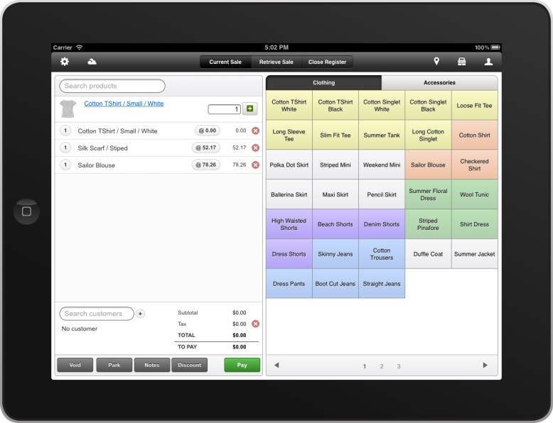

**Figure 2. ABC Interface**

ABC is a cloud-based point-of-sale and retail management software that lets retailers run their business in-store, online, and via mobile. ABC solution includes POS software, inventory management, E-commerce, customer loyalty, and reporting analytics. ABC integrates with other business and payments applications including Shopify, Square, Xero and PayPal, and is a key retail partner in Apple’s global Mobility Partner Program.

These are the features that ABC offer: Quick keys and product lookup, Multiple payment methods/split payments, product returns, refunds and store credit features, User accounts and permissions, Mobile Registers, Customer-facing display, Bulk product imports, Product variants and composites, Barcodes, Stock and auto-filled orders, Inventory counts, Stock Transfers, Promotions, Searchable customer database, Customer history attached to each profile, Custom properties, Loyalty program, Product reports, Employee reporting and Customer reports.

*DEF Application*

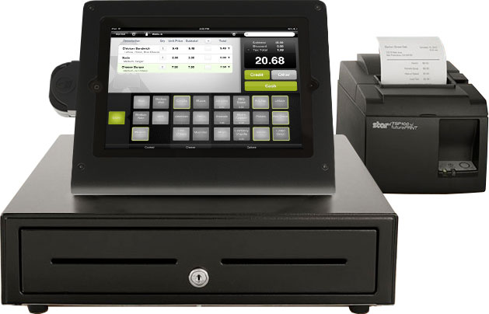

**Figure 3. DEF Interface**

DEF is a cloud-based [point of sale](https://en.wikipedia.org/wiki/Point_of_sale) system that enables online shopping for the end consumers. DEF's [hyper local](https://en.wikipedia.org/wiki/Hyperlocal) marketplace allows merchants to run their stores and merchandise online and connect them with consumers in their neighborhood.  DEF creates a real-time product graph that connects brands, consumers, and merchants.

These are the key features of DEF POS: Time clock, Customer Relationship Management (CRM), Tax management, Mobile POS, Online storefront, Cash register, Refunds management, API integration, Reporting & analytics, Supply management, PIN-based employee management, QuickBooks POS integration, Loyalty program, Cash management, Shift activity management, Customer management, Email receipts, Customer spending history, EMV card support, Intelligent re-ordering, Face capture, Catalog management, Multi-user management, Stock & sales tracking, Product matrix, Income statement analysis, Side-by-side product comparisons, Historical comparisons, Transaction breakdown report, Color coded KPIs, O2O (online to offline) data analytics, Apple Pay support and an Online dashboard.

*GHI Application*

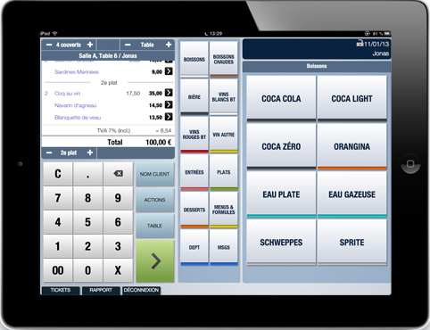

**Figure 4. GHI Interface**

GHI is an app that supports tableside ordering, custom restaurant layouts, custom menus, bill splitting, sales reports, and an unlimited number of order and cash register printers. It is available from the [iTunes](https://en.wikipedia.org/wiki/ITunes) store. It is the top grossing Food and Beverage iTunes app in over 34 countries.  GHI does not require an Internet connection, communicating with printers’/cash drawers via local WIFI.

The key features of GHI application are the following: Billing & Invoicing, Built-in Accounting, Employee Management, Inventory Management, Kitchen Management, Menu Management, Point of Sale (POS), Reporting/Analytics, Reservations Management, Table Management and Wait List Management.

*JKL Application*

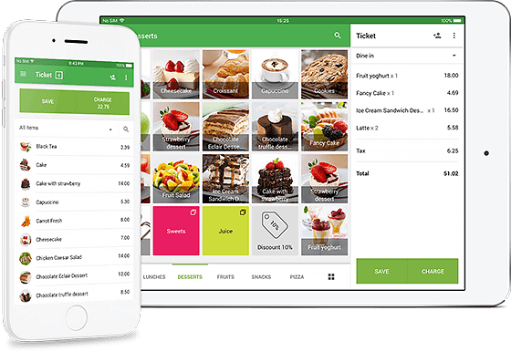

**Figure 5. JKL Interface**

JKL is a free sales solution that can be used by SMBs, particularly restaurants, coffee shops, bars, and retail stores, among others. It is even ideal for sole entrepreneurs since it does not need commitments, credit cards, and contracts.

*Synthesis*

Aliquam congue imperdiet augue vel consectetur. Cras dapibus posuere neque eget luctus. Suspendisse facilisis congue sem. Integer eleifend dictum lectus, eu egestas sapien ullamcorper quis. Nunc lectus lacus, finibus eu consectetur sed, tincidunt at neque. Donec eu metus volutpat, aliquam orci et, semper massa. Phasellus ornare nibh eget felis laoreet, quis pretium elit imperdiet. Phasellus et ligula eget nulla ornare varius. Mauris pellentesque nisi ac est sodales volutpat. Nulla lectus justo, placerat id arcu at, ultrices cursus lorem.

Vivamus pharetra ornare ex eget ornare. Etiam non felis quis velit venenatis ullamcorper eu sed est. Aenean consectetur suscipit magna non dictum. Vivamus ut euismod diam. Vivamus at enim sed odio varius fermentum. Nulla sagittis enim sit amet egestas scelerisque. Nunc nisl augue, placerat ut est vel, dapibus porta odio. Ut hendrerit neque diam, ac volutpat ante accumsan eget. Suspendisse gravida arcu id bibendum maximus.

In pretium ex massa, fringilla luctus nisl fermentum iaculis. Nam hendrerit, ante a ullamcorper eleifend, elit mi dictum lorem, sit amet rhoncus turpis justo at quam. Nullam mattis in magna a rhoncus. Pellentesque lobortis ligula quis lacus blandit pellentesque ut vel lectus. Aliquam erat volutpat. Etiam ut pretium justo. Sed pretium tincidunt odio eu ornare. Pellentesque nunc ligula, imperdiet quis iaculis eget, lobortis tincidunt felis. Lorem ipsum dolor sit amet, consectetur adipiscing elit. Quisque orci nunc, pretium nec orci ac, rhoncus imperdiet nibh. Vestibulum ullamcorper fringilla purus et hendrerit. Nam ut rutrum nisl. Vivamus ut leo laoreet, iaculis leo et, porttitor risus. Vestibulum in posuere purus. Sed blandit risus non rutrum dapibus.

**Table1. Synthesis**

|  |  |  |  |  |  |  |
| --- | --- | --- | --- | --- | --- | --- |
|  | ABC | DEF | GHI | JKL | MNO | PQR |
| Security Module | ✔ |  | ✔ | ✔ |  | ✔ |
| File Maintenance Module | ✔ |  |  | ✔ |  | ✔ |
| Sales Module | ✔ | ✔ | ✔ |  | ✔ | ✔ |
| Inventory Module | ✔ | ✔ | ✔ | ✔ | ✔ | ✔ |
| Report Module | ✔ | ✔ | ✔ | ✔ | ✔ | ✔ |
| Statistical Module | ✔ | ✔ | ✔ | ✔ | ✔ | ✔ |

. Etiam ut pretium justo. Sed pretium tincidunt odio eu ornare. Pellentesque nunc ligula, imperdiet quis iaculis eget, lobortis tincidunt felis. Lorem ipsum dolor sit amet, consectetur adipiscing elit. Quisque orci nunc, pretium nec orci ac, rhoncus imperdiet nibh. Vestibulum ullamcorper fringilla purus et hendrerit. Nam ut rutrum nisl.

**CHAPTER III**

**RESEARCH METHODOLOGY**

Lorem ipsum dolor sit amet, consectetur adipiscing elit. Nam quis ornare sem. Aenean lobortis justo felis, eget dapibus arcu volutpat semper. Morbi in consequat mauris, a egestas velit. Duis pulvinar tortor sed gravida tempus. Maecenas sed risus condimentum lorem efficitur pellentesque sed ac mauris. Etiam tincidunt tellus leo, quis porta magna facilisis in. Phasellus tincidunt eu enim eget ornare. Ut pretium, lorem porta convallis molestie, lacus ante faucibus sem, eget eleifend nunc nisl sed lorem. In hac habitasse platea dictumst. Vivamus a lorem nec massa aliquam ultrices eget nec magna.

Nunc tincidunt erat fringilla leo tempor, a fringilla tortor posuere. Donec non fermentum quam. In semper venenatis pharetra. Duis in nunc sed turpis sollicitudin pharetra. Donec euismod mauris turpis. Duis ornare tristique efficitur. Nunc semper libero a odio imperdiet bibendum. Aliquam volutpat tellus sit amet tincidunt vulputate. Vivamus ut imperdiet augue, vitae facilisis elit. Praesent pharetra purus eget turpis finibus fringilla. Morbi ornare volutpat nisi ut euismod. Lorem ipsum dolor sit amet, consectetur adipiscing elit.

Vestibulum porta a ipsum sit amet ultricies. Vivamus convallis mi id odio tincidunt, vitae euismod augue rhoncus. Orci varius natoque penatibus et magnis dis parturient montes, nascetur ridiculus mus. Nam rhoncus mi risus, quis tempor risus sollicitudin eu. Suspendisse posuere, nunc non consectetur tempus, lectus lacus sollicitudin metus, ac fermentum tortor augue sed libero. Duis tempor accumsan felis, ultricies aliquet mauris tempus vitae.

**The Waterfall Model**

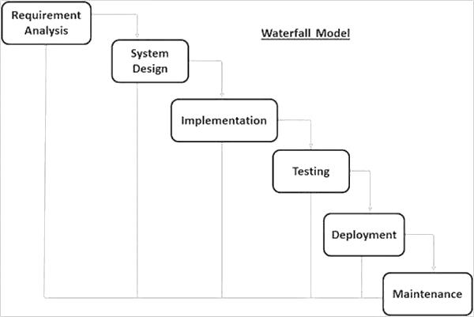

**Figure 7. The Waterfall Model**

*Requirement Gathering and Analysis*

All possible requirements of the system developed were captured in this phase and documented in a requirement specification document. This phase is the most crucial step in creating a successful system. During this phase, one must decide exactly what he wants to do and the problems he is trying to solve by submerging in the processes of the business or performing data gathering methods such as interview or observation.

Before proceeding to the next step, all possible requirements should be gathered and activities should be planned to have an overview of the whole activity and development of the system or the project as a whole.

The researchers interviewed and observed the business processes while taking down notes of the important information and sample forms and documents. Then, after all the needed information is gathered, the problems, solutions and objectives are then defined based on the gathered information.

*System Design*

The requirement specifications from first phase were studied in this phase and the system design was prepared. This phase involved specifying hardware and system requirements and define the overall system architecture. Also, in this part, it is where the end-user’s requirements were determined, what their expectations were for the system, and how it performed. A good design comes after a good understanding of customer’s requirements. This phase defined the elements of a system, the components, the security level, modules, architecture and the different interfaces and type of data that goes through the system.

The researchers determined which modules and features were to be included, as well as the components like the hardware and software to be used in implementing the system. These are important things to consider before proceeding to the creation of the design. Then, when all the components were defined and the modules to be created were listed, the researchers started created wireframes and system prototypes. Furthermore, finding related literature was included in this phase, where the features and design from other existing applications were used as guide throughout the designing of the system.

*Implementation*

With inputs from the system design, the system was then developed. This phase came after a complete understanding of system requirements and specifications; it is the actual construction process after having a complete and illustrated design for the requested system which was done in the previous phase. The actual code was written here, and if the system contains hardware, then the implementation phase will include configuration and fine-tuning for the hardware to meet certain requirements.

In this phase, the researchers started the actual development of the system. First was the installation of required applications like Visual Studio as the IDE (Integrated Development Environment), XAMPP which is a full stack server platform that includes a database and also the installation of required hardware drivers like printer drivers. After all the needed applications were installed, the actual coding comes using the existing design from the previous phase. Also, since the system involves to be connected to multiple computers, computer networking was done in this phase.

*Integration and Testing*

If program units were created in the previous phase, all the units developed in the implementation phase were integrated into a system after the testing of each unit. After the integration, the entire system is tested for any faults and failures.

Testing is important to ensure customer’s satisfaction, and it requires no knowledge in coding, hardware configuration or design. Testing can be performed by real users, or by a team of specialized personnel. It can also be systematic and automated to ensure that the actual outcomes are compared and equal to the predicted and desired outcomes.

In this phase, the researchers tested the running system while being connected to another computer and checked if all the functionalities are working. Also, the researchers presented the system to University Enterprise to give them a bit of user experience and see whether the actual developed system met their requirements and expectations. The next step was fixing the found problems and system bugs and implementing the suggestions from the users in University Enterprise.

*Deployment of System*

Once the functional and non-functional testing was done; the product was deployed in the customer environment or released into the market.

In this phase, the finished system was then deployed at the University Enterprise. Trainings were given to the users to give them the knowledge of the usage of the system.

*Maintenance*

There were some issues which came up in the client environment. To fix those issues, patches were released. Also, to enhance the product, some better versions were released. Maintenance was done to deliver these changes in the customer environment.

In this phase, periodic maintenance for the system was carried out to make sure that the system would not become obsolete. This included replacing the old hardware and continuously evaluating system’s performance. It also included providing latest updates for certain components to make sure it meets the right standards and the latest technologies to face current security threats. The researchers performed continuous checking of the system’s function and fixing problems or bugs if there is.

# 

**BIBLIOGRAPHY**

Acopiado S. B., Dabodabo T. D., Gomez A. L. & Santiago K. C. (2015). Sales and

Inventory System Thesis Documentation. Retrieved from

https://www.academia.edu/16863814/Sales_and_Inventory_System_Thesis_

Documentation

Rouse, M. (2018). Integrated Development Environment (IDE). Retrieved from

<https://searchsoftwarequality.techtarget.com/definition/integrated-development->environment

# Alwan, M. (2015). System Development Life Cycle. Retrieved from

<https://airbrake.io/blog/sdlc/what-is-system-development-life-cycle>

Rouse, M. (2005). System. Retrieved from

https://searchwindowsserver.techtarget.com/definition/system

Rouse, M. (2017). Creating and Maintaining a corporate app store: Strategies for

success. Security. Retrieved from https://searchsecurity.techtarget.com/

definition/security

Cambridge Advanced Learner’s Dictionary and Thesaurus. Computerize Definition.

Retrieved from https://dictionary.cambridge.org/us/dictionary/english/computerize

Automated. Retrieved from https://www.merriam-webster.com/dictionary/automated

Collins English Dictionary. Leaseholder Definition. Retrieved from

https://www.collinsdictionary.com/dictionary/english/leaseholder

Wikipedia. Visual Studio 2010. Retrieved from https://en.wikipedia.org/wiki/Microsoft_

Visual_Studio

Kenton, W. (2018). Inventory. Retrieved from https://www.investopedia.com/terms/i/

inventory.asp

Module definition. Retrieved from https://www.techopedia.com/definition/3843/module

Collins English Dictionary. Stock Definition. Retrieved from https://www.collinsdictionary.

com/dictionary/english/stock

Hayes, A. (2019). Business Essentials: Business. Retrieved from https://www.

investopedia.com/terms/b/business.asp