# Table of Contents

Table of Contents 1

Project Proposal 2

Executive Summary 5

System Definition 6

System Requirements Specifications 7

Entity-Relationship Diagram 8

Physical Layout 9

Data Dictionary 11

Architecture 12

Project Plan / Schedule 13

Test Cases 14

Sample Data 15

# Project Proposal

## Team Members

David Aquino

Tim Bibo

Rohan Dangi

## Proposed Client

In the year 1988, Dan Gordon and Dean Biersch co-founded Gordon Biersch (GB) Company with the goal of creating most authentic German-style larger. With the experience of 25 years, GB has doubled its annual production and increased its capacity to 4 million gallon of beer which made them the largest craft brewery in San Francisco Bay Area (Pulse, 2014). According to Brewers Association, GB ranks in top 49th Breweries in 2013 (Association, n.d.). Currently, there are 34 GB locations around the States that brews 40 different beers (Advocate, n.d). GB uses Ctuit software (also used by its parent company-Craftwork) that combines the restaurant POS data with inventory, accounting, and other tools to form consistent system throughout its brewery (Biersch, n.d.).

## Project Description

Our group would like to apply an existing concept to a new industry. Our idea resembles a stock exchange; however, instead of buying stock in a company, customers would be purchasing products to be consumed. In this particular case, customers would be purchasing alcoholic drinks such as beer or cocktails as they normally do in a bar or restaurant. The twist in this scenario is that the prices of these drinks (and possibly food in the future) will fluctuate according to demand and inventory levels. For example, if a group of people were to order 6 Miller Lites, the result after this purchase would be an increase (~ +5%) in the price of Miller Lites and a decrease in another drink/beer such as Bud Light (~ -5%).

We would be introducing a new POS system which would handle sales and relay them to our system. The system would be smart enough to make decisions such as price changes for the drinks. The business need we are addressing is alcohol sales. We predict that with our system, we can help track sales and introduce methods to increase sales. We intend to build a system which will be incorporated with inventory and track sales. In (almost) real-time we would like to adjust the prices of alcohol based on demand. The system will be smart enough to acknowledge trends as they occur and attempt to capitalize on these trends. It will be able to produce on the fly analysis regarding daily highs/lows compared to original price and current price (based on demand). There will also be periodic (daily/weekly/monthly/yearly) snapshots which can be used to analyze sales trends and affect purchasing decisions.

## Project Justification

Throughout the planning, design, and implementation of the project, the group members will demonstrate many of the skills that they acquired in their completed coursework, and they will acquire new skills that they will attain through independent methods.

The overall design and implementation of the project will follow the SDLC, a theory of design that has been reinforced in every course of the AIT-MS program at Towson University. Beginning with the project proposal and culminating in the operational maintenance of the project, the group members will adhere to the SDLC’s pillars of planning, designing, building, testing, and delivering a database system that meets the needs of a hypothetical customer. In addition to following the SDLC, the project will incorporate a number of skills learned in AIT-632 and AIT-732, the two prerequisite courses for AIT -735.

AIT-632 and AIT- 732 introduced the group members to a number of database design elements which the group members will incorporate into the project. For example, data modifications will be driven by stored procedures, while considering transaction controls and methods of reinforcing business rules. Also, data will be validated, and all code will be commented in such a way that the instructor (and hypothetically future developers) will be able to quickly and thoroughly understand it. In addition to the aforementioned topics, the group members will broaden their skill-set by learning and developing other database management techniques.

While the project is nascent, the group members have identified a number of skills that they wish to develop as part of this project. At the most basic level, group members will create a new database on an existing Microsoft SQL Server. (There has also been discussion of learning to install and configure SQL Server as a piece of this project). Also, the group members will learn about and implement sufficiently robust user access and permissions. Additionally, the group members will learn about different methods for backing up and restoring SQL Server databases. The group intends to implement a backup strategy for the project.

## Project Plan / Schedule

Our group has broken down the project into following tasks:

1. Project Planning: During this phase, our team will provide a system proposal to the client.
2. Requirement Gathering: This section will analyze and determine the needs and expectation of end users of newly developed system. We have decided to utilize the functions available in the existing system within the industry for our initial requirement gathering phase.
3. Design for System: This phase will define the architectural component of the system to satisfy the requirements gathered in the previous stage. Our team will create ER Diagram, Physical Table Layout, and Data Dictionary during this phase.
4. Implementation: This phase includes writing SQL queries, procedure, and triggers.
5. Data Conversion and Loading: Our team will upload a sample data in the system.
6. Testing: During this phase, our team will test if the queries, procedure, and triggers are working as intended or not.
7. Operational Maintenance: During this phase, our team will examine the available solutions for Backup/recovery option during the system failure.

The following table highlights the above mentioned phase with its estimated timeline.

|  |  |  |
| --- | --- | --- |
| TASKS | Estimated Timeline | TOTAL HOURS |
| Task 1. Project Planning | August 29, 2014 – September 01, 2014 |  |
| David Aquino | 3 |
| Tim Bibo | 3 |
| Rohan Dangi | 3 |
| Task 2. Requirement gathering | September 08, 2014– September 16, 2014 |  |
| David Aquino | 20 |
| Tim Bibo | 20 |
| Rohan Dangi | 20 |
| Task 3. Design for system | September 18, 2014– October 20, 2014 |  |
| David Aquino | 85 |
| Tim Bibo | 85 |
| Rohan Dangi | 85 |
| Task 4. Implementation | October 22, 2014– October 27, 2014 |  |
| David Aquino | 15 |
| Tim Bibo | 15 |
| Rohan Dangi | 15 |
| Task 5. Data Conversion & Loading | October 29, 2014– October 31, 2014 |  |
| David Aquino | 4 |
| Tim Bibo | 4 |
| Rohan Dangi | 4 |
| Task 6. Testing | November 03, 2014– November 14, 2014 |  |
| David Aquino | 10 |
| Tim Bibo | 10 |
| Rohan Dangi | 10 |
| Task 7. Operational Maintenance | November 17, 2014– November 19, 2014 |  |
| David Aquino | 3 |
| Tim Bibo | 3 |
| Rohan Dangi | 3 |
| **TOTAL HOURS TO COMPLETE PROJECT** | | **420 Hours** |
| **TOTAL HOURS TO COMPLETE PROJECT PER PARTICIPANT** | | **140 Hours** |

## Work Cited

* Advocate. (n.d.). Gordon Biersch Brewery Restaurant | United States | Beers.BeerAdvocate. Retrieved September 1, 2014, from <http://www.beeradvocate.com/beer/profile/1551/>.
* Association. (n.d.). Brewers Association Lists Top 50 Breweries of 2013.brewersassociation.org. Retrieved August 31, 2014, from <http://www.brewersassociation.org/attachments/0001/4525/CBP13_Top_50.pdf/>
* Biersch. (n.d.). Careers. Growth. Retrieved August 31, 2014, from http://www.gordonbiersch.com/careers/growth
* Pulse. (2014, May 20). Gordon Biersch Dunkles release marks brewery's 25th anniversary. BeerPulse. Retrieved August 31, 2014, from <http://beerpulse.com/2014/05/gordon-biersch-dunkles-release-marks-brewerys-25th-anniversary-3108/>.

# 

# Executive Summary

Text

# 

# System Definition

Project Scope  
This project will consist of creating a database and inventory management system for GB. The project will be completed by December 04, 2014. Our group has recognized the following areas within GB that will be impacted through the implementation of this project.

* Sales Branch
* Purchase Branch
* Reporting Group
* IT
* Accounting Department: Accounts Payable/Receivable
* Inventory Management
* Vendor management
* Customer Service

Product Sales

Employees

Inventory control

Reporting

**Sales Branch**

**Purchase Branch**

**IT**

**Vendor Management**

**Accounting  
Branch**

User Views  
The primary users of this system include

* bar Staffs
* management
* accountants
* purchasing manager
* shift manager
* store/bar manager

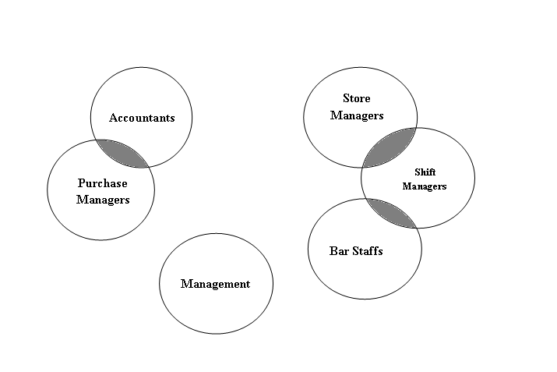

Application Areas  
The primary uses of this project include

* backend system to manage purchases from vendors
* frontend POS system to process sales
* fisual reporting (via television) to show the current running prices of beers.

# 

# System Requirements Specifications

1. The POS system shall integrate with an external payment processor.
2. The POS system shall provide a data dump for sales and purchases via ETL process to the accounting software.
3. The system must be able to add new inventory (products) with no duplicate records.
4. The system must be able to add new vendors.
5. The system must be able to update the vendor information.
6. The system must be able to display all the beverages inventory belonging to a given vendor.
7. The system must produce a formatted report of all products and available quantities for every vendor.
8. The system must display original prices and current prices, % difference in price from current to original, daily high price for products, daily low price for products.
9. The system must display prices for most recently sold products.
10. The system must display top selling products of the day.
11. The system must create a nightly backup, after normal business hours, and differential backups throughout the day.
12. The system must be able to update product prices based on sales.
13. The system must not be able to sell a quantity which exceeds the inventory available, and the system must not be able to sell inventory to a customer below the age of 21.
14. The system must update real-time inventory levels according to sales.
15. The system must be able to display the unpaid items for a customer.
16. The system must be able to predict when to order inventory based on sales and current inventory levels.
17. The system must be able to generate profit report.
18. The system must be able to display total number of inventory sold by type per day.
19. The system must be able to display total revenue for a day.
20. The system must display monthly sales reports.
21. The system must display monthly purchase reports.
22. The system shall keep historical data
23. The system must insert new purchases and update the inventory levels in the product table.
24. The system must reset prices to their base levels.
25. The system must be able to add new product types without duplicates.
26. The system must be able to insert new customers without duplicates.

# Entity-Relationship Diagram



# Physical Layout

| **TABLE** | **VARIABLE** | **DATA_TYPE** | **NOT_NULL** | **PK** | **FK** | **IDENTITY** | **CHECK** | **UNIQUE** | **DESCRIPTION** | **SAMPLE** |
| --- | --- | --- | --- | --- | --- | --- | --- | --- | --- | --- |
| **T_VENDOR** | VEN_ID | INT | Y | Y |  | Y |  | Y | UNIQUE ID FOR EACH VENDOR | 1 |
| VEN_NAME | VARCHAR(30) | Y |  |  |  |  | Y | VENDOR NAME | WM BREWERY |
| VEN_STREET1 | VARCHAR(30) | Y |  |  |  |  |  | VENDOR ADDRESS ONE | 123 FAKE STREET |
| VEN_STREET2 | VARCHAR(30) |  |  |  |  |  |  | VENDOR ADDRESS TWO | UNIT X |
| VEN_CITY | VARCHAR(30) | Y |  |  |  |  |  | CITY | WHITE MARSH |
| VEN_STATE | CHAR(2) | Y |  |  |  |  |  | STATE | MD |
| VEN_ZIP | NUMERIC(5,0) | Y |  |  |  | >=01000<=99999 |  | U.S. ZIP CODE | 21245 |
| VEN_PHONE | VARCHAR(12) | Y |  |  |  |  |  | PHONE NUMBER OF VENDOR | 410-111-1111 |
| VEN_EMAIL | VARCHAR(50) | Y |  |  |  |  |  | EMAIL OF CONTACT AT VENDOR | [JJ@WMBREW.COM](mailto:JJ@WMBREW.COM) |
| VEN_CONTACT | VARCHAR(50) | Y |  |  |  |  |  | NAME OF CONTACT AT VENDOR | JANET JONES |
|  |  |  |  |  |  |  |  |  |  |  |
| **T_PRODUCT** | PRO_ID | INT | Y | Y |  | Y |  | Y | UNIQUE ID FOR EACH PRODUCT | 1 |
| PRO_NAME | VARCHAR(30) | Y |  |  |  |  | Y | DESCRIPTIVE NAME OF PRODUCT | SPICY SUMMER ALE |
| TY_ID | INT | Y |  | Y |  |  |  | REFERENCE TYPE (TY_ID) | 5 |
| PRO_BASE | NUMERIC(5,2) | Y |  |  |  | >0 |  | BASE PRICE OF THE PRODUCT | $5.00 |
| PRO_INSTOCK | INT | Y |  |  |  | >=0 |  | NUMBER OF PRODUCT IN STOCK |  |
| VEN_ID | INT | Y |  | Y |  |  |  | REFERENCE VENDOR (VEN_ID) | 546 |
|  |  |  |  |  |  |  |  |  |  |  |
| **T_TYPE** | TY_ID | INT | Y | Y |  | Y |  | Y | UNIQUE ID FOR EACH PRODUCT CATEGORY | 1 |
| TY_DESCRIPTION | VARCHAR(50) | Y |  |  |  |  | Y | TYPE OF PRODUCT | 16 OZ BEER BOTTLE |
| TY_AGERESTRICTED | INT | Y |  |  |  | IN(1,2) |  | MUST CUSTOMER BE 21 TO PURCHASE? | 1=YES / 2=NO |
|  |  |  |  |  |  |  |  |  |  |  |
| **T_PURCHASE** | PUR_ID | INT | Y | Y |  | Y |  | Y | UNIQUE ID FOR EACH PURCHASE | 1 |
| PRO_ID | INT | Y |  | Y |  |  |  | REFERENCE PRODUCT (PRO_ID) | 33 |
| VEN_ID | INT | Y |  | Y |  |  |  | REFERENCE VENDOR (VEN_ID) | 12 |
| PUR_QTY | INT | Y |  |  |  | >0 |  | QUANTITY PURCHASED | 480 |
| PUR_UNT_PRICE | NUMERIC(5,2) | Y |  |  |  | >0 |  | PRICE PAID PER UNIT | $1.25 |
| PUR_DATE | DATETIME | Y |  |  |  |  |  | DATE AND TIME OF PURCHASE | 8/15/2015:15:32:42 |
|  |  |  |  |  |  |  |  |  |  |  |
| **T_ACCT_SALES** | ACCT_ID | INT | Y | Y |  | Y |  | Y | UNIQUE ID FOR EACH ITEM IN THE CART | 1 |
| ACCT_DATETIME | DATETIME | Y |  |  |  |  |  | DATE AND TIME OF PURCHASE | 8/15/2015:15:32:42 |
| ACCT_PRICE | NUMERIC(5,2) | Y |  |  |  | >0 |  | PRICE AT WHICH PRODUCT WAS SOLD | $1.87 |
| CUS_ID | INT | Y |  | Y |  | >0 |  | REFERENCE CUSTOMER (CUS_ID) | 133 |
| ACCT_QTY | INT | Y |  |  |  | >0 |  | QTY SOLD |  |
| PRO_ID | INT | Y |  | Y |  |  |  | REFERENCE PRODUCT (CUS_ID) | 2 |
|  |  |  |  |  |  |  |  |  |  |  |
| **T_PRICE** | PRI_ID | INT | Y | Y |  | Y |  | Y | UNIQUE ID FOR EACH PRICE CHANGE | 4876 |
| PRO_ID | INT | Y |  |  |  |  |  | REFERENCE PRODUCT (PRO_ID) | 33 |
| PRO_PRI | NUMERIC(5,2) | Y |  |  |  | >0 |  | CURRENT SELLING PRICE OF PRODUCT | $1.87 |
|  |  |  |  |  |  |  |  |  |  |  |
| **T_CUSTOMER** | CUS_ID | INT | Y | Y |  | Y |  |  | UNIQUE ID FOR EACH CUSTOMER | 21 |
| CUS_DOB | DATE | Y |  |  |  |  |  | CUSTOMER DOB | 9/12/1990 |
| CUS_STREET1 | VARCHAR(30) |  |  |  |  |  |  | CUSTOMER ADDRESS ONE | 123 FAKE STREET |
| CUS_STREET2 | VARCHAR(30) |  |  |  |  |  |  | CUSTOMER ADDRESS TWO | UNIT X |
| CUS_CITY | VARCHAR(30) |  |  |  |  |  |  | CITY | WHITE MARSH |
| CUS_STATE | CHAR(2) |  |  |  |  |  |  | STATE | MD |
| CUS_ZIP | NUMERIC(5,0) |  |  |  |  | >=01000<=99999 |  | U.S. ZIP CODE | 21245 |
| CUS_EMAIL | VARCHAR(50) |  |  |  |  |  |  | CUSTOMER EMAIL ADDRESS | [JAKE@OLDMAN.COM](mailto:JAKE@OLDMAN.COM) |
| CUS_FNAME | VARCHAR(25) |  |  |  |  |  |  | CUSTOMER FIRST NAME | JAKE |
| CUS_LNAME | VARCHAR(30) |  |  |  |  |  |  | CUSTOMER LAST NAME | OLDMAN |
| CUS_MI | VARCHAR(1) |  |  |  |  |  |  | CUSTOMER MIDDLE INITIAL | R |
| CUS_SUFFIX | VARCHAR(5) |  |  |  |  |  |  | CUSTOMER NAME SUFFIX | III |
|  |  |  |  |  |  |  |  |  |  |  |
| **T_SALES_INFO** | SI_ID | INT | Y | Y |  | Y |  | Y | UNIQUE ID USED FOR SETTING PRICES | 3 |
| PRO_ID | INT | Y |  | Y |  |  |  | REFERENCES PRO_ID IN PRODUCT TABLE | 9 |
| QTY_SOLD | INT | Y |  |  |  |  |  | QTY SOLD | 12 |
|  |  |  |  |  |  |  |  |  |  |  |
| **T_SALES_PERC** | SP_ID | INT | Y | Y |  | Y |  | Y | UNIQUE ID FOR EACH SALES PERCENTAGE | 34 |
| PRO_ID | INT | Y |  | Y |  |  |  | REFERENCES PRO_ID IN PRODUCT TABLE | 9 |
| PERC_SALES | INT | Y |  | Y |  |  |  | PERCENT * 100 | 44 |
|  |  |  |  |  |  |  |  |  |  |  |
| **T_POS_SALES** | POS_ID | INT | Y | Y |  | Y |  | Y | UNIQUE ID FOR EACH ITEM IN THE CART | 1 |
| POS_DATETIME | DATETIME | Y |  |  |  |  |  | DATE AND TIME OF PURCHASE | 8/15/2015:15:32:42 |
| PRO_PRICE | NUMERIC(5,2) | Y |  |  |  | >0 |  | PRICE AT WHICH PRODUCT WAS SOLD | $1.87 |
| CUS_ID | INT | Y |  | Y |  | >0 |  | REFERENCE CUSTOMER (CUS_ID) | 133 |
| POS_QTY | INT | Y |  |  |  | >0 |  | QTY SOLD |  |
| PRO_ID | INT | Y |  | Y |  |  |  | REFERENCE PRODUCT (CUS_ID) | 2 |

# 

# Data Dictionary

Note: The following format is utilized to illustrate the entities and descriptive information.

|  |
| --- |
| **Entity Name** |
|  |
| Field Designator Type Size |
|  |
| Required/Optional – Definition |

## T_VENDOR

|  |
| --- |
| Vendor ID (Primary Key) |
|  |
| ven_id INT (Auto-Generated) |
|  |
| Required – The ven_id is a unique number that all the vendors should have which is assigned during the first time transaction between the vendor and the organization. |

|  |
| --- |
| Vendor Name |
|  |
| ven_name VARCHAR 30 |
|  |
| Required – Name of the vendor. For example, Towson Brewery |

|  |
| --- |
| Street1 Name |
|  |
| ven_street1 VARCHAR 30 |
|  |
| Required – The street name of the Vendor’s address. |

|  |
| --- |
| Street2 Name |
|  |
| ven_street2 VARCHAR 30 |
|  |
| Optional – If the Vendor’s address requires a second line. |

|  |
| --- |
| City |
|  |
| ven_city VARCHAR 30 |
|  |
| Required – The city of the Vendor’s address. |

|  |
| --- |
| State |
|  |
| ven_state CHAR 2 |
|  |
| Required – The two character state code of the vendor’s address |

|  |
| --- |
| Zip Code |
|  |
| ven_zip NUMERIC 5,0 |
|  |
| Required – The zip code of the vendor. |

|  |
| --- |
| Vendor’s Phone |
|  |
| ven_phone VARCHAR 12 |
|  |
| Required – Phone number of the Vendor including dash delimiters. For example: “410-458-8774”. |

|  |
| --- |
| Vendor’s Email Address |
|  |
| ven_email VARCHAR 50 |
|  |
| Required – Email Address of the Vendor |

|  |
| --- |
| Vendor’s Contact Person |
|  |
| ven_contact VARCHAR 50 |
|  |
| Required – First name & last name of contact person at Vendor |

## T_PRODUCT

|  |
| --- |
| Product ID (Primary Key) |
|  |
| pro_id INT(Auto-Generated) |
|  |
| Required- The pro_id is a unique number for products. |

|  |
| --- |
| Name of Product |
|  |
| pro_name VARCHAR 30 |
|  |
| Required – Name given to the product |

|  |
| --- |
| Type ID of the Product (Foreign Key-References T_TYPE Table) |
|  |
| ty_id INT |
|  |
| Required- This is a type id from the T_Type table. |

|  |
| --- |
| Price of the Product |
|  |
| pro_base NUMERIC 5,2 |
|  |
| Required – This is the base price of the product which has to be >0 |

|  |
| --- |
| Vendor ID (Foreign Key- References T_VENDOR Table) |
|  |
| ven_id INT 10 |
|  |
| Required – The ven_id is a unique number that all the vendors should have which is assigned during the first time transaction between the vendor and the organization. See T_Vendor Table. |

|  |
| --- |
| Products in Stock |
|  |
| pro_instock INT |
|  |
| Required – Total number of products in stock must be >=0 |

## T_TYPE

|  |
| --- |
| Type ID (Primary Key) |
|  |
| type_id INT |
|  |
| Required – This is a unique ID given to a product based on its type |

|  |
| --- |
| Type Description |
|  |
| ty_description VARCHAR 50 |
|  |
| Required – Type description of the product such as 12/16 Oz Beer can, 8.4/20 Oz Energy Drink, etc. |
| Age Restriction |
|  |
| ty_restricted Int 1 |
|  |
| Required – Ty_Restricted can be either “0” or “1” where “1” denotes as Alcohol drink requiring to be 21 to purchase whereas, “0” denotes as non-alcoholic drink. |

## T_PURCHASE

|  |
| --- |
| Purchase ID (Primary key) |
|  |
| pur_id INT (Auto-Generated) |
|  |
| Required – This is a unique ID given for each purchase from a vendor. |

|  |
| --- |
| Product ID (Foreign Key- References T_PRODUCT Table) |
|  |
| pro_id INT |
|  |
| Required- The pro_id is a unique number for products. See T_PRODUCT Table. |

|  |
| --- |
| Vendor ID (Foreign Key- References T_VENDOR Table) |
|  |
| ven_id INT |
|  |
| Required – The ven_id is a unique number that all the vendors should have which is assigned during the first time transaction between the vendor and the organization. See T_Vendor Table. |

|  |
| --- |
| Purchased Quantity |
|  |
| pur_qty INT |
|  |
| Required – Total number of quantities of product purchased which has to be >0. |

|  |
| --- |
| Unit Price |
|  |
| Pur_Unt_Price Numeric 5,2 |
|  |
| Required – This is price paid per unit of product. |

|  |
| --- |
| Date of Purchase |
|  |
| Pur_Date Datetime 8 |
|  |
| Required – This is date and time of the day when purchase occurred |

## T_ACCT_SALES

|  |
| --- |
| Accounting ID (Primary key) |
|  |
| acct_ID INT(Auto-Generated) |
|  |
| Required – This is a unique ID for sales. The Accounting Sales table is permanent and is used to track historical data. |

|  |
| --- |
| Date of Sales |
|  |
| acct_datetime DATETIME |
|  |
| Required – This is date and time of the day when sales occurred. |

|  |
| --- |
| Price of Sold Price |
|  |
| acct_price NUMERIC 5,2 |
|  |
| Required – This is the price at which the product was sold. |

|  |
| --- |
| Customer ID (Foreign key- Reference T_CUSTOMER Table) |
|  |
| cus_ID INT |
|  |
| Required – This is a unique ID given for each customer. See T_CUSTOMER table |

|  |
| --- |
| Sold Quantity |
|  |
| acct_qty INT |
|  |
| Required – Total number of quantities of product sold which has to be >0. |

|  |
| --- |
| Product ID (Foreign Key- References T_PRODUCT Table) |
|  |
| pro_id INT |
|  |
| Required- The pro_id is a unique number for products. See T_PRODUCT Table |

## T_PRICE

|  |
| --- |
| Price ID (Primary key) |
|  |
| pri_id INT (Auto-Generated) |
|  |
| Required – This is a unique ID for the price table. |

|  |
| --- |
| Product ID (Foreign Key- References T_PRODUCT Table) |
|  |
| pro_id INT |
|  |
| Required- The pro_id is a unique number for products. See T_PRODUCT Table |

|  |
| --- |
| Current Price |
|  |
| pro_price NUMERIC 5,2 |
|  |
| Required – This is the current price of the product. |

## T_CUSTOMER

|  |
| --- |
| Customer ID (Primary Key) |
|  |
| cus_id INT |
|  |
| Required – This is a unique ID given for each customer. |

|  |
| --- |
| Customer’s Date of Birth |
|  |
| cus_dob DATETIME |
|  |
| Required- Date of Birth is needed to calculate customer age and determine eligibility to purchase products. |

|  |
| --- |
| Customer’s Address Street 1 |
|  |
| cus_street1 VARCHAR 30 |
|  |
| Optional – Customer’s street address line 1. |

|  |
| --- |
| Customer’s Address Street2 |
|  |
| cus_street2 VARCHAR 30 |
|  |
| Optional – Customer’s street address line 2. |

|  |
| --- |
| Customer’s Address City |
|  |
| cus_city VARCHAR 30 |
|  |
| Optional – The city of the Customers’s address. |

|  |
| --- |
| Customer’s State |
|  |
| cus_state CHAR 2 |
|  |
| Optional – The two character state code of the Customer’s address. |

|  |
| --- |
| Zip Code |
|  |
| cus_zip NUMERIC 5,0 |
|  |
| Optional – The zip code of the Customer’s Address. |

|  |
| --- |
| Customer’s Email Address |
|  |
| cus_email VARCHAR 50 |
|  |
| Optional – Email Address of the Customer |

|  |
| --- |
| Customer’s First Name |
|  |
| cus_fname VARCHAR 25 |
|  |
| Optional – First name of the customer |

|  |
| --- |
| Customer’s Last Name |
|  |
| cus_lname VARCHAR 30 |
|  |
| Optional – Last name of the customer |

|  |
| --- |
| Middle Initial |
|  |
| cus_mi VARCHAR 1 |
|  |
| Optional – Middle initial of the customer |

|  |
| --- |
| Customer Name Suffix |
|  |
| cus_suffix VARCHAR 5 |
|  |
| Optional – Customer Name Suffix such Jr., Sr. Ph.D., II, III, IV, V, etc. |

## T_SALES_INFO

|  |
| --- |
| Sales ID (Primary Key) |
|  |
| si_id INT (Auto-generated) |
|  |
| Required – This is a unique ID for this helper table. |

|  |
| --- |
| Product ID (Foreign Key- References T_PRODUCT Table) |
|  |
| pro_id INT |
|  |
| Required- The pro_id is a unique number for products. See T_PRODUCT Table. |

.

|  |
| --- |
| Quantity |
|  |
| qty_sold INT |
|  |
| Required – Total number of product sold. |

## T_SALES_PERC

|  |
| --- |
| Sales Percentage ID (Primary Key) |
|  |
| sp_id INT (Auto-Generated) |
|  |
| Required – This is a unique ID for this helper table. |

|  |
| --- |
| Product ID (Foreign Key- Reference T_PRODUCT Table) |
| pro_id INT |
|  |
| Required- The pro_id is a unique number for products. See T_PRODUCT Table. |

|  |
| --- |
| Percentage Sold |
| pct_of_sales INT |
|  |
| Required- Percentage of sales for products sold. |

## T_POS_SALES

|  |
| --- |
| POS ID (Primary Key) |
|  |
| pos_id INT (Auto-generated) |
|  |
| Required – This is a unique ID given for sales at the pos terminal. |

|  |
| --- |
| Date/Time of Sale |
|  |
| pos_datetime DATETIME |
|  |
| Required – This is date and time of the sale at the pos terminal. |

|  |
| --- |
| Price |
|  |
| pro_price NUMERIC 5,2 |
|  |
| Required – This is the price at which the product was sold. |

|  |
| --- |
| Customer ID (Foreign key- References T_CUSTOMER Table) |
|  |
| cus_id INT |
|  |
| Required – This is a unique ID given for each customer. See T_CUSTOMER Table |

|  |
| --- |
| POS Paid |
|  |
| pos_paid INT |
|  |
| Required – 0 for unpaid, 1 for paid |

|  |
| --- |
| Quantity |
|  |
| pos_qty INT |
|  |
| Required – Number products sold which has to be >0. |

|  |
| --- |
| Product ID (Foreign Key- References T_PRODUCT Table) |
|  |
| pro_id INT |
|  |
| Required- The pro_id is a unique number for products. See T_PRODUCT Table |

## T_PRICE_DIFF

|  |
| --- |
| Price Differential ID |
|  |
| diff_id INT |
|  |
| Required- The diff_id is a unique number for this helper table |

|  |
| --- |
| Product ID (Foreign Key- References T_PRODUCT Table) |
|  |
| pro_id INT |
|  |
| Required- The pro_id is a unique number for products. See T_PRODUCT Table |

|  |
| --- |
| Percentage Difference |
|  |
| diff_perc DECIMAL 5,1 |
|  |
| Required- The percentage difference between current price of a product and it’s base price. |

## T_CUS_AGE

|  |
| --- |
| Customer Age ID |
|  |
| cage_id INT |
|  |
| Required- The cage_id is a unique number this helper table. |

|  |
| --- |
| Customer ID (Foreign Key- References T_Customer Table) |
|  |
| pro_id INT |
|  |
| Required- The pro_id is a unique number for products. See T_PRODUCT Table |

|  |
| --- |
| Age |
|  |
| age INT |
|  |
| Required- Age is determined by a date diff from the customer date of birth. |

# 

# System Architecture

We have divided the hardware & software requirements for the system into two parts. One part will be used for maintaining POS activities and the other part will be used to support the database functionality.

The requirements POS activities include:

* Computer workstation
* Touch screen monitor
* Credit card stripe reader
* Printer (for receipts and reports)
* POS (PHP Point of Sale) software for each workstation
* Network routers
* Battery backup
* Automated cash drawer
* Supported Operating Systems: Windows POS Ready 7 Windows 7 Professional, and Windows 8 Pro
* CPU: 1.5 GHz or Better Intel Based
* RAM: 1 GB or More
* Hard Drive: 16 GB or More Free Space
* RAID 1
* NIC: 100 Mbit or 1 Gbit

Requirements for the database activities include:

* 3 x Dell Poweredge T420 Servers
* Microsoft Windows Server 2012
* Microsoft SQL Server 2012 5-User + 5-Pack of Device CAL
* Dual Intel Xeon E5-2420 Processors
* 8GB RDIMM RAM
* RAID 1 with PERC H310 Controller
  + 1TB 7200 RPM, Hot-Swap Drives
* Powervault RD100 Backup System
* 5 Years on-site support

GB will have a powerful, stable and flexible system that will allow performing point of sale, cash management, customer and resource management. The overall technical IT architecture is divided into in-store and enterprise architecture. The in-store infrastructure includes POS systems running 64-bit Windows POS Ready 7 operating system with 16 GB RAM, Intel core i7-2630QM CPU @ 2.00GHz, and 500 GB HDD on each workstation. These systems are used for processing sales transactions such as placing and processing orders, viewing customer orders, managing daily operations and inventory, or viewing role-based reports like shift report etc.

To carry out these activities POS systems also have application/software, touch screen monitor, card reader, receipt/report printer, and automated cash drawer. These systems do not do the data processing; however, they transmit data to the local database server, which does the heavy data processing activities.

There are two database servers -Windows Server 22012, configured with RAID 1 in each store. One is the primary database server (POS1), and other one is the secondary/backup database server (POS2).

Every every 10 minutes there is a log shipping function that replicates data from POS1 to POS2. In addition, there is a third database server that runs in Microsoft SQL express with limited CPU and memory that connects directly to cash registers and is automatically online during disaster recovery, for example when the network is down or primary servers are not functioning as required.

The in-store network LAN is setup using combination of LAN-Ethernet cables and WAN- wireless network technology, which is connected to the headquarter computer via Internet.

There are daily full-backups, with incremental backups occurring throughout the day. These backups are stored locally and are transmitted to a remote backup system (Amazon’s S3 service).

# 

# Project Plan / Schedule

|  |  |  |
| --- | --- | --- |
| TASKS | Estimated Timeline | TOTAL HOURS |
| Task 1. Project Planning | August 29, 2014 – September 01, 2014 |  |
| David Aquino | 3 |
| Tim Bibo | 3 |
| Rohan Dangi | 3 |
| Task 2. Requirement gathering | September 08, 2014– September 16, 2014 |  |
| David Aquino | 20 |
| Tim Bibo | 20 |
| Rohan Dangi | 20 |
| Task 3. Design for system | September 18, 2014– October 20, 2014 |  |
| David Aquino | 35 |
| Tim Bibo | 35 |
| Rohan Dangi | 35 |
| Task 4. Implementation | October 22, 2014– October 27, 2014 |  |
| David Aquino | 25 |
| Tim Bibo | 25 |
| Rohan Dangi | 25 |
| Task 5. Testing | October 28, 2014– November 28, 2014 |  |
| David Aquino | 54 |
| Tim Bibo | 54 |
| Rohan Dangi | 54 |
| Task 6. Operational Maintenance | November 29, 2014– December 11, 2014 |  |
| David Aquino | 3 |
| Tim Bibo | 3 |
| Rohan Dangi | 3 |
| **TOTAL HOURS TO COMPLETE PROJECT** | | **420 Hours** |
| **TOTAL HOURS TO COMPLETE PROJECT PER PARTICIPANT** | | **140 Hours** |

# 

# Test Cases

Text

# 

# Sample Data

T_VENDOR

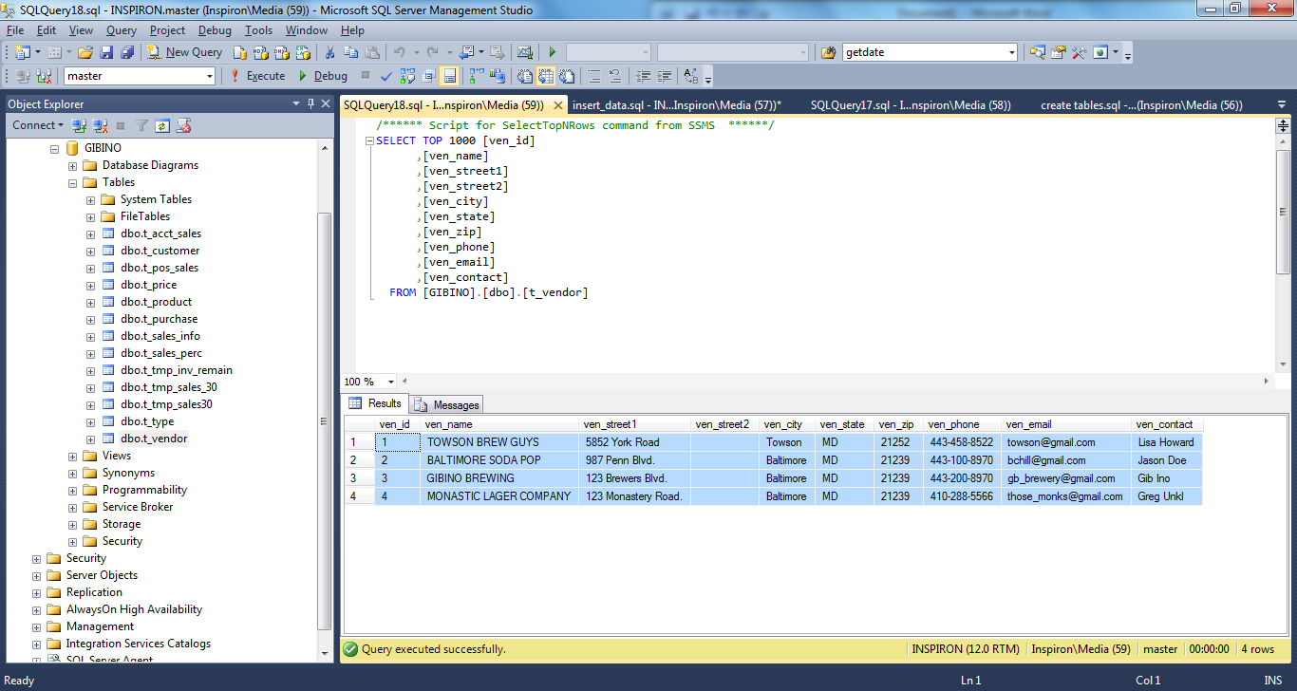

T_PRODUCT

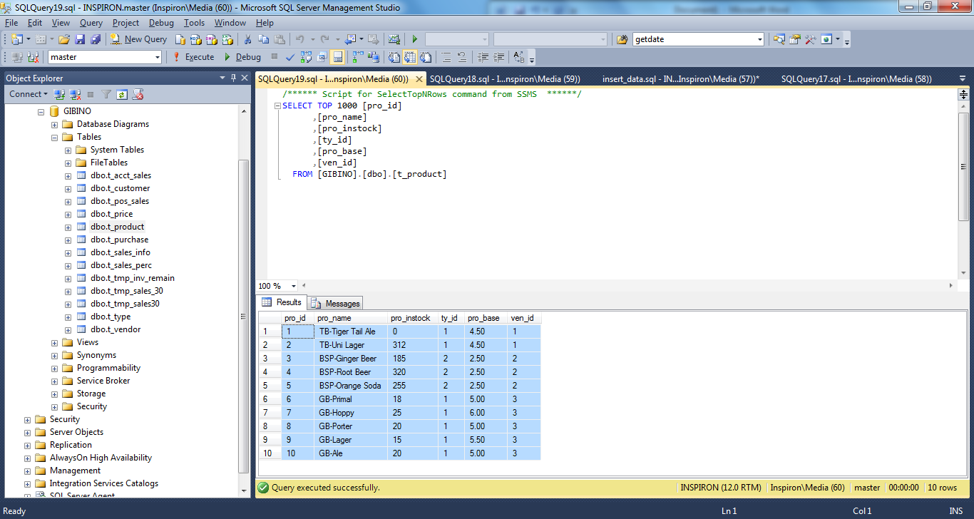

T_TYPE

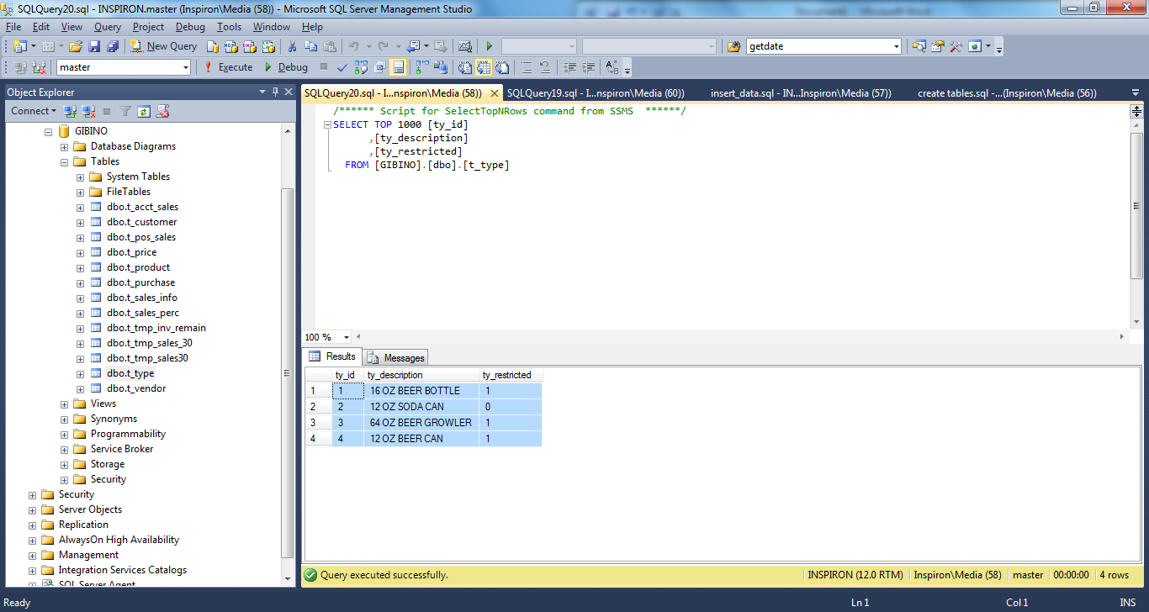

T_PURCHASE

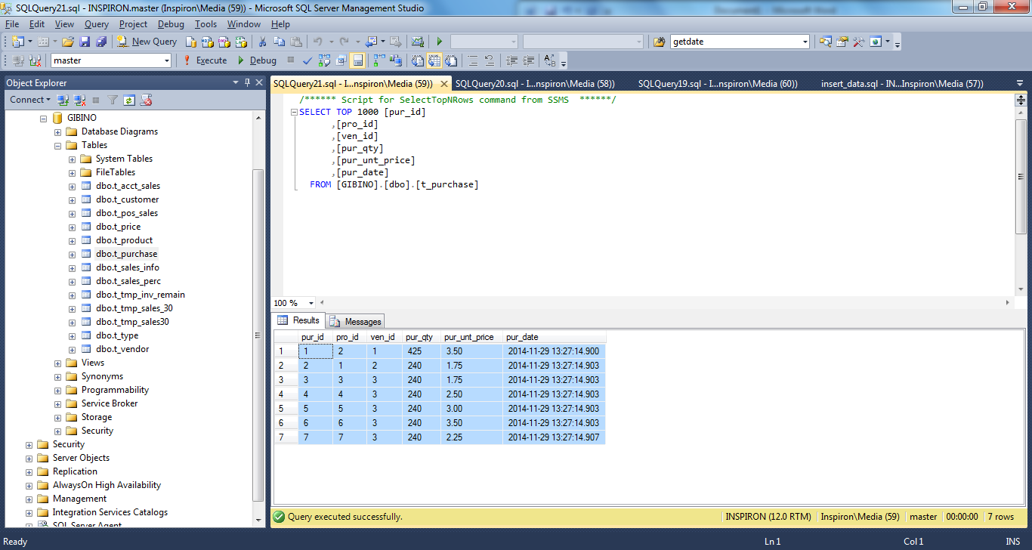

T_ACCT_SALES

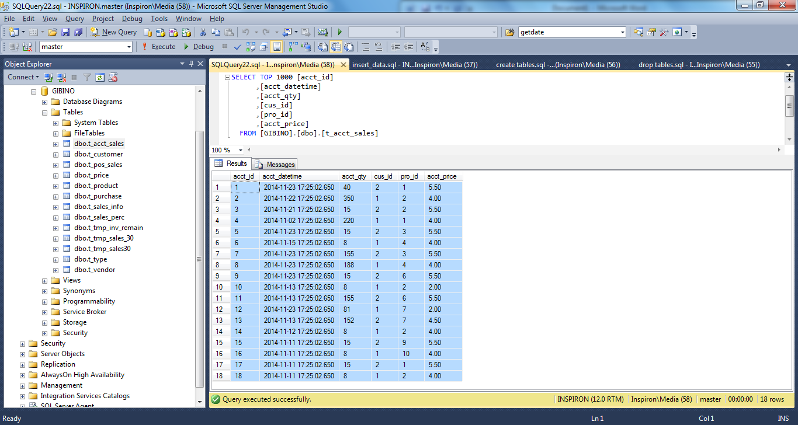

T_PRICE

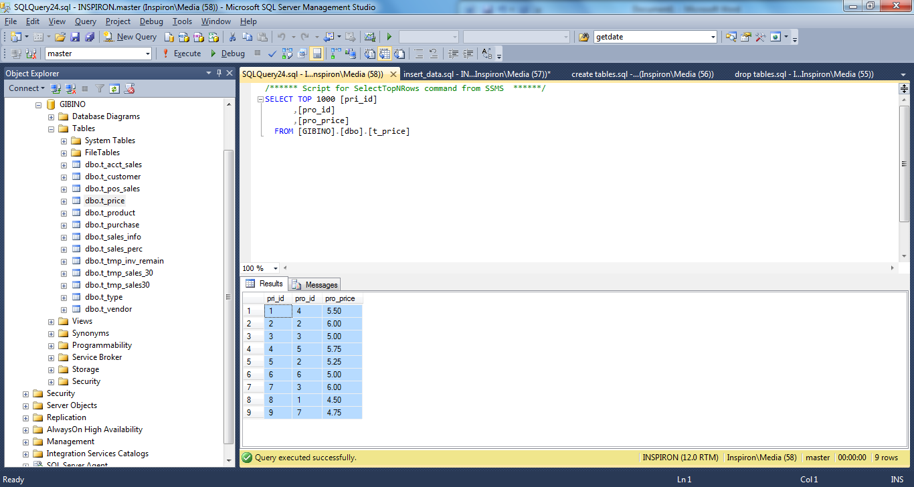

T_CUSTOMER

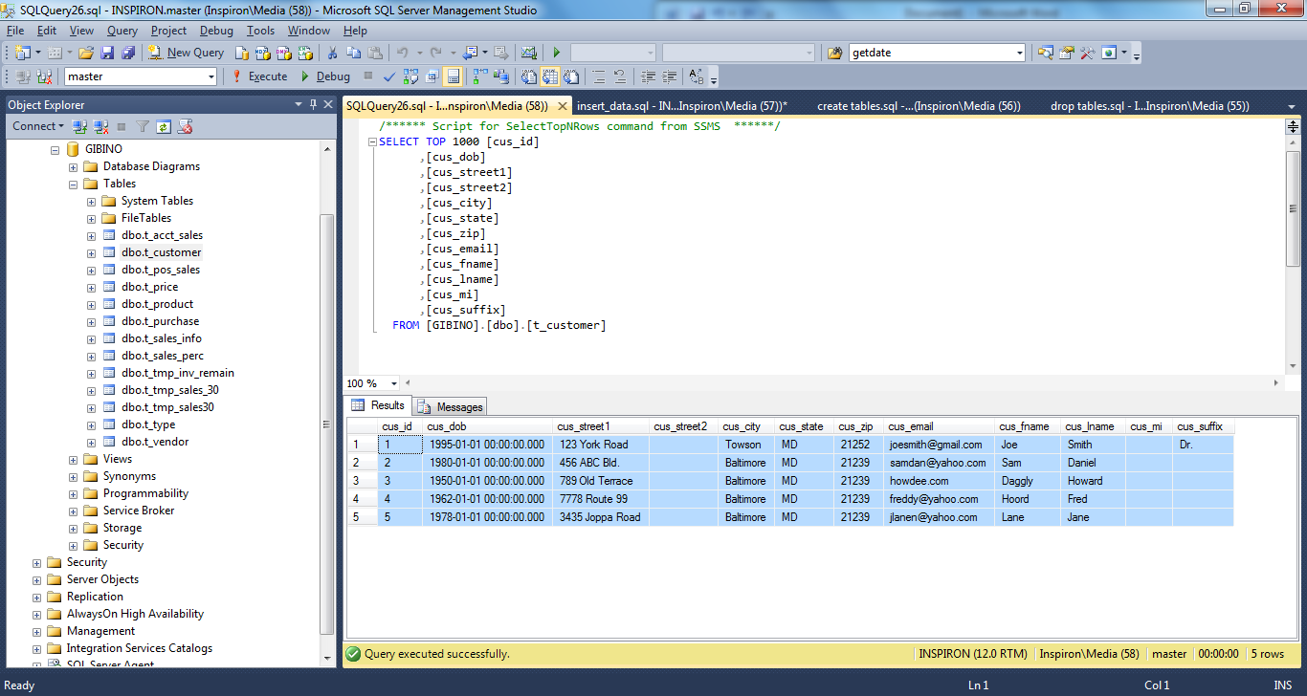

T_SALES_INFO

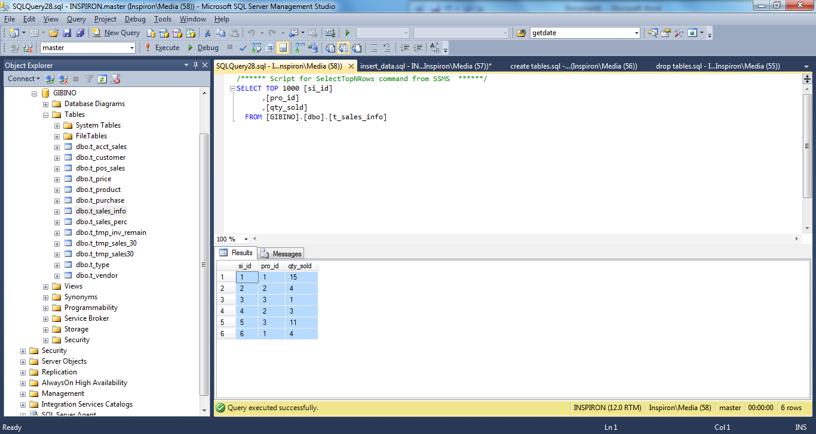

T_SALES_PERC

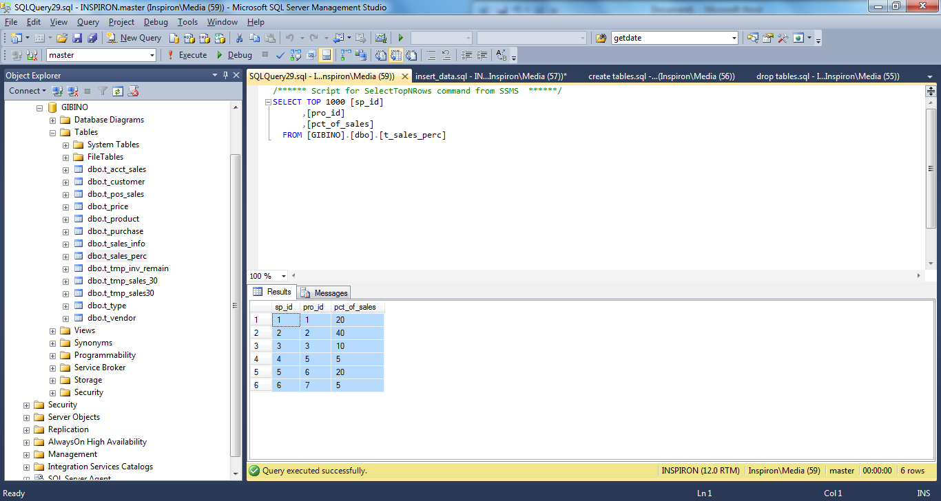

T_POS_SALES

