**Requirement 3** - The system must be able to add new inventory items (products) with no duplicate records.

The following code creates a stored procedure to add new items. It validates that the product does already exist in the system and the product does have a valid type.

drop procedure sp_add_product

go

create procedure sp_add_product (@pro_name varchar(30), @pro_instock int, @ty_id int, @pro_base numeric(5,2)) as

begin

--Checks for duplicate product names

if exists (select * from t_product where upper(pro_name)=upper(@pro_name))

begin

select @pro_name, 'already exsists in this system as a product.'

return

end

else

--NEED Checks that type is valid

if not exists (select * from t_type where upper(ty_id)=upper(@ty_id))

begin

select @pro_name, 'was not given a valid type.'

return

end

--inserts product data into t_product table

begin transaction

insert into t_product

(pro_name, pro_instock, ty_id, pro_base)

values

(@pro_name, @pro_instock, @ty_id, @pro_base)

if @@error<>0

begin

rollback transaction

select 'Product ', @pro_name, ' not added'

return

end

commit transaction

select 'Product ', @pro_name, ' was added'

end

This screen shot demonstrates the insertion of a successful product.

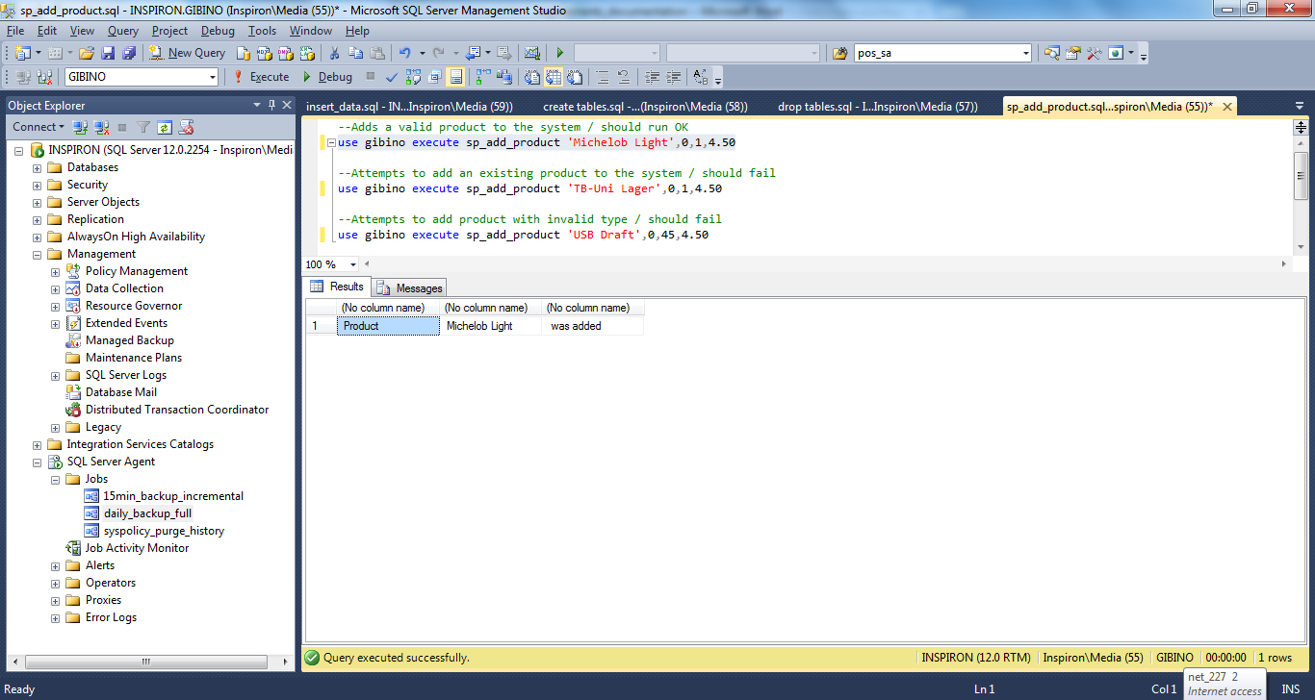

This screen shot demonstrates a failed attempt to insert an existing product.

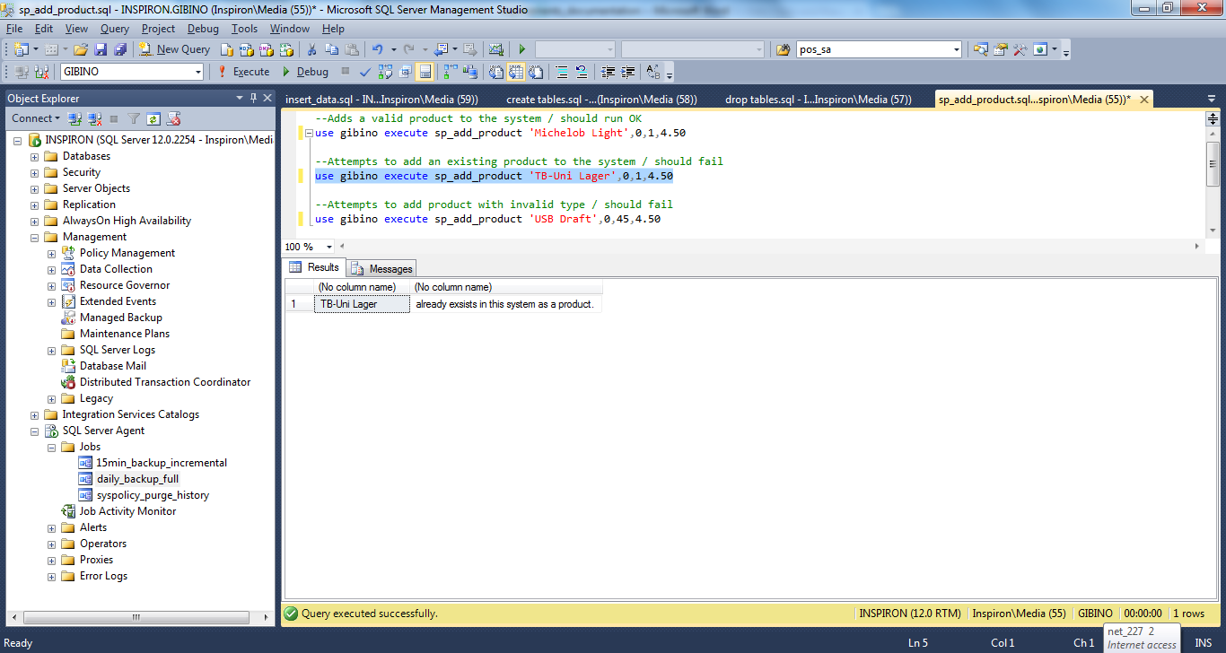

This screen shot demonstrates a failed attempt to insert a product with an invalid type.

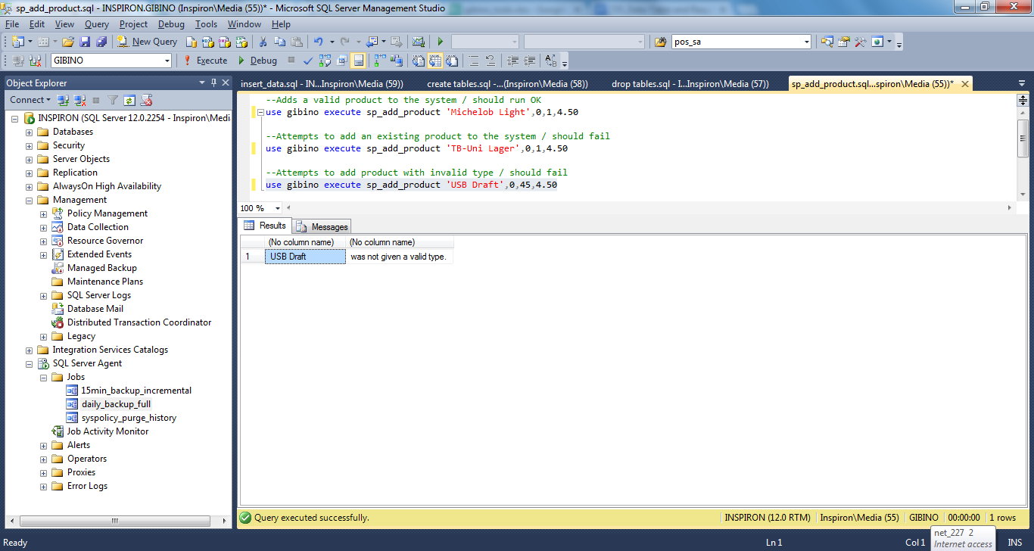

**Requirement 14** -The system must create a nightly backup, after normal business hours.

The following code demonstrates how to setup the database for ad hoc, full, and differential backups. It also shows how to put the database into simple recovery mode.

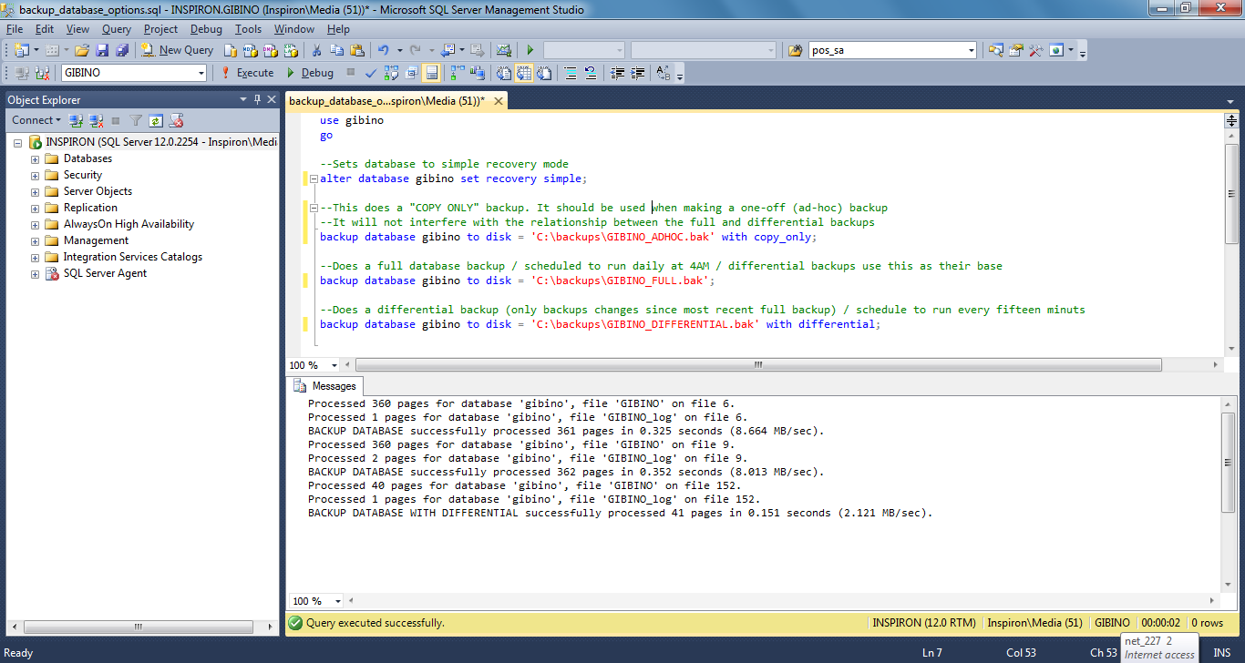

This screen capture shows that the full backup is a scheduled job, which runs at 4:00 AM every day.

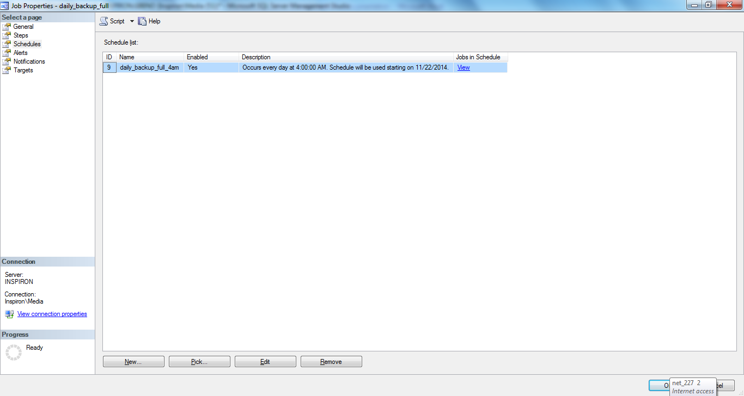

This screen capture shows that the differential backup is a scheduled job, which runs every 15 minutes.

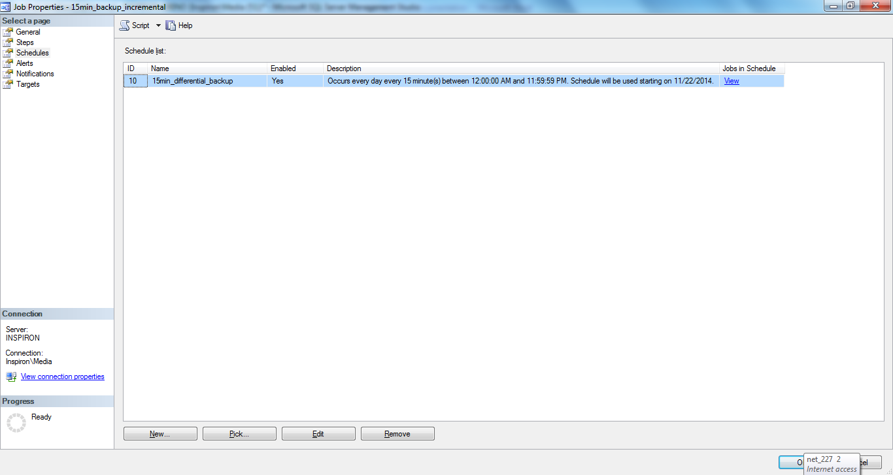

This screen capture demonstrates the code and output for a successful ad hoc backup.

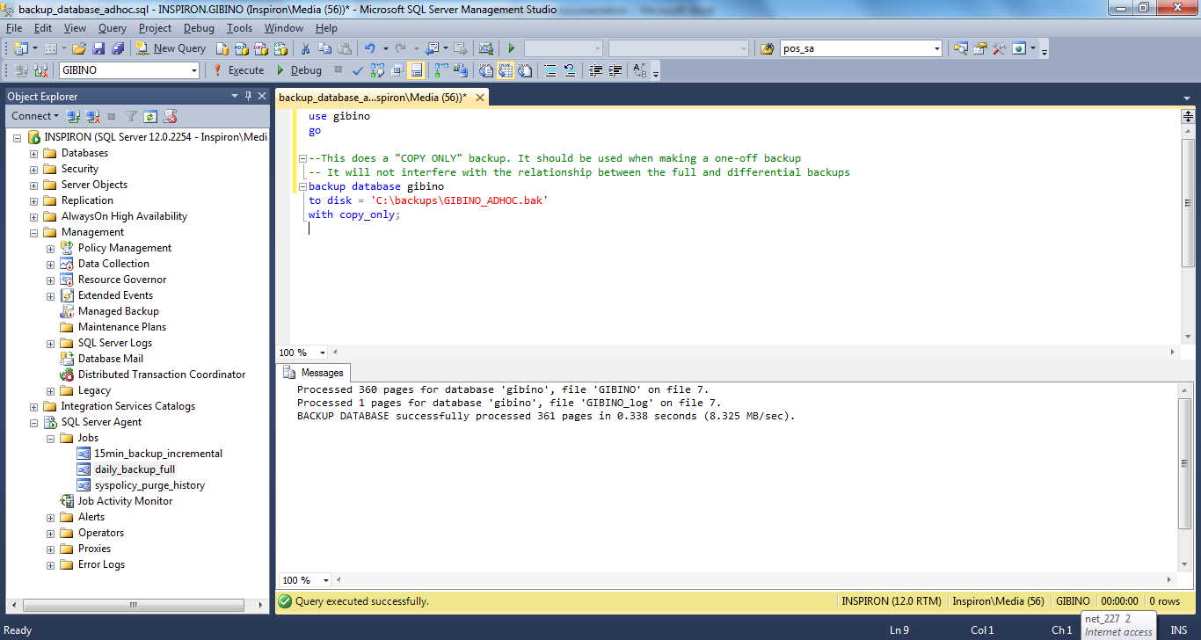

**Requirement 21** – The system must be able to display the unpaid items for a customer.

The following code creates a stored procedure to query the system for unpaid items. It validates that the product does already exist in the system and the product does have a valid type.

IF OBJECTPROPERTY(object_id('sp_customer_tab'), N'IsProcedure') = 1

DROP PROCEDURE [dbo].[sp_customer_tab]

GO

CREATE PROCEDURE dbo.sp_customer_tab

@cus_id INT

As

Begin

If not exists (Select * from T_CUSTOMER where cus_id = @cus_id)

begin

select 'Invalid Customer!'

return

end

Select pro.pro_name, s.pro_price, s.pos_qty

from t_customer c

inner join t_pos_sales s on c.cus_id=s.cus_id

inner join t_product pro on pro.pro_id=s.pro_id

where s.pos_paid=0

and s.cus_id = @cus_id

Select c.cus_fname, c.cus_lname,sum(s.pro_price) As SubTotal

from t_customer c

inner join t_pos_sales s on c.cus_id=s.cus_id

inner join t_product pro on pro.pro_id=s.pro_id

where s.pos_paid=0

and s.cus_id = @cus_id

group by c.cus_id,c.cus_fname, c.cus_lname

End

This screenshot demonstrates an execution of stored procedure for an existing customer

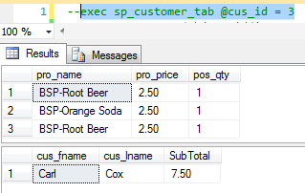

This screenshot demonstrates the validation for an existing customer

