Even Semester (2022)

Assignment Cover Letter

(Individual Work)

**Student Information : Surname Given Names Student ID Number**

1. Filbert Filbert 2502005263

**Course Code**  : COMP6699001

**Course Name** : Object Oriented Programming

**Class** : L2AC

**Name of Lecturer** : Jude Joseph Lamug Martinez

**Major** : Computer Science

**Title of Assignment** : Pac-man

**Type of Assignment** : Final Project

**Submission Pattern**

**Due Date** : 14/06/2022

**Submission Date**  : 14/06/2022

The assignment should meet the below requirements.

1. Assignment (hard copy) is required to be submitted on clean paper, and (soft copy) as per lecturer’s instructions.

2. Soft copy assignment also requires the signed (hardcopy) submission of this form, which automatically validates the softcopy submission.

3. The above information is complete and legible.

4. Compiled pages are firmly stapled.

5. Assignment has been copied (soft copy and hard copy) for each student ahead of the submission. Plagiarism/Cheating BiNus International seriously regards all forms of plagiarism, cheating and collusion as academic offenses which may result in severe penalties, including loss/drop of marks, course/class discontinuity and other possible penalties executed by the university. Please refer to the related course syllabus for further information. Declaration of Originality By signing this assignment, I understand, accept and consent to BiNus International terms and policy on plagiarism. Herewith I declare that the work contained in this assignment is my own work and has not been submitted for the use of assessment in another course or class, except where this has been notified and accepted in advance. Signature of Student:

Benedictus Filbert Federico

Table of Contents

Plagiarism/Cheating.....................................................................................................................................1

Declaration of Originality.............................................................................................................................2

I. Program Description ...................................................................................................................4

II. Class Diagram..............................................................................................................................

III. Application Flow......................................................................................................................

IV. Lessons that Have Been Learned ............................................................................................

V. Project Technical Description .....................................................................................................

VI. Code Explanation ....................................................................................................................

VII. Project Link............................................................................................................................

VIII. References ............................................................................................................................

1. Program Description

Pac-man

1. Program description

Pac-man is a 2D maze game, the player’s objective is to traverse the maze collecting all the white dots while avoiding the opposition, the ghosts. Upon succession will continue to the next level.

As a gamer and a coder I found it lies in between. As a coder this coding difficulty isn’t as high as I thought it would be, and from a gamer perspective Pac-man is quite fun to play. It invoke a quick-decisive strategy as the pieces in the field are on constantly moving.

1. Application Flow

Press spacebar

1. Class Diagram

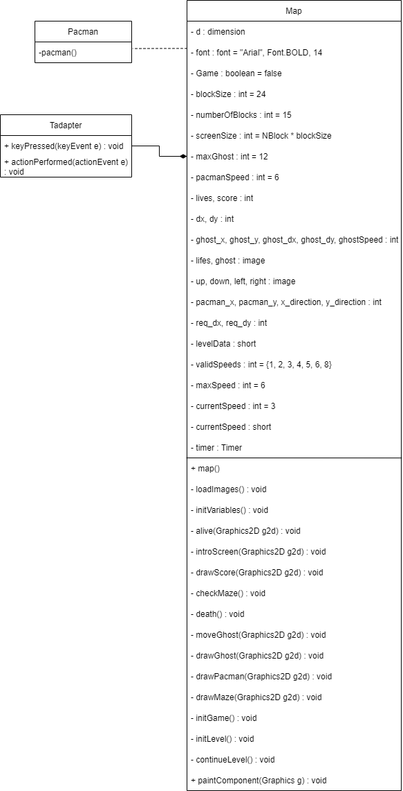

1. Lessons learned

Game development with java, ive learnt that java is not a suitable way to make a game. I also learnt about Jpanel

1. Project Technical Description

JPanel

ActionEvent

1. Code Explanation

First are all the imports, these above are the imports that are used in the program.

here are the declarations of the variables. Dimension d is the area of the game. Font is for displaying specific text. inGame boolean is to confirm whether the game is running and dying boolean is to determine is Pac-man is alive. BlockSize is to set how big a box is in the game, and numberOfBlock is the arena of the game, while screenSize is the game window. Number of the enemies that is the ghosts is maxGhost and then pacman speed is speed.

ghostQuantity as it says number of ghost. Lives represent the number of lives and score is the score. Every entity in the game has a position thus a series of coordinates of the ghost and pac-man. Lifes has been renamed to heart to remove confusion, it is for the heart icon accompanied with score as score. Up, down, left, right are actions for pac-man able to do.

here is behind the scene, the arena is made up of the numbers. The arena is 19x19 square. 0 represents the wall, 1 is left border, 2 is top border, 4 is right border, 8 is bottom border, and 16 is the white dot.

for example I want to create a particular block like the picture, I would need right border(+4), bottom border(+8), and the white dot(+16), resulting to 28

this declare the speed and time

constructor to call multiple functions, loadImages() load the image, initVariable() initialize variables, addKeyListener() is control functions, setFocusable() sets the focusable state of this component to the specified value. initGame() starts the game.

loadImages() is to load the image

This is to initiate the variables

Alive() is an indicator if pac-man is still alive, when pac-man ran out of hearts he dies, death() activates if dying resulted in True, otherwise pac-man is playable

this is for the intro screen and responsible for “press space to play” text

This is to check the environment if the player has won the game, this function resulted in an increase of ghost number and speed

this is to indicate if pac-man is a live or dead

This above and below is the function to move the ghost automatically, following rules similar to pac-man except the movement isn’t being controlled by player

This above is how the player move pac-man

Put the pac-man image in according to the direction of where its heading

initialize the game or the level

determine the position of the ghosts and their random speed

This function emphasize on the design display such as background

Tadapter enable the program to react to button on the keyboard

1. Reference

docs.oracle.com

github.com

Pac-man a backup project, it serves as a foundation for the game I was planning to make, however being too ambitious can be malicious, after concluding that it can’t make it I decided to scrap the game and turn to pac-man. The game I’m terminate is called Iron Lung, its a 2D maze exploration with objectives to reach within a certain time span with limited visual display.

Background:

The player controls the submarine, the sub mission is to traverse the underwater caves, the sub can’t afford to have windows therefore will rely on radar and a map. The player is to venture to the objectives called the extraction points and collect samples (this collection process is not considered to be in the game when planned). Completing the mission counts if 10 objectives are collected and the sub is on E or the exit.

Mechanics:

The player is tasked with exploring the maze from the start(S) to collect the objectives called extraction points, marked with the hashtag symbol. Upon completion the player will exit(E). It does sound easy however the player cant look the map and control the sub in the same time. To enable maneuver players must rely radar indicator and a static map, like a paper map, unlike google maps that constant update the user’s position. If the sub is close to a wall the radar will announce it. The sub has health points, to crash will reduce the health points by a few numbers. Crashing won’t be the main concern for the player as this is time based, realistically sub has limited oxygen capacity, if time runs out it’ll instantly reduce the health points to zero, and that’s game over.